Test Script Number: | register_participant |  |  |  | Module: |  |  | Tester Name: |  | Steven Cheng | Pass/Fail:  Pass
Use Case #: |  |  |  |  | Username: | registrar@wfubmc.edu |  | Test Date: |  | 01/30/2008 | Pass/Fail:  Pass
Estimated Execution Time: |  |  |  |  |  |  | Actual Execution Time: |  | 50 min
Test Objective: register a participant.

Test Setup: log in as a registrar.

Related Requirements
or Configuration Change Requests (Number/Description):

 | Test Action | Expected Results | Pass / Fail | Actual Results/Comments | gForge Tracker Bug ID
 | Click Registration tab, click Create Registration link, run Subject/Study search to find the subject and study. Click hide/show icon to display epochs, then select the right one. See figure 1. |  | Pass | Study Search results displayed.  Tested features:  - Search study by Identifier, Short Title and Status works fine. In addition, input one blank space and run search, get all studies displayed.  - Search subject by Last Name and Identifier works fine. Blank space search not work on the subject search.  - Hide/Show buttons work fine.  - Good feature: can not search and select a study which is closed to accrual  Comments:  - Hyperlinks on Select Study tab and Select Subject tab do nothing. It’s better remove the hyperlinks on them. In iteration 4, all tabs have hyperlinks, but do nothing.  - Mouse icon is not changed on hyperlinks of study or subject  - System does not accept the search criteria having space at the front or the end in Create Registration >> Search Subject.  - Hitting Enter key after typing search criteria clear the page.  - Reset tab button does not work.  - Update button does not work | 6892 - fixed  8128 - fixed  8792  8798  8800  8802
 | Fill the information for Enrollment Details, then click Continue button. See figure 2 |  | pass | Subject Search results displayed.  Tested features:  - Reset tab, Update button work fine  - Clear button works fine.  - Calendar works fine.  - Duplicate registration checked  Comments:  - Clicking Back button lose the whole work. | 8804
 | Answer the questions in Check Eligibility. See figure 3. |  | pass | Tested features:  - Reset tab, Update button work fine  - Back button works fine  - Hide/Show buttons work fine.  Comments:  - Exclusion Criteria is required?  - Default answer should be displayed. | 9648 - fixed  9587 - fixed
 | Answer the questions in Stratify. See figure 4. |  |  | Tested features:  - Reset tab, Update button work fine  - Back button works fine
 | Answer the questions in Select Arm. See figure 5. |  |  | Tested features:  - Reset tab, Update button work fine  - Back button works fine
 | Review and submit. See figure 6 |  | pass | Tested features:  - Back button works fine  - Register button works fine  Comments:  - Remove Rest tab button. | 8813
 | After modify the eligibility check, subject successfully registered. See figure 7, 8, 9 |  | pass | Subject has been successfully Registered.  Comments:  1) print link does not work. | 9650 - fixed

Tester Signature: Steven Cheng
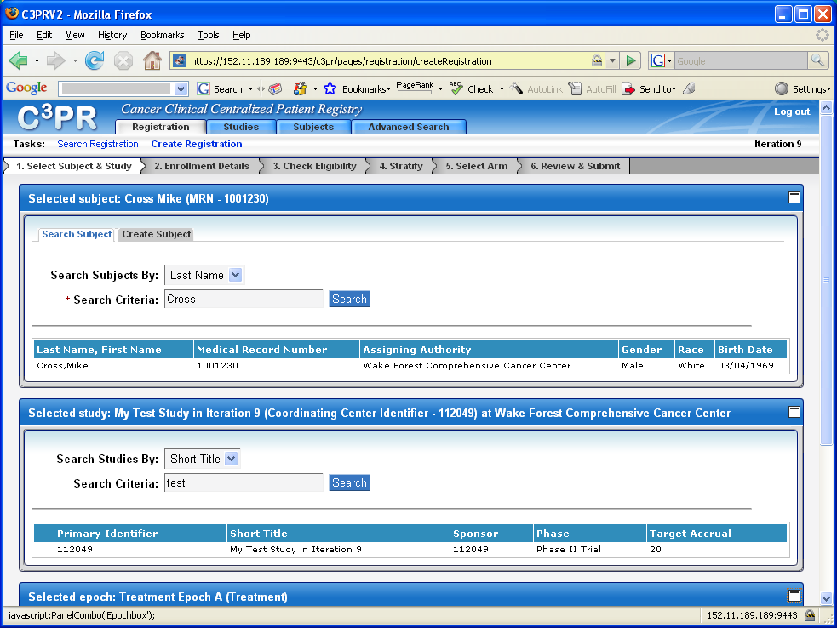
Figure 1
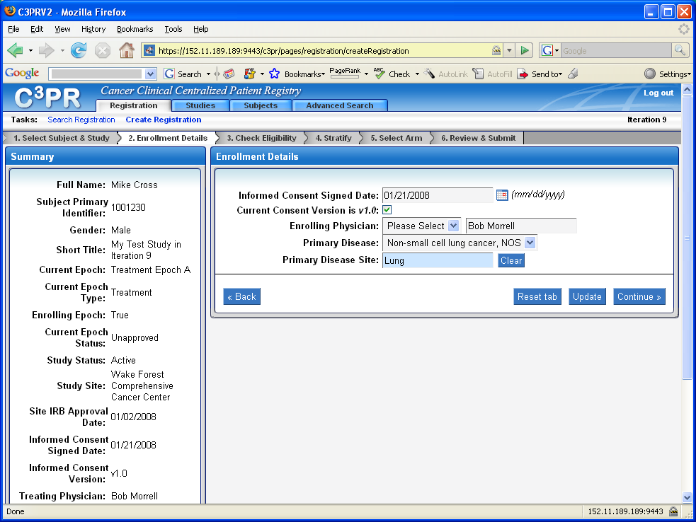
Figure 2
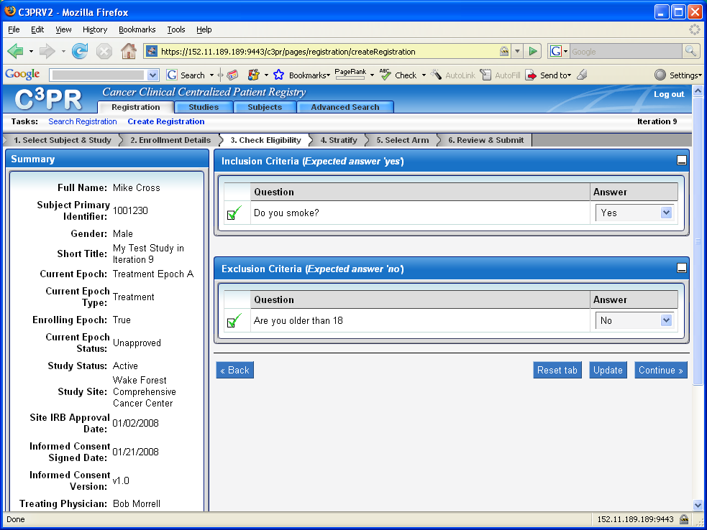
Figure 3
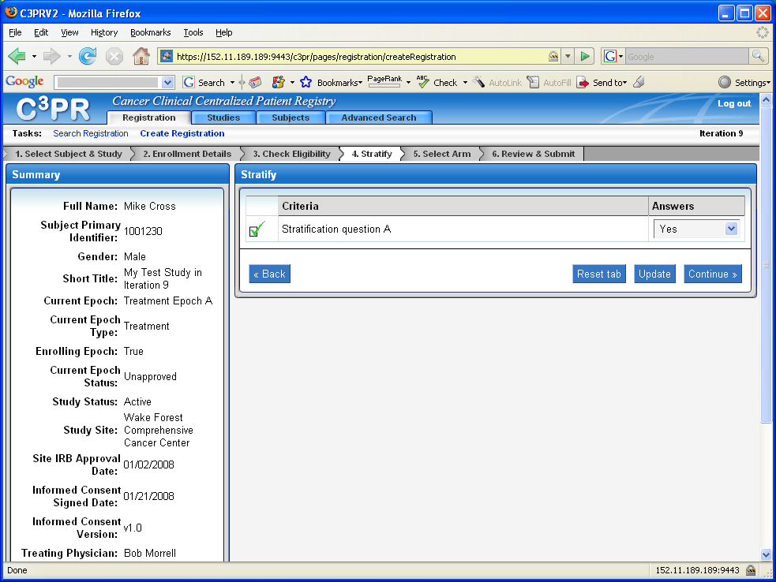
Figure 4
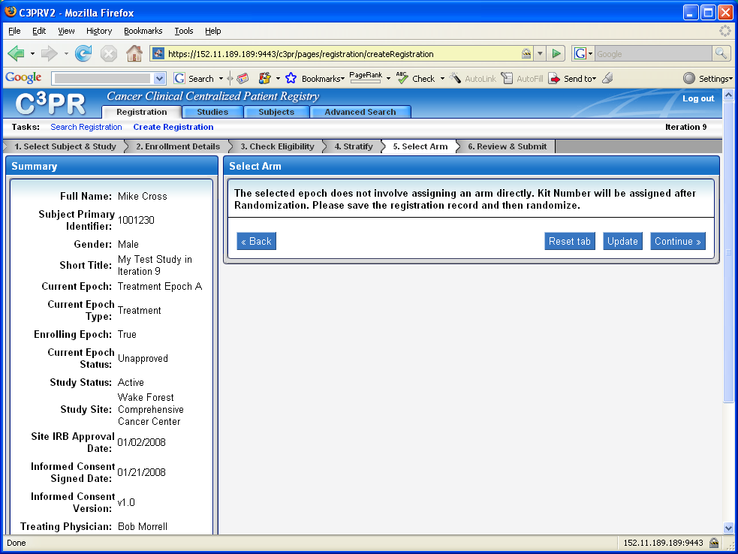
Figure 5
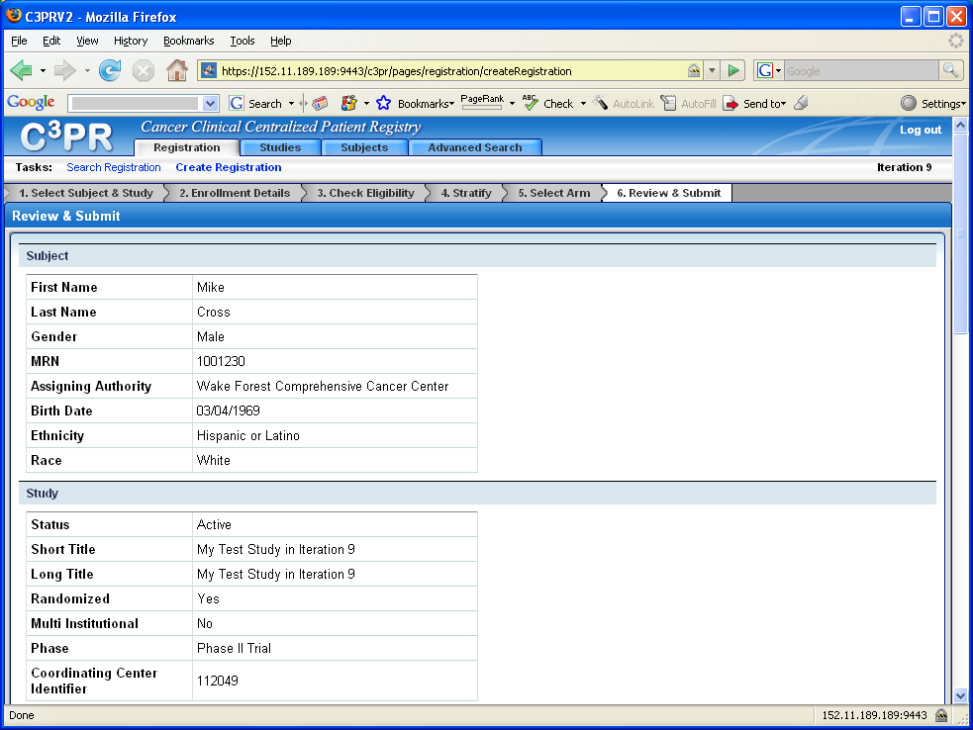
Figure 6

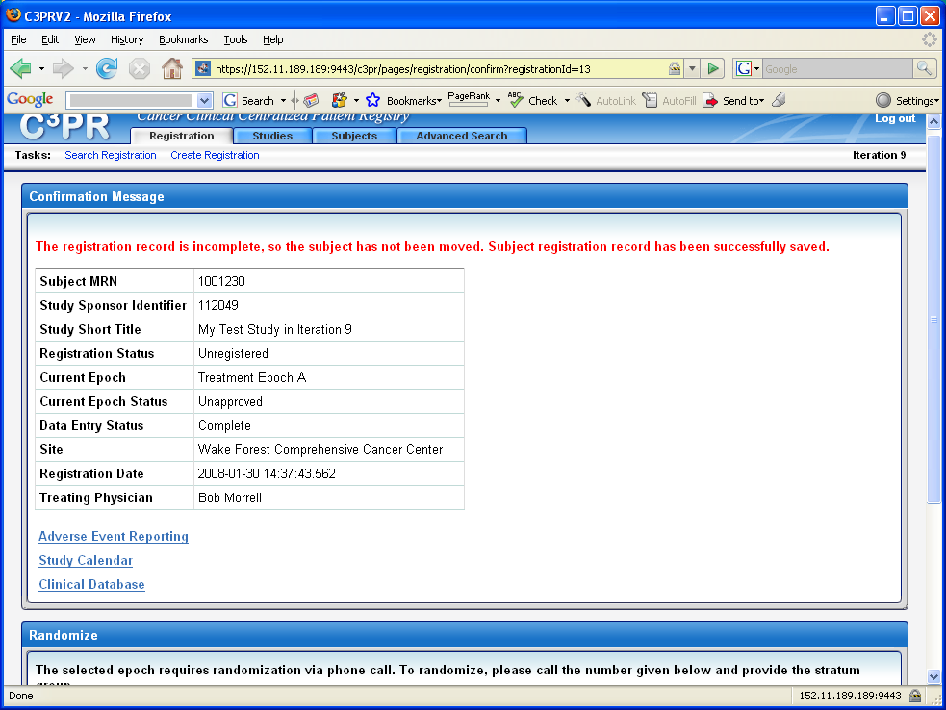
Figure 7
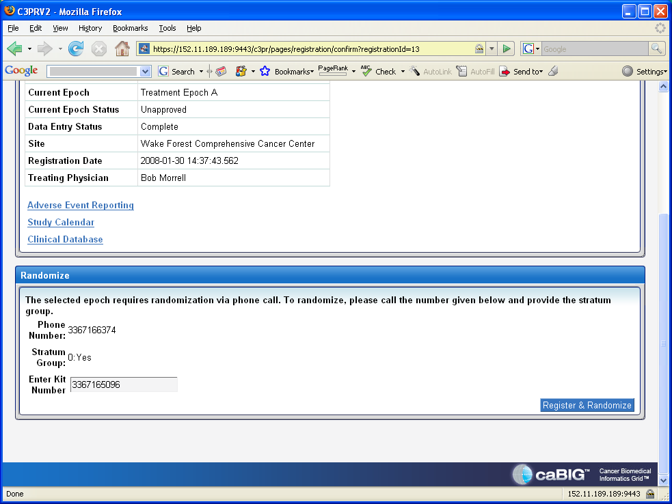
Figure 8
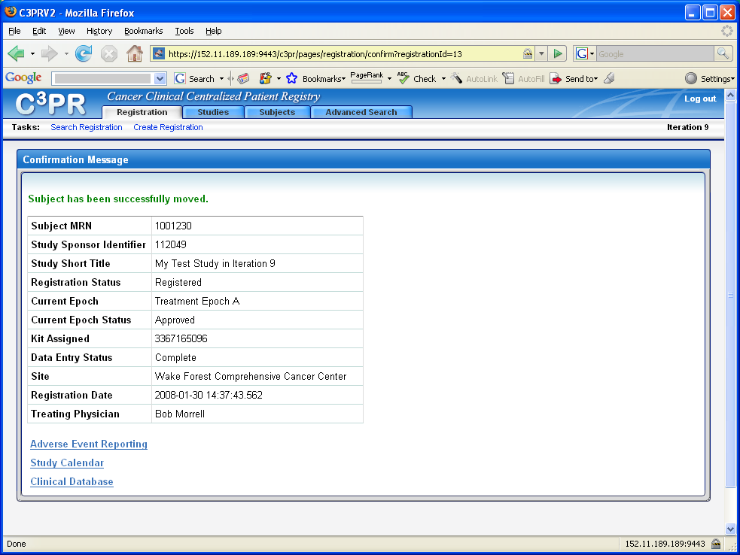
Figure 9

