Cancer central Clinical
Participant Registry V2
Administration Guide

Document Change History
Version Number | Date | Contributor | Description
V1.0 | 3/28/2007 | Patrick | Created template
V1.1 | 3/28/2007 | Manav Kher | Added details
V1.2 | 5/04/2007 | Manav Kher | Added Section on CSM
V1.3 | 1/30/2008 | Patrick | Updated w/ feedback
V1.4 | 1/30/2008 | Vinay Gangoli | Added User Management Section
V1.5 | 1/30/2008 | Manav Kher | Major revision with addition of Administration Console
V1.6 | 2/19/2008 | Jennifer Reed | Minor grammar and screenshot changes


Updated February 19, 2008

Copyright and License
Copyright Notice. Copyright 2006 Duke Comprehensive Cancer Center (“caBIG™ Participant”). The Cancer Central Clinical Participant Registry (C3PR) was created with National Cancer Institute (NCI) funding and is part of the caBIG™ initiative. The software subject to this notice and license includes both human readable source code form and machine readable, binary, object code form (the “caBIG™ Software”).
This caBIG™ Software License (the “License”) is between caBIG™ Participant and You. “You (or “Your”) shall mean a person or an entity, and all other entities that control, are controlled by, or are under common control with the entity. “Control” for purposes of this definition means (i) the direct or indirect power to cause the direction or management of such entity, whether by contract or otherwise, or (ii) ownership of fifty percent (50%) or more of the outstanding shares, or (iii) beneficial ownership of such entity.
License. Provided that You agree to the conditions described below, caBIG™ Participant grants You a non-exclusive, worldwide, perpetual, fully-paid-up, no-charge, irrevocable, transferable and royalty-free right and license in its rights in the caBIG™ Software, including any copyright or patent rights therein that may be infringed by the making, using, selling, offering for sale, or importing of caBIG™ Software, to (i) use, install, access, operate, execute, reproduce, copy, modify, translate, market, publicly display, publicly perform, and prepare derivative works of the caBIG™ Software; (ii) make, have made, use, practice, sell, and offer for sale, and/or otherwise dispose of caBIG™ Software (or portions thereof); (iii) distribute and have distributed to and by third parties the caBIG™ Software and any modifications and derivative works thereof; and (iv) sublicense the foregoing rights set out in (i), (ii) and (iii) to third parties, including the right to license such rights to further third parties. For sake of clarity, and not by way of limitation, caBIG™ Participant shall have no right of accounting or right of payment from You or Your sublicensees for the rights granted under this License. This License is granted at no charge to You. Your downloading, copying, modifying, displaying, distributing or use of caBIG™ Software constitutes acceptance of all of the terms and conditions of this Agreement. If you do not agree to such terms and conditions, you have no right to download, copy, modify, display, distribute or use the caBIG™ Software.
- Your redistributions of the source code for the caBIG™ Software must retain the above copyright notice, this list of conditions and the disclaimer and limitation of liability of Article 6 below. Your redistributions in object code form must reproduce the above copyright notice, this list of conditions and the disclaimer of Article 6 in the documentation and/or other materials provided with the distribution, if any.
- Your end-user documentation included with the redistribution, if any, must include the following acknowledgment: “This product includes software developed by Duke Comprehensive Cancer Center.” If You do not include such end-user documentation, You shall include this acknowledgment in the caBIG™ Software itself, wherever such third-party acknowledgments normally appear.
- You may not use the names “Duke Comprehensive Cancer Center”, “The National Cancer Institute”, “NCI”, “Cancer Bioinformatics Grid” or “caBIG™” to endorse or promote products derived from this caBIG™ Software. This License does not authorize You to use any trademarks, service marks, trade names, logos or product names of either caBIG™ Participant, NCI or caBIG™, except as required to comply with the terms of this License.
- For sake of clarity, and not by way of limitation, You may incorporate this caBIG™ Software into Your proprietary programs and into any third party proprietary programs. However, if You incorporate the caBIG™ Software into third party proprietary programs, You agree that You are solely responsible for obtaining any permission from such third parties required to incorporate the caBIG™ Software into such third party proprietary programs and for informing Your sublicensees, including without limitation Your end-users, of their obligation to secure any required permissions from such third parties before incorporating the caBIG™ Software into such third party proprietary software programs. In the event that You fail to obtain such permissions, You agree to indemnify caBIG™ Participant for any claims against caBIG™ Participant by such third parties, except to the extent prohibited by law, resulting from Your failure to obtain such permissions.
- For sake of clarity, and not by way of limitation, You may add Your own copyright statement to Your modifications and to the derivative works, and You may provide additional or different license terms and conditions in Your sublicenses of modifications of the caBIG™ Software, or any derivative works of the caBIG™ Software as a whole, provided Your use, reproduction, and distribution of the Work otherwise complies with the conditions stated in this License.
- THIS caBIG™ SOFTWARE IS PROVIDED "AS IS" AND ANY EXPRESSED OR IMPLIED WARRANTIES (INCLUDING, BUT NOT LIMITED TO, THE IMPLIED WARRANTIES OF MERCHANTABILITY, NON-INFRINGEMENT AND FITNESS FOR A PARTICULAR PURPOSE) ARE DISCLAIMED. IN NO EVENT SHALL THE DUKE COMPREHENSIVE CANCER CENTER OR ITS AFFILIATES BE LIABLE FOR ANY DIRECT, INDIRECT, INCIDENTAL, SPECIAL, EXEMPLARY, OR CONSEQUENTIAL DAMAGES (INCLUDING, BUT NOT LIMITED TO, PROCUREMENT OF SUBSTITUTE GOODS OR SERVICES; LOSS OF USE, DATA, OR PROFITS; OR BUSINESS INTERRUPTION) HOWEVER CAUSED AND ON ANY THEORY OF LIABILITY, WHETHER IN CONTRACT, STRICT LIABILITY, OR TORT (INCLUDING NEGLIGENCE OR OTHERWISE) ARISING IN ANY WAY OUT OF THE USE OF THIS caBIG™ SOFTWARE, EVEN IF ADVISED OF THE POSSIBILITY OF SUCH DAMAGE.

Development Team
Development | Administration Guide | Program Management
Patrick McConnell¹ | Manav Kher² | Jamie Cuticchia¹
Ram Chilukuri² | Ram Chilukuri² | Bob Annechiarico¹
Ramakrishna Gundala² | Patrick McConnell¹ | Patrick McConnell¹
Kruttik Aggarwal² |  | Ram Chilukuri²
Priyatam Mudivarti²
Manav Kher²
Vinay Gangoli²
¹Duke Comprehensive Cancer Center
²SemanticBits
Contacts and Support
Training Contact | Patrick McConnell  (patrick.mcconnell@duke.edu)
Customer Support Contact | None available
LISTSERV Facilities Pertinent to software teams
LISTSERV | URL | Name
C3prv2-elaborator | c3prv2-elaborators@gforge.nci.nih.gov | C3PR Elaborators Forum
C3prv2-general | c3prv2-general@gforge.nci.nih.gov | C3PR General Forum
C3prv2-developers | c3prv2-developers@gforge.nci.nih.gov | C3PR Developers Forum

Table of Contents

Chapter 1 Introduction to the Administration Guide 3
1.1 About C3PRv2 3
1.2 Overview of the Guide 3
1.3 Additional Documentation 3
1.4 Document Text Conventions 4
Chapter 2 Overview of the Software 5
2.1 Software Overview 5
2.2 Design and Architecture 5
Chapter 3 How to administer C3PRv2 7
3.1 External Property file 7
3.2 Administration console 7
Chapter 4 C3PRv2 Administration 9
4.1 Configuring Logging 9
4.2 Configuring Database Connections 9
4.3 Configuring ESB Communication 9
4.3.1 Sending Messages 10
4.3.2 Receiving messages 10
4.4 Modifying Security 10
4.5 Creating/Editing Research Staff 11
4.5.1 Creating Research Staff 11
4.5.2 Editing Research Staff Information 12
Chapter 5 Glossary 14

Introduction to the Administration Guide

About C3PRv2
The Cancer Central Participant Registry Release 2 (C3PRV2) is a web-based application used for end-to-end registration of patients to clinical trials. This includes capturing the consent signed date, eligibility criteria, stratification, randomization, and screening. Clinical workflows are enabled by both subject- and study-centric views into the registration process. C3PR can be run either in a standalone mode where study definitions, investigators, study personnel, and sites are entered into the system, or in an integrated mode with the caBIG Clinical Trials Suite (CCTS). C3PR also enables multi-site clinical trials where registration information is entered locally at affiliate sites and the registration is completed by call-out to the coordinating site.

Overview of the Guide
This guide is intended for administrators of the C3PRV2 system who will be configuring C3PR for local use. C3PR must first be installed before administration can take place. In order to perform administrative tasks, the user should be familiar with Tomcat administration, database connectivity, and, in the case of a CCTS deployment, grid deployment and infrastructure. In general, this guide will provide an overview of how to administer a pre-installed C3PRV2 system. Information on the installation of C3PRV2 can be found in the Installation Guide..
Information on the project can also be found on our Gforge Homepage or through our mailing lists (mentioned earlier in this guide).

Additional Documentation
Additional details on use cases, design, and installation can be found in the following documents.
Document | Link
c3prv2_use_cases.doc | https://gforge.nci.nih.gov/docman/view.php/214/10350/c3prv2_use_cases.doc
c3prv2_srs.doc | https://gforge.nci.nih.gov/docman/view.php/214/10351/c3prv2_srs.doc
c3prv2_architecture_guide.doc | https://gforge.nci.nih.gov/docman/view.php/214/10352/c3prv2_architecture_guide.doc
C3PRv2_Installation_Guide.doc | https://gforge.nci.nih.gov/docman/view.php/214/10332/C3PRv2_Installation_Guide.doc

Document Text Conventions
The following table shows various typefaces to differentiate between regular text and menu commands, keyboard keys, and text that you type. This illustrates how conventions are represented in this guide.
Table 1. 1 Document Conventions
Convention | Description | Example
Bold & Capitalized Command  Capitalized command > Capitalized command | Indicates a Menu command  Indicates Sequential Menu commands | Admin > Refresh
text in small caps | Keyboard key that you press | Press enter.
text in small caps + text in small caps | Keyboard keys that you press simultaneously | Press shift + ctrl and then release both.
Boldface type | Options that you select in dialog boxes or drop-down menus. Buttons or icons that you click. | In the Open dialog box, select the file and click the Open button.
Italics | Used to reference other documents, sections, figures, and tables. | caCORE Software Development Kit 1.0 Programmer’s Guide
Italic boldface type | Text that you type | In the New Subset text box, enter Proprietary Proteins.
Courier typestyle | Used for filenames, directory names, commands, file listings, source code examples and anything that would appear in a Java program, such as methods, variables, and classes. | URL_definition ::= url_string
Note: | Highlights a concept of particular interest | Note: This concept is used throughout the installation manual.
Warning! | Highlights information of which you should be particularly aware. | Warning! Deleting an object will permanently delete it from the database.
{} | Curly brackets are used for replaceable items. | Replace {root directory} with its proper value such as c:\cabio

Overview of the Software

Software Overview
C3PRV2 consists of a Java web application that based on the Java 2 Enterprise Edition (J2EE) Servlets infrastructure, Web Services Resource Framework (WSRF)-compliant web services that are built on top of caGrid infrastructure, and Java Business Integration (JBI) components that are hosted by Apache ServiceMix JBI container.
For more details on software requirements, please see the Installation Guide.

Design and Architecture
C3PRV2 is based on the J2EE n-tier architecture where business logic is partitioned in its own distinct re-usable layer, as shown in Figure 2-1. Each layer communicates with its adjacent layer only. This architecture promotes reusability, scalability, and ease of implementation. See the Architecture Guide for more information.
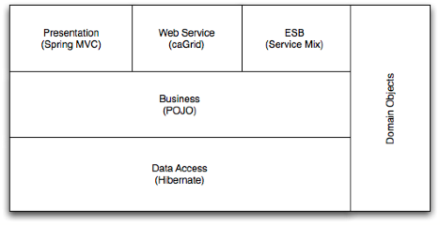
Figure 2-1 High-level overview of the C3PR system

How to administer C3PRv2

External Property file
C3PRV2 has externalized all its configuration into property files and/or the database. The basic set of properties that C3PRV2 uses is located in $CATALINA_HOME/conf/c3pr.properties. This property file contains only those properties that are required to get the C3PRV2 web application up and running. The database configuration is generally in this property file as well.
Note: When using the installer, the c3pr.properties will automatically be placed in your $CATALINA_HOME/conf directory. If you follow a manual build and deployment process, it’s possible that the property file is packaged either in an archive file and deployed in the application server. In such a case, you can copy $C3PR_SRC/codebase/antfiles/build.properties to $CATALINA_HOME/conf/c3pr.properties.

Administration console
Once you have C3PRV2 deployed, log in with the default admin account (see below) and select Administration, as shown in Figure 3-2. This will automatically open to the Configure C3PR task. A brief description of the properties on this page is provided in Table 3-1.

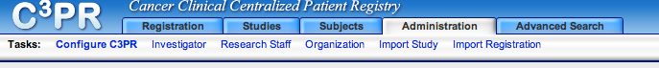
Figure 3-2 Administration tab in C3PRV2

Property | Description
Authentication Mode | Can be local (database based) or using caGrid Single Sign on. See Modifying Security for more information
Authorization Switch | Will enable/disable user authorization
C3D Hotlink URL | Hotlinking (URL shortcut) to the C3D application.
caAERS Hotlink URL | Hotlinking (URL shortcut) to the caAERS application
Study Calendar hotlink URL | Hotlinking (URL shortcut) to the Sudy Calendar application
ESB enable switch | This will enable disable messaging to the enterprise service bus (ESB).  Note: More information can be in Configuring ESB Communication
ESB URL | URL to the ESB message consuming (grid/JMS) service  Note: More information can be in Configuring ESB Communication
C3PR URL | URL to the C3PRV2 webapplication. This property is used only when authentication mode is webSSO  Note: See Modifying Security for more information
WebSSO base URL | Note: See Modifying Security for more information
WebSSO certificate file | Note: See Modifying Security for more information
Host certificate file | Note: See Modifying Security for more information
Host key | Note: See Modifying Security for more information
Hosted Mode | Note: See Modifying Security for more information
Local site NCI institute code | The NCI code for the site hosting this instance of C3PRV2
SMTP autentication | Authentication mode for SMTP. This is used when sending emails from the C3PRV2 web application
From address | From address for the emails. Emails sent from C3PRV2 will have this as the from address.
SMTP password | Password for the SMTP server (optional)
SMTP port | Port for the SMTP server
SMTP user name | Username for the SMTP server
Table 3-1 C3PR configuration properties

C3PRv2 Administration
In this section we will cover common administrative tasks that you can do with C3PRV2.

Configuring Logging
C3PRV2 system uses Log4J for logging. By default, the logging is set to a minimum so only errors and severe problems encountered during the runtime are logged. However, you can modify the settings if you would like to collect additional information on system failures. To change any of the log4j settings for C3PRV2 system, edit the log4j.properties file. For a pre-deployed C3PRV2 system, this file will typically be in the WEB-INF folder of your web application.
To make edits to the WEB-INF/log4j.properties file, you need to be familiar with the Log4j API. More information on this can be found at the Apache log4j publications page.
Note: You will have to restart your application server (tomcat) for the new logging rules to take effect.

Configuring Database Connections
As seen in Figure 2-1, C3PRV2 relies on a relational database for persisting information. There might be situation when a pre-deployed C3PRV2 system’s database connection details need to be modified. To change the database connection details you will have to edit the property file as described in External Property file.

Configuring ESB Communication
C3PRV2 has the capability to communicate using an ESB (caAdapter) with other CTMSi applications. For more information on the design, refer to the Architecture Guide.
C3PRV2 has two channels of communications with the ESB. It has the ability to send messages and receive messages. To modify the ESB communication settings, modify the properties in the Administration console.

Sending Messages
The following properties in the Administration console control the ESB communication (see Figure 4-3).
ESB enable switch: Set to True to enable ESB communication
ESB URL: Enter the the URL to the receiving service (caGrid or JMS)
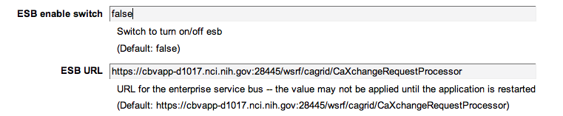
Figure 4-3 ESB configuration in Administration Console

Receiving messages
C3PRV2 also has the capability to receive messages from the ESB. This is done by deploying a special grid service that will accept messages from the ESB. To disable receiving messages, simply shut down or remove the RegistrationConsumer grid service. This typically will be deployed in $CATALINA_HOME/webapps/wsrf. This can be accomplished by removing the wsrf directory completely from webapps.
Note: This grid service is not deployed by default in the present iteration of C3PRV2.

Modifying Security
By default, C3PRV2 will redirect users to a login page where users are asked to enter their username and password. C3PRV2 uses caCORE Common Security Module (CSM version 3.2) and Acegi Security for authentication and authorization. By default the c3prv2 system ships with the following logins and roles:
Login Name | Default Password | User Group
c3pr_admin | c3pr_admin | System administrator
c3pr_registrar | c3pr_registrar | Registrar
c3pr_study_coordinator | c3pr_study_coordinator | Study Coordinator

Depending on the User Group the user belongs to, the user has certain privileges and will not be able to access certain sections of the C3PRV2 web application. More details can be found in the C3PRv2 design document.
There are two ways to administer the authorization module of C3PRV2: using the CSM User Provisioning tool (UPT), or the preferred method, creating and editing research staff. To download and install UPT, visit the NCICB Download Site. For more information on creating and editing research staff, see Creating/Editing Research Staff.
Authorization is configurable at build time by setting the enableAuthorization flag.
There are two ways to authenticate users in C3PRV2 – Local and WebSSO.
- Local Authentication – This is the default authentication mode and will use the C3PRV2 database to store user details. There is no further configuration needed beyond setting the enableAuthorization flag.
- WebSSO – This uses the caGrid single-sign-on module to authenticate users to C3PRV2. This authentication mode will be used when C3PRV2 is installed as part of the CCTS suite of applications. Single sign on will enable users to sign in once and be able to navigate to any of the CCTS applications without having to log in multiple times.
The webSSO authentication mode stores the user authentication information in caGrid Dorian service. For the user to have any privileges in C3PRV2, the administrator has to create the Dorian user in C3PRV2 (see Creating Research Staff) with the same userid as used in Dorian. This allows C3PRV2 to properly map a webSSO user to a local user.
By default, a new installation of C3PRV2 will use the local authentication mode. To change to WebSSO mode, log in to C3PRV2 using an administrator account and select Administrator to bring up the Configure C3PR task. Then edit the following properties:
- Authentication Mode: Set this to webSSO
- WebSSO Base URL: Enter the {URL to the caGrid webSSO service}
- WeSSO certificate file: Enter the {Public key for the webSSO service}.
Note: If you used Java Keytool to generate the certificate for webSSO and the webSSO service ishosted on the same server (same JDK) as C3PRV2, this should be in $JAVA_HOME/lib/security/cacerts
- Host Certificate file: Enter the {Host certificate that the C3PRV2 service is using}
- Host Key – Enter the {Host key that the C3PRV2 service is using}
Note: You can enter the hotlinks for the other CCTS service (caAERS, PSC, etc) now or at a later time.
A restart of the application server will be required for some of the configuration changes to take effect. To do this, restart Tomcat by running shutdown.bat (or shutdown.sh) and startup.bat (or startup.sh).

Creating/Editing Research Staff
The C3PR web-application lets the user create and edit research staff, which is used for authentication and authorization.

Creating Research Staff
The user clicks on the administration tab to view all the administrative functions he/she can perform. “Research Staff ” is a task listed under this tab. Clicking on this will take the user to the search research staff page. Click on the Create Research staff sub-task to go to the create page.
To successfully create a Research staff, fill out the following mandatory fields, as indicated by a * in the application (Figure 4-4 Create Research Staff Screenshot):
- Organization
- First Name
- Last Name
- Email Address
- NCI Identifier
- Role (more than one may be selected)

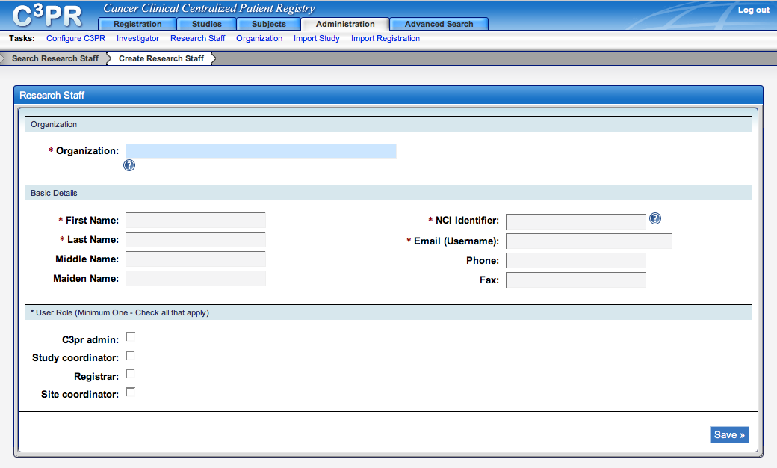
Figure 4-4 Create Research Staff Screenshot
All the other fields are optional. Organization is a auto-completer field, which means that entering a letter in that field will display a list of potential organization names that you can select instead of typing it.
Once you’ve entered all the information, click Save. The saved confirmation page will be displayed.

Editing Research Staff Information
The user can also edit the created Research staff information by searching for the staff. The search takes one of the following four parameters:
- Organization
- First Name
- Last Name
- NCI Identifier

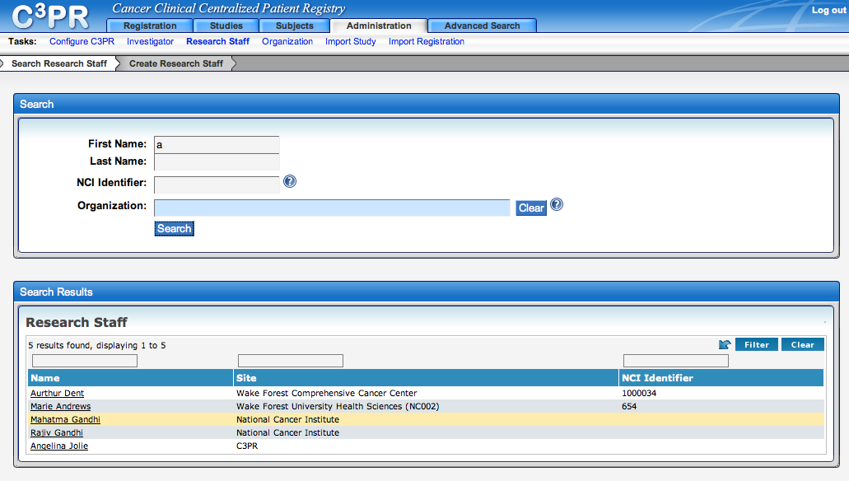
Figure 4-5 Search Research Staff screenshot

You can click on any first name in the search results to go to the edit page for that research personnel. This takes you back to the create staff page; however, this time it is pre-filled with the staff members information. Edit the information and save your changes by clicking Save.
Note: The organization name is not editable and will be grayed out.

Glossary
Term | Definition
CSM | Common Security Module
IdP | Identity Provider
API | Application Programming Interface
CDE | Common Data Element
GUI | Graphical User Interface
UML | Unified Modeling Language
JMS | Java Message Service
API | Application Programming Interface
caBIG | cancer Biomedical Informatics Grid
DAO | Data Access Objects
HTTP | Hypertext Transfer Protocol
JDBC | Java Database Connectivity
JSP | JavaServer Pages
ORM | Object Relational Mapping
RDBMS | Relational Database Management System
SDK | Software Development Kit
HASTE | High-level Automated System Test Environment
WSRF | Web service resource framework
ESB | Enterprise Service Bus
AJAX | Asynchronous JavaScript a
BC | Binding Component
SE | Service Engine
NMR | Normalized Message Router
JAAS | Java Authentication and Authorization Service
GAARDS | Grid authentication and authorization with Reliably Distributed Services
DWR | Direct Web Remoting

