Test Script Number: | create_new_organization |  |  |  | Module: |  |  | Tester Name: |  | Steven Cheng | Pass/Fail:  pass
Use Case #: |  |  |  |  | Username: | c3pr_admin |  | Test Date: |  | 08/31/2007 | Pass/Fail:  pass
Estimated Execution Time: |  |  |  |  |  |  | Actual Execution Time: |  | 10 min
Test Objective: create a new organization.

Test Setup:

Related Requirements
or Configuration Change Requests (Number/Description):

 | Test Action | Expected Results | Pass / Fail | Actual Results/Comments | gForge Tracker Bug ID
 | Click Administration tab, then click Create Organization link, fill the required information, then click Save button. See figure 1. |  | Pass | Tested features:  1) Required field validation is active.  2) Save button works  3) Reset tab works
 | Confirmation message displayed. See figure 2 |  | Pass | New organization successfully created.  Tested features:  - the link to create another organization works properly

Tester Signature: Steven Cheng
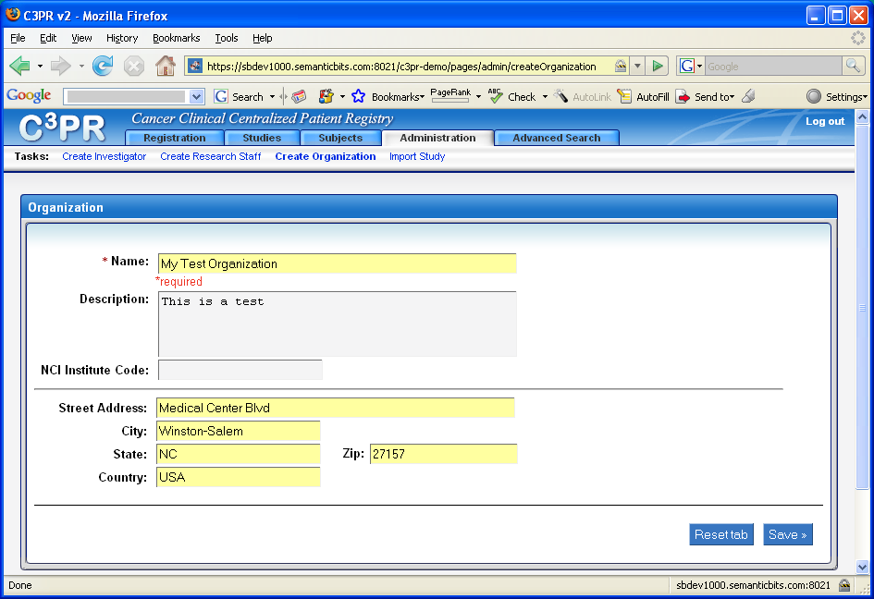
Figure 1
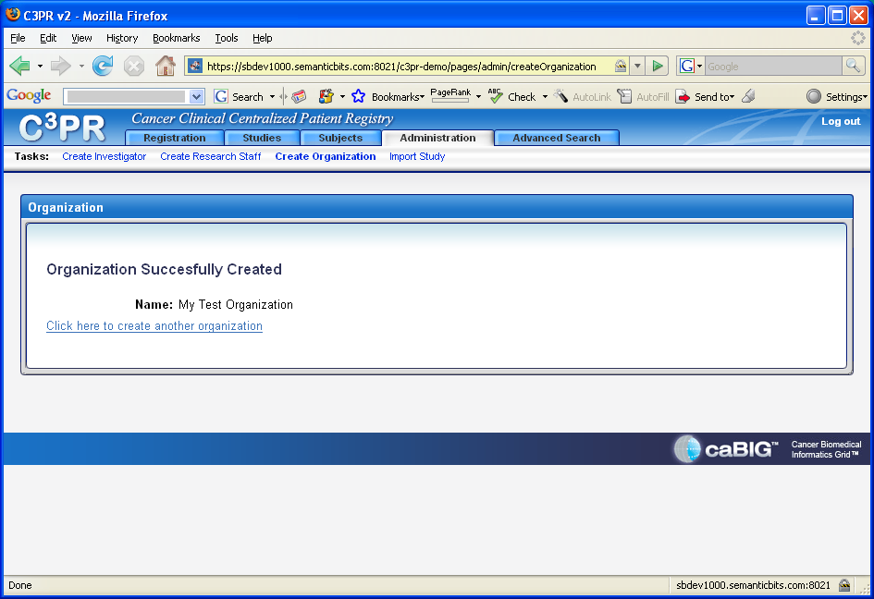
Figure 2

