Use Case Document
Data Transformation Service
Owner: caAdapter Development Team

National Cancer Institute
Center for Biomedical Informatics and Information Technology
2115 East Jefferson Street
Rockville, MD 20852
 | 


DOCUMENT REVISION HISTORY
Version Number | Date | Description
1.0 | 04-Jan-11 | - Initial Draft

Background/Summary
This document contains the use cases for the caAdapter Data Transformation Service model. This module provides the following capabilities:
- SOA compliant system
- Data Derivation Transformation Service
- Domain Value Mapping Transformation Service
- Distributed XML Data Source.
- Flexible and Secure Deployment Framework
- Integration and Extension Framework
Table of Content
Background/Summary 3
1 Introduction 6
1.1 Overview 6
1.2 Related Documents 7
2 Actors and Goals 7
2.1 Medical Systems Analyst 7
2.2 Medical Application Developer 7
2.3 External System 7
3 Use Cases 7
3.1 Use Case 1 – Open Data Structures in the Source Panel of the Mapping Tool 8
3.1.1 Use Case Model 8
3.1.2 Brief Description 8
3.1.3 Primary Actor 8
3.1.4 Preconditions 8
3.1.5 Basic Flow of Events 8
3.1.6 Alternative Flow 9
3.1.7 Post Conditions 9
3.1.8 Special Requirements 9
3.2 Use Case 2 – Open a Data Structure in the target Panel of the Mapping Tool 10
3.2.1 Use Case Model 10
3.2.2 Brief Description 10
3.2.3 Primary Actor 10
3.2.4 Preconditions 10
3.2.5 Basic Flow of Events 10
3.2.6 Alternate Flow 11
3.2.7 Post Conditions 11
3.2.8 Special Requirements 11
3.3 Use Case 3 – Map Source Data Elements from Source to Target Data Structures 12
3.3.1 Use Case Model 12
3.3.2 Brief Description 12
3.3.3 Primary Actor 12
3.3.4 Preconditions 12
3.3.5 Basic Flow of Events 12
3.3.6 Alternate Flow 13
3.3.7 Post Conditions 13
3.3.8 Special Requirements 14
3.4 Use Case 4 – Register Mapping Scenario 15
3.4.1 Use Case Model 15
3.4.2 Brief Description 15
3.4.3 Primary Actor 15
3.4.4 Secondary Actor 15
3.4.5 Preconditions 15
3.4.6 Basic Flow of Events 15
3.4.7 Alternate Flow 16
3.4.8 Post Conditions 16
3.4.9 Special Requirements 16
3.5 Use Case 5 – Transform Source Dataset(s) and Create a Target Dataset Using UI 16
3.5.1 Use Case Model 17
3.5.2 Brief Description 17
3.5.3 Primary Actor 17
3.5.4 Secondary Actor 17
3.5.5 Preconditions 17
3.5.6 Basic Flow of Events 17
3.5.7 Alternate Flow 18
3.5.8 Post Conditions 18
3.5.9 Special Requirements 18
3.6 Use Case 6 – Transform Source Dataset(s) and Create a Target Dataset Using Webservice APIs 19
3.6.1 Use Case Model 19
3.6.2 Brief Description 19
3.6.3 Primary Actor 19
3.6.4 Secondary Actor 19
3.6.5 Preconditions 19
3.6.6 Basic Flow of Events 20
3.6.7 Alternate Flow 20
3.6.8 Postconditions 20
3.6.9 Special Requirements 21
3.7 Overall Requirements 22
3.8 Requirements Prioritization 22
4 Sign Off 23
4.1 Approval 23

Introduction

Overview
The National Cancer Institute Center for Biomedical Informatics and Information Technology (NCI CBIIT) has developed the open source caAdapter tool kit with the goal of creating standards-based infrastructure components to facilitate medical research data exchange. The caAdapter tool kit includes Module Mapping Service (http://caadapter.nci.nih.gov/caadapter-mms/index.html ), HL7 Map and Transformation Service (http://caadapter.nci.nih.gov/caadapter-hl7/index.html ), Global Model Exchange Service (http://caadapter.nci.nih.gov/caadapter-gme/index.html ), Common Mapping and Transformation Service (http://caadapter.nci.nih.gov/caadapter-ctms/index.html) , and Data Transformation Service.
The Data Transformation Service module provides two kind of data transformation: data derivation transformation and domain value mapping transformation. The derivation transformation process converts a set of data (one or more parameter) into the derived data by invoking a predefined derivation operation (formula). The domain value mapping transformation process replaces the data values of a source domain with their corresponding values in the target domain based on a predefined mapping between the source domain and the target domain.
The Data Transformation Service module maintains a distributed data repository system storing derivation definition data or mapping data in XML providing the software- and hardware- independent way of data sharing ^{[3]}. The distributed data repository provides transparent data access to all application. It maintains its data integrity across all data sources with transparent transaction management.
This Use Case Document captures the main use cases for caAdapter Data Transformation Service module including functionalities of data derivation transformation and domain value mapping transformation. We will implement this module incrementally with multiple iterations, but all use cases are included in this document with each identified by implementation plan.

Related Documents
- Data Transformation Service Scope Document
- Data Transformation Service Requirements
- Data Transformation Service Design Document
- Data Transformation Service User’s Guide

Actors and Goals
An actor is a person, organization, or external system that plays a role in one or more interaction with the Data Transformation Service module. The following is a list of Actors that interact with this module:

System Analyst
This actor will use the Data Transformation Service module to derive existing data elements into new data element or transform data values from one value domain into values of another value domain.

Application Developer
This actor is responsible for developing medical application using data derivation or domain value transformation functionalities.

External System
This actor represents any external system that interacts with the caAdapter Data Transformation Service module using its APIs or SOA service agent.

Use Cases

Define Derivation Formula

Use Case Model
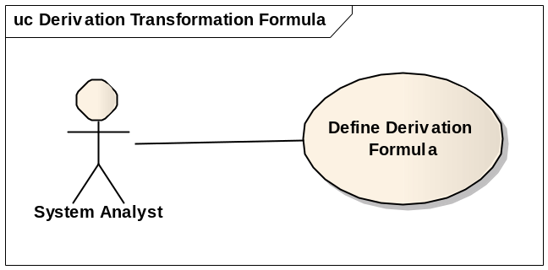

Brief Description
A System Analyst derives a new data concept from one or more known data concept based on given mathematical operations. The known data concept may be a public concept like NCI Common Data Element (CDE), a constant, or user defined variable. The new data concept may or may not be assigned a public code. The derivation formula may work independent from the derived data concept for data reformatting, or any requested data manipulation.
This use case covers defining a new formula or updating an existing formula as well.

Primary Actor
System Analyst

Preconditions
- Derivation process is defined.
- Source data concepts are identified.
- Derived data concept is optional.

Basic Flow of Events
- The Analyst launches the Data Transformation Service module UI
- The Analyst selects source data concept(s).
- The Analyst optionally set derived data concept.
- The system guide user interactively input mathematical operations step-by-step.
- The system validates the defined deriving process.
- A derivation formula is ready for execution, persistent as xml, or sharing for public uses.

Alternative Flow
User may create a derivation formula xml based on the schema of formula xml using third party xml editing tool.

Post Conditions

Success Condition
- Derivation formula is persisted for future use.
- Derived data concept is optionally set.

Error Condition
Fail to create valid derivation formula.

Special Requirements
Public standard, such as MathML, is recommended for formula and mapping.

Invoke Derivation Transformation

Use Case Model
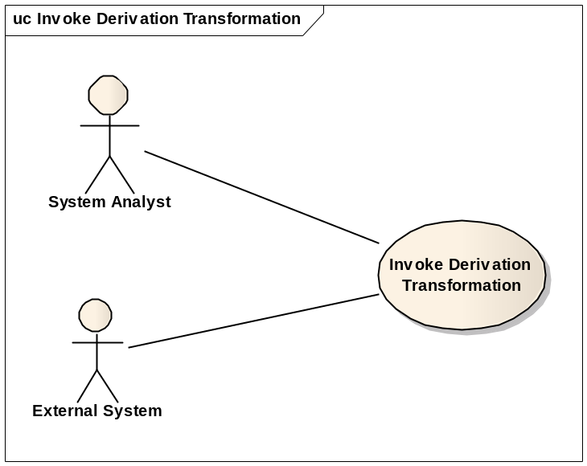

Brief Description
User invokes a derivation formula and generates a result data from using source data as parameters of the formula.
This use case covers using formula from either local system or remote system.

Primary Actor
Systems Analyst or External System

Preconditions
- The derivation formula is defined and valid.
- Data values are set for all formula parameters.

Basic Flow of Events
- User search and identify a derivation formula.
- User prepares data for all formula parameters.
- The transformation engine invokes the derivation formula using provided parameters.
- The transformation engine generates result value.

Alternate Flow
N/A

Post Conditions

Success Condition
The result data is ready for further business uses. User optionally processes the result for further business.

Error Condition
The system fails in calculating result with given parameter values.

Special Requirements
N/A

Define Domain Value Mapping

Use Case Model
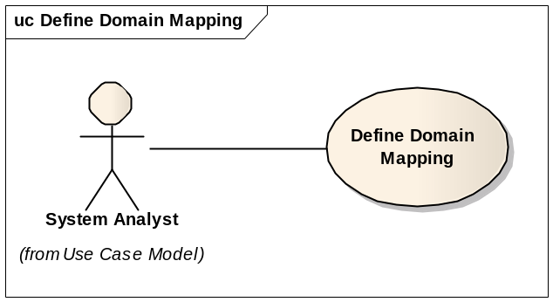

Brief Description
‘Domain’ means one vocabulary unit concept such as ‘marital status’ or ‘disease code’. One vocabulary concept is one angle of view to one ‘Domain’ which can be differently represented by another system. This mapping work sets up definitions of practical translation each by each between the both for semantic communication. One mapping definition set should be stored as a file which is very similar to a language dictionary.

Primary Actor
Systems Analyst

Secondary Actor
N/A

Preconditions
- Source and target coding or vocabulary domains must be exist and obviously differentiated
- About one domain concept, each of source and target has own code definitions

Basic Flow of Events
            - Fetch coding data of the source domain
            - Fetch coding data of the target domain
            - Set translation mapping from the source to the target for each definition
            - Set ‘else case’ value for each domain
            - If necessary, add proper annotations or comments
            - Save those mapping data up to one file.

Alternate Flow
N/A

Post Conditions

Success Conditions
- All source coding definitions are mapped
- ‘Else case’ is defined.

Error Conditions
- No mapping happened
- Any null coding value at either source or target side

Special Requirements
GUI, mapping with drag and drop

Invoke Domain Value Mapping Transformation

Use Case Model
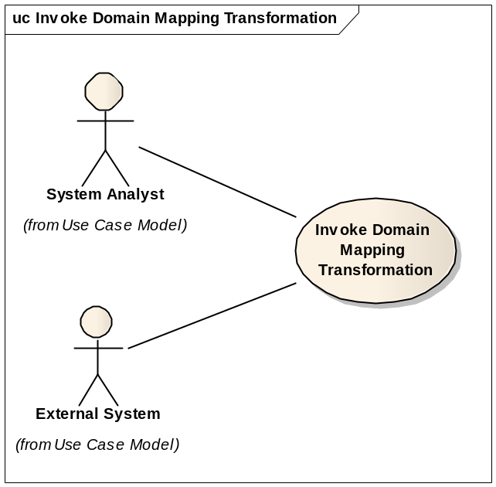

Brief Description
As a semantic communication, one code of a vocabulary system is translated into a target code of another coding system using already made domain mapping data.

Primary Actor
External System
3.4.4 Secondary Actor
Systems Analyst

Preconditions
- Domain mapping data are prepared

Basic Flow of Events
- Receive a source data
- Read Domain value mapping data and find the target data (local or web)
- If not found, act the ‘else case’
- If found, return the target data

Alternate Flow
As a future plan, we can consider three alternate flows as followings that are not using any separate domain mapping data in stand alone. As matter of fact, it may not be advisable to use local domain mapping data as a file format because of indiscreet distribution which can be a cause of transforming inconsistency.
              - Direct database query
In case that a database includes domain mapping data, via a SQL statement, the source data can be translated.
              - Translation SOA API or web service
In case that a database includes domain mapping data, it is not desirable to access to database directly due to security issues. So, we can assume separate web service or SOA API as an intermediate agent between client and the database.
In this case, a separate standard for how to service the mapping data should be established.

Post Conditions

Success Conditions
- Not blank or null, but valid printable code output

Error Conditions
- Null data output
- Non-printable code output

Special Requirements

Deploy Local System

Use Case Model
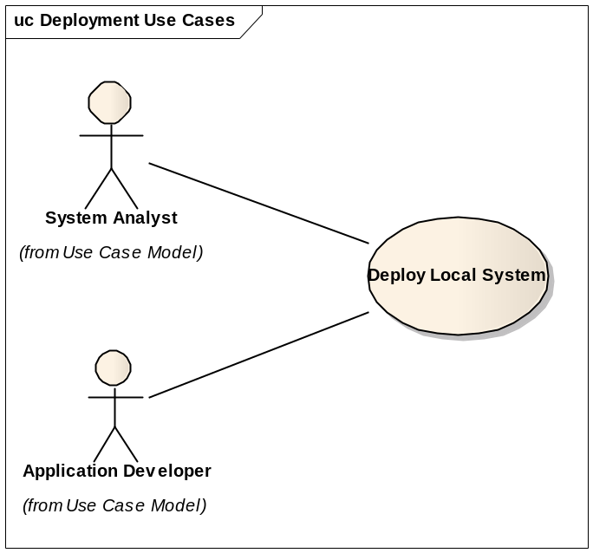

Brief Description
This use case covers deploying the Data Transformation Service module for one or group of local users. The basic scenario is to deploy the application as the standalone for local user. A variation of this use case is web server deployment. In a web server deployment, the web server processes all web client requests and invoke Data Transformation Service functionalities.

Primary Actor
System Analyst

Secondary Actor
Application Developer

Preconditions
- The Data Transformation Service is implemented, tested and packed.
- Persistent data repository (database or file system) is ready for data derivation formula and/or domain value mapping.

Basic Flow of Events
- Setup and configure system as required by caAdapter Data Transformation Service. For example, JDK is required to run the application.
- Setup up data repository (database or file system) for data derivation formula and/or domain value mapping.
- Install third party software required by the application. For example, unzipping software is required to extract the application package.
- Install the application following application installation guide.
- Verify installation following application installation guide.

Alternate Flow
- Setup application server or web server for web deployment.
- Verify installation from web client.

Post Conditions

Success Conditions
The application is ready for local users or web client users

Error Conditions

Special Requirements
N/A

Deploy SOA Service Agent

Use Case Model
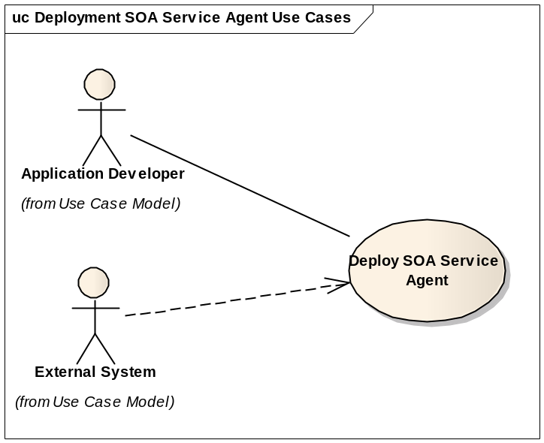

Brief Description
This use case covers deploying the Data Transformation Service module as a service agent on provided SOA infrastructure. The application is implemented in the manner of “build once, run anywhere”. It provides full scope of functionalities independently from the implementation and technology of the underneath SOA infrastructure.

Primary Actor
Application Developer

Secondary Actor
External System

Preconditions
- SOA infrastructure is ready
- The Data Transformation Service is implemented, tested and packed.
- Persistent data repository (database or file system) is set for data derivation formula and/or domain value mapping.

Basic Flow of Events
- Setup and configure SOA infrastructure ready for deploying new service agent
- Deploy caAdapter Data Transformation Service module following the deploy process required by the underneath SOA infrastructure server.
- Verify deployment from SOA infrastructure server.
- Verify deployment by accessing the service agent using service contract (WSDL).

Alternate Flow
N/A

Postconditions

Success Conditions
The service agent is ready to process service request. External System send service request and get service response through the agent access point.

Error Conditions
- Failed in deployment to SOA server
- Failed to send service request to the service agent

Special Requirements
N/A

Overall Requirements
TBD

Requirements Prioritization
TBD
Priority | Use Case Name | Supp Requirement Ref #

Sign Off

Approval

Workspace General Contractor Rep Print Name Date
Architecture Workspace Rep Print Name Date
VCDE Workspace Rep Print Name Date
Workspace Working Group Rep Print Name Date
NCICB Rep Print Name Date

