caAdapter
Translational Data Mapping Service (TDMS) Module

Version 4.0TDMS1.0

User’s Guide




January 4, 2008


Center for Biomedical Informatics and Information Technology

This is a U.S. Government Work

Change Record

Date | Author(s) | Document Version | Change Reference (Major Changes)
12/20/07 | Eugene Wang | 0.1 | First Draft
12/26/07 | Nicholas Schroedl | 0.2 | Spelling and format corrections
01/02/08 | Charles Yaghmour | 0.3 | Various Edits

Credits and Resources
caAdapter Development
and Management Teams
Development | User’s Guide |  | Program Management
Charles Yaghmour ³ | Charles Yaghmour ³ |  | Anand Basu ²
Nick Schroedl ¹ | Nick Schroedl ¹ |  | Christo Andonyadis ²
Ki Sung Um ² | Ki Sung Um ² |  | Sichen Liu ²
Eugene Wang ¹ | Eugene Wang ¹ |  | Sharon Settnek ¹
 |  |  | Smita Hastak ³
¹ Science Application International Corporation (SAIC) |  | ³ ScenPro, Inc.
² National Cancer Institute Center for Biomedical Informatics and Information Technology (NCI CBIIT)

Contacts and Support
NCI CBIIT Application Support | http://ncicb.nci.nih.gov/NCICB/support  Telephone: 301-451-4384  Toll free: 888-478-4423

LISTSERV facilities pertinent to the caAdapter
LISTSERV | URL | Name
caAdapter_Users | https://list.nih.gov/archives/caadapter_users-l.html | caAdapter Users Discussion Forum
caBIO_Users | https://list.nih.gov/archives/cabio_users.html | caBIO Users Discussion Forum
caBIO_Developers | https://list.nih.gov/archives/cabio_developers.html | caBIO Developers Discussion Forum

Release Schedule
This guide is for the TDMS Module of caAdapter. It may be updated between releases if errors or omissions are found. The current document refers to the 4.0 version of caAdapter, released in December 2007 by the NCI CBIIT.

Table of Contents

Chapter 1 Using This Guide 6
Intended Audience 6
Document Text Conventions 6
Organization of this Guide 7
Chapter 2 Using the TDMS Module 8
Introduction 8
Create a CSV Metadata File 8
Modify a CSV Metadata File 11
Export a UML Model to an XMI File 11
Map a CSV Metadata to an Object Model or Data Model 13
Validate the Mapping 18
Glossary 20
Index 21

Chapter 1 Using This Guide
This chapter introduces the user to the caAdapter TDMS Module User’s Guide. Topics include:

- Intended Audience on this page
- Document Text Conventions on this page
- Organization of this Guide on page 8

Intended Audience
The intended audience for this guide is the medical data analyst interested in mapping CSV data to an object model, or to a data model for the purpose of migrating legacy data to new data structures.

This User's Guide is the companion document to caAdapter’s TDMS Module. It includes instructions on using the TDMS module to map a CSV metadata file to an object model, or to a data model. It also contains instructions on creating a CSV metadata file from an existing CSV data file.

Note that this guide includes instructions for using the TDMS module only. For information on using other caAdapter functionality, please refer to the User’s Guide document for caAdapter release 4.0.

This guide assumes that the reader is familiar with the following:
- CSV metadata file structures
- Data and object models
- Enterprise Architect (EA)
- Using caAdapter’s mapping tool

Document Text Conventions
The following table shows various typefaces to differentiate between regular text and menu commands, keyboard keys, tool bar buttons, dialog box options, and text that you type. This illustrates how text conventions are represented in this manual:

Convention | Description
Notes | Notes: Notes are enclosed for emphasis
Bold | Bold type is used for emphasis, buttons, or tabs to select on windows, and names of dialog boxes.
Text In Small Caps | Text In Small Caps is used for keyboard keys that you press (for example, ALT+F4)
Text in italics | Italics are used to reference other documents, sections, figures, and tables.
Special typestyle | Special typestyle is used for filenames, directory names, commands, file listings, and anything that would appear in a Java program, such as methods, variables, and classes.
Bold italics typestyle | Bold italics is used for information the user needs to enter
{ } | Curly brackets are used for replaceable items (for example, replace {home directory} with its proper value such as C:\caadapter).

Organization of this Guide
The caAdapter TDMS Module User’s Guide contains the following Chapters:

- Chapter 1 Using this Guide – This chapter provides an introduction to this guide.
- Chapter 2 Using the TDMS Module – This chapter provides the user with step-by-step instructions for using the TDMS module. This includes creating a CSV metadata file from a CSV data file; exporting a UML model from EA into an XMI file; use caAdapter’s mapping tool to map CSV data elements to an object model, or to a data model.

Chapter 2 Using the TDMS Module
This chapter provides the user with step-by-step instructions for using the TDMS module. Topics include:

- IntroductionCreate a CSV Metadata File on this page
- Modify a CSV Metadata File on page 12
- Export a UML Model to an XMI File on page 12
- Map a CSV Metadata to an Object Model or Data Model on page 14
- Validate the Mapping on page 19

Introduction
caAdapter provides mapping capabilities between different source and target formats. Each mapping type has its own business rules. This guide describes caAdapter’s mapping capability from a CSV metadata to an object model, or a data model. This capability was designed to support the TrWorkbench prototype effort currently under development at NCI CBIIT. This chapter provides step-by-step instructions to create a CSV metadata file from a CSV data file, export a UML model from EA to an XMI file (XML Metadata Interchange), and map a CSV metadata to the object model, or data model, represented in the XMI file.

For details on caAdapter design and implementation, please refer to caAdapter 4.0 documentation distributed with the caAdapter 4.0 product.

Create a CSV Metadata File
A CSV metadata file defines the specification of a comma-separated data file. caAdapter supports two kinds of CSV metadata: structural and non-structural. The structural metadata presents the segment-based structure of CVS data files. Each segment may contain zero or more children segments, and zero or more fields. The non-structural metadata is a simplified version of the structural metadata. There is only one segment, which is the root segment, with a series of children fields.

The following steps describe how to create a new non-structural metadata file from an existing CSV data file:

- Select File > New > CSV Specification (Figure 2-1)
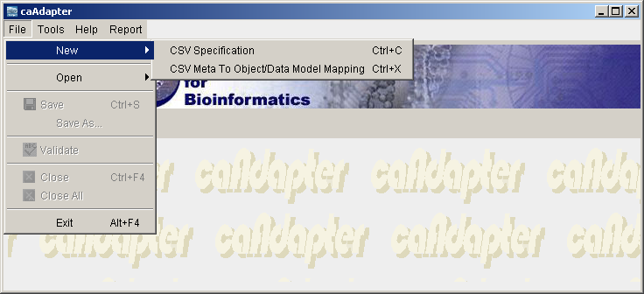
Figure 2-1 New CSV Specification Menu Item

- The system will display a selection dialog box. Check the “Generate from a Non-Structure CSV file” (Figure 2-2).

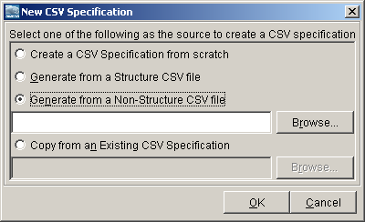
Figure 2-2 Select Data Source to Create New CSV Metadata

- Click the Browse button to locate the source CVS data file (Figure 2-3).

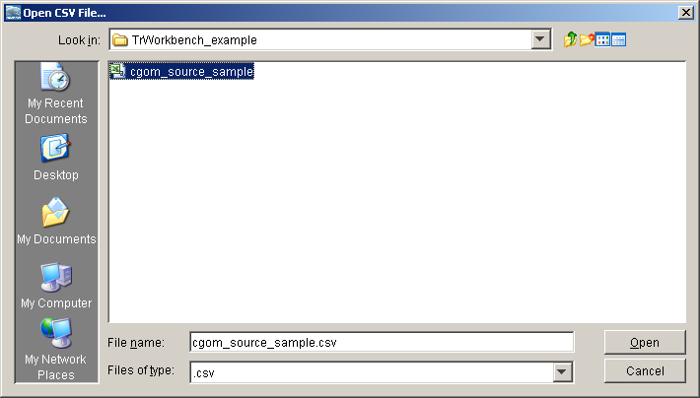
Figure 2-3 Locate the Source CSV Data File
- Once the file is selected, caAdapter will display the selected CVS data file name and path (Figure 2-4).

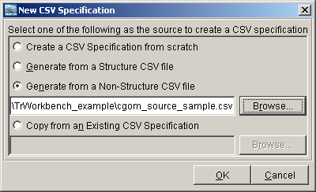
Figure 2-4 File Name and Path of the Selected CSV Data File
- Click OK to start the generation process. The system will then present the generated non-structure CSV metadata in the CSV specification panel (Figure 2-5).
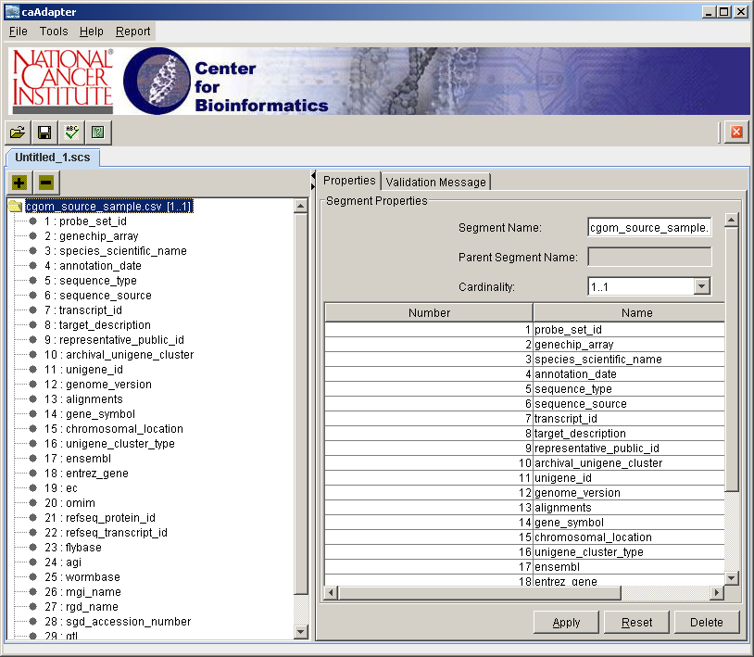
Figure 2-5 Created CSV Metadata File from a CSV Data File

Modify a CSV Metadata File
Once a non-structural CSV metadata file is created and saved, the user can modify that using caAdapter. For details on using this capability please refer to the caAdapter 4.0 User’s Guide.

Export a UML Model to an XMI File
Before beginning to map between CSV data elements to an object model or a data model, the user must create an XMI file containing a representation of both models. The user can use EA to create this XMI file using the following steps:

- Open the .eap file that contains the object and data models) and right click on Logical View. Select Import/Export > Export package to XMI file (Figure 2-6).

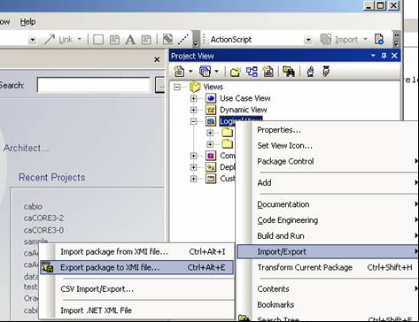
Figure 2-6 Export XMI file from EA
- On the Export Package to XMI window, check the Format XMI Output box and the Enable Full EA Roundtrip box. Select XMI Type as “UML1.3(XMI 1.1)”. Specify the output file name of the XMI file and click Export to create the XMI file (Figure 2-7).
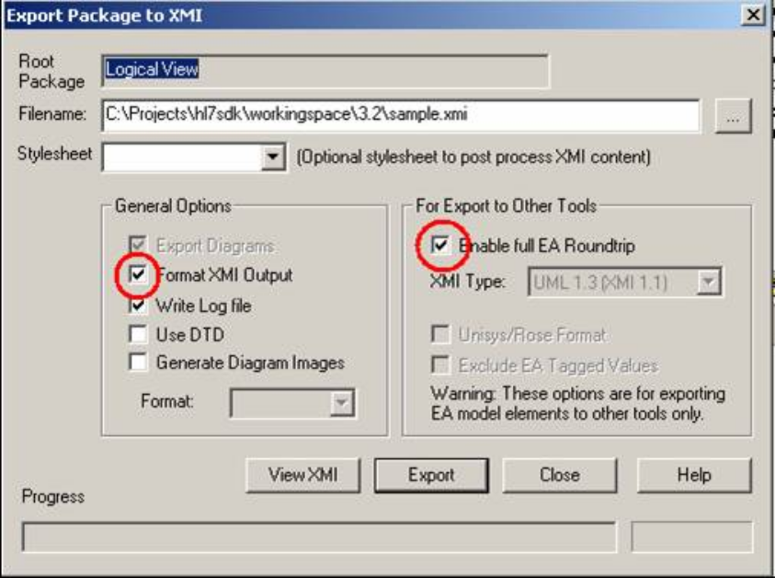
Figure 2-7 Options to export XMI file from EA
Note: Make sure to uncheck “Use DTD” option as shown with Figure 2-7. If the “Use DTD” option is checked, the generated XMI file will contain the DOCTYPE tag: <!DOCTYPE XMI SYSTEM "UML_EA.DTD">. This will cause the caAdapter XMI loader to verify Document Type Definition (DTD) and may cause validation errors if the required DTD (UML_EA.DTD) is not available.

Map a CSV Metadata to an Object Model or Data Model
The following steps will guide you through mapping a CSV data elements to the object, or data, model.
- Select File > New > CSV Meta To Object/Data Model Mapping (Figure 2-8).
Figure 2-8 Invoke new CSV Meta to Object Model Mapping menu
- The system will prompt you to specify the mapping target; i.e. “Object Model” or “Data Model” (Figure 2-9)
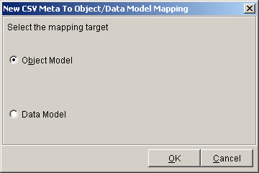
Figure 2-9 Select Mapping Target Model
- The system will then present an empty mapping panel (Figure 2-10).
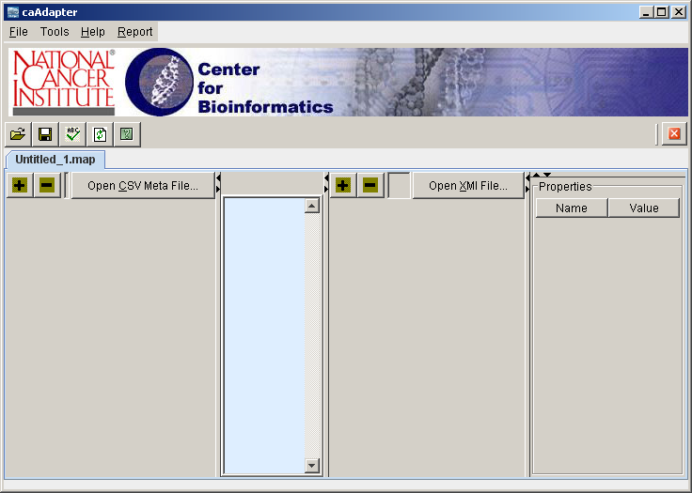
Figure 2-10 Empty Mapping Panel
- Click Open CSV Meta File… button to display the Open CSV Meta file … dialog box (Figure 2-11). Select the source CSV metadata file.
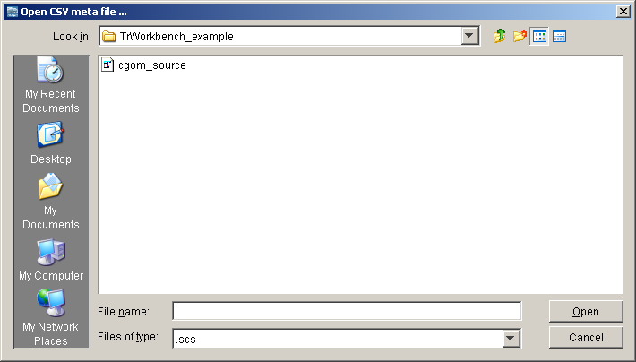
Figure 2-11 Select Source CSV Metadata File
- Once a valid CSV metadata file is selected, the system will load that in the left panel of the mapping tool in a tree structure (Figure 2-12).
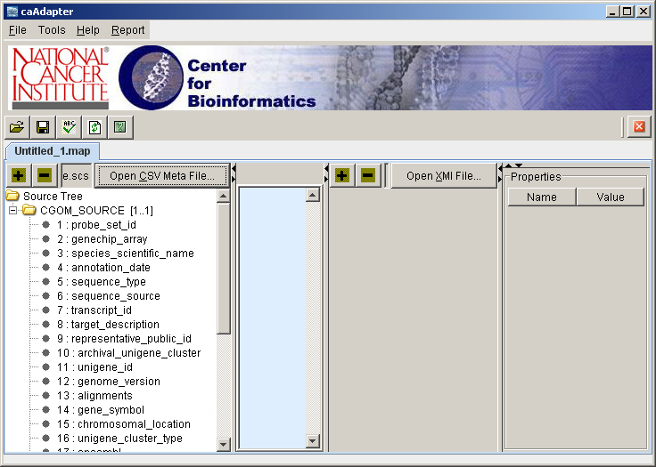
Figure 2-12 Loaded CSV Metadata into Mapping tool
6. Click Open XMI File… button to select the target XMI file. The Open CSV XMI file … dialog box will be opened (Figure 2-13). Select the target XMI file.
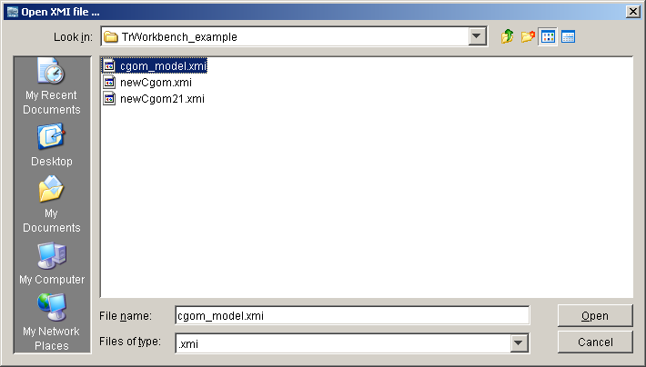
Figure 2-13 Select Target XMI File
7. Once a valid XMI file is selected, the system will then load that in the right panel of the mapping tool. The selection in Step 2 above will determine whether caAdapter will load the Object Model or the Data Model in the right panel (Figure 2-14a and 2-14b).
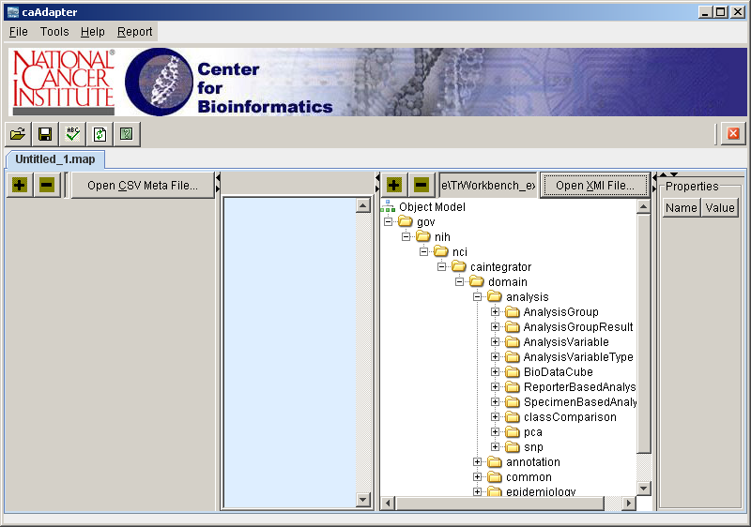
Figure 2-14a Loaded Object Model in the Mapping Tool
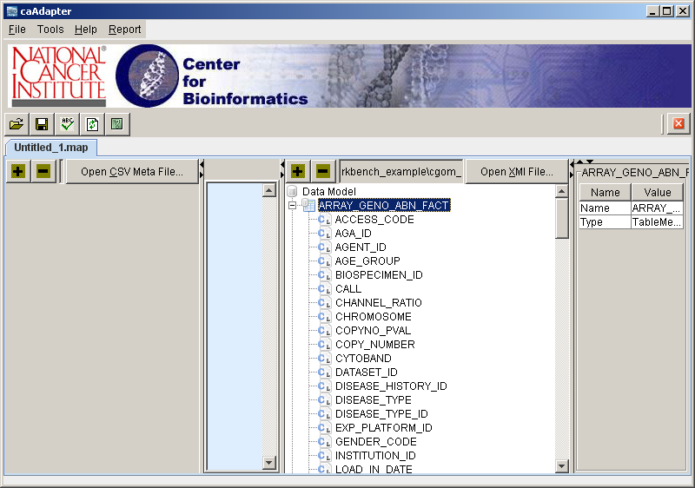
Figure 2-14b Loaded Data Model in the Mapping Tool
Note: Steps 4,5 and Steps 6,7 are exchangeable. The user may load either the CSV metadata file or the XMI file first. caAdapter in neutral to such order.
- Once the source and destination files have been selected displayed in the mapping tool, the user is now ready to perform the mapping using drag-and-drop mechanism (Figure 2-15).

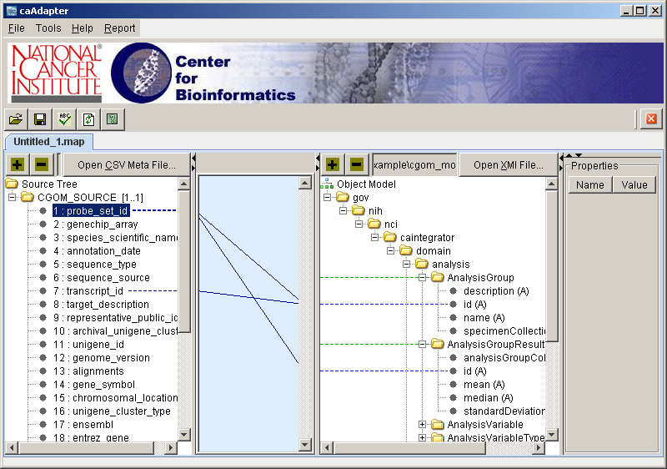
Figure 2-15 Mapping Source to Target Using Drag-and-Drop
Note: This version of the TDMS Module uses the following basic mapping rules. Additional mapping rules will be implemented in later versions.
- The user may not map from a CSV segment. Mapping can only be done from a CSV field within the segment
- The user may not map to a table, or to an object. The target mapping can only be a table column, or an object attribute
- The user may map multiple CSV fields to the same target field. A target field can be a table column or an object attribute
- The same CSV field may be mapped to more than one target field. A target field can be a table column or an object attribute

Validate the Mapping
The user can invoke the validation process in two ways: select File > Validation from the menu bar; or click the validation icon on the toolbar. Figure 2-16 shows the validation report. The validation report is presented in an XML format. The user may save that for later use.

Note: The current validation process is limited to identifying unmapped fields in the metadata file. The validation report contains a list of those fields. Additional validation rules, specific to the TrWorkbench, will be defined and implemented in later versions.

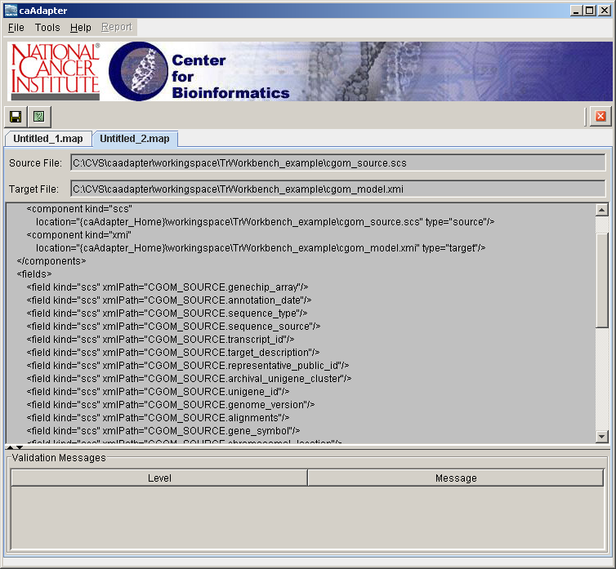
Figure 2-16 Validation Report

Glossary
The following table contains a list of terms used in this document, with accompanying definitions.

Term | Definition
CSV | Comma Separated Value
DTD | Document Type Definition
EA | Enterprise Architect. UML Modeling Tool.
NCI CBIIT | National Cancer Institute Center for Biomedical Informatics and Information Technology
TDMS | Translational Data Mapping Service
UML | Unified Modeling Language
XMI | XML Metadata Interchange
XML | Extensible Markup Language

Index

CSV Metadata File 6, 7, 8, 11, 14, 15, 17, 18
DTD 13, 20
EA 6, 7, 8, 11, 12, 13, 20
Full EA Roundtrip 12
NCI CBIIT 3, 4, 8, 20
Non-structural Metadata 8, 11
Segment 8
Structural Metadata 8
TDMS 4, 6, 7, 8, 18, 20
TrWorkbench 8
UML 7, 8, 11, 13, 20
Validate 8, 18, 19

