Computationally Independent Model and Service Specification

Data Transformation Service

Version 1.0

March 10, 2011

Enterprise Architecture Specification Team | Sudha Chudamani –SAIC Frederick  Sichen Liu – NCI CBIIT
Editor | Identify main editor, if different from project lead
Authors | Eugene Wang –SAIC Frederick  Ki Sung Um – SAIC Frederick

Document Version | Date | Author | Changes
0.0.1 | March 9, 2011 | Eugene Wang | Initial draft
Table of Contents
1 Overview and Business Case 5
1.1 Service Description and Purpose 5
1.2 Scope 5
1.3 Assumptions 6
2 Business Storyboards 8
2.1 Storyboards Overview 8
2.2 Primary Actors 8
2.2.1 People Actors 8
2.2.2 System Actors 8
2.3 Story Boards 9
2.3.1 DTS-SB1 – Define Transformation Formula 9
2.3.2 DTS-SB2 – Retrieve Transformation Formula 9
2.3.3 DTS-SB2 – Invoke Transformation Formula 9
3 Detailed Functional Model 10
3.1 Structure of the Service 10
3.2 Detail of the Capabilities 10
3.2.1 Define Transformation Formula 11
3.2.2 Invoke Transformation Formula 12
3.2.3 Deploy Local System 12
3.2.4 Deploy SOA Service Agent 13
4 Profiles 15
4.1 Functional Profiles 15
4.2 Semantic Profiles 16
4.3 Conformance Profiles 17
5 System Implementation Details 21
5.1 System Runtime Interaction Details 21
5.1.1 Define Transformation Formula 21
5.1.2 Retrieve Transformation Formula 22
5.1.3 Invoke Transformation Formula 24
In this scenario, a system analyst searches transformation formula store with business criteria. The system analyst produces desired data from source data using the found transformation formula. 24
5.2 Implementation Considerations 24
5.2.1 System Architecture 24
5.2.2 Information Model 25
5.2.3 Service Interface 26
5.2.4 Standard and MathXL 27
5.3 Deployment Considerations 27
5.3.1 Local Deployment 28
5.3.2 Remote Deployment 28
5.3.3 SOA Deployment 28
6 Conformance and Compliance 29
6.1 Compliance and Conformance Statements 29
7 Appendix A - Relevant Standards 30
8 Appendix B - References 31
9 Appendix C - Glossary 32
10 Appendix D – Cross Reference Tables 33
10.1 List of Storyboards 33
10.2 Storyboards to Capabilities Mapping 33
10.3 Actors 33

Overview and Business Case

Service Description and Purpose
caAdapter Data Transformation Service (DTS) module is a set of loose-coupled capabilities which manage data derivation algorithm (formula) and provide derivation transformation service.
Users in the caBIG community need a user-friendly tool to create mathematical formulae for data derivation transformation, which produce desired data using raw data from data warehouse, online collection or information system. This new DTS module extends caAdapter’s mapping and transformation capabilities with the goal of creating standards-based infrastructure tools to facilitate medical research data exchange.

Scope
The scope of DTS module includes items summarized as following:
- Formula manipulation service enables users to create and edit mathematical formula with graphic user interface (GUI), describing mathematical formula with standard based Mathematical Markup Language, or MathML.
- Formula XML data service is a distributed XML data repository with functionalities of submitting, searching and retrieving formula.
- Data derivation service generates a data value from one or more contributing data values using predefined derivation formula.

The table below provides a list of items that are in scope or out of scope.
Items | Scope / Out of Scope | Source
Providing the ability for data analysts to create new mathematical formula for data transformation. | Scope | Data Transformation Service Scope Description Document
Providing the ability for data analysts to modify draft mathematical formula. | Scope | Data Transformation Service Scope Description Document
Providing the ability for data analysts to submit final mathematical formula to the centralized or distributed data repository. | Scope | Data Transformation Service Scope Description Document
Providing the ability for data analysts or information application to retrieve mathematical formula from the centralized or distributed data repository. | Scope | Data Transformation Service Scope Description Document
Providing the ability for data analysts or information application to execute mathematical formula and produce desired data using raw data, which includes input data validation, transformation and output formatting | Scope | Data Transformation Service Scope Description Document
Providing the ability to maintain flexible formula XML data with centralized or distributed repository. | Scope | Data Transformation Service Scope Description Document
Providing the ability to deploy service in diverse deployment environments, including standalone application, web server, and SOA service agent. | Scope | Data Transformation Service Scope Description Document
Providing the ability to integrate with enterprise service or information application  - Service API implements access interface for other SOA service enabled systems.  - Integration API enables DTS module to seamlessly integrate with other application as a plug-in unit. | Scope | Data Transformation Service Scope Description Document
Providing the ability to customize/extend generic derivation formula for generating customized data | Scope | Data Transformation Service Scope Description Document
Leveraging LexEVS ability to map and transform domain value | Out of scope | “Domain Value Mapping and Transformation Service” Analysis document

Assumptions
Assumption | Affects | Source
It is assumed that this service enable user to create data derivation formula for public using, thus the formula should be verified and approved before release to public. | Only approved formula is guaranteed to provide valid transformation. | Formula Review Storyboard

Business Storyboards

Storyboards Overview
These storyboards include functionalities in formula managements and derivation transformation using predefined formulae. The formula management capabilities allow user to create, modify, and retrieve transformation formula using a centralized or distributed formula repository. Derivation transformation capabilities produce target data element from source data elements using transformation formula. For the detail of each scenario, see the usecase document referenced in Appendix B.

Primary Actors
The actors defined for the CIM are constrained to actors necessary to perform formula management operations or data transformation operation per the DTS scope.

People Actors
Name | Role | Notes
Application Developer | Responsible for developing medical application using data transformation
System Analyst | Use the Data Transformation Service module to derive existing data elements into new data element

System Actors
Name | Notes
External System | Represents any external system that interacts with the caAdapter Data Transformation Service module using its APIs or SOA service agent.

Story Boards

DTS-SB1 – Define Transformation Formula
Outline | This storyboard covers defining a new formula or updating an existing formula as well
Detail | A System Analyst derives a new data concept from one or more known data concept based on given mathematical operations. The known data concept could be public concept like NCI Common Data Element (CDE), constant, or user defined variable. The new data concept may or may not be assigned a public code.
.

DTS-SB2 – Retrieve Transformation Formula
Outline | This storyboard covers retrieve formula from a local system or remote system.
Detail | User retrieves a transformation formula for the purpose of updating or execution.

DTS-SB2 – Invoke Transformation Formula
Outline | This storyboard covers executing existing formula.
Detail | User invokes a transformation formula and generates a result data using source data as parameters of the formula.

Detailed Functional Model

Structure of the Service
Name | Description
Create new data transformation formula | This function is used to create new data transformation formula using UI tools provided by the service. System persist a new valid formula into formula repository for future uses.
Update existing data transformation formula | This function is used to update an existing data transformation formula.
Retrieve data transformation formula | This function is used to retrieve data transformation formula from centralized or distributed formula repository.
Execute data transformation formula | This function is used to execute data transformation formula and produce desired data using raw data, which includes input data validation, transformation and output formatting
Maintain flexible formula XML data repository | This function enable user to access publicly defined formula from other system. It also enable user to share a locally defined formula with others.
Deploy service in diverse environments | This function enables user to deploy Data Transformation Service module as a standalone application, web application, SOA service agent, or a plug-in unit of a system.
Provide integration interface | This function enable user to integrate the Data Transformation Service with enterprise service or information application  - Service API provides access interface for other SOA service enabled systems.  - Integration API enables DTS module to seamlessly integrate with other application as a plug-in unit.

Detail of the Capabilities
[M]: Are mandatory sections.
[O]: Are optional sections

3.2.1 Define Transformation Formula
Name [M] | Define Transformation Formula
Description [M] | A System Analyst derives a new data concept from one or more known data concept based on given mathematical operations. The known data concept may be a public concept like NCI Common Data Element (CDE), a constant, or user defined variable. The new data concept may or may not be assigned a public code. The derivation formula may work independent from the derived data concept for data reformatting, or any requested data manipulation.  This function covers defining a new formula or updating an existing formula as well
Pre-Conditions [M] | - Derivation process is defined.  - Source data concepts are identified.  - Derived data concept is optional.
Security Pre-Conditions [M] | Access control mechanism needs to be in place to ensure that the user is logged in and has valid privileges define a new derivation formula.
Inputs [M] | Derivation algorithm, parameters, variables
Outputs [M] | Transformation formula is created with required algorithm
Post-Conditions [O] | - Transformation formula is persisted for future use.  - Derived data concept is optionally set.
Exception Conditions [M] | Fail to create valid derivation formula.
Aspects left for Technical Bindings [O] | Where identifier is not part of the input, some means is necessary to identify potential duplicates. This may necessitate matching on other key attributes such as derivation algorithm, application scope, parameter list, etc.
Notes [O] | Public standard, such as MathML, is recommended for formula and mapping.

3.2.2 Invoke Transformation Formula
Name [M] | Invoke Transformation formula
Description [M] | User invokes a transformation formula and generates a result data from using source data as parameters of the formula.  This function covers using formula from either local system or remote system.
Pre-Conditions [M] | - The derivation formula is defined and valid.  - Data values are set for all formula parameters.
Security Pre-Conditions [M] | Access control mechanism needs to be in place to ensure that the user is logged in and has valid privileges execute the preferred transformation.
Inputs [M] | Retrieve transformation formula, valid data for all variables
Outputs [M] | Target data generated using the source data
Post-Conditions [O] | The result data is ready for further business uses. User optionally processes the result for further business.
Exception Conditions [M] | The system fails in calculating result with given parameter values
Aspects left for Technical Bindings [O] | Where identifier is not part of the input, some means is necessary to identify potential duplicates. This may necessitate matching on other key attributes such as derivation algorithm, application scope, parameter list, etc.
Notes [O] | N/A

3.2.3 Deploy Local System
Name [M] | Deploy Local System
Description [M] | This function covers deploying the Data Transformation Service module for one or group of local users. The basic scenario is to deploy the application as the standalone for local user. A variation of this use case is web server deployment. In a web server deployment, the web server processes all web client requests and invoke Data Transformation Service functionalities.
Pre-Conditions [M] | - The Data Transformation Service is implemented, tested and packed.  - Persistent data repository (database or file system) is ready for data derivation formula and/or domain value mapping.
Security Pre-Conditions [M] | The deployment environment is ready.
Inputs [M] | Application deployment package.
Outputs [M] | N/a
Post-Conditions [O] | The application is ready for local users or web client users
Exception Conditions [M] | System error
Aspects left for Technical Bindings [O] | N/A
Notes [O] | N/A

3.2.4 Deploy SOA Service Agent
Name [M] | Deploy SOA Service Agent
Description [M] | This function covers deploying the Data Transformation Service module as a service agent on provided SOA infrastructure. The application is implemented in the manner of “build once, run anywhere”. It provides full scope of functionalities independently from the implementation and technology of the underneath SOA infrastructure.
Pre-Conditions [M] | - SOA infrastructure is ready  - The Data Transformation Service is implemented, tested and packed.  - Persistent data repository (database or file system) is set for data derivation formula.
Security Pre-Conditions [M] | The deployment environment is ready.
Inputs [M] | Application deployment package.
Outputs [M] | N/a
Post-Conditions [O] | The service agent is ready to process service request. External System send service request and get service response through the agent access point.
Exception Conditions [M] | - Failed in deployment to SOA server  - Failed to send service request to the service agent
Aspects left for Technical Bindings [O] | N/A
Notes [O] | N/A

Profiles

Functional Profiles
Functional Profile No. | Functional Profile Name | Functional Profile Description | Capability Name
DTS-FP1 | Create formula | Create new formula | - Ability for data analysts to create new mathematical formula for data transformation.
DTS-FP2 | Modify formula | Modify draft formula | - Ability for data analysts to modify draft mathematical formula.
DTS-FP3 | Submit formula | Submit final formula | - Ability for data analysts to submit final mathematical formula to the centralized or distributed data repository.
DTS-FP4 | Retrieve formula | Retrieve formula | - Ability for data analysts or information application to retrieve mathematical formula from the centralized or distributed data repository.
DTS-FP5 | Execute formula | Execute formula | - Ability for data analysts or information application to execute mathematical formula and produce desired data using raw data, which includes input data validation, transformation and output formatting.
DTS-FP6 | Maintain flexible formula repository | Maintain flexible formula repository | - Ability to maintain flexible formula XML data with centralized or distributed repository.
DTS-FP7 | Deploy service | Deploy service in diverse deployment environments | - Ability to deploy service in diverse deployment environments, including standalone application, web server, and SOA service agent.
DTS-FP8 | Provide integration service API | Implements Service access interface for other SOA service to integrate with enterprise service or information application | - Ability to integrate with enterprise service or information application with service API implements access interface for other SOA service enabled systems.
DTS-FP9 | Provide integration programming API | Implement programming API for integration with other enterprise service or information application | - Ability to enables DTS module to seamlessly integrate with other application as a plug-in unit with programming API.
DTS-FP10 | Provide extension framework | Implement customization or extension framework | - Ability to customize/extend generic derivation formula for generating customized data.

Semantic Profiles
Semantic Profile No. | Semantic Profile Name | Constrained Information Model | Semantic Profile Description
DTS-SP2 | caBIG Vocabularies and Common Data Elements | caBIG VCDE | The NCI, together with its partners in the Cancer Biomedical Informatics Grid (caBIG®) community, is actively developing common data elements (CDEs) and standard vocabularies to be used as metadata descriptors for NCI-sponsored research and for caCORE CBIIT and caBIG® applications. These data standards are based on health information business needs or use cases from data collection forms, databases, clinical applications, data exchange formats, UML models, and common vocabularies.
DTS-SP2 | Mathematical Markup Language http://www.w3.org/TR/MathML3/ | MathML | This specification defines the Mathematical Markup Language, or MathML. MathML is an XML application for describing mathematical notation and capturing both its structure and content. The goal of MathML is to enable mathematics to be served, received, and processed on the World Wide Web, just as HTML has enabled this functionality for text

Conformance Profiles
Conformance No | DTS-CP1
Conformance Name | Derivation Formula Full Management Conformance Profile
Description | This is the conformance profile defines all the Management functionality for the derivation formula to be used for data transformation
Usage Context | A System Analyst derives a new data concept from one or more known data concept based on given mathematical operations. The known data concept may be a public concept like NCI Common Data Element (CDE), a constant, or user defined variable. The new data concept may or may not be assigned a public code. The derivation formula may work independent from the derived data concept for data reformatting, or any requested data manipulation
Mandatory | Yes
Functional Profile(s) | DTS-FP1 : Create formula  DTS-FP2 : Modify formula  DTS-FP3 : Submit formula  DTS-FP4 : Retrieve formula
Semantic Profile(s) | DTS-SP1 : caBIG Vocabularies and Common Data Elements  DTS-SP2 : MathML

Conformance No | DTS-CP2
Conformance Name | Invoke Derivation Transformation Conformance Profile
Description | This is the conformance profile defines all the functionality to perform data transformation using the derivation formula.
Usage Context | User invokes a derivation formula and generates a result data from using source data as parameters of the formula.
Mandatory | Yes
Functional Profile(s) | DTS-FP4 : Retrieve formula  DTS-FP5 : Execute formula
Semantic Profile(s) | DTS-SP1 : caBIG Vocabularies and Common Data Elements  DTS-SP2 : MathML

Conformance No | DTS-CP3
Conformance Name | Flexible Repository Conformance Profile
Description | This function provides the ability to maintain flexible formula XML data with centralized or distributed repository
Usage Context | User maintains flexible formula XML data with centralized or distributed repository.
Mandatory | Yes
Functional Profile(s) | DTS-FP6 : Maintain flexible formula repository
Semantic Profile(s) | DTS-SP1 : caBIG Vocabularies and Common Data Elements  DTS-SP2 : MathML

Conformance No | DTS-CP4
Conformance Name | Deployment Conformance Profile
Description | This is the conformance profile provide the ability to deploy service in diverse deployment environments, including standalone application, web server, and SOA service agent
Usage Context | User deploys service in diverse deployment environments, including standalone application, web server, and SOA service agent.
Mandatory | Yes
Functional Profile(s) | DTS-FP7 : Deploy service
Semantic Profile(s) | DTS-SP1 : caBIG Vocabularies and Common Data Elements  DTS-SP2 : MathML

Conformance No | DTS-CP5
Conformance Name | Integration Conformance Profile
Description | This is the conformance profile to provide the ability to integrate with enterprise service or information application.
Usage Context | User integrates with enterprise service or information application
Mandatory | Yes
Functional Profile(s) | DTS-FP8 : Service API integration  DTS-FP9 : Programming API integration
Semantic Profile(s) | DTS-SP1 : caBIG Vocabularies and Common Data Elements  DTS-SP2 : MathML

Conformance No | DTS-CP6
Conformance Name | Extension framework Conformance Profile
Description | Providing the ability to customize/extend generic derivation formula for generating customized data.
Usage Context | User customize/extend generic derivation formula for generating customized data.
Mandatory | Yes
Functional Profile(s) | DTS-FP10 : Customization and extension framwork
Semantic Profile(s) | DTS-SP1 : caBIG Vocabularies and Common Data Elements  DTS-SP2 : MathML

System Implementation Details

System Runtime Interaction Details
The sections below describe the business scenarios of the Data Transformation Service by sequence diagrams and class diagrams. It is important to note that the structure of interfaces is specifically defined for the service consumer and reflects a natural structure of components that may provide the Data Transformation Service functionality.

Define Transformation Formula
In this scenario, an application developer search transformation formula store with business criteria. A new formula will be created if no existing formula meets the requirements. The application developer may recursively edit the attributes and terms associated with a formula. Once the formula is ready, it will be added into the formula repository.

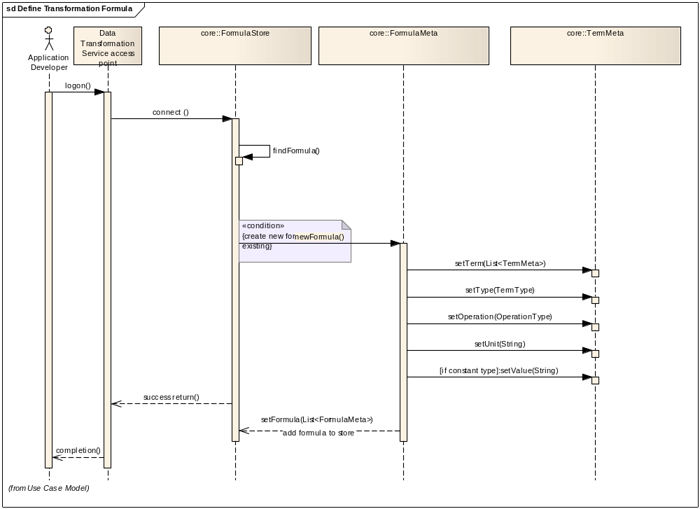

Retrieve Transformation Formula
In this scenario, an application developer or system analyst searches transformation formula with business criteria from formula repository. The formula repository can either be a local one or a remote one.
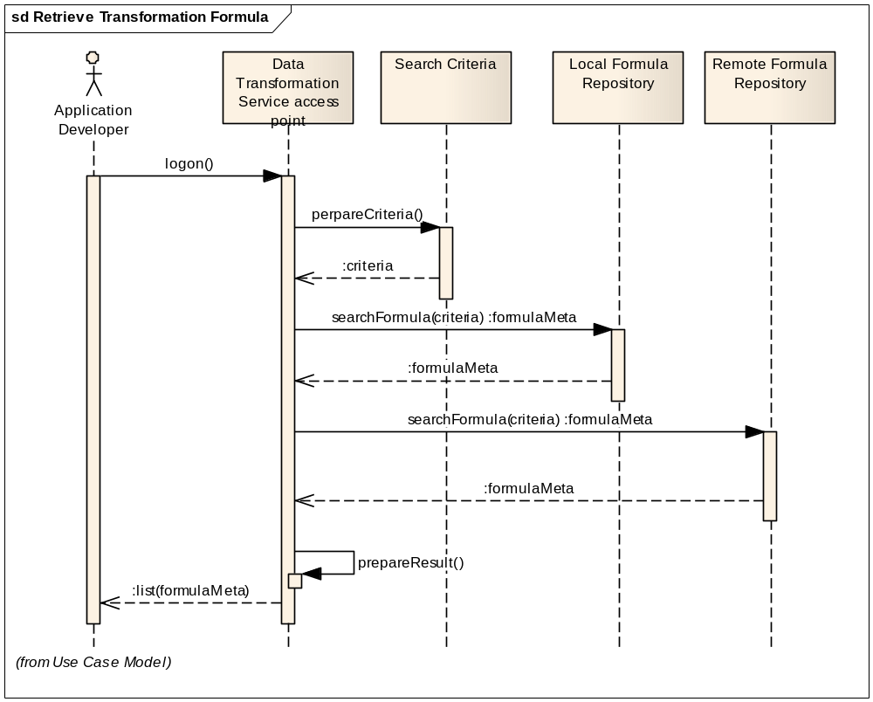

Invoke Transformation Formula

In this scenario, a system analyst searches transformation formula store with business criteria. The system analyst produces desired data from source data using the found transformation formula.
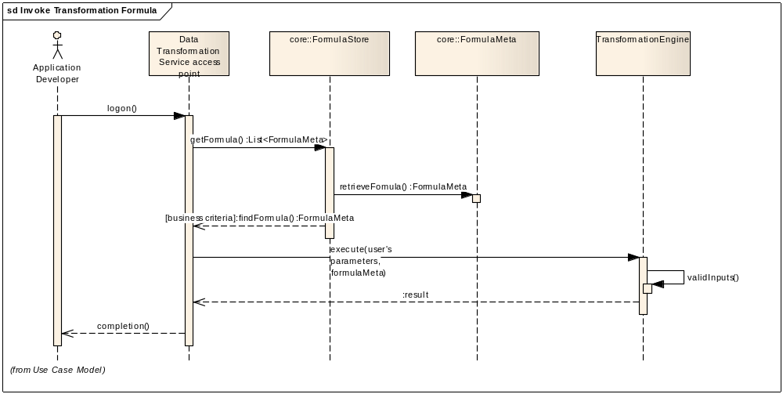

Implementation Considerations

System Architecture
The following high level architecture diagram depicts the Data Transformation Service module with components, deployment, and its interactions with clients or other enterprise information systems.
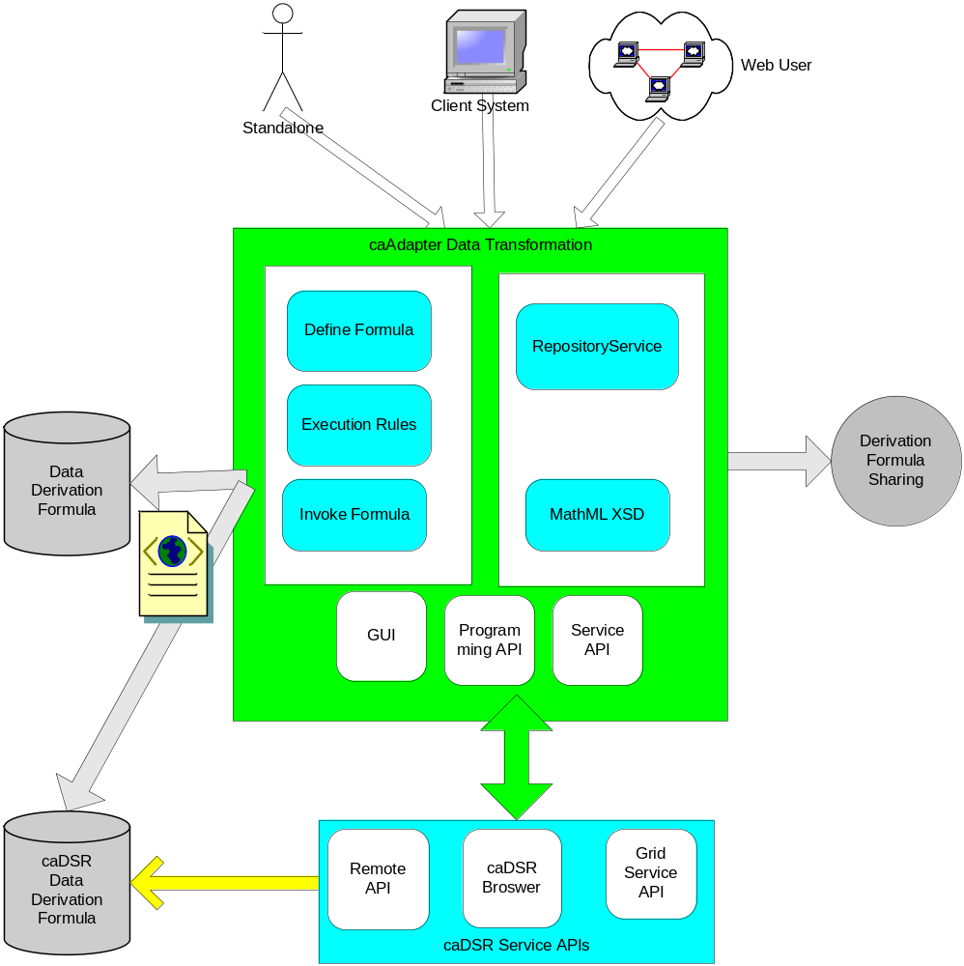

Information Model
The Data Transformation Service is made up of the functionalities of formula management and formula execution. The core of these functionalities is transformation formula represented in the following subset of the transformation formula information model.
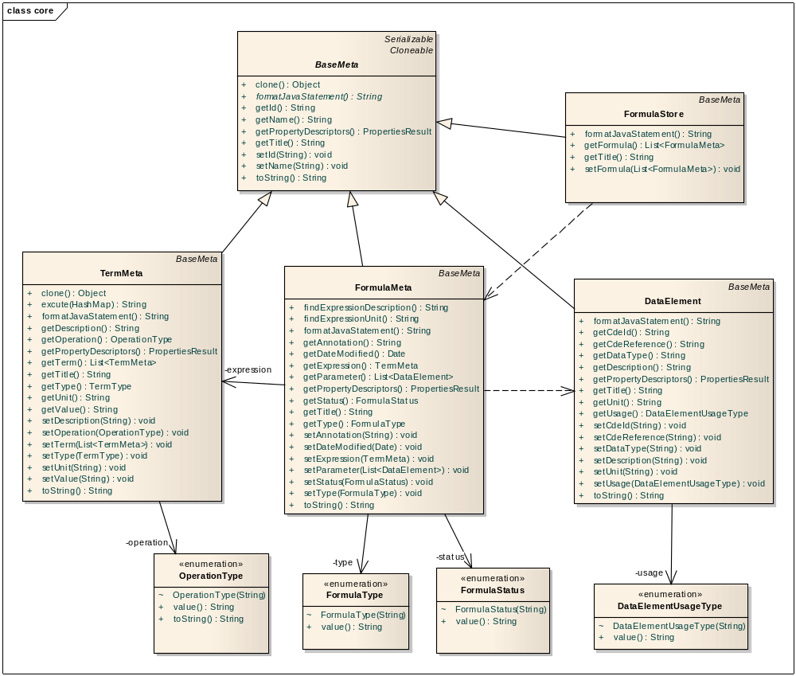

Service Interface
The Data Transformation Service categorizes its service interface into three loosely coupled units: RepositoryInterface, FormulaInterface,TransformationInterface. They are shown in the following subset of the transformation formula information model.
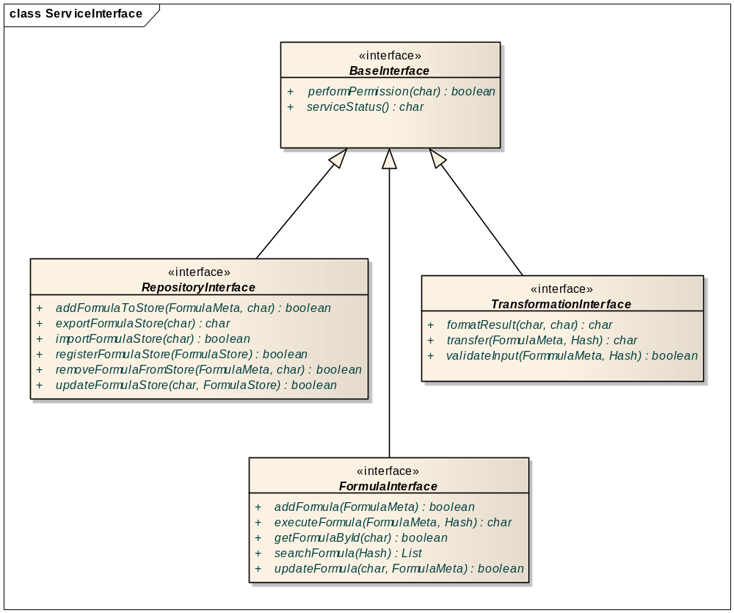

Standard and MathXL
The Data Transformation Service defines derivation formula, the core of derivation transformation, based on open source standard such as MathML. It enables users to maintain both private and public derivation formula, to reuse formula in support of knowledge sharing, and to guarantee the accuracy of resulting data.

Deployment Considerations
Following are the possible deployment modes for the Data Transformation Service. A service implementation can be developed to support any or all of these. The exact deployment mode supported by the service implementation should be properly documented in the Platform Specific Model.

Local Deployment
The Data Transformation Service should be able to run locally in the same container as the client application. Alternatively, it may run as a web application serving web clients.

Remote Deployment
The Data Transformation Service should be able to run remotely and to support remote client interfacing.

SOA Deployment
The Data Transformation Service should be able to run as a SOA agent providing SOA compliant service with the features of service registry, service discovery, caBIG security infrastructure compliance, one-time sign on, etc. This service agent would be in the platform-independent manner without compromise in technology or implementation of underneath infrastructure.

Conformance and Compliance

Compliance and Conformance Statements
Name | Type | Viewpoint | Description | Test method
Formula repository access performance | Obligation | Engineering | This profile should provide a response within 0.5 seconds to support a synchronous UI based client | 1. Test cases to include performance testing.
Local deployment | Obligation | Technology | This profile should enable deployment only within organization boundary restricting access and visibility to the external world | 1. Test cases to be defined to test for network access
SOA deployment | Obligation | Technology | This profile should enable deployment on a SOA hub boundary with open access to the external world | 1. Test cases to be defined to test for network access
Secured Access | Obligation | Engineering | This profile should provide access control mechanism in place to restrict access to the secured data | 1. Design review  2. Test cases to be defined for security
Semantic Model | Obligation | Informational | This profile enable support all terminologies represented in the LexEVS API for all operations. | 1. Design Review

Appendix A - Relevant Standards
Name | Description | Location
LexEVS and EVS APIs | NCI Enterprise Vocabulary Services. LexEVS is a mechanism for the standard storage of controlled vocabularies and ontologies defining a flexible format for accurately representing a wide variety of vocabularies and other lexically-based resources in several different server storage repositories as well as a XML format. | https://cabig.nci.nih.gov/tools/LexEVS_API
MathML | Mathematical Markup Language (MathML). MathML can be used to encode both mathematical notation and mathematical content. | http://www.w3.org/Math/

Appendix B - References
Name | Description | Location
Data Transformation Service Use Case Document | Document containing use cases for the Data Transformation Service application | https://ncisvn.nci.nih.gov/svn/caadapter/trunk/software/cdms/doc/UsecaseDocument.doc

Appendix C - Glossary
Term | Description
caBIG | The mission of caBIG® is to develop a collaborative information network that accelerates the discovery of new approaches for the detection, diagnosis, treatment, and prevention of cancer. caBIG® is sponsored by the National Cancer Institute (NCI) and its activities are supervised by the National Cancer Institute Center for Bioinformatics and Information Technology (NCI-CBIIT).
MathML | Mathematical Markup Language (MathML). MathML can be used to encode both mathematical notation and mathematical content.

Appendix D – Cross Reference Tables

List of Storyboards
# | Name | Description | Source
DTS-SB1 | Define transformation formula | This function covers defining a new formula or updating an existing formula.
DTS-SB2 | Retrieve transformation formula | User retrieves a transformation formula for the purpose of updating or execution.
DTS-SB3 | Invoke transformation formula | User invokes a transformation formula and generates a result data using source data as parameters of the formula.

Storyboards to Capabilities Mapping
# | Storyboard | Capabilities | Functional Profiles
DTS-SB1 | Define transformation formula | Define Transformation Formula | DTS-FP1
DTS-SB1 | Define transformation formula | Define Transformation Formula | DTS-FP2
DTS-SB1 | Define transformation formula | Define Transformation Formula | DTS-FP3
DTS-SB2 | Retrieve transformation formula | Retrieve Transformation Formula | DTS-FP4
DTS-SB3 | Invoke transformation formula | Invoke Transformation Formula | DTS-FP4

Actors
Actors | Functional Profile | Type | Operations used
Application Developer | All functional profiles | People | All operations
System Analyst | All functional profiles | People | All operations
External System | All functional profiles | System | All operations

