caAdapter Capability of Semantic Data Sharing
- Semantic interoperability requires system “understand” the data exchanged. This “understanding” requires shared data models which, in turn, depend on standard (controlled) vocabulary and Common Data Elements (CDEs) (https://cabig.nci.nih.gov/sharable/compatible).
- CMTS processes semantic information the CDEs defined by caDSR (https://cabig.nci.nih.gov/concepts/caDSR/).
- CMTS processes semantic information international standard chosen by NCI/caDSR, such as the ISO/IEC 11179 Standard for Metadata Registries
- CMTS process semantic information of structure and content expressed with W3C XML schema (XSD) (http://www.w3.org/XML/Schema).
- CMTS process semantics of XML documents defined XSD annotation and semantic markup(metadata).

Transformation Algorithm of Semantic Data Sharing
Semantic Support in  Source Data Schema | Semantic Support  in Target Data Schema | Transformation Action
Yes | Yes | - Convert source data value to target data  - If semantic mapping exist between data schema and target data schema, convert the semantic data of source data to the semantic data of target data.  - Else if default semantic data is available in target data schema, set the default data as the semantic data of target data.  - Else, no semantic data is set for target data
Yes | No | - Convert source data value to target data  - Option I:  - Ignore the semantic data of source data  - No semantic data is set for target data  - Option II:  - To be decided  - Consider user’s feedback from business usages
No | Yes | - Convert source data value to target data  - If user provides semantic data in mapping, set user’s mapping data as the semantic data of target data.  - Else if default semantic data is available in target data schema, set the default data as the semantic data of target data.  - Else, no semantic data is set for target data
No | No | - Convert source data value to target data  - No semantic data is set for target data

Display Semantic Information on Property Panel
- Connect to CDE browser https://cdebrowser.nci.nih.gov/CDEBrowser/, provide browsing, searching, and exporting CDE’s.
- Connect to caDSR Adminitration Tool http://cadsradmin.nci.nih.gov/, access all of the caDSR features and components.

System Compatibility
XSLT and XQuery are the languages developed by the W3C for transforming and querying XML data. Many tools either support XSLT or XQuery. CMTS generate mapping artifacts to be used by third party data transformation tool as long as it supports XSLT, XQuery, or both.
- Map source data schema (XSD) to target data schema (XSD).
- Generate artifacts for XSLT compatible data transformation tools based XSLT 2.0. Since XSLT 2.0 is not backward compatible with XSLT 1.0, caAdatper CMTS may not be required to support XSLT 1.0.
- Generate artifacts for XQuery compatible data transformation tools.
- The compatibility of XQuery, XSLT, and XPath is following:
XQuery | XSLT | XPath Compatibility
N/A | 1.0 W3C recommended on November 16, 1999 | 1.0 W3C recommended on November 16, 1999
1.0 W3C recommended on January 23, 2007 | 2.0 W3C recommended on January 23, 2007 | 2.0 W3C recommended on January 23, 2007

Data Processing Functions
- caAdatper HL7 transformation module 4.3 and CMTS version 0.5 implements data processing functions which are grouped into: math, constant, date time, and string.
- caAdapter HL7 transformation implemented these function with Java
- CMTS 0.5 implemented these functions with XPath 1.0 functions using XQuery syntax.
- CMTS version 1.0 implements all function groups in CMTS version 0.5.
- CMTS version 1.0 implements functions to be compatible with both XSLT and XQuery specifications.
- CMTS version 1.0 function framework is extensible, which is open to modify existing and add new function based on user’s feedback.
Notes:
  - XPath includes over 100 built-in functions. There are functions for string values, numeric values, date and time comparison, node and QName manipulation, sequence manipulation, Boolean values, and more
  - LexEVS API 6.x (https://cabig.nci.nih.gov/tools/LexEVS_API) provides mapping and transformation of data elements from one domain to another domain, which is similar to the Vocabulary Mapping (VOM) function provided by caAdapter HL7 transformation module.

MapForce Analysis
Capability -- MapForce is a graphical data mapping, conversion, and integration tool, which:
- Map source data template to target data template
- Transforms data instantly using mapping and source data
- Generate data integration code for the execution of recurrent conversions: XSLT 1.0, XSLT 2.0, XQuery, Java, C#, and C++
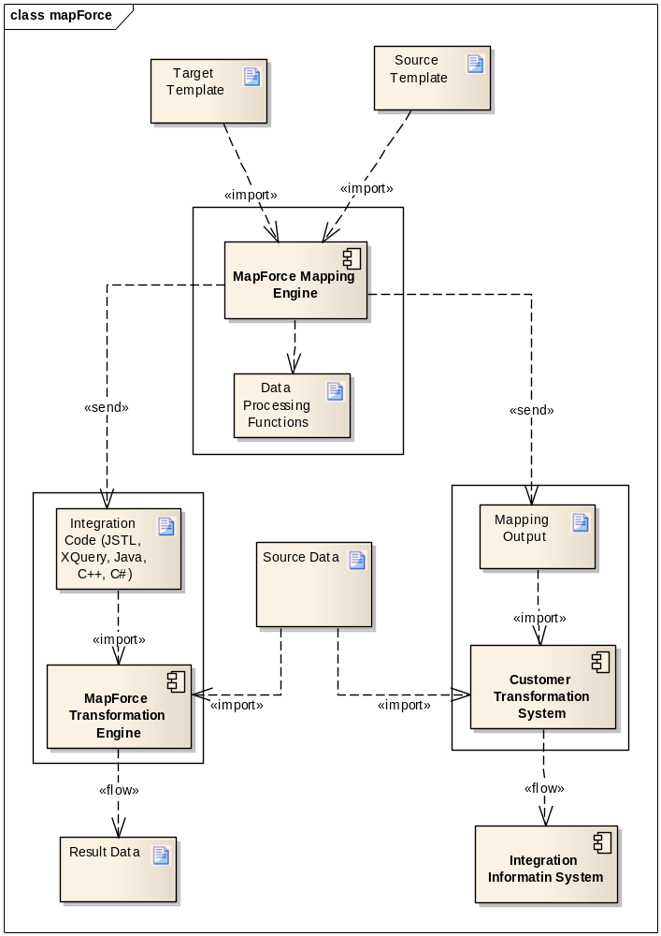
System Integration
- MapForce is an independent IDE tool, it is not a web application
- MapForce provides free package to integrate with Eclipse and Netbean
- MapForce supports integration to MS Visual Studio

Implementation Technology
It is a great change to CMTS as a web application because of its rich graphical features. We propose Java Applet with assistance of JavaScript and Ajax as the implementation technology based on the following considerations:
Applet Features
- Provide web application with interactive features that cannot be provided by HTML
- Support mouse actions and UI controls like button, check boxes, etc
- Be transferred to the client’s system and executed by browser’s Java Virtual Machine (JVM) as platform-independent
- Part of Java language, available with library, supporting software, IDE, etc. It is feasible with our limited resource and complex requirements.
Applet Usage
By May 16, 2010, applet is used by 3,772 of over top million web sites (http://trends.builtwith.com/websitelist/Applet#). The top million results are ordered from highest traffic to lowest traffic.
Alternative Technologies
They satisfy some of the scope of that is possible with an applet, but none of them has been achieve its popularity as applet does.
- ActiveX
- Curl
- Java Servlet
- Java Web Start
- JavaFX
- Adobe Flash

