Computationally Independent Model and Service Specification

Scientific Algorithm Service

Version 1.0

March 21, 2011

Enterprise Architecture Specification Team | Sichen Liu – NCI CBIIT  Sudha Chudamani –SAIC Frederick
Project Lead | Eugene Wang
Authors | Eugene Wang –SAIC Frederick  Ki Sung Um – SAIC Frederick

Document Version | Date | Author | Changes
0.0.1 | March 9, 2011 | Eugene Wang | Initial draft
0.0.2 | March 21, 2011 | Peter Yan | Internal review
Table of Contents
1 Overview and Business Case 5
1.1 Service Description and Purpose 5
1.2 Scope 5
1.3 Assumptions 7
2 Business Storyboards 8
2.1 Storyboards Overview 8
2.2 Primary Actors 8
2.2.1 People Actors 8
2.2.2 System Actors 8
2.3 Story Boards 9
2.3.1 caSAS-SB1 – Define Transformation Formula 9
2.3.2 caSAS-SB2 – Search Transformation Formula 9
2.3.3 caSAS -SB2 – Execute Transformation Formula 9
3 Detailed Functional Model 10
3.1 Structure of the Service 10
3.2 Detail of the Capabilities 11
3.2.1 Define Transformation Formula 11
3.2.2 Execute Transformation Formula 12
3.2.3 Deploy Local System 13
3.2.4 Deploy SOA Service Agent 14
4 Profiles 16
4.1 Functional Profiles 16
4.2 Semantic Profiles 17
4.3 Conformance Profiles 18
5 System Implementation Details 22
5.1 System Runtime Interaction Details 22
5.1.1 Define Transformation Formula 22
5.1.2 Update Transformation Formula 23
5.1.3 Search Transformation Formula 24
5.1.4 Execute Transformation Formula 25
5.2 Implementation Considerations 26
5.2.1 System Architecture 26
5.2.2 Information Model 27
5.2.3 Service Interface 28
5.2.4 Standard and MathXL 29
5.3 Deployment Considerations 29
5.3.1 Local Deployment 30
5.3.2 Remote Deployment 30
5.3.3 SOA Deployment 30
6 Conformance and Compliance 31
6.1 Compliance and Conformance Statements 31
7 Appendix A - Relevant Standards 32
8 Appendix B - References 33
9 Appendix C - Glossary 34
10 Appendix D – Cross Reference Tables 35
10.1 List of Storyboards 35
10.2 Storyboards to Capabilities Mapping 35
10.3 Actors 35

Overview and Business Case

Service Description and Purpose
caBIG community users have expressed keen interest in having a service to create mathematical formulae for data derivation transformation to get desired output using raw data from various means such as, data warehouse, online collection or information system. The Scientific Algorithm Service (caSAS) module is a set of loosely-coupled capabilities which manage data derivation algorithm (formula) and provide derivation transformation service. It extends caAdapter’s mapping and transformation capabilities to include creation of standards-based infrastructure tools to facilitate medical research data exchange.

Scope
The scope of caSAS service includes items summarized as following:
- Formula management service suffices users with the affiliation of a default user interface (UI) to create and edit mathematical formula, describing mathematical formula with standard based Mathematical Markup Language, or MathML.
- Formula XML data service is a distributed XML data repository with functionalities of submitting, searching and retrieving formula.
- Data derivation service generates a data value from one or more contributing data values using predefined derivation formula.

The table below provides a list of items that are in scope or out of scope.
Items | Scope / Out of Scope | Source
Providing the ability for data analysts to create new mathematical formula for data transformation. | Scope | Scientific Algorithm Service Scope Description Document
Providing the ability for data analysts to update draft mathematical formula. | Scope | Scientific Algorithm Service Scope Description Document
Providing the ability for data analysts to delete draft mathematical formula. | Scope | Scientific Algorithm Service Scope Description Document
Providing the ability for data analysts to submit final mathematical formula to the centralized or distributed data repository. | Scope | Scientific Algorithm Service Scope Description Document
Providing the ability for data analysts to deactivate final mathematical formula. It does not allow deleting any final formula from data repository, but deactivated one would be excluded from any modification or execution. | Scope | Scientific Algorithm Service Scope Description Document
Providing the ability for data analysts to search and retrieve mathematical formula from centralized or distributed data repository. | Scope | Scientific Algorithm Service Scope Description Document
Providing the ability for data analysts or information application to execute mathematical formula and produce desired data using raw data. | Scope | Scientific Algorithm Service Scope Description Document
Providing the ability to maintain flexible formula XML data with centralized or distributed repository. | Scope | Scientific Algorithm Service Scope Description Document
Providing the ability to deploy service in diverse deployment environments, including standalone application, web server, and SOA service agent. | Scope | Scientific Algorithm Service Scope Description Document
Providing the ability to integrate with enterprise service or information application  - Service API implements access interface for other SOA service enabled systems.  - Integration API enables caSAS service to seamlessly integrate with other application as a plug-in unit. | Scope | Scientific Algorithm Service Scope Description Document
Providing the ability to customize/extend generic mathematical formula for processing customized data | Scope | Scientific Algorithm Service Scope Description Document
Leveraging LexEVS ability to map and transform domain value | Out of scope | “Domain Value Mapping and Transformation Service” Analysis document

Assumptions
Assumption | Affects | Source
It is assumed that this service enable user to create data derivation formula for public using, thus the formula should be verified and approved before release to public. | Only approved formula is guaranteed to provide valid transformation. | Formula Review Storyboard

Business Storyboards

Storyboards Overview
These storyboards include functionalities in formula managements and in data derivation transformation using predefined formulae. The formula management capabilities allow user to create, modify, delete, submit, search, and retrieve transformation formula using a centralized or distributed formula repository. Data derivation transformation capabilities produce target data element from source data elements using mathematical formula. For the detail of each scenario, see the usecase document referenced in Appendix B.

Primary Actors
The actors defined for the CIM are constrained to actors necessary to perform formula management operations or data transformation operation per the caSAS scope.

People Actors
Name | Role | Notes
Application Developer | Responsible for developing medical application integrated with the Data Transformation Service module. | Access service API or programming API
System Analyst | Responsible for deriving existing data elements into new data element using the Data Transformation Service module. | Primarily work as web user.

System Actors
Name | Role | Notes
External System | Defined by business logic of the related enterprise information system | Represents any external system that interacts with the caSAS service using its service API or programming API.

Story Boards

caSAS-SB1 – Define Transformation Formula
Outline | This storyboard covers defining a new formula, updating a draft formula, deleing draft formula, submitting final formula, and deactivating final formula.
Detail | A System Analyst derives a new data concept from one or more known data concept based on given mathematical algorithm. It may create a new formula or modify an existing one. The known data concept could be public concept like NCI Common Data Element (CDE), constant, or user defined variable. The new data concept may or may not be assigned a public code.
.

caSAS-SB2 – Search Transformation Formula
Outline | This storyboard covers search mathematical formula from either centralized or distributed formula repository.
Detail | User searches transformation formula for the purpose of updating or execution.

caSAS -SB2 – Execute Transformation Formula
Outline | This storyboard covers executing formula found in either centralized or distributed formula repository.
Detail | User executes transformation formula and generates a result data using source data as parameters of the formula.

Detailed Functional Model

Structure of the Service
Name | Description
Create new data transformation formula | This function is used to create new data transformation formula using UI tools provided by the service.
Update draft data transformation formula | This function is used to update a draft data transformation formula using UI tools provided by the service.
Delete draft data transformation formula | This function is used to update a draft data transformation formula using UI tools provided by the service.
Submit final data transformation formula | This function is used to submit a final data transformation formula to either centralized or distributed formula repository.
Deactivate final data transformation formula | This function is used to deactivate a final data transformation formula from either centralized or distributed formula repository. A deactivated formula is excluded from any modification or execution.
Search data transformation formula | This function is used to search data transformation formula from either centralized or distributed formula repository.
Execute data transformation formula | This function is used to execute data transformation formula and produce desired data using raw data, which includes input data validation, transformation and output formatting
Maintain flexible formula XML data repository | This function enable user to access publicly defined formula from other system. It also enable user to share a locally defined formula with others.
Deploy service in diverse environments | This function enables user to deploy caSAS service as a standalone application, web application, SOA service agent, or a plug-in unit of a system.
Provide integration interface | This function enable user to integrate caSAS service with enterprise service or information application  - Service API provides access interface for other SOA service enabled systems.  - Integration API enables caSAS service to seamlessly integrate with other application as a plug-in unit.

Detail of the Capabilities
[M]: Are mandatory sections.
[O]: Are optional sections

3.2.1 Define Transformation Formula
Name [M] | Define Transformation Formula
Description [M] | A System Analyst derives a new data concept from one or more known data concept based on given mathematical operations. The known data concept may be a public concept like NCI Common Data Element (CDE), a constant, or user defined variable. The new data concept may or may not be assigned a public code. The derivation formula may work independent from the derived data concept for data reformatting, or any requested data manipulation.  This function covers defining new formula, updating draft formula, deleting draft formula. It covers submitting final formula to formula repository and deactivating final formula as well.
Pre-Conditions [M] | - Derivation process is defined.  - Source data concepts are identified.  - Derived data concept is optional.
Security Pre-Conditions [M] | Access control mechanism needs to be in place to ensure that the user is logged in and has valid privileges define a new derivation formula.
Inputs [M] | - Derivation algorithm  - Variables needed for the formula  - Parameters for execution
Outputs [M] | Transformation formula is created or updated with required algorithm.
Alternative Outputs [O] | Transformation formula is deleted or deactivated successfully.
Post-Conditions [O] | - Transformation formula is ready for future use.  - Derived data concept is optionally set.
Alternative Post-Conditions [O] | - Transformation formula is excluded from future use.
Exception Conditions [M] | Fail to create, delete or update a derivation formula.
Aspects left for Technical Bindings [O] | Where identifier is not part of the input, some means is necessary to identify potential duplicates. This may necessitate matching on other key attributes such as derivation algorithm, application scope, parameter list, etc.
Notes [O] | Public standard, such as MathML, is recommended for formula and mapping.

3.2.2 Execute Transformation Formula
Name [M] | Execute Transformation formula
Description [M] | User executes transformation formula and gets output using source data as parameters of the formula.  This function covers using formula from either local formula repository or remote formula repository.
Pre-Conditions [M] | - The derivation formula is defined and valid.  - Data values are available for all formula parameters.
Security Pre-Conditions [M] | Access control mechanism needs to be in place to ensure that the user is logged in and has valid privileges execute the preferred transformation.
Inputs [M] | - Transformation formula  - Source data for all variables
Outputs [M] | Output data generated using the source data
Post-Conditions [O] | The output data is ready for further business uses.
Exception Conditions [M] | The system fails in calculating result with given parameter values
Aspects left for Technical Bindings [O] | Where identifier is not part of the input, some means is necessary to identify potential duplicates. This may necessitate matching on other key attributes such as derivation algorithm, application scope, parameter list, etc.
Notes [O] | N/A

3.2.3 Deploy Local System
Name [M] | Deploy Local System
Description [M] | This function covers deploying the caSAS service for one or group of local users.  - The basic scenario is to deploy the application as the standalone for local user.  - A variation scenario is web server deployment. In a web server deployment, the web server processes all web client requests and invoke caSAS functionalities.
Pre-Conditions [M] | - caSAS is implemented, tested and packed.  - Persistent data repository (database or file system) is ready for data derivation formula.
Security Pre-Conditions [M] | The deployment environment is ready.
Inputs [M] | Application deployment package.
Outputs [M] | N/A
Post-Conditions [O] | The application is ready for local users or web client users
Exception Conditions [M] | System error
Aspects left for Technical Bindings [O] | N/A
Notes [O] | N/A

3.2.4 Deploy SOA Service Agent
Name [M] | Deploy SOA Service Agent
Description [M] | This function covers deploying the caSAS service as a service agent on provided SOA infrastructure. The service module is implemented in the manner of “build once, run anywhere”. It provides full scope of functionalities independently from the implementation and technology of the underneath SOA infrastructure.  The SOA service agent works as the access point service provider encapsulating caSAS formula management logic and derivation transformation logic. It start with processing request message from client, executing related activities and interacting with client with message exchange protocol as specified in the service description. For instance, it the SOA service agent is deployed as a web service, its WSDL provides the detailed description of access interface and message protocol.
Pre-Conditions [M] | - SOA infrastructure is ready  - caSAS service is implemented, tested and packed.  - Persistent data repository (database or file system) is set for data derivation formula.
Security Pre-Conditions [M] | The deployment environment is ready.
Inputs [M] | Application deployment package.
Outputs [M] | N/A
Post-Conditions [O] | The service agent is ready to process service request. External System send service request and get service response through the agent access point.
Exception Conditions [M] | - Failed in deployment to SOA server.  - Failed to send service request to the service agent
Aspects left for Technical Bindings [O] | N/A
Notes [O] | N/A

Profiles

Functional Profiles
Functional Profile No. | Functional Profile Name | Functional Profile Description | Capability Name
caSAS-FP1 | Create formula | Create new formula | - Ability for data analysts to create new mathematical formula for data transformation.
caSAS -FP2 | Update formula | Update draft formula | - Ability for data analysts to update draft mathematical formula.
caSAS –FP3 | Delete formula | Delete draft formula | - Ability for data analysts to delete draft mathematical formula.
caSAS –FP4 | Submit formula | Submit final formula | - Ability for data analysts to submit final mathematical formula to either centralized or distributed data repository.
caSAS –FP5 | Deactivate formula | Deactivate final formula | - Ability for data analysts to deactivate final mathematical formula from either centralized or distributed data repository.
caSAS –FP6 | Search formula | Search formula | - Ability for data analysts or information application to search mathematical formula from either centralized or distributed data repository.
caSAS –FP7 | Execute formula | Execute formula | - Ability for data analysts or information application to execute mathematical formula and produce desired data using raw data.
caSAS –FP8 | Maintain flexible formula repository | Maintain flexible formula repository | - Ability to maintain formula XML data with flexible either centralized or distributed repository.
caSAS –FP9 | Deploy service | Deploy service in diverse deployment environments | - Ability to deploy service in diverse deployment environments, including standalone application, web server, and SOA service agent.
caSAS –FP10 | Provide integration service API | Implements Service access interface for other SOA service to integrate with enterprise service or information application | - Ability to integrate with enterprise service or information application with service API implements access interface for other SOA service enabled systems.
caSAS –FP11 | Provide integration programming API | Implement programming API for integration with other enterprise service or information application | - Ability to enables caSAS service to seamlessly integrate with other application as a plug-in unit with programming API.
caSAS -FP12 | Provide extension framework | Implement customization or extension framework | - Ability to customize/extend generic derivation formula for generating customized data.

Semantic Profiles
Semantic Profile No. | Semantic Profile Name | Constrained Information Model | Semantic Profile Description
caSAS-SP1 | caBIG Vocabularies and Common Data Elements | caBIG VCDE | The NCI, together with its partners in the Cancer Biomedical Informatics Grid (caBIG®) community, is actively developing common data elements (CDEs) and standard vocabularies to be used as metadata descriptors for NCI-sponsored research and for caCORE CBIIT and caBIG® applications. These data standards are based on health information business needs or use cases from data collection forms, databases, clinical applications, data exchange formats, UML models, and common vocabularies.
caSAS -SP2 | Mathematical Markup Language http://www.w3.org/TR/MathML3/ | MathML | This specification defines the Mathematical Markup Language, or MathML. MathML is an XML application for describing mathematical notation and capturing both its structure and content. The goal of MathML is to enable mathematics to be served, received, and processed on the World Wide Web, just as HTML has enabled this functionality for text

Conformance Profiles
Conformance No | caSAS -CP1
Conformance Name | Derivation Formula Management Conformance Profile
Description | This is the conformance profile that defines all the Management functionality for the derivation formula to be used for data transformation
Usage Context | A System Analyst derives a new data concept from one or more known data concept based on given mathematical operations. The known data concept may be a public concept like NCI Common Data Element (CDE), a constant, or user defined variable. The new data concept may or may not be assigned a public code. The derivation formula may work independent from the derived data concept for data reformatting, or any requested data manipulation
Mandatory | Yes
Functional Profile(s) | caSAS –FP1: Create formula  caSAS –FP2: Update formula  caSAS –FP3: Delete formula  caSAS –FP4: Submit formula  caSAS –FP5: Deactivate formula  caSAS –FP6: Search formula
Semantic Profile(s) | caSAS -SP1 : caBIG Vocabularies and Common Data Elements  caSAS -SP2 : MathML

Conformance No | caSAS -CP2
Conformance Name | Execute Derivation Transformation Conformance Profile
Description | This is the conformance profile that defines all the functionality to perform data transformation using the derivation formula.
Usage Context | User executes a derivation formula and generates a result data from using source data as parameters of the formula.
Mandatory | Yes
Functional Profile(s) | caSAS –FP6: Search formula  caSAS –FP7: Execute formula
Semantic Profile(s) | caSAS -SP1 : caBIG Vocabularies and Common Data Elements  caSAS -SP2 : MathML

Conformance No | caSAS -CP3
Conformance Name | Flexible Repository Conformance Profile
Description | This is the conformance profile that defines all the functionality to maintain flexible formula XML data with either centralized or distributed repository
Usage Context | User maintains flexible formula XML data with either centralized or distributed repository.
Mandatory | Yes
Functional Profile(s) | caSAS –FP8 : Maintain flexible formula repository
Semantic Profile(s) | caSAS -SP1 : caBIG Vocabularies and Common Data Elements  caSAS -SP2 : MathML

Conformance No | caSAS -CP4
Conformance Name | Deployment Conformance Profile
Description | This is the conformance profile that provide the ability to deploy service in diverse deployment environments, including standalone application, web server, and SOA service agent
Usage Context | User deploys service in diverse deployment environments, including standalone application, web server, and SOA service agent.
Mandatory | Yes
Functional Profile(s) | caSAS –FP9 : Deploy service
Semantic Profile(s) | caSAS -SP1 : caBIG Vocabularies and Common Data Elements  caSAS -SP2 : MathML

Conformance No | caSAS -CP5
Conformance Name | Integration Conformance Profile
Description | This is the conformance profile that provides the ability to integrate caSAS service with enterprise service or information application.
Usage Context | User integrates caSAS service with enterprise service or information application
Mandatory | Yes
Functional Profile(s) | caSAS –FP10: Service API integration  caSAS –FP11: Programming API integration
Semantic Profile(s) | caSAS -SP1 : caBIG Vocabularies and Common Data Elements  caSAS -SP2 : MathML

Conformance No | caSAS -CP6
Conformance Name | Extension framework Conformance Profile
Description | This is the conformance profile that defines all the functionality to provide the ability to customize/extend generic derivation formula for generating customized data.
Usage Context | User customizes/extends generic derivation formula for processing customized data.
Mandatory | Yes
Functional Profile(s) | caSAS -FP12 : Customization and extension framework
Semantic Profile(s) | caSAS -SP1 : caBIG Vocabularies and Common Data Elements  caSAS -SP2 : MathML

System Implementation Details

System Runtime Interaction Details
The sections below describe the business scenarios of caSAS service by sequence diagrams and class diagrams. It is important to note that the structure of interfaces is specifically defined for the service consumer and reflects a natural structure of components that may provide functionalities of formula management and data derivation transformation.

Define Transformation Formula
In this scenario, an application developer search transformation formula store with business criteria. If no existing formula meets the requirements, the application developer will create a new formula. The application developer may recursively edit the attributes and terms associated with a formula. Once the editing process is completed, the formula will be added into the formula repository. If the formula is added into repository with status “draft”, it is open for further update; if the formula is added into repository with status “final”, it does not allow any further update.

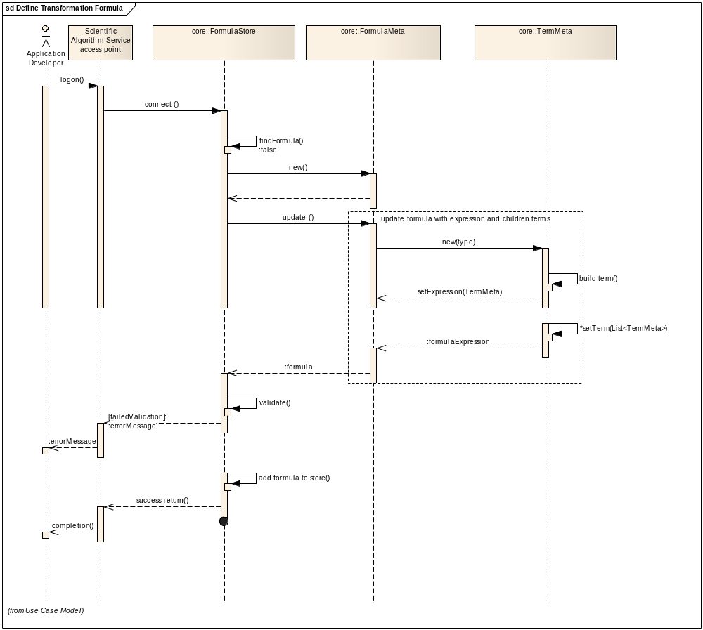

Update Transformation Formula
In this scenario, an application developer updates a formula with status “draft”. The application developer may recursively edit the attributes and terms associated with a formula. Once the editing process is completed, all changes will be persisted into the formula repository. If the updated formula is with status “draft”, it is open for further update; if the updated formula is with status “final”, it does not allow any further update

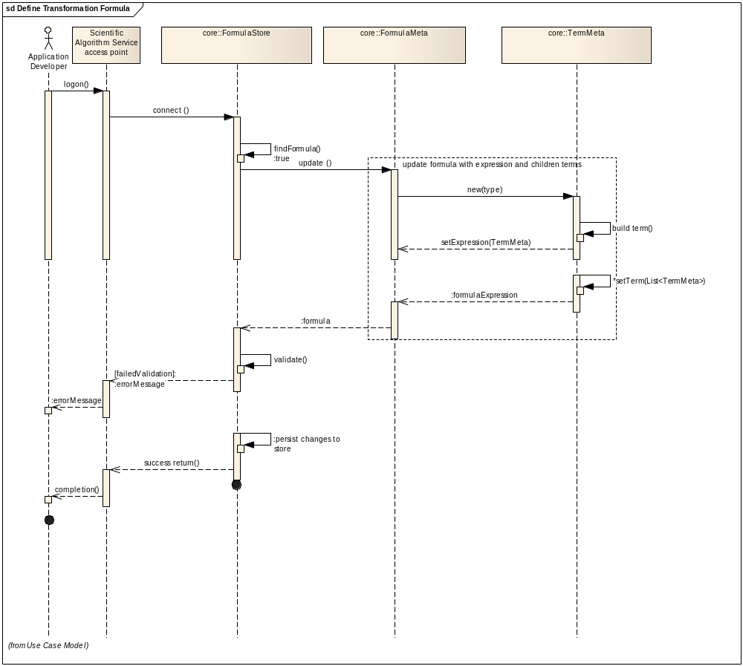

Search Transformation Formula
In this scenario, an application developer or system analyst searches transformation formula with business criteria from either a local formula repository or remote ones. Duplicate formula may be found from different formula repository, but system would avoid any duplicate record in the same formula repository.
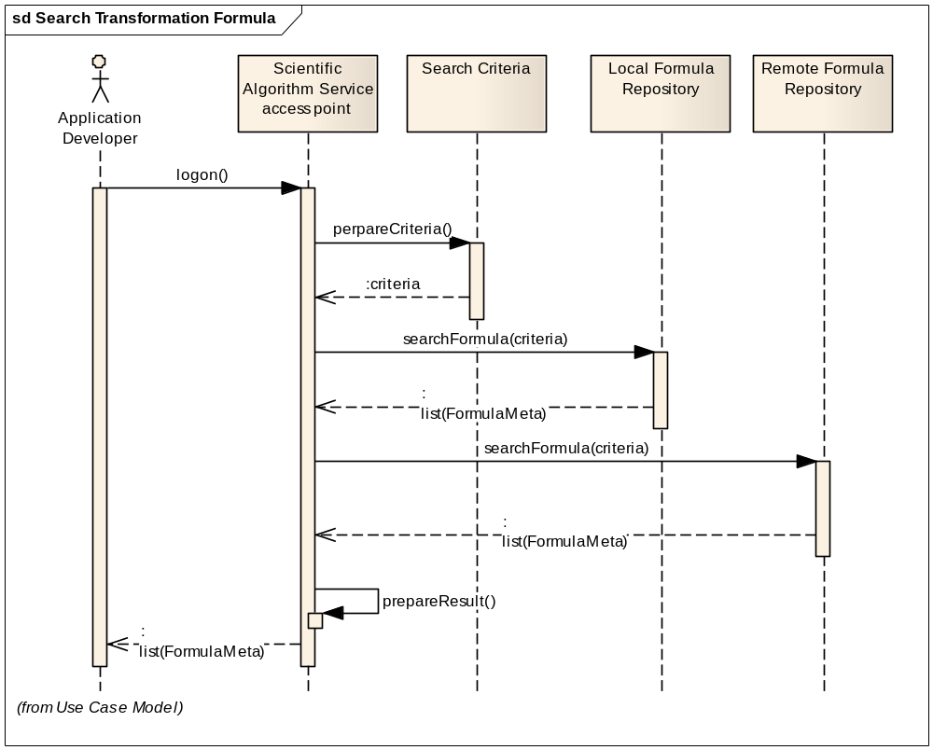

Execute Transformation Formula
In this scenario, a system analyst searches transformation formula store with business criteria. The system analyst produces desired data from source data using the found transformation formula.
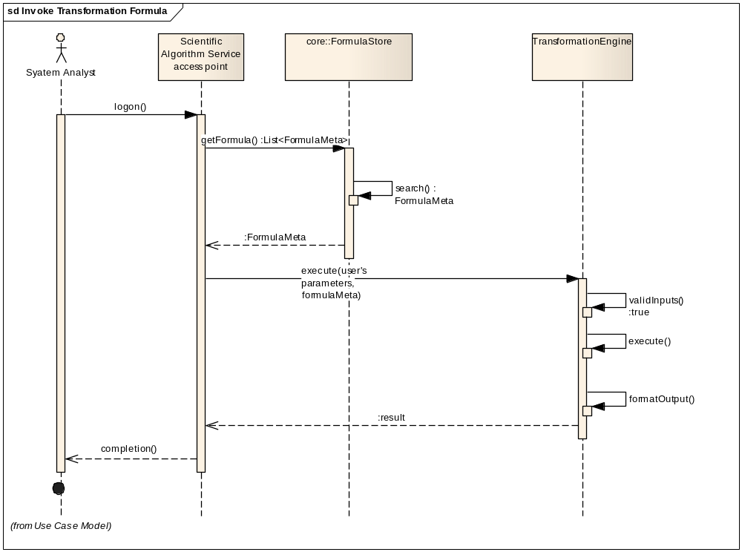

Implementation Considerations

System Architecture
The following high level architecture diagram depicts the caSAS service with components, deployment, and its interactions with web user or other enterprise information systems.
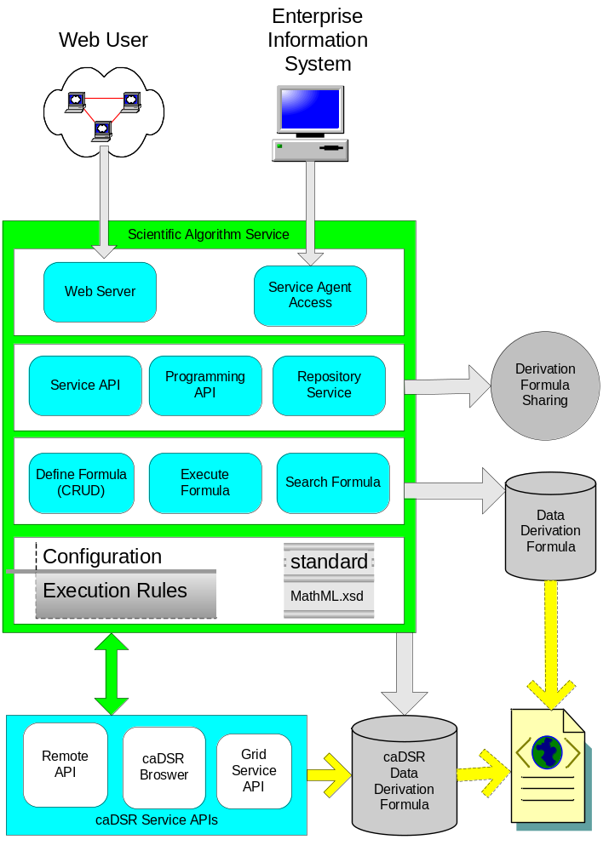

Information Model
The caSAS service is made up of functionalities of formula management, formula execution, and formula sharing. The core of these functionalities is derivation formula. The following class diagram is a subset of system information model representing the derivation formula.
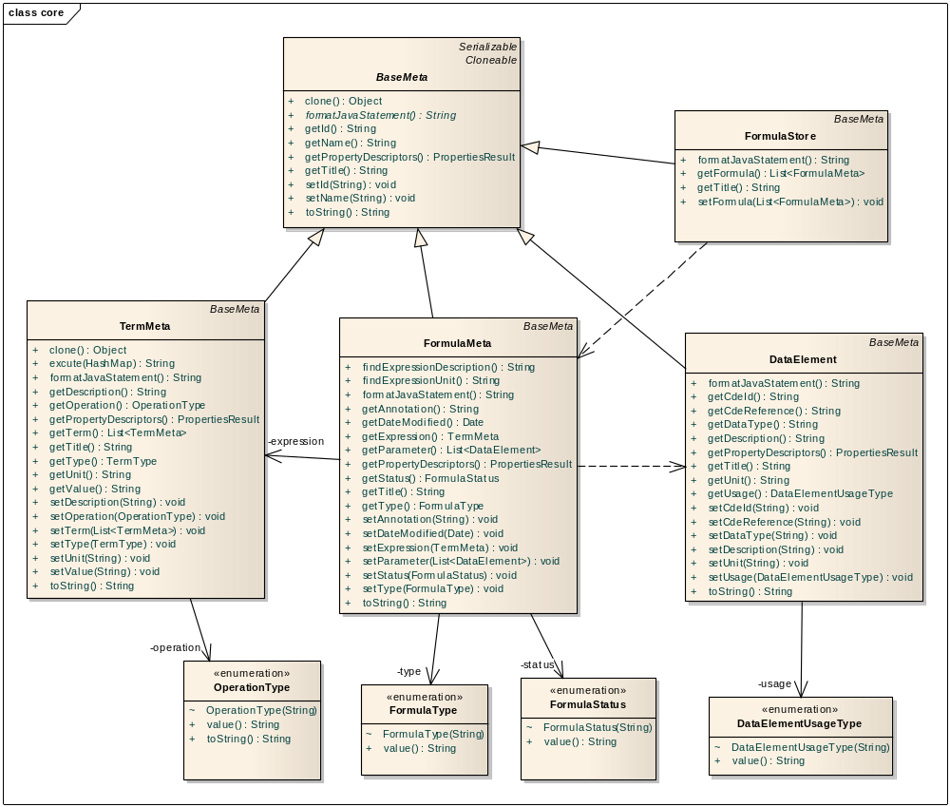

Service Interface
The service interface of caSAS service is made up of three loosely coupled units: RepositoryInterface, FormulaInterface, TransformationInterface. They are shown in the following subset of the system information model.
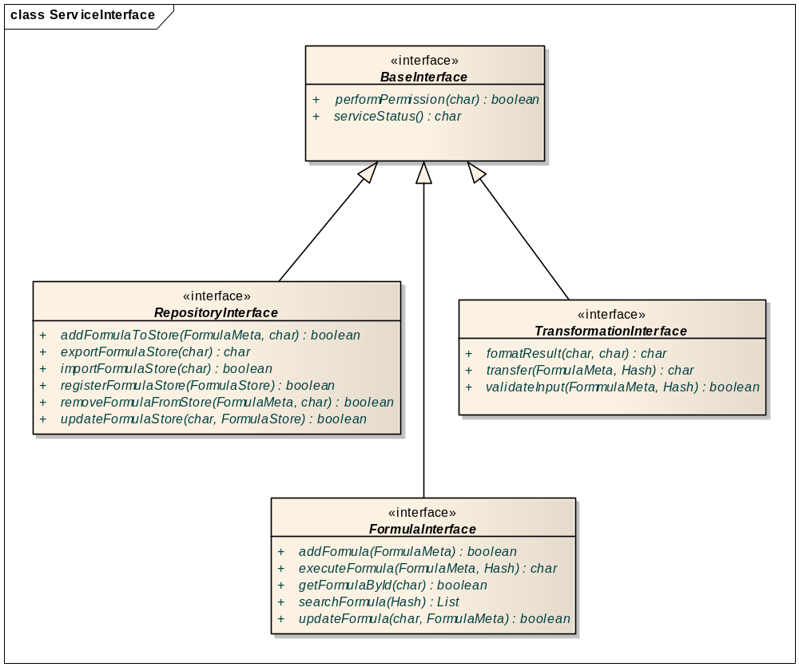

Standard and MathXL
The caSAS service defines derivation formula, the core of derivation transformation, based on open source standard such as MathML (see Relevant Standards: MathML). It enables users to compatibly use formulae either privately defined or publicly obtained, to reuse formula in support of knowledge sharing, and to guarantee the accuracy of resulting data.

Deployment Considerations
The caSAS service supports flexible deployment modes shown in following section. It can be developed to support any or all of following modes. The exact deployment mode supported by the service implementation would be properly documented in the Platform Specific Model.

Local Deployment
The caSAS service should be able to run locally in the same container as the client application. Alternatively, it may run as a web application serving web clients.

Remote Deployment
The caSAS service should be able to run remotely and to support remote client interfacing.

SOA Deployment
The caSAS service should be able to run as a SOA agent (see Reference: SOA Patterns) providing with the features of service registry, service discovery, caBIG security infrastructure compliance, and one-time sign on. This service agent would be in the platform-independent manner without compromise in technology or implementation of underneath infrastructure.

Conformance and Compliance

Compliance and Conformance Statements
Name | Type | Viewpoint | Description | Test method
Formula repository access performance | Obligation | Engineering  Conformance Profile:caSAS-CP1 | This profile should provide a response within 0.5 seconds to support a synchronous UI based client | 1. Test cases to include performance testing.
Local deployment | Obligation | Technology  Conformance Profile:caSAS-CP4 | This profile should enable deployment only within organization boundary restricting access and visibility to the external world | 1. Test cases to be defined to test for network access
SOA deployment | Obligation | Technology  Conformance Profile:caSAS-CP4 | This profile should enable deployment on a SOA hub boundary with open access to the external world | 1. Test cases to be defined to test for network access
Semantic Model | Obligation | Informational  Semantic Profile: caSAS-SP1 | This profile enable support all terminologies represented in the LexEVS API for all operations. | 1. Design Review

Appendix A - Relevant Standards
Name | Description | Location
LexEVS and EVS APIs | NCI Enterprise Vocabulary Services. LexEVS is a mechanism for the standard storage of controlled vocabularies and ontologies defining a flexible format for accurately representing a wide variety of vocabularies and other lexically-based resources in several different server storage repositories as well as a XML format. | https://cabig.nci.nih.gov/tools/LexEVS_API
MathML | Mathematical Markup Language (MathML). MathML can be used to encode both mathematical notation and mathematical content. | http://www.w3.org/Math/

Appendix B - References
Name | Description | Location
Scientific Algorithm Service Use Case Document | Document containing use cases Scientific Algorithm Service application | https://ncisvn.nci.nih.gov/svn/caadapter/trunk/software/cdms/doc/UsecaseDocument.doc
SOA Patterns | A Community Site for SOA Design Patterns | http://www.soapatterns.org/

Appendix C - Glossary
Term | Description
caBIG | The mission of caBIG® is to develop a collaborative information network that accelerates the discovery of new approaches for the detection, diagnosis, treatment, and prevention of cancer. caBIG® is sponsored by the National Cancer Institute (NCI) and its activities are supervised by the National Cancer Institute Center for Bioinformatics and Information Technology (NCI-CBIIT).
MathML | Mathematical Markup Language (MathML). MathML can be used to encode both mathematical notation and mathematical content.

Appendix D – Cross Reference Tables

List of Storyboards
# | Name | Description | Source
caSAS -SB1 | Define transformation formula | This function covers defining a new formula or updating an existing formula.
caSAS -SB2 | Search transformation formula | User searches transformation formula for the purpose of updating or execution.
caSAS -SB3 | Execute transformation formula | User executes transformation formula and generates a result data using source data as parameters of the formula.

Storyboards to Capabilities Mapping
# | Storyboard | Capabilities | Functional Profiles
caSAS -SB1 | Define transformation formula | Define Transformation Formula | CASAS-FP1
caSAS -SB1 | Define transformation formula | Define Transformation Formula | CASAS-FP2
caSAS -SB1 | Define transformation formula | Define Transformation Formula | CASAS-FP3
caSAS -SB1 | Define transformation formula | Define Transformation Formula | CASAS-FP4
caSAS -SB1 | Define transformation formula | Define Transformation Formula | CASAS-FP5
caSAS -SB2 | Search transformation formula | Search Transformation Formula | CASAS-FP6
caSAS -SB3 | Execute transformation formula | Execute Transformation Formula | CASAS-FP7

Actors
Actors | Functional Profile | Type | Operations used
Application Developer | All functional profiles | People | All operations
System Analyst | All functional profiles | People | All operations
External System | All functional profiles | System | All operations

