caAdapter Capability of Semantic Data Sharing
- Semantic interoperability requires system “understand” the data exchanged. This “understanding” requires shared data models which, in turn, depend on standard (controlled) vocabulary and Common Data Elements (CDEs) (https://cabig.nci.nih.gov/sharable/compatible).
- CMTS processes semantic information the CDEs defined by caDSR (https://cabig.nci.nih.gov/concepts/caDSR/).
- CMTS processes semantic information international standard chosen by NCI/caDSR, such as the ISO/IEC 11179 Standard for Metadata Registries
- CMTS process semantic information of structure and content expressed with W3C XML schema (XSD) (http://www.w3.org/XML/Schema).
- CMTS process semantics of XML documents defined XSD annotation and semantic markup(metadata).

Transformation Algorithm of Semantic Data Sharing
Semantic Support in  Source Data Schema | Semantic Support  in Target Data Schema | Transformation Action
Yes | Yes | - Convert source data value to target data  - If semantic mapping exist between data schema and target data schema, convert the semantic data of source data to the semantic data of target data.  - Else if default semantic data is available in target data schema, set the default data as the semantic data of target data.  - Else, no semantic data is set for target data
Yes | No | - Convert source data value to target data  - Option I:  - Ignore the semantic data of source data  - No semantic data is set for target data  - Option II:  - To be decided  - Consider user’s feedback from business usages
No | Yes | - Convert source data value to target data  - If user provides semantic data in mapping, set user’s mapping data as the semantic data of target data.  - Else if default semantic data is available in target data schema, set the default data as the semantic data of target data.  - Else, no semantic data is set for target data
No | No | - Convert source data value to target data  - No semantic data is set for target data

Display Semantic Information on Property Panel
- Connect to CDE browser https://cdebrowser.nci.nih.gov/CDEBrowser/, provide browsing, searching, and exporting CDE’s.
- Connect to caDSR Adminitration Tool http://cadsradmin.nci.nih.gov/, access all of the caDSR features and components.

System Compatibility
XSLT and XQuery are the languages developed by the W3C for transforming and querying XML data. Many tools either support XSLT or XQuery. CMTS generate mapping artifacts to be used by third party data transformation tool as long as it supports XSLT, XQuery, or both.
- Map source data schema (XSD) to target data schema (XSD).
  - Users have options to use either XQuery or XSLT
- Generate artifacts for XSLT compatible data transformation tools based XSLT 2.0. Since XSLT 2.0 is not backward compatible with XSLT 1.0, caAdatper CMTS may not be required to support XSLT 1.0.
- Generate artifacts for XQuery compatible data transformation tools.

Data Processing Functions
- caAdatper HL7 transformation module 4.3 and CMTS version 0.5 implements data processing functions which are grouped into: math, constant, date time, and string.
- caAdapter HL7 transformation implemented these function with Java
- CMTS 0.5 implemented these functions with XPath 1.0 functions using XQuery syntax.
- CMTS version 1.0 implements all function groups in CMTS version 0.5.
- CMTS version 1.0 implements functions to be compatible with both XSLT and XQuery specifications.
- CMTS version 1.0 function framework is extensible, which is open to modify existing and add new function based on user’s feedback.
Notes:
  - XPath includes over 100 built-in functions. There are functions for string values, numeric values, date and time comparison, node and QName manipulation, sequence manipulation, Boolean values, and more
  - LexEVS API 6.x (https://cabig.nci.nih.gov/tools/LexEVS_API) provides mapping and transformation of data elements from one domain to another domain, which is similar to the Vocabulary Mapping (VOM) function provided by caAdapter HL7 transformation module.

Support Resource Description Framework (RDF)
- Resource Description Framework (RDF) is a family of W3C specification originally designed as metadata data model.
- RDF has been used as a general method for conceptual description or modeling of information that is implemented in web resources, using a variety of syntax formats.
- RDF vocabularies, constraints, structures, relationships, and annotation can be defined with XSD.
- UML can be extended to be “RDF-compatible”. Representing the conceptual model of UML in RDF is similar to defining an alternative RDF schema specification. http://infolab.stanford.edu/~melnik/rdf/uml/
- CMTS encodes caCORE compatible associations and references. The UML association ends correspond to RDF properties. The object instances correspond to RDF resources.

Supporting Materials

Compatibility of XQuery, XSLT, and XPath
XQuery | XSLT | XPath Compatibility
N/A | 1.0 W3C recommended on November 16, 1999 | 1.0 W3C recommended on November 16, 1999
1.0 W3C recommended on January 23, 2007 | 2.0 W3C recommended on January 23, 2007 | 2.0 W3C recommended on January 23, 2007

MapForce Analysis
Capability -- MapForce is a graphical data mapping, conversion, and integration tool, which:
- Map source data template to target data template
- Transforms data instantly using mapping and source data
- Generate data integration code for the execution of recurrent conversions: XSLT 1.0, XSLT 2.0, XQuery, Java, C#, and C++
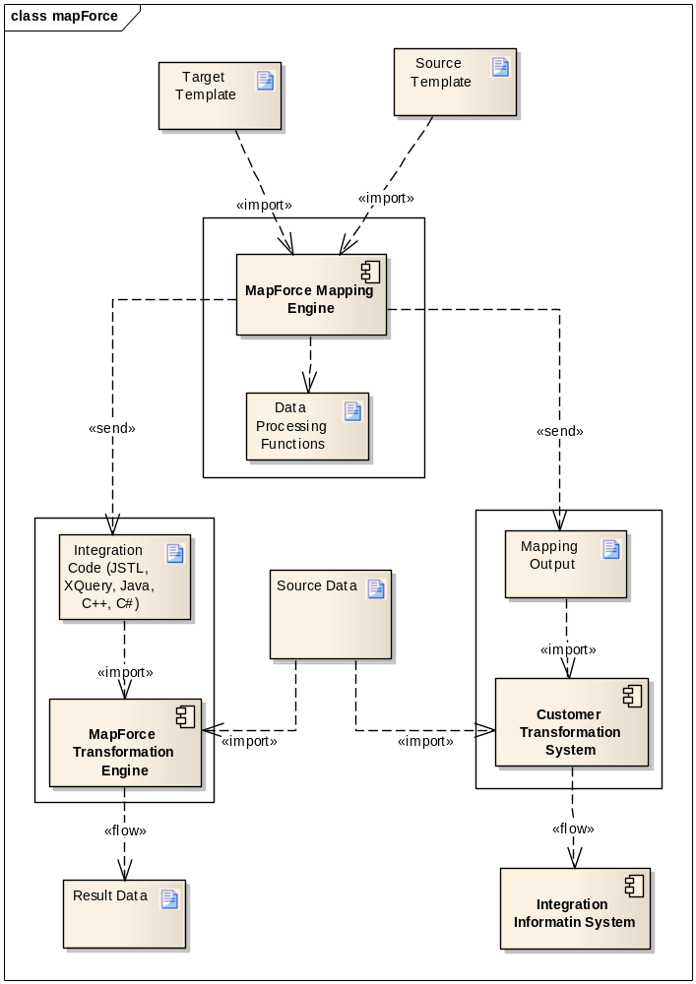
System Integration
- MapForce is an independent IDE tool, it is not a web application
- MapForce provides free package to integrate with Eclipse and Netbean
- MapForce supports integration to MS Visual Studio

Implementation Technology
It is a great change to CMTS as a web application because of its rich graphical features. We propose Java Applet with assistance of JavaScript and Ajax as the implementation technology based on the following considerations:
Java Applet Features
- Provide web application with interactive features that cannot be provided by HTML
- Support mouse actions and UI controls like button, check boxes, etc
- Be transferred to the client’s system and executed by browser’s Java Virtual Machine (JVM) as platform-independent
- Part of Java language, available with library, supporting software, IDE, etc. It is feasible with our limited resource and complex requirements.
Java Applet Usage
By May 16, 2010, java applet is used by 3,772 of over top million web sites (http://trends.builtwith.com/websitelist/Applet#). The top million results are ordered from highest traffic to lowest traffic.
Alternative Technologies
They satisfy some of the scope of that is possible with java applet, but none of them has been achieve its popularity as java applet does.
- ActiveX – a Microsoft sponsored framework for defining reusable program building blocks, which serve to create distributed application working over web browsers. It is comparable with java applet.
- Curl -- a reflective object-oriented programming language for interactive web applications which goal is to provide a smoother transition between formatting and programming. It makes it possible to embed complex objects in simple documents without needing to switch between programming languages or development platforms.
- Java Servlet -- a Java programming language class used to extend the capabilities of servers that host applications accessed via a request-response programming model.
- Java Web Start -- a framework developed by Sun Microsystems (now Oracle) that allows users to start application software for the Java Platform directly from the Internet using a web browser.
- JavaFX -- a software platform for creating and delivering rich Internet applications that can run across a wide variety of connected devices. The current release (JavaFX 1.3, April 2010) enables building applications for desktop, browser and mobile phones. TV set-top boxes, gaming consoles, Blu-ray players and other platforms are planned.
- Adobe Flash – developing tools and resource to build cross-platform, browser-based application runtime that provides uncompromised viewing of expressive applications, content, and videos across browsers and operating systems.

