Platform Independent Model and Service Specification

Scientific Algorithm Service

Version 1.0

April 1, 2011

Enterprise Architecture Specification Team |  |  |  | Sichen Liu – NCI CBIIT  Sudha Chudamani –SAIC Frederick
Project Lead |  |  |  | Eugene Wang
Authors |  |  |  | Eugene Wang –SAIC Frederick  Ki Sung Um – SAIC Frederick
 | Document Version | Date | Author |  | Changes
 | 0.0.1 | March 25, 2011 | Eugene Wang |  | Initial draft
 | 0.0.2 |  |  |  | Internal review

TABLE OF CONTENTS

1 Introduction 3
1.1 Overview 3
1.2 Relationship to Standards 3
1.3 Relation to Computationally Independent Model (CIM) and Service Specification 4
1.3.1 Conformance and Compliance 4
2 Platform Independent Model and Service Specification 7
2.1 Overview and Architecture 7
2.2 Implementation Considerations 10
2.2.1 Assumptions 10
2.2.2 Deployment Considerations 11
2.2.3 Jurisdictional Domains 13
2.2.4 MathXL Standard Adoption 14
2.3 Information Model 16
2.3.1 Formula Object Model 16
2.3.2 Derivation Formula State Model 17
2.3.3 Service Implementation model 18
2.3.4 Web Application Implementation Model 18
2.3.5 Error Implementation Model 19
2.4 Control Data Type Definitions 20
2.4.1 Status/Return Values/Exceptions 20
2.4.2 Error Codes 21
2.4.3 Query Parameters and Result Sets 21
3 Interfaces 22
3.1 UML Model of Interfaces 22
3.2 Operations (Enumeration) 22
3.3 Operation Behavior Descriptions 24
3.3.1 caSAS-INF1:ServiceBase Interface 24
3.3.2 caSAS-INF2:FormulaManagement Interface 26
3.3.3 caSAS-INF3:FormulaQuery Interface 29
3.3.4 caSAS-INF4:DataTransformation Interface 31
3.3.5 caSAS-INF5:ReopsitoryAccess Interface 33
4 Dynamic Model 35
5 Profiles 35
5.1 Functional Profiles 35
5.2 Semantic Profiles 37
6 Relationship with other services 38
7 Conformance Statements 38
8 Appendix A - References 38
9 Appendix B - Glossary 39
10 Appendix C - Cross Reference Tables 39
10.1 Interface to Profile Mapping 39
10.2 Interface Operations to Profile Operations 41
11 Appendix D MathML 3.0 Schema 42

Scientific Algorithm Service Platform Independent Model and Service Specification

Introduction

Overview
Scientific Algorithm Service (caSAS) service is a set of loosely-coupled capabilities which manage data derivation algorithm (formula) and provide derivation transformation service. It is part of NCI’s Enterprise Services (NES) and has to adhere to all the service specifications and guidelines set by the NCI’s Enterprise Conformance and Compliance Framework (ECCF). It defines all derivation formula based on open source standard MathML encoding mathematical notation and capturing mathematical content and structures.

caBIG community users have expressed keen interest in having a service to create mathematical formulae for data derivation transformation to get desired output using raw data from various means such as, data warehouse, online collection or information system. The caSAS service extends caAdapter’s mapping and transformation capabilities to include creation of standards-based infrastructure tools to facilitate medical research data exchange.

The following document provides the Platform Independent Model and Service Specification (PIMSS) for caSAS service which is compliant with all the standards and guidelines mentioned above and at the same time are compliant to all the functionality described by the conformance profiles in the Computational Independent Model Service Specification (CIMSS) of Scientific Algorithm Service.

Relationship to Standards

Standards | Description
MathML | Mathematical Markup Language (MathML) can be used to encode both mathematical notation and mathematical content. http://www.w3.org/Math/
LexEVS and EVS APIs | NCI Enterprise Vocabulary Services and LexEVS is a mechanism for the standard storage of controlled vocabularies and ontology defining a flexible format for accurately representing a wide variety of vocabularies and other lexically-based resources in several different server storage repositories as well as a XML format. https://cabig.nci.nih.gov/tools/LexEVS_API

Relation to Computationally Independent Model (CIM) and Service Specification
Computationally Independent Model and Service Specification Name | Computationally Independent Model and Service Specification Version | Description & Link to the Computationally Independent Model and Service Specification
The Scientific Algorithm Service Computationally Independent Model and Service Specification | 1.0 | The Scientific Algorithm Service Platform Independent Model and Service Specification follows the Scientific Algorithm Service Computationally Independent Model and Service Specification located at the following location: https://ncisvn.nci.nih.gov/svn/caadapter/trunk/software/cdms/doc/ComputationalIndependentModel.doc

Deviation from the Computationally Independent Model and Service Specification | Reason for Deviation
None | Not Applicable

Conformance and Compliance
This service is conformant and compliant to the following conformance profiles described in the Computationally Independent Module Service Specification of Scientific Algorithm Service.

Conformance Profile No. | caSAS -CP1
Conformance Profile Name | Derivation Formula Management Conformance Profile
Functional Profiles
  Functional Profile No. | Functional Profile Name
  caSAS –FP1 | Create formula
  caSAS –FP2 | Update formula
  caSAS –FP3 | Delete formula
  caSAS –FP4 | Submit formula
  caSAS –FP5 | Deactivate formula
  caSAS –FP6 | Search formula
Semantic Profiles
  Semantic Profile No. | Semantic Profile Name
  caSAS-SP1 | caBIG Vocabularies and Common Data Elements
  caSAS-SP2 | Mathematical Markup Language

Conformance Profile No. | caSAS –CP2
Conformance Profile Name | Execute Derivation Transformation Conformance Profile
Functional Profiles
  Functional Profile No. | Functional Profile Name
  caSAS –FP6 | Search formula
  caSAS –FP7 | Execute formula
Semantic Profiles
  Semantic Profile No. | Semantic Profile Name
  caSAS-SP1 | caBIG Vocabularies and Common Data Elements
  caSAS-SP2 | Mathematical Markup Language

Conformance Profile No. | caSAS –CP3
Conformance Profile Name | Flexible Repository Conformance Profile
Functional Profiles
  Functional Profile No. | Functional Profile Name
  caSAS –FP8 | Maintain flexible formula repository
Semantic Profiles
  Semantic Profile No. | Semantic Profile Name
  caSAS-SP1 | caBIG Vocabularies and Common Data Elements
  caSAS-SP2 | Mathematical Markup Language

Conformance Profile No. | caSAS –CP4
Conformance Profile Name | Deployment Conformance Profile
Functional Profiles
  Functional Profile No. | Functional Profile Name
  caSAS –FP9 | Deploy service
Semantic Profiles
  Semantic Profile No. | Semantic Profile Name
  caSAS-SP1 | caBIG Vocabularies and Common Data Elements
  caSAS-SP2 | Mathematical Markup Language

Conformance Profile No. | caSAS –CP5
Conformance Profile Name | Integration Conformance Profile
Functional Profiles
  Functional Profile No. | Functional Profile Name
  caSAS –FP10 | Service API integration
  caSAS –FP11 | Programming API integration
Semantic Profiles
  Semantic Profile No. | Semantic Profile Name
  caSAS-SP1 | caBIG Vocabularies and Common Data Elements
  caSAS-SP2 | Mathematical Markup Language

Conformance Profile No. | caSAS –CP6
Conformance Profile Name | Extension framework Conformance Profile
Functional Profiles
  Functional Profile No. | Functional Profile Name
  caSAS –FP12 | Customization and extension framework
Semantic Profiles
  Semantic Profile No. | Semantic Profile Name
  caSAS-SP1 | caBIG Vocabularies and Common Data Elements
  caSAS-SP2 | Mathematical Markup Language

Platform Independent Model and Service Specification

Overview and Architecture

The following high level architecture diagram depicts the caSAS service with components, deployment, and its interactions with web user or other enterprise information systems.
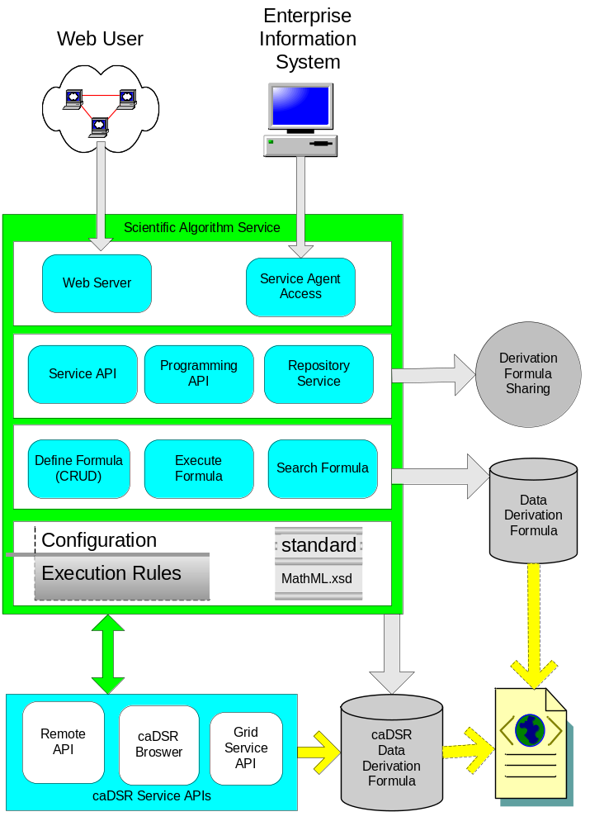
The sections below fully describe the overall architecture of the caSAS service. It provides details about the operations and behavior of the interfaces exposed by the service. These interfaces are designed for the end consumer and are designed based on the functionality which is accessed cohesively by each of the consumers. Based on this grouping of functionality the overall service is split into three loosely coupled units: Formula Management, Formula Query, Repository Access, and Data Transformation.

Formula Management: This interface contains all the operations of formula management, including:
- Create formula
- Update formula
- Delete draft formula
- Submit final formula
- Deactivate final formula
These operations are accessed both by end user through default interface (web client) as well as associated enterprise information system through integration interface.

Formula Query: This interface contains operations search transformation formula with business criteria from either a local formula repository or remote ones. Duplicate formula may be found from different formula repository, but system would avoid any duplicate record in the same formula repository. These operations are accessed both by end user through default interface (web client) as well as associated enterprise information system through integration interface.

Repository Access: This interface contains only those operations about sharing formula between formula repositories, including:
- Import formulae
- Export formulae
These operations are only accessed by associated enterprise information system through integration interface.

Data Transformation: This interface contains operations to access Formula Query service for interested formula and execution of formula with source data as parameters. These operations are accessed both by end user through default interface (web client) as well as associated enterprise information system through integration interface.

This grouping is done in order to be compliant with the functional profiles described in the Computationally Independent Model (CIM) and Service Description of Scientific Algorithm Service. The following component diagram highlights the relationship of above interfaces and their dependence on formula repository.
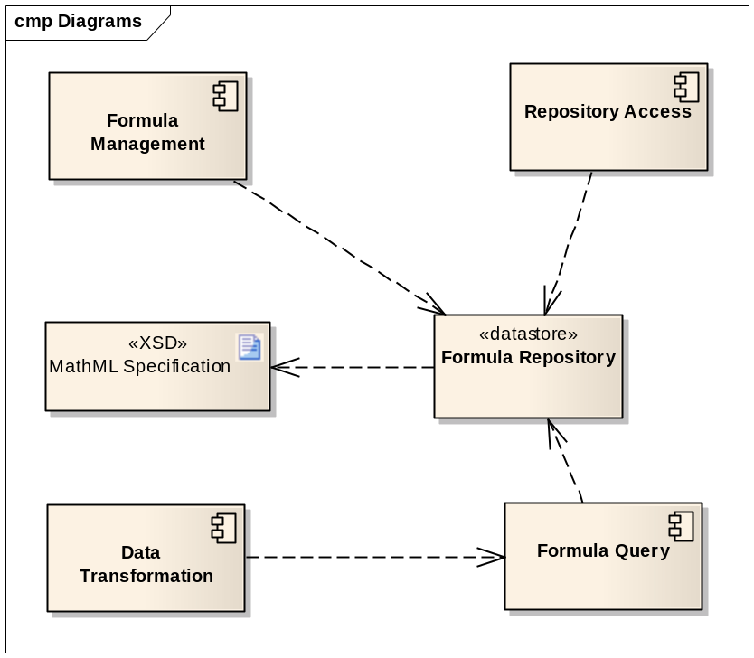

Implementation Considerations
Implementation Consideration | Impact
Support caDSR tools. | The service will implement interoperable data repository of derivation formula which support caDSR browser, remote AIP, and grid service API.
Adopt MathML to define derivation formula in describing mathematical notation and capturing both its structure and content. | The service developed might not be fully support MathML specification in presentation.

Assumptions

Assumptions | Affects
It is assumed that this service enable user to create data derivation formula for public using, thus the formula should be verified and approved before release to public. | Only approved formula is guaranteed to provide valid transformation.

Deployment Considerations
Deployment Consideration | Impact
Local Deployment Mode | Service should run locally to support local user. The primary scenario is run as web server to support web client with browser.
SOA Agent Deployment Mode | Service should run as SOA agent on SOA infrastructure to support SOA client through its service access point.
Scalability | Service should be able to serve 50(?) users simultaneously
Up time | Service should have downtime less than one hour
Failover | Service should have a hot fail over

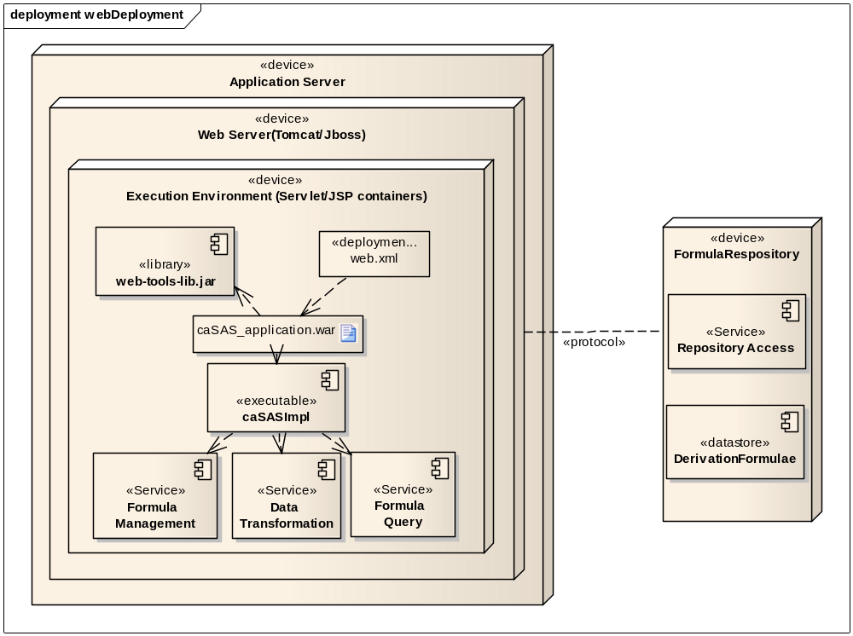
Web Deployment: The above diagram depicts the web application deployment. caSAS_application.war is deployed on a web server which are servlet and JSP containers. It is packed with the caSAS service implementation package which implements three service interfaces: Formula Management, Formula Query, and Data Transformation. The web server interacts with independent Formula Repository which implements Repository Access interface.

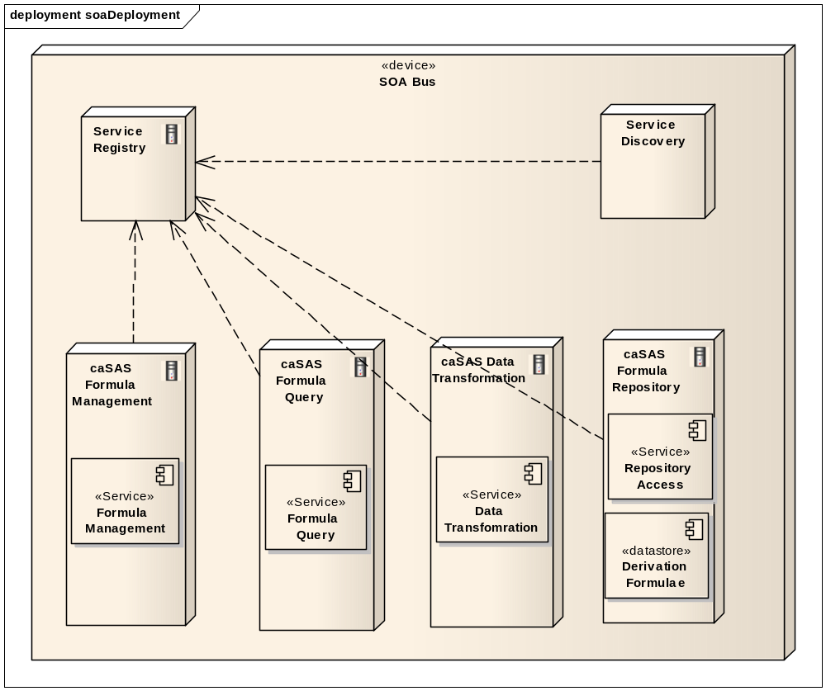

SOA Agent Deployment: The above diagram shows that all services are deployed as agent nodes on SOA bus. These agents are registered through Service Registry. SOA client systems find any required service through Service Discovery.

Jurisdictional Domains
Jurisdictional Domains | Boundary
NCI caDSR Scientific Algorithm Service | The service is going to be deployed within NCI network, which maintains a common derivation formula repository.
Institutional Scientific Algorithm Service | The service will be deployed at various institutions it comes within their boundary. Each service maintains its own derivation formula repository and also has access to NCI caDSR repository.

MathXL Standard Adoption
MathML is a leading standard of XML for describing mathematical notations and capturing both its structure and content (see Appendix A. Reference: MathML). caSAS service adopts the MathML standard to markup the definition of derivation formula in support of formula sharing. The following sections compare caSAS markup requirements with MathML markup capabilities.

caSAS Markup Requirements
The markup requirements of caSAS derivation formula fall into three categories: algorithm encoding capability, semantic interoperability, and presentation (display) compatibility.
- Algorithm encoding capability – be able to encode all required mathematical operations and concepts.
- Semantic interoperability – be understandable by other information system, software tool, or public acceptable markup language, i.e. all interoperable systems will understand the meaning of formula components (content.
- Presentation compatibility – be able to presentable/displayable by UI software, such as web browser, graphic editor, or applications implemented with public markup standard. For example, if an application is implemented with W3C MathML standard, it will able to uniquely display a formula.

MathXL Markup Capabilities
The schema of MathML 3.0 defines a mathematical notation (including structure and content) with element “math” which contains zero of more elements with the type of “MathExpression”. The type “MathExpression” has three type choice children elements: “ContExp” encodes formula content, “semantics-contexp” carries semantic annotation statements associate with a formula, and “PresentationExpression” focuses on the display of an equation. MathML 3.0 schema (XSD) is detailed in Appendix D:

- MathML Content Markup
The element “ContExp” is used in MathML content markup on the mathematically semantic meaning of the express.” The “ContExp” uses child elements covering all different kinds of mathematic operations, components, and relationships. The core of these child elements is the <apply> element to represent a function or operator, given in the first child, applied to the remaining child elements. In other words, “ContExp” represents a mathematical expression with “Polish Notation” (see Appedix A. Referecne: Polish Notation) of its child elements, which is also known as “prefix notation” that places operators to the left of their operands. There are over a hundred different elements for different functions and operators, but content MathML uses only a few attributes

- MathML Semantic Markup
MathML use < semantics> element with child <annotation> elements to embed any additional semantic requirements beyond mathematical meaning.
- MathML Presentation Markup
Presentation MathML focuses on the display of an equation, and has about 30 elements, and 50 attributes. The elements all begin with m and include token element: <mi>x</mi> - identifiers; <mo>+</mo> - operators; <mn>2</mn> - number. Tokens are combined using layout elements that include: <mrow> - a row; <msup> - superscripts; <mfrac> - fractions. The attributes mainly control fine details of the presentation. A large number of entities are available that represent letters (&pi;), symbols (&RightArrow;) and some non-visible characters such as &InvisibleTimes; representing multiplication.

Implementation Proposal
- Content Markup
In the prototype of caSAA, we use <term> element to represent a mathematic expression with “operation” attribute operating on its child elements. The following table provides summary of the features in caSAS prototype formula and the capabilities of MathML “ContExp” element.
caSAS Protoype Features | MathML ContExp
<expression> | N/A.  Possible work-around with <apply> element.
<term> | <apply>
Attribute “type=operation”  And attribute “operation=addition, subtraction, multiplication, division, power…” | <plus>, <minus>, <times>, <divide>, <power>….
Attribute “type=variable” | <ci>
Attribute “type=constant” | <cn>
Attribute “name=…” | Sequence of child elements.

- Semantic Markup
caSAS can adopt the similar approach to carry both semantic information about algorithm and CDE.
caSAS Protoype Features | MathML ContExp
Attribute “status=….” | <annotation name=” status” value=”…”/>
Attribute “unit=….” | <annotation name=” unit” value=”…”/>
Attribute “description=…” | <annotation name=” description” value=”…”/>
<parameter> | <semantic class=”variable” name=”…”>  <annotation name=”…” value=”…”/>  <annotation …/>  … …  </semantic>
Attribute “dataType=….” | <annotation name=” dataType” value=”…”/>
Attribute “usage=….” | <annotation name=” usage” value=”…”/>
Attribute “cdeId =….” | <annotation name=” cdeId” value=”…”/>
Attribute “cdeReference =….” | <annotation name=”cdeReference” value=”…”/>

- MathML Presentation Markup
In caSAS prototype, we left all the presentation work to UI program to layout a formula. The system and underneath formula XML data do not carry permanent presentation information. The feather still could be deferred for the release beyond 1.0 (?).

Information Model

Formula Object Model
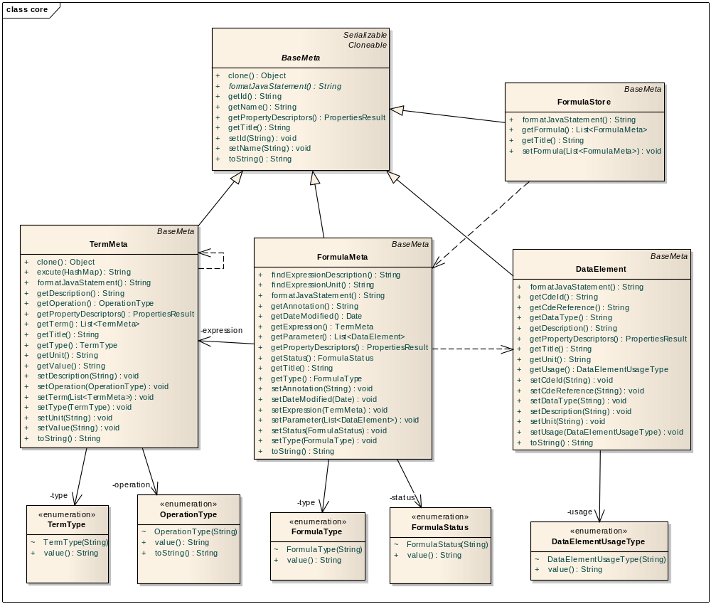

The core caSAS object model is made up the objects defining derivation formula. The above class diagram is a subset of system information model representing the derivation formula.
- BaseMeta: Represents the base all caSAS core objects with shared common attributes.
- FormulaMeta: Represents a derivation formula with name, operation, units, status, variables, etc. A FormulaMeta object can have one and only one child TermMeta object.
- TermMeta: Represents mathematic operation with operator, oprand(s). A TermMeta object may contain other children TermMeta objects.
- DateElement: Represents a value object of CDE concept, formula variable, caSAS transformation concept, or mathematic constant.
- FormulaStore: Represent a list FormulaMeta objects retrieved from or to be persisted to formula repository.
- Enumeration Objects: Implements the Enumeration interface and carries a series if value object. These include: TermType, OperationType, FormulaType, FormulaStatus, and DataElementUsgeType.

Derivation Formula State Model
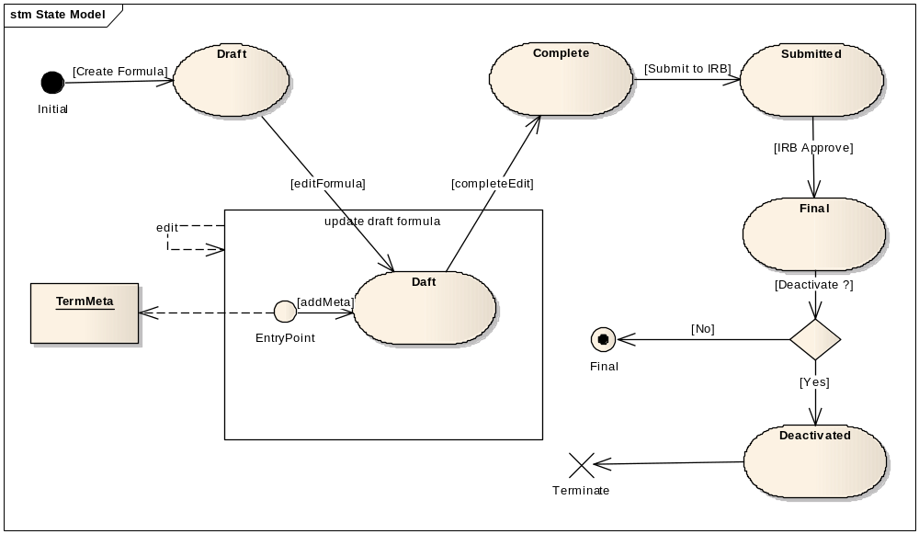
Derivation FormulaMeta Object State Diagram

Operations | Transitions Caused
Create Formula | Create a new FormulaMeta
Edit Formula | Update an attribute or children TermMeta
Edit | Update an attribute or children TermMeta
Add Meta | Create a new TermMeta and add it to a FormulaMeta
Complete Edit | Complete all editing actions
Submit to IRB | Submit to IRB for approval
IRB Approve | Approve a formula, ready for use.
Deactivate | Deactivate a formula, exclude it from any further up or execution.

Service Implementation model
All caSAS service components are implemented on the base of Formula Object Model described in section 2.3.1.

Web Application Implementation Model
The caSAS is rich UI web application in view formula and collecting user’s inputs to edit formula. A formula is represented by the data of the Formula Object Model described in section 2.3.1, which can be created, validated, destroyed, and saved to the server. Whenever a UI action causes an attribute of a model to change, the model notify web browser to re-render and update the views without intervention from web server. An object is saved to server only on client request.
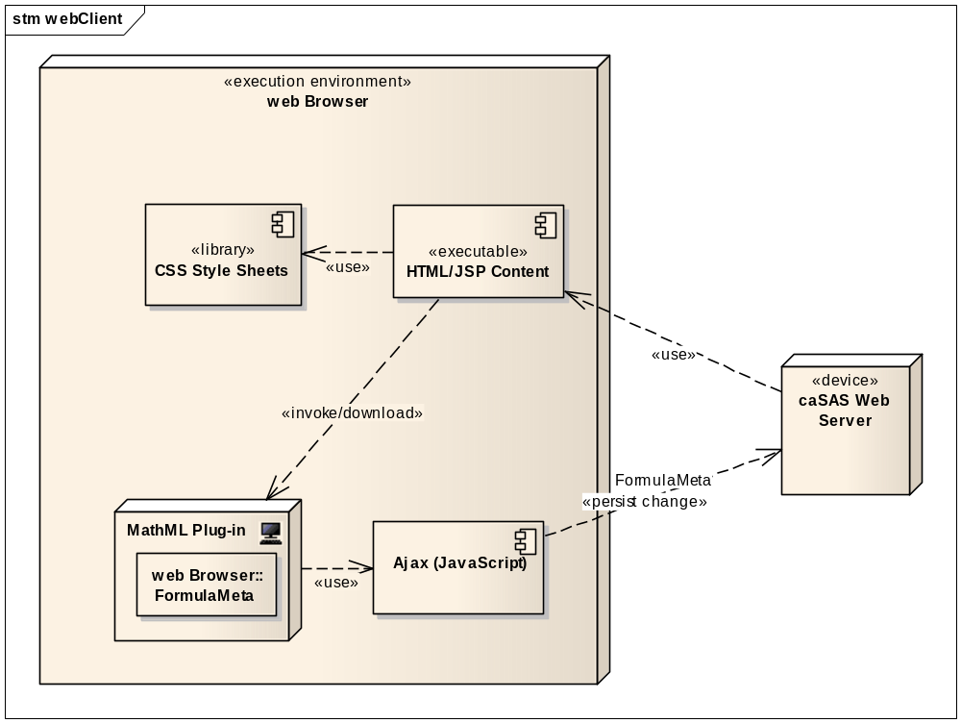

- CSS Style Sheets: display the content with consistent presentation, including elements such as layout, colors, and fonts.
- HTML/JSP Content: Generate dynamic content to direct download and process of MathML ploug-in unit. It also process the standard web client actions such as submit page, choose file, forward request, so on.
- MathML Plug-in: Edit mathematic formula with MathML markup elements and roles.
- Ajax: implemented on the basis of JavaScript to asynchronously update formula data on web server in the background without interfering with the display and behavior of the existing page.

Error Implementation Model
This service returns only one exception class named SASException. The structure and details of SASException class are given below

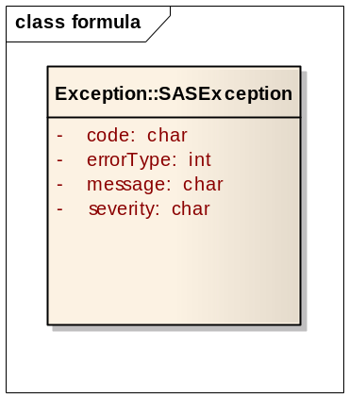

Attribute Name | Type | Attribute Description
code | Char | The actual error code which the Exception class represents
errorType | Int | Indicates what type of error has occurred. Eg. Business, System etc.
message | Char | The detailed error message
severity | Char | The severity of this error. It can be “FATAL”, “HIGH”, “MEDIUM” or “LOW”

Control Data Type Definitions

Status/Return Values/Exceptions
Data Type | Type (Status / Return Value / Exception) | Data Type Description
SASException | Exception | The return object in case there is any exception during the execution of any of the operations listed below

Error Codes
Error Code | Error Condition | Error/Exception Description
caSAS10100 | Incomplete formula submitted for approval | Values of all the mandatory attributes for the FormulaMeta have not been provided
caSAS10200 | Invalid formula provided | Invalid FormulaMeta object has been provided

Query Parameters and Result Sets
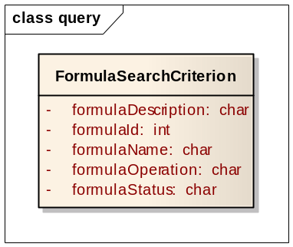

Attribute Name | Type | Attribute Description
formulaDescription | char | The description of the formula to the search for
formulaId | int | The ID of the formula to the search for
formulaSName | char | The name of the formula to the search for
formulaOperation | char | The operation of the formula to the search for
formulaStatus | char | The status of the formula to the search for

Interfaces

UML Model of Interfaces
Interface No |  | Interface Name | Interface Description
caSAS-INF1 | ServiceBase |  | Provides the functionality common to both client access permission as well as server status.
caSAS-INF2 | FormulaManagement |  | Provides the functionality to manage derivation formula in a formula repository.
caSAS-INF3 | FormulaQuery |  | Provides the functionality to query derivation formula over local or remote formula repository.
caSAS-INF4 | DataTransformation |  | Provides the functionality to transfer source data elements into target data element with derivation formula
caSAS-INF5 | RepositoryAccess |  | Provides the functionality to export from or import to a formula repository

Operations (Enumeration)
Operation No. | Operation Name | Interface Name | Operation Description
caSAS- INF1-OP1 | performPermisson | ServiceBase | To verify user’s operation privilege, always return true if a service is free for public use.
caSAS- INF1-OP2 | serviceStatus | ServiceBase | To check current status of service
caSAS- INF2-OP1 | createFormula | FormulaManagement | To create a new formula and add it into formula repository.
caSAS- INF2-OP2 | updateFormula | FormulaManagement | To update a formula with new value for one or more attributes.
caSAS- INF2-OP3 | submitFormula | FormulaManagement | To submit a formula for IRB approval.
caSAS- INF2-OP4 | deleteFormulaById | FormulaManagement | To delete a draft formula from formula repository given a formula Id.
caSAS- INF2-OP5 | deactivateFormula | FormulaManagement | To deactivate a final formula.
caSAS- INF3-OP1 | searchFormula | FormulaQuery | To search formula from one or more formula repositories.
caSAS- INF3-OP2 | getFormula | FormulaQuery | To retrieve formula from repositories given formula Id.
caSAS- INF4-OP1 | transfer | DataTransformation | To transfer source data elements to target data element using derivation formula provided.
caSAS- INF4-OP2 | validateInput | DataTransformation | To validate source data elements against the parameter of the formula provided.
caSAS-INF4-OP3 | formatResust | DataTransformation | To format a result data element with provided format.
caSAS-INF5-OP1 | exportFormula | RepositoryAccess | To export formulae from formula repository into XML document.
caSAS-INF5-OP2 | importFormula | RepositoryAccess | To import formulae into formula repository from XML document.

Operation Behavior Descriptions

caSAS-INF1:ServiceBase Interface

caSAS-INF1-OP1:performPermisson Operation
Behavior Description | To verify user’s operation privilege, always return true if a service is free for public use.
Pre-Conditions | - The service access point is ready.  - User’s profile/confidential is available.
Security Conditions | N/A
Inputs | - User’s credential : Unique identifier for caSAS user [M]
Outputs | True if:  - user has privilege to invoke the service  - or the service is free for public use
Post-Conditions | User is ready to invoke the services provided.
Exception Conditions | - The service is not ready.
Additional Implementation Details | N/A
Notes

caSAS-INF1-OP2:serviceStatus Operation
Behavior Description | To check current status of service
Pre-Conditions | - The service access point is ready.
Security Conditions | N/A
Inputs | N/A
Outputs | True if the service provider is ready to accept client request.
Post-Conditions | The service provider is ready to accept client request.
Exception Conditions | - The service is not ready.
Additional Implementation Details | N/A
Notes

caSAS-INF2:FormulaManagement Interface

caSAS-INF2-OP1: createFormula Operation
Behavior Description | To create a new formula and add it into formula repository.
Pre-Conditions | - The service access point is ready.  - User has the privilege to perform this operation.
Security Conditions | N/A
Inputs | N/A
Outputs | A new formula with status “Draft”.
Post-Conditions | The new formula is persisted into formula repository. It ready for further update actions.
Exception Conditions | - Failed in persist the new formula into formula repository.
Additional Implementation Details | N/A
Notes

caSAS-INF2-OP2: updateFormula Operation
Behavior Description | To update a formula with new value for one or more attributes
Pre-Conditions | - The service access point is ready.  - User has the privilege to perform this operation.  - The formula to update has status “Draft”.
Security Conditions | N/A
Inputs | N/A
Outputs | One or more attribute the formula have been updated.
Post-Conditions | The updated formula is persisted into formula repository. It ready for further actions.
Exception Conditions | - Failed in persist the updated formula into formula repository.
Additional Implementation Details | N/A
Notes

caSAS-INF2-OP3: submitFormula Operation
Behavior Description | To submit a formula for IRB approval.
Pre-Conditions | - The service access point is ready.  - User has the privilege to perform this operation.  - The formula to update has status “Complete”.
Security Conditions | N/A
Inputs | N/A
Outputs | The formula is submitted for approval and is updated with status “Submit”.
Post-Conditions | The formula is submitted and waiting for approval.
Exception Conditions | - Failed in submit the formula to IRB  - Failed to persist the formula with status “Submitted”.
Additional Implementation Details | N/A
Notes

caSAS-INF2-OP4: deleteFormulaById Operation
Behavior Description | To delete a draft formula from formula repository given a formula Id.
Pre-Conditions | - The service access point is ready.  - User has the privilege to perform this operation.  - The formula to update has status “Draft”.
Security Conditions | N/A
Inputs | N/A
Outputs | None.
Post-Conditions | The new formula deleted from formula repository.
Exception Conditions | - Failed in delete the formula from formula repository.
Additional Implementation Details | N/A
Notes

caSAS-INF2-OP5: deactivateFormula Operation
Behavior Description | To deactivate a final formula.
Pre-Conditions | - The service access point is ready.  - User has the privilege to perform this operation.  - The formula to update has status “Final”.
Security Conditions | N/A
Inputs | N/A
Outputs | None.
Post-Conditions | The formula is change to “Deactivated”. No more action is allowed for this formula.
Exception Conditions | - Failed in to change the “Final” formula.
Additional Implementation Details | N/A
Notes

caSAS-INF3:FormulaQuery Interface

caSAS-INF3-OP1: searchFormula Operation
Behavior Description | To search formula from one or more formula repositories.
Pre-Conditions | - The service access point is ready.  - User has the privilege to perform this operation.  - The search criterion is ready.
Security Conditions | N/A
Inputs | Search criterion.
Outputs | One or more formulae.
Post-Conditions | One or more formulae are ready for further processing.
Exception Conditions | - Failed to perform the search request against local or remote formula repository.
Additional Implementation Details | N/A
Notes

caSAS-INF3-OP2: getFormula Operation
Behavior Description | To retrieve formula from repositories given formula Id.
Pre-Conditions | - The service access point is ready.  - User has the privilege to perform this operation.  - Formula Id is ready.  - URL of the target formula repository is ready.
Security Conditions | N/A
Inputs | Formula Id, URL of the target formula repository.
Outputs | The found formula from target formula repository.
Post-Conditions | The found formula is ready for further process.
Exception Conditions | - Failed to communicate the target formula repository.  - Failed to find any formula in the target formula repository.
Additional Implementation Details | N/A
Notes

caSAS-INF4:DataTransformation Interface

caSAS-INF4-OP1: transfer Operation
Behavior Description | To transfer source data elements to target data element using derivation formula provided.
Pre-Conditions | - The service access point is ready.  - User has the privilege to perform this operation.  - Source data elements are ready.  - Derivation formula is ready.
Security Conditions | N/A
Inputs | N/A
Outputs | The target data element is created using source data elements and derivation formula provided.
Post-Conditions | The target data element is ready for further processing.
Exception Conditions | - Runtime error in executing the derivation formula.
Additional Implementation Details | N/A
Notes

caSAS-INF4-OP2: validateInput Operation
Behavior Description | To validate source data elements against the parameter of the formula provided.
Pre-Conditions | - The service access point is ready.  - User has the privilege to perform this operation.  - Source data elements are ready.  - Derivation formula is ready.
Security Conditions | N/A
Inputs | N/A
Outputs | True if source data satisfy the input parameter of the derivation formula.
Post-Conditions | Source data and derivation formula are ready for further transformation service.
Exception Conditions | - Mismatch error of source data with input parameter of derivation formula.  - Invalid data error of each individual source data with its data type.
Additional Implementation Details | N/A
Notes

caSAS-INF4-OP2: formatResust Operation
Behavior Description | To format a result data element with provided format.
Pre-Conditions | - The service access point is ready.  - User has the privilege to perform this operation.  - Source data have been transferred into target data.
Security Conditions | N/A
Inputs | N/A
Outputs | The target data with provided format.
Post-Conditions | The target data in new formula is ready for further processing.
Exception Conditions | - The target data mismatch the format provided.
Additional Implementation Details | N/A
Notes

caSAS-INF5:ReopsitoryAccess Interface

caSAS-INF5-OP1: exportFormula Operation
Behavior Description | To export formulae from formula repository into XML document.
Pre-Conditions | - The service access point is ready.  - User has the privilege to perform this operation.
Security Conditions | N/A
Inputs | N/A
Outputs | XML file of derivation formulae.
Post-Conditions | The formulae are exported into a XML file. It ready for further sharing with other systems.
Exception Conditions | - Failed in export formulae from formula repository.
Additional Implementation Details | N/A
Notes

caSAS-INF5-OP2: importFormula Operation
Behavior Description | To import formulae into formula repository from XML document.
Pre-Conditions | - The service access point is ready.  - User has the privilege to perform this operation.  - The formulae to input are ready as a XML document.
Security Conditions | N/A
Inputs | XML document of formulae to input.
Outputs | N/A
Post-Conditions | The formulae are successfully input into the formula repository
Exception Conditions | - Invalid formula is found in the input XML document.  - Failed in input the formulae.
Additional Implementation Details | N/A
Notes

Dynamic Model
This section includes the descriptions of the interactions of the service.
- Sequence diagrams describe significant interactions with the service. They are listed in CIM document section 5.1 System Runtime Interaction Details.
- A collaboration diagram depicts all the external interactions of the system as following.

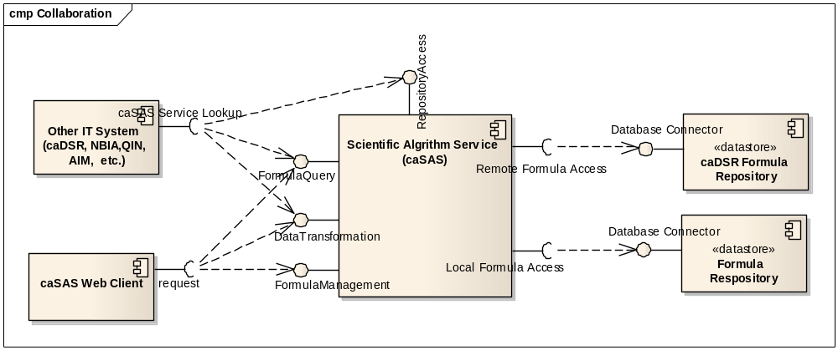

Profiles

Functional Profiles
The information of the functional profiles can be obtained from the Computationally Independent Model and Service Specification

Profile No. | Profile Name | Profile Description
N/A |  | See section 4.1 Functional Profiles in CIM

Interface Operation No. | Interface Operation Name | Profile No. | Profile Name
caSAS- INF1-OP1 | performPermisson | N/A
caSAS- INF1-OP2 | serviceStatus | N/A
caSAS- INF2-OP1 | createFormula | caSAS-FP1 | Create formula
caSAS- INF2-OP2 | updateFormula | caSAS -FP2 | Update formula
caSAS- INF2-OP3 | submitFormula | caSAS –FP4 | Submit formula
caSAS- INF2-OP4 | deleteFormulaById | caSAS –FP3 | Delete formula
caSAS- INF2-OP5 | deactivateFormula | caSAS –FP5 | Deactivate formula
caSAS- INF3-OP1 | searchFormula | caSAS –FP6 | Search formula
caSAS- INF3-OP2 | getFormula | N/A
caSAS- INF4-OP1 | transfer | caSAS –FP7 | Execute formula
caSAS- INF4-OP2 | validateInput | caSAS –FP7 | Execute formula
caSAS- INF4-OP3 | formatResust | caSAS –FP7 | Execute formula
caSAS- INF5-OP1 | exportFormula | caSAS –FP8 | Maintain flexible formula repository
caSAS- INF5-OP2 | importFormula | caSAS –FP8 | Maintain flexible formula repository

The following UML model displays the listing of the interface operations for each of the profiles.
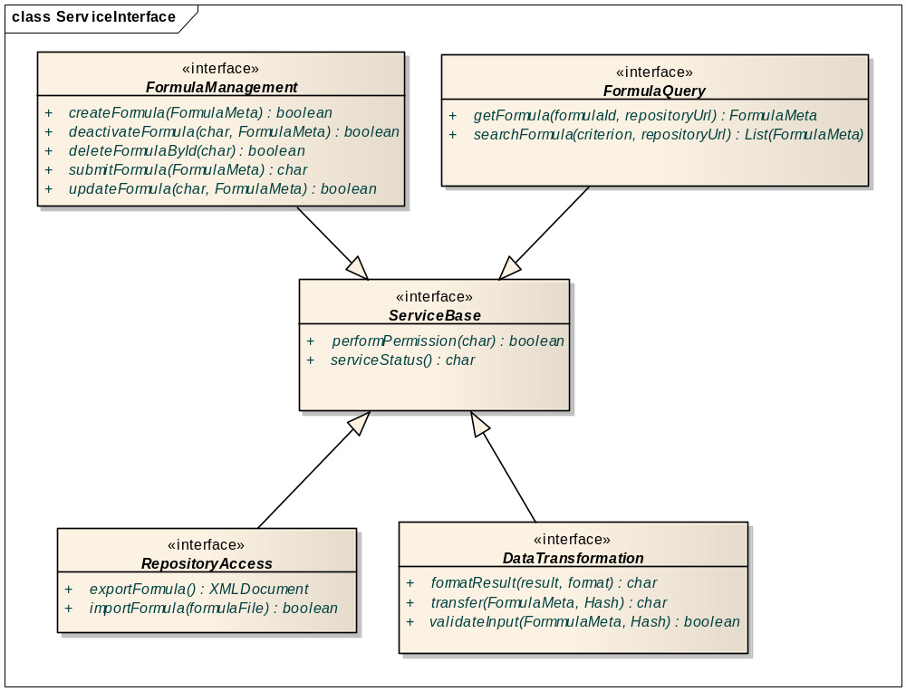

Semantic Profiles
Semantic Profile No. | Semantic Profile Name | Semantic Profile Description
N/A |  | See section 4.2 of Computational Independent Model(CIM) and Service Description of Scientific Algorithm Service

Relationship with other services
Service Name | Dependant / Depends | Data | Description
N/A

Conformance Statements

No. | Name | Type | Viewpoint | Description | Test method
N/A |  |  |  | See section 6.1 of Computational Independent Model(CIM) and Service Description of Scientific Algorithm Service

Appendix A - References
Name | Description | Location
LexEVS and EVS APIs | NCI Enterprise Vocabulary Services. LexEVS is a mechanism for the standard storage of controlled vocabularies and ontologies defining a flexible format for accurately representing a wide variety of vocabularies and other lexically-based resources in several different server storage repositories as well as a XML format. | https://cabig.nci.nih.gov/tools/LexEVS_API
MathML | Mathematical Markup Language (MathML). MathML can be used to encode both mathematical notation and mathematical content. | http://www.w3.org/Math/
Polish Notation | A notation for arithmetic (and logical) formulae in which operations (respectively, quantifiers and operands) are written immediately before their operands, used to avoid the need for parentheses; for example, 3 * (4 + 7) is written as * 3 + 4 7 and A AND B is written as AND A B. | http://en.wikipedia.org/wiki/Polish_notation

Appendix B - Glossary
caBIG | The mission of caBIG® is to develop a collaborative information network that accelerates the discovery of new approaches for the detection, diagnosis, treatment, and prevention of cancer. caBIG® is sponsored by the National Cancer Institute (NCI) and its activities are supervised by the National Cancer Institute Center for Bioinformatics and Information Technology (NCI-CBIIT).
MathML | Mathematical Markup Language (MathML). MathML can be used to encode both mathematical notation and mathematical content.

Appendix C - Cross Reference Tables

Interface to Profile Mapping
Map between the Interfaces from the Platform Independent Model and Service Specification (PIMSS) to the corresponding profiles in the Conceptual Model.
Interface No. | Interface | Profile No. | Profile
caSAS-INF1 | ServiceBase | N/A

caSAS-INF2 | FormulaManagement | caSAS-FP1  caSAS-FP2  caSAS-FP3  caSAS-FP4  caSAS-FP5 | Create new formula  Update draft formula  Delete draft formula  Submit final formula  Deactivate final formula
caSAS-INF3 | FormulaQuery | caSAS-FP6 | Search formula
caSAS-INF4 | DataTransformation | caSAS-FP7 | Execute formula
caSAS-INF5 | RepositoryAccess | caSAS-FP8 | Maintain flexible formula repository

Interface Operations to Profile Operations
Map between the operations of the Interfaces from the Platform Independent Model and Service Specification (PIMSS) to the corresponding operations from the profiles in the Conceptual Model.

Operation No. | Operation Name | Capability No. | Profile Capability
caSAS- INF1-OP1 | performPermisson | N/A
caSAS- INF1-OP2 | serviceStatus | N/A
caSAS- INF2-OP1 | createFormula | caSAS-SB1-FP5 | Define transformation formula
caSAS- INF2-OP2 | updateFormula | caSAS-SB1-FP5 | Define transformation formula
caSAS- INF2-OP3 | submitFormula | caSAS-SB1-FP5 | Define transformation formula
caSAS- INF2-OP4 | deleteFormulaById | caSAS-SB1-FP5 | Define transformation formula
caSAS- INF2-OP5 | deactivateFormula | caSAS-SB1-FP5 | Define transformation formula
caSAS- INF3-OP1 | searchFormula | caSAS-SB2-FP6 | Define transformation formula
caSAS- INF3-OP2 | getFormula | caSAS-SB2-FP6 | Search transformation formula
caSAS- INF4-OP1 | transfer | caSAS-SB3-FP7 | Search transformation formula
caSAS- INF4-OP2 | validateInput | caSAS-SB3-FP7 | Execute transformation formula
caSAS- INF4-OP3 | formatResust | caSAS-SB3-FP7 | Execute transformation formula
caSAS- INF5-OP1 | exportFormula | N/A
caSAS- INF5-OP2 | importFormula | N/A

Appendix D MathML 3.0 Schema
<xs:element name="math">
<xs:complexType>
<xs:group minOccurs="0" maxOccurs="unbounded" ref="m:MathExpression"/>
<xs:attributeGroup ref="m:math.attributes"/>
</xs:complexType>
</xs:element>
<xs:group name="MathExpression">
<xs:choice>
<xs:group ref="m:ContExp"/>
<xs:element ref="m:PresentationExpression"/>
<xs:group ref="m:semantics"/>
</xs:choice>
</xs:goupp>
<xs:group name="ContExp">
<xs:choice>
<!--Ambiguous content model altered (ContExp)-->
<xs:element ref="m:apply"/>
<xs:element ref="m:bind"/>
<xs:element ref="m:ci"/>
<xs:element ref="m:cn"/>
<xs:element ref="m:csymbol"/>
<xs:element ref="m:piecewise"/>
<xs:element ref="m:DeprecatedContExp"/>
<xs:element ref="m:interval.class"/>
<xs:element ref="m:unary-functional.class"/>
<xs:element ref="m:lambda.class"/>
<xs:element ref="m:nary-functional.class"/>
<xs:group ref="m:binary-arith.class"/>
<xs:group ref="m:unary-arith.class"/>
<xs:element ref="m:nary-minmax.class"/>
<xs:element ref="m:nary-arith.class"/>
<xs:element ref="m:nary-logical.class"/>
<xs:element ref="m:unary-logical.class"/>
<xs:element ref="m:binary-logical.class"/>
<xs:element ref="m:quantifier.class"/>
<xs:element ref="m:nary-reln.class"/>
<xs:element ref="m:binary-reln.class"/>
<xs:element ref="m:int.class"/>
<xs:element ref="m:Differential-Operator.class"/>
<xs:element ref="m:partialdiff.class"/>
<xs:element ref="m:unary-veccalc.class"/>
<xs:element ref="m:nary-setlist-constructor.class"/>
<xs:element ref="m:nary-set.class"/>
<xs:element ref="m:binary-set.class"/>
<xs:element ref="m:nary-set-reln.class"/>
<xs:element ref="m:unary-set.class"/>
<xs:element ref="m:sum.class"/>
<xs:element ref="m:product.class"/>
<xs:element ref="m:limit.class"/>
<xs:element ref="m:unary-elementary.class"/>
<xs:element ref="m:nary-stats.class"/>
<xs:element ref="m:nary-constructor.class"/>
<xs:element ref="m:unary-linalg.class"/>
<xs:element ref="m:nary-linalg.class"/>
<xs:element ref="m:binary-linalg.class"/>
<xs:element ref="m:constant-set.class"/>
<xs:element ref="m:constant-arith.class"/>
</xs:choice>
</xs:group>
<xs:group name="semantics">
<xs:sequence>
<xs:element name="semantics">
<xs:complexType>
<xs:sequence>
<xs:group ref="m:MathExpression"/>
<xs:choice minOccurs="0" maxOccurs="unbounded">
<xs:element ref="m:annotation"/>
<xs:element ref="m:annotation-xml"/>
</xs:choice>
</xs:sequence>
<xs:attributeGroup ref="m:semantics.attributes"/>
</xs:complexType>
</xs:element>
</xs:sequence>
</xs:group>

Example, the expression ax² + bx + c could be represented its content as
<math>
<apply>
<plus/>
<apply>
<times/>
<ci>a</ci>
<apply>
<power/>
<ci>x</ci>
<cn>2</cn>
</apply>
</apply>
<apply>
<times/>
<ci>b</ci>
<ci>x</ci>
</apply>
<ci>c</ci>
</apply>
</math>
The presentation of above expression could be represented as:
<?xml version="1.0" encoding="UTF-8"?>
<!DOCTYPE math PUBLIC "-//W3C//DTD MathML 2.0//EN"
"http://www.w3.org/Math/DTD/mathml2/mathml2.dtd">
<math xmlns="http://www.w3.org/1998/Math/MathML">
<mrow>
<mi>a</mi>
<mo>&#x2062;<!-- &InvisibleTimes; --></mo>
<msup>
<mi>x</mi>
<mn>2</mn>
</msup>
<mo>+</mo>
<mi>b</mi>
<mo>&#x2062;<!-- &InvisibleTimes; --></mo>
<mi>x</mi>
<mo>+</mo>
<mi>c</mi>
</mrow>
</math>

