MathML Standard Adoption
Contents
1. Background 2
2. DTS Markup Requirements 3
3. MathXL Capabilities 3
a. MathML Content Markup 4
b. MathML Semantic Markup 6
c. MathML Presentation Markup 7
4. Implementation Approach 8
a. Formula Object Model 9
b. Formula Parser 9
c. Formula Execution Engine 9
d. Data Transformation API 9
e. Formula Sharing API 9
5. Open Source Software Availability 10
Reference 11
Appendix A MathML 3.0 Schema (XSD) 11
Appendix B Available Resources – free MathML S/W 15

Background
MathML is a leading standard of XML ^{[1]} for describing mathematical notations and capturing both its structure and content. caAdapter Data Transformation Service (DTS) adopts the MathML standard to markup the definition of derivation formula to reuse formula in support of knowledge sharing, and to guarantee the accuracy of resulting data. This adoption suggestion has been shared and reviewed with NCI Enterprise Service Integration team^{[2]}. The following diagram is the high level architecture from the Computational Independent Model (CIM)^{[3]}of DTS system. It refers MathXL XSD as the standard of formula managements, repository service to promote “Derivation Formula Sharing”.
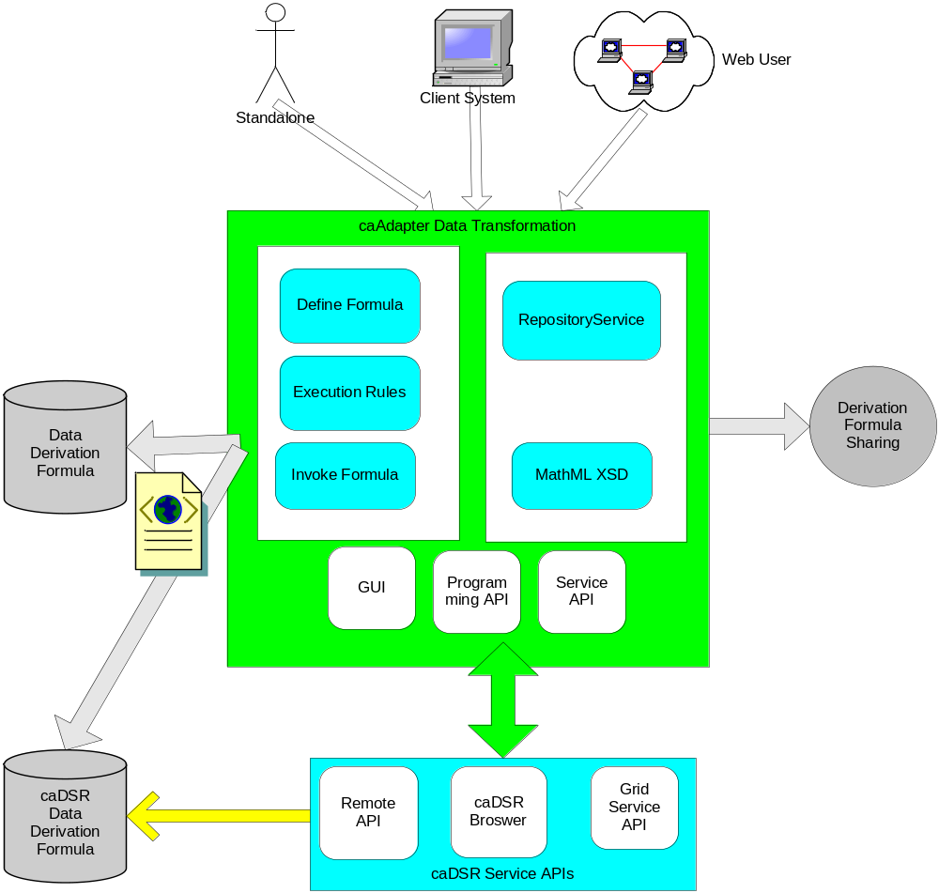

DTS Markup Requirements
The markup requirements of DST derivation formula fall to three categories: algorithm encoding capability, semantic interoperability, and presentation (display) compatibility.
Algorithm encoding capability – be able to encode all required mathematical operations and concepts. – Priority I, mandatory with all operation without any compromise.
Semantic interoperability – be understandable by other information system, software tool, or public acceptable markup language, i.e. all interoperable systems will understand the meaning of formula components (content) unambiguously. --Priority II mandatory for caDSR CDE information, the implementation approaches are adjustable based on resources, timeline, technology, etc.
Presentation compatibility – be able to presentable/displayable by UI software/tools, such as web browser, graphic editor, or applications implemented with public markup standard. For example, if an application is implemented with W3C MathML/standard, it will able to uniquely display a formula defined by caAdapter DTS. -- Priority III, optional but required minimal support .

MathXL Capabilities
The schema of MathML 3.0 defines a mathematical notation (including structure and content) with element “math” which contains zero of more elements with the type of “MathExpression”. The type “MathExpression” has three type choice children elements: “ContExp” encodes formula content, “semantics-contexp” carries semantic annotation statements associate with a formula, and “PresentationExpression” focuses on the display of an equation. The following the segment quoted from MathML 3.0 XSD, the detail information is available in Appendix A:
<xs:element name="math">
<xs:complexType>
<xs:group minOccurs="0" maxOccurs="unbounded" ref="m:MathExpression"/>
<xs:attributeGroup ref="m:math.attributes"/>
</xs:complexType>
</xs:element>
<xs:group name="MathExpression">
<xs:choice>
<xs:group ref="m:ContExp"/>
<xs:element ref="m:PresentationExpression"/>
<xs:group ref="m:semantics"/>
</xs:choice>
</xs:goupp>
<xs:group name="semantics-contexp">
<xs:sequence>
<xs:element name="semantics">
<xs:complexType>
<xs:sequence>
<xs:group ref="m:ContExp"/>
<xs:choice minOccurs="0" maxOccurs="unbounded">
<xs:element ref="m:annotation"/>
<xs:element ref="m:annotation-xml"/>
</xs:choice>
</xs:sequence>
<xs:attributeGroup ref="m:semantics.attributes"/>
</xs:complexType>
</xs:element>
</xs:sequence>
</xs:group>

MathML Content Markup
The element “ContExp” is used in MathML content markup on the mathematically semantic meaning of the express.” The “ContExp” uses child elements covering all different kinds of mathematic operations, components, and relationships. The core of these child elements is the <apply> element to represent a function or operator, given in the first child, applied to the remaining child elements. In other words, “ContExp” represents a mathematical expression with “Polish Notation”[4] of its child elements, which is also known as “prefix notation” that places operators to the left of their operands. For example <apply><sin/><ci>x</ci></apply> represents sin(x) and <apply><plus/><ci>x</ci><cn>5</cn></apply> represents x+5. The <ci> element represents an identifier, <cn> a number, and there are over a hundred different elements for different functions and operators. Content MathML uses only a few attributes.
The expression ax² + bx + c could be represented as
<math>
<apply>
<plus/>
<apply>
<times/>
<ci>a</ci>
<apply>
<power/>
<ci>x</ci>
<cn>2</cn>
</apply>
</apply>
<apply>
<times/>
<ci>b</ci>
<ci>x</ci>
</apply>
<ci>c</ci>
</apply>
</math>

In the prototype of Data Transformation Service, we use <term> element to represent a mathematic expression with “operation” attribute operating on its child elements. The above expression could be represented as:
<term type="expression" operation="addition" name=" addend">
<term type="expression" operation="multiplication" name=”addend”>
<term value="a" type="variable" factor=" factor "/>
<term type="expression" operation="power" name="factor">
<term value="x" type="variable" name="base"/>
<term value="2" type="constant" name="index"/>
</term>
</term>
</term>
<term type="expression" operation="addition" name=”addend”>
<term type="expression" operation="multiplication" name="addend">
<term value="b" type="variable" name="factor"/>
<term value="x" type="variable" name="factor "/>
</term>
<term value="c" type="variable" name="addend"/>
</term>
</term>

The following table provides summary of the features in DTS prototype formula and the capabilities of MathML “ContExp” element.

DTS Protoype Features | MathML ContExp
<expression> | N/A. Possible work-around with <apply> element.
<term> | <apply>
Attribute “type=operation”  And attribute “operation=addition, subtraction, multiplication, division, power…” | <plus>, <minus>, <times>, <divide>, <power>….
Attribute “type=variable” | <ci>
Attribute “type=constant” | <cn>
Attribute “name=…” | Sequence of child elements.

MathML Semantic Markup
MathML use < semantics> element with child <annotation> elements to embed any additional semantic requirements beyond mathematical meaning. Data Transformation Service can adopt the similar approach to carry both semantic information about algorithm and CDE.
DTS Protoype Features | MathML ContExp
Attribute “status=….” | <annotation name=” status” value=”…”/>
Attribute “unit=….” | <annotation name=” unit” value=”…”/>
Attribute “description=…” | <annotation name=” description” value=”…”/>
<parameter> | To Be Done.
Attribute “dataType=….” | <annotation name=” dataType” value=”…”/>
Attribute “usage=….” | <annotation name=” usage” value=”…”/>
Attribute “cdeId =….” | <annotation name=” cdeId” value=”…”/>
Attribute “cdeReference =….” | <annotation name=”cdeReference” value=”…”/>

The following section is quoted from Ki Sung’s report, for detail information, please see attached document.
- Using ‘<semantic>’ block
- Mata data are stored with ‘<annotation>’ tag
- Sample implemented data
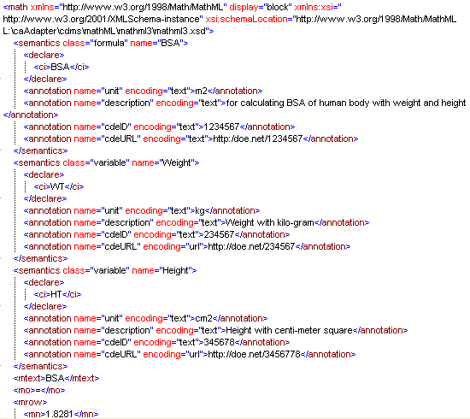

MathML Presentation Markup
Presentation MathML focuses on the display of an equation, and has about 30 elements, and 50 attributes. The elements all begin with m and include token element: <mi>x</mi> - identifiers; <mo>+</mo> - operators; <mn>2</mn> - number. Tokens are combined using layout elements that include: <mrow> - a row; <msup> - superscripts; <mfrac> - fractions. The attributes mainly control fine details of the presentation. A large number of entities are available that represent letters (&pi;), symbols (&RightArrow;) and some non-visible characters such as &InvisibleTimes; representing multiplication. Thus, the expression ax² + bx + c could be represented in a valid MathML file as:
<?xml version="1.0" encoding="UTF-8"?>
<!DOCTYPE math PUBLIC "-//W3C//DTD MathML 2.0//EN"
"http://www.w3.org/Math/DTD/mathml2/mathml2.dtd">
<math xmlns="http://www.w3.org/1998/Math/MathML">
<mrow>
<mi>a</mi>
<mo>&#x2062;<!-- &InvisibleTimes; --></mo>
<msup>
<mi>x</mi>
<mn>2</mn>
</msup>
<mo>+</mo>
<mi>b</mi>
<mo>&#x2062;<!-- &InvisibleTimes; --></mo>
<mi>x</mi>
<mo>+</mo>
<mi>c</mi>
</mrow>
</math>

In the prototype of Data Transformation Service, we leave all the presentation work to UI program to layout a formula. The system and underneath formula XML data do not carry permanent presentation information. The feather still could be deferred for the release beyond 1.0 (?).

Implementation Approach
The following component diagram depicts how the public standard and open source tool will be wired together to form the Data Transformation Service core engine implementing Data Transformation API and Formula Sharing API. Data Transformation API implements the required transformation functionalities using local or public formula defined based on MathML 3.0 specification. The formula sharing API implements functionalities to export local formula for public use or import public formula into the local system.
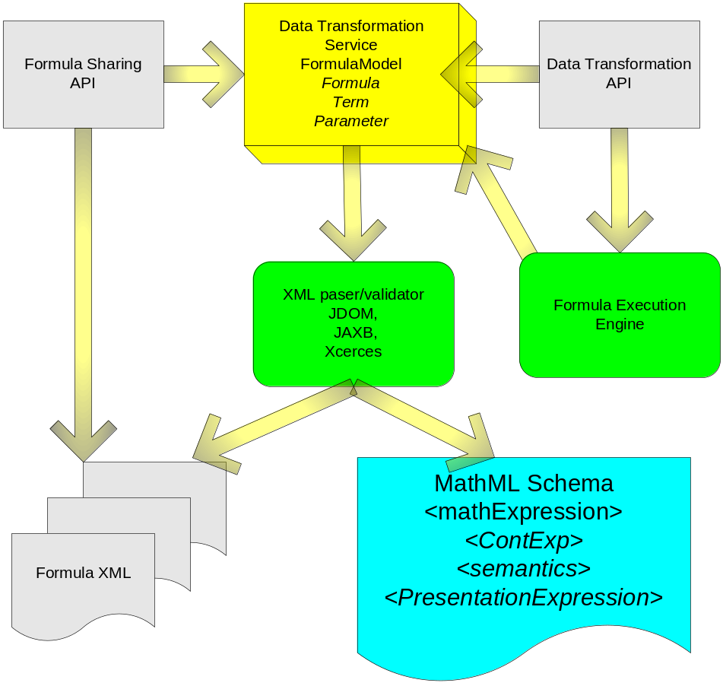

Formula Object Model

Formula Parser

Formula Execution Engine

Data Transformation API

Formula Sharing API

Open Source Software Availability
- Available free software
Following Java based MathML free tools has been studied and analyzed so far for applying to caAdapter DTS. The source codes of these are can be downloaded and with free licenses (GNU or Apache license). Appendix B provides more detailed information.
- DragMath
- JEuclid
- Jasymca
- Comparing Table: Capabilities vs. Tools
Capability |  | Free Tools |  |  | Remarks | Code Availability
 |  | DragMath | Jeuclid | Jasymca | Remarks | Code Availability
Invoke Formula |  | None | None | None |  | No
Define Formula | WYSIWYG Mathematical Editing | Very good | None | None | DragMath | Yes
Define Formula | Formula Viewing | Exist, but viewing is not good | Very Good | None | - It is ideally if editor with nice rendering. However, the mathematical rendering functionality of DragMath looks worse than Jeuclid.  - JEuclid doesn’t support mathematical special tags (e.g. &plus;).  - Jeuclid's MathML viewer includes simple MathML validator | Yes
Define Formula | Generating MathML | Good | Good | None | Jeuclid's MathML viewer includes simple MathML validator. | Yes
Define Formula | Validating MathML | None | Exist | None | Real-time validating, Black fore-color is valid and red is invalid. | Yes
Define Formula | Meta data tagging | None | None | None |  | No
Execution Rules: MathML tester |  | None | None | Support | Jasymca doesn't support MathML directly, but LateX. Both DragMath and Jeuclid can support transforming mathematical format. | Yet studied

Reference
- Mathematical Markup Language (MathML), http://www.w3.org/Math/
- caAdatpter Data Transformation Service, NCI Enterprise Service Integration, Face-to-Face Review Presentation, https://ncisvn.nci.nih.gov/svn/caadapter/trunk/software/cdms/doc/caAdapter_DTS_ESST.PPT
- Computational Independent Model, caAdapter Data Transformation Service, https://ncisvn.nci.nih.gov/svn/caadapter/trunk/software/cdms/doc/ComputationalIndependentModel.doc
- Polish notation, http://en.wikipedia.org/wiki/Polish_notation

Appendix A MathML 3.0 Schema (XSD)
<xs:element name="math">
<xs:complexType>
<xs:group minOccurs="0" maxOccurs="unbounded" ref="m:MathExpression"/>
<xs:attributeGroup ref="m:math.attributes"/>
</xs:complexType>
</xs:element>
<xs:group name="MathExpression">
<xs:choice>
<xs:group ref="m:ContExp"/>
<xs:element ref="m:PresentationExpression"/>
<xs:group ref="m:semantics"/>
</xs:choice>
</xs:goupp>
<xs:group name="ContExp">
<xs:choice>
<!--Ambiguous content model altered (ContExp)-->
<xs:element ref="m:apply"/>
<xs:element ref="m:bind"/>
<xs:element ref="m:ci"/>
<xs:element ref="m:cn"/>
<xs:element ref="m:csymbol"/>
<xs:element ref="m:piecewise"/>
<xs:element ref="m:DeprecatedContExp"/>
<xs:element ref="m:interval.class"/>
<xs:element ref="m:unary-functional.class"/>
<xs:element ref="m:lambda.class"/>
<xs:element ref="m:nary-functional.class"/>
<xs:group ref="m:binary-arith.class"/>
<xs:group ref="m:unary-arith.class"/>
<xs:element ref="m:nary-minmax.class"/>
<xs:element ref="m:nary-arith.class"/>
<xs:element ref="m:nary-logical.class"/>
<xs:element ref="m:unary-logical.class"/>
<xs:element ref="m:binary-logical.class"/>
<xs:element ref="m:quantifier.class"/>
<xs:element ref="m:nary-reln.class"/>
<xs:element ref="m:binary-reln.class"/>
<xs:element ref="m:int.class"/>
<xs:element ref="m:Differential-Operator.class"/>
<xs:element ref="m:partialdiff.class"/>
<xs:element ref="m:unary-veccalc.class"/>
<xs:element ref="m:nary-setlist-constructor.class"/>
<xs:element ref="m:nary-set.class"/>
<xs:element ref="m:binary-set.class"/>
<xs:element ref="m:nary-set-reln.class"/>
<xs:element ref="m:unary-set.class"/>
<xs:element ref="m:sum.class"/>
<xs:element ref="m:product.class"/>
<xs:element ref="m:limit.class"/>
<xs:element ref="m:unary-elementary.class"/>
<xs:element ref="m:nary-stats.class"/>
<xs:element ref="m:nary-constructor.class"/>
<xs:element ref="m:unary-linalg.class"/>
<xs:element ref="m:nary-linalg.class"/>
<xs:element ref="m:binary-linalg.class"/>
<xs:element ref="m:constant-set.class"/>
<xs:element ref="m:constant-arith.class"/>
</xs:choice>
</xs:group>
<xs:group name="semantics">
<xs:sequence>
<xs:element name="semantics">
<xs:complexType>
<xs:sequence>
<xs:group ref="m:MathExpression"/>
<xs:choice minOccurs="0" maxOccurs="unbounded">
<xs:element ref="m:annotation"/>
<xs:element ref="m:annotation-xml"/>
</xs:choice>
</xs:sequence>
<xs:attributeGroup ref="m:semantics.attributes"/>
</xs:complexType>
</xs:element>
</xs:sequence>
</xs:group>

Appendix B Available Resources – free MathML S/W

This tool will be developed based on already exist java based free open source software which are DragMath, JEuclid and Jasymca.

- DragMath
- Developers: Chris Sangwin and Alex Billingsley who are English mathematicians
- Features
- Java Applet based GUI
- WYSIWYG formula editing – easy approach with drag and drop
- Generates various mathematical formats – LaTeX, MathML, Maple, Maxima, Moodle Tex, ASCIIMathML
- Open source - from SouceForge.net
- Screen shot
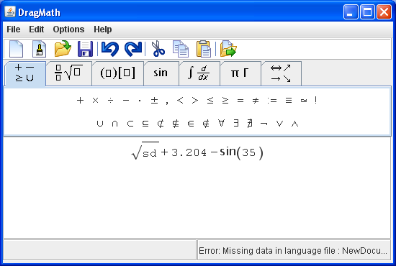

- License: GNU GPL (http://www.dragmath.bham.ac.uk/LICENSE-gpl.txt)
- URL: http://www.dragmath.bham.ac.uk/

- JEuclid
- JEuclid is a complete MathML rendering solution
- Conforms to the MathML Document Object Model Java Binding (http://www.w3.org/TR/MathML2/appendixe.html#dom-bindings.JavaBindings)
- Developers:
- Started as a subproject from BMBF project (www.vs-c.de) in Germany.
- Became one of W3C consortium
- Features and components
- Open source from SourceForge.net
- A MathViewer application
- Command line converters from MathML to other formats
- An ant task for automated conversion
- Display components for AWT, Swing, and SWT
- Screen shot
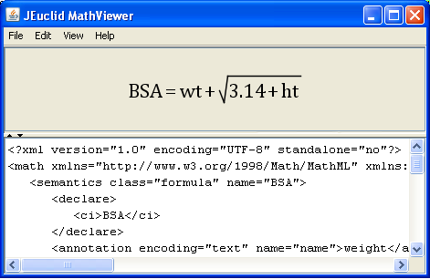

- License: Apache License (http://www.apache.org/licenses/)
- URL: http://jeuclid.sourceforge.net/

- Jasymca
- Java Symbolic Calculator
- Developer: Helmut Dersch who is a German Mathematician
- Features
- Mathematical calculation
- Support various format – Maxima, LateX
- But not support MathML directly
- Screen shot
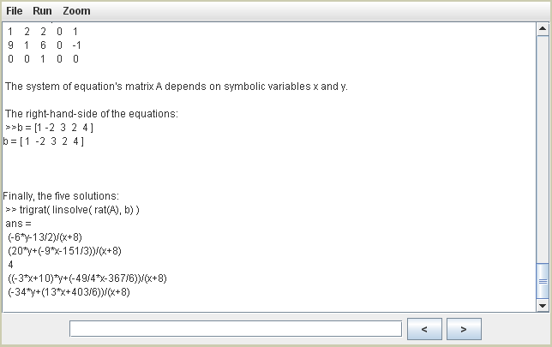

- License: GNU GPL
(http://webuser.hs-furtwangen.de/~dersch/jasymca2/Jasymca2en/node77.html )
- URL: http://webuser.hs-furtwangen.de/~dersch/jasymca2/indexEN.html

