Service Use Case Description
Scientific algorithm Service
Version 0.1
May 31, 2011
Project Lead | Eugene Wang –SAIC Frederick  Sudha Chudamani –SAIC Frederick
Authors | Eugene Wang –SAIC Frederick  Ki Sung Um – SAIC Frederick  Dianne Reeves – NCI CBIIT

DOCUMENT REVISION HISTORY
Version Number | Date | Description
0.1 | 25-April-11 | - Initial Draft
0.2 | 31-May-11 | - Update: Dianne Reeves

Background/Summary
This document contains the use cases for the Scientific Algorithm Service (caSAS) module. It provides the following capabilities:
- Formula management service: It enables users to manage derivation formulae with graphic user interface (GUI). It describes mathematical formula with Mathematical Markup Language, or MathML, which is recommendation of the W3C math working group.
- Formula XML sharing service: It is a distributed XML data repository which enables enterprise service systems or information applications to share formulae.
- Data derivation service: It generates a data value from one or more contributing data values using predefined derivation formula.
Table of Content
Background/Summary 3
1 Introduction 5
1.1 Overview 5
1.2 Related Documents 5
2 Actors and Goals 5
2.1 Metadata Curator 5
2.2 System Analyst 5
2.3 Application Developer 6
2.4 External System 6
3 Use Cases 6
3.1 Formula Management Service 6
3.2 Formula Sharing Service 7
3.3 Formula Import and Export Service 9
3.4 Data Derivation Transformation 12
3.5 Data Mapping and Derivation Transformation 13
3.6 Algorithm Validation 15
3.7 Batch Data Processing 17
3.8 Deploy Web Application 19
3.9 Deploy Web Service 20
3.10 Integration with Computational Engine 21
3.11 Others 22
4 Overall Requirements 24
5 Requirements Prioritization 24
6 Data Definition 24
7 Reference 24
8 Sign Off 24

Introduction

Overview
caBIG community users have expressed keen interest in having a service to create mathematical formulae for data derivation transformation to get desired output using raw data from various means such as, data warehouse, online collection or information system. The Scientific Algorithm Service module is a set of loosely-coupled capabilities which manage data derivation algorithm (formula) and provide derivation transformation service. It will extend caAdapter’s mapping and transformation capabilities to develop standards-based infrastructure tools in facilitating medical research data exchange. It includes the following service components (agents):
- Formula management service: It enables users to manage derivation formulae with graphic user interface (GUI). It describes mathematical formula with Mathematical Markup Language^{[1]}, or MathML, which is recommendation of the W3C math working group.
- Formula sharing service: It is a distributed XML data repository which enables enterprise service systems or information applications to share formulae.
- Data derivation service: It generates a data value from one or more contributing data values using predefined derivation formula.
This Use Case Description Document captures the major use cases for Scientific Algorithm Service from user community.

Related Documents
- Service Scope Description: Scientific Algorithm Service

Actors and Goals
An actor is a person, organization, or external system that plays a role in one or more interaction with Scientific Algorithm Service module. The following is a list of Actors that interact with this module:

Metadata Curator
This actor validate algorithm and that the input data element are present in caDSR.

System Analyst
This actor executes derivation formulae maintained by Scientific Algorithm Service to generate result values from existing data values.

Application Developer
This actor is responsible for developing medical application using functionalities of formula managements and data derivation transformation.

External System
This actor represents any external system that interacts with the Scientific Algorithm Service module using its programming APIs or web service APIs.

Use Cases

Formula Management Service
- Use Case Model
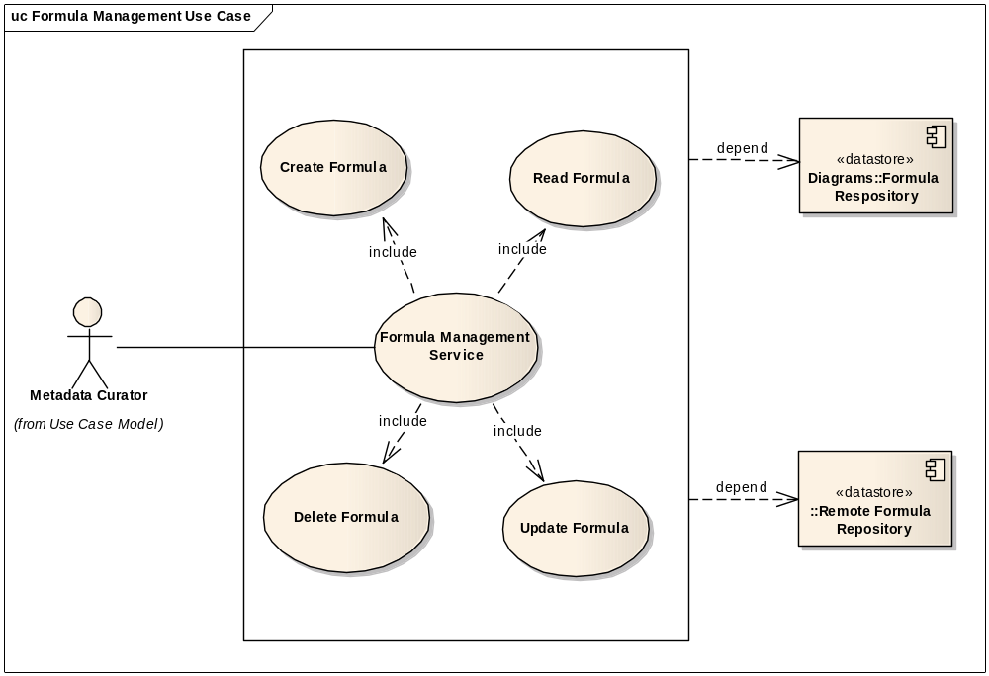

- Brief Description
A Metadata Curator derives a new data element from one or more known data elements based on given scientific algorithms.
This use case covers managing formula actions: create a new formula, read existing formula, update existing formula, and delete outdated formula.
- Primary Actor
Metadata Curator
- Preconditions
- Derivation algorithm is defined.
- Source data elements are identified and annotated with caDSR.
- Derived data element is not registered with caDSR.
- Basic Flow of Events
- Alternative Flow
- Post Conditions
- Special Requirements
- ID and version of the input elements
- Source of the rule (algorithm) used
- Sequence or of variables that define how each variable is used in the algorithm
- Detail about the intended use or audience of the resulting derived variable, like “standard Post-BMT dosing calculation for CIBMTR trials”.

Formula Sharing Service
- Use Case Model
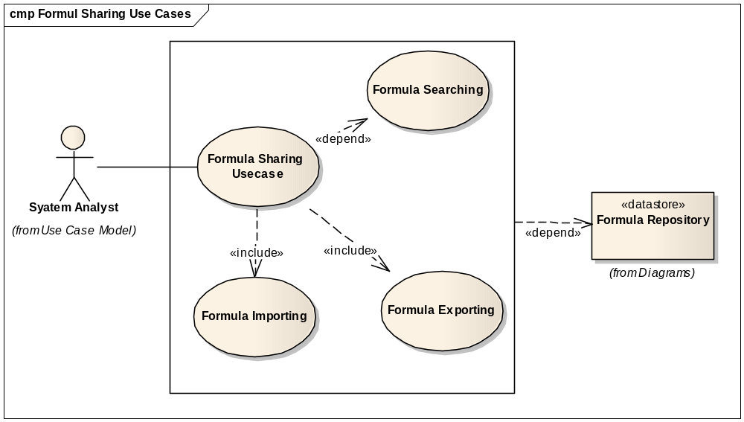
- Brief Description
A System Analyst finds one or more derivation formulae implementing the required algorithm. The System Analyst extracts the found formulae from source formula management system and imports them into local formula management system.
This use case covers formula sharing actions: formula searching, formula exporting, and formula importing.
- Primary Actor
System Analyst
- Preconditions
- Derivation algorithm is defined.
- Interested formula repositories are identified either locally or remotely.
- Basic Flow of Events
- User launches the Scientific Algorithm Service module formula searching UI
- User provides searching parameters.
- System searches formula against target formula repositories.
- System found the interested formulae in one or more formula repositories.
- User launches the Scientific Algorithm Service module formula exporting UI
- System exports the derivation formulae from source formula repositories as xml data.
- Optionally, user launches the Scientific Algorithm Service module formula importing UI
- System imports the formula xml data into local formula repository.
- Alternative Flow
User may get the interested formulae xml from trusted source. These xml data may be prepared using third party xml editing tool based on the schema of formula xml.
- Post Conditions

Success Condition
- Derivation formula xml data is exported from source formula repository.
- Optionally, Derivation formula xml data is imported into local formula repository.

Error Condition
- Fail to find interested derivation formula.
- Or failed to import formula xml into formula repository.
- Special Requirements
Public standard, such as MathML, is mandatorily required for formula description. It works as the foundation of formula semantic interoperability.

Formula Import and Export Service
- Use Case Model
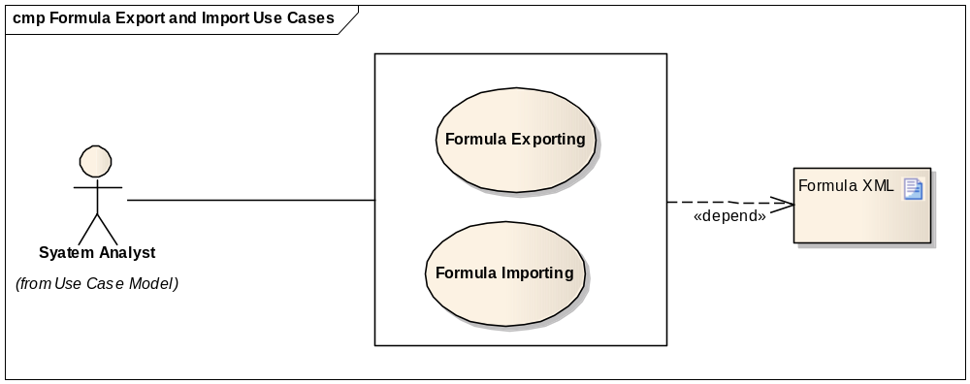
- Brief Description
A System Analyst could export one or formula to be used by other Scientific Algorithm Service instance or any computational engine. Alternatively, a System Analyst may import a formula into Scientific Algorithm Service; the formula has been defined and tested by other computational engine.
This use case covers formula sharing actions: formula exporting and formula importing.
- Primary Actor
System Analyst
- Preconditions
- Interested formula repositories are identified for exporting/importing.
- Basic Flow of Events
- User launches the Scientific Algorithm Service module formula exporting UI
- System exports the derivation formulae from source formula repositories as xml data.
- Alternative Flow
  - Optionally, user launches the Scientific Algorithm Service module formula importing UI
  - System imports the formula xml data into formula repository.
User may get the interested formulae xml from trusted source. These xml data may be prepared using third party xml editing tool based on the schema of formula xml.
- Post Conditions

Success Condition
- For formula exporting, derivation formula xml data is exported from source formula repository.
- For formula importing, derivation formula xml data is imported into local formula repository.

Error Condition
- Failed to export formula from local formula repository into xml
- Or failed import formula xml into formula repository.
- Special Requirements
Public standard, such as MathML, is mandatorily required for formula description. It works as the foundation of formula semantic interoperability.

Data Derivation Transformation
- Use Case Model
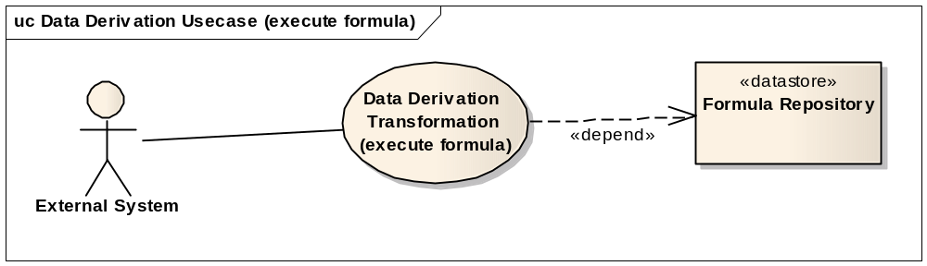
- Brief Description
User executes a derivation formula and generates a result data value using source data values as input parameters of the derivation formula.
This use case covers using derivation formula from either local formula repository or remote formula repository.
- Primary Actor
Systems Analyst
- Preconditions
- The derivation formula is defined and valid.
- Data values are set for all formula input parameters.
- Basic Flow of Events
- User launches the Scientific Algorithm Service module to search and identify a derivation formula.
- User prepares data values for all formula input parameters.
- The transformation engine executes the derivation formula using provided parameters.
- The transformation engine generates result value.
- Alternate Flow
N/A
- Post Conditions

Success Condition
The result data value is ready for further business uses. User optionally processes the result for further business.
  - Error Condition
The system fails in calculating result with given parameter values.
- Special Requirements
N/A

Data Mapping and Derivation Transformation
- Use Case Model
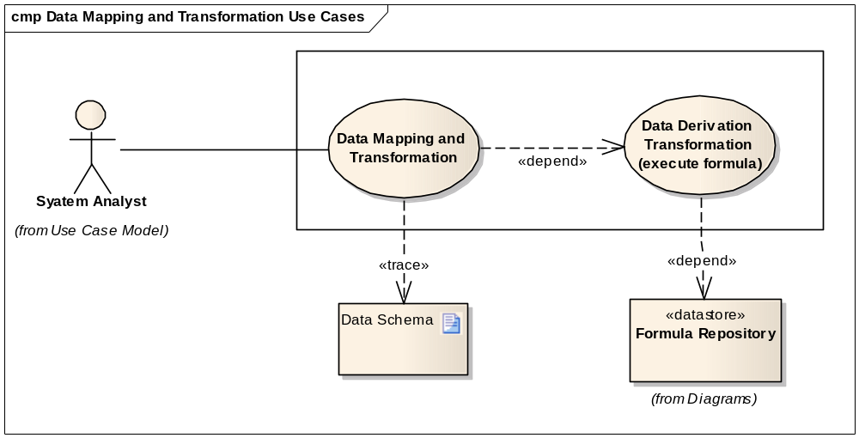
- Brief Description
User executes a derivation formula and generates a result data value using source data values as input parameters of the derivation formula, but the source data formats do not match the formats of the formula input parameters.
This use case involves two transformation steps: Data Mapping Transformation; Date Derivation Transformation.
- Primary Actor
Systems Analyst
- Preconditions
- The derivation formula is defined and valid.
- Data values are set for all formula parameters.
- Metadata of source data is ready.
- Basic Flow of Events
- User launches the Scientific Algorithm Service module to search and identify a derivation formula.
- User map source data schema to the schema of formula input parameters
- User prepares data for all formula parameters.
- The transformation converts the input data into the format of formula input parameters.
- Transformation engine executes the derivation formula using converted data set.
- The transformation engine generates result value.
- Alternate Flow
N/A
- Post Conditions

Success Condition
The result data is ready for further business uses. User optionally processes the result for further business.
  - Error Condition
The system fails in calculating result with given parameter values.
- Special Requirements
N/A

Algorithm Validation
- Use Case Model
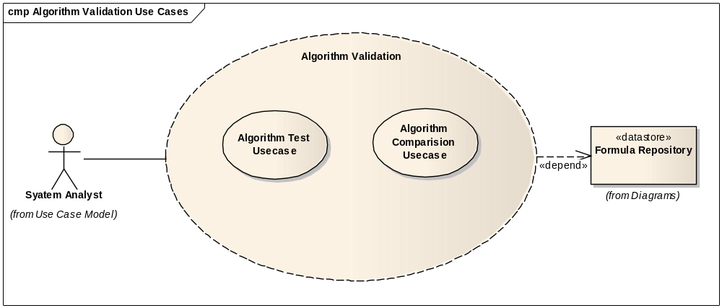
- Brief Description
User runs data derivation transformation functionalities of Scientific Algorithm Service module using one or more algorithms available. (Quantitative Imaging Network team may provide detailed information for this use case).
This use case covers algorithm testing and algorithm comparison. The algorithm testing enable user to execute the formula again and again with multiple data sets and validate the results. The algorithm comparison enable user to execute multiple formulae with the same data set and compare the results.
- Primary Actor
Systems Analyst
- Secondary Actor
N/A
- Preconditions
- Derivation formulae are identified.
- Testing data sets are provided.
- Basic Flow of Events
            - User launches the Scientific Algorithm Service transformation UI
            - User executes the derivation formula with testing data sets provided
            - Transformation engine generates result data element for each execution.
            - User prepares testing report or comparison report using transformation results.
- Alternate Flow
For algorithm testing, user may create testing script to invoke the transformation programming API or web service API and generate testing report.
- Post Conditions
- Success Conditions
    - Result element is generated for each formula execution.
    - User is able to prepare algorithm validation report using transformation result data elements.
- Error Conditions
- Failed to execute formula with given one or more data elements
- Invalid format of result is generated.
- Special Requirements
Programming skill may be required to use Scientific Algorithm Service programming APIs or web service APIs.

Batch Data Processing
- Use Case Model
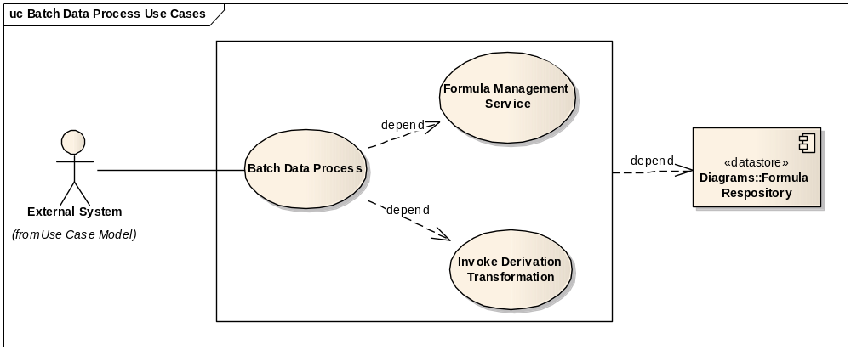
- Brief Description
In this scenario, use builds a system processing batch data, which invokes derivation transformation. The same derivation formula is executed again and again using source data from process pipe line. After each execution, the generates data value is forwarded to downstream work flow step.
This use case covers batch data processes both using Scientific Algorithm Service programming APIs and using web service APIs.
This use case depends on success of Formula Management Service use case and Data Derivation Transformation use case.
- Primary Actor
External System
- Secondary Actor
Application Developer
- Preconditions
- Derivation formula is identified.
- Derivation formula is tested and valid using test data sets.
- Basic Flow of Events
- User develops data process script invoking data derivation transformation functionalities of Scientific Algorithm Service.
- User tests the data process script using testing data sets.
- Result set with one or more results data elements is generated.
- Integrate data process script with system work flow.
- The data process script run in batch automatically.
- Alternate Flow
User may manually invoke the data process script on demands, which generates result data sets for final reports.
- Post Conditions
- Success Conditions
- Result data set is successfully generated and ready for following data processing steps.
- Error Conditions
- Failed to invoke data transformation functionalities of Scientific Algorithm Service.
- Invalid data set is generated.
- Special Requirements
User may require enough programming skills in developing batch data processing script and invoke data transformation functionalities of Scientific Algorithm Service.

Deploy Web Application
- Use Case Model
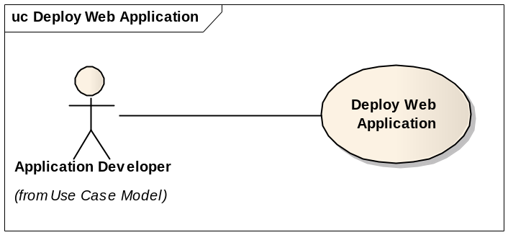
- Brief Description
This use case covers deploying the Scientific Algorithm Service module as a web application. The web server processes all client requests and invokes data derivation transformation service functionalities.
- Primary Actor
Application Developer
- Secondary Actor
System Analyst
- Preconditions
- The Scientific Algorithm Service application is implemented, tested and packed.
- Persistent data repository (database or file system) is ready for data derivation formula xml data.
- Basic Flow of Events
- Setup and configure system as required by Scientific Algorithm Service module.
- Setup up data repository (database or file system) for data derivation formula xml data.
- Install third party software required by the application. For example, unzipping software is required to extract the application package.
- Install the application following application installation guide.
- Verify installation following application installation guide.
- Alternate Flow
- Setup application server or web server for web deployment.
- Verify installation from web client.
- Post Conditions
- Success Conditions
The application is ready for local users or web client users
- Error Conditions
Any deployment error or post-deployment error
- Special Requirements
N/A

Deploy Web Service
- Use Case Model
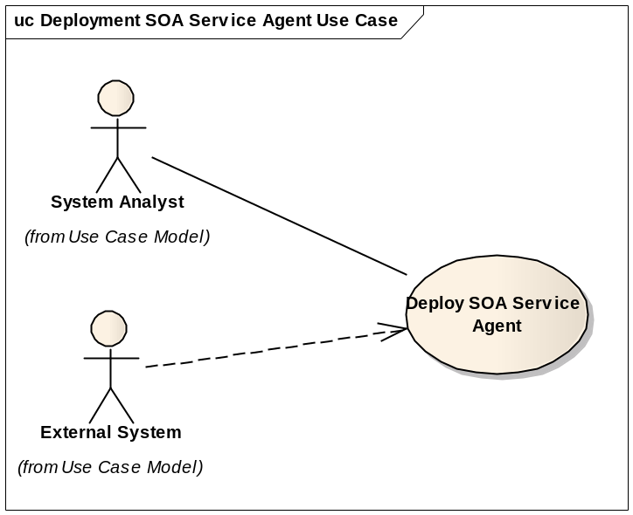
- Brief Description
This use case covers deploying the Scientific Algorithm Service module as web service. The application is implemented in the manner of “build once, run anywhere”. User is able to deploy it over any web service infrastructure.
- Primary Actor
Application Developer
- Secondary Actor
External System
- Preconditions
- Web service infrastructure is ready
- The Scientific Algorithm Service is implemented, tested and packed.
- Persistent data repository (database or file system) is set for data derivation formula.
- Basic Flow of Events
- Setup and configure web service infrastructure ready for deploying new service agent
- Deploy Scientific Algorithm Service module following the deploy process required by the underneath web service infrastructure server.
- Verify deployment from web service infrastructure server.
- Verify deployment by accessing the service access point using service contract (WSDL).
- Alternate Flow
N/A
- Postconditions
- Success Conditions
The web service is ready to process service request. External System send service request and get service response through the service access point.
- Error Conditions
- Failed in deployment to web service server
- Failed to send service request to the service
- Special Requirements
N/A

Integration with Computational Engine
- Use Case Model
TBD
- Brief Description
This use case covers possibility to integrate Scientific Algorithm Service with other computational engine (commercial or non-commercial), such as Wolfram Alpha^{[2]}.
- Primary Actor
Application Developer
- Secondary Actor
External System
- Preconditions
- TBD
- Basic Flow of Events
- TBD
- Alternate Flow
N/A
- Postconditions
Success Conditions
TBD
Error Conditions
TBD
- Special Requirements
N/A

Others
- Use Case Model
TBD
- Brief Description
Open to define other use cases.
- Primary Actor
TBD
- Secondary Actor
TBD
- Preconditions
- TBD
- Basic Flow of Events
- Xxx
- ….
- Alternate Flow
N/A
- Postconditions
- Success Conditions
TBD
- Error Conditions
- TBD
- Special Requirements
TBD

Overall Requirements
TBD

Requirements Prioritization
TBD
Priority | Use Case Name | Supp Requirement Ref #

Data Definition
Formula XML – an xml document describes a mathematical formula syntactically and semantically based on standard such as MathML.
Parameter – a caDSR registered and annotated VDE element working as a formula input.

Reference
      - Mathematical Markup Language (MathML), http://www.w3.org/Math/
      - Wolfram Alpha, Computational Knowledge Engine, http://www.wolframalpha.com/

Sign Off

- Approval

Workspace General Contractor Rep Print Name Date
Architecture Workspace Rep Print Name Date
VCDE Workspace Rep Print Name Date
Workspace Working Group Rep Print Name Date
NCICB Rep Print Name Date

