Mapping database to SDTM (define.xml)

  - Step 1:

Create a New Profile using this window by providing all the fields

“File>New>SDTM Mapping and Transformation Service>CSV to SDTM map specification>Choose Database>New Profile”

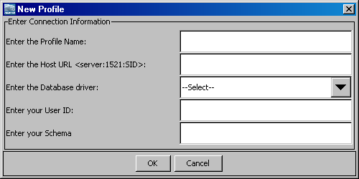

  - Step 2:

Choose the profile you just created to login to the database by typing the password and hit ‘Enter’ key

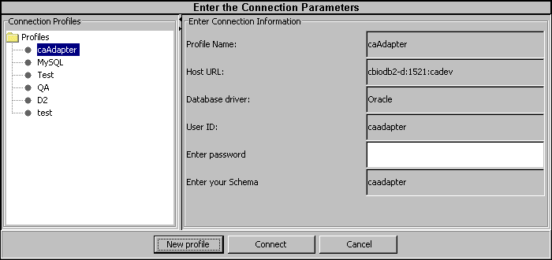

  - Step 3:

You will see this window below with the Database information on the left hand side displaying all the tables and views

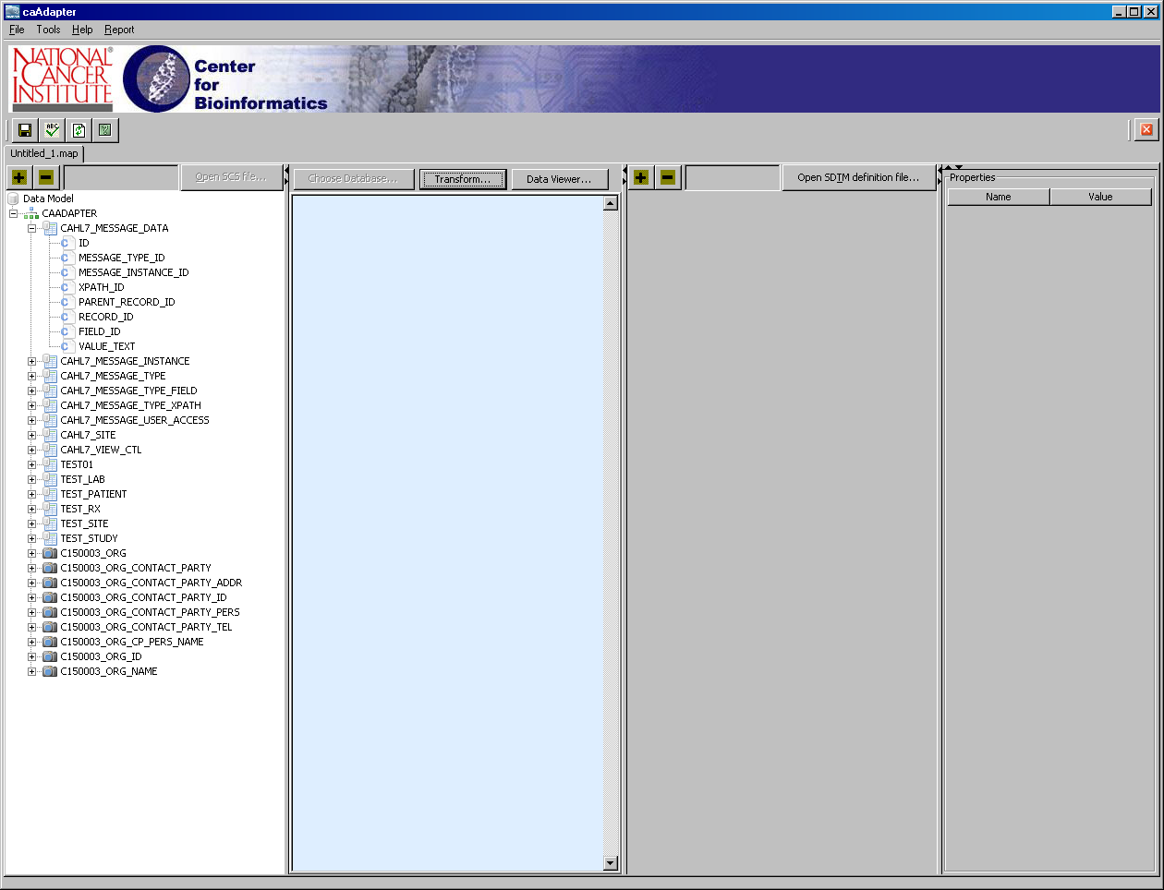

  - Step 4:

Click on the Open SDTM definition file opens a file browse and choosing the define.xml will display as shown below

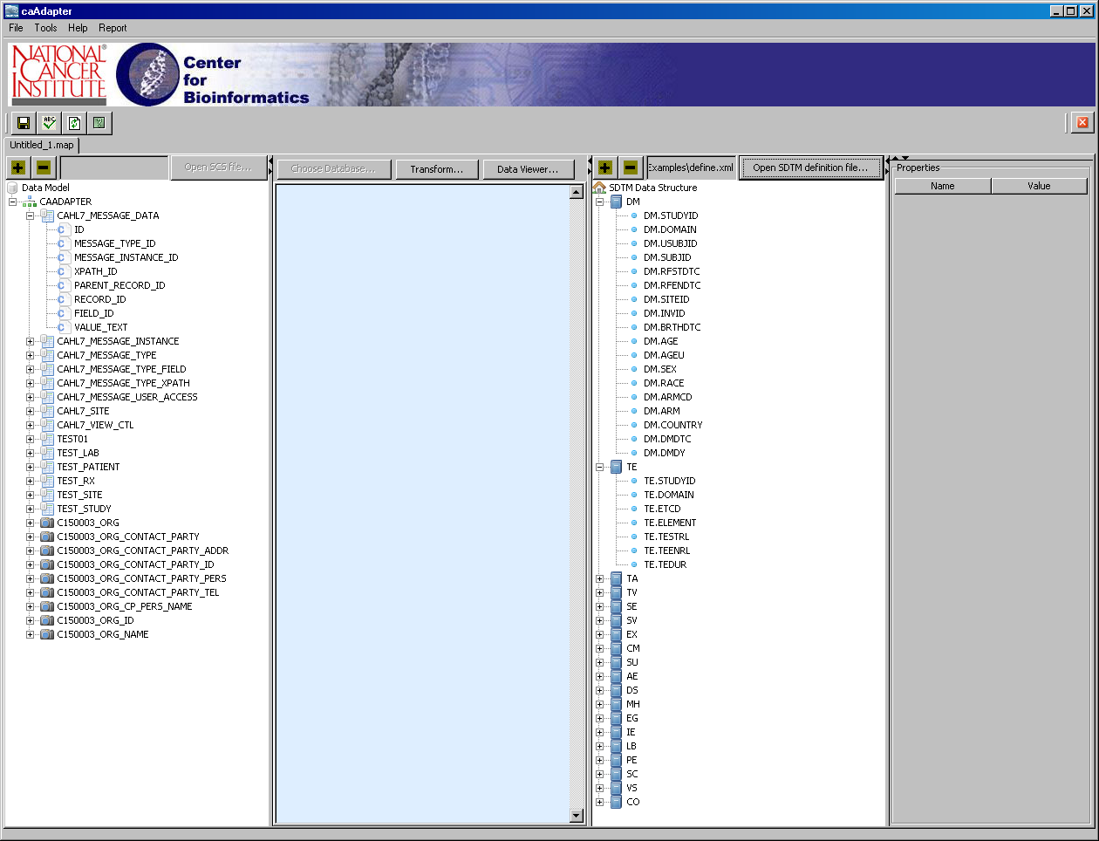

  - Step 5:

Do the mappings from the source to the target as shown below by drawing the lines from database to the domains.

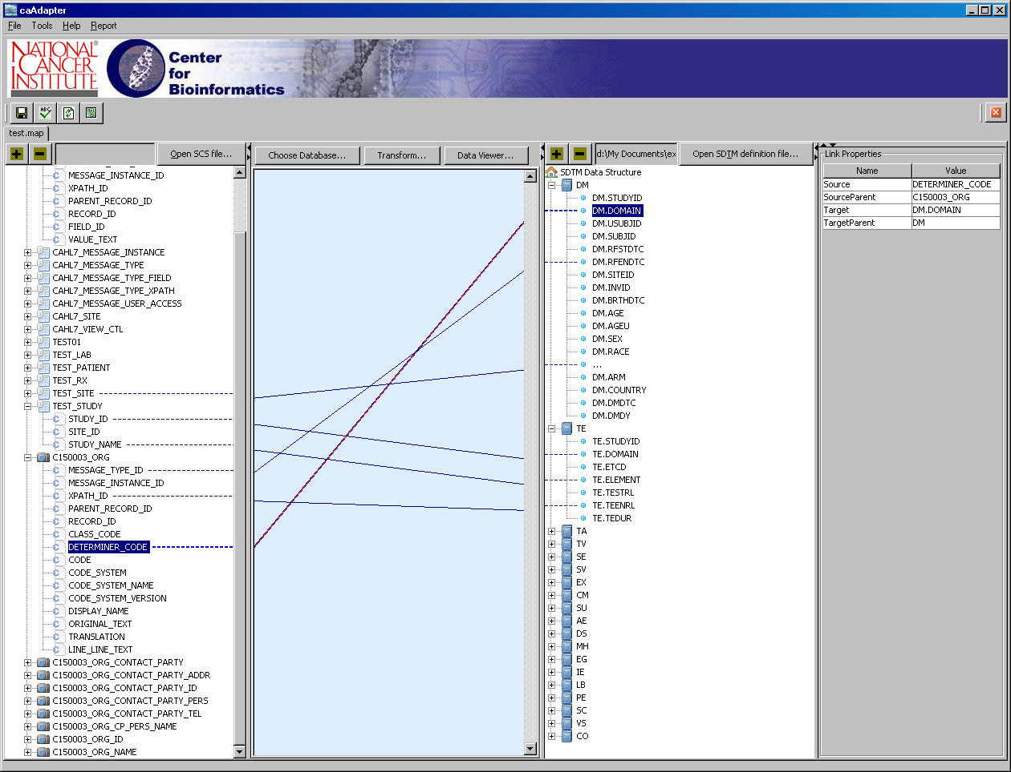

  - Step 6:

Once the mapping is complete and the user successfully saves the mapping information, the user is presented with dialog box as shown below.

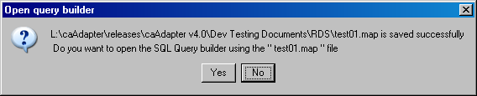

  - Step 7:

When the user chooses ‘Yes’, the Data Viewer window loads following the dialog box below

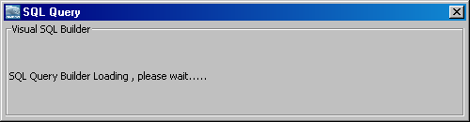

  - Step 8:

The data viewer window looks as shown below, the user can perform drag and drop to draw lines and generate a SQL query

The user can modify sql query (add more tables), run query & validate the query

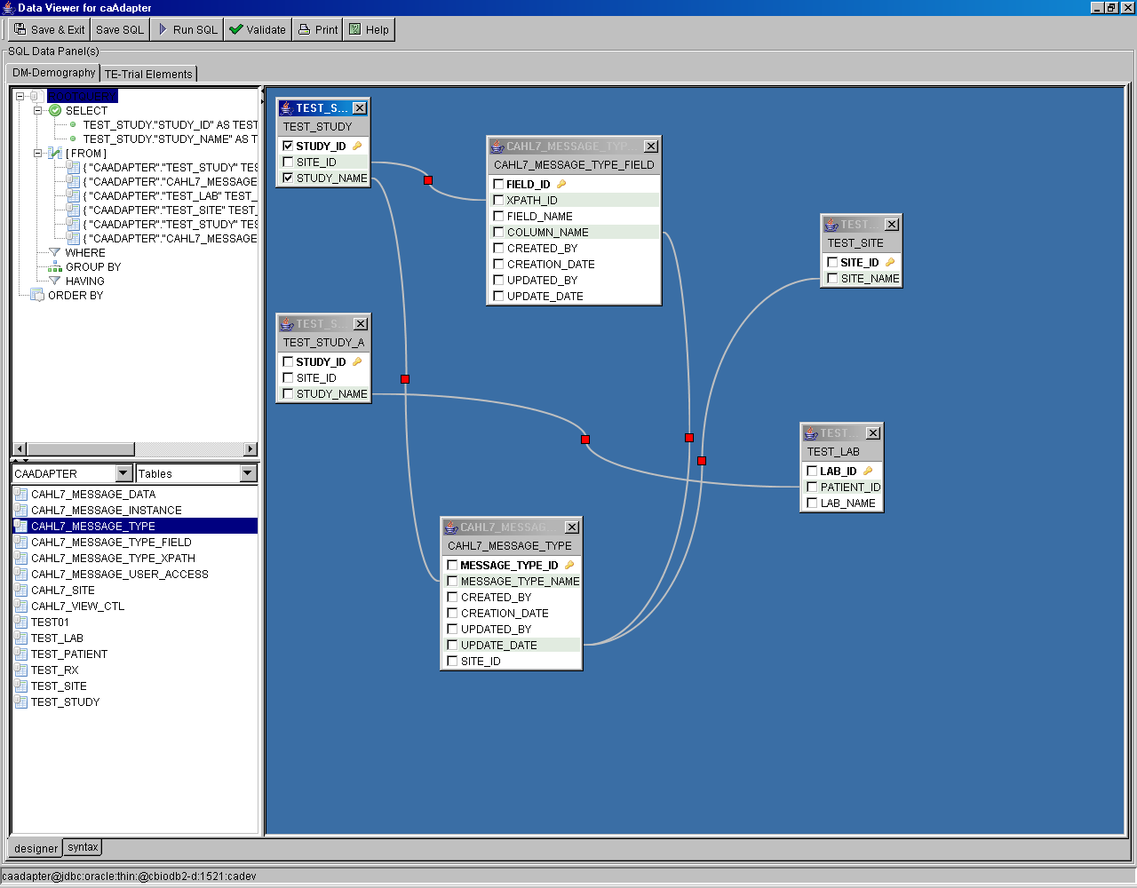

  - Step 9:
The user can review the sql by using the syntax tab (lower left hand corner)

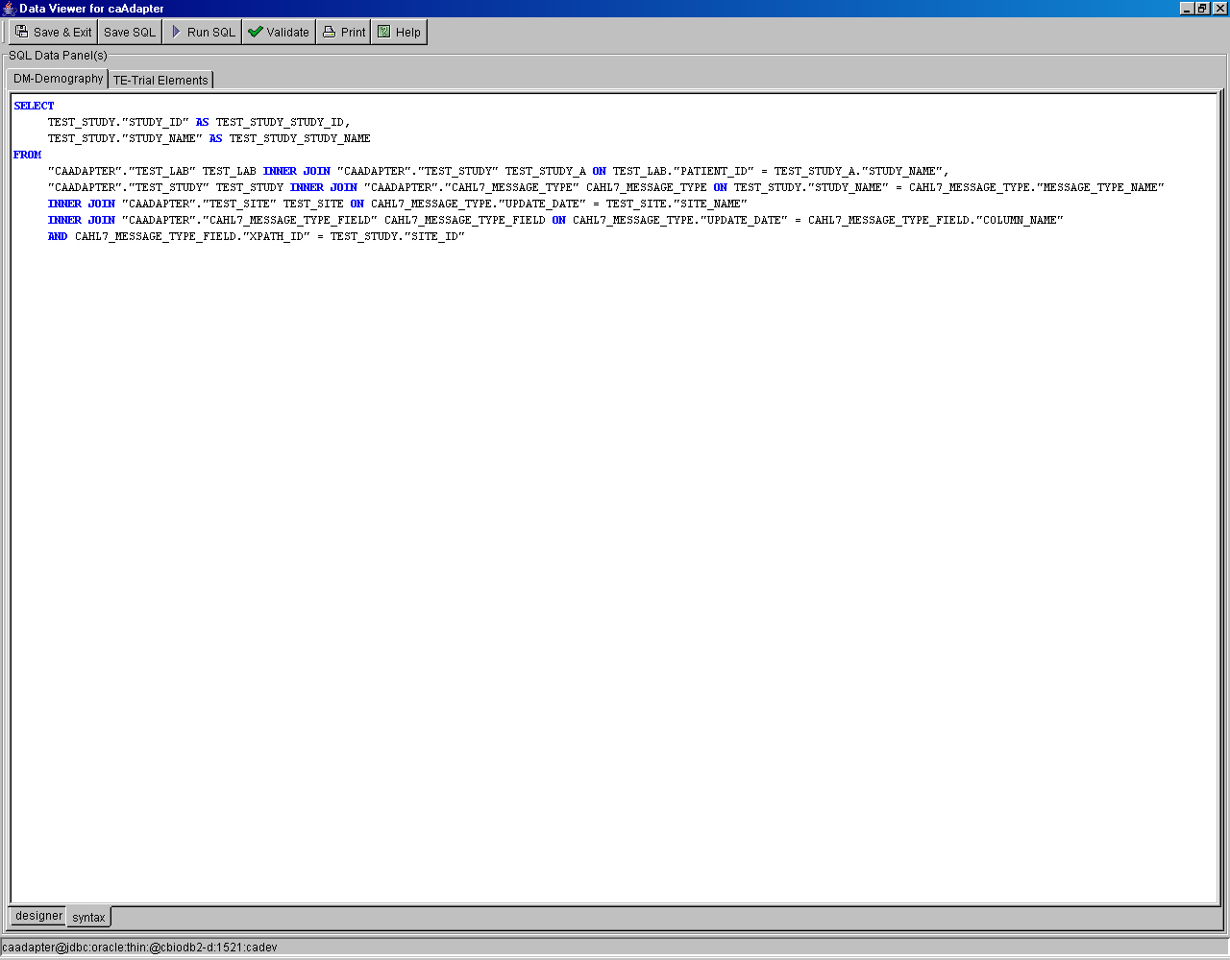

  - Step 10:

To save the SQL’s and exit, go to each domain tab and click on save sql until the “Save & Exit” button is enabled. Clicking on this will save the map file with SQL’s and closes the window.

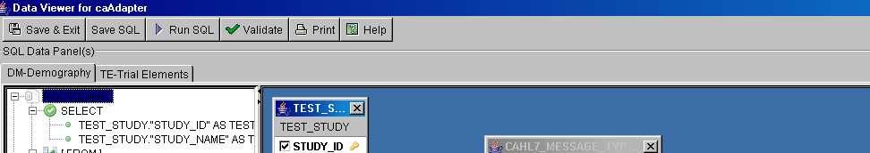

  - Step 11:

If the user tries to close the window by clicking on ’X’, this dialog appears. Which means that the user needs to go each tab and click on Save button.

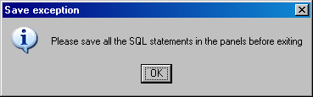

  - Step 12:

Upon choosing ‘Yes’ to the dialog box below, the generated SQL’s are saved in the map file.

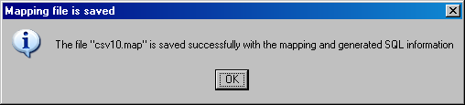
  - Step 13:

For the transformation the user clicks on the ‘Transformation’ button and the browse window appears

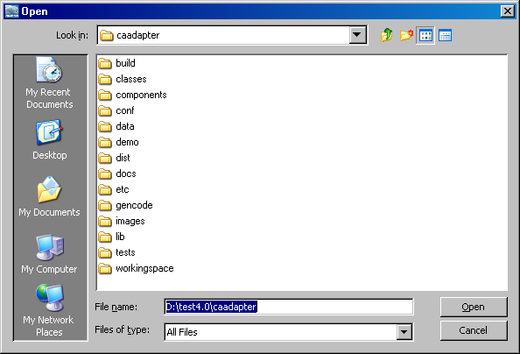

  - Step 14:

The user may choose fixed length records to be written out

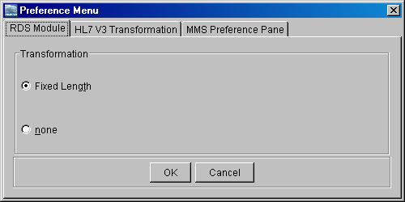
If the preference menu is checked for fixed length records then the following window appears before the transformation begins

  - Step 15:

To open a map file

“File>Open>CSV to SDTM map specification” using the menu bar.

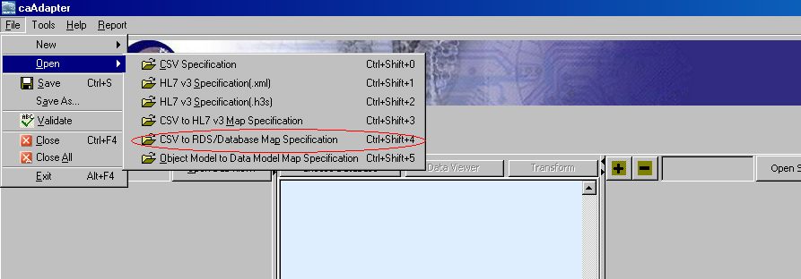

  - Step 16:

A enter password window appears as shown below

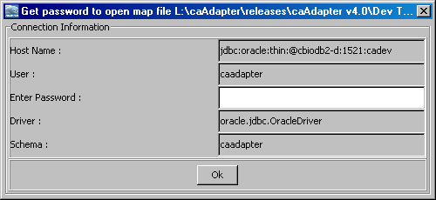

If a connection already exists then the password is auto filled

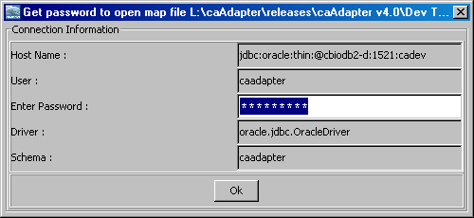

Click on enter and the panel displays with the mapped information

  - Step 17:

Transformation can be done using the ‘Transformation’ button and
And clicking on ‘Data Viewer’ button displays a pop as shown below

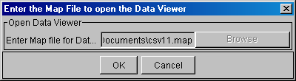
Additional Notes:

The open map action is context sensitive, in that it can dynamically determine if the file is SCS or Database map file and set the behavior accordingly.

When a map file is provided as an input to create RDS text file action, either a provide password for the database connection (see Figure b) or provide input parameters for creating text file (see Figure a) using CSV data appears.

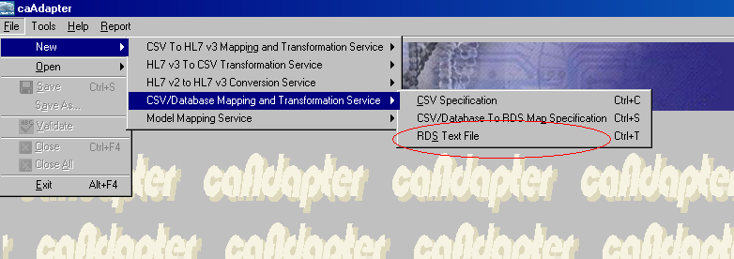

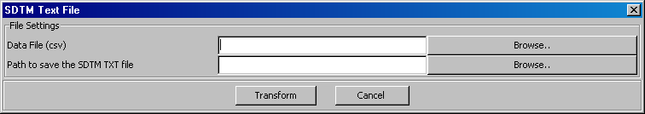
Figure a.

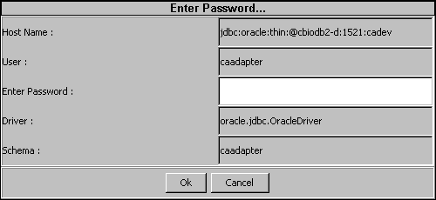
Figure b.

Known Limitations:

- If a transformation is requested and if the result set runs into millions and millions of rows, it may take a while.
  - The best way to deal with this is to check the number of row count the sql has by using toad or dbvisualizer.
  - The user can navigate to the folder where the txt files are created and can refresh the window explorer by clicking on ‘F5’ to check if the file is being updated.
- The exception displayed to the user may not be adequate.
- With help of testing and QA testing the exception reported to the screen needs to be improved.

