caBIG® Platform Independent Model and Service Specification

Adverse Event Management Service

0.5.6

February 21, 2011

Authors | Srini Akkala
Editors | Denis Krylov, Paul Baumgartner, Jessica Pritchard
Reviewers | ESST
Architecture Inception Team | Kalpesh Patel, Christo Andonyadis

Version Number | Date | Contributor | Description
0.0.2 |  | Harsh Marwaha | Updated based on changes to the CFSS.
0.0.3 |  | Kunal Modi  Harsh Marwaha | Updated based on the 0.1.4v of AE CFSS
0.0.4 |  | Harsh Marwaha  Kunal Modi | Updated based on review with caAERS team and Michele Ehlman. Also removed the retrieveExpectedAdverseEvents method.
0.1.0 | 01/13/2010 | Kunal Modi | Converted to new Template
0.1.1 | 01/22/2010 | Kunal Modi | Incorporated changes to the Reporting Section for CTEP Requirements
0.1.2 | 01/22/2010 | Kunal Modi | Added Update AE Report based on input from Paul Baumgartner
0.1.3 | 01/28/2010 | Kunal Modi | Incorporated internal ESST team’s review comments
0.1.4 | 02/03/2010 | Kunal Modi | Updated after review with caAERS team and also to reflect changes to the CFSS
0.5.0 | 10/10/2010 | Srini Akkala | Re-authored to correspond with rewrite of the CFSS
0.5.1 | 11/18/2010 | Paul Baumgartner | Minor modifications made
0.5.2 | 12/10/2010 | Srini Akkala  Paul Baumgartner | Modifications made in response to ESST review.
0.5.3 | 12/23/2010 | Srini Akkala | Modifications made in response to changes to the PSMSS.
0.5.4 | 01/13/2011 | ESST | Modifications made regarding inputs and output standards.
0.5.5 | 01/19/2011 | Srini Akkala | Modifications made in response to ESST review.
0.5.6 | 02/21/2011 | Paul Baumgartner | Modifications made in response to ESST review.

TABLE OF CONTENTS

1 Introduction 4
1.1 Overview 4
1.2 Relationship to Standards 4
1.3 Relation to the Adverse Event Management Conceptual Functional Service Specification 4
1.3.1 Conformance and Compliance 5
2 Platform Independent Model and Service Specification 6
2.1 Overview and Architecture 6
2.2 Implementation Considerations 6
2.2.1 Assumptions 7
2.2.2 Deployment Considerations 7
2.2.3 Jurisdictional Domains 7
2.3 Information Model 9
2.3.1 AdverseEvent Type 9
2.3.2 Adverse Event Implementation model 11
2.3.3 Error Implementation Model 15
2.4 Control Data Type Definitions 15
2.4.1 Status/Return Values/Exceptions 15
2.4.2 Error Codes 15
3 Interfaces 17
3.1 UML Model of Interfaces 17
3.2 Operations (Enumeration) 19
3.3 Operation Behavior Descriptions 20
3.3.1 AEQuery Interface 20
3.3.2 AEManagement Interface 22
3.3.3 AEAssociation Interface 24
3.3.4 AENotification Interface 28
3.3.5 AEReview Interface 29
3.3.6 AEProtocol Interface 31
3.3.7 AEAdvancedQuery Interface 38
3.3.8 AEEvaluate Interface 41
4 Dynamic Model 42
5 Profiles 43
5.1 Functional Profiles 43
5.2 Semantic Profiles 46
6 Relationship with other services 48
7 Conformance Statements 50
8 Appendix A - References 52
9 Appendix B - Glossary 53
10 Appendix C - Cross Reference Tables 54
10.1 Interface to Profile Mapping 54
10.2 Interface Operations to Profile Operations 54

Adverse Event Service Platform Independent Model and Service Specification

Introduction

Overview
The Adverse Event Management Service provides a standardized set of interfaces to record, manage, query, and obtain adverse event records within the clinical trial space and healthcare delivery space. For its representation, it uses a constrained AdverseEvent class from the NCI version of BRIDG 3.0.2 (http://gforge.nci.nih.gov/frs/?group_id=342) and ISO 21090 data types (http://gforge.nci.nih.gov/frs/download.php/3819/ISO_21090_20080317.pdf). Thus, the semantics of the Adverse Event Management Service’s AdverseEvent representation are directly conformant to the BRIDG 3.0.2 and ISO 21090 data types.

Relationship to Standards

Standards | Description
BRIDG v3.0.2 | Service conforms to NCI’s version of BRIDG v3.0.2
HL7v3 | Service conforms to NCI’s HL7V3 RIM
ISO 21090 | Service conforms to NCI’s version of ISO 21090 data types

Relation to the Adverse Event Management Conceptual Functional Service Specification

Conceptual Functional Service Specification Name | Conceptual Functional Service Specification Version | Description & Link to the Conceptual Functional Service Specification
Adverse Event Conceptual Functional Service Specification | 0.5.0 | https://ncisvn.nci.nih.gov/svn/caaersappdev/docs/DesignDocs/essn/AdverseEventService/docs/CFSS/CFSS_Adverse_Event_Management_Service.doc

Deviation from the Conceptual Functional Service Specification | Reason for Deviation
None

Conformance and Compliance

Conformance Profile No. | AE-CP1
Conformance Profile Name | BRIDG Based Entire AE Conformance Profile
Functional Profiles
  Functional Profile No. | Functional Profile Name
  AE-FP1 | AE Query
  AE-FP2 | AE Management
  AE-FP3 | AE Associate
  AE-FP4 | AE Notification
  AE-FP5 | AE Review
  AE-FP6 | AE Protocol
  AE-FP7 | AE Advanced Query
  AE-FP8 | AE Evaluate
Semantic Profiles
  Semantic Profile No. | Semantic Profile Name
  AE-SP1 | BRIDG V3.0.2 Adverse Event

Platform Independent Model and Service Specification

Overview and Architecture
The sections below fully describe the operations and behavior of the interfaces provided by the Adverse Event Management Service. It is important to note that the structure of interfaces is specifically defined for the Service provider. These are effectively distinct to the groupings of capabilities defined in Functional Profiles that form the basis for conformance and consumption of the Service by clients. In some cases, the functional profiles may approximate or match the interface structure.

Eight interfaces have been defined:
- Query includes all read-only operations to find and retrieve adverse events, audit trail of adverse events, associated adverse events.
- Management includes all operations that initiate, update, and deactivate adverse events.
- Associate includes all operations that associate adverse events to a study and dissociate adverse events from a study. Associate additional information, subject treatment information to study and dissociate additional information, subject treatment information from study.
- Notification includes all operations that update and deactivate adverse event notifications.
- Review includes all for other systems, services, and users to manage and execute the adverse event review process.
- Protocol includes operations that manage adverse events contained with in a protocol.
- Advanced Query includes operations that find and retrieve adverse events, audit trail of adverse events, associated adverse events.
- Evaluate includes operations that evaluate adverse events against recording rules.

Implementation Considerations

Implementation Consideration | Impact
ISO data types may need to be constrained for the implementation | The Service developed might not be fully compliant with ISO 21090

Assumptions

Assumptions | Affects
Audit & Logging is assumed to be handled by supporting infrastructure | As a result, it is not explicitly referenced in individual operations and assumed to be done automatically.
Authorization checks are enforced | Only authorized users will be allowed access

Deployment Considerations

Deployment Consideration | Impact
Local Deployment Mode | Service should be able to run locally in the same container as the client application
Remote Deployment Mode | Service should run remotely and be able to support remote client
Inter domain / Inter Enterprise | The Adverse Event Management Service provides inter-domain or inter-enterprise access by multiple applications / services from remote domains and enterprises.

Jurisdictional Domains

Jurisdictional Domains | Boundary
NCI’s OCIO | The Service will be deployed within NCI network
Institutional IRB | The Service will be deployed at various institutions and will be subject to the management procedures and policies within their jurisdictional boundaries

Information Model

AdverseEvent Type
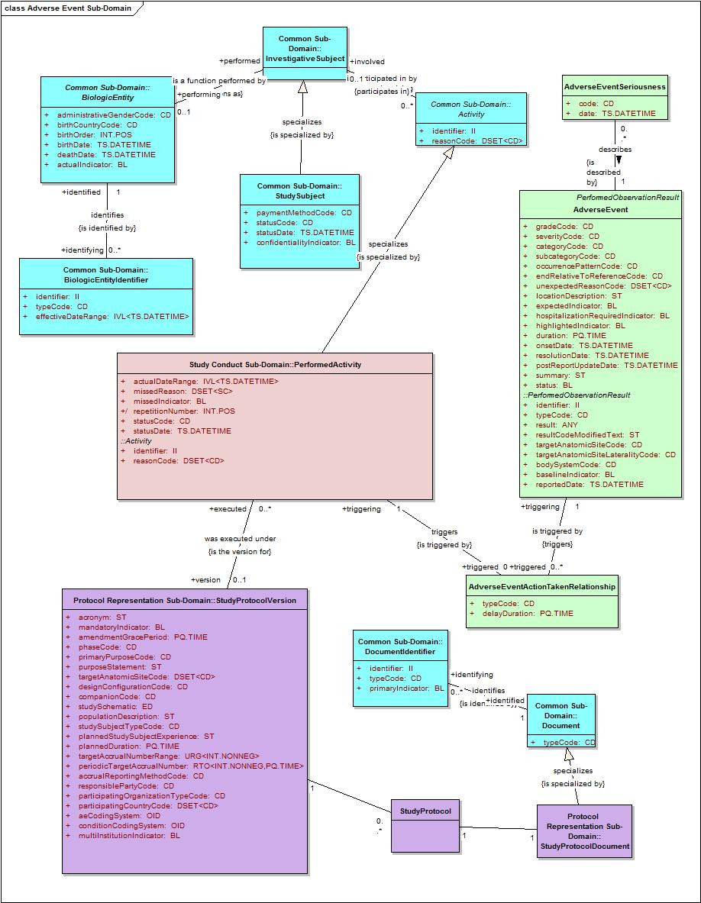

AdverseEvent and its associated classes used by Adverse Event Services

Attribute Name | Type | Type
categoryCode | CD | A coded value specifying a classification of the adverse event; for example, bleeding, hypoglycemia.  NOTE: Theoretically speaking, the category should be derivable from the subcategory; however, if there may only be a category and not a subcategory, then both attributes must be present in the model.
duration | PQ.TIME | The length of time of an adverse event. For example, one day, two hours.  NOTE: This is used only when duration is collected on the CRF and not derived from start and end date/times.
endRelativeToReferenceCode | CD | A coded value specifying when this adverse event ended with respect to the sponsor-defined reference period; for example, before, during, during/after, after, etc.  NOTE: If the reference period is computably represented, AdverseEvent.endRelativeToReferenceCode is conceptually derivable based on the reference period and the resolution date of the adverse event. Sponsors should define the reference period in the study metadata, which may be populated when a start date is not.
expectedIndicator | BL | Specifies whether the specificity (nature), frequency, or severity of an adverse event is consistent with the applicable study documentation (e.g., investigator’s brochure, protocol document, or consent document) or product labeling (package insert).
gradeCode | CD | A coded value specifying the level of injury suffered by the subject for whom the event is reported. For example, the gradeCode could be three if the CTCAE coding system is being used.
highlightedIndicator | BL | Specifies whether the adverse event or reaction term is a major concern or reason for reporting the adverse event.
hospitalizationRequiredIndicator | BL | Specifies whether the subject requires hospitalization as a result of the adverse event.
occurrencePatternCode | CD | A coded value specifying the time recurrence by which an adverse event occurs; for example, intermittent.
onsetDate | TS.DATETIME | The date (and time) on which an adverse event began. NOTE: Must be at least a full date (8 digits) but could contain a time (14 digits).
postReportUpdateDate | TS.DATETIME | The date (and time) an adverse event was updated after it had been submitted.
resolutionDate | TS.DATETIME | The date (and time) when the adverse event ends or returns to baseline.  NOTE: Must be at least a full date (8 digits) but could contain a time (14 digits).
severityCode | CD | A coded value specifying the intensity of the event; for example, moderate could be used to describe acne.
subcategoryCode | CD | A coded value specifying a subdivision within a larger category of an adverse event; for example, neurologic.  NOTE: Theoretically speaking, the category should be derivable from the subcategory; however, if there is only a category and not a subcategory, then both attributes must be present in the model.
Summary | ST | A description of the adverse event and the treatment of the event.
unexpectedReasonCode | DSET<CD> | A coded value specifying the representation of the criteria for determining whether an adverse event (experience or reaction) is considered unanticipated for example, severity, frequency, or specificity from what has been previously documented.
status | BL | Specifies if the adverse event is active or inactive.

Adverse Event Implementation Model

AdverseEvent class and its associations are derived from BRIDG information model. The Enterprise Architect Project for the Adverse Event Implementation Model can be found at http://gforge.nci.nih.gov/frs/?group_id=342. The class diagram of the Adverse Event Implementation Model is shown below:

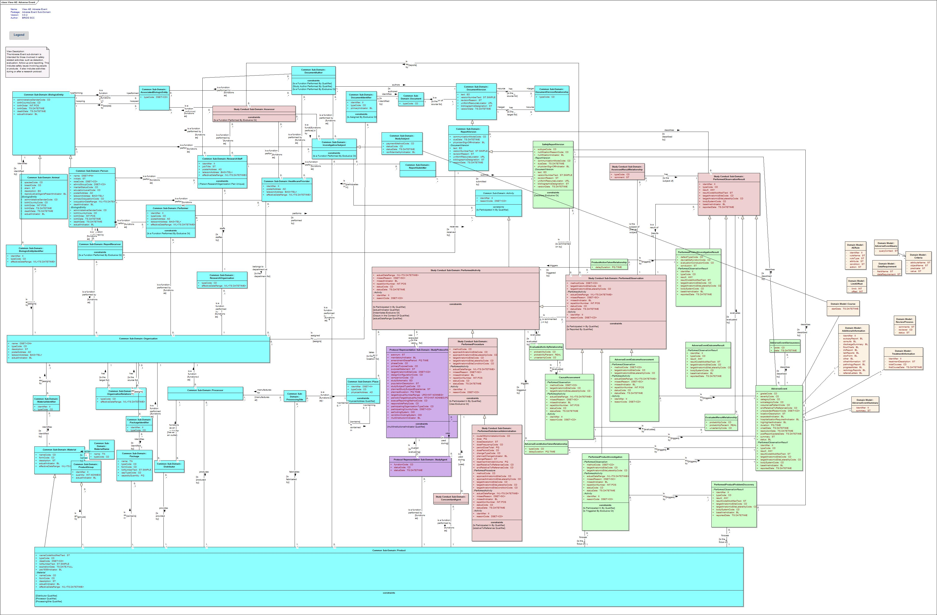
Adverse Event – Implementation Model derived from BRIDG3.0.2 Information Model

Additional classes were defined in the Adverse Event Implementation Model. These classes are not derived from the BRIDG 3.0.2 model. These classes are used for control parameters for searching, subscribing and reporting adverse events. The class diagram below shows these classes:

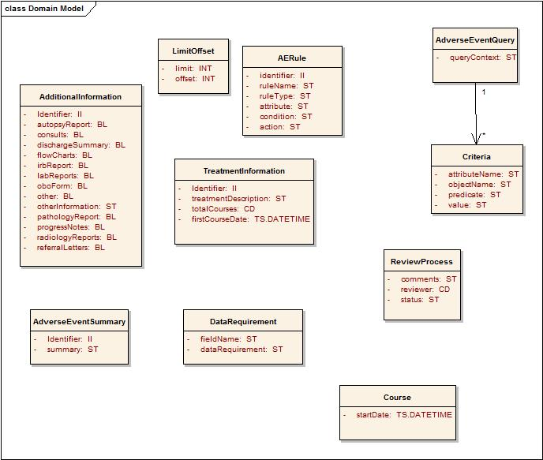

Adverse event implementation classes not derived from BRIDG

Since BRIDG uses ISO 21090 data types, which are HL7 V3 RIM R2-compliant, the Adverse Event Service uses the following ISO 21090 data types:

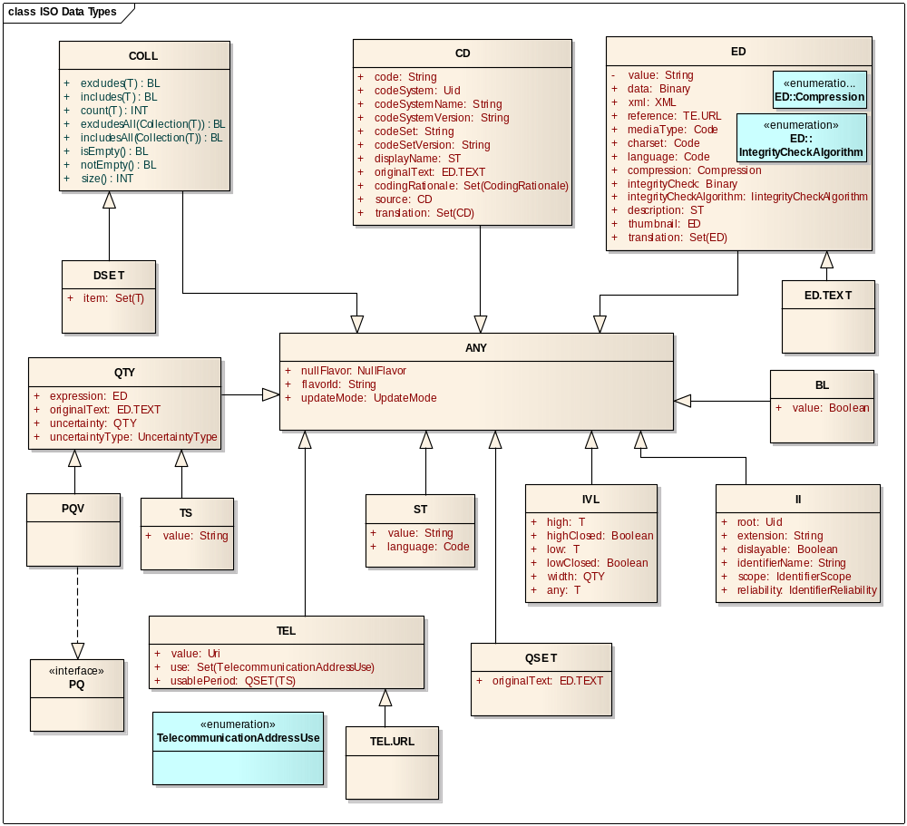
ISO 21090 data types used by the Adverse Event Service

Error Implementation Model

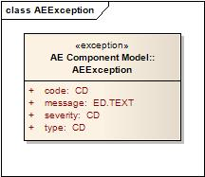

Attribute Name | Type | Attribute Description
code | CD | The actual error code which the Exception class represents
message | ED.TEXT | The detailed error message
severity | CD | The severity of this error, which can be “FATAL”, “HIGH”, “MEDIUM” or “LOW”
type | CD | Indicates what type of error has occurred; for example, business or system

Control Data Type Definitions

Status/Return Values/Exceptions

Data Type | Type (Status / Return Value / Exception) | Data Type Description
AEException | Exception | Exception thrown when there is an error in the operation of AE Service methods

Error Codes

Error Code | Error Condition | Error/Exception Description
AEE10100 | Major | Values of all mandatory attributes for <Object> have not been provided
AEE10101 | Fatal | Invalid <Object>
AEE10102 | Minor | Adverse event is not found for the given identifier
AEE10103 | Major | More than one adverse event found
AEE10104 | Minor | Invalid data type or code value for any attribute
AEE10105 | Minor | Association not found for the specified adverse events
AEE10106 | Minor | Minimum and mandatory attributes of search criteria have not been provided, especially identifier or key term
AEE10107 | Minor | No boundaries provided for find/search operation
AEE10108 | Minor | Not all required parameters provided
AEE10200 | Fatal | One of the dependent systems of adverse management system is unavailable momentarily and hence the given operation failed
AEE10203 | Minor | Study protocol cannot be verified
AEE10204 | Minor | Study participant cannot be verified
AEE10203 | Minor | Subject not found for the given identifier
AEE10302 | Minor | Minimum and mandatory attributes of report criteria have not been provided, especially identifier or key term
AEE10303 | Minor | Study not found for the given identifier
AEE10304 | Minor | Rule not found for the given identifier
AEE10305 | Minor | Rules not found on specified study
AEE10306 | Minor | Terminology not found for the given identifier

Interfaces

UML Model of Interfaces

Interface ID | Interface Name | Interface Description
AE-INF1 | AEQuery | This interface provides operations to find and retrieve adverse events.
AE-INF2 | AEManagement | This interface facilitates functionality for managing the adverse events.
AE-INF3 | AEAssociate | This interface provides operations to associate multiple adverse events together for study purpose and dissociate multiple events that were previously associated.
AE-INF4 | AENotification | This interface provides operations to notify other systems and services based upon updates to adverse events.
AE-INF5 | AEReview | This interface provides operations for other systems, services, and users to manage and execute the adverse event review process.
AE-INF6 | AEProtocol | This interface provides operations to manage adverse events contained within a protocol.
AE-INF7 | AEAdvancedQuery | This interface provides operations to find and retrieve adverse events, audit trail of adverse events, associated adverse events.
AE-INF8 | AEEvaluate | This interface provides operations to evaluate adverse events against recording rules.

The following is the Interface Model for the Adverse Event Service:

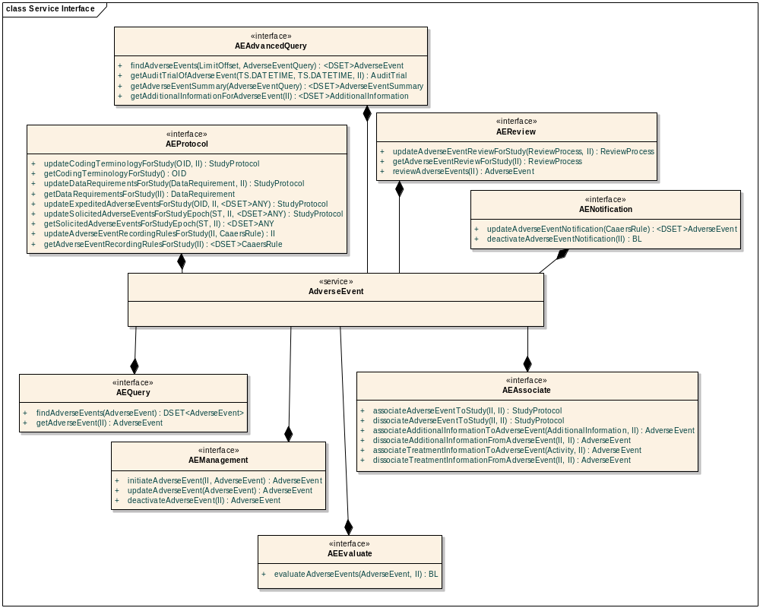
Adverse Event Services Interface Model

Operations (Enumeration)

Operation ID | Operation Name | Interface Name
AE-INF1-OP1 | findAdverseEvents | AEQuery
AE-INF1-OP2 | getAdverseEventData | AEQuery
AE-INF2-OP1 | initiateAdverseEvent | AEManagement
AE-INF2-OP2 | updateAdverseEvent | AEManagement
AE-INF2-OP3 | deactivateAdverseEvent | AEManagement
AE-INF3-OP1 | associateAdverseEventToStudy | AEAssociate
AE-INF3-OP2 | dissociateAdverseEventToStudy | AEAssociate
AE-INF3-OP3 | associateAdditionalInformationToAdverseEvent | AEAssociate
AE-INF3-OP4 | dissociateAdditionalInformationFromAdverseEvent | AEAssociate
AE-INF3-OP5 | associateTreatmentInformationToAdverseEvent | AEAssociate
AE-INF3-OP6 | dissociateTreatmentInformationFromAdverseEvent | AEAssociate
AE-INF4-OP1 | updateAdverseEventNotification | AENotification
AE-INF4-OP2 | deactivateAdverseEventNotification | AENotification
AE-INF5-OP1 | updateAdverseEventReviewProcessForStudy | AEReview
AE-INF5-OP2 | getAdverseEventReviewProcessForStudy | AEReview
AE-INF5-OP3 | reviewAdverseEvents | AEReview
AE-INF6-OP1 | updateCodingTerminologyForStudy | AEProtocol
AE-INF6-OP2 | getCodingTerminologyForStudy | AEProtocol
AE-INF6-OP3 | updateDataRequirementsForStudy | AEProtocol
AE-INF6-OP4 | getDataRequirementsForStudy | AEProtocol
AE-INF6-OP5 | updateExpectedAdverseEventsForStudy | AEProtocol
AE-INF6-OP6 | getExpectedAdverseEventsForStudy | AEProtocol
AE-INF6-OP7 | updateSolicitedAdverseEventsForStudyEpoch | AEProtocol
AE-INF6-OP8 | getSolicitedAdverseEventsForStudyEpoch | AEProtocol
AE-INF6-OP9 | updateAdverseEventRecordingRulesForStudy | AEProtocol
AE-INF6-OP10 | getAdverseEventRecordingRulesForStudy | AEProtocol
AE-INF7-OP1 | queryAdverseEvents | AEAdvancedQuery
AE-INF7-OP2 | getAuditTrailOfAdverseEvent | AEAdvancedQuery
AE-INF7-OP3 | getAdverseEventSummary | AEAdvancedQuery
AE-INF7-OP4 | getAdditionalInformationForAdverseEvent | AEAdvancedQuery
AE-INF8-OP1 | evaluateAdverseEvents | AEEvaluate

Operation Behavior Descriptions

AEQuery Interface
This interface provides operations to find and retrieve adverse events.

AE-INF1-OP1: findAdverseEvents

Behavior Description | Query by Example model of querying and will retrieve all adverse events which match the input AdverseEvent attributes with search limit offset
Pre-Conditions
Security Conditions | The requestor  - Must be assigned the AE Query privilege role for the studies and organizations of interest.
Inputs | - BRIDG : AdverseEvent
Outputs | ISO:DSET<BRIDG:AdverseEvent>
Post-Conditions | No
Exception Conditions | - Values of all mandatory attributes for the Adverse Event Class have not been provided  - Invalid Adverse Event
Additional Details
Notes

AE-INF1-OP2: getAdverseEventData

Behavior Description | Retrieves an entire adverse event based on the specified adverse event identifier(s)
Pre-Conditions | Adverse event exists
Security Pre-Conditions | The requestor  Must be assigned the AE Query privilege role for the studies and organizations of interest.
Inputs | BRIDG:AdverseEvent.Identifier
Outputs | ISO:DSET<BRIDG:AdverseEvent>
Post-Conditions
Exception Conditions | - Adverse event is not found for the given identifier  - Invalid Identifier
Additional Details
Notes

AEManagement Interface
This interface facilitates functionality for managing the Adverse Events.

AE-INF2-OP1: initiateAdverseEvent

Behavior Description | Allows initiation of adverse event and associates with study and subject
Pre-Conditions | BRIDG:Study exists  BRIDG: Subject exists  Course Exists
Security Pre-Conditions | The requestor  Must be assigned the AE Reporter privilege role for the studies and organizations of interest.
Inputs | - BRIDG:AdverseEvent and instances of its aggregation/composition classes with the mandatory attributes filled and desired optional attributes provided  - BRIDG:Subject.Identifier  - BRIDG:StudyProtocolVersion.Identifier  - ISO:TSDateTime (Course Start Date)
Outputs | BRIDG: AdverseEvent
Post-Conditions | An adverse event is initiated and the business process is started to report adverse event
Exception Conditions | Invalid Study protocol  Invalid Study participant  Invalid Adverse Event  Subject not found for the given identifier  Study not found for the given identifier
Additional Details | Not all attributes of the AdverseEvent class need to be provided to initiate an adverse event
Notes

AE-INF2-OP2: updateAdverseEvent

Behavior Description | Allows updating adverse event attributes
Pre-Conditions | Adverse event exists
Security Pre-Conditions | The requestor  Must be assigned the AE Reporter privilege role for the studies and organizations of interest.
Inputs | BRIDG:AdverseEvent class and instances of its associated classes with required attributes filled and with optional attributes filled optionally. Identifier is required for update.  NOTE: You will need to provide values for all the existing attributes along with the changed ones to avoid them from being nullified.
Outputs | BRIDG:AdverseEvent
Post-Conditions | Adverse event is updated
Exception Conditions | Invalid Adverse Event  Adverse event is not found for the given identifier
Additional Details | When more than one adverse event is found, some means is necessary to identify the exact adverse event to be updated, which may necessitate matching on other key mandatory attributes.
Notes

AE-INF2-OP3 : deactivateAdverseEvent

Behavior Description | Deactivates adverse event
Pre-Conditions | Adverse event exists
Security Pre-Conditions | The requestor  Must be assigned the AE Reporter privilege role for the studies and organizations of interest.
Inputs | ISO : II (AdverseEvent Identifier)
Outputs | BRIDG:AdverseEvent
Post-Conditions | Adverse event is deactivated
Exception Conditions | Adverse event is not found for the given identifier  Invalid AdverseEvent
Additional Details | Update adverse event status flag
Notes

AEAssociation Interface
This interface provides operations to associate multiple adverse events together for study purpose and dissociate multiple events that were previously associated.

AE-INF3-OP1 : associateAdverseEventToStudy

Behavior Description | Associates an adverse event record to a study
Pre-Conditions | - Specified adverse event exists  - Specified study exists
Security Pre-Conditions | The requestor  Must be assigned the AE Reporter privilege role for the studies and organizations of interest.
Inputs | - ISO : II (Adverse Event Identifier)  - ISO : II (Study Protocol Identifier)
Outputs
Post-Conditions | None
Exception Conditions | Adverse event is not found for the given identifier  Study not found for the given identifier  Invalid Adverse Event Identifier  - Invalid Study Identifier
Additional Details
Notes

AE-INF3-OP2 : dissociateAdverseEventFromStudy
Behavior Description | Removes association between an adverse event record and a study
Pre-Conditions | - Specified adverse event exists  - Specified study exists  - Adverse event record is associated to the study
Security Pre-Conditions | The requestor  Must be assigned the AE Reporter privilege role for the studies and organizations of interest.
Inputs | - ISO : II (Adverse Event Identifier)  - ISO : II (Study Protocol Identifier)
Outputs
Post-Conditions | None
Exception Conditions | - Adverse event is not found for the given identifier  - Invalid Study protocol
Additional Details
Notes

AE-INF3-OP3 : associateAdditionalInformationToAdverseEvent

Behavior Description | Associates an adverse event to additional information
Pre-Conditions | Specified adverse event exists
Security Pre-Conditions | The requestor  Must be assigned the AE Reporter privilege role for the studies and organizations of interest.
Inputs | - BRIDG:AdverseEvent.identifier  - AE : AdditionalInformation
Outputs
Post-Conditions
Exception Conditions | - Adverse event is not found for the given identifier  - Invalid Identifier
Additional Details
Notes

AE-INF3-OP4 : dissociateAdditionalInformationFromAdverseEvent

Behavior Description | Removes association between an adverse event and additional information
Pre-Conditions | - Specified adverse event exists  - Association with specified AdditionInformation exists
Security Pre-Conditions | The requestor  Must be assigned the AE Reporter privilege role for the studies and organizations of interest.
Inputs | - BRIDG:Adverse Event.identifier  - AE:AdditionalInformation.identifier
Outputs
Post-Conditions
Exception Conditions | - Adverse event is not found for the given identifier Association not found for the specified adverse events
Additional Details
Notes

AE-INF3-OP5 : associateTreatmentInformationToAdverseEvent

Behavior Description | Creates the association between the adverse event and the information regarding what the subject was treated within relation to the presentation of the adverse event.
Pre-Conditions | - Specified adverse event exists  - Treatment information exists
Security Pre-Conditions | The requestor  Must be assigned the AE Reporter privilege role for the studies and organizations of interest.
Inputs | - BRIDG:AdverseEvent.identifier  - BRIDG:Activity.identifier
Outputs
Post-Conditions
Exception Conditions | - Adverse event is not found for the given identifier  - Invalid Identifier
Additional Details
Notes

AE-INF3-OP6: disassociateTreatmentInformationFromAdverseEvent

Behavior Description | Removes the association between an adverse event and the subject treatment information.
Pre-Conditions | - Specified adverse event exists  - Association exists between the subject treatment information and the adverse event record
Security Pre-Conditions | The requestor  Must be assigned the AE Reporter privilege role for the studies and organizations of interest.
Inputs | - BRIDG:AdverseEvent.identifier  - BRIDG:Activity.identifier
Outputs
Post-Conditions
Exception Conditions | - Adverse event is not found for the given identifier Association not found for the specified adverse events  - Invalid Identifier
Additional Details
Notes

AENotification Interface
This interface provides operations to notify other systems and services based upon updates to adverse events.

AE-INF4-OP1: updateAdverseEventNotification

Behavior Description | Updates the notification rule (adverse event criteria on which a notification should be triggered)
Pre-Conditions
Security Pre-Conditions | The requestor  Must be assigned the AE Notification Manager privilege role for the studies and organizations of interest.
Inputs | AERule
Outputs | ISO:DSET<BRIDG : AdverseEvent>
Post-Conditions | - A rule is created  - Trigger notification service when adverse event meets notification criteria
Exception Conditions
Additional Details
Notes

AE-INF4-OP2: deactivateAdverseEventNotification

Behavior Description | Deactivates notification rule (adverse event criteria on which a notification should be triggered)
Pre-Conditions | Notification rules exists
Security Pre-Conditions | The requestor  Must be assigned the AE Notification Manager privilege role for the studies and organizations of interest.
Inputs | AERule.Identifier (II)
Outputs | ISO : BL (Rule Status )
Post-Conditions | Rule deactivated
Exception Conditions | Notification rule not found
Additional Details
Notes

AEReview Interface
This interface provides operations for other systems, services, and users to manage and execute the adverse event review process.

AE-INF5-OP1: updateAdverseEventReviewForStudy

Behavior Description | Updates the workflow process that must be followed for reviewing adverse event records.
Pre-Conditions | Specified study exists
Security Pre-Conditions | The requestor  Must be assigned the AE Review Manager privilege role for the studies and organizations of interest.
Inputs | - BRIDG:StudyProtocol.identifier  - AE:ReviewProcess
Outputs
Post-Conditions | None
Exception Conditions | Study not found for the given identifier  Invalid Identifier
Additional Details
Notes

AE-INF5-OP2: getAdverseEventReviewForStudy

Behavior Description | Retrieves the workflow process that must be followed for reviewing adverse event records.
Pre-Conditions | Specified study exists
Security Pre-Conditions | The requestor  Must be assigned the AE Reviewer privilege role for the studies and organizations of interest.
Inputs | BRIDG:StudyProtocol.identifier
Outputs | AE : ReviewProcess
Post-Conditions | None
Exception Conditions | - Study not found for the given identifier  - Invalid Identifier
Additional Details
Notes

AE-INF5-OP3: reviewAdverseEvent

Behavior Description | Review adverse events
Pre-Conditions | Specified adverse event exists
Security Pre-Conditions | The requestor  Must be assigned the AE Reviewer privilege role for the studies and organizations of interest.
Inputs | - BRIDG:AdverseEvent.identifier  - AE : ReviewProcess
Outputs | BRIDG:AdverseEvent
Post-Conditions | None
Exception Conditions | Adverse event is not found for the given identifier  Invalid Identifier
Additional Details
Notes

AEProtocol Interface
This interface provides operations to manage adverse events contained within a protocol.

AE-INF6-OP1: updateCodingTerminologyForStudy

Behavior Description | Updates the terminology system to be used for encoding adverse events on a study
Pre-Conditions | - Specified study exists  - Adverse event terminology exists
Security Pre-Conditions | The requestor  Must be assigned the Supplemental Study Information Manager privilege role for the studies of interest.
Inputs | - BRIDG:StudyProtocol.identifier  - BRIDG:StudyProtocolVersion.aeCodingSystem
Outputs
Post-Conditions | None
Exception Conditions | - Study not found for the given identifier  - Invalid Identifier
Additional Details
Notes

AE-INF6-OP2: getCodingTerminologyForStudy

Behavior Description | Retrieves the terminology system used for encoding adverse events on a study.
Pre-Conditions | Specified study exists
Security Pre-Conditions | The requestor  - Must be assigned the Supplemental Study Information Manager privilege role for the studies of interest, or  Must be assigned the AE Reporter privilege role for the studies of interest.
Inputs | BRIDG:StudyProtocol.identifier
Outputs | BRIDG:StudyProtocolVersion.aeCodingSystem
Post-Conditions | None
Exception Conditions | Study not found for the given identifier  Invalid Identifier
Additional Details
Notes

AE-INF6-OP3: updateDataRequirementsForStudy

Behavior Description | Updates the mandatory, optional, and not applicable (disallowed) attributes for adverse event records on a study.
Pre-Conditions | Specified study exists
Security Pre-Conditions | The requestor  Must be assigned the Supplemental Study Information Manager privilege role for the studies of interest.
Inputs | - BRIDG:StudyProtocol.identifier  - AE : DataRequirement
Outputs
Post-Conditions | None
Exception Conditions | Study not found for the given identifier  Invalid Identifier
Additional Details
Notes

AE-INF6-OP4: getDataRequirementsForStudy
Behavior Description | Retrieves the mandatory, optional, and not applicable (disallowed) attributes for adverse event records on a study.
Pre-Conditions | Specified study exists
Security Pre-Conditions | The requestor  - Must be assigned the Supplemental Study Information Manager privilege role for the studies of interest, or  Must be assigned the AE Reporter privilege role for the studies of interest.
Inputs | BRIDG:StudyProtocol.identifier
Outputs | AE : DataRequirement
Post-Conditions | None
Exception Conditions | Study not found for the given identifier  Invalid Identifier
Additional Details
Notes

AE-INF6-OP5: updateExpectedAdverseEventsForStudy

Behavior Description | Updates the expected adverse event records associated to a study.
Pre-Conditions | - Specified adverse event term(s) exists  - Specified study exists
Security Pre-Conditions | The requestor  Must be assigned the Supplemental Study Information Manager privilege role for the studies of interest.
Inputs | - ISO:DSET<ISO : ANY>(Adverse Event Term or Verbatim)  - BRIDG:StudyProtocol.identifier  - BRIDG:StudyProtocolVersion.aeCodingSystem
Outputs
Post-Conditions | Any expected adverse events that were previously associated to the study will be removed
Exception Conditions | - Study not found for the given identifier  Terminology not found for the given identifier  Invalid Identifier
Additional Details
Notes

AE-INF6-OP6: getExpectedAdverseEventsForStudy

Behavior Description | Retrieves the expected adverse event associated to a study.
Pre-Conditions | Specified study exists
Security Pre-Conditions | The requestor  - Must be assigned the Supplemental Study Information Manager privilege role for the studies of interest, or  Must be assigned the AE Reporter privilege role for the studies of interest.
Inputs | BRIDG:StudyProtocol.identifier
Outputs | ISO:DSET<BRIDG : AdverseEvent >
Post-Conditions
Exception Conditions | Study not found for the given identifier  Invalid Identifier
Additional Details
Notes

AE-INF6-OP7: updateSolicitedAdverseEventsForStudyEpoch

Behavior Description | Updates the solicited adverse event records associated to a study epoch
Pre-Conditions | - Specified adverse event term(s) exists  - Specified study exists  - Specified epoch exists
Security Pre-Conditions | The requestor  Must be assigned the Supplemental Study Information Manager privilege role for the studies of interest.
Inputs | - ISO:DSET<ISO: ANY> (Adverse Event Term or Verbatim)  - BRIDG:StudyProtocol.identifier  - BRIDG:Epoch.name
Outputs
Post-Conditions | Any solicited adverse events that were previously associated to the study epoch will be removed
Exception Conditions | - Study not found for the given identifier  - Invalid Identifier
Additional Details
Notes

AE-INF6-OP8: getSolicitedAdverseEventsForStudyEpoch
This operation allows obtaining the solicited adverse event records associated to a study epoch.

Behavior Description | Retrieves the solicited adverse event records associated to a study epoch.
Pre-Conditions | - Specified study exists  - Specified epoch exists
Security Pre-Conditions | The requestor  - Must be assigned the Supplemental Study Information Manager privilege role for the studies of interest, or  Must be assigned the AE Reporter privilege role for the studies of interest.
Inputs | - BRIDG:StudyProtocol.identifier  - BRIDG:Epoch.name
Outputs | ISO:DSET<ISO : ANY>
Post-Conditions
Exception Conditions | - Study not found for the given identifier  - Invalid Identifier
Additional Details
Notes

AE-INF6-OP9: updateAdverseEventRecordingRulesForStudy

Behavior Description | Updates/creates rule against which an adverse event record should be evaluated to determine if it is an appropriate record for associating to a study
Pre-Conditions
Security Pre-Conditions | The requestor  Must be assigned the Supplemental Study Information Manager privilege role for the studies of interest.
Inputs | - AE : AERule  - BRIDG:StudyProtocolVersion.identifier
Outputs | ISO : II (AERule Identifier)
Post-Conditions | Rule is created
Exception Conditions | Study not found for the given identifier  Rule not found for the given identifier  Invalid Identifier
Additional Details
Notes

AE-INF6-OP10: getAdverseEventRecordingRulesForStudy

Behavior Description | Retrieves rules against which an adverse event record should be evaluated to determine if it is an appropriate record for associating to a study
Pre-Conditions
Security Pre-Conditions | The requestor  - Must be assigned the Supplemental Study Information Manager privilege role for the studies of interest, or  Must be assigned the AE Reporter privilege role for the studies of interest.
Inputs | BRIDG : StudyProtocolVersion.identifier
Outputs | ISO:DSET<AE:Rule>
Post-Conditions
Exception Conditions | Rule not found for the given identifier  Invalid Identifier
Additional Details
Notes

AEAdvancedQuery Interface
This interface provides operations to find and retrieve adverse events, an audit trail of adverse events, and associated adverse events.

AE-INF7-OP1: queryAdverseEvents

Behavior Description | Query by search criteria (caAERS) model of querying and will retrieve all adverse events that match the input search criteria with search limit offset
Pre-Conditions
Security Conditions | The requestor  Must be assigned the Data Analyst privilege role for the studies of interest.
Inputs | - AE: AdverseEventQuery.  - AE: LimitOffset.
Outputs | ISO:DSET<BRIDG:AdverseEvent>
Post-Conditions | No
Exception Conditions | - Minimum and mandatory attributes of search criteria have not been provided, especially identifier or key term
Additional Details
Notes

AE-INF7-OP2: getAuditTrailOfAdverseEvent

Behavior Description | Retrieve an audit trail of all changes that have been made to an adverse event record based on the adverse event identifier and month worth of data from provided date
Pre-Conditions
Security Pre-Conditions | The requestor  Must be assigned the Data Reader privilege role for the studies of interest.
Inputs | - BRIDG:AdverseEvent.identifier)  - ISO : TS.DATETIME (date)
Outputs | ISO:DSET<AE : AuditTrail>
Post-Conditions
Exception Conditions | - Adverse event is not found for the given identifier  - Invalid start date
Additional Details
Notes

AE-INF7-OP3: getAdverseEventSummary

Behavior Description | Retrieves summarized information regarding adverse event records based on provided search criteria (caAERS)
Pre-Conditions
Security Pre-Conditions | The requestor  Must be assigned the Data Analyst privilege role for the studies of interest.
Inputs | AE: AdverseEventQuery.
Outputs | ISO:DSET<AE : AdverseEventSummary>
Post-Conditions
Exception Conditions
Additional Details
Notes

AE-INF7-OP4: getAdditionalInformationForAdverseEvent

Behavior Description | Retrieves the additional information records associated to an adverse event
Pre-Conditions | Specified AdverseEvent exists
Security Pre-Conditions | The requestor  Must be assigned the Data Analyst privilege role for the studies of interest.
Inputs | BRIDG:AdverseEvent.identifier)
Outputs | ISO:DSET<AE:AdditionalInformation>
Post-Conditions
Exception Conditions | Adverse event is not found for the given identifier  Invalid Identifier
Additional Details
Notes

AEEvaluate Interface
This interface provides operations that evaluate adverse events against recording rules

AE-INF8-OP1: evaluateAdverseEvents

Behavior Description | Evaluate an adverse event against the criteria, which must be satisfied in order for an adverse event to be considered an appropriate record for associating to a study
Pre-Conditions
Security Conditions | The requestor  Must be assigned the AE Reporter privilege role for the studies of interest.
Inputs | - BRIDG : AdverseEvent  - BRIDG:StudyProtocolVersion.identifier
Outputs | ISO : BL (adverse event meets the criteria or not)
Post-Conditions
Exception Conditions | - Study not found for the given identifier  - Rules not found on specified study
Additional Details | Validates the adverse event against the rules
Notes

Dynamic Model

The Adverse Event Service is a core service with a fairly simple dynamic model that can be used in many contexts and thus should be illustrated in context of the Clinical Trials business process. The following architecturally significant component diagram should sufficiently demonstrate the dynamics of the Adverse Event Service.

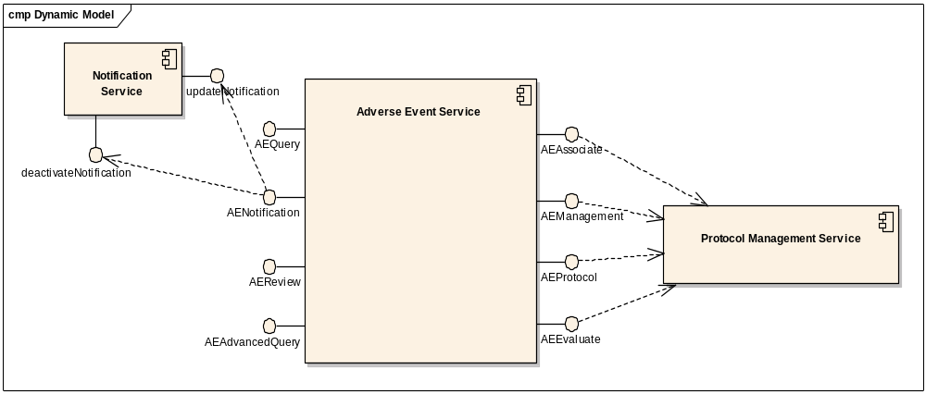

Profiles

Functional Profiles

Profile No. | Profile Name | Profile Description
AE-FP1 | AE Query | The query functional profile provides an encapsulation boundary for the commissioner of the query to be guaranteed that the information provided by a given query is correct and complete.
AE-FP2 | AE Management | The management series of capabilities details the complete encapsulation boundary behind which the adverse event object may be managed.
AE-FP3 | AE Associate | The association functional profile provides for a series of capabilities to connect an adverse event record with other information, whether that association happens across system or organizational boundaries.
AE-FP4 | AE Notification | The notification functional profile provides a series of functional capabilities for other systems, services, and users to manage the notifications that shall be triggered based upon updates to adverse event records and the associations to those records.
AE-FP5 | AE Review | The AE review functional profile provides a series of functional capabilities for other systems, services, and users to manage and execute the adverse event review process
AE-FP6 | AE Protocol | The AE protocol functional profile provides a series of functional capabilities for other systems, services, and users to manage the adverse event specific information contained within a protocol.
AE-FP7 | AE Advanced Query | The advanced query functional profile provides an encapsulation boundary for the commissioner of the query to be guaranteed that the information provided by a given query is correct and complete. This functional profile provides functionality beyond that provided in the AE query functional profile.
AE-FP8 | AE Evaluate | The AE evaluate functional profile provides a series of functional capabilities for other systems, services, and users to evaluate if an adverse event should be recorded.

Interface Operation No. | Interface Operation Name | Profile No. | Profile Name
AE-INF1-OP1 | findAdverseEvents | AE-FP1 | AE Query
AE-INF1-OP2 | getAdverseEventData | AE-FP1 | AE Query
AE-INF2-OP1 | initiateAdverseEvent | AE-FP2 | AE Management
AE-INF2-OP2 | updateAdverseEvent | AE-FP2 | AE Management
AE-INF2-OP3 | deactivateAdverseEvent | AE-FP2 | AE Management
AE-INF3-OP1 | associateAdverseEventToStudy | AE-FP3 | AE Associate
AE-INF3-OP2 | dissociateAdverseEventToStudy | AE-FP3 | AE Associate
AE-INF3-OP3 | associateAdditionalInformationToAdverseEvent | AE-FP3 | AE Associate
AE-INF3-OP4 | dissociateAdditionalInformationFromAdverseEvent | AE-FP3 | AE Associate
AE-INF3-OP5 | associateTreatmentInformationToAdverseEvent | AE-FP3 | AE Associate
AE-INF3-OP6 | dissociateTreatmentInformationFromAdverseEvent | AE-FP3 | AE Associate
AE-INF4-OP1 | updateAdverseEventNotification | AE-FP4 | AE Notification
AE-INF4-OP2 | deactivateAdverseEventNotification | AE-FP4 | AE Notification
AE-INF5-OP1 | updateAdverseEventReviewProcessForStudy | AE-FP5 | AE Review
AE-INF5-OP2 | getAdverseEventReviewProcessForStudy | AE-FP5 | AE Review
AE-INF5-OP3 | reviewAdverseEvent | AE-FP5 | AE Review
AE-INF6-OP1 | updateCodingTerminologyForStudy | AE-FP6 | AE Protocol
AE-INF6-OP2 | getCodingTerminologyForStudy | AE-FP6 | AE Protocol
AE-INF6-OP3 | updateDataRequirementsForStudy | AE-FP6 | AE Protocol
AE-INF6-OP4 | getDataRequirementsForStudy | AE-FP6 | AE Protocol
AE-INF6-OP5 | updateExpectedAdverseEventsForStudy | AE-FP6 | AE Protocol
AE-INF6-OP6 | getExpectedAdverseEventsForStudy | AE-FP6 | AE Protocol
AE-INF6-OP7 | updateSolicitedAdverseEventsForStudyEpoch | AE-FP6 | AE Protocol
AE-INF6-OP8 | getSolicitedAdverseEventsForStudyEpoch | AE-FP6 | AE Protocol
AE-INF6-OP9 | updateAdverseEventRecordingRulesForStudy | AE-FP6 | AE Protocol
AE-INF6-OP10 | getAdverseEventRecordingRulesForStudy | AE-FP6 | AE Protocol
AE-INF7-OP1 | findAdverseEvents | AE-FP7 | AE Advanced Query
AE-INF7-OP2 | getAuditTrailOfAdverseEvent | AE-FP7 | AE Advanced Query
AE-INF7-OP3 | getAdverseEventSummary | AE-FP7 | AE Advanced Query
AE-INF7-OP4 | getAdditionalInformationForAdverseEvent | AE-FP7 | AE Advanced Query
AE-INF8-OP1 | evaluateAdverseEvents | AE-FP8 | AE Evaluate

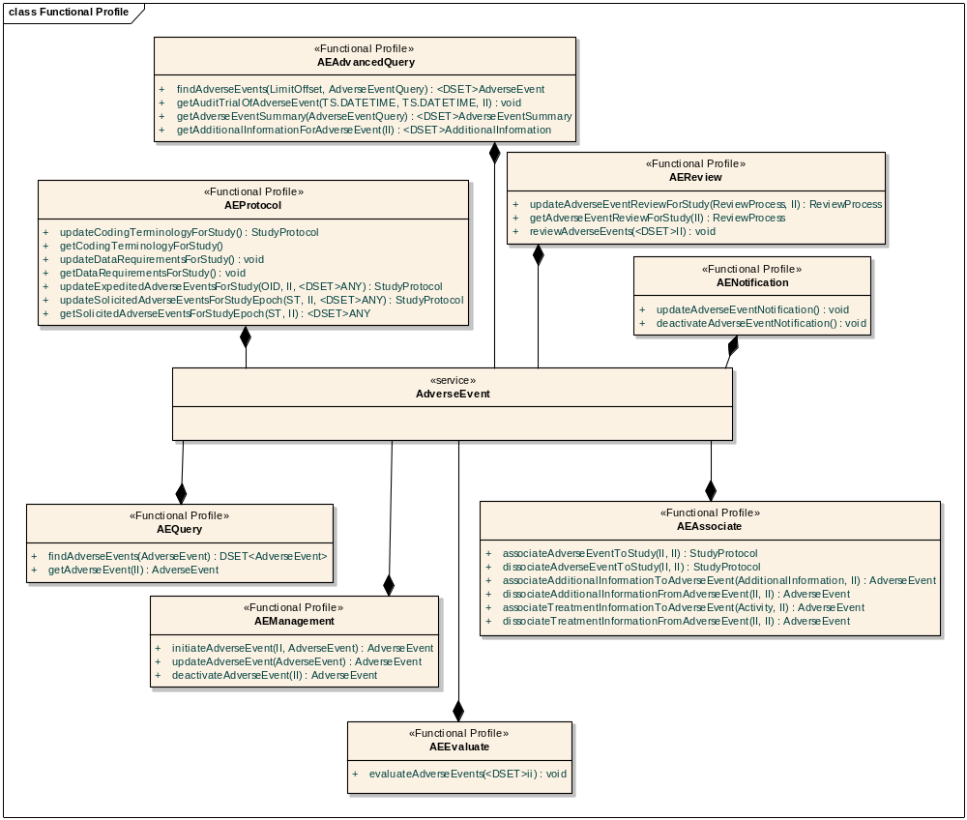
Profile view of the Operations of Adverse Event Service

Semantic Profiles

Semantic Profile No. | Semantic Profile Name | Semantic Profile Description
AE-SP1 | BRIDG V3.0.2 Adverse Event | NCI’s version of BRIDG v3.0.2-based semantic profile

Relationship with other services

The following diagram illustrates the positioning of the Adverse Event Service within the Clinical Trials business process (at a logical level). The full set of interactions depicted here are beyond the scope of this specification, but the overall intent is to convey the interoperability from adverse event management.

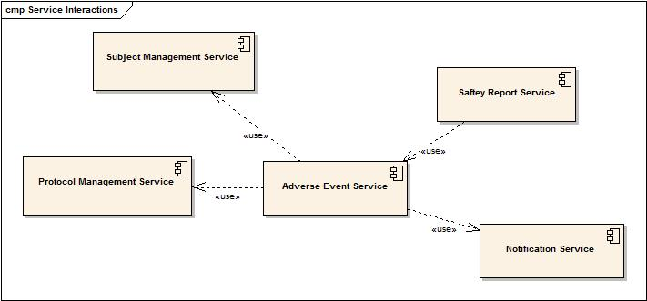
Adverse Event Management Component and Dependency Model

Service / System / Actors Name | Dependant / Depends | Data | Description
Protocol Management | Dependant | Study Information | AE Service relies on Protocol Management Service to retrieve study information and ensure that the study exists
Subject Registration Service | Dependant | Subject Information | AE Service relies on Subject Registration Service to retrieve subject information and verify that subject is registered on the study
Safety Report Service | Depends | Report Information | Safety Report Service relies on AE Service to report adverse event data
Notification Management Service | Dependant | Notifications | AE Service relies on Notification Management service to trigger notifications based on modifications to adverse events

Conformance Statements

No | Name | Type | Viewpoint | Description | Test method
1 | Query Performance | Obligation | Engineering | The AE query profile should provide a response within 0.5 seconds to support a synchronous UI-based client | Test cases to include performance testing
2 | Multiple Jurisdictions | Obligation | Enterprise | The AE Service will span jurisdictional boundaries and will need to support a federated data model | Test cases include multiple domain scenarios
3 | Secured Access | Obligation | Engineering | The AE service should have access control mechanism in place to restrict access to the secured data | Design review  Test cases to be defined for security
4 | Additional Functionality | Permission | Computational | The AE service can provide additional functionality other than specified in these specifications | Design Review
5 | Semantic Model | Obligation | Informational | The AE service must support NCI’s version of BRIDG 3.0.2 model adverse event class. | Design Review
6 | Functional Profiles | Obligation | Computational | Functional profiles shall be deployed as functional wholes. Ignoring or omitting functional behavior defined within a functional profile is not permitted, nor is diverging from the detailed functional specifications provided in Section 4. | Design Review  Test cases
7 | Functional Profiles | Obligation | Computational | A conformant implementation of this specification must deploy at least one functional profile. If that functional profile has dependencies on other profiles, then those dependencies must be deployed as well to support the provenance of that service instance. | Design Review  Test cases
8 | ISO Data types | Obligation | Information | Implementers are obligated to support ISO 1090 data types in all operations | Test cases
9 | Auditing | Obligation | Engineering | Designers/implementers are obligated to decide  on and document the approach for logging or  auditing operation calls. | Design Review

Appendix A - References

Name | Description | Location
NCI’s BRIDG v3.0.2 | NCI’s BRIDG model used for modeling the AE Service | http://gforge.nci.nih.gov/frs/download.php/8831/BRIDG_Release_3.0.2_Package.zip
caAERS Use Case Document | Document containing use cases for the caAERS application | https://wiki.nci.nih.gov/display/CTMS/Use+Cases+-+caAERS

Appendix B - Glossary

Term | Description
BRIDG | The Biomedical Research Integrated Domain Group (BRIDG) has developed a comprehensive domain analysis model representing biomedical/clinical research.
caAERS | Cancer Adverse Events Reporting System

Appendix C - Cross Reference Tables

Interface to Profile Mapping

Interface No. | Interface | Profile No. | Profile
AE-INF1 | AEQuery | AE-FP1 | AE Management
AE-INF2 | AEManagement | AE-FP2 | AE Associate
AE-INF3 | AEAssociate | AE-FP3 | AE Publication
AE-INF4 | AENotification | AE-FP4 | AE Report
AE-INF5 | AEReview | AE-FP5 | AE Query
AE-INF6 | AEProtocol | AE-FP6 | AE Protocol
AE-INF7 | AEAdvancedQuery | AE-FP7 | AE Advanced Query
AE-INF8 | AEEvaluate | AE-FP8 | AE Evaluate

Interface Operations to Profile Operations

Operation No. | Operation Name | Capability No. | Profile Capability
AE-INF1-OP1 | findAdverseEvents | AE-CPB1 | Find Adverse Event
AE-INF1-OP2 | getAdverseEventData | AE-CPB2 | Get Adverse Event Details
AE-INF2-OP1 | initiateAdverseEvent | AE-CPB3 | Initiate Adverse Event
AE-INF2-OP2 | updateAdverseEvent | AE-CPB4 | Update Adverse Event
AE-INF2-OP3 | deactivateAdverseEvent | AE-CPB5 | Deactivate Adverse Event
AE-INF3-OP1 | associateAdverseEventToStudy | AE-CPB6 | Associate Adverse Event to Study
AE-INF3-OP2 | dissociateAdverseEventToStudy | AE-CPB7 | Dissociate Adverse Event from Study
AE-INF3-OP3 | associateAdditionalInformationToAdverseEvent | AE-CPB8 | Associate Additional Information to Adverse Event
AE-INF3-OP4 | dissociateAdditionalInformationFromAdverseEvent | AE-CPB9 | Dissociate Additional Information from Adverse Event
AE-INF3-OP5 | associateTreatmentInformationToAdverseEvent | AE-CPB10 | Associate Treatment Information To Adverse Event
AE-INF3-OP6 | dissociateTreatmentInformationFromAdverseEvent | AE-CPB11 | Dissociate Treatment Information from Adverse Event
AE-INF4-OP1 | updateAdverseEventNotification | AE-CPB12 | Update Adverse Event Notification
AE-INF4-OP2 | deactivateAdverseEventNotification | AE-CPB13 | Deactivate Adverse Event Notification
AE-INF5-OP1 | updateAdverseEventReviewProcessForStudy | AE-CPB14 | Update Adverse Event Review Process for Study
AE-INF5-OP2 | getAdverseEventReviewProcessForStudy | AE-CPB15 | Retrieve Adverse Event Review Process for Study
AE-INF5-OP3 | reviewAdverseEvent | AE-CPB16 | Review Adverse Events
AE-INF6-OP1 | updateCodingTerminologyForStudy | AE-CPB17 | Update Adverse Event Coding System for Study
AE-INF6-OP2 | getCodingTerminologyForStudy | AE-CPB18 | Retrieve Adverse Event Coding System for Study
AE-INF6-OP3 | updateDataRequirementsForStudy | AE-CPB19 | Update Adverse Event data requirements for Study
AE-INF6-OP4 | getDataRequirementsForStudy | AE-CPB20 | Retrieve Adverse Event data requirements for Study
AE-INF6-OP5 | updateExpectedAdverseEventsForStudy | AE-CPB21 | Update expedited Adverse Events associated to Study
AE-INF6-OP6 | getExpectedAdverseEventsForStudy | AE-CPB22 | Retrieve expedited Adverse Events associated to Study
AE-INF6-OP7 | updateSolicitedAdverseEventsForStudyEpoch | AE-CPB23 | Update solicited Adverse Events associated to Study
AE-INF6-OP8 | getSolicitedAdverseEventsForStudyEpoch | AE-CPB24 | Retrieve expedited Adverse Events associated to Study
AE-INF6-OP9 | updateAdverseEventRecordingRulesForStudy | AE-CPB25 | Update Adverse Event Study rules
AE-INF6-OP10 | getAdverseEventRecordingRulesForStudy | AE-CPB26 | Retrieve Adverse Event Study rules
AE-INF7-OP1 | findAdverseEvents | AE-CPB27 | Find Adverse Events by Advanced Query model
AE-INF7-OP2 | getAuditTrailOfAdverseEvent | AE-CPB28 | Retrieve Audit Trial Information of Adverse Event
AE-INF7-OP3 | getAdverseEventSummary | AE-CPB29 | Retrieve Summarized Information of Adverse Event
AE-INF7-OP4 | getAdditionalInformationForAdverseEvent | AE-CPB30 | Retrieve Additional Information of Adverse Event
AE-INF8-OP1 | evaluateAdverseEvents | AE-CPB31 | Evaluate Adverse Events

