Once caAERS is installed, the product needs to be configured and the password policy needs to be defined. If you are a caBIG Clinical Trials Suite user, you must complete additional fields for the configuration so that caAERS knows how to communicate with the other caBIG Suite products, like caBIG Patient Study Calendar and caBIG Lab Viewer. Besides configuring the product, you also can track all the adverse event reports in caAERS.
Note: All fields in caAERS that have a red asterisk next to them means that you must complete the field to save and continue to the next page.

Contents
[hide]
- 1 caAERS Configuration
  - 1.1 Configuring Options
    - 1.1.1 Configuring caBIG Clinical Trials Suite Options
  - 1.2 Defining the Password Policy for caAERS
  - 1.3 Configuring Adverse Event Entry Fields in caAERS
- 2 Tracking Adverse Event Reports

caAERS Configuration
caAERS is installed with an empty configuration, so the first time the caAERS Administrator accesses caAERS, you must configure the product, define the password policy, and specify required adverse event fields.

Configuring Options
To specify the configuration options for caAERS
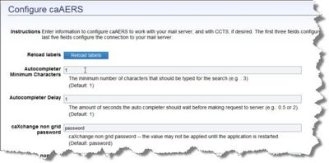
Note: There are additional configuration options if you are a caBIG Clinical Trials Suite user. See Configuring caBIG Clinical Trials Suite Options.
- Click the Administration tab.
- Click the Configure caAERS task. The Configure caAERS page opens.
- Click Reload Labels. Labels loaded successfully displays.
- Configure the following information to specify values for the caAERS autocomplete search boxes. An autocomplete search box enables users to search for an item based on only a portion of a name or identifier. A popup list displays from which the user can select from a list of items with the containing that portion. For example, if the user searches for a subject using "Alex" in the name, all subjects with "Alex", "Alex"andra, "Alex"ander, or "Alex"is may appear in the list.
  - Autocomplete Minimum Characters specifies the minimum number of characters a user can enter in an auto-complete box to perform a search. Maintain the default of 1 alpha-numeric character or increase the value. If you maintain the default of 1, the user only has to enter one letter or number and any items fulfilling that criteria will be listed in the popup box.
  - Autocomplete Delay is the number of seconds the auto completer should wait before making request to the server (e.g.: 0.5 or 2). The default is 1.
- Maintain the default value or change the caAERS help URL, the base URL of the online help file. The default is URL for the current version of caAERS.
- Maintain the default URL or change the caAERS base URL, the base URL for this version.
- Configure the following inactivity options:
- Show debugging information. This is relevant only for developers.
  - Maintain the default or change the Inactivity Duration, the number of minutes that will pass before you are logged out of caAERS based on inactivity. The default is 15 minutes.
  - Maintain the default or change the Inactivity Grace Period, the number of minutes to wait after showing the warning before the user is logged out. The default is 2 minutes.
- Configure the following search limit options:
  - Maintain the default or change the PA search limit, the maximum number of records returned from the NCI Enterprise Protocol Abstraction Service. The default is 100 records.
  - Maintain the default or change the PO search limit, the maximum number of records returned from the NCI Enterprise Person Service. The default is 200 records.
- Maintain or change the ESB URL, the URL for the NCI Enterprise Services (NES) component which enables you to update information in caAERS and synchronize with the NCI Enterprise Service.
- Specify the following information to configure caAERS to work with your mail server:
  - Enter the SMTP server, the address of the outgoing mail server (e.g.: smtp.gmail.com). Simple Mail Transfer Protocol (SMTP) is an Internet standard for electronic mail (e-mail) transmission across Internet Protocol (IP) networks. If you are a Clinical Trials Suite User and you do not enter this value, you cannot use all the Suite capabilities.
  - Enter the SMTP password or mail server password if the mail server requires authentication.
  - Maintain the SMTP port of 25 or change the port number of the outgoing mail server.
  - For Secure SMTP, specify Yes or No to indicate whether the mail server requires secure connection.
  - Enter the SMTP username if the mail server requires authentication.
  - Enter an email address that will be used as the From address for all mail sent by caAERS. This address does not need to be a legitimate email address.
  - Maintain the default Unidentified mode. False forces the user to "hide" the subject information for any email sent from caAERS. This minimizes problems with privacy issues.
- When you are done filling in the initial configuration information, click Save at the bottom of the page. The message Settings Saved appears at the bottom.
Note: Once you complete the configuration options, you may need to restart caAERS so that the options take affect.

Configuring caBIG Clinical Trials Suite Options
Configure the following information for caAERS to work with the caBIG Clinical Trials Suite:
Note: Once you complete the configuration options, you may need to restart caAERS so that the options take affect.
- Maintain the default value or change the caXchange Non-Grid Password for the caBIG Integration Hub. The default value is Password. The caBIG Integration Hub sends messages between the applications.
- Enter the caXchange non grid service URL, the URL for the caBIG Integration Hub non-grid interface.
- Maintain the default value or change the caXchange non grid user name for the caBIG Integration Hub. The default username is cxfbcUser.
- Enter the caXchange URL, the URL for the caBIG Integration Hub.
- Specify whether Enable Routing and Review? The defaults is No.
- Enter the Lab Viewer base URL, the base URL for the caBIG Lab Viewer deployment to which this caAERS instance can link.
- Enter the Study Calendar base URL, the base URL for the Patient Study Calendar (PSC) deployment to which this caAERS can link.
Note: Once you complete the configuration options, you may need to restart caAERS so that the options take affect.

Defining the Password Policy for caAERS
caAERS allows you to create specific rules regarding the creation of user passwords. This increases the level of security for passwords.
To define the password policy in caAERS
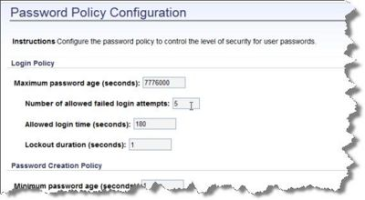
- Click the Administration tab.
- Click the Configure caAERS task.
- Click Password Policy. The Password Policy Configuration page opens.
- Enter the Maximum password age (in seconds). This determines how long a user can keep a password before having to reset it. They will receive an email when it is time to change it.
- Enter the Number of allowed failed login attempts before the user is locked out of caAERS.
- Enter the Lockout duration (in seconds) to specify how long a person is locked out after entering the wrong password more than the Number of allowed failed login attempts.
- Enter the Minimum password age (in seconds) to prevent a user from recreating their password numerous times in a row to go back to the same password.
- Enter the Password history size to specify how many past passwords are kept in the system for a user. This is useful if a user cannot remember a password.
- Enter Minimum password length to specify the least number of characters that a user can use to define a password.
- Select the Complexity Requirement checkboxes to specify what items are required in a user-defined password:
  - At least one uppercase letter
  - At least one lowercase letter
  - At least one non-alphanumeric character
  - At least one digit
- Enter the Largest substring of username allowed to specify the largest number of username characters in a row that are allowed to appear in the user password. This prevents user passwords from being too similar to usernames.
- When you are done defining the password policy options, click Save at the bottom of the page. The message Settings Saved appears at the bottom.

Configuring Adverse Event Entry Fields in caAERS
When a user adds an adverse event to caAERS, as the caAERS administrator you can specify what fields a user is required to enter, what is optional, and what fields do not display on the page.
To specify the Mandatory, Optional, or Not Applicable fields in caAERS
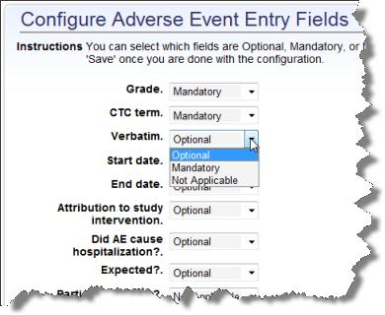
- Click the Administration tab.
- Click the Configure caAERS task.
- Click Mandatory Fields. The Configure Adverse Event Entry Fields page opens.
- Specify whether the following fields must be filled in by the user (Mandatory), do not have to be filled in by the user (Optional), or are Not Applicable and will not be displayed on the page. Each field is described in Adding Adverse Events.
  - Grade
  - CTC term
  - Verbatim
  - Start date and End date
  - Attribution to study intervention
  - Hospitalization
  - Expected
  - Does this place participant at increased risk?
  - Where was the patient when the event occurred?
  - Time of event
  - Outcomes
  - Comments
- When you are done defining the field options, click Save at the bottom of the page. The message Settings Saved appears at the bottom.

Tracking Adverse Event Reports
The Administration, Tracking Reports option enables you to follow the adverse events reports generated for your instance of caAERS.
What is the different between this and Manage Reports? An increased level.
To search for adverse event reports submitted in caAERS
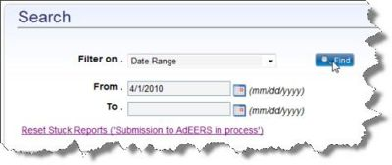
- From the Filter On list, select how to display the reports submitted in caBIG caAERS:
  - Reports Submitted in Last 30 Days
  - All Reports
  - Failed Reports
  - Report ID
    - Specify the identifier of the report.
    - Enter the From date or the starting date of reports in the format mm/dd/yyyy or click the calendar icon and select a date.
    - Enter the To date or the ending date of reports in the format mm/dd/yyyy or click the calendar icon and select a date.
- Click Reset Stuck Reports ('Submission to AdEERS in process') to ... The message Reports stuck for more than 5 minutes are reset to a 'Failed Status'. Please resubmit. appears. The search results display at the bottom of the page. To navigate, sort, and filter the results, see the Finding a Search Result.
To review information about each report
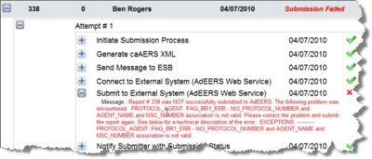
- For each report in the search results, the following information is listed:
  - Report ID is assigned to the report once the report is submitted.
  - Amendment # is the number of amendments or updates made to the report.
  - Submitter is the name of the person who submitted the report.
  - Status Date is the date that the status was assigned.
  - Submission Status indicates the current status of the report:
    - Submitted indicates that the report was successfully submitted.
    - Amended indicates that the report was updated and resubmitted.
    - Withdrawn indicates that before the report was submitted it was withdrawn from the submission process.
    - Failed indicates that during the submission process the report failed.
  - Click More Info and a popup window displays the following information: 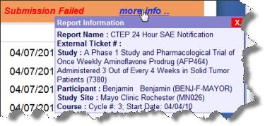
    - Report Name
    - External Ticket #
    - Study
    - Study Participant
    - Study Site Course
    - Course #
- On the left side of the report row, click the plus sign to display the attempts made to submit the report.
- On the left side of the attempt row, click the plus sign to display the steps followed during the report submission, and whether the step was completed (check mark) or not completed (x).
  - If the step fails, click the plus sign next to the step to display why the report did not complete. When you submit the report, caAERS does not verify that all information is provided when you submit the report.
    - Initiate Submission Process
    - Generate caAERS XML
    - Send Message to ESB Enterprise Service Bus
    - Connect to External System (AdEERS Web Service)
    - Submit to External System (AdEERS Web Service)
    - Notify Submitter with Submission Status displays the message and the email address of the submitter.

