caAERS Reporting and Scheduling Design Document

Technical Specification

Version History
Version | Date Modified | Author
1.0 (Iteration 0.5) | 8/25/2007 | Biju Joseph
1.0.1 (Iteration 0.7) | 10/18/2007 | Biju Joseph

Contacts and Support
Biju Joseph (biju.joseph@semanticbits.com)

LISTSERV Facilities Pertinent to software teams
LISTSERV | URL | Name
Caaersappdev-technical | caaersappdev-technical@gforge.nci.nih.gov. | caAERS technical forum

Table of Contents
1 Scope and Purpose 5
2 Overview 6
2.1 Requirements 8
2.2 Assumptions 8
3 Design Approach 9
3.1 Domain Objects 9
3.2 Persistence Layer 12
3.2.1 Table definition 14
3.3 Service Layer 19
3.4 Controller Layer 20
3.5 View Layer 22
4 Implementation 22
4.1 Class Diagram 22
4.2 Sequence Diagram 26
4.3 Activity Diagram 28
5 Testing 29
5.1 Domain Layer 29
5.2 Persistence Layer 29
5.3 Service Layer 29
6 References 30

List of Figures
Figure 1 – High level view of Reporting Service
Figure 2 - Domain Concept Model
Figure 3 – Report Service table model.
Figure 4 – Report Definition Classes.
Figure 5 - Report Definition Service Layer Classes
Figure 6 - Dao layer class diagram
Figure 7 - Mandatory Report Definition Flow
Figure 8 - Manual selection of Report Definitions
Figure 9 - Report enactment

Appendix
Terms | Definitions
Final Report /  Adverse Event Report | The adverse event report that is submitted to external agencies.
SAE | Severe Adverse Event
FDA | Food And Drug Administration
IRB | Institutional Review Board
Spring MVC | A frame work from Spring
Rules Engine | A component in caAERS project

Scope and Purpose
caAERS for expedited adverse event reporting, needs a facility by which a site coordinator can configure the details such as the recipients of the adverse event report, reminder notifications and mandatory fields associated to each section of the adverse event report. This document elaborates the implementation design for the reporting and scheduling service module.

Overview

The figure 1 shows a high level overview of the report service module.
In the system, the site coordinator creates report definitions. In adverse event reporting flow, the adverse event being entered is evaluated and is categorized as serious or routine.
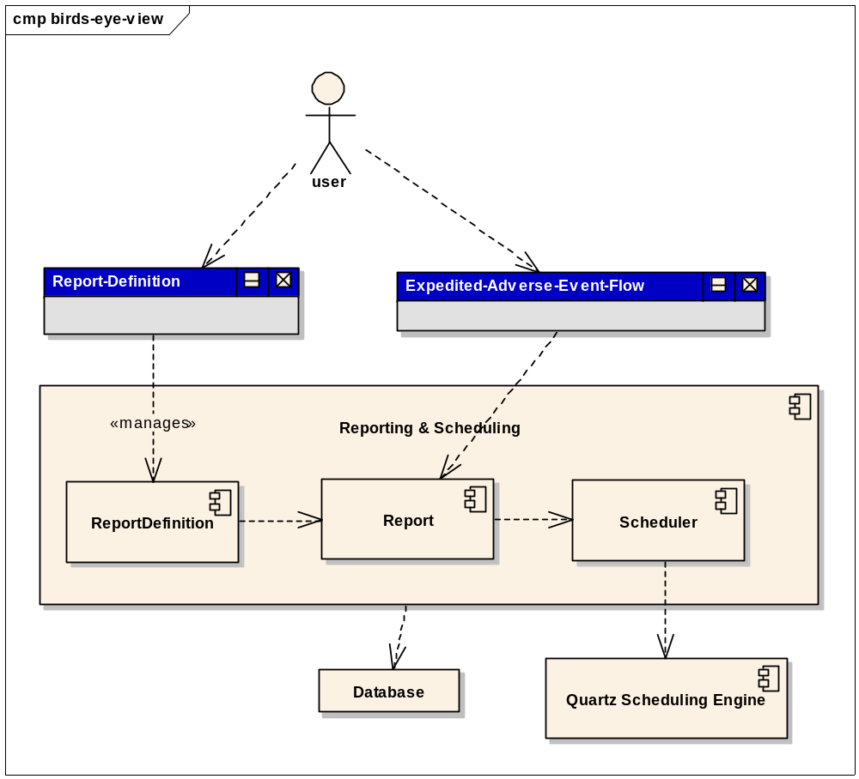
Figure 1 – High level view of Reporting Service
The system mandates that all severe adverse events (SAE) must be reported in expedited fashion. An expedited report must be reported within stipulated time frame. caAERS allow manual as well as auto selection of reports, which in turn is based on the reporting rules configured in the system.
The reporting and scheduling service module can be sub divided in three major parts.
Report Definition
This sub module deals with capturing of the details such as
- The delivery details of the adverse event report such as the recipient information, the file format of the adverse event report.
- Reminder templates (recipients, subject, content, time intervals) that are to be sent out, from the time an adverse event is reported till it is submitted.
- The fields that are mandatory in an adverse event report.
Report
The reports are instances of a Report Definition, which is instantiated when an adverse event report is associated with a reporting schedule (Report Definition). It encapsulates the actual reminders that are to be sending out.
Scheduler
The scheduler component is used to schedule the reminders that are associated in the report.

Requirements
These requirements are gathered based on the use case documents and review meetings with the caAERS technical team.
- Ability to associate multiple report definition templates with an organization.
- Site coordinator should be able to create and modify the report definition templates.
- Ability to capture the recipients of the final report along with their choice of final report MIME format.
- Ability to configure the reminder notifications for a pending adverse event report.
  - Ability to define the content, subject and recipient of the notifications
  - Support role based & direct recipients
  - Ability to specify context sensitive place holders in content and subject.
- Ability to configure the mandatory fields of a section (tabs in Adverse Event Flow).
- Ability to schedule reminder notifications per adverse event report.
- Ability to unschedule, scheduled notifications in a report.
The sections 1.9 through 1.12 of caAERS Use Case document.

Assumptions

Design Approach
caAERS has a domain driven design with analysis starting from a Bridge Harmonized model. Similar to other modules in caAERs, reporting and scheduling service module follows a layered architecture, which is described in caAERS Technical Architecture Guide.
The domain layer comprises of Hibernate annotated classes and must be defined in gov.nih.nci.cabig.caaers.domain.report package. The data access layer classes are to be defined in gov.nih.nci.cabig.caaers.dao.report. The service layer classes are to be defined in gov.nih.nci.cabig.caaers.service. The above mentioned layers should be defined in the core project.
The controller layer comprises of Spring MVC & CCTS tab flow supported classes, which are to be defined in gov.nih.nci.cabig.caaers.web.rule.notification of the web project.
The view layer comprises of Spring MVC & CCTS tab flow supported with JSPs, which are to be defined in web/src/main/webapp/WEB-INF/views/rule/notification directory of web project.

Domain Objects
The diagram comprising of major domain concepts involved in report module are shown in figure 2. The domain concepts can be classified into two broad categories:-
(1) Concepts related to definition and (2) concepts that represents an enactment of a definition. A brief description of the intent behind each concept is described below.
ReportDefinition
A report definition captures vital information related to the reporting aspects of an expedited adverse event report. The key attributes are name, time interval (scale), and duration till final report.Valid time intervals supported are Minutes, Hour, Day
ReportDeliveryDefinition
Represent the “where and what” aspect related to the delivery of an adverse event report. This concept represents information related to the recipient and the format of the final report accepted by the recipient. A report recipient could either be a system, a person, or a role represented by a person.
PlannedNotification
Represent the details of a reminder notification such as recipients and content. The attribute ‘indexOnTimeScale’ stores the knowledge of when this notification is planned based on the time interval (unit of measurement) chosen in the ReportDefinition.
TimeScaleType
This an enumeration of the time scale supported.
ReportMandatoryFieldDefinition
The sponsor or institution organization mandates certain fields to be mandatory in the final adverse event report. This concept cpatures the details of the mandatory fields.
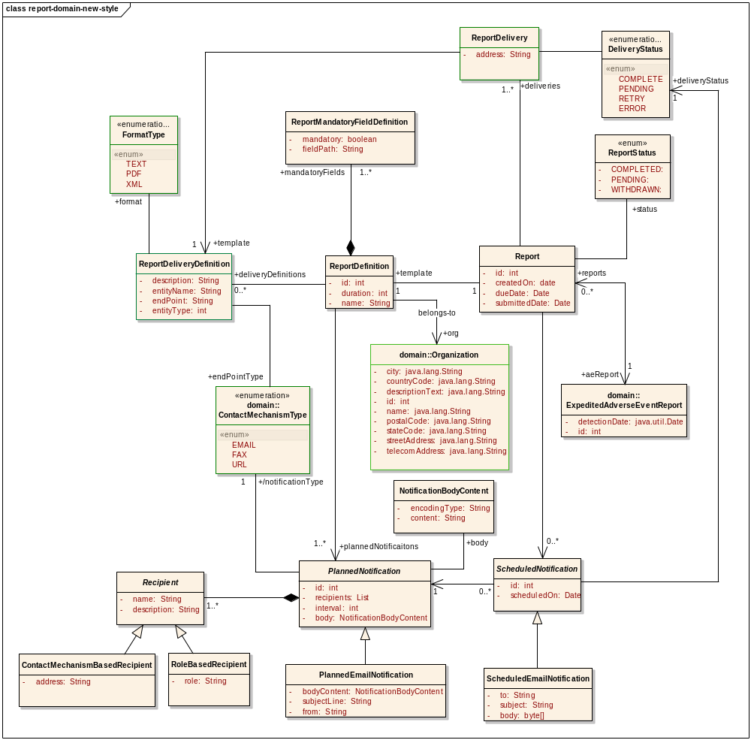Figure 2 - Domain Concept Model
Recipient
This concept stores the details of the recipients associated with each reminder (PlannedNotification) configured. This concept is further realized to ContactMechanismBasedRecipient and RoleBasedRecipient.
Report
This concept represents an instance of a ReportDefinition, in the context of a specific AdverseEventReport. It captures details like scheduled-date, final-report-due-date, report deliveries and scheduled notifications.
ReportDelivery
This concept represents an enactment of a ReportDeliveryDefinition in the context of a specific AdverseEventReport.
ScheduledNotification
This concept represents the enactment of a PlannedNotification, per recipient, in the context of a specific AdverseEventReport. The ScheduledEmailNotification a specialization of this concept represents an email notification.
DeliveryStatus
An enumeration consisting of the statuses associated to a delivery from the system.
ReportStatus
Enumeration representing the status of the Report

Persistence Layer
DAO interface and implementations will be created to facilitate database access. The application will only access the database via a DAO interface object. Each implementation of the dao interface will extend the org.springframework.orm.hibernate3.support.HibernateDaoSupport class.
The following DAO are to be defined for report service module:-
- gov.nih.nci.cabig.caaers.dao.report.ReportDefinitionDao
The responsibility of this class is to provide operations to persist and retrieve ReportDefinition.
Method | Use
save(ReportDefinition):void | This method will save a ReportDefinition
getByName(String):ReportDefinition | This method will retrieve a ReportDefinition from the database, given its name
getAll():List<ReportDefinition> | This method will retrieve all the available ReportDefinition
initialize(ReportDefinition):void | This method will initialize the report definitions.

- gov.nih.nci.cabig.caaers.dao.report.ReportDeliveryDefinitionDao
The responsibility of this class is to provide operations to persist, retrieve and remove ReportDeliveryDefinition
Method | Use
save(ReportDeliveryDefinition):void | This method will save a ReportDeliveryDefinition
getById(Integer):ReportDeliveryDefinition | This method will retrieve a ReportDeliveryDefinition from the database, given its ID
getAll():List<ReportDeliveryDefinition> | This method will retrieve all the available ReportDeliveryDefinition
initialize(ReportDeliveryDefinition):void | This method will initialize the report definitions.

- gov.nih.nci.cabig.caaers.dao.report.ReportDao
The responsibility of this class is to provide operations to persist, retrieve and remove a Report
Method | Use
save(Report):void | This method will save a Report
deleteById(Integer):boolean | This method will remove a Report from the database, given its ID.
getAll():List<Report> | This method will retrieve all the available Report
getAllByDueDate(Date) | This method will retrieve all the Report that are due on the date mentioned.
getAllBySubmittedDate(Date) | This method will retrieve all the Report which are submitted on the date mentioned.
getAllByCreatedDate(Date) | This method will retrieve all the Report which are created on the date mentioned

- gov.nih.nci.cabig.caaers.dao.report.ReportDeliveryDao
The responsibility of this class is to provide operations to persist, retrieve and remove ReportDelivery.
Method | Use
save(ReportDefinition):void | This method will save a ReportDelivery
deleteById(Integer):boolean | This method will remove a ReportDelivery identified by the given ID.
getAll():List<ReportDelivery> | This method will retrieve all the available ReportDelivery
delete(ReportDelivery):void | This method will delete the mentioned ReportDelivery.

The dao layer class diagram is shown below in figure 6.

Table definition
The database table model is presented in Figure 3.
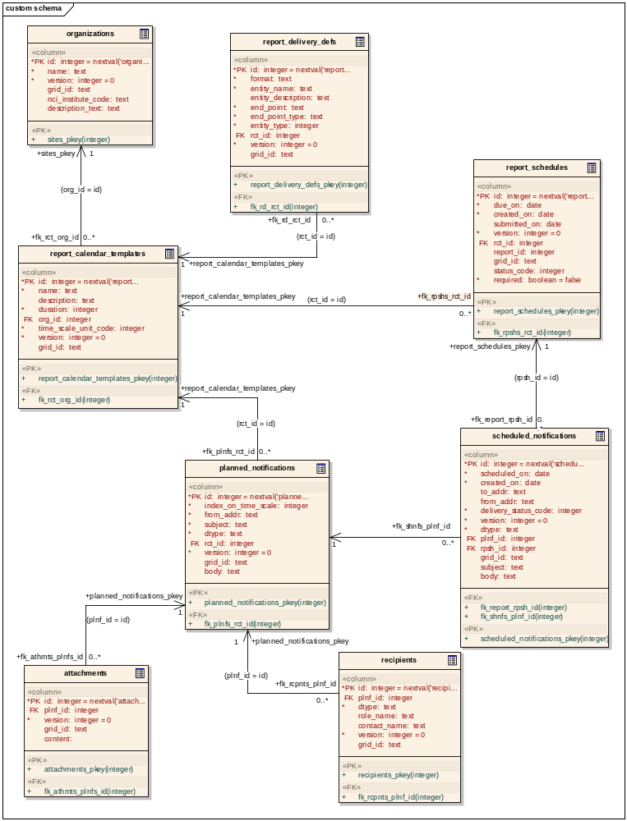
Figure 3 – Report Service table model.
A brief description of the table,intent and the domain classes to which each table is mapped is outlined below.
REPORT_CALENDAR_TEMPLATE
DESCRIPTION | This table stores the details associated to ReportDefinition concept
COLUMN | DATATYPE | NOTES
ID | INTEGER | nextval('report_calendar_templates_id_seq')
NAME | TEXT | To store the name of the ReportDefinition  NOT NULL
DESCRIPTION | TEXT | Will store the description associated to the ReportDefinition
DURATION | INTEGER | Will store the duration until final report  NOT NULL
ORG_ID | INTEGER | Will store the id of the organization to which the ReportDefinition belongs.  NOT NULL
TIME_SCALE_UNIT_CODE | INTEGER | Will store the type of the timescale used.  NOT NULL
VERSION | INTEGER | Will store the version associated with the ReportDefinition (Hibernate requirement)
GRID_ID | INTEGER | Will store the grid identifier associated to this domain object.

PLANNED_NOTIFICATIONS
DESCRIPTION | This table will store the details presented in PlannedNotification and its sub-types.
COLUMN | DATATYPE | NOTES
ID | INTEGER | nextval('planned_notifications_id_seq')
FROM_ADDR TEXT | TEXT | To store the from email address associated to the notification which is configured. Only valid for email-notification  NOT NULL
SUBJECT TEXT | TEXT | The subject line of the email notification is stored in this field
INDEX_ON_TIME_SCALE | INTEGER | Will store the relative instance in time on which this planned notification to be delivered.  NOT NULL
DTYPE | TEXT | Will store the discriminator type, this is needed for Hibernate to fetch the values.
BODY | TEXT | Will store the body text associated to reminder notification
RCT_ID | INTEGER | References the REPORT_CALENDAR_TEMPLATES.ID
VERSION | INTEGER | Will store the version associated with the domain object (Hibernate requirement)
GRID_ID | INTEGER | Will store the grid identifier associated to this domain object.

REPORT_DELIVERY_DEFS
DESCRIPTION | This table stores the values associated with ReportDeliveryDefinition object.
COLUMN | DATATYPE | NOTES
ID | INTEGER | nextval(‘report_delivery_defs_id_seq')
FORMAT | TEXT | Will store the format of the final adverse event.  NOT NULL
ENTITY_NAME | TEXT | Will store the display name of the recipient of the final report.
ENTITY_DESCRIPTION | TEXT | Will store the description associated to the recipient
ENTITY_TYPE | INTEGER | Will store the organization to which the ReportDefinition belongs to.  NOT NULL
END_POINT | TEXT | Will store the destination to which the delivery is to be made.
END_POINT_TYPE | INTEGER | The type of the destination, whether it is a URL or email etc.
RCT_ID | INTEGER | This column references the REPORT_CALENDAR_TEMPLATE.ID
VERSION | INTEGER | Will store the version associated with the domain object (Hibernate requirement)
GRID_ID | INTEGER | Will store the grid identifier associated to this domain object.

RECIPIENTS
DESCRIPTION | This table stores the details associated to Recipient object
COLUMN | DATATYPE | NOTES
ID | INTEGER | nextval(‘recipients_id_seq')
DTYPE | TEXT | Will store the discriminator type, this is needed for Hibernate to fetch the values.
PLNF_ID | INTEGER | Refers to PLANNED_NOTIFICATIONS.ID
ROLE_NAME | TEXT | Will store the name associated to the role
CONTACT_NAME | TEXT | Will store the end point associated with the recipient.
VERSION | INTEGER | Will store the version associated with the domain object (Hibernate requirement)
GRID_ID | INTEGER | Will store the grid identifier associated to this domain object.

REPORT_SCHEDULES
DESCRIPTION | This table stores the information associated to the Report object
COLUMN | DATATYPE | NOTES
ID | INTEGER | nextval(report_scedules_id_seq')
DUE_ON | DATE | When the report is due
CREATED_ON | DATE | Will store the date the report is created
SUBMITTED_ON | DATE | When the report is actually submitted.
REPORT_ID | INTEGER | Will reference the AE_REPORTS.ID
STATUS_CODE | INTEGER | Will refer to the status of the Report object
REQUIRED | BOOLEAN | Tells whether this report is mandatory or not
RCT_ID | INTEGER | This column references the REPORT_CALENDAR_TEMPLATE.ID
DTYPE | TEXT | Will store the discriminator type, this is needed for Hibernate to fetch the values.
VERSION | INTEGER | Will store the version associated with the domain object (Hibernate requirement)
GRID_ID | INTEGER | Will store the grid identifier associated to this domain object.

SHEDULED_NOTIFICATIONS
DESCRIPTION | This table stores the values associated to the ScheduledNotification and its sub-types
COLUMN | DATATYPE | NOTES
ID | INTEGER | nextval(‘scheduled_notificaitons_id_seq')
SCHEDULED_ON | DATE | Tells when the notification is scheduled for delivery.
CREATED_ON | DATE | Will store the date the report is created
TO_ADDR | TEXT | The TO address associated to a ScheduledEmailNotification
FROM_ADDR | TEXT | The from address associated to a ScheduledEmailNotification
DELIVERY_STATUS_CODE | INTEGER | Will refer to the status associated to the delivery of the notification
DTYPE | TEXT | Will store the discriminator type, this is needed for Hibernate to fetch the values.
PLNF_ID | INTEGER | Refers to PLANNED_NOTIFICATIONS.ID
RCT_ID | INTEGER | This column references the REPORT_CALENDAR_TEMPLATE.ID
RPSH_ID | INTEGER | Refers to the REPORT_SCHEDULES.ID
SUBJECT | TEXT | The subject associated to an email notification
BODY | TEXT | The body associated to an email notification
VERSION | INTEGER | Will store the version associated with the domain object (Hibernate requirement)
GRID_ID | INTEGER | Will store the grid identifier associated to this domain object.

REPORT_DELIVERIES
DESCRIPTION | This table stores the details associated to the ReportDelivery object
COLUMN | DATATYPE | NOTES
ID | INTEGER | nextval(‘report_deliveries_id_seq')
END_POINT | TEXT | Will store the destination to which the delivery is to be made.
DELIVERY_STATUS | TEXT | The delivery status associated to this delivery
RDD_ID | INTEGER | This column references the REPORT_DELIVERY_DEFS.ID
RP_ID | INTEGER | This column references the REPORT_SCHEDULES.ID
VERSION | INTEGER | Will store the version associated with the domain object (Hibernate requirement)
GRID_ID | INTEGER | Will store the grid identifier associated to this domain object.

Service Layer
The service layer will be comprising of the following service classes:-
gov.nih.nci.cabig.caaers.service.ReportService
The responsibility of the this class is to provide operations to create a Report instance from ReportDefinition.
Method | Use
applyRuntimeReplacements(String, Report):String | This method will return a String after replacing the place-holder elements in the input String, with the context specific values, which is obtained from the input Report.
createReport(ReportDefinition, ExpeditedAdverseEventReport):Report | This method will create a Report, based on the ReportDefinition and ExpeditedAdverseEventReport.
deleteReport(Report):void | This method will logically delete (changes the status of the Report to ReportStatus.WITHDRAWN) the Report, and unschedules any pending reminder notifications that are scheduled when this Report was instantiated.
validate(Report, Collection<ExpeditedReportSection>) :ReportSubmittability | This method will validate the given Report against the mandatory fields that are configured in the ReportDefinition associated with this Report.
withdrawLastReportVersion(Report):void | This method will logically delete (changes the status of the Report to ReportStatus.WITHDRAWN) the Report, and unschedules any pending reminder notifications that are scheduled when this Report was instantiated.

gov.nih.nci.cabig.caaers.service.SchedulerService
The responsibility of this class is to provide operations to schedule and unschedule reminders (ScheduledNotification) in a Report.
Method | Use
scheduleNotification(Report):void | This method will schedule the ScheduledNotification(s) (reminders) present in the Report.
unscheduleNotification(Report):void | This method will remove the notifications which are scheduled for a future date.

The class diagram of the service layer classes are mentioned in Figure 5.

Controller Layer
caAERS uses Spring MVC, the controller classes of reporting module are to be defined under the gov.nih.nci.cabig.caaers.web.rule.notification package.
CreateReportDefinitionController
This handles the create report definition flow.
Method | Use
#initFlow():void | This method will initialize the flow, and properly create the tabs.
#initBinder(HttpServletRequest, ServletRequestDataBinder):void | This method will initialize the data binders.
#processFinish(…):ModelAndView | This method is executed at the end of the page flow.
formBackingObject( …):ReportDefinitionCommand | This method will return the form object or the command object for the flow. In the create flow, this will return a new instance of the ReportDefinitionCommand.
getViewName(..):String | This method will return the view name associated to the request, esp. used in AJAX based requests that are invoked during the flow.
#suppressValidation(…):Boolean | This method will return true in the case if there are no error objects. In the case of AJAX requests this method will always return true.
#collectRoleOptions(..):Map | This method will return the values that are used in the roles drop down.
EditReportDefinitionController
This controller handles the edit report definition flow.
Method | Use
#initFlow():void | This method will initialize the flow, and properly create the tabs.
#initBinder(HttpServletRequest, ServletRequestDataBinder):void | This method will initialize the data binders.
#processFinish(…):ModelAndView | This method is executed at the end of the page flow.
formBackingObject( …):ReportDefinitionCommand | This method will return the form object or the command object for the flow. In the edit flow, this will return a new instance of the ReportDefinitionCommand, populated with the ReportDefinition retrieved from the backend.
getViewName(..):String | This method will return the view name associated to the request, esp. used in AJAX based requests that are invoked during the flow.
#suppressValidation(…):Boolean | This method will return true in the case if there are no error objects. In the case of AJAX requests this method will always return true.
#collectRoleOptions(..):Map | This method will return the values that are used in the roles drop down.
ReportDefinitionCommand
This is the command object, which is used by both create and edit flow.

View Layer
Views will be built jsps using css, Ajax and Spring tag libraries.

Implementation

Class Diagram
The class diagram consisting of domain classes are represented in Figure4,the classes diagram associated to service layer classes are represented in Figure 5 and the class diagram representing the DAO layer classes are represented in Figure 6.
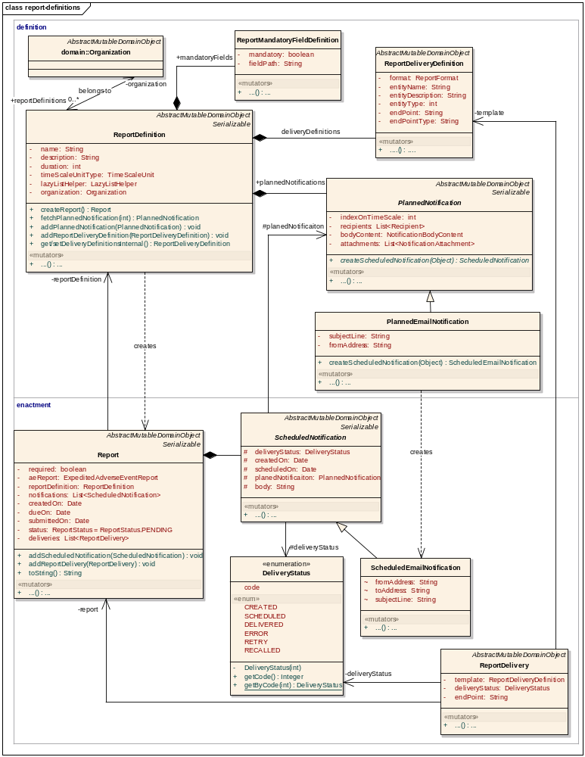
Figure 4 – Report Definition Classes.

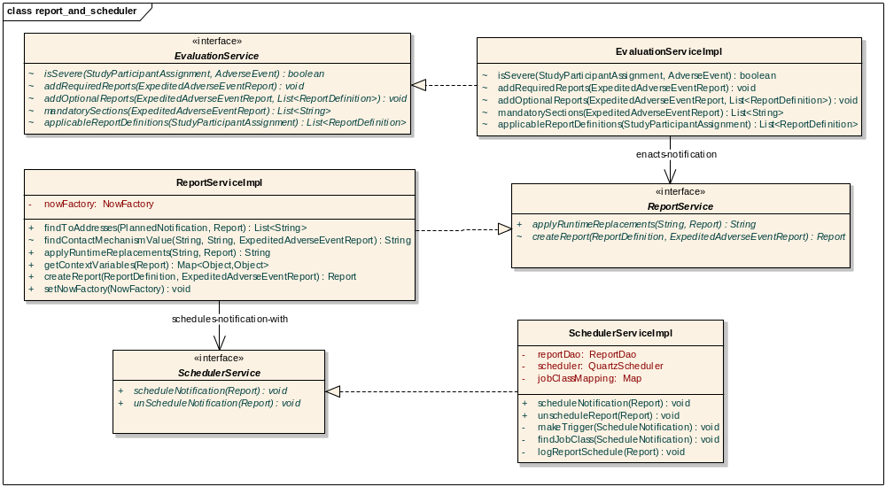
Figure 5 - Report Definition Service Layer Classes

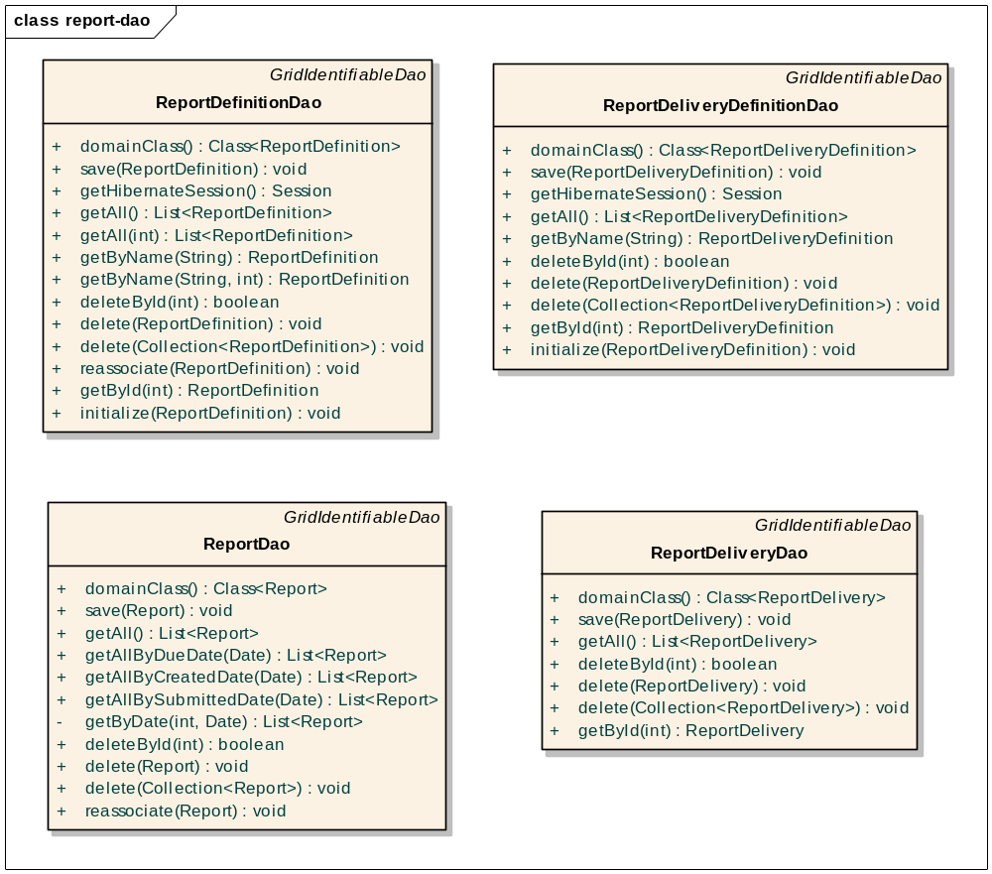
Figure 6 - Dao layer class diagram

Sequence Diagram
The enactment of a Report happens in the Expedited Adverse Event reporting flow.The basic information entered for the adverse event is sent to the rules engine for evaluation. The rules engine based on the pre-configured rules, will evaluate the adverse event, and tags it into severe or non-severe category.
It is a must that all severe adverse event (SAE) must be reported to external agencies, which has to follow a specific reporting pattern. The caAERS system provides two ways to achieve this.
- Based on the rules configured, the rules engine will determine the ReportDefinition templates to which the report should be associated. The sequence representing this flow is represented in Figure 7.
- The report definition templates choosen by rules engine, can also be overridden by the user. The sequence of flow in this scenario is represented in Figure 8.
For more details on the implementation of Rules Engine, refer to Rules Engine design document
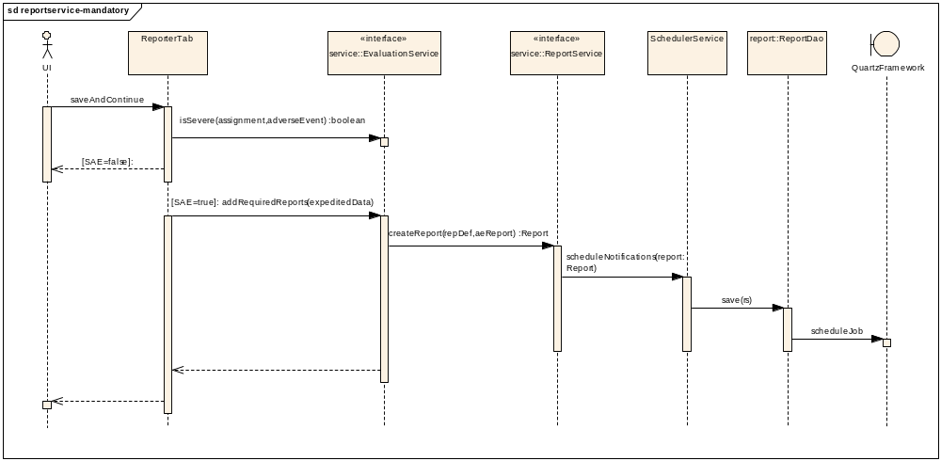
Figure 7 - Mandatory Report Definition Flow

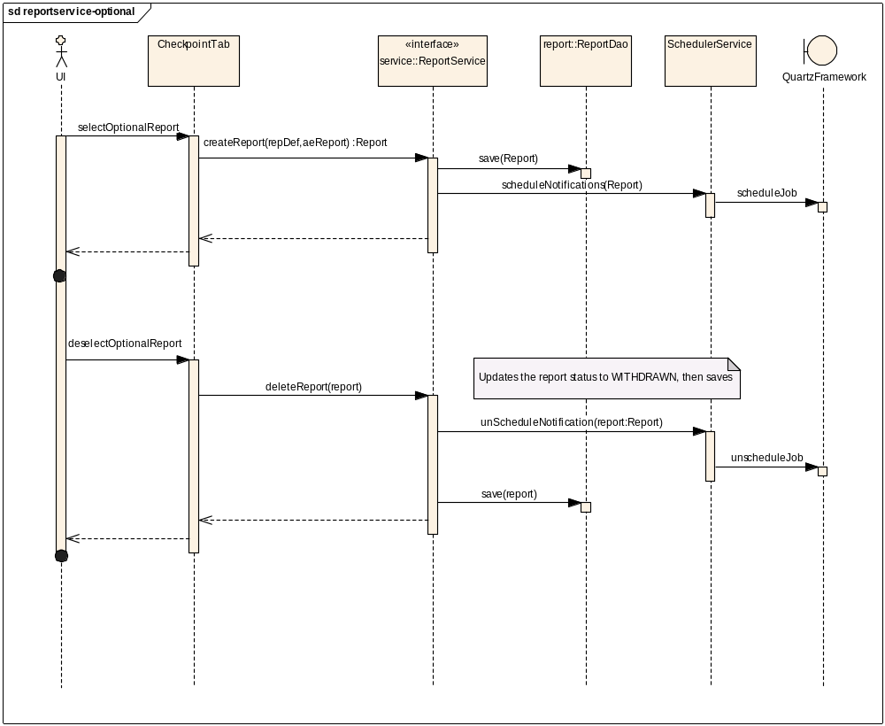
Figure 8 - Manual selection of Report Definitions

Activity Diagram

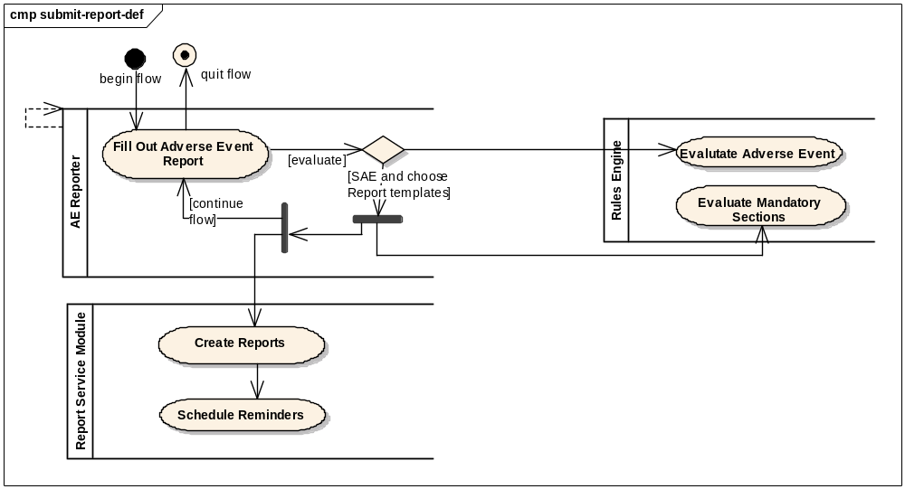
Figure 9 - Report enactment

Testing
The testcases for all the layers are written in JUnit. The details of the testcases are described in the following sections.

Domain Layer
gov.nih.nci.cabig.caaers.domain.report.ReportDefinitionTest
gov.nih.nci.cabig.caaers.domain.report.ReportMandatoryFieldDefinitionTest

Persistence Layer
gov.nih.nci.cabig.caaers.dao.ReportDefinitionDaoTest
testGetAll()
testDomainClass()
testGetByName()
testSave()
gov.nih.nci.cabig.caaers.dao.ReportDeliveryDefinitionDaoTest
testDomainClass()
testGetByName()
testSave()
gov.nih.nci.cabig.caaers.dao.ScheduledNotificationDaoTest
testDomainClass()
testRecallScheduledNotifications()
testUpdate()
gov.nih.nci.cabig.caaers.dao.ReportDaoTest
saveWithReportDelivery()
testDeleteByID()
testDeleteExistingById()
testDomainClass()
testGetAllByDueDate()
testGetById()
testSave()
testUpdate()

Service Layer
gov.nih.nci.cabig.caaers.service.ReportServiceTest
testFindEmailAddress()
testFindToAddress()
testValidateAcceptsGrade3Through5ForConcomitantMedication()
testValidateAcceptsGrade3Through5ForCourseAgent()
testValidateAcceptsGrade3Through5ForDisease()
testValidateAcceptsGrade3Through5ForOtherCause()
testValidateChecksForNoAttribution()
testValidateDoesNotAcceptGrade3Through5ForRadiation()
testValidateDoesNotAcceptGrade3Through5ForSurgery()
gov.nih.nci.cabig.caaers.service.SchedulerServiceImplTest
testScheduleNotification()
testUnScheduleNotification()

References
caAERS Use Case
http://gforge.nci.nih.gov/svnroot/caaersappdev/docs/Use Cases/caAERS_draft_Use_Case.doc
caAERS Technical Architecture Guide
http://gforge.nci.nih.gov/svnroot/caaersappdev/docs/DesignDocs/caaers_tech_arch_guide.doc
Rules Component Design
http://gforge.nci.nih.gov/svnroot/caaersappdev/docs/DesignDocs/

