Enter AE report flow design (as of iteration 2)

Activity Diagram
The enter adverse event report flow is a 12-step tabbed wizard, of which 4 steps are currently implemented. The flow creates a single AdverseEventReport object. The AdverseEventReport is a container for several dependent objects – one class per wizard tab. Some tabs will allow multiple instances – for instance, you might have multiple lab values for a single report.
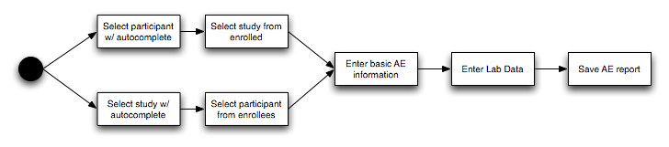

Sequence diagram
This high-level sequence diagram shows the interactions between the user of the system, her web browser, and the caAERS application. The caAERS application is broken into three portions: the DWR façade receives asynchronous data requests in response to use input. The Servlet/MVC layer handles synchronous requests to change from tab to tab or to submit a form. The core backs both of these layers, providing uniform access to the application’s data.

(This diagram covers only the lower branch of the activity diagram. The upper branch is similar.)
