caAERS – Create Study
Technical Specification

W
Updated Dec 12,2006 2006

Copyright Notice.

Development Team(s)
Development | Technical Documentation | Program Management
Sujith V T | Sujith V T | Edmond Mulaire
Padmaja Vedula | Padmaja Vedula | Vinay Kumar
 |  | Ram Chilukuri

Contacts and Support
Enter training contact
Enter customer support contact

LISTSERV Facilities Pertinent to software teams
LISTSERV | URL | Name

Table of Contents

Table of Contents 6
1 Scope & Purpose 7
2 Overview 7
2.1 Technology Stack 7
2.2 Core Modules 7
2.2.1 Domain Object Layer 7
2.2.2 Views 7
2.2.3 Controllers 7
2.2.4 Commands 7
2.2.5 Service Layer 7
2.2.6 Persistence Layer 7
2.2.7 Utilities 7
3 Domain, Analysis Model 8
4 Implementation Model 9
5 Data Model 10
6 Use Case Realization 10
6.1 Use Case 1 10
6.1.1 Activity diagram 10
6.1.2 Sequence diagram – core/web 10
6.2 Use Case 2 10
6.2.1 Activity diagram 10
6.2.2 Sequence diagram – core/web 10
7 Integration / External Systems 10
8 Unit Testing 10
8.1 JUnit 10
8.2 Spring Mock Objects 10
8.3 Generic Classes 10
9 Integration Testing 10
10 Configuration/Build/Deployment 10
Documentation /Artifacts 11

Scope & Purpose
The purpose of this document is to elaborate the implementation design of the create study module of caAERS.

Overview

Technology Stack
Operating System | Windows XP/Linux
Java Version | JDK 5.0
MVC framework | Spring MVC 2.0
View Technology | JSP, Tag libraries, Ajax
Ajax Framework
ORM | Hibernate 3.2.1
Transactions, IOC, dependency injection | Spring 2.0
Web Server | Tomcat 5.5.20
Database | Oracle 9i / PostgreSQL
Development Tools | Eclipse 3.2/JBoss IDE 2.0, Enterprise Architect 4.5
Build | Ant
Source Control | SVN

caAERS has a domain driven design with analysis starting from a Bridge Harmonized model. The domain package will be gov.nih.nci.cabig.caaers.domain. The domain objects are persisted using Hibernate and Hibernate 3 annotations will be used for mapping to database elements instead of separate hbm files. These annotations can be configured via Spring’s bean configuration files.

Core Modules

Domain Object Layer
Study : Domain class which captures the new study attributes
caAERS views will be jsps using css, Ajax and Spring tag libraries.

Views

caAERS will use Spring MVC. All the Controller classes for the respective use case will be under the gov.nih.nci.cabig.caaers.web package

Controllers
StudyController : Spring MVC Controller class

Commands
All command classes will be under the gov.nih.nci.cabig.caaers.web package

Service Layer
DAO interface and implementations will be created to facilitate database access. The application will only access the database via a DAO interface object. Each implementation of the dao interface will extend the org.springframework.orm.hibernate3.support.HibernateDaoSupport class.

Persistence Layer
StudyDao : DAO class for persistence and retrieval of the study object.

Utilities

Domain Analysis Model

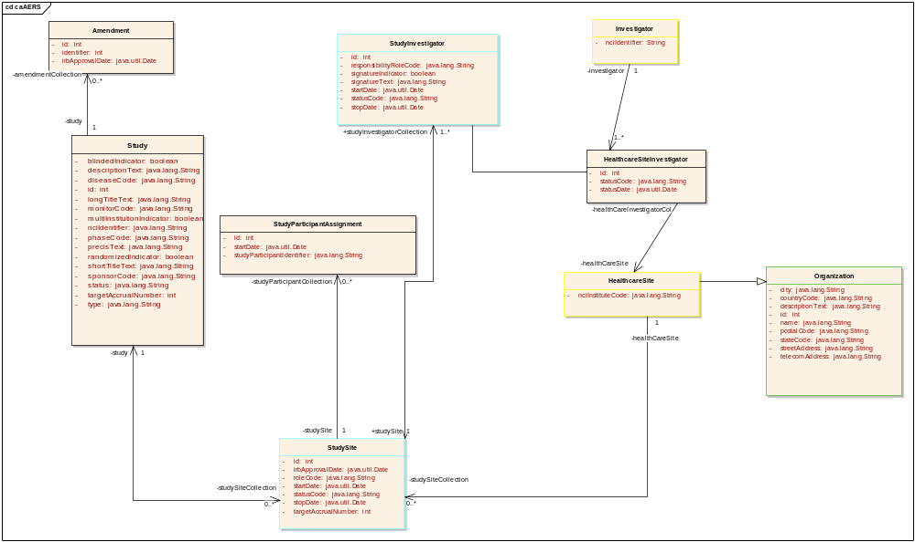

Implementation Model
Class Diagrams : Core
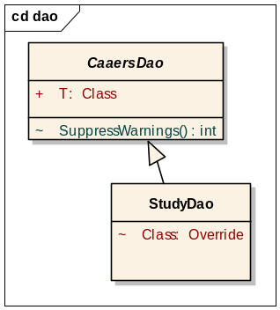 StudyDao Class
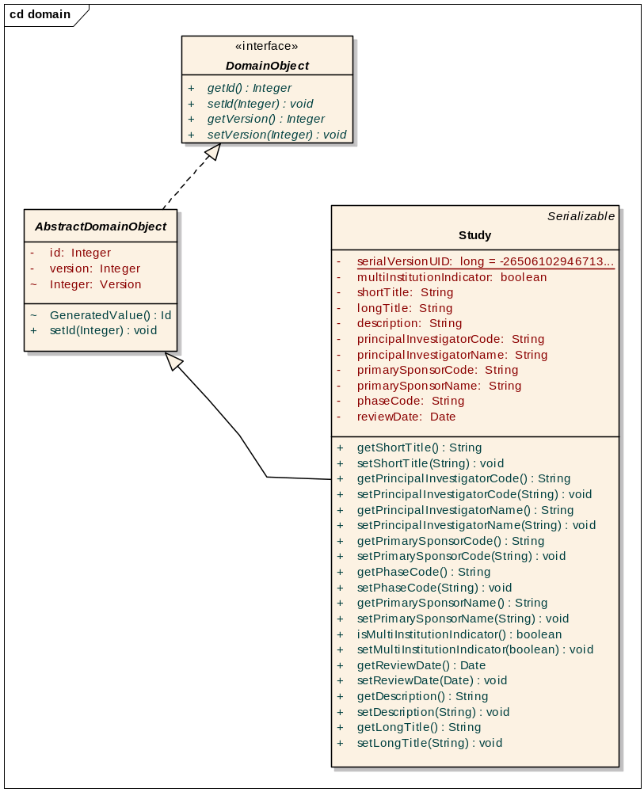 Study domain class
Class Diagram : Web
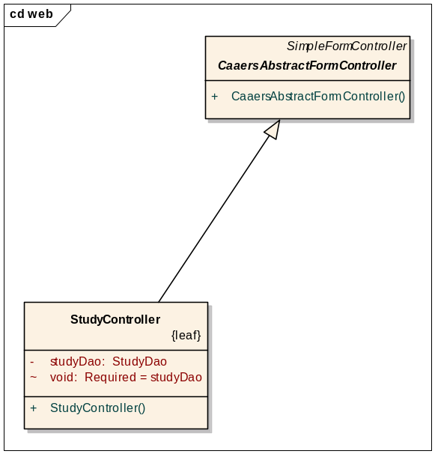

Data Model
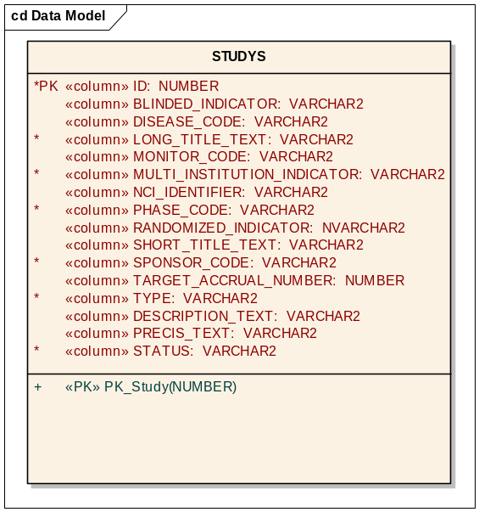

Use Case Realization
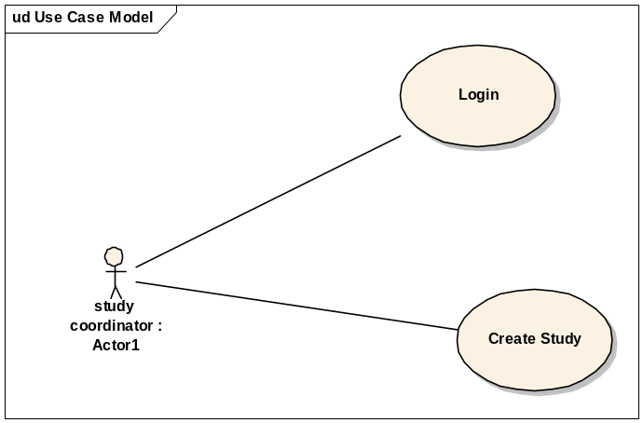

Use Case 1

Activity diagram
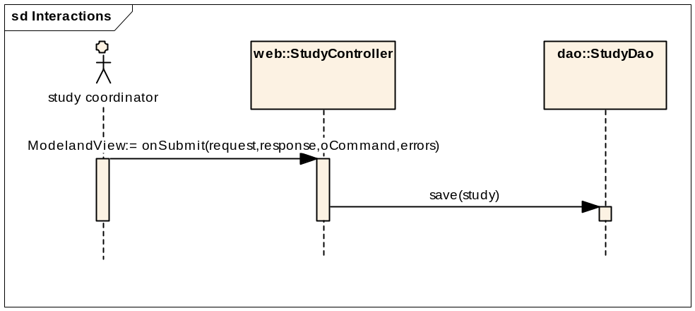

Sequence diagram – core/web

Integration / External Systems
None currently

Unit Testing
Core package :

JUnit
StudyDaoTest: test cases -
testGet : Test get study by id
testGetAllStudies : Test get all studies
testSave: Test save a new study object

web package:
StudyControllerTest : test cases –
testViewOnGet
testViewonSubmit

Integration Testing

Spring Mock Objects

Generic Classes

Configuration/Build/Deployment
- References

Documentation /Artifacts
SI No | Artifact | Type | Link

- Glossary
Term | Definition

