caAERS – Create/Assign Participant
Technical Specification

Akaza Research

W
Updated Dec 12,2006 2006

Copyright Notice.
License.

Development Team(s)
Development | Technical Documentation | Program Management
Krikor Krumlian | Krikor Krumlian | Edmond Mulaire
 |  | Vinay Kumar
 |  | Ram Chilukuri

Contacts and Support
Enter training contact
Enter customer support contact

LISTSERV Facilities Pertinent to software teams
LISTSERV | URL | Name
caAERS technical | caaersappdev-technical@gforge.nci.nih.gov

Table of Contents

Table of Contents 6
1 Scope & Purpose 7
2 Overview 7
2.1 Technology Stack 7
2.2 Core Modules 7
2.2.1 Domain Object Layer 7
2.2.2 Views 7
2.2.3 Controllers 8
2.2.4 Commands 8
2.2.5 Service Layer 9
2.2.6 Persistence Layer 9
2.2.7 Utilities 9
Domain, Analysis Model 10
3 Implementation Model 11
4 Data Model 12
5 Use Case Realization 12
5.1 Create Participant 12
5.1.1 Activity diagram 12
5.2 Assign Participant 12
5.2.1 Activity Diagram 12
6 Integration / External Systems 13
7 Unit Testing 13
7.1 JUnit 13
7.2 Spring Mock Objects 13
7.3 Generic Classes 14
8 Integration Testing 14
9 Configuration/Build/Deployment 14
Documentation /Artifacts 15

Scope & Purpose
Add the ability to create a new participant in the caAERS system.

Overview

Technology Stack
Operating System | Windows XP/Linux
Java Version | JDK 5.0
MVC framework | Spring MVC 2.0
View Technology | JSP, Tag libraries, Ajax
Ajax Framework | <not yet finalized>
ORM | Hibernate 3.2.1
Transactions, IOC, dependency injection | Spring 2.0
Web Server | Tomcat 5.5.20
Database | Oracle 9i / PostgreSQL/MySQL
Development Tools | Eclipse 3.2/JBoss IDE 2.0, Enterprise Architect 4.5
Build | Ant
Source Control | CVS (gForge)

No changes for the domain layer

Core Modules

Domain Object Layer
Moved all the jsp files to its own package.

Views
par/par_choose_study
par/par_confirm
par/par_confirmation
par/par_create_participant
par/reg_assign
par/reg_participant_search
par/par_reg_protocol_search
par/reg_review_submit
The Participant Controllers have been moved to its own package.

Controllers
gov.nih.nci.cabig.caaers.web.participant.CreateParticipantController
gov.nih.nci.cabig.caaers.web.participant.AssignController
gov.nih.nci.cabig.caaers.web.participant.AssignParticipantController
gov.nih.nci.cabig.caaers.web.participant.AssignStudyController
gov.nih.nci.cabig.caaers.web.participant.AssignParticipantStudyController
gov.nih.nci.cabig.caaers.web.participant.ViewParticipantStudyController

Commands
The Participant Command Objects have been moved to its own package.
gov.nih.nci.cabig.caaers.web.participant.NewParticipantCommand
gov.nih.nci.cabig.caaers.web.participant.AssignParticipantStudyCommand

gov.nih.nci.cabig.caaers.core.service.ParticipantService

Service Layer
gov.nih.nci.cabig.caaers.core.service.ParticipantServiceImpl
gov.nih.nci.cabig.caaers.core.service.StudyService
gov.nih.nci.cabig.caaers.core.service.StudyServiceImpl
No changes here

Persistence Layer

Utilities
No changes here

Domain, Analysis Model
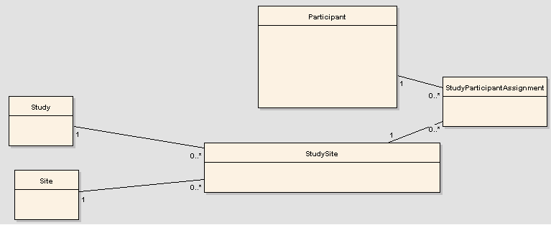

Implementation Model

Data Model

Use Case Realization
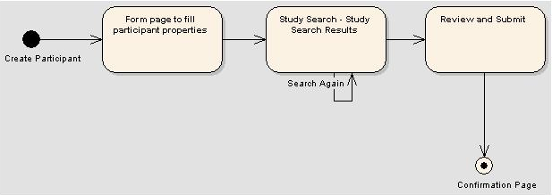

Create Participant

Activity diagram

Assign Participant

Activity Diagram
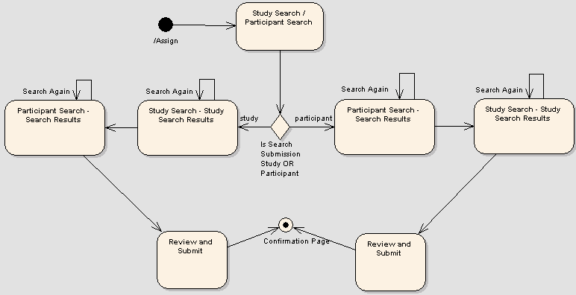

Integration / External Systems

Unit Testing
gov.nih.nci.cabig.caaers.service.ParticipantServiceTest

JUnit
gov.nih.nci.cabig.caaers.service.testdata.ParticipantServiceTest.xml
gov.nih.nci.cabig.caaers.service.StudyServiceTest
gov.nih.nci.cabig.caaers.service.testdata.StudyServiceTest.xml

gov.nih.nci.cabig.caaers.web.NewParticipantControllerTest

Spring Mock Objects
gov.nih.nci.cabig.caaers.web.AssignParticipantControllerTest
.nih.nci.cabig.caaers.web.AssignStudyControllerTest

Integration Testing

Generic Classes

Non Available at this point

Configuration/Build/Deployment
- References

Documentation /Artifacts
SI No | Artifact | Type | Link

- Glossary
Term | Definition

