caAERS – Create Study
Technical Specification

W
Updated Dec 12,2006 2006

Copyright Notice.

Development Team(s)
Development | Technical Documentation | Program Management
Sujith V T | Sujith V T | Edmond Mulaire
Padmaja Vedula | Padmaja Vedula | Vinay Kumar
 |  | Ram Chilukuri

Contacts and Support
Enter training contact
Enter customer support contact

LISTSERV Facilities Pertinent to software teams
LISTSERV | URL | Name

Table of Contents

Table of Contents 5
1 Scope & Purpose 8
2 Overview 9
2.1 Technology Stack 9
2.2 Core Modules 9
2.2.1 Domain Object Layer 9
2.2.2 Views 9
2.2.3 Controllers 10
2.2.4 Commands 10
2.2.5 Service Layer 10
2.2.6 Persistence Layer 10
2.2.7 Utilities 10
2.2.8 10
2.2.9 10
3 Domain Analysis Model 11
4 Implementation Model 12
5 Data Model 13
5.1 Login Authentication 13
5.2 Create Study 14
6 Use Case Realization 14
6.1 LoginAuthentication 14
6.1.1 Activity Diagram 14
6.1.2 Sequence diagram – core/web 14
6.2 Create Study 15
6.2.1 Activity diagram 15
6.2.2 Sequence diagram – core/web 15
7 Integration / External Systems 16
8 Unit Testing 16
8.1 JUnit 16
8.2 Spring Mock Objects 17
8.3 Generic Classes 17
8.4 17
9 Integration Testing 17
10 Configuration/Build/Deployment 17
10.1 Documentation /Artifacts 18

Scope & Purpose
The purpose of this document is to elaborate the implementation design for various modules of caAERS.

Overview

Technology Stack
Operating System | Windows XP/Linux
Java Version | JDK 5.0
MVC framework | Spring MVC 2.0
View Technology | JSP, Tag libraries, Ajax
Ajax Framework
ORM | Hibernate 3.2.1
Transactions, IOC, dependency injection | Spring 2.0
Web Server | Tomcat 5.5.20
Database | Oracle 9i / PostgreSQL
Development Tools | Eclipse 3.2/JBoss IDE 2.0, Enterprise Architect 4.5
Build | Ant
Source Control | SVN

caAERS has a domain driven design with analysis starting from a Bridge Harmonized model. The domain package will be gov.nih.nci.cabig.caaers.domain. The domain objects are persisted using Hibernate and Hibernate 3 annotations will be used for mapping to database elements instead of separate hbm files. These annotations can be configured via Spring’s bean configuration files.

Core Modules

Domain Object Layer
Study : Domain class which captures the new study attributes
caAERS views will be jsps using css, Ajax and Spring tag libraries.

Views

caAERS will use Spring MVC. All the Controller classes for the respective use case will be under the gov.nih.nci.cabig.caaers.web package

Controllers
StudyController : Spring MVC Controller class
All command classes will be under the gov.nih.nci.cabig.caaers.web package

Commands

Service Layer
DAO interface and implementations will be created to facilitate database access. The application will only access the database via a DAO interface object. Each implementation of the dao interface will extend the org.springframework.orm.hibernate3.support.HibernateDaoSupport class.

Persistence Layer
StudyDao : DAO class for persistence and retrieval of the study object.

Domain Analysis Model

Utilities

Implementation Model

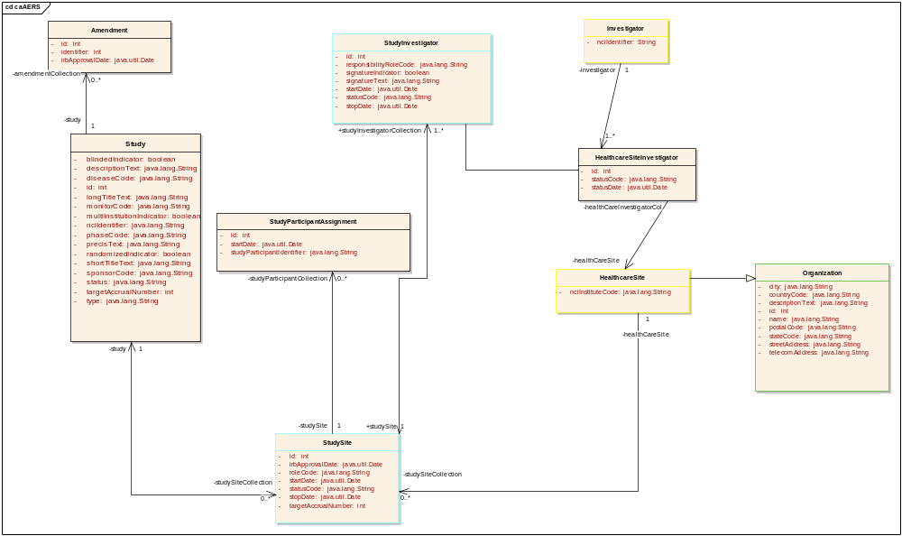

Data Model

Login Authentication
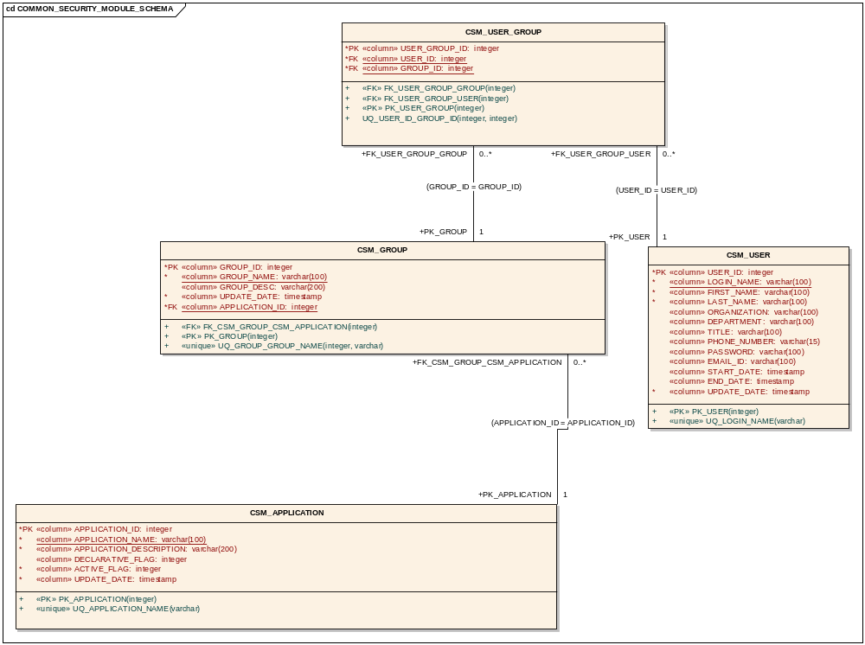
Relevant tables of csm for login authentication

Create Study
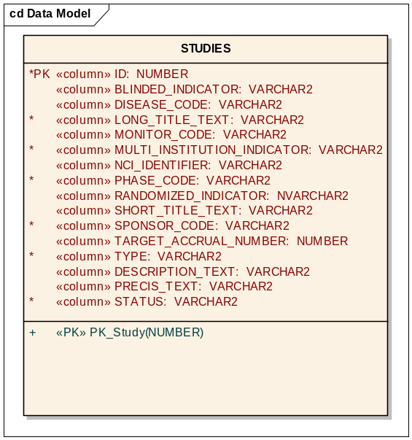

Use Case Realization
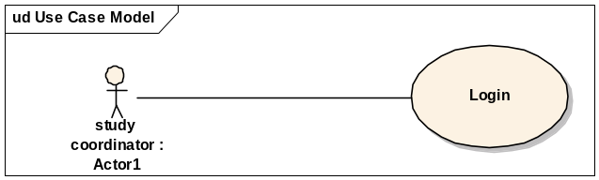

LoginAuthentication

Activity Diagram

Sequence diagram – core/web
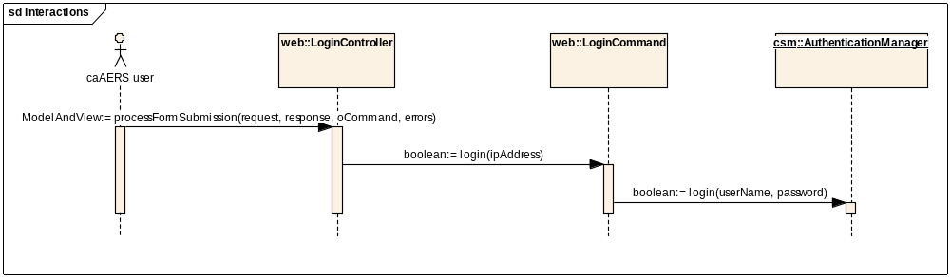
When a caAERS authorized user enter the login credentials on the login page form and submits the form, the processFormSubmission method of the LoginController is invoked. This method calls the login method of the LoginCommand class. The return value of this call is a boolean value of true/false depending on success/failure of the login.
caAERS uses the CSM AuthenticationManager api for login authentication. The LoginCommand passes the username and password provided by the user to the login method of the AuthenticationManager. The return value for this call is boolean true/false for success/failure of authentication. caEARS schema includes the csm schema tables for user profile, authentication and authorization.

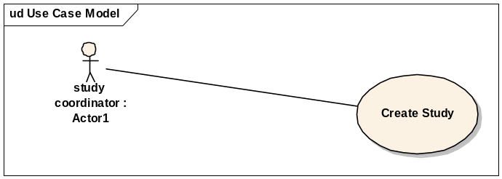

Create Study

Activity diagram
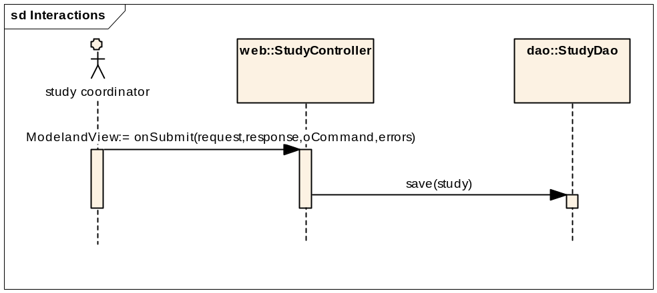

Sequence diagram – core/web
A user with the study coordinator role will have the access rights to create a new study.
When the user enters the study information in the UI form and submits it, the onSubmit method of the StudyContoller is invoked, which acquires the study command object and passes it to the save method of the StudyDao. The StudyDao uses spring HibernateTemplate class to save the study.

Integration / External Systems

None currently

Unit Testing
Core package:

JUnit
StudyDaoTest: test cases –
testGet : Test get study by id
testGetAllStudies : Test get all studies
testSave: Test save a new study object

Web package:
StudyControllerTest : test cases –
testViewOnGet
testViewonSubmit
LoginControllerTest: test cases –
testViewOnGet
testPostWithValidCredentials – tests the view returned if the login credentials are valid. (View returned should be the the success view page)
testPostWithBadCredentials – tests the view returned if the login credentials are invalid. (View returned should be the login page).

Integration Testing

Spring Mock Objects

Generic Classes

Configuration/Build/Deployment
- References

Documentation /Artifacts
SI No | Artifact | Type | Link

- Glossary
Term | Definition

