caAERS v0.8
Admin Guide

( End User Guide)

Document Change History
Version Number | Date | Contributor | Description
V0.7 | Oct. 16, 2007 | Paul Galvin | Up to date with Iteration 7 changes to the Administration module.
V0.8.1 | Oct. 29, 2007 | Paul Galvin | Added rules module and made the manual more consistent with the end user manual.
V08.2 | Nov. 13, 2007 | Paul Galvin | Provided reference and location of the QuickStart Guide.
V08.3 | Dec. 26, 2007 | Jennifer Reed | Updated sections (mainly Rules and Admin), added front material, moved Quick Ref to sep doc


Updated December 21, 2007
Copyright and License page
Copyright 2007 SemanticBits, LLC. This software was developed in conjunction with the National Cancer Institute, and so to the extent government employees are co-authors, any rights in such works shall be subject to Title 17 of the United States Code, section 105.
Redistribution and use in source and binary forms, with or without modification, are permitted provided that the following conditions are met:
1. Redistributions of source code must retain the above copyright notice, this list of conditions and the disclaimer of Article 3, below. Redistributions in binary form must reproduce the above copyright notice, this list of conditions and the following disclaimer in the documentation and/or other materials provided with the distribution.
2. The MedDRA terminology was developed by the International Conference on Harmonisation (ICH) and is owned by the International Federation of Pharmaceutical Manufacturers and Associations (IFPMA) acting as trustee for the ICH steering committee. The MedDRA codeset is not included with the caAERS source code. For information about obtaining and using MedDRA, go to http://www.meddramsso.com.
3. The end-user documentation included with the redistribution, if any, must include the following acknowledgment:
"This product includes software developed by SemanticBits, LLC and the National Cancer Institute (NCI).”
If no such end-user documentation is to be included, this acknowledgment shall appear in the software itself, wherever such third-party acknowledgments normally appear.
4. The names "The National Cancer Institute", "NCI" and “SemanticBits, LLC” must not be used to endorse or promote products derived from this software.
5. This license does not authorize the incorporation of this software into any proprietary programs. This license does not authorize the recipient to use any trademarks owned by either NCI or SemanticBits, LLC.
6. THIS SOFTWARE IS PROVIDED "AS IS," AND ANY EXPRESSED OR IMPLIED WARRANTIES, (INCLUDING, BUT NOT LIMITED TO, THE IMPLIED WARRANTIES OF MERCHANTABILITY AND FITNESS FOR A PARTICULAR PURPOSE) ARE DISCLAIMED. IN NO EVENT SHALL THE NATIONAL CANCER INSTITUTE, SAIC, OR THEIR AFFILIATES BE LIABLE FOR ANY DIRECT, INDIRECT, INCIDENTAL, SPECIAL, EXEMPLARY, OR CONSEQUENTIAL DAMAGES (INCLUDING, BUT NOT LIMITED TO, PROCUREMENT OF SUBSTITUTE GOODS OR SERVICES; LOSS OF USE, DATA, OR PROFITS; OR BUSINESS INTERRUPTION) HOWEVER CAUSED AND ON ANY THEORY OF LIABILITY, WHETHER IN CONTRACT, STRICT LIABILITY, OR TORT (INCLUDING NEGLIGENCE OR OTHERWISE) ARISING IN ANY WAY OUT OF THE USE OF THIS SOFTWARE, EVEN IF ADVISED OF THE POSSIBILITY OF SUCH DAMAGE.
A number of people have made contributions to the development of caAERS. The table below lists the primary developers, subject matter experts, testers, technical writers, and key contributors.
Insert Names of Development Team(s) here
Development | User’s Guide | Program Management
Vinay Kumar¹ | Jennifer Reed¹ | Edmond Mulaire¹
Joshua Philips¹ | Paul Galvin³ | Ram Chilukuri¹
Rhett Sutphin²
Krikor Krumlian³
Srini Akkala¹
Biju Joseph¹
Karthik Iyer¹
Jared Flatow²
Key Contributors
Sharon Elcombe, MA⁴ | Ann Setser⁷ | Lisamarie Schick6
Robert Morrell⁵ | Anne Tompkins⁸ | Christo Andonyadis9
Sonja Hamilton⁴ |  | Warren Kibbe, Ph.D.2
Jennifer Frank⁴ |  | Cal Collins3
Kim Livengood⁵
Steven Cheng⁵
Larry Esser⁴
Renee Webb, MA, CCRC²
David Patton²
¹ SemanticBits ² Northwestern University ³ Akaza Research ⁴ Mayo Clinic ⁵ Wake Forest University ⁶ Booz Allen Hamilton ⁷ CTEP ⁸ DCP ⁹ NCICB

Contacts and Support
Edmond Mulaire | edmond.mulaire@semanticbits.com
caAERS Project Site | http://gforge.nci.nih.gov/projects/caaersappdev/

LISTSERV Facilities Pertinent to software teams
LISTSERV | URL | Name
Caaers-Developers | Caaersappdev-developers@gforge.nci.nih.gov | caAERS Developers Listserv
Caaers-Domain | Caaersappdev-developers@gforge.nci.nih.gov | caAERS Domain Listserv
Caeers-Technical | caaersappdev-technical@gforge.nci.nih.gov | caAERS Technical Listserv

Table of Contents
Chapter 1 Introduction to the Manual 1
Overview of the Guide 1
Audience 1
Organization of this Guide 1
Relevant Documents 2
Document Text Conventions 2
Chapter 2 Overview of the Software 5
Software Overview 5
Components of the Software 5
System Requirements 5
Chapter 3 User Interface 7
Technical Overview 7
User Interface 8
Launching the application 8
Exiting the application 8
Application Workspace 8
Navigation Elements 8
Expanding and Collapsing Windows 9
Help 10
Instructions for the module/task 11
Instructions for a field 11
In-line 11
Online Help 11
Miscellaneous Interface features 11
Auto-complete functionality 12
Search functionality 12
Required Information/Missing information 12
Chapter 4 Administration module 15
Chapter Organization and Content 15
Configuring the Application 16
Configuring caAERS to work with a Mail Server 17
Configuring caAERS to work with CCTS 1.0 17
Investigators 18
Create/Edit Investigator 18
Searching for an Investigator 19
Research Staff 20
Creating an account 22
Searching for an account 22
Import 23
Import MedDRA 24
IND # 25
Creating an IND 25
Searching for an IND 25
Organization 26
Searching for an Organization 26
Creating an Organization 27
Configure Password Policy 27
Chapter 5 Rules module 30
Introduction 30
Manage Rules 30
Select Category 31
Select Ruleset 32
Rules 33
Review 35
List Rulesets 36
Enabling Rulesets 36
Disabling Rulesets 36
Export/Download Rulesets 36
Deleting Rulesets 37
Import Rulesets 37
Create Report Definition 37
Basic Details 38
Report Delivery Details 39
Mandatory Fields 40
Notifications 41
Review 43
List Report Definitions 43
Chapter 6 Advanced Search 45
Overview 45
Study Search 45
Participant Search 45
AE Search 46
Expedited Report Search 46
Routine AE Search 46
Chapter 7 Error Messages/Indicators and Problem Resolutions 49
Error Messages 49
Submission Errors 49
Import Errors 50
Activity Issues 50
System Errors 50
Support 50
Appendix A. References 51
Technical Articles 51
Scientific Publications 51
caBIG Material 51
caGrid Material 52
caCORE Material 52
Appendix B. Glossary 53

Introduction to the Manual
Topics in this chapter include:
- Overview of the Guide
- Audience
- Organization of this Guide
- Relevant Documents
- Document Text Conventions

Overview of the Guide
The caAERS Admin Guide covers general administration tasks for caAERS. These tasks can only be performed by system administrators and site coordinators, so are separated from the general User’s Guide.
Chapters 1-3 of this guide include general information on caAERS and an overview of the user interface. Chapters 4-5 cover admin-specific areas of caAERS and include detailed instructions on performing specific tasks. Chapter 6 provides troubleshooting tips and information.

Audience
This manual is intended for caAERS administrators, both the system administrator and the site administrator (site coordinator). The administrators are responsible for setting up the caAERS system, including adding caAERS users and investigators, importing information from other systems, and creating and maintaining rules.
Administrators are expected to have basic familiarity with caBIG systems and XML files. In addition, if you’ll be doing any work on the server itself, you should be comfortable working with TomCat and Databases.

Organization of this Guide
This guide includes general caAERS information, task-specific steps, and troubleshooting information. The following table briefly describes each chapter.
Chapter | Chapter Contents
Chapter 1 | Introduction to the Guide
Chapter 2 | Overview of the Software
Chapter 3 | User Interface
Chapter 4 | Administration Module
Chapter 5 | Rules Module
Chapter 6 | Advanced Search
Chapter 7 | Errors and Resolutions
Appendix A | References
Appendix B | Glossary
Table 1-1 Chapter Outline of the Installation Guide

Relevant Documents
This Guide addresses Admin tasks for caAERS. Additional information about caAERS can be found in the following documents:
Document | Location
caAERS_QuickStart _Guide | http://gforge.nci.nih.gov/frs/?group_id=249
caAERS_User_Guide | http://gforge.nci.nih.gov/frs/?group_id=249
caAERS_Installation Guide | http://gforge.nci.nih.gov/frs/?group_id=249
Table 1-2 List of relevant documents

Document Text Conventions
The following table shows various typefaces to differentiate between regular text and menu commands, keyboard keys, and text that you type. This illustrates how conventions are represented in this guide.
Convention | Description | Example
Bold & Capitalized Command  Capitalized command > Capitalized command | Indicates a Menu command  Indicates Sequential Menu commands | Admin > Refresh
text in small caps | Keyboard key that you press | Press enter
text in small caps + text in small caps | Keyboard keys that you press simultaneously | Press shift + ctrl and then release both.
Special typestyle | Used for filenames, directory names, commands, file listings, source code examples and anything that would appear in a Java program, such as methods, variables, and classes. | URL_definition ::= url_string
Boldface type | Options that you select in dialog boxes or drop-down menus. Buttons or icons that you click. | In the Open dialog box, select the file and click the Open button.
Italics | Used to reference other documents, sections, figures, and tables. | caCORE Software Development Kit 1.0 Programmer’s Guide
Italic boldface type | Text that you type | In the New Subset text box, enter Proprietary Proteins.
Note: | Highlights a concept of particular interest | Note: This concept is used throughout the installation manual.
Warning! | Highlights information of which you should be particularly aware. | Warning! Deleting an object will permanently delete it from the database.
{} | Curly brackets are used for replaceable items. | Replace {root directory} with its proper value such as c:\cabio
Table 1-3 Document Conventions

Overview of the Software
This chapter provides an overview of the software. Topics in this chapter include:
- Software Overview
- Component of software
- System Requirements

Software Overview
The caAERS (Cancer Adverse Event Reporting System) application is an open source, standards-compliant application designed to collect, assess, and manage adverse events in cancer clinical trials. It is web-based, uses a controlled vocabulary, and enables multiple users to access, search for, and report on Adverse Events (AE), both in-house and to external agencies.
caAERS is a caBIG silver-level compliant module and is interoperable with other caBIG-compliant CTMS components.

Components of the Software
The caAERS application has five modules and a search function. The five modules are:
- Adverse Events
- Studies
- Participants
- Rules
- Administration
Each of the modules is used to collect or provide specific information. Used together, the modules track, maintain, and report any adverse events that occur during a clinical study at any of the participating organizations.
caAERS was developed to integrate with other caBIG-compliant CTMS components. This allows sharing of information across application. In addition, caAERS also has the ability to accept information from other systems by importing XML files containing the information.

System Requirements
caAERS is a web-based application. To access caAERS, your computer must meet the following requirements:
- Internet connection: speed of 56K or faster (broadband) recommended
- Browser: Firefox 1.5 or 2.0, Internet Explorer 7.0 or higher supported
- Display: resolution of 1024 x 768 or better is recommended, 800 x 600 is supported

User Interface
This chapter provides an overview of the software. Topics in this chapter include:
- Technical Overview
- User Interface
- Description of the Interface
- Launching the application
- Exiting the application
- Application Workspace
- Help
- Miscellaneous Interface features

Technical Overview
The caAERS User Interface is built on Java-based software and supported by an Oracle or Postgres database. This application allows a user to enter clinical study information and report adverse events. The following diagram illustrates the caAERS system workflow and relationships to external systems. All bolded boxes are workflows associated with the caAERS system.
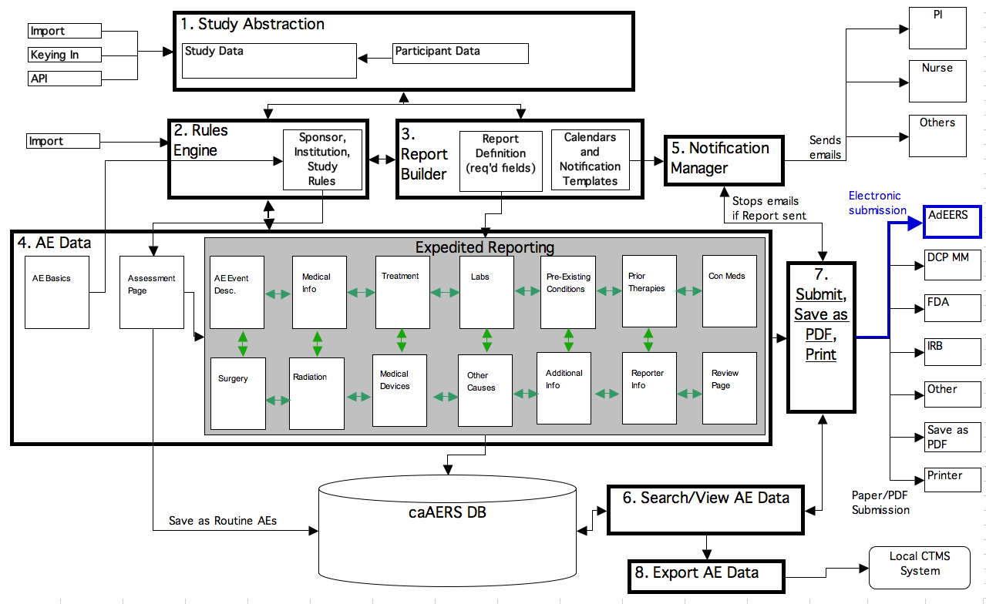

User Interface
caAERs is a web-based application, connected to a database. It was developed to work on all standard operating systems. Security measures include required user accounts and passwords, all controlled within the system.
To access caAERS, it must be installed on a local network. Then an end user connected to the network can launch their browser to access it.
The applications contains all necessary navigation elements, so the browser navigation elements do not need to be, and should not be, used to navigate through the system.

Launching the application
caAERS is a web-based application, so to launch it, just access the web address. From here, you’ll be asked for your username and password to log in. If the username or password is invalid the message, “Incorrect username and/or password. Please try again” appears at the top of the page. If you enter the incorrect username and/or password three times, you will be locked out of the system for a certain amount of time before you can reset your password.

Exiting the application
To exit or logout of the caAERS application, click the logout link located in the top right-hand corner of the window. You can also just close the browser.

Application Workspace

Navigation Elements
Navigation elements of caAERS are found at the top of the page. These include the Navigation Menu (tabs at the top), the Task menu (middle row of links), and the steps menu (bottom arrows). Each page will also contain buttons to help navigate through the tasks.
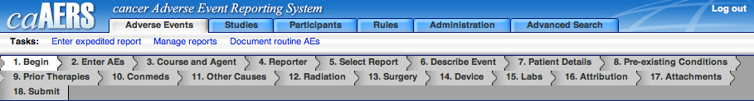

- Navigation Menu: The navigation menu allows access to the modules. To access a module, click on the tab, for example, Adverse Events.
Task Menu: Each module may have multiple tasks associated to it, which are displayed in the Task menu. To access, a task, click on it, for example, Enter expedited report.
- Steps Menu: Some tasks may have multiple steps, which are displayed in the steps menu. The step you are on is highlighted in white, for example, Begin. You can access a step by clicking on it. However, as you use the buttons on the page, it will automatically navigate you through the steps.
- Buttons: Many of the pages have navigation buttons, such as Continue, Update, and Reset.
- Back – When selected, the user will be brought to the previous page. All unsaved data will be lost.
- Continue – When selected, the user will move to the next page of the application. If any information was added to the page, it will be saved.
- Reset Tab – When selected, the information on the current page will be reset to its last saved state.
- Save – When selected, the information on the current page will be saved to the database and the user will stay on the same page.
- Save & Continue – When selected, the information on the current page will be saved to the database and the user will move on to the next page of the application.
- Update – When selected, the information in the current page will be saved and updated, but the user will not move to the next page.

Expanding and Collapsing Windows
Some of the modules and tasks have areas where you can add multiple items. For example, a report can have multiple notifications, and a ruleset can have multiple rules. These areas allow you to collapse the information to provide easier navigation and viewing.
These areas are identifiable by the expanding/collapsing icon in the upper right-hand corner of the area that can expand or collapse. See the screenshot below to see an example of a window collapsed.
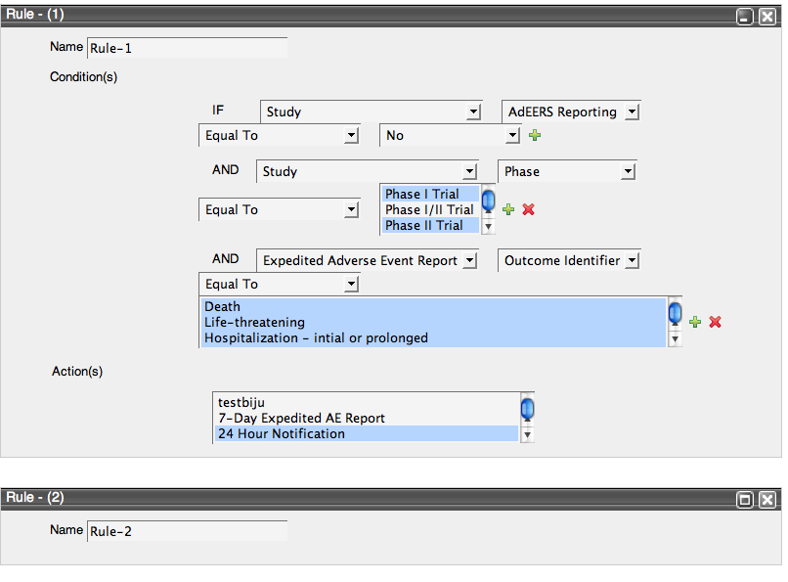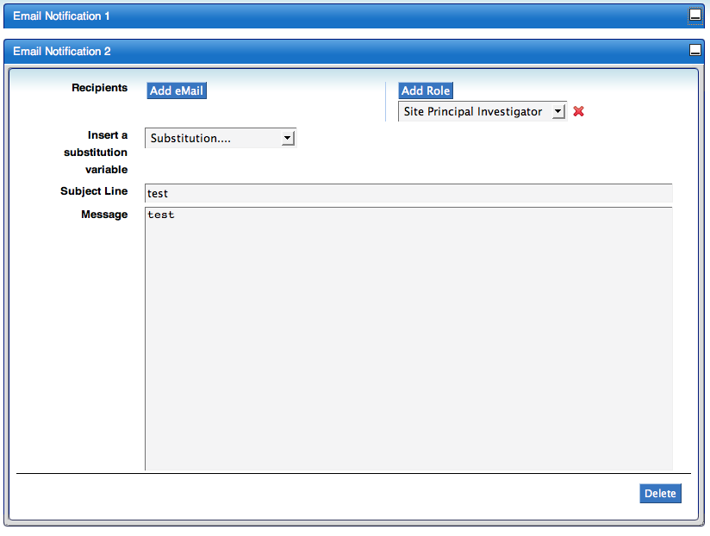

Help
caAERS has three types of help:
- Instructions for the module/task
- Instructions for a field
- In-line

Instructions for the module/task
When you select a module or a task, you will often see instructions at the top of the screening explaining the purpose of the module and what information you needed to supply.
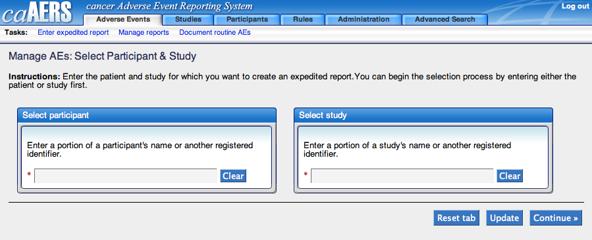

Instructions for a field
Similarly, some fields on a page for a module or task will include instructions concerning the information you need to provide.

In-line
Some fields will not have visible instructions. However, they may have the help icon, , next to the field. If you click on this icon, additional information to help explain what is expected will be provided.

Online Help
Some modules are attached to online help. If this is the case, an icon, , will appear in the top right-hand corner of the page. When you click on the icon it will launch the online help in another browser window or tab.

Miscellaneous Interface features
There are a few other interface features worth noting. These features are:
- Auto-complete functionality
- Search function
- Required fields/missing information

Auto-complete functionality
caAERS was built with an auto-complete function, similar to what you find when using Google search. If a field has auto-complete enabled, it will bring up a list of possible matches when you start to type. For example, if you type can in a field with auto-complete enabled, you will get a list of possibilities such as what’s shown in the picture below.
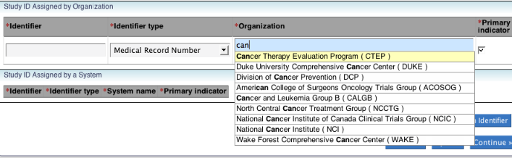
Fields with auto-complete enabled have a blue background while the other fields are grey, making these fields easy to recognize.

Search functionality
There are two main search areas in caAERS, the Advanced Search which has tasks associated to many of the modules and searches associated to tasks. To search for information, choose the appropriate search and then click Search. You can enter something into the search field to narrow down the search, but it is not required.
Once a search is completed, the results are displayed and you can choose the item you want. If there are too many results, there are filter fields for each field displaying, allowing you to further narrow down the results until you find the item you are looking for.

Required Information/Missing information
As you use caAERS, you will find many of the tasks require you to add information before you can save or make changes. Information that is required is identified by a red asterisk (*) to the left of the title (both field and step titles).
If you try to continue without including all required information, you will receive error messages indicating what information is missing. These error messages will appear in two locations, listed together at the top of the page and listed individually under the appropriate field.
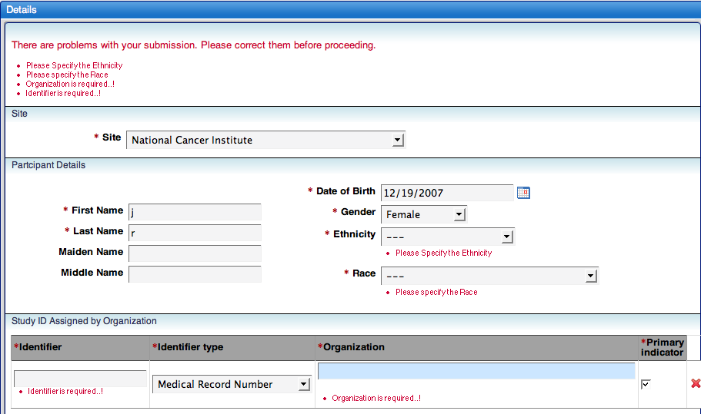

Administration module
Topics in this chapter include:
- Configure caAERS
- Investigator
- Research Staff
- Import
- Import MedDRA
- IND#
- Organization
- Configure Password Policy

Chapter Organization and Content
After caAERS is installed, you need to complete a series of initial setup tasks before the users can fully use caAERSs. These tasks include:
- Configure the Application
- To work with a mail server
- To work as part of the CCTS Suite (optional)
- Add Personnel
- Investigators
- Research Personnel\users
- Import information
- Studies
- Subjects
- Legacy AE data (optional)
- MedDRA vocabulary codeset (optional)
- Add INDs
- Add Organizations\sites
- Configure the Password Policy
Unless otherwise noted, all these tasks are part of the Administration Module. To access the module, click on the Administration tab in the navigation menu.
Note: For security purposes, the Administration module is only accessible by Administrators and Site Coordinators.
For a quick lesson on configuring and setting up caAERS, you can also refer to the caAERS_QuickStart _Guide.

Configuring the Application
caAERS is installed with empty configuration information. You will need to use the Configure caAERS task to configure caAERS to work with a mail server and with CCTS, if desired. All configuration is done on a single page, as shown below.
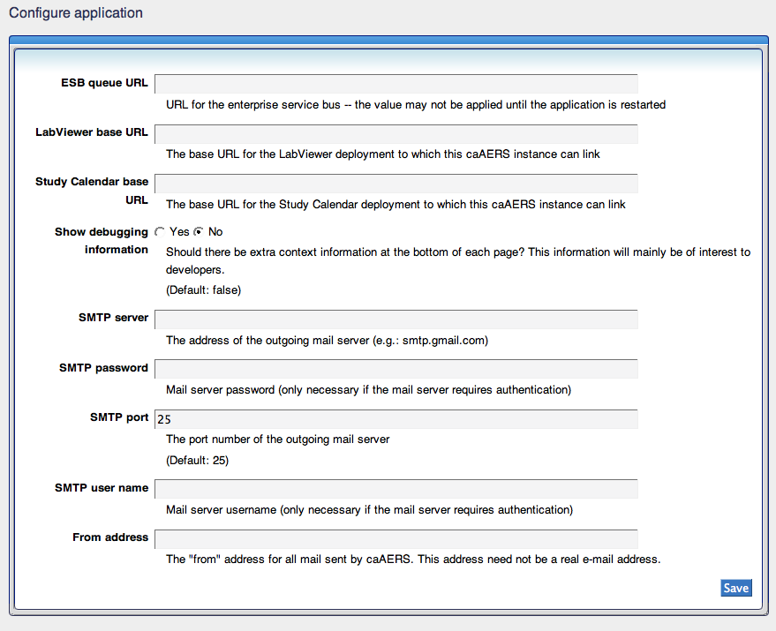
The following table describes each field and notes whether its for mail server configuration or CCTS 1.0 configuration.
Field Name | Description/Notes | Mail Server config | CCTS 1.0 config
ESB queue URL | End point URL for accessing the CCTS ESB component |  | Required for ESB
LabViewer base URL | URL for accessing the CCTS LabViewer component |  | Required for Labviewer
Study Calendar base URL | URL for accessing the Patient Study Calendar (PSC) application (allowing you to place AEs on the calendar) |  | Required for PSC
Show debugging information | Only necessary if you’re interested in development
SMTP server | Address of your outgoing mail server, for example, smtp.gmail.com | Required
SMTP password | Server password used to send mail; it is only necessary if the mail server requires authentication | Sometimes required
SMTP port | Port used to send mail; this defaults to 25, but can be changed if you use a different port to send outgoing mail | Required
SMTP user name | Server user name; it is only necessary if the mail server requires authentication | Sometimes required
From address | Email address to be displayed in the “from” field of all mail sent from caAERS; this does not have to be a valid email address | Not required, but useful
Note: There is one field on this page that is not related to either mail server or CCTS configuration. This field is for developers only.

Configuring caAERS to work with a Mail Server
The caAERS application relies on being able to send emails – for alerts, reminders, and submission of some reports. In order to successfully send emails, caAERS must be set up to use a working Mail Server. To configure caAERS to work with your mail server:
- Click Configure caAERS
- Enter {SMTP server}
- Enter {SMTP password}, if required
- Enter {SMTP port}, if different than 25
- Enter {SMTP user name}, if required
- Enter {from address}, if desired
- Click Save
Note: if you do not provide information for your SMTP mail server, you will not be using caAERS full capabilities.
Note: You may need to restart the server before all the changes are recognized.

Configuring caAERS to work with CCTS 1.0
If you plan to use caAERS as a module in the caBIG Clinical Trials Suite, you will need to complete the steps outlined in this section. If you will be using caAERS as a standalone application, you can leave these fields blank. To configure caAERS to work with CCTS:
- Click Configure caAERS
- Enter {ESB queue URL}, if desired
- Enter {LabViewer base URL}, if desired
- Enter {Study Calendar base URL}, if desired
- Click Save
Note: You may need to restart the server before all the changes are recognized.

Investigators
The Investigators tasks allows you to create Investigators and associate them to studies. It also allows you to search the system for Investigators to see if they are already in the system and/or associated to their studies. Investigators who are added to caAERS can receive email alerts and report submissions.

Create/Edit Investigator
- Click Investigator to bring up the create/edit investigator page
- Enter the {first name}
- Enter the {middle name} if desired
- Enter the {last name}
- Enter the {NCI Identifier} if desired
- Enter the {email address}
- Enter the {phone number}
- Enter the {fax number} if desired
- Enter the {organization}; this field will auto-complete for you
- Select Inactive or Active
- If the Investigator works with another Organization, click Add Organization and repeat steps 9 and 10
- Click Save
Note: If you want an Investigator to be able to log into caAERS, you will also need to add the Investigator to caAERS as a Research Staff/User. To do this, please see Research Staff.
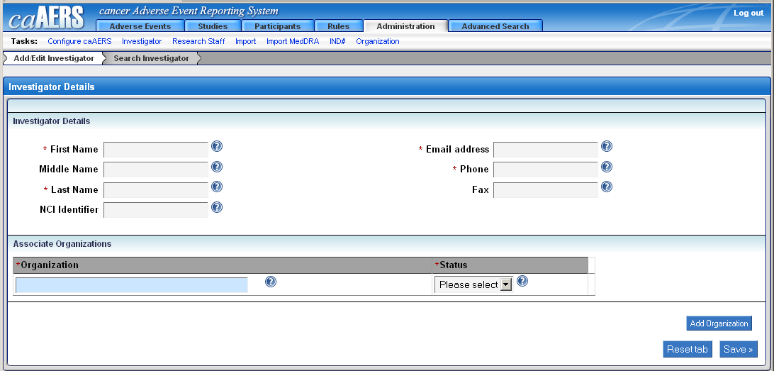

Searching for an Investigator
- Click Search Investigator from the Investigator task
- Enter {search criteria} in the First Name, Last Name, and/or the NCI Identifier field and then click Search
Note: You can also just click Search to list all Investigators
- The Investigators available will be listed. You can further refine the search by typing something in any of the Name filter fields and/or the NCI Identifier filter field and then click Filter
- To view the description and/or make changes to the investigator, click on {the investigator}
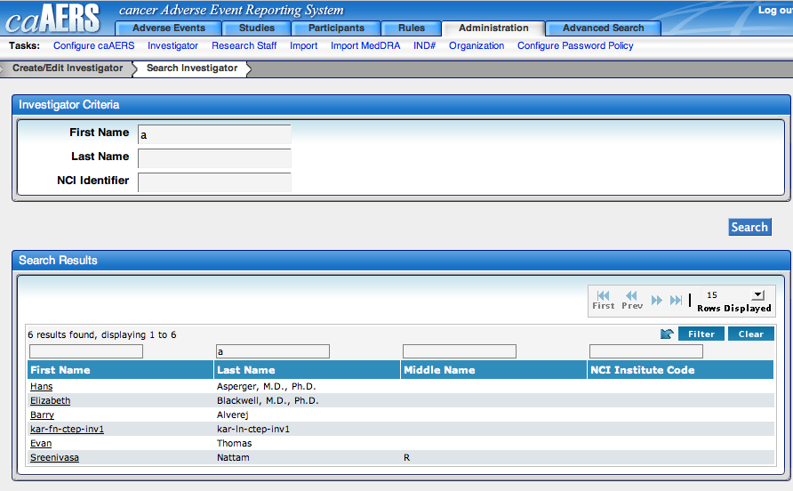

Research Staff
All users of the caAERS system have accounts, although their access rights vary. The Research Staff Page allows you to create the user accounts.
Access to the different areas of caAERS is controlled by the user roles and each user can be assigned to multiple roles. These roles are:
- Participant Coordinator – Provides access to the Adverse Events, Studies, and Participants modules; the user can document AEs and create reports, studies, and participants
- Study Coordinator – Provides access to the Studies module; the user can review studies, AEs, and expedited reports
- Adverse Event Coordinator – Provides access to the Adverse Events module; the user can view and report AEs for studies they are assigned to
- Site Coordinator – Provides access to the Adverse Events, Studies, Rules, and Administration modules; the user can report AEs, create studies, set up rules, and have access to administrative features of the application
Note: the only tasks the site coordinator doesn’t have access to are creating participants, documenting AEs, and entering reports
The following matrix shows what modules and tasks a user role has access to. . If there is a √ in the box, it means that role has access to that task

 | System Admin | Site Coordinator | Study Coordinator | AE Coordinator | Participant Coordinator
AE Module
View AEs | √ | √ (for assigned studies) | √ (for assigned studies) | √ (for assigned studies) | √ (for assigned studies)
Create/Edit AEs | √ |  |  | √ (for assigned studies)
Studies Module
Create/Edit | √ | √ | √ |  | √ (for assigned studies)
View | √ | √ | √ |  | √ (for assigned studies)
Participants Module
Create and Assign/Edit | √ |  |  |  | √ (for assigned studies)
View | √ | √ |  |  | √ (for assigned studies)
Rules Module
Create/Edit Rules | √ | √
View Rules | √ | √
Create/Edit Report Defs | √ | √
View Report Defs | √ | √
Administration Module
Create/Edit Users | √ | √
Create/Edit Investigators | √ | √
Import Studies/Subjects | √ | √
Import AEs | √ | √
Import Participants | √ | √
Import MedDRA | √ | √
IND # | √ | √
Create/Edit Organizations | √ | √
Configure Password Policy | √ | √

Creating an account
- Click Research Staff to access the Create Investigator page
- Type the {organization}
- Enter the user details
- Select the User Role(s) and click Save

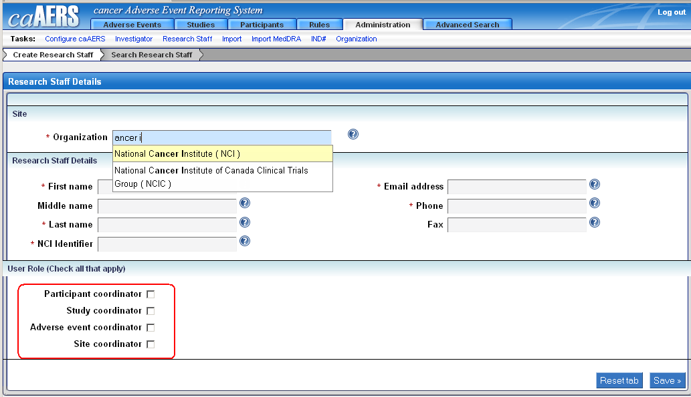
Both the user name and password are case sensitive. The user name will be what was entered in the Email Address field and the default password will be what was entered in the Last Name field.
Note: If the user forgets their password, he/she can reset it by clicking Reset Password on the login window.

Searching for an account
- Click Search Research Staff from the Research Staff task
- Enter {search criteria} in the First Name, Last Name, and/or the Organization field and then click Search
Note: You can also just click Search to list all Investigators
- The users will be listed. You can further refine the search by typing something in any of the Name filter fields and/or the Organization filter field and then click Filter
- To view the description and/or make changes to the user, click on {the user}
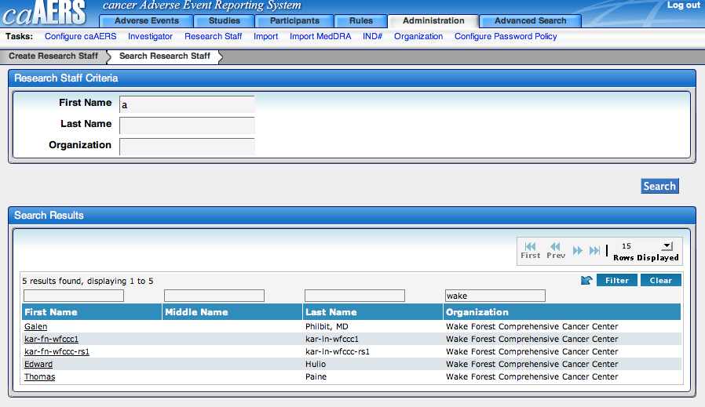

Import
Studies, participants, and routine AEs can be imported into caAERS. This means if you’ve previously used other applications and databases to maintain this information, an import will alleviate the need to manually enter the individual pieces of information.
To import studies, participants, or AEs, create valid XML files from the information in your existing application/database. Create separate XML files for each type of data (studies, participants, and AEs). Combining everything into a single XLM file will cause the import to fail. To review copies of the XSD files and sample XML files, go to https://gforge.nci.nih.gov/svnroot/caaersappdev/docs/import/.
To import the studies, participants, or routine AEs:
- Create an XML file containing the information you want to import
- Select the Import task from the Administration Module
- Click on Import {type}
- Click Browse to locate and select the XML file that contains the information, then select Save & Continue
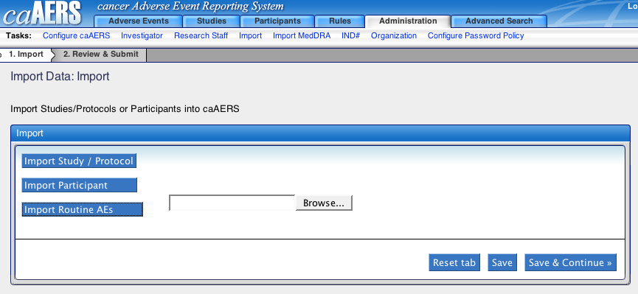
- The system will validate the XML file and show a synopsis of what will be imported on the Review and Submit page; if the information looks correct, click Save; depending on the size of the file, this could take minutes to hours to complete
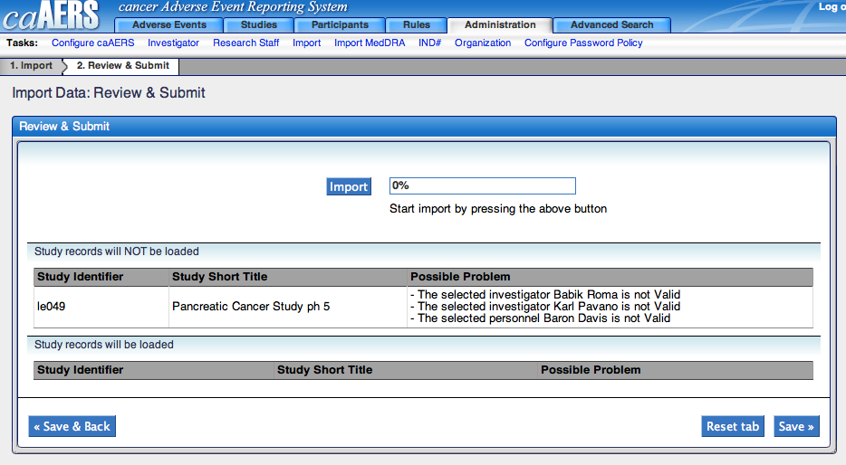
- To verify the information imported correctly, use the search task in the Adverse Events, Studies, or Participants Module.

Import MedDRA
The caAERS installation includes the CTC vocabulary. CTC is a free open-source medical vocabulary that can be used to code clinical studies. An alternative to CTC is MedDRA terminology. If your organization uses MedDRA, the vocabulary can be imported into the application. Currently, only MedDRA versions 9.0, 9.1, and 10.0 are supported.
MedDRA is stored in several ASCII (.asc) files. If the file format you try to import does not mach the allowed format, the import will fail.
To import MedDRA files:
- Locate the folder where MedDRA is stored
- Click Import MedDRA
- Enter {the full path} into the field provided and click Import MedDRA
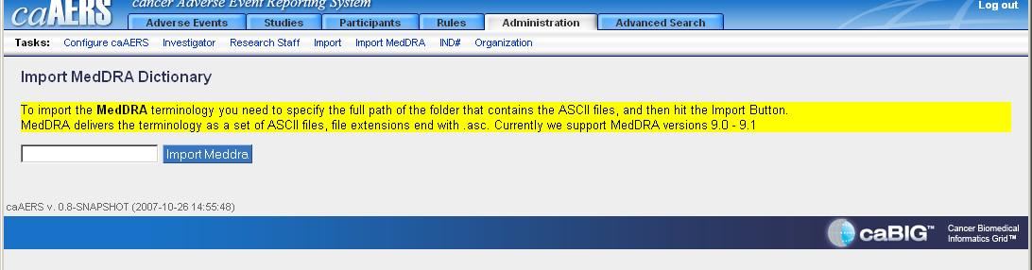

IND #
Investigational new drugs (IND) can be added in caAERS for use in studies. By adding the IND information, adverse events related to a particular IND can be tracked more efficiently.

Creating an IND
- Type the {IND #}
- Select {who holds the IND}
- Type the {IND Holder} and click Save
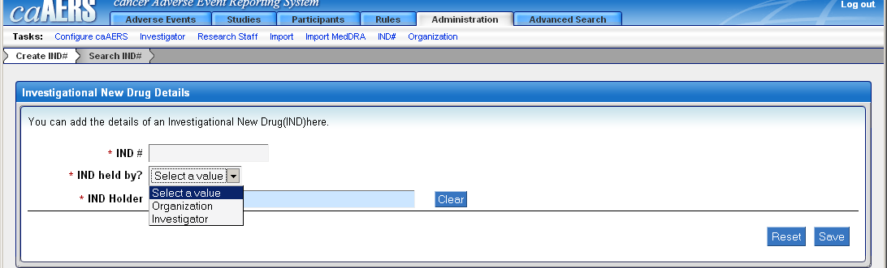

Searching for an IND
- Click Search IND from the IND# task
- Enter {search criteria} in the IND # and/or the IND holder field and then click Search
Note: You can also just click Search to list all INDs
- The INDs will be listed. You can further refine the search by typing something in the IND # and/or the Sponsor holder filter fields and then click Filter

Organization
An Organization can be a site, a sponsor, or any institution associated with clinical trials and is a required field to add investigators and research staff. caAERS includes a large list of organizations as part of the basic install. If needed, additional organizations can be added to the list.

Searching for an Organization
Since Organizations are included in the installation, you should first search caAERS for the organization before you add it. To search for an organization:
- Click Organization > Search Organization to bring up the Search Organization page
- Enter {search criteria} in the Name and/or the NCI Identifier field and then click Search
Note: You can also just click Search to list all Organizations
- The Organization available will be listed. You can further refine the search by typing something in the Name and/or the NCI Identifier filter area and then click Filter
- To view the description and/or make changes to the organization, click on {the organization}
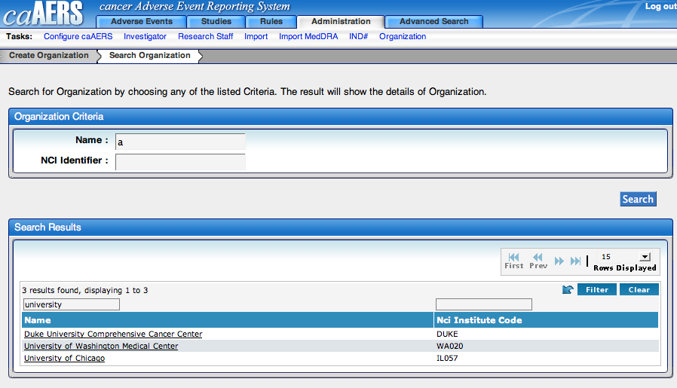

Creating an Organization
- Click Organization to open the Create Organization page
- Enter the {name}
- Enter the {NCI Identifier}. The NCI Identifier is the primary id used by NCI.
- If you want to provide additional details, enter the {description}.
- Click Save to create the organization or Reset to clear information from all the fields.
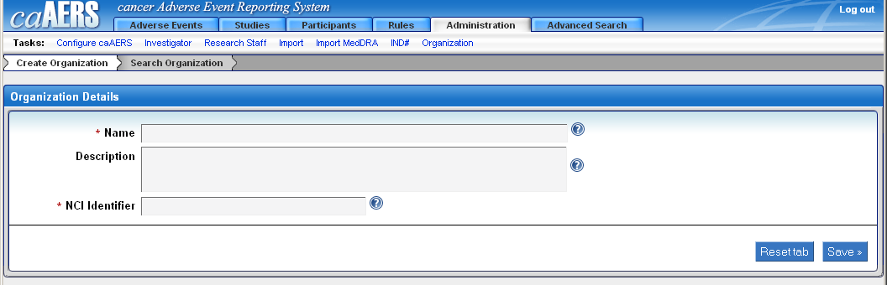

Configure Password Policy
caAERS allows you to create specific rules regarding the creation of user passwords. This creates a more secure environment and allows you to control the level of security for user passwords. To configure the password policy:
- Click Configure Password Policy
- Enter {maximum password age} – this determines how long a user can keep a password before having to reset it
- Enter {number of allowed failed login attempts}
- Enter {lockout duration} – this determines how long a person is locked out of the system after entering the wrong password the number of allowed times
- Enter {minimum password age} – this prevents a user from recreating their password numerous times in a row to go back to the same password
- Enter {password history size} – this determines how many past password you keep in the system for a user
- Enter {minimum password length}
- Select {complexity requirements}
- Enter {largest substring of username allowed} – this prevents users from having their password too similar to their user name
- Click Save
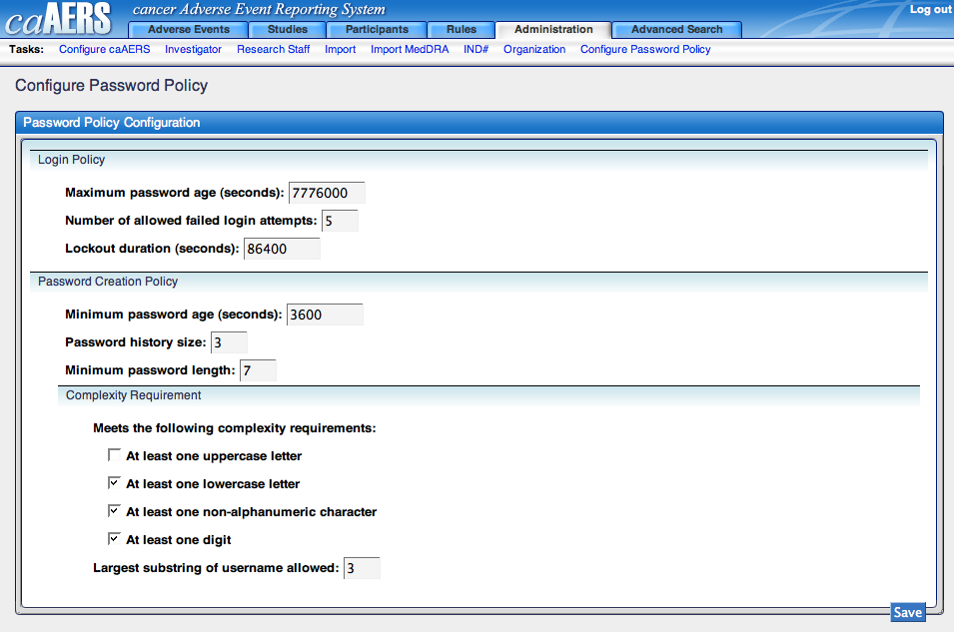

Rules module
Topics in this chapter include:
- Introduction to the Rules Module
- Creating Rules
- Listing Rules
- Importing Rules
- Creating Report Definitions
- Listing Report Definitions

Introduction
To help organizations stay in compliance with AE reporting regulations, the caAERS application comes loaded with a full complement of industry-standard AE reports, including the FDA MedWatch 3500A form, the CTEP AdEERS reports, and the NCI-DCP SAE form. In addition, the caAERS system features a powerful, state-of-the-art rules engine, which can capture a range of sponsor, institution, and protocol-level reporting requirements. Using these rules, caAERS can automatically determine if an adverse event requires expedited reporting and when and to whom the report must be submitted -- for any of an organization's trials.
To use caAERS, you must first set up a set of rules and report definitions. The rules and report definitions used by caAERS can be authored within the application itself or imported from a library.
This section describes the Rules Module, which allows you to:
- Create new rules
- View and modify existing rules
- Import rules from other sources
- Create and modify reports

Manage Rules
There are four categories (or Rule Levels) for rules:
- Sponsor
- Institution
- Sponsor defined for a study
- Institution defined for a study
Each category can have multiple rulesets associated to it. At this time, there are two rulesets:
- SAE Reporting Rules
- Mandatory Sections Rules
Each of these rulesets can then have one or more rules associated to it. The following diagram shows this visually.
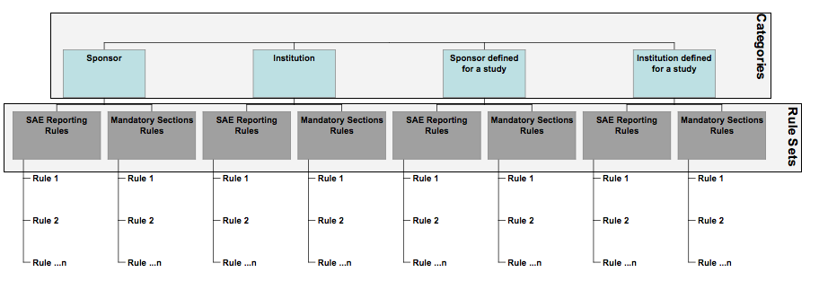
To provide a specific example, If you’re entering rules for the Sponsor Wake Forest, it could have an SAE Reporting Ruleset and a Mandatory Sections Ruleset, each with their own rules. Another Sponsor, DCP might only have the SAE Reporting Ruleset, and it’d be completely separate from Wake Forest.
The creation process is broken into four sections:
- Select Category (Rule Level)
- Select Ruleset
- Create Rules
- Review

Select Category
The first step for creating rules is determine what category the rule falls in. You do this on the Select Rule Set page. As discussed in the introduction, there are four different categories to choose from:
- Sponsor
- Institution
- Sponsor defined for a study
- Institution defined for a study
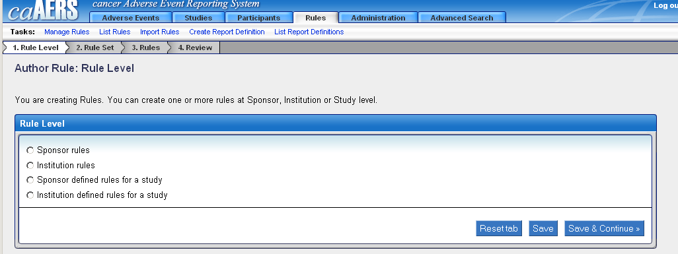
- Select the radio button associated with the rule level you want to use
- Enter information into the fields that appear (the auto complete feature is available). This may mean you’re entering {a Sponsor} or {an Institute}, with the possibility of entering {a study}
- Click Save & Continue
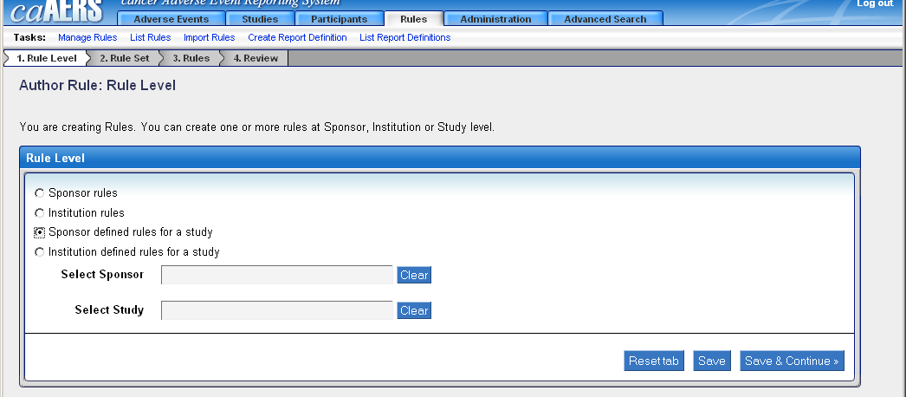

Select Ruleset
The next page allows you to select the rulesets to use. It will display any existing rulesets associated with the rule level you selected. You have the option to select an existing ruleset or create a new ruleset.

Existing Rulesets
If you chose Sponsor defined for a study or Institution defined for a study, and you’ve already went through the process for Sponsor or Institution rules, some of the information may already exist.
Note: Remember, there are only two Rulesets to choose from, and you can only have one of each type. So, if there’s an existing Ruleset, any changes you make to the rules will override what currently exists, not create a separate Ruleset.
- Select the radio button next to an existing Ruleset.
- Click Save & Continue.
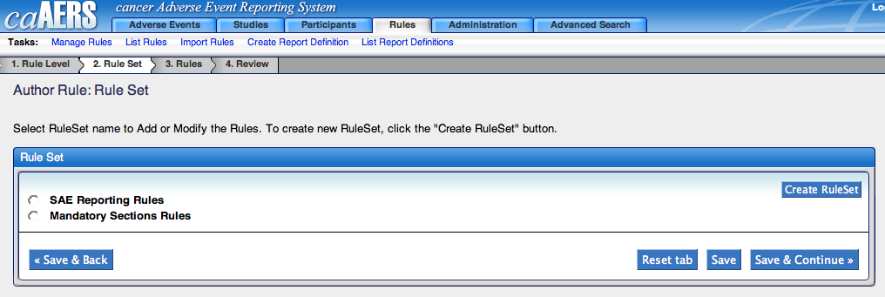

No existing Rulesets
- Click Create RuleSet
- Select one of the options from the RuleSet Name field
- Click Save & Continue
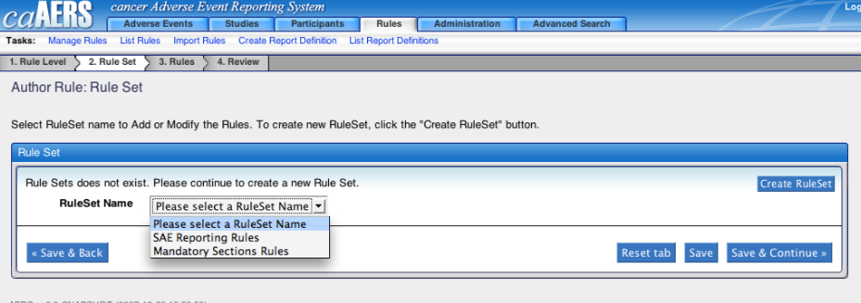

Rules
On the Rules page you will add rules to the Ruleset.
Note: If you chose an exiting Ruleset for the Sponsor or Institution category, it’s possible that rules are already associated with it. Any changes you make will override what currently exists, not create a separate Ruleset.
Note: If you chose an existing Ruleset for the Sponsor defined for a study or Institution defined for a study category, the Rulesets for the corresponding Sponsor or Institution category are automatically included so you don’t have to reenter the information. You can then add or delete rules. These changes will only affect the ruleset associated with the Sponsor defined for a study or Institution defined for a study category, not for the original Sponsor or Institution category.
- Click Add Rule to bring up a form which will allow you to define the rules that go with the Ruleset.
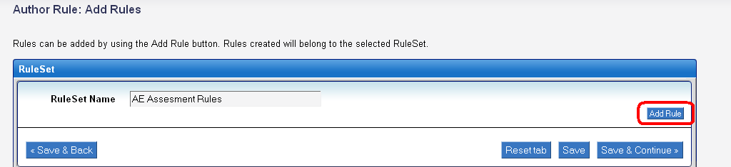
- Select Adverse Event, Study, or Report Definition from the Domain Object drop-down menu.
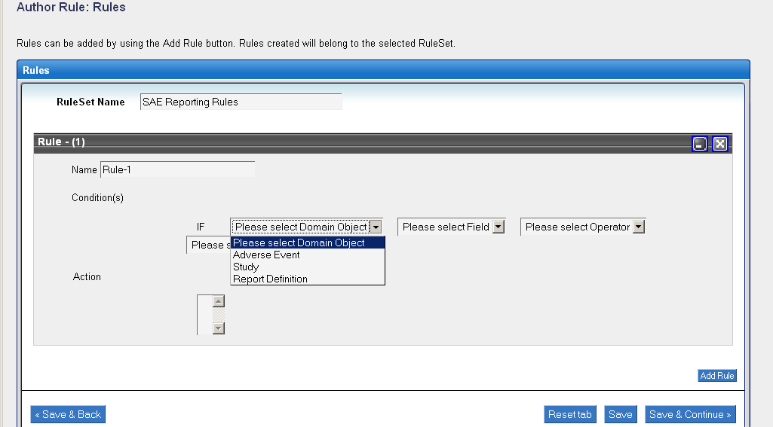
- Select an option from the Field drop-down menu. The options available are dependent on what was selected as the Domain Type.
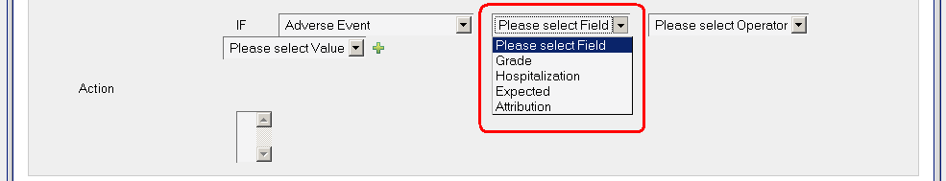
- Select an option from the Operator drop-down menu . This menu will always list Equal to and Not Equal to, and depending on your previous selections, may also list Greater Than or Equal To and Less Than or Equal To.
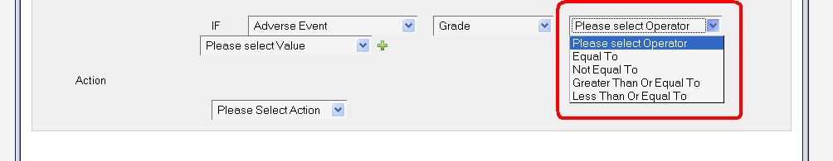
- Select a value from the Value drop-down menu. The options will vary based on the Domain Object and Field selects.
- If there are additional conditions you want to assign to this Rule, click on the Plus () icon and repeat steps 2-5.
Note: All of the conditions listed must be met for the Action to be completed. If you don’t require all the conditions to be met, create a separate Ruleset.
Note: You can remove conditions by clicking on the Red x () icon.
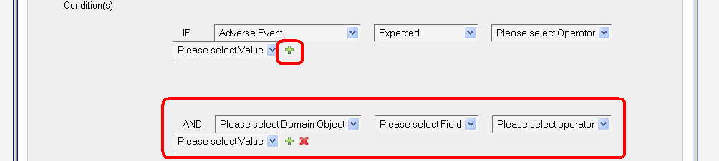
Else
- Select an option from the Action box.
- To continue, click Save & Continue. To add another rule, click Add Rule and then repeat steps 1-7. To delete a rule, click the icon, , in the right-hand corner of the rule.

Review
The Review page allows you to review and verify the information before saving the ruleset. Click the Save button to save the rule you’ve created, or click Save & Back to go back and make changes.
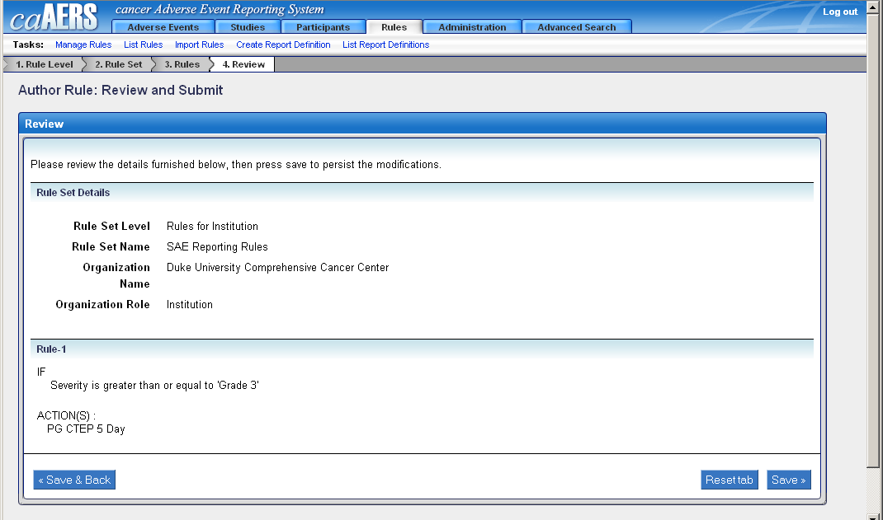
All new rules sets are given the status of Disabled. To modify the ruleset, including its status, go to the List Rulesets Module.

List Rulesets
The List Rules page displays all Rules that exist in the system. For each Ruleset, you can view the Level, the Organization, the Study, and the Status. You can also choose to Enable, Disable, or Delete the Ruleset, or Export/Download the Ruleset to an XML file.
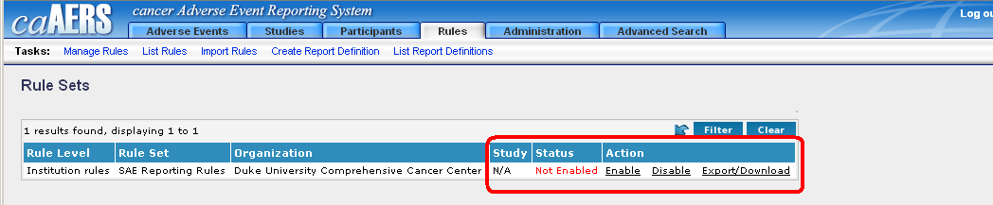

Enabling Rulesets
Rulesets may have a Status of Not Enabled, such as newly created Rulesets. To enable a ruleset, click Enable from the Action column.

Disabling Rulesets
If you don’t want a ruleset to be active anymore, you can disable it by clicking Disable from the Action column.

Export/Download Rulesets
You have the ability to export the ruleset to XML files. To export a ruleset, click Export/Download from the Action column.

Deleting Rulesets
If the ruleset is no longer valid, you can delete it by clicking Delete from the Action Column.

Import Rulesets
You can import existing rulesets into caAERS. This is an easier and faster way to set up rules in caAERS.
At present, there is a small set of existing rules covering the baseline reporting rules for most CTEP sponsored trials. New rulesets are being developed and added to this library. Copies of these existing rulesets can be obtained from the caAERS Gforge project site, http://gforge.nci.nih.gov/projects/caaersappdev/.
.
To import rulesets:
- Click Browse to locate and select the XML file that contains the ruleset
- Click Import
- If the import was successful, you will receive the message “Rules imported successfully”. If it was not successful, you will receive a message telling you to contact the system administrator.
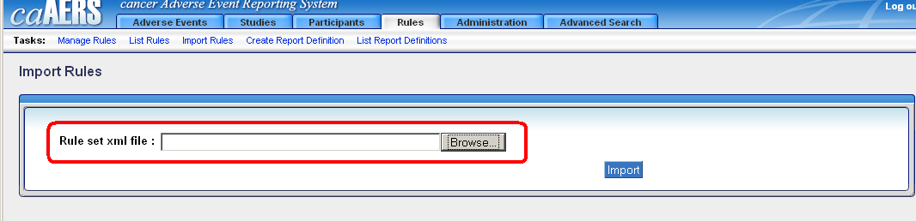

Note: Although it is possible to create rulesets for imporiting using an XML authoring tool, we recommend against presently. Rulesets that are to be imported into caAERS should be obtained from the caAERS ruleset library or else should be created in caAERS using the Ruleset XML export feature.

Create Report Definition
Report definitions are the backbone of caAERS, identifying what information is required in a report and who receives the report. The report definitions you create will be used when defining rules for your rulesets. Creating a report definitions is done in five steps:
- Basic Details – enter the general information for the report
- Delivery Details – enter who receives the report
- Mandatory Fields – enter what information ins mandatory
- Notifications – enter reminders for the report
- Review – review the settings for the report

Basic Details
The Basic Details page has you setup the general information for the report. A “*” next to a field means it is required information.
- Enter the organization in the Organization field.
- Type a name in the Name field. Keep the name simple but descriptive.
- Add a description if you want to add more information for the report.
- Select Yes or No for Amendable. This field defaults to Yes, which means the report can be added to.
- Select Yes or No for Attribution required. This field defaults to No. If you change it to Yes, it means any time an AE is reported on, it must be related to an attribute..
- Select a value for Time Scale UOM (unit of measurement). This value tells you the measurement of time before the report is due.
- Enter a number for Time Till Report Due. This number is associated with what you selected for Time Scale UOM, and determines the specific measurement for when the report is due. For example, if you chose Days for Time Scale UOM, and then entered 5 here, you’re saying the report will be due 5 days after the AE occurs.
- To add delivery information, click Continue. To reset the information and start over, click Reset.
Note: If you navigate from this page to a different area of caAERS without completing the entire report definition process, all information will be lost, even if you have clicked Update or Continue.

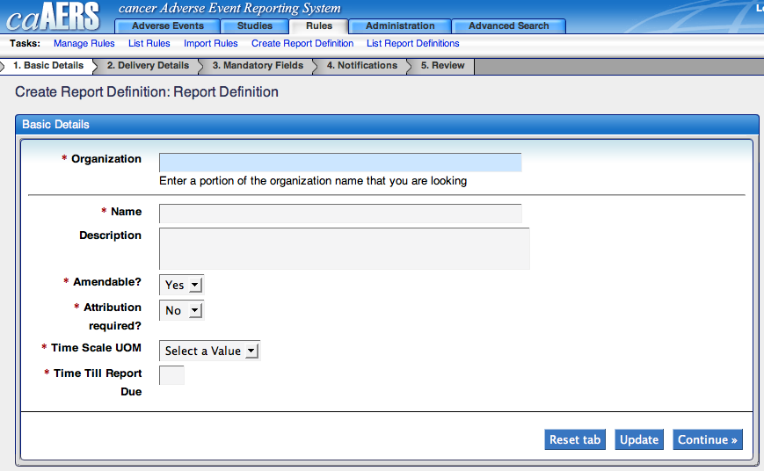

Report Delivery Details
The delivery details allows you to setup recipients of this report. The report can be sent to a specific email address, a role, or a URL. Reports sent to email addresses and roles are sent as PDF files while reports sent to URLs go through as XML files.
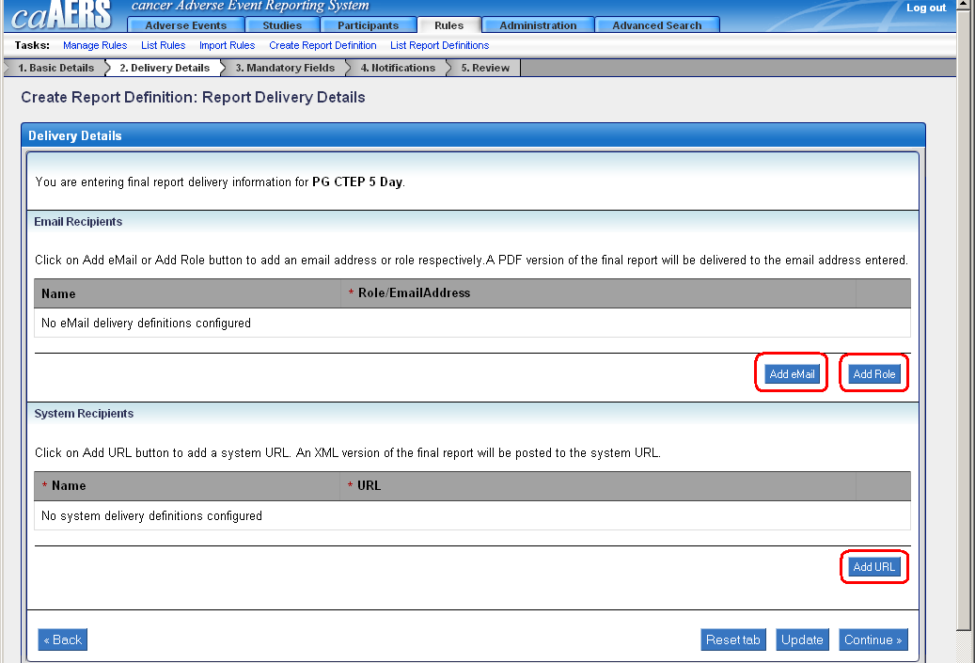

Send to email
- Click Add Email.
- Type {name} in the Name field. This can be the recipient’s name or another way to identify the role.
- Type {the email address} in the Role/Email Address field.
- If at any time you want to remove information you’ve added, click the Delete button that corresponds to the information you want to remove. To add mandatory information, click Continue. To reset the information and start over, click Reset.

Send to role
- Click Add Role.
- Type {name} in the Name field. This can be the recipient’s name or another way to identify the email address.
- Select {the role} from the Role/Email Address field.
- If at any time you want to remove information you’ve added, click the Delete button that corresponds to the information you want to remove. To add mandatory information, click Continue. To reset the information and start over, click Reset.

Send to url
- Click Add URL.
- Type {name} in the Name field. This can be the recipient’s name or another way to identify the URL.
- If the site requires a username and password to access it, enter the information in the Username and Password fields.
- Type {the URL} in the URL field.
- If at any time you want to remove information you’ve added, click the Delete button that corresponds to the information you want to remove. To add mandatory information, click Continue. To reset the information and start over, click Reset.

Mandatory Fields
The mandatory fields page allows you to select the specific information that must be included in the report. The sections are based on the sections of the expedited report, where you will enter the information into the appropriate fields
To make a field a required field when creating an expedited report, select the checkbox associated with it on this page. Once you have completed your selections, click Continue to add notifications. To reset the information and start over, click Reset.
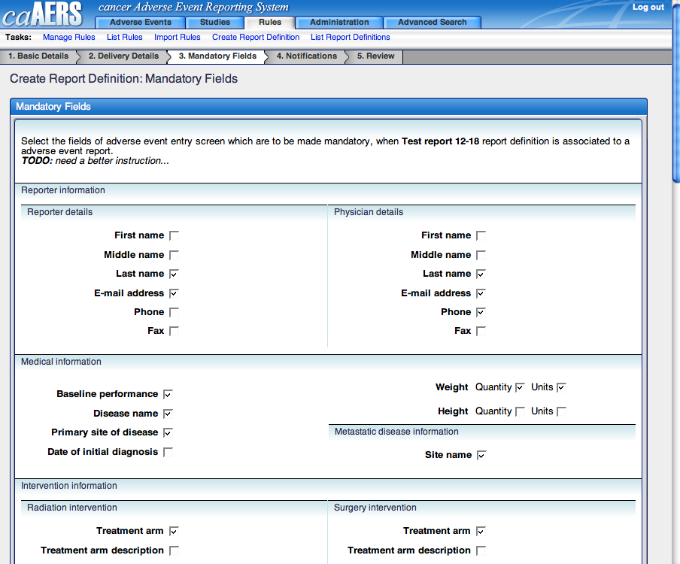

Notifications
Notifications can be set up to send reminders to people about the report. Multiple reminders can be created for the same report, reminding people that the report is almost due or informing them the report is past due.

Adding a notification
- Select {number} from the Time Scale. For example, if your report is due on Day 5 (as selected on the Basic Details page), you could select 2 to send a reminder three days before the report is due.
- Add a recipient. Click Add Email to enter {email address} or click Add Role to select {a role} from the list. You can add multiple recipients to the notification.
- Type {a subject line}. To add a variable, place your cursor where you want the variable to appear, then select {the variable} from the variable list.
- Type the body of the message in the Message field. To add a variable, place your cursor where you want the variable to appear, then select {the variable} from the variable list.
- Click Reset to clear the information, Delete to completely remove the notification, or Continue to review the report.
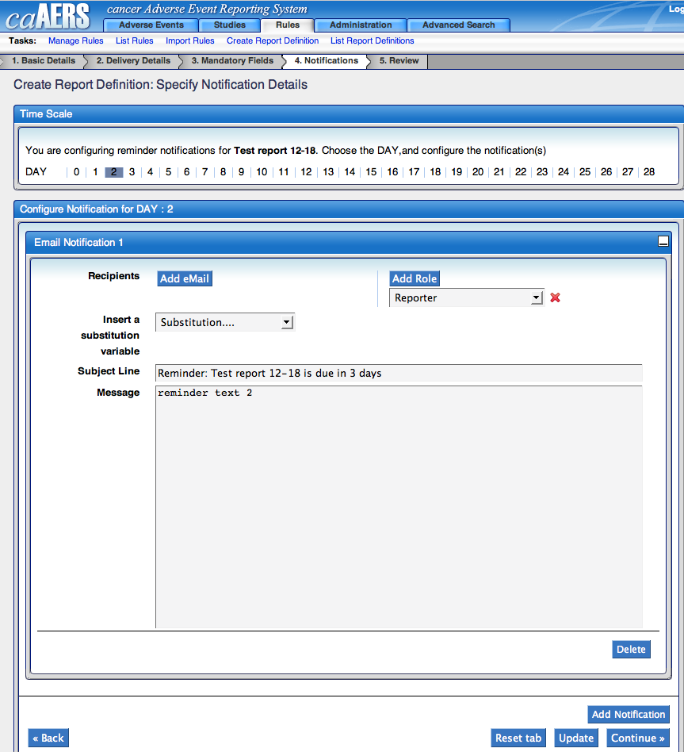

Adding additional notifications for the same time period
You can have multiple notifications sent out for the same Time Period. For example, you could have two different notifications being sent three days before the report is due. To do this, click Add Notification and a second Email notification will appear in the same area.
Note: The notifications can be minimized by clicking on the minimize icon ().
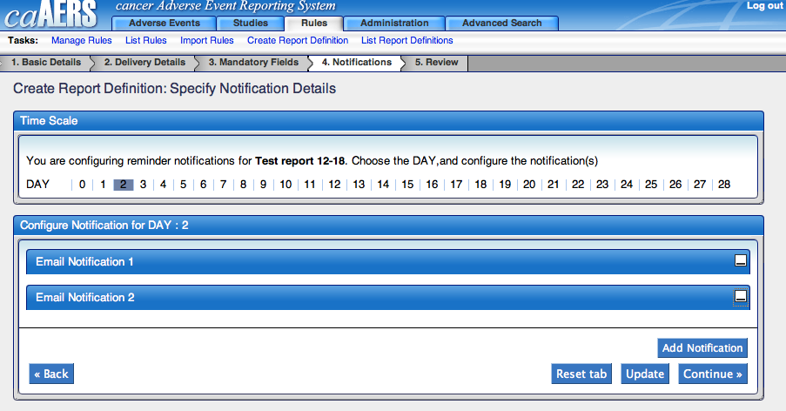

Adding notifications for a different time period
If you want to add a notification for a different time period, for example, the day after the report was due, select a new {number} from Time Scale. The notifications you’ve previously created will be saved and the page will only show notifications setup for the new time select. From here, follow the steps for Adding a notification.

Review
The Review pages allows you to review the Report Definition you’ve created. If the information is correct, click Save. If you want to make changes, click Back to return to previous sections and made your changes.

List Report Definitions
The list report definition page displays all the report definitions that have been created in caAERS. This page shows some general information about the definition, including the name, description, organization it is for, and when the final report is due.
To see more information about the report definition, click on the {report definition name}. This will open the definition in create/edit mode.

Advanced Search
Topics in this chapter include:
- Overview
- Study Search
- Participant Search
- AE search
- Expedited Report search
- Routine AE search

Overview
The Advanced Search module enables a user to quickly search and locate different information in caAERS. Different users will have access to different search tasks, based on the roles they were assigned.
Each of the search tasks work the same way as the searches in the other modules. The following sections provide step-by-step instructions on using these search options.

Study Search
The study search allows the user to locate a particular study, searching by study or participant information. To search for a study:
- Click Study search from the Advanced Search module
- Enter {search criteria} in any of the fields of the Study Criteria box, the Participant Criteria box, or both and then click Search
Note: You can also just click Search to list all Studies
- The Studies available will be listed. You can further refine the search by typing something in the Primary ID, Short Title, Sponsor, Phase, and Status filter fields and then clicking Filter
- To view the study and/or make changes to it, click on {the study’s Primary ID}

Participant Search
The participant search allows the user to locate a particular participant, searching by study or participant information. To search for a participant:
- Click Participant search from the Advanced Search module
- Enter {search criteria} in any of the fields of the Study Criteria box, the Participant Criteria box, or both and then click Search
Note: You can also just click Search to list all Participants
- The Participants available will be listed. You can further refine the search by typing something in the Primary ID, First Name, Last Name, Gender, Race, Ethnicity, and Associated Study ID(s) filter fields and then clicking Filter
- From here, you can view the associated study and/or make changes to it by clicking on {the study’s ID}

AE Search
The AE search allows the user to locate an AE, searching by AE, study, or participant information. To search for an AE:
- Click AE search from the Advanced Search module
- Enter {search criteria} in any of the fields of the AE Criteria box, Study Criteria box, the Participant Criteria box, or all three and then click Search
Note: You can also just click Search to list all Participants
- The AEs available will be listed. You can further refine the search by typing something in the Study ID, Sponsor, AE Type, CTC Category, CTC Term, Grade, MedDRA Code, and Start Date filter fields and then clicking Filter

Expedited Report Search
The Expedited Report search allows the user to locate a report searching by expedited report, study, or participant information. To search for an expedited report:
- Click Expedited Report search from the Advanced Search module
- Enter {search criteria} in any of the fields of the Expedited Report Criteria box, Study Criteria box, the Participant Criteria box, or all three and then click Search
Note: You can also just click Search to list all Participants
- The expedited reports available will be listed. You can further refine the search by typing something in the Primary Ctc term, Grade, Attribution, Start Date, Study ID, and Participant ID filter fields and then clicking Filter
- From here, you can view the associated study or participant and/or make changes to it by clicking on {the study’s ID} or the {the participant ID}

Routine AE Search
The Routine AE search allows the user to locate a Routine AE report, searching by Routine report, study, or participant information. To search for a routine AE report:
- Click Routine AE search from the Advanced Search module
- Enter {search criteria} in any of the fields of the Routine Report Criteria box, Study Criteria box, the Participant Criteria box, or all three and then click Search
Note: You can also just click Search to list all Participants
- The Routine AE reports available will be listed. You can further refine the search by typing something in the Primary Ctc term, Grade, Attribution, Observation Dates, Study ID, and Participant ID filter fields and then clicking Filter

Error Messages/Indicators and Problem Resolutions
Topics in this chapter include:
- Error messages/Issues
- Support

Error Messages
caAERS has been setup to provide descriptive messages whenever it encounters a problem.
- submission errors
- import issues
- activity issues
- system errors

Submission Errors

I get an error when I try to save or continue
As you go through the modules and try to save changes, you may forget to add information and receive an error. The error will state what information is missing.

I get an error when I try to go back to a previous step
caAERS is setup to check a page for all required information before moving to the next step. If you want to go to a previous step, you may receive an error on the previous page about missing information. This is just the information it expected to be entered before you went back. At other times, it may not allow you to go back until you fill out the required fields (the information will be saved when you come back to the page).

Import Errors
When importing XML files, you may receive error messages. The message could mean some of the information won’t be imported if you continue, or it could prevent the import completely. If you receive an error during an import, verify the file is the correct format and doesn’t contain the wrong information. If it is and you still have issues, contact the support team.

Activity Issues

I was taken back to the log on page
caAERS automatically logs out inactive accounts. If you’ve been inactive and then you try to access a module or click on a button, it’ll have you log back in before accessing the module. You will lose any unsaved information.
caAERS will automatically log you out after approximately 30 minutes of idle time.

I had to start over while entering information
If you went idle while entering information across multiple pages, such as an adverse event, you may lose your information because the system automatically logged you out. To verify the information is lost, you can use the advanced search feature to search for the partially created report, study, etc.

System Errors
You may run into a system error. If this happens, save contact the support team. They may request the detailed error information, so either save the website or copy the information.

Support
To get support when you have issues, please check the caAERS Project site, http://gforge.nci.nih.gov/projects/caaersappdev/ or contact support at edmond.mulaire@semanticbits.com.
- References

Technical Articles
- Foundations of Object-Relational Mapping: http://www.chimu.com/publications/objectRelational/
- Object-Relational Mapping articles and products: http://www.service-architecture.com/object-relational-mapping/
- Hibernate Reference Documentation: http://www.hibernate.org/hib_docs/reference/en/html/
- Basic O/R Mapping: http://www.hibernate.org/hib_docs/reference/en/html/mapping.html
- Java Programming: http://java.sun.com/learning/new2java/index.html
- Javadoc tool: http://java.sun.com/j2se/javadoc/
- Extensible Markup Language: http://www.w3.org/TR/REC-xml/
- XML Metadata Interchange: http://www.omg.org/technology/documents/formal/xmi.htm

Scientific Publications
- Cancer Therapy Evaluation Program, “Common Terminology Criteria for Adverse Events, Version 3.0", ctep.cancer.gov/forms/CTCAEv3.pdf
- Cancer Therapy Evaluation Program, “Adverse Event Expedited Reporting System (AdEERS)", ctep.cancer.gov/forms/CTCAEv3.pdf
- Cancer Therapy Evaluation Program, “CTEP, NCI Guidelines: Adverse Event Reporting Requirements", http://ctep.cancer.gov/reporting/newadverse_2006.pdf
- Division of Cancer Prevention, “DCP Serious Adverse Event Reporting Procedures and Guidelines, http://dcp.cancer.gov/clinicaltrials/management/consortia/step-3/adverse
- Division of Cancer Prevention, “DCP Serious Adverse Event Reporting Form, http://dcp.cancer.gov/Files/clinical-trials/sae_guidelines.doc
- FDA, “The FDA Safety Information and Adverse Event Program”, http://gforge.nci.nih.gov/projects/ccts/

caBIG Material
- caBIG: http://cabig.nci.nih.gov/
- caBIG Compatibility Guidelines: http://cabig.nci.nih.gov/guidelines_documentation
- caBIG Clinical Trial Suite Project Site: http://gforge.nci.nih.gov/projects/ccts/

caGrid Material
- caGrid: http://www.cagrid.org/mwiki/index.php?title=CaGrid

caCORE Material
- caCORE: http://ncicb.nci.nih.gov/core
- caBIO: http://ncicb.nci.nih.gov/core/caBIO
- caDSR: http://ncicb.nci.nih.gov/core/caDSR
- EVS: http://ncicb.nci.nih.gov/core/EVS
- CSM: http://ncicb.nci.nih.gov/core/CSM
- Glossary
The following is a list of terms and their definitions that you may find useful as you work with caAERS.
Term | Definition
API | Application Programming Interface
caArray | cancer Array Informatics
caBIG | cancer Biomedical Informatics Grid
caBIO | Cancer Bioinformatics Infrastructure Objects
caCORE | cancer Common Ontologic Representation Environment
caDSR | Cancer Data Standards Repository
caMOD | Cancer Models Database
cardinality | Cardinality describes the minimum and maximum number of associated objects within a set
CSM | Common Security Module
CTEP | Cancer Therapy Evaluation Program
CUI | Concept Unique Identifier
CVS | Concurrent Versions System
EVS | Enterprise Vocabulary Services
GAI | CGAP Genetic Annotation Initiative
HTTP | Hypertext Transfer Protocol
JDBC | Java Database Connectivity
JET | Java Emitter Templates
JMI | Java Metadata Interface
JSP | JavaServer Pages
LLT | Lowest Level Term
MedDRA | Medical Dictionary for Regulatory Activities
metadata | Definitional data that provides information about or documentation of other data.
multiplicity | Multiplicity of an association end indicates the number of objects of the class on that end may be associated with a single object of the class on the other end
NCI | National Cancer Institute
NCICB | National Cancer Institute Center for Bioinformatics
OIL | Ontology Inference Layer
OilEd | Ontology editor allowing you to build ontologies using DAML+OIL
PT | Preferred Term
SQL | Structured Query Language
SSC | Special Search Categories
UML | Unified Modeling Language
UMLS | Unified Medical Language System
UPT | User Provisioning Tool
URL | Uniform Resource Locators

Index
It is very easy to generate an index and extremely helpful to the manual user. See the Style Guide (https://cabig.nci.nih.gov/working_groups/Training_SLWG/Documents/Technical_Pubs_Style_Guide_021405_jbh.pdf) for suggestions for inserting index markers and generating an index.
Note: You may need to check the font size of your index text. The index font in the template has been configured as Times New Roman, size 10, but MS Word is subject to some bugs. While size 10 font is configured, some text may display as size 9 (as you can see in the following index). To manually correct the font size, select the entire index and select Format > Font, and choose Font Size 10. Each time you update your index, however, you will need to re-verify the font size.

Glossary, 17
References
caBIG materials, 15
caCORE material, 15
scientific publications, 15
technical manuals, guides, 15
Text conventions, Supplement, 3

