

Quarterly Adoption and KC Support Outline Report

The caBIG® Adverse Event Management System
subcontract number: 28xs108
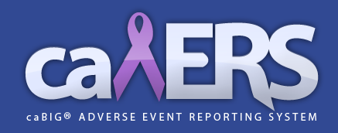

Submitted by Paul Baumgartner
paul.baumgartner@semanticbits.com

Submitted: 03/10/2011

The updates regarding system adoption and support to the Knowledge Center are included in the monthly status reports, available at the following url: https://ncisvn.nci.nih.gov/svn/caaersappdev/docs/Status_Reports

