caAERS Application Development
Communications Plan

Submitted By: Edmond Mulaire, SemanticBits, LLC
Date: December 8, 2006
Document Version: 1.01

DOCUMENT CONTROL

Change Record
3
Date | Author | Version | Change Reference
12/8/06 | Edmond Mulaire | 1.00 | No Previous Document
12/13/06 | Edmond Mulaire | 1.01 | Updates to WS Mentors and Adopters POC

Reviewers

Name | Position

Approved By

Date | Name | Position

TABLE OF CONTENTS

DOCUMENT CONTROL ii
Change Record ii
Reviewers ii
Approved By ii
1.0 INTRODUCTION 1
1.1 Project Background 1
1.2 Purpose of Document 1
1.3 Document Organization 1
2.0 Project Stakeholders 2
2.1 Primary and Secondary Stakeholders 2
2.2 Stakeholder Interests and Membership 2
3.0 Communications Strategy 4
3.1 Tier 1 – Project Team Communications 4
3.2 Tier 2 – Communications with Elaborators 5
3.3 Tier 3 – Communications with Sponsors 5
3.3.1 Status Reporting 6
3.3.2 Budget/Financial Reporting 6
3.4 Tier 4 – Communications with caBIG Community 6
4.0 Communications Matrix 7

INTRODUCTION

Project Background
The goal of this project is to develop and to deploy an adverse event reporting system that is nationally scalable with a robust architecture to meet the needs of the caBIG™ Community. The caAERS requirements, data model, and use cases developed during Release 1 will be the foundation for this effort. The Developer Team will execute Elaboration, Construction and Transition Phase activities for this project. The project will be carried out using the Agile Unified Process Framework, emphasizing continuous integration, testing, and risk management. Two Adopters, Wake Forest and The Mayo Clinic, have been assigned and funded by caBIG™ and their input and collaboration throughout this project is critical to the timely release of functional software. The Developer Team will work closely with these Adopters, and any additional adopters identified by NCICB, and the Adverse Events Special Interest Group to ensure the deliverables of this project will meet the needs of the caBIG™ Community.

Purpose of Document
The caAERS development effort requires the involvement of multiple organizations and varying levels of interaction to ensure a successful product is produced. The purpose of this document is to identify the key stakeholders and to describe the principle methods and tools that will be used in this project for ensuring effective communications among the Stakeholders.

Document Organization
This document contains the following sections:
- Project Stakeholders
- Communications Strategy

Project Stakeholders
There are a number of groups that can be identified as stakeholders in this project.

Primary and Secondary Stakeholders
Primary Stakeholders play a direct role in elaboration, module development, and testing during this project. Secondary stakeholders have strong interests in and influence over the project but will not be regularly involved in the development or testing of the caAERS module.

Primary Stakeholders
- Development Team (SemanticBits, Northwestern University, Akaza Research)
- Funded Adopters (Mayo Clinic and Wake Forest)
- AE SIG and CTMS Workspace
- Cross-cutting Workspaces (VCDE and Architecture)

Secondary Stakeholders
- Cancer Centers
- Other NCI Funded Programs
- National Cancer Institute (NCI)
- NCI Center for Bioinformatics (NCICB)
- Booz Allen Hamilton (BAH)

Stakeholder Interests and Membership
The Primary Stakeholders will be directly involved in project elaboration, development, and testing. The following three Primary Stakeholders have been identified for this project: The Development Team, Funded Adopters, and CTMS WS and SIGS (in particular, the AE SIG).

- Project/Development Team
The caAERS application development team is made up of three organziations (SemanticBits, Northwestern University, and Akaza Research). The team is organized into three groups: Project Management, Functional, and Technical. The members of the project team are listed in the table below.
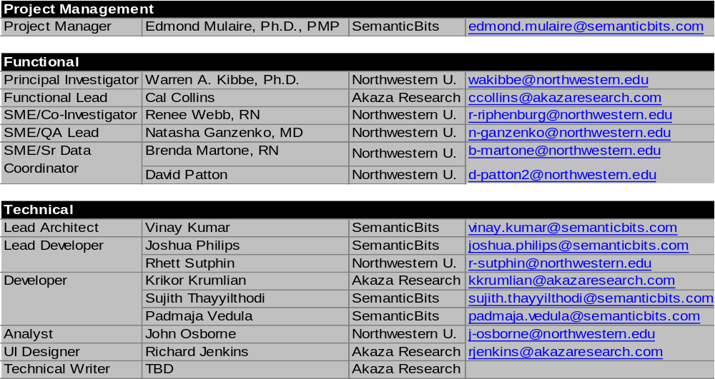

- Funded Adopters
The project will begin with two funded adopters. There is a possibility that additional funded adopters will be added to the project at a later date.

- Wake Forest
Wake Forest is a funded adopter of caAERS and will be involved in elaboration, testing, and adoption. The following are the key POCs for this team:
- Bob Morrel: Lead Elaborator, Lead Adopter
- Kimberly Hill Livengood: Domain Expert
- Xhiquiang Cheng: Technical Expert

- Mayo
Mayo is a funded adopter of caAERS and will be involved in elaboration, testing, and adoption. The following are the key POCs for this team:
- Sharon Elcombe: Lead Elaborator
- Diane Parkin: Domain Expert
- Rammohan Deeduvanu: Technical Expert

- Clinical Trial Management Systems: Adverse Event Reporting SIG
The AE SIG has a special interest in the caAERS application and will be an integral collaborator on this project. The primary POCs for the AE SIG are:
- Joyce Nyland
- Susan Pannoni

4. Cross-cutting Workspaces
The VCDE and Architecture Workspaces will play an important role in the elaboration and testing phases of the project. Representatives from these workspaces will assist with requirements and project artifact reviews.

VCDE WS Mentors and POCs
- Brian Davis
- Lynne Wilkens

Architecture WS Mentor and POC
- Michael Keller
- Pankaj Agarwal

Communications Strategy
To assist with the broad-based communication needs of this project, the following tools will be used:

- GForge
The caAERS team will use the GForge project collaboration environment for managing project communications, for project document version control, and as the interface to the source control tool for managing code for the caAERS project. Subversion will be used as the SCM tool for this project.
The caAERS project can be access on GForge at http://gforge.nci.nih.gov/projects/caaersappdev/ or by browsing the GForge Project Tree. The caAERS project is categorized on this tree under the following branches: caBIG>CTMS>CTMS WS Projects.
The PM, Lead Architect, and Lead Developer will act as the primary caAERS project GForge administrators.

- Listservs
The caAERS project will use the following listservs to facilitate communications:
Caaersappdev-developers@gforge.nci.nih.gov
Caaersappdev-domain@gforge.nci.nih.gov

The caAERS Project Team will take a four-tiered approach to communications to best match the needs and interests of the different Stakeholder groups. The four tiers are listed below:
- Tier 1: Project/Developer Team Communications
- Tier 2: Communications with Elaborators
(This group includes Funded Adopters, AE SIG, CTMS WS Members and Mentors)
- Tier 3: Communications with Sponsors
(BAH/NCICB)
- Tier 3: Communications with caBIG™ End Users

Tier 1 – Communications within Project Team
Internal project communications are vital to the success of AUP-based projects. The team will therefore engage in close, daily communications and interaction using email, ad hoc meetings, listservs, and a variety of other tools.

In addition, the team’s Lead Architect and Lead Developer will hold a weekly team meeting with the full development team to ensure that project goals are being met in a timely fashion. These meetings will be held every Monday at 11:00 am – 12:00 pm.

Event | Group(s) | When | Method
Weekly Developers Meeting | Technical Team, Functional Team, PM | Weekly, Mondays, 11:00am – 12:00pm (Eastern) | Teleconference
Ad Hoc Meetings | Technical Team, Functional Team, PM | As Needed | Method to be determined on a per meeting basis.

Tier 2 – Communications with Elaborators
The success of the caAERS project depends critically on full participation from Elaborators. The Elaborators group is made up of many different teams and organizations. For our project, the Elaborators are drawn from the Primary Stakeholders group and include the following:
- Funded Adopters
- AE SIG
- CTMS WS

Communications with Elaborators will handled in a hierarchical way. A primary point of contact (POC) will be identified for Elaborator group, team, or organization. Typically, this will be a PI or PM at each group. Requests from the caAERS team for document reviews, use case elaboration, or requirements analysis will be made to each POC. Requests from the POC will then filter down through the hierarchy to the lead elaborators and to the domain experts (see Figure 1).
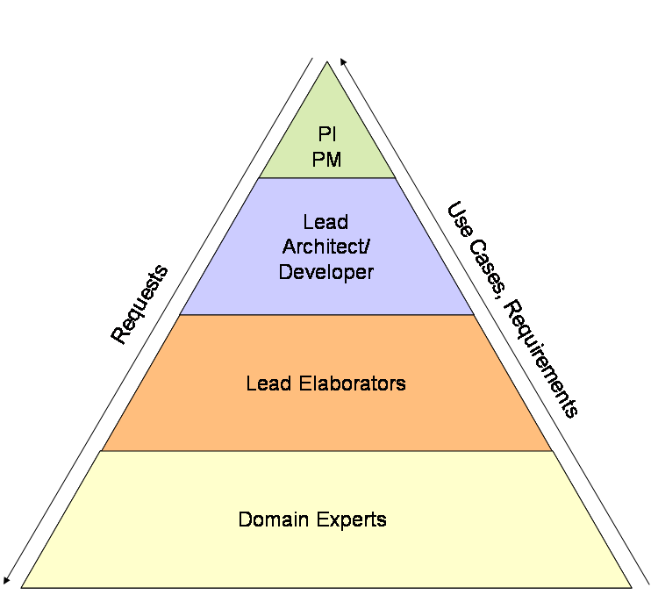
Figure 1: Communications Flow at Each Adopter or Collaborator Site

A bi-weekly teleconference will be held between project management, the lead architect, the lead developer, and lead elaborators, and domain experts. It is expected that each lead elaborator will manage requests and tasks for their team, collect feedback, and present it back to the group (either verbally or in documentation form).

Tier 3 – Communications with Sponsors
This section describes the caAERS team’s plans for formally managing communications with BAH and NCI management. At this tier, our primary goals are as follows:
- To present progress reports and discuss high-level scope, feature, and design decisions.
- To discuss deliverables, risks, and critical issues.

The caAERS project team will communicate with BAH and NCI formally using the following:
- Bi-Weekly Status Meetings
- Monthly Status Reports
- Bi-Weekly Risk Matrix Update

In addition to these formal means of communication, the caAERS team will communicate project status and issues to BAH and NCI on an ad hoc and informal basis. In addition, it is anticipated that the project sponsors will participate, as needed, in the project’s various team meetings and activities.

Tier 4 – Communications with caBIG Community
This section describes plans for managing communications with the end users and larger caBIG community. Domain Experts will act as the ambassadors for the end users and will be expected to represent the needs and requirements of this critical group of stakeholders over the course of the project. The Domain Experts will also take the lead in formulating the ‘take-home message’ of the initial work of the caAERS project to the targeted stakeholders at the caBIG™ Annual Meeting.

Communications Matrix
Event | Primary Group(s) | When | Method and Tools
Developer Team Meeting | Developers | Mondays, 11:00am – 12:00pm | Telecon and Centra
Developer  Communication | Developers | Ad Hoc | Email listserv:  caaersappdev-developers@gforge.nci.nih.gov
Elaborators  Meeting/Requirements Meeting | caAERS Project Team Leads and Lead Elaborators and Domain Experts (from Adopters, Collaborators, Mentors) | Thursdays, Bi-weekly, 12:00pm - 1:00pm (To alternate with AE SIG mtg dates) (First meeting on 12/21) | Telecon and Centra
Elaborators  Communication | caAERS Project Team Leads and Lead Elaborators and Domain Experts from Adopters, Collaborators, Mentors | Ad Hoc | Email listserv:  caaersappdev-domain@gforge.nci.nih.gov
Face-to-face | Project Team, Adopters (Wake Forest, Mayo) and participants from CTMS WS, SIGS. | 1/4/2007-1/5/2007 and twice in construction phase | Multi-day onsite meeting at Northwestern
CTMS SIGs | Project Management and Functional Team Representatives, End Users | Ad Hoc | Teleconferences
BAH/NCI Update | Project Management, BAH, NCI | 2nd & 4th Thursday of each month 3:00-4:00 | Teleconference

