caAERS – Create Participant
Technical Specification

Akaza Research

W
Updated Dec 12,2006 2006

Copyright Notice.
License.

Development Team(s)
Development | Technical Documentation | Program Management
Krikor Krumlian | Krikor Krumlian | Edmond Mulaire
 |  | Vinay Kumar
 |  | Ram Chilukuri

Contacts and Support
Enter training contact
Enter customer support contact

LISTSERV Facilities Pertinent to software teams
LISTSERV | URL | Name
caAERS technical | caaersappdev-technical@gforge.nci.nih.gov

Table of Contents

Table of Contents 5
1 Scope & Purpose 6
2 Overview 6
2.1 Technology Stack 6
2.2 Core Modules 6
2.2.1 Domain Object Layer 6
2.2.2 Views 7
2.2.3 Controllers 7
2.2.4 Commands 7
2.2.5 Service Layer 7
2.2.6 Persistence Layer 7
2.2.7 Utilities 7
ControllerTools.java 7
Domain, Analysis Model 8
3 Implementation Model 9
4 Data Model 10
5 Use Case Realization 10
5.1 Create Participant 10
5.1.1 Activity diagram 10
5.1.2 Sequence diagram – core/web 10
6 Integration / External Systems 11
7 Unit Testing 11
7.1 JUnit 11
7.2 Spring Mock Objects 11
7.3 Generic Classes 11
8 Integration Testing 12
9 Configuration/Build/Deployment 12
Documentation /Artifacts 13

Scope & Purpose
Add the ability to create a new participant in the caAERS system.

Overview

Technology Stack
Operating System | Windows XP/Linux
Java Version | JDK 5.0
MVC framework | Spring MVC 2.0
View Technology | JSP, Tag libraries, Ajax
Ajax Framework | <not yet finalized>
ORM | Hibernate 3.2.1
Transactions, IOC, dependency injection | Spring 2.0
Web Server | Tomcat 5.5.20
Database | Oracle 9i / PostgreSQL/MySQL
Development Tools | Eclipse 3.2/JBoss IDE 2.0, Enterprise Architect 4.5
Build | Ant
Source Control | CVS (gForge)

Added the following domain objects.

Core Modules

Domain Object Layer
gov.nih.nci.cabig.caaers.domain.Site
gov.nih.nci.cabig.caaers.domain.StudySite
gov.nih.nci.cabig.caaers.domain.StudyParticipantAssignment
gov.nih.nci.cabig.caaers.domain.Participant
Added the following jsp pages createParticipant.java

Views
gov.nih.nci.cabig.caaers.web.NewParticipantController

Controllers

Commands
gov.nih.nci.cabig.caaers.web.NewParticipantCommand
Nothing added

Service Layer
gov.nih.nci.cabig.caaers.dao.SiteDao

Persistence Layer
gov.nih.nci.cabig.caaers.domain.StudyParticipantAssignmentDao
gov.nih.nci.cabig.caaers.domain.StudySiteDao

Utilities
gov.nih.nci.cabig.caaers.web.ControllerTools

ControllerTools.java

Domain, Analysis Model
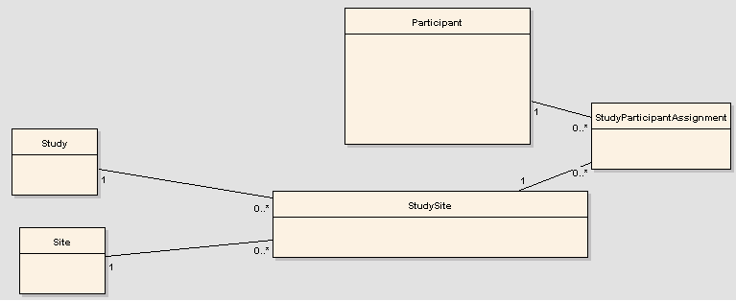

Implementation Model

Data Model

Use Case Realization
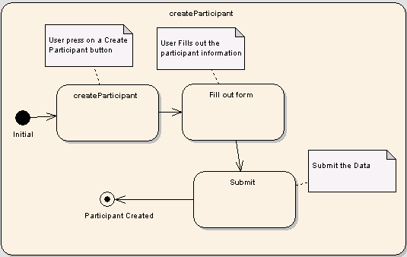

Create Participant

Activity diagram

Sequence diagram – core/web
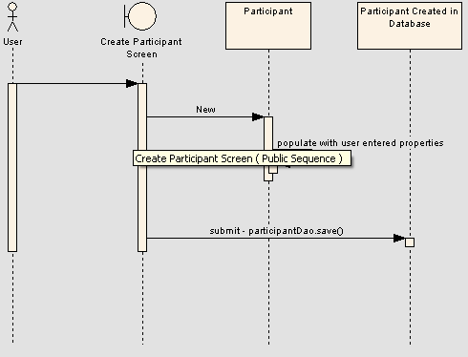

Integration / External Systems

Unit Testing
gov.nih.nci.cabig.caaers.dao.ParticipantDaoTest

JUnit
gov.nih.nci.cabig.caaers.dao.testdata.StudyDaoTest.xml
gov.nih.nci.cabig.caaers.web.NewParticipantCommandTest
gov.nih.nci.cabig.caaers.web.NewParticipantControllerTest

Spring Mock Objects

Integration Testing

Generic Classes

Non Available at this point

Configuration/Build/Deployment
- References

Documentation /Artifacts
SI No | Artifact | Type | Link

- Glossary
Term | Definition

