caAERS Application Development
Communications Plan

Submitted By: Edmond Mulaire, SemanticBits, LLC
Date: March 2008
Document Version: 1.00

DOCUMENT CONTROL

Change Record
3
Date | Author | Version | Change Reference
3/30/08 | Edmond Mulaire | 1.00 | No Previous Document

Reviewers

Name | Position

Approved By

Date | Name | Position

TABLE OF CONTENTS

DOCUMENT CONTROL ii
Change Record ii
Reviewers ii
Approved By ii
1.0 INTRODUCTION 1
1.1 Project Background 1
1.2 Purpose of Document 1
1.3 Document Organization 1
2.0 Project Stakeholders 2
2.1 Primary and Secondary Stakeholders 2
2.2 Stakeholder Interests and Membership 2
3.0 Communications Strategy 4
3.1 Tier 1 – Project Team Communications 4
3.2 Tier 2 – Communications with Elaborators 5
3.3 Tier 3 – Communications with Sponsors 5
3.3.1 Status Reporting 6
3.3.2 Budget/Financial Reporting 6
3.4 Tier 4 – Communications with caBIG Community 6
4.0 Communications Matrix 7

INTRODUCTION

Project Background
The goal of this project is to develop and to deploy an adverse event reporting system that is nationally scalable with a robust architecture to meet the needs of the caBIG™ Community. The caAERS requirements, data model, and use cases developed during Release 1 will be the foundation for this effort. The Developer Team will execute Elaboration, Construction and Transition Phase activities for this project. The project will be carried out using the Agile Unified Process Framework, emphasizing continuous integration, testing, and risk management. Two Adopters, Wake Forest and The Mayo Clinic, have been assigned and funded by caBIG™ and their input and collaboration throughout this project is critical to the timely release of functional software. The Developer Team will work closely with these Adopters, and any additional adopters identified by NCICB, and the Adverse Events Special Interest Group to ensure the deliverables of this project will meet the needs of the caBIG™ Community.

Purpose of Document
The caAERS development effort requires the involvement of multiple organizations and varying levels of interaction to ensure a successful product is produced. The purpose of this document is to identify the key stakeholders and to describe the principle methods and tools that will be used in this project for ensuring effective communications among the Stakeholders.

Document Organization
This document contains the following sections:
- Project Stakeholders
- Communications Strategy

Project Stakeholders
There are a number of groups that can be identified as stakeholders in this project.

Primary and Secondary Stakeholders
Primary Stakeholders play a direct role in elaboration, module development, and testing during this project. Secondary stakeholders have strong interests in and influence over the project but will not be regularly involved in the development or testing of the caAERS module.

Primary Stakeholders
- Development Team (SemanticBits)
- Funded Adopters (Mayo Clinic, Wake Forest, and CALGB)
- Reporting & Sharing SIG and CTMS Workspace
- Cross-cutting Workspaces (VCDE and Architecture)

Secondary Stakeholders
- Cancer Centers
- Other NCI Funded Programs
- NCI Center for Bioinformatics (NCI-CBIIT)
- SAIC

Stakeholder Interests and Membership
The Primary Stakeholders will be directly involved in project elaboration, development, and testing. The following three Primary Stakeholders have been identified for this project: The Development Team, Funded Adopters, and CTMS WS and SIGS.

- Project/Development Team
The caAERS application development team is organized into three groups: Project Management, Functional, and Technical. The members of the project team are listed in the table below.

Project Management
Project Director | Edmond Mulaire, Ph.D., PMP | SemanticBits | edmond.mulaire@semanticbits.com
Project Manager | Paul Baumgartner | SemanticBits | paul.baumgartner@semanticbits.com
Functional
Analyst | Jennifer Reed | SemanticBits | jennifer.reed@semanticbits.com
SME | Sharon Elcombe | MCCC | elcombe@mayo.edu
SME | Sonja Hamilton | MCCC | hamilton@mayo.edu
SME | Jennifer Frank | MCCC | Frank.jennifer@mayo.edu
SME | Jean Hanson | MCCC | hansonj@mayo.edu
SME | Bob Morrell | WFU | bmorrell@wfubmc.edu
SME | Kim Livengood | WFU | klivengo@wfubmc.edu
SME | Cissy Yates | WFU
SME | Rhonda Kimball | WFU
SME | Kimberly Johnson | CALGB | johns001@mc.duke.edu
SME | Debbie Sawyer | CALGB | debbie.sawyer@duke.edu
SME | Susan Sutherland | CALGB | suthe003@mc.duke.edu
SME | Robin Heinze | CALGB | robin.heinze@duke.edu
SME | Robert Dale | CALGB | robert.dale@duke.edu
SME | Nimesh Patel | CALGB | nimesh.patel@duke.edu
SME | John Postiglione | CALGB | posti001@notes.duke.edu
SME | Allison Booth | CALGB
Technical
Lead Architect | Vinay Kumar | SemanticBits | vinay.kumar@semanticbits.com
Lead Architect | Ram Chilukuri | SemanticBits | ram.chilukuri@semanticbits.com
Lead Developer | Biju Joseph | SemanticBits | biju.joseph@semanticbits.com
 | Srini Akkala | SemanticBits | srini.akkala@semanticbits.com
Developer | Monish Dombla | SemanticBits | monish.dombla@semanticbits.com
 | Sameer Sawant | SemanticBits | sameer.sawant@semanticbits.com
 | Arun Kumar | SemanticBits | arun.kumar@semanticbits.com
QA Engineer | Karthik Iyer | SemanticBits | Karthik.iyer@semanticbits.com
UI Designer |  | SemanticBits
Technical Writer |  | SemanticBits

The Development team will work closely with the following Funded Adopters:

Mayo (MCCC)
Mayo is a funded adopter of caAERS and will be involved in elaboration, testing, and adoption. The following are the key Points of Contact (POCs) for this team:
- Sharon Elcombe: Lead Elaborator
- Sonja Hamilton: Elaborator
- Jennifer Frank, Jean Hanson: Domain Experts
- Michael Carston, Bradley Andersen: Technical Expert

Wake Forest (WFU)
Wake Forest is a funded adopter of caAERS and will be involved in elaboration, testing, and adoption. The following are the key POCs for this team:
- Bob Morrell: Lead Elaborator, Lead Adopter
- Kimberly Hill Livengood: Domain Expert
- Xhiquiang (Steven) Cheng: Technical Expert
- Cissy Yates: Domain Expert
- Rhonda Kimball: Domain Expert

CALGB
CALGB is a funded adopter of caAERS and will be involved in elaboration, testing, and adoption. The following are the key POCs for this team:
- Kimberly Johnson: Institutional Lead
- Amish Shah: Technical Lead
- Josh Yoder: Technical Lead
- Robert Dale: Domain Expert
- Nimesh Patel: Domain Expert
- Debbie Sawyer: Domain Expert
- Susan Sutherland: Domain Expert
- Robin Heinze: Domain Expert
- John Postiglione: Domain Expert
- Allison Booth: Domain Expert

3. WS Mentors:
The VCDE and Architecture Workspaces will play an important role in the elaboration and testing phases of the project. Representatives from these workspaces will assist with requirements and project artifact reviews.

VCDE WS Mentors and POCs
- Brian Davis
- Lynne Wilkens

Architecture WS Mentor and POC
- Michael Keller
- Pankaj Agarwal

4. Reporting & Sharing Special Interest Group
The Reporting & Sharing SIG has a special interest in the caAERS application and will be an integral collaborator on this project. The primary POC for the Reporting & Sharing SIG are:
- Christo Andonyadis
- Derek Walker

Communications Strategy
To assist with the broad-based communication needs of this project, the following tools will be used:

- Wiki
The caAERS team will use the NCI wiki site as the primary online communications and collaboration tool. The wiki is located here: https://wiki.nci.nih.gov/display/CTMS/Cancer+Adverse+Events+Reporting+System+(caAERS)

- GForge
The caAERS team will use the GForge project collaboration environment for managing project communications, for project document version control, and as the interface to the source control tool for managing code for the caAERS project. Subversion will be used as the SCM tool for this project.
The caAERS project can be access on GForge at http://gforge.nci.nih.gov/projects/caaersappdev/ or by browsing the GForge Project Tree. The caAERS project is categorized on this tree under the following branches: caBIG>CTMS>CTMS WS Projects.
The PM, Lead Architect, and Lead Developer will act as the primary caAERS project GForge administrators.

- Listservs
The caAERS project will use the following listservs to facilitate communications:
Caaersappdev-general@gforge.nci.nih.gov
Caaersappdev-technical@gforge.nci.nih.gov

The caAERS Project Team will take a four-tiered approach to communications to best match the needs and interests of the different Stakeholder groups. The four tiers are listed below:
- Tier 1: Project/Developer Team Communications
- Tier 2: Communications with Elaborators
(This group includes Funded Adopters, CTEP, DCP, SIGs, CTMS WS Members and Mentors)
- Tier 3: Communications with Sponsors
(SAIC/NCICBIIT)
- Tier 3: Communications with caBIG™ End Users

Tier 1 – Communications within Project Team
Internal project communications are vital to the success of AUP-based projects. The team will therefore engage in close, daily communications and interaction using email, ad hoc meetings, listservs, and a variety of other tools.

In addition, the team’s Lead Architect and Lead Developer will hold a weekly team meeting with the full development team to ensure that project goals are being met in a timely fashion. These meetings will be held every Monday at 11:00 am – 12:00 pm.

Event | Group(s) | When | Method
Daily Developers Meeting | Technical Team, Functional Team, PM | Monday - Friday, 9:30am – 10:00am (Eastern) | Onsite & Teleconference
Ad Hoc Meetings | Technical Team, Functional Team, PM | As Needed | Method to be determined on a per meeting basis.

Tier 2 – Communications with Elaborators
The success of the caAERS project depends critically on full participation from Elaborators. The Elaborators group is made up of many different teams and organizations. For our project, the Elaborators are drawn from the Primary Stakeholders group and include the following:
- Funded Adopters
- CTEP, DCP
- CTMS WS

Communications with Elaborators will be handled in a hierarchical way. A primary point of contact (POC) will be identified for Elaborator group, team, or organization. Typically, this will be a PI or PM at each group. Requests from the caAERS team for document reviews, use case elaboration, or requirements analysis will be made to each POC. Requests from the POC will then filter down through the hierarchy to the lead elaborators and to the domain experts (see Figure 1).
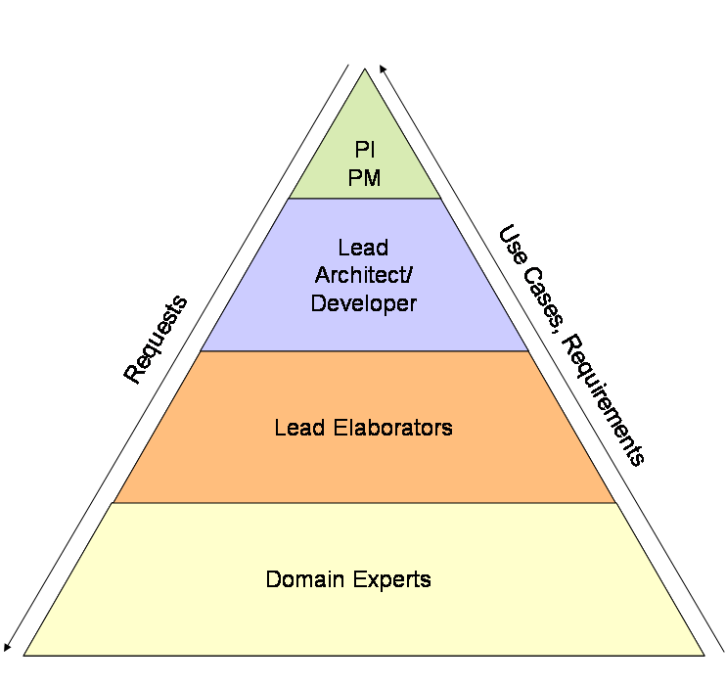
Figure 1: Communications Flow at Each Adopter or Collaborator Site

A bi-weekly teleconference will be held between project management, the lead architect, the lead developer, and lead elaborators, and domain experts. It is expected that each lead elaborator will manage requests and tasks for their team, collect feedback, and present it back to the group (either verbally or in documentation form).

Tier 3 – Communications with Sponsors
This section describes the caAERS team’s plans for formally managing communications with SAIC and NCI management. At this tier, our primary goals are as follows:
- To present progress reports and discuss high-level scope, feature, and design decisions.
- To discuss deliverables, risks, and critical issues.

The caAERS project team will communicate with SAIC and NCI formally using the following:
- Bi-Weekly Status Meetings
- Monthly Status Reports
- Bi-Weekly Risk Matrix Update

In addition to these formal means of communication, the caAERS team will communicate project status and issues to SAIC and NCI on an ad hoc and informal basis. In addition, it is anticipated that the project sponsors will participate, as needed, in the project’s various team meetings and activities.

Tier 4 – Communications with caBIG Community
This section describes plans for managing communications with the end users and larger caBIG community. Domain Experts will act as the ambassadors for the end users and will be expected to represent the needs and requirements of this critical group of stakeholders over the course of the project. The Domain Experts will also take the lead in formulating the ‘take-home message’ of the initial work of the caAERS project to the targeted stakeholders at the caBIG™ Annual Meeting.

Communications Matrix
Event | Primary Group(s) | When | Method and Tools
Developer Team/Scrum Meeting | Developers | Monday - Friday 9:30am – 10:00am | Telecon and Centra
Developer  Communication | Developers | Ad Hoc | Email listserv:  caaersappdev-technical@gforge.nci.nih.gov
Elaborators  Meeting/Requirements Meeting | caAERS Project Team Leads and Lead Elaborators and Domain Experts (from Adopters, Collaborators, Mentors) | Thursdays, Weekly, 12:00pm - 1:00pm Meetings. | Telecon: 1-800-857-4816  Passcode: 72114  Centra URL: http://ncicb.centra.com  Centra Event ID: caAERS Project
Project Team/Adopters Meetings. | caAERS Project Team Leads (PM, Functional Leads, Tech Leads), Adopter POCs (Lead Elaborators) | Ad Hoc Meetings, as needed. Standing Monthly Meeting (First Monday of each Month, 11:00am – 12:00pm) | Telecon and Centra
Elaborators  Communication | caAERS Project Team Leads and Lead Elaborators and Domain Experts from Adopters, Collaborators, Mentors | Ad Hoc | Email listserv:  caaersappdev-general@gforge.nci.nih.gov
Face-to-face | Project Team, Adopters (Wake Forest, Mayo, CALGB) and participants from CTEP, DCP, CTMS WS, SIGS. | Twice. (April 15-17) and TBD | Multi-day onsite meeting.
CTMS SIGs | Project Management and Functional Team Representatives, End Users | Ad Hoc | Teleconferences
SAIC/NCICBIIT Bi-weekly Status Meeting | Project Management, SAIC, NCI | Thursday, 1:00-2:00 | Teleconference

