caAERS Phase II

Mayo Clinic Cancer Center Adoption Report
(Task 5.5)

DOCUMENT REVISION HISTORY
Version Number | Date | Description
1.0 | 9/23/08 | Final Draft

Introduction

Project Overview
The goal of this adoption report is to document the progress of the Mayo Clinic Cancer Center (MCCC) in its plan to implement caAERS as its adverse event management system.

Project Participants and Responsibilities

The MCCC caAERS team consists of Mses. Sharon Elcombe, Sonja Hamilton, Jean Hanson, and Jennifer Frank from the business side. All participated in the caAERS adopter activities since its inception. Brad Andersen and Michael Carston represent the MCCC IT staff. The team is responsible for installing, piloting, integrating/configuring caAERS at the MCCC, and training new users of the system.

Additionally, Robbin Peterson, a MCCC Clinical Research Associate (CRA), Heather Ondler, a MCCC CRA, Patricia McNamara, the MCCC SAE Coordinator and members of the Clinical Trials Management System (CTMS) IT staff, and others, as necessary, will participate in piloting, evaluating, and integration strategy development.

Mayo Clinic IT staff, including IT Security, will be responsible for approving and implementing necessary components for data sharing and ensuring that data sharing on the caGrid is handled appropriately.

Dependencies/Risks

The overall strategy is dependent upon:
- Installation of the Oracle database on an institutional server – this should be completed in mid-September of 2008.
- Access to API documentation.
- Access to data models.

Constraints / Issues
- Past and on-going MCCC clinical trials do not routinely collect hospitalization and expectedness on every AE. This will pose challenges for legacy data and on-going trials. The developers are addressing this issue for routine adverse event capture in a future release.
- The current MCCC CTMS will not allow for updates to adverse events via the caAERS mechanism and also via the data entry system. Therefore, we will only be able to instantiate caAERS for studies where MCCC is the data center and the only participant in the study.
- Only studies where the MCCC is the data center can be instantiated, as studies with other data centers may not be defined in the caAERS data base. This may change as the product is instantiated across the Cooperative Group system.
- Because MCCC does not currently have a Tomcat server available in the DMZ, we will not be able to use caAERS as the point of entry for studies that use our remote data capture system outside of our firewall e.g. NCCTG studies.
- Data Sharing will be constrained by institutional and MCCC policy and the ability to implement those policies in the caGrid security environment.

Project Plan
Pre-Pilot:
The MCCC performed a pre-pilot of caAERS on three on-going studies where the MCCC is the data center. This pilot assessed both the AE data collection and AEs requiring AdEERS reporting. The studies and patients were imported from the MCCC CTMS and AEs added manually.
Pilot
The MCCC will perform a pilot test of caAERS on 22 selected studies in three phases. See Appendix A for the pilot process details.
Step 1) MCCC will enter 3 – 5 previously submitted AdEERS reports via the caAERS application and compare the reports. This will be done on a few studies selected by the developers.
Step 2) MCCC will test caAERS in parallel with AdEERS
Step 3) At the point that the application is deemed ready for production testing, we will use the caAERS application as the front end for the AdEERS system for the identified studies.
Based upon the pilot outcome a decision will be made regarding how caAERS should be instantiated into the Mayo CTMS system.
Integration: The intention at this point is that the MCCC will use caAERS as the front end for AdEERS reporting. When the caAERS user interface is user accepted and fully tested, we will evaluate how we might integrate caAERS with our CTMs. How caAERS will interact with the new CDMS will also affect the plan.
Data Sharing: Based on lessons learned during the caAERS construction and transition phases, a data sharing plan will be developed that will consider institutional policies, technical infrastructure, and security.

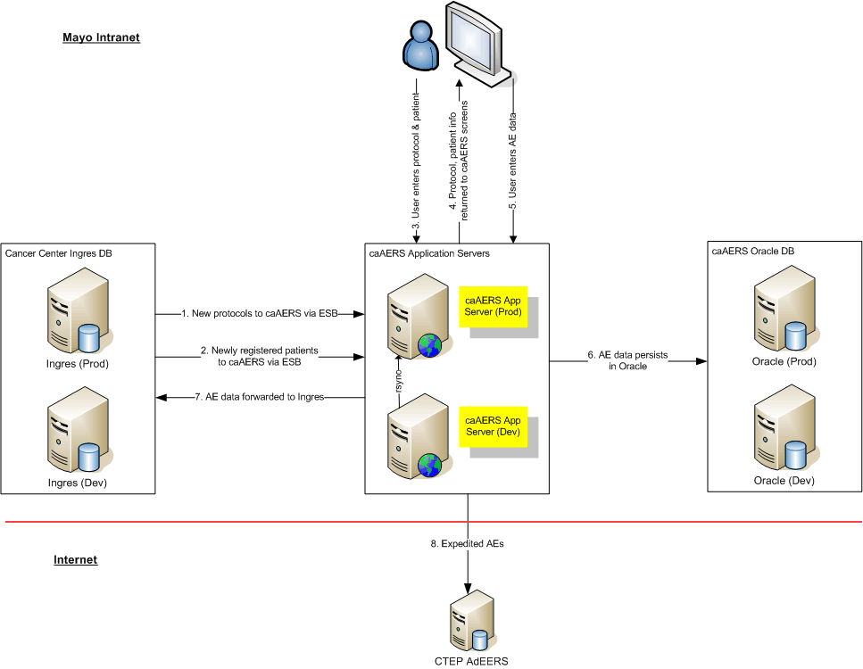

Appendix A

Mayo Clinic Cancer Center
caAERS Pilot Process
Step 1 – Previously Submitted Reports
The pilot will begin with some retrospective AdEERS reports and move to
parallel testing when Mayo and CTEP are assured that the application functions correctly.

Process: Start Date: week approximately 9/22/08
- Testing will be done on caAERS version 1.5.
- Semantic Bits will provide a list of studies for testing, a list of the previously submitted AdEERS reports on those studies, and test scripts for testing.
- Studies will be assigned to each of the testers.
- Testers will print 3 to 4 AdEERS reports on each of the identified studies through the AdEERS website.
- Testers will enter each of these reports through the expedited route in caAERS and complete provided test scripts for each case.
- Notification of the reports will be sent to the tester.
- The tester will print the report generated by caAERS from the AdEERS staging area and compare with the previously submitted AdEERS report for accuracy.
- The test scripts and copies of both the caAERS report and the original AdEERS report will be sent electronically to Sonja Hamilton for filing and submission to Semantic Bits.

Business Process To Do List

Item | Responsibility | Status
Import protocols from the CTEP spreadsheet | Michael | Start 9/1/08
Validate protocol import | Jean, Jennifer, Robbin, Paula | Start approx. 9/22/08
Import patients | Michael | Start approx. 9/22/08
Add exceptions and notifications in the study report set up. To include  email addresses and phone numbers for reporters. | Jennifer, Sonja | Start approx. 9/22/08
Test | Jean, Jennifer, Robbin, Paula, Heather, Deb | Start approx. 9/22/08
Review reports for accuracy | Jean, Jennifer, Robbin, Paula, Heather, Deb | Start approx. 9/22/08

Constraints and Issues

Issue | Solution | Status
Bugs from pre-pilot must be addressed by the developers prior to the pilot phase. | Changes to application by developers | In process
Must have the ability to amend AdEERS reports via caAERS before going to the production phase of the pilot

Mayo Clinic Cancer Center
caAERS Pilot Process
Step 2 – Parallel Testing
Step 2 of the pilot will be a parallel test of submission of adverse events through the AdEERS system and the caAERS system.

Process: Start Date: TBD

- CRAs enter SAEs through AdEERS.
- CRA will print a paper copy of the AdEERS report and fax to one of the following testers: Robbin Peterson, Paula Orr, Heather Ondler, Jennifer Frank, Jean Hanson, or Deb Schott. Refer to the schedule to determine which tester to notify by phone call or email to alert them that a report is coming.
- Tester enters the AdEERS report through the expedited route in caAERS. Note: The testers must define new patients on a study manually in caAERS during the pilot phase.
- Notifications of AdEERS report will be sent to the tester as well as Ann Setser and Shanda Finnigan. Setser: setsera@mail.nih.gov; Finnigan finnigans@mail.nih.gov
- The tester will print the report and review for accuracy. If a report must be amended, this will be done through AdEERS only. Reports that must be withdrawn will be done by the SAE coordinator who will contact NCI to withdraw the report.
- Ann Setser and Shanda Finnigan will ensure that the report is processed correctly in the staging area at AdEERS.

Business Process To Do List

Item | Responsibility | Status
Set up notifications for reports to go to Pat McNamara and the tester for the study | Jennifer
Define the caAERS protocol QC process | Jean, Jennifer
Set up schedule for verifying receipt and accuracy of the AdEERS report | Jean
Notify study CRAs of the list of studies to follow this process | Jean
Test | Jean, Jennifer, Robbin, Paula, Heather, Deb
Review reports for accuracy | Jean, Jennifer, Robbin, Paula, Heather, Deb

Constraints and Issues

Issue | Solution | Status
Bugs from step 1 of this pilot must be addressed by the developers prior to moving to step 2 of the pilot
Must have the ability to amend/delete AdEERS reports via caAERS before moving to step 3 of the pilot

Mayo Clinic Cancer Center
caAERS Pilot Process
Step 3 – Production Testing

Step 3 of the pilot will be a production test and will involved entry of SAEs solely using the caAERS application.

Process: Start Date: TBD
- CRA fills out a paper AdEERS report. Refer to the schedule to determine which tester to notify. Fax the paper AdEERS to the tester and call to alert the tester that a report is coming. If the tester is away, call one of the backups listed. (Deb Schott, Jennifer Frank, or Jean Hanson)
- The tester will enter the AdEERS report via the CaAERS application. Alternately, the CRAs may be trained to do entry of AdEERS reports in the caAERS application. Note: The testers must define new patients on a study manually in caAERS during the pilot phase
- Notifications of AdEERS report entered via the CaAERS application will be sent to the AE coordinator, the tester, and the CRA for the study, as well as Ann Setser and Shanda
Finnigan. (setsera@mail.nih.gov; finnigans@mail.nih.gov).
- The AE coordinator, CRA, and testers will review the AdEERS reports for accuracy.
- The SAE coordinator will enter data in JCCS for the grade 4/5 notification, when appropriate.
- Ann Setser and Shanda Finnigan will ensure that the report is processed appropriately and contact the tester upon receipt of the report. If the tester has not heard back from Ann and/or Shanda within 6 working hours, the tester will contact Ann and/or Shanda.
- If, during review of the report, the SAE Coordinator feels that the report was not needed or needs to be amended, the SAE Coordinator will contact the CRA so that the appropriate changes to the report are made. The CRA will resubmit the report directly to AdEERSs (Reports will be amended only via AdEERS until caAERS has the ability to amend a report.) If the report must be withdrawn, the SAE coordinator will contact NCI as per the normal routine.

Business Process To Do List

Item | Responsibility | Status
Set up notifications for reports to go to Pat McNamara ,the testers, and the CRA for the study | Jennifer
Set up schedule for verifying receipt and accuracy of the AdEERS report | Jean
Notify study CRAs of the list of studies to follow this process | Jean
Test | Jean, Jennifer, Robbin, Paula, Heather, Deb
Review reports for accuracy | Jean, Jennifer, Robbin, Paula, Heather, Deb, Pat, study CRAs

Constraints and Issues

Issue | Issue | Status
Bugs from pilot step 2 must be addressed by the developers prior to the pilot phase step 3
Must have the ability to amend AdEERS/withdraw reports via caAERS

