Platform Specific Service Specification

caBIG® Platform Specific Service Specification

Adverse Event Service

Authors | Srini Akkala
Editor
Reviewers | Denis Krylov, Jessica Pritchard, Paul Baumgartner
Architecture Inception Team | Christo Andonyadis

Version Number | Date | Contributor | Description
0.0.1 | 10/26/2010 | Srini Akkala | Initial version
0.0.2 | 11/19/2010 | Jessica Pritchard, Paul Baumgartner | Copy editing, minor revisions
0.0.3 | 12/20/2010 | Srini Akkala

Table of Contents
1 Executive Summary: 4
1.1 Service Description and Purpose 4
1.2 Scope 4
1.3 Relationship to Standards 4
1.3.1 Domain Standards 4
1.3.2 Technology Standards 4
2 Conformance to Platform Independent Model 5
2.1 Conformance Profile 5
2.2 Functional Profiles 5
2.3 Semantics 5
2.3.1 Adverse Event Semantics 5
2.3.2 Study Semantics 8
2.3.3 StudySubject Semantics 10
2.3.4 Document Identifier Semantics 11
2.3.5 Document Semantics 11
2.3.6 PerformedActivity Semantics 12
2.3.7 Return Value Semantics 12
2.3.8 Error Handling Semantics 13
3 Platform Specific Model 14
3.1 Overview 14
3.2 Assumptions 15
3.3 Service Interface 15
3.3.1 Interface Model 15
3.3.2 WSDL Messages and Port Types 16
3.4 Operations Details 16
3.5 Message Information Model 17
3.5.1 Information Model 17
3.6 Service Interactions 18
3.6.1 Interaction Details 18
3.7 Implementation Considerations 19
3.7.1 Security 19
3.7.2 Auditing 21
3.7.3 Privacy 21
3.7.4 Error Handling 21
3.8 Deployment Details 22
3.8.1 Performance 22
3.8.2 Scalability 22
3.8.3 Discovery 22
3.8.4 Uptime 22
3.8.5 Failover 22
3.9 Constraints 23
4 Recommendations for Conformance and Compliance 23
4.1 Conformance Assertions 23
5 Appendix A - Relevant Standards 25
6 Appendix B – Relevant Standards 25
7 Appendix C – Glossary 25

Executive Summary:

Service Description and Purpose
The Service provides a standardized set of interfaces for managing and exposing the Adverse Event Service. For its representation of the Adverse Event Service, it uses constrained classes from NCI’s version of BRIDG 3.0.2 expressed as XML. The semantics are directly conformant to BRIDG 3.0.2.

Scope
The scope of this document is limited to the specification of the Adverse Event Service as a grid service using the WSDL 1.1 standard.

Relationship to Standards

Domain Standards
Domain Standards | Description
BRIDG v3.0.2 | https://cabig.nci.nih.gov/inventory/infrastructure/bridg
HL7v3 | http://www.hl7.org
ISO 21090 | Health Informatics – Harmonized data types for information interchange

Technology Standards
Standards | Description
Globus Toolkit 4.0.3 | GTK is used to develop this WSRF compliant grid service
caGrid 1.3 | caGrid version 1.3 for grid service development
XML Schema 1.0 | XML schema version 1.0 will be used to define types used to interact with the web service
WSDL 1.1 | Web Services Description Language 1.1 will be used to describe the web service.

Conformance to Platform Independent Model

Conformance Profile
This Service implements the BRIDG 3.0.2 conformance profile and the ISO 21090 data type conformance profile.

Functional Profiles
This Service implements the Adverse Event Management Service profiles described in the platform independent model (PIM).

Semantics
This Service implements the BRIDG V3.0.2-based adverse event management semantic profile from the Platform Independent Model (PIM). The referenced “ISO” package contains NCI’s version of ISO 21090 data types. The element and type names in the XML directly correspond to the types in the Platform Independent Model (PIMSS). The complete WSDL can be located in “3.3.2 WSDL Messages and Port Types.”
Platform-specific representation of a few important classes is detailed in the following sections.

Adverse Event Semantics
This Service directly implements the semantics of Adverse Event via the following XSD fragment. The referenced “ISO” package contains ISO 21090 data types and is omitted for brevity. The element and type names in the XML directly correspond to the types in PIMSS.

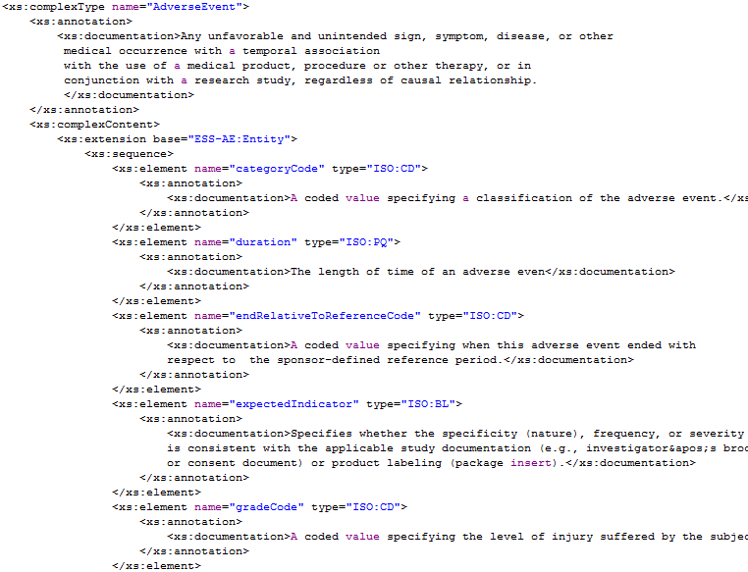
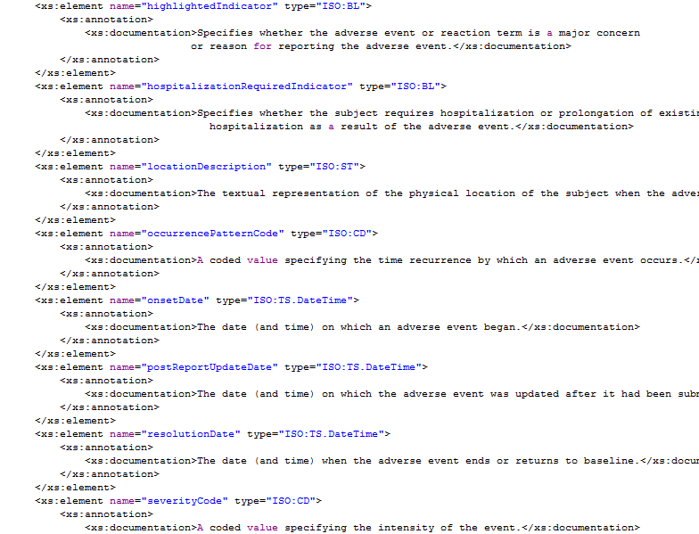
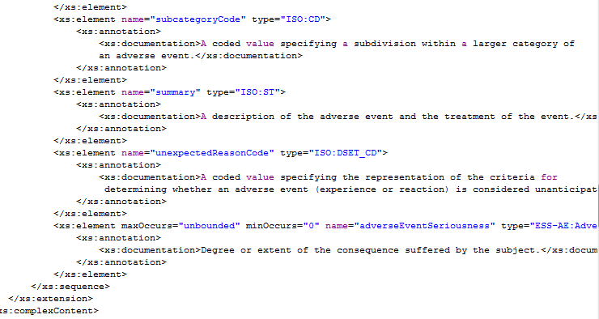

Study Semantics
This Service directly implements the semantics of Study via the following XSD fragment. The referenced “ISO” package contains ISO 21090 data types and is omitted for brevity. The element and type names in the XML directly correspond to the types in PIMSS.
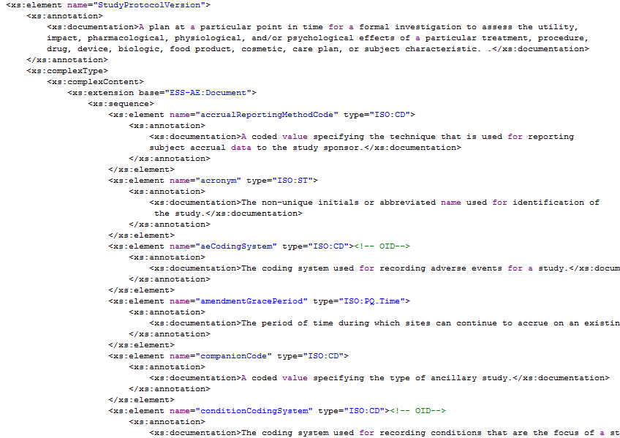
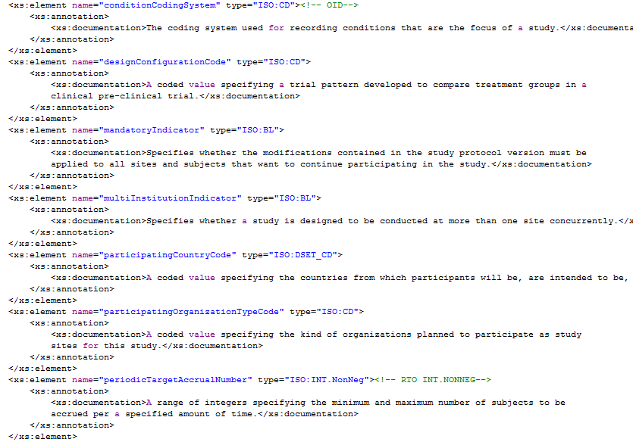
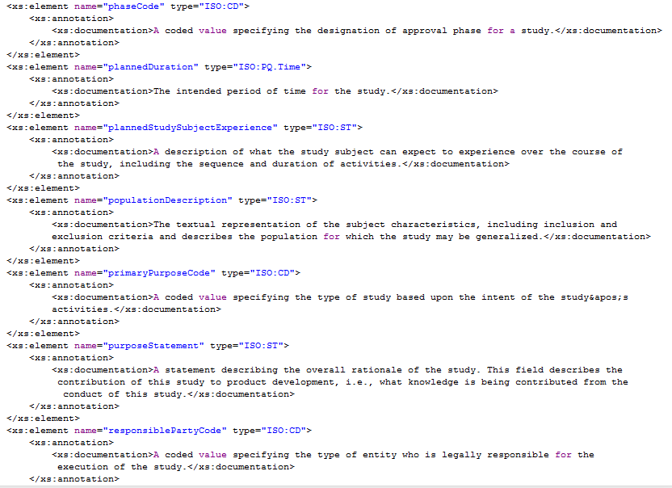
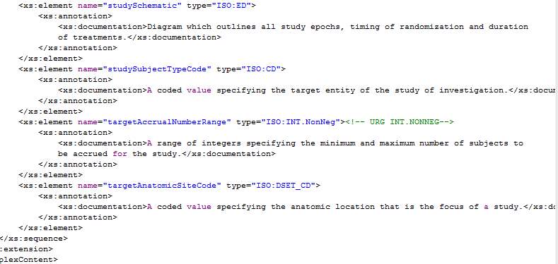

StudySubject Semantics
This Service directly implements the semantics of StudySubject via the following XSD fragment. The referenced “ISO” package contains ISO 21090 data types and is omitted for brevity. The element and type names in the XML directly correspond to the types in PIMSS.
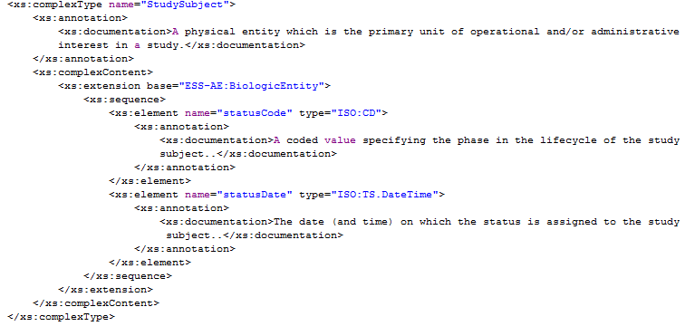

Document Identifier Semantics
This Service directly implements the semantics of Document Identifier via the following XSD fragment. The referenced “ISO” package contains ISO 21090 data types and is omitted for brevity. The element and type names in the XML directly correspond to the types in PIMSS.
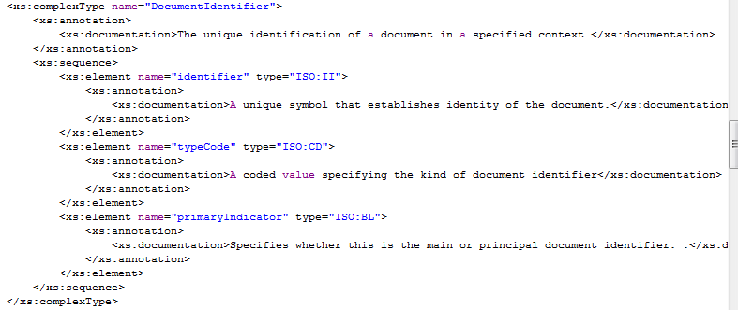

Document Semantics
This Service directly implements the semantics of Document via the following XSD fragment. The referenced “ISO” package contains ISO 21090 data types and is omitted for brevity. The element and type names in the XML directly correspond to the types in PIMSS.
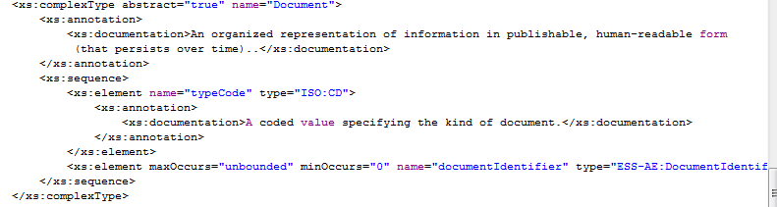

PerformedActivity Semantics
This Service directly implements the semantics of PerformedActivity via the following XSD fragment. The referenced “ISO” package contains ISO 21090 data types and is omitted for brevity. The element and type names in the XML directly correspond to the types in PIMSS.
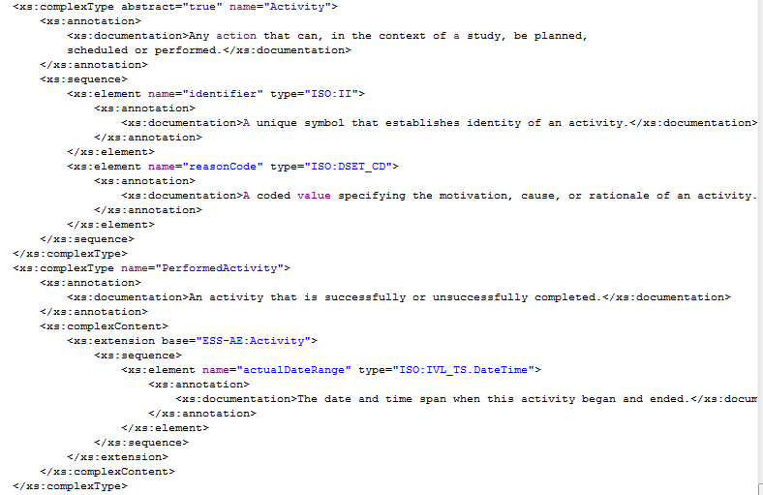

Return Value Semantics
Any SOAP reply that does not contain a fault and contains HTTP 200 OK code is to be considered a successful acknowledgement of the service operation. Any service operation that does not return a SOAP reply is to be considered successfully executed if it returns HTTP 200 OK or 202 Accepted status code.

Error Handling Semantics
At the logical level described in PIMSS, the Adverse Event Management Service throws a single exception with attributes for severity, type, and code. In this platform-specific model, each exception is typed independently as shown on the diagram below. Error code, severity, and type attributes are thus eliminated, and service clients are encouraged to rely on exception type hierarchy to derive this information.

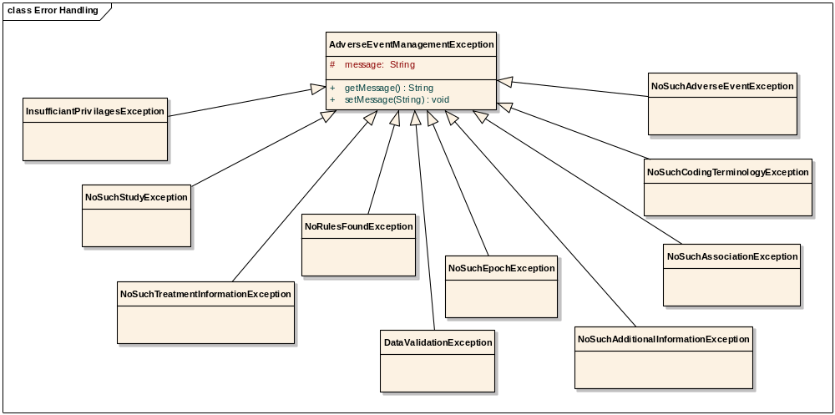

NoSuchAdverseEventException
This exception is thrown when an XML message contains an invalid Adverse Event Identifier.

NoSuchStudyException
This exception is thrown when an XML message contains an invalid study identifier.

NoRulesFoundException
This exception is thrown when no rules are present in the system to trigger.

DataValidationException
This exception is thrown when an XML message contains invalid or malformed data.

NoSuchCodingTerminologyException
This exception is thrown when an XML message contains invalid coding terminology data.

NoSuchAssociationException
This exception is thrown when there is no association between two objects.

NoSuchAdditionalInformationException
This exception is thrown when an XML message contains invalid additional information data.

NoSuchPerformedActivityException
This exception is thrown when an XML message contains invalid performed activity data.

NoSuchStudySubjectException
This exception is thrown when an XML message contains an invalid StudySubject identifier.

Platform Specific Model

Overview
This section details the service payload model and the service interface contract. Schemas for the service message payloads are included. The service interface is described using WSDL snippets and the complete WSDL is in the appendix. This section also provides guidelines for implementing this service.
Standards | Description
NCI’s BRIDG v3.0.2 | The service specifications will be based on NCI’s version of the BRIDG model.
NCI’s implementation of ISO 21090 data types | The service specifications will be based on NCI’s restricted implementation of ISO 21090 data types.

Assumptions

Assumption | Affects
caGrid1.3 | This Service is deployed in the caGrid 1.3 environment.
This Service will require the following supporting services to be in place in order to provide all functionality:  - Person  - Organization  - Protocol Abstraction | If one or more of these dependencies is not met, the Adverse Event Service interface cannot be used.

Service Interface

Interface Model
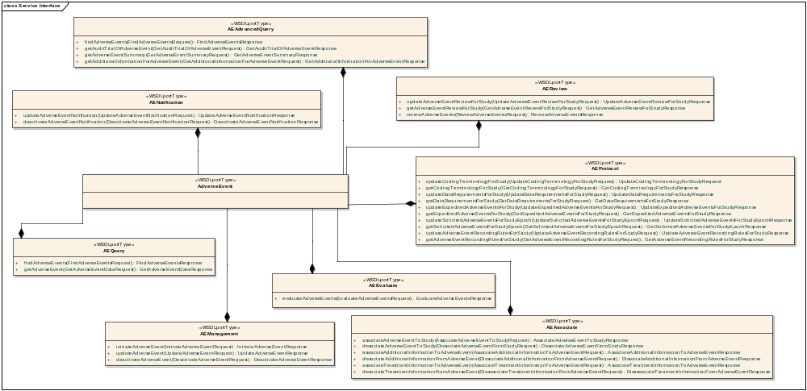
This service interface consists of all the interfaces and its operations. The service interface details are provided in the following sections.

WSDL Messages and Port Types
The Service shall conform to the messages and port types defined in the WSDL located at the following URLs. Each interface in PIM is represented as service context in the Adverse Event Grid Service. The purpose of a service context is to provide operations for a given context.
Description | URL
Adverse Event Service WSDL (Primary Service) | https://ncisvn.nci.nih.gov/svn/caaersappdev/docs/DesignDocs/essn/AdverseEventService/AdverseEventService.wsdl
AE Query Service Context WSDL | https://ncisvn.nci.nih.gov/svn/caaersappdev/docs/DesignDocs/essn/AdverseEventService/Query.wsdl
AE Advanced Query Service Context WSDL | https://ncisvn.nci.nih.gov/svn/caaersappdev/docs/DesignDocs/essn/AdverseEventService/AEAdvancedQuery.wsdl
AE Associate Service Context WSDL | https://ncisvn.nci.nih.gov/svn/caaersappdev/docs/DesignDocs/essn/AdverseEventService/AEAssociate.wsdl
AE Evaluate Service Context WSDL | https://ncisvn.nci.nih.gov/svn/caaersappdev/docs/DesignDocs/essn/AdverseEventService/Evaluate.wsdl
AE Management Service Context WSDL | https://ncisvn.nci.nih.gov/svn/caaersappdev/docs/DesignDocs/essn/AdverseEventService/Management.wsdl
AE Notification Service Context WSDL | https://ncisvn.nci.nih.gov/svn/caaersappdev/docs/DesignDocs/essn/AdverseEventService/Notification.wsdl
AE Protocol Service Context WSDL | https://ncisvn.nci.nih.gov/svn/caaersappdev/docs/DesignDocs/essn/AdverseEventService/Notification.wsdl
AE Review Service Context WSDL | https://ncisvn.nci.nih.gov/svn/caaersappdev/docs/DesignDocs/essn/AdverseEventService/Review.wsdl
Adverse Event Service XML Schema | https://ncisvn.nci.nih.gov/svn/caaersappdev/docs/DesignDocs/essn/AdverseEventService/AE-PSM.xsd
ISO 21090 Healthcare Data Types | https://ncisvn.nci.nih.gov/svn/caaersappdev/docs/DesignDocs/essn/AdverseEventService/ISO_datatypes_Narrative.xsd

Operations Details

Query Service Context
This interface provides operations to find and retrieve adverse events.

AE-INF1-OP1 : findAdverseEvents

Behavior Description | Query by Example model of querying and will retrieve all adverse events that match the input AdverseEvent attributes with search limit offset.
Pre-Conditions
Security Conditions | The requestors  - Must be an AE reporter
Inputs | - BRIDG : AdverseEvent Fully or Partially populated instance of AdverseEvent object
Outputs | BRIDG:AdverseEvent[ ] Collection of Adverse Event objects matching specified criteria
Post-Conditions | No
Exception Conditions | - Values of all mandatory attributes for the Adverse Event Class have not been provided  - Invalid Adverse Event
Additional Details | Empty collection will be returned if no adverse events are found
Notes

AE-INF1-OP2 : getAdverseEventData

Behavior Description | Retrieves an entire adverse event based on the specified adverse event identifier(s)
Pre-Conditions | Adverse events exists
Security Pre-Conditions | The requestors  - Must be an AE reporter
Inputs | ISO:II[ ] Collection of Adverse Event Identifiers
Outputs | BRIDG:AdverseEvent[ ] Collection of Adverse Event objects matching specified criteria
Post-Conditions
Exception Conditions | - Adverse event is not found for the given identifier  - Invalid Identifier
Additional Details | Only adverse event objects for matched identifiers are returned
Notes

Management Service Context
This interface facilitates functionality for managing the adverse events.

AE-INF2-OP1 : initiateAdverseEvent

Behavior Description | Allows initiation of adverse event and associates with study and subject
Pre-Conditions | BRIDG:StudySubject object exists
Security Pre-Conditions | The requestors  - Must be an adverse event reporter
Inputs | - BRIDG:AdverseEvent and instances of its aggregation/composition classes with the mandatory attributes filled and desired optional attributes provided  - ISO : II (StudySubject identifier )
Outputs | BRIDG: AdverseEvent instance of adverse event class
Post-Conditions | An adverse event is initiated and the business process is started to report the adverse event
Exception Conditions | Invalid Study protocol  Invalid Study participant  Invalid Adverse Event  Subject not found for the given identifier  Study not found for the given identifier
Additional Details | Not all attributes of the AdverseEvent class need to be provided to initiate an adverse event
Notes

AE-INF2-OP2 : updateAdverseEvent

Behavior Description | Allows updating adverse event attributes
Pre-Conditions | Adverse event exists
Security Pre-Conditions | The requestors  - Must be an adverse event reporter
Inputs | BRIDG:AdverseEvent object and instances of its associated classes with required attributes filled and with optional attributes filled optionally. Identifier is required for update.  NOTE: You will need to provide values for all the existing attributes along with the changed ones to avoid them from being nullified
Outputs | BRIDG:AdverseEvent updated instance of adverse event
Post-Conditions | Adverse event is updated
Exception Conditions | Invalid Adverse Event  Adverse event is not found for the given identifier
Additional Details | If identifier is unique, only one adverse event should be found.
Notes

AE-INF2-OP3 : deactivateAdverseEvent

Behavior Description | Deactivates adverse event
Pre-Conditions | Adverse event exists
Security Pre-Conditions | The requestors  - Must be an adverse event reporter
Inputs | ISO : II (AdverseEvent Identifier)
Outputs | BRIDG:AdverseEvent
Post-Conditions | Adverse Event is deactivated and the status flag is updated from ACTIVE to INACTIVE
Exception Conditions | If adverse event is already inactive, no action is taken.  Adverse event is not found for the given identifier  Invalid AdverseEvent
Additional Details | Update adverse event status flag
Notes

Associate Service Context
This interface provides operations to associate multiple adverse events together for study purpose and dissociate multiple events that were previously associated.

AE-INF3-OP1 : associateAdverseEventToStudy

Behavior Description | Associates an adverse event record to a study
Pre-Conditions | - Specified adverse event exists  - Specified study exists
Security Pre-Conditions | The requestor  - Must be a clinical data coordinator or some equivalent associated with the study
Inputs | - ISO : II (adverse event identifier)  - ISO : II (study protocol identifier)
Outputs
Post-Conditions | Adverse event is associated to study
Exception Conditions | Adverse event is not found for the given identifier  Study not found for the given identifier  Invalid Adverse Event Identifier  Invalid Study Identifier  - * If AE is already associated to Study , No action taken .
Additional Details
Notes

AE-INF3-OP2 : dissociateAdverseEventFromStudy
Behavior Description | Removes association between an adverse event record and a study
Pre-Conditions | - Specified adverse event exists  - Specified study exists  - Adverse event record is associated to the study
Security Pre-Conditions | The requestor  - Must be a clinical data coordinator or some equivalent associated with the study
Inputs | - ISO : II (adverse event identifier)  - ISO : II (study protocol identifier)
Outputs
Post-Conditions | Adverse event is dissociated from study
Exception Conditions | - Adverse event is not found for the given identifier  - Invalid Study protocol
Additional Details
Notes

AE-INF3-OP3 : associateAdditionalInformationToAdverseEvent

Behavior Description | Associates an adverse event to additional information
Pre-Conditions | Specified adverse event exists
Security Pre-Conditions | The requestor  - Must be a clinical data coordinator or some equivalent associated with the study
Inputs | - ISO : II (AdverseEvent Identifier)  - caAERS : Additional Information
Outputs
Post-Conditions | Additional information is associated to adverse event
Exception Conditions | - Adverse event is not found for the given identifier  - Invalid Identifier
Additional Details
Notes

AE-INF3-OP4 : dissociateAdditionalInformationFromAdverseEvent

Behavior Description | Removes association between an adverse event and additional information
Pre-Conditions | - Specified adverse event exists  - Association with specified AdditionalInformation exists
Security Pre-Conditions | The requestor  - Must be a clinical data coordinator or some equivalent who are associated with the study
Inputs | - ISO: II (adverse event identifier)  - ISO: II (additional information identifier)
Outputs
Post-Conditions | AdditionalInformation is dissociated from adverse event
Exception Conditions | - Adverse event is not found for the given identifier Association not found for the specified adverse events
Additional Details
Notes

AE-INF3-OP5 : associateTreatmentInformationToAdverseEvent

Behavior Description | Creates the association between the adverse event and the information regarding what the subject was treated with in relation to the presentation of the adverse event.
Pre-Conditions | - Specified adverse event exists  - Treatment information exists
Security Pre-Conditions | The requestor  - Must be an adverse event reporter
Inputs | - ISO : II (BRIDG:AdverseEvent Identifier)  - ISO : II (BRIDG:Activity.identifier)
Outputs
Post-Conditions | TreamentInformation is associated to adverse event
Exception Conditions | - Adverse event is not found for the given identifier  - Invalid Identifier  * No action taken if associated already exists .
Additional Details
Notes

AE-INF3-OP6 : disassociateTreatmentInformationFromAdverseEvent

Behavior Description | Removes the association between an adverse event and the subject treatment information
Pre-Conditions | - Specified adverse event exists  - The association exists between the subject treatment information and the adverse event record
Security Pre-Conditions | The requestor  - Must be an adverse even reporter
Inputs | - ISO : II (AdverseEvent Identifier)  - ISO : II (Activity.identifier)
Outputs
Post-Conditions | Treatment information is dissociated from adverse event
Exception Conditions | - Adverse event is not found for the given identifier Association not found for the specified adverse events  - Invalid Identifier
Additional Details
Notes

Notification Service Context
This interface provides operations to notify other systems and services based upon updates to adverse events.

AE-INF4-OP1 : updateAdverseEventNotification

Behavior Description | Updates the notification rule (adverse event criteria on which a notification should be triggered)
Pre-Conditions
Security Pre-Conditions | The requestor  - Must be a study data manager
Inputs | AERule
Outputs | BRIDG : AdverseEvent [ ]
Post-Conditions | - A rule is created  - Trigger notification service when adverse event meets notification criteria
Exception Conditions
Additional Details | Will leverage caAERS rules engine
Notes

AE-INF4-OP2 : deactivateAdverseEventNotification

Behavior Description | Deactivates notification rule (adverse event criteria on which a notification should be triggered)
Pre-Conditions | Notification rules exists
Security Pre-Conditions | The requestor  - Must be a study data manager
Inputs | AERule.Identifier (II)
Outputs | ISO : BL (Rule Status )
Post-Conditions | Rule deactivated
Exception Conditions | Notification rule not found
Additional Details | Will leverage caAERS rules engine
Notes

Review Service Context
This interface provides operations for other systems, services, and users to manage and execute the adverse event review process.

AE-INF5-OP1 : updateAdverseEventReviewProcessForStudy

Behavior Description | Updates the workflow process that must be followed for reviewing adverse event records
Pre-Conditions | Specified study exists
Security Pre-Conditions | The requestor  - Must be a study data manager
Inputs | - ISO : II (study protocol identifier)  - CAAERS:ReviewProcess
Outputs
Post-Conditions | None
Exception Conditions | Study not found for the given identifier  Invalid Identifier
Additional Details
Notes

AE-INF5-OP2 : getAdverseEventReviewProcessForStudy

Behavior Description | Retrieves the workflow process that must be followed for reviewing adverse event records
Pre-Conditions | Specified study exists
Security Pre-Conditions | The requestor  - Must be a study data manager
Inputs | - ISO : II (study protocol identifier)
Outputs | CAAERS : ReviewProcess
Post-Conditions | None
Exception Conditions | - Study not found for the given identifier  - Invalid Identifier
Additional Details
Notes

AE-INF5-OP3 : reviewAdverseEvent

Behavior Description | Review adverse events
Pre-Conditions | Specified adverse event exists
Security Pre-Conditions | The requestor  - Must be a healthcare provider
Inputs | - ISO : II (adverse event identifier)  - CAAERS : ReviewProcess
Outputs | BRIDG:AdverseEvent
Post-Conditions | None
Exception Conditions | Invalid adverse event identifier
Additional Details
Notes

Protocol Service Context
This interface provides operations to manage adverse events contained within a protocol.

AE-INF6-OP1 : updateCodingTerminologyForStudy

Behavior Description | Updates the terminology system to be used for encoding adverse events on a study
Pre-Conditions | - Specified study exists  - Adverse event terminology exists
Security Pre-Conditions | The requestor  - Must be an adverse event reporter
Inputs | - ISO : II (study protocol identifier)  - ISO : OID (StudyProtocolVersion.aeCodingSystem)
Outputs
Post-Conditions | None
Exception Conditions | - Study not found for the given identifier  - Invalid Identifier
Additional Details
Notes

AE-INF6-OP2 : getCodingTerminologyForStudy

Behavior Description | Retrieves the terminology system used for encoding adverse events on a study
Pre-Conditions | Specified study exists
Security Pre-Conditions | The requestor  - Must be an adverse event reporter
Inputs | ISO : II (Study Protocol Identifier)
Outputs | ISO : OID
Post-Conditions | None
Exception Conditions | Study not found for the given identifier  Invalid Identifier
Additional Details
Notes

AE-INF6-OP3 : updateDataRequirementsForStudy

Behavior Description | Updates the mandatory, optional, and not applicable (disallowed) attributes for adverse event records on a study
Pre-Conditions | Specified study exists
Security Pre-Conditions | The requestor  - Must be an adverse event reporter
Inputs | - ISO : II (study protocol identifier)  - AE : DataRequirement
Outputs
Post-Conditions | None
Exception Conditions | Study not found for the given identifier  Invalid Identifier
Additional Details
Notes

AE-INF6-OP4 : getDataRequirementsForStudy
Behavior Description | Retrieves the mandatory, optional, and not applicable (disallowed) attributes for adverse event records on a study
Pre-Conditions | Specified study exists
Security Pre-Conditions | The requestor  - Must be an adverse event reporter
Inputs | ISO : II (study protocol identifier)
Outputs | AE : DataRequirement
Post-Conditions | None
Exception Conditions | Study not found for the given identifier  Invalid Identifier
Additional Details
Notes

AE-INF6-OP5 : updateExpecteddverseEventsForStudy

Behavior Description | Updates the expected adverse event records associated to a study
Pre-Conditions | - Specified adverse event term(s) exists  - Specified study exists
Security Pre-Conditions | The requestor  - Must be an adverse event reporter
Inputs | - ISO : ANY[ ] (Adverse Event Term or Verbatim)  - ISO : II (Study Protocol Identifier)  - ISO : OID (Adverse Event Coding Terminology)
Outputs
Post-Conditions | Any expected adverse events that were previously associated to the study will be removed
Exception Conditions | Study not found for the given identifier  Terminology not found for the given identifier  - Invalid Identifier
Additional Details
Notes

AE-INF6-OP6 : getExpecteddverseEventsForStudy

Behavior Description | Retrieves the expected adverse events associated to a study
Pre-Conditions | Specified study exists
Security Pre-Conditions | The requestor  - Must be an adverse event reporter
Inputs | ISO : II (study protocol identifier)
Outputs | BRIDG : AdverseEvent [ ]
Post-Conditions
Exception Conditions | Study protocol identifier is invalid
Additional Details
Notes

AE-INF6-OP7 : updateSolicitedAdverseEventsForStudyEpoch

Behavior Description | Updates the solicited adverse event records associated to a study epoch
Pre-Conditions | - Specified adverse event term(s) exists  - Specified study exists  - Specified epoch exists
Security Pre-Conditions | The requestor  - Must be an adverse event reporter
Inputs | - ISO: ANY [ ] (adverse event term or verbatim)  - ISO : II (study protocol identifier)  - ISO : ST (epoch name)
Outputs
Post-Conditions | Any solicited adverse events that were previously associated to the study epoch will be removed.
Exception Conditions | - Study not found for the given identifier  - Invalid Identifier  * Invalidates even one Object in the list is not valid .
Additional Details
Notes

AE-INF6-OP8 : getSolicitedAdverseEventsForStudyEpoch
This operation allows obtaining the solicited adverse event records associated to a study epoch.
Behavior Description | Retrieves the solicited adverse event records associated to a study epoch.
Pre-Conditions | - Specified study exists  - Specified epoch exists
Security Pre-Conditions | The requestor  - Must be an adverse event reporter
Inputs | - ISO : II (study protocol identifier)  - ISO : ST ( study epoch name)
Outputs | ISO : ANY [ ]
Post-Conditions
Exception Conditions | - Study not found for the given identifier  - Invalid Identifier
Additional Details
Notes

AE-INF6-OP9 : updateAdverseEventRecordingRulesForStudy

Behavior Description | Updates/creates rule against which an adverse event record should be evaluated to determine if it is an appropriate record for associating to a study.
Pre-Conditions
Security Pre-Conditions | The requestor  - Must be an adverse event reporter
Inputs | - AERule  - BRIDG : II (StudyProtocolVersion Identifier)
Outputs | ISO : II (AERule Identifier)
Post-Conditions | Rule is created
Exception Conditions | Study not found for the given identifier  Rule not found for the given identifier  Invalid Identifier
Additional Details
Notes

AE-INF6-OP10 : getAdverseEventRecordingRulesForStudy

Behavior Description | Retrieves rules against which an adverse event record should be evaluated to determine if it is an appropriate record for associating to a study.
Pre-Conditions
Security Pre-Conditions | The requestor  - Must be an adverse event reporter
Inputs | BRIDG : II (StudyProtocolVersion Identifier)
Outputs | AERule [ ]
Post-Conditions
Exception Conditions | Rule not found for the given identifier  Invalid Identifier
Additional Details
Notes

AdvancedQuery Service Context
This interface provides operations to find and retrieve adverse events, audit trail of adverse events, and associated adverse events.

AE-INF7-OP1 : queryAdverseEvents

Behavior Description | Query by search criteria (caAERS) model of querying and will retrieve all adverse events that match the input search criteria with search limit offset.
Pre-Conditions
Security Conditions | The requestor  - Must be an adverse event reporter
Inputs | - CAAERS : AdverseEventQuery  - CAAERS : LimitOffset
Outputs | BRIDG:AdverseEvent [ ]
Post-Conditions | No
Exception Conditions | - Minimum and mandatory attributes of search criteria have not been provided, especially identifier or key term  - Invalid data type or code value for any attribute  - Inputs fail validation specified under Behavior Description above
Additional Details
Notes

AE-INF7-OP2 : getAuditTrailOfAdverseEvent

Behavior Description | Retrieve an audit trail of all changes that have been made to an adverse event record based on an adverse event identifier and month worth of data from provided date
Pre-Conditions
Security Pre-Conditions | The requestors  - Must be a study QA manager
Inputs | - ISO : II (Adverse Event Identifier)  - ISO : TS.DATETIME (date)
Outputs | AE : AuditTrial[]
Post-Conditions
Exception Conditions | - Invalid start date  - Invalid adverse event identifier
Additional Details
Notes

AE-INF7-OP3 : getAdverseEventSummary

Behavior Description | Retrieves summarized information regarding adverse event records based on provided search criteria (caAERS)
Pre-Conditions
Security Pre-Conditions | The requestors  - Must be a principal investigator
Inputs | CAAERS : AdverseEventQuery
Outputs | CAAERS : AdverseEventSummary [ ]
Post-Conditions
Exception Conditions
Additional Details
Notes

AE-INF7-OP4 : getAdditionalInformationForAdverseEvent

Behavior Description | Retrieves the additional information records associated to an adverse event
Pre-Conditions | Specified AdverseEvent exists
Security Pre-Conditions | The requestor  - Must be an adverse event reporter
Inputs | ISO : II (AdverseEvent Identifier)
Outputs | AE:AdditionalInformation [ ]
Post-Conditions
Exception Conditions | Invalid adverse event identifier
Additional Details
Notes

Evaluate Service Context
This interface provides operations that evaluate adverse events against recording rules.

AE-INF8-OP1 : evaluateAdverseEvents

Behavior Description | Evaluate an adverse event against the criteria that must be satisfied in order for an adverse event to be considered an appropriate record for associating to a study.
Pre-Conditions
Security Conditions | The requestor must be an adverse event reporter.
Inputs | - BRIDG : AdverseEvent  - ISO : II (StudyProtocolVersion Identifier)
Outputs | ISO : BL (adverse even meets the criteria or not)
Post-Conditions
Exception Conditions | - Study not found for the given identifier  - Rules not found on specified study
Additional Details | Validates the adverse event against rules
Notes

Message Information Model
Communication protocol of the Referral Service is chosen to be SOAP 1.1, so all messages of the service will contain appropriate SOAP envelope and will conform to this protocol standard.

Information Model
The platform for this PSM is chosen to be Java, thus Platform Independent Model presented in the PIMSS specification document is transformed into the Java Platform Specific Model. The Java PSM class diagram is shown in the following diagram.

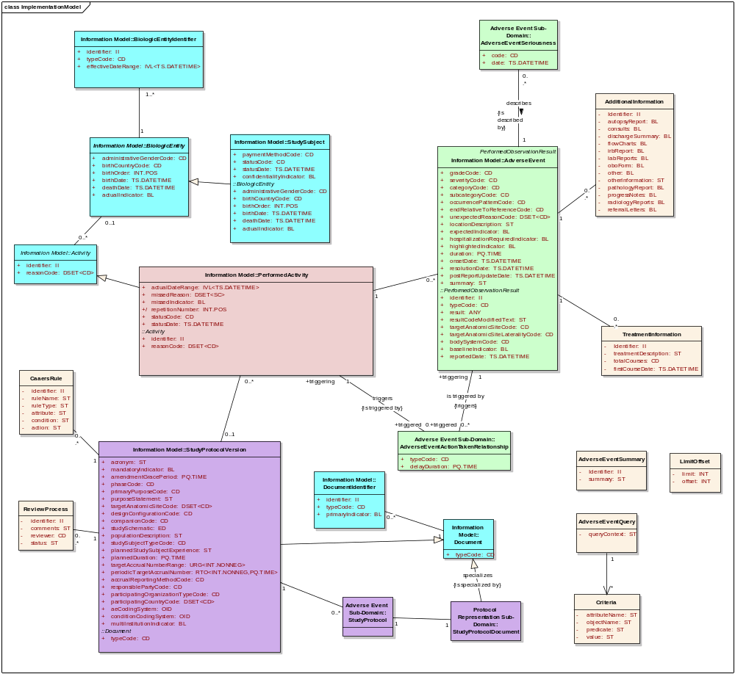

Service Interactions
The Adverse Event Service interacts with other enterprise services.

Interaction Details

Service / System / Actors Name | Dependant / Depends | Data | Description
Protocol Management | Dependant | Study Information | Adverse Event Service relies on Protocol Management Service to retrieve study information and ensure that the study exists
Subject Registration Service | Dependant | Subject Information | The Adverse Event Service relies on the Protocol Management Service to retrieve subject information and that subject is registered with the study
Coding Service | Dependant | Coding Information | The Adverse Event Service relies on the Coding Service for automatic coding of the adverse events
CDMS | Depends | AE Information | CDMS initiated adverse event, which will be stored in the Adverse Event Service
Lab Management Systems | Depends | AE Information | Lab Management Systems initiated adverse event, which will be stored in the Adverse Event Service
Patient Care Systems | Depends | AE Information | Patient Care Systems initiated adverse event, which will be stored in the Adverse Event Service
NCI (CTEP) | Depends | AE Reports | The Adverse Event Service provides adverse event-related reports for NCI (CTEP) reporting
FDA | Depends | AE Reports | The Adverse Event Service provides adverse event-related reports for FDA reporting
IRB | Depends | AE Reports | The Adverse Event Service provides adverse event-related reports for IRB reporting
Sponsor | Depends | AE Reports | The Adverse Event Service provide adverse event-related reports for sponsor reporting

Implementation Considerations

Security
The Service will be deployed in a secure https environment. Thus, client/server communication itself will be secured. Also, the Service will be deployed on a caGrid container that requires caBIG-style authentication.

Access Control
Does the Service require the access control mechanism to be in place to restrict access to only authenticated users or systems? | Yes
If Yes, then provide the following in detail:
- Users need to get provisioned by an IdP in the production trust fabric
- caGrid X509 certificates
Application (Service) Security [Access Policy]
Does the Service incorporate any security controls (authorization) to ensure that access to information is granted to only the authorized users / systems? | Yes
If Yes, then provide the following in detail:
Cryptography
Does the Service require encryption of data transmitted to and from it? | Yes
If Yes, then provide the following in detail:
- Use standard caGrid encryption
Information Security and Risk Management
Is the information served by the Service confidential or privileged? And if yes, is it at risk from any external threats or vulnerabilities? | No
If Yes, then provide the following in detail:
Legal, Regulations, Compliance and Investigations
Does the information served by the Service fall under any legal / regulatory compliance either at federal, state, local or institutional level ? | No
If Yes, then provide the following in detail:
Telecommunications and Network Security
Does the Service need any network or transport level security such as SSL, Firewall protection, etc.? | Yes
If Yes, then provide the following in detail:

Auditing
Operation Name | Auditing Details
Create/Update/ Delete | All operations will be audited using the AdverseEvent Management Service. Each table has four audit columns:  - Create by  - Date last created  - Updated by  - Date last updated

Privacy
CTRP / NES does not contain any information that is consider Personally Identifiable Information (PII). Clinical investigators who conduct NIH-supported clinical research and their research administrative designees will be asked to register online and provide work related information. They will be assigned a unique identifier in order to search and view clinical trial details. The system was designed to retrieve an investigator’s name, but the name does not link to any personally identifiable information. An HHS Privacy Impact Assessment performed on the NIH NCI Clinical Trials Reporting Program determined that there is no PII in the system; therefore, the Privacy Act does not apply to CTRP data collection.

The CTRP PIA is available at https://gforge.nci.nih.gov/svnroot/coppa/trunk/documents/project_management/CTRP_program_management/Policy/PIA/06_1HHS Privacy Impact Assessment-NIH NCI Clinical Trials Reporting Program CTRP.doc

As confirmation, the NIH Privacy Act Officer issued a memo to John Speakman, Product Owner of CTRP, stating that the Privacy Act does not apply.

The memo is available at https://gforge.nci.nih.gov/svnroot/coppa/trunk/documents/project_management/CTRP_program_management/Policy/PIA/CTRP-Privacy-Memo.doc

Error Handling
Subclasses of Globus BaseFaultType are instantiated and thrown in case of errors along with user-friendly error messages. Java exceptions are translated into SOAP faults correspondingly by globus runtime.

Deployment Details
Deployment Details | Impact
Deployment Modes | caGrid 1.3 environment

Performance
The table below lists, per operation, the maximum average performance conformant implementations must meet, under the load given in the next section. Times are expressed in seconds and should be measured using clients on networks local to the deployed services. Roundtrip times are for full message delivery but do not include network latency or client serialization/de-serialization overhead.
Operation | Maximum Average Roundtrip
CRUD operations | < 5.0s
Query Operations | < 30s

Scalability
Conformant services will support the performance metrics described in the previous section under a sustained maximum load of two requests per second. The requests should be a random mix of the available operations.

Discovery
The service posts all specifications in a WSDL and is accessible via web service endpoints. There will be global and local registries, such as globus Index service, that list available service providers in the context of further metadata aiding the discovery of relevant services. Clients can invoke the web service via caGrid service client.

Uptime
The expected uptime for this service is to be 99.9% during business hours.

Failover
Failover should be provided for endpoints in the case of failing server software (servlet container, database) or hardware. Recommended is a second server (hardware) that can either be switched in when the primary hardware fails or concurrently deployed in a load balancing setup.

Constraints

Constraints | Impact
None

Recommendations for Conformance and Compliance

Conformance Assertions
Name | Type | Viewpoint | Description | Test method
NCI’s Version of BRIDG 3.0.1 Conformant | Obligation | Informational | The semantics of the adverse event representation are directly conformant to BRIDG 3.0.1. | 1. Design Review  2. Inspection of WSDL and XSD
ISO 21090 Data Type Conformant | Obligation | Informational | The attributes of the adverse event class use ISO 21090 data types as defined in the referenced PIM_21090 document, as represented by the ISO 21090 XSD. | 1. Design Review  2. Inspection of WSDL and XSD
Observable Behavior | Prohibition | Computational | Service clients are prohibited from making any assumptions based on the internal implementation details of the Service. As a corollary, all observable behavior must be made explicit in the Service specification. | 1. Design Review  2. Change of implementation does not affect clients
Functional Profile | Obligation | Computational | All functional profiles must be implemented. | 1. Design review  2. Inspection of WSDL and XSD
Operations Required | Obligation | Computational | Designers/implementers are obligated to implement all of the operations of both identified functional profiles. | 1. Test cases include all identified operations
Information Model Conformance | Obligation | Information | The Information Model representation will conform to the Information Model provided in Section 3.5.1. | 1. Design Review  2. Test cases to be defined to test specified Information Model conformance
Multiple Jurisdictions | Obligation | Enterprise | Implementers will provide an implementation that supports multiple jurisdictional domains to support different coordinating centers and sites, as well as multi-site trials. | 1. Test cases include multiple domain scenarios
Query Performance | Obligation | Enterprise | The performance of the query operations operation should be within 0.2 second to return a single record from the underlying database. | 1. Test cases to include performance testing
Auditing | Obligation | Engineering | Designers/implementers are obligated to decide on and document the approach for logging or auditing of operation calls. | 1. Design Review

Appendix A - Relevant Standards

Name | Description | Location
NCI’s BRIDG v3.0.2 | NCI’s BRIDG model used for modeling the AE Management Service | http://gforge.nci.nih.gov/frs/download.php/8831/BRIDG_Release_3.0.2_Package.zip
Use Case Document | Document containing use cases for the caAERS application | Please add Links.
Adverse Event Service PIMSS | Platform Independent Model and Service Specification for Adverse Event Service | Please add a link.
PIM_21090.doc | ISO 21090 data types | https://gforge.nci.nih.gov/svnroot/coppa/trunk/documents/analysis_and_design/PIM_21090.doc

Appendix B – Relevant Standards
Please refer to the Section Error: Reference source not found of this document.

Appendix C – Glossary
Please refer to the caBIG shared glossary located at https://wiki.nci.nih.gov/display/Suite/10+-+Glossary+v2.2.
Appendix B - Glossary
Term | Description
BRIDG | The Biomedical Research Integrated Domain Group (BRIDG) has developed a comprehensive domain analysis model representing biomedical/clinical research.
COPPA | NCI’s Enterprise Services of Correlation, Organization, Person and Protocol Abstraction.

