Computationally Independent Model and Service Specification

Safety Reporting

0.6

12/23/2010

Architecture Inception Team | Srini Akkala, ESST, Christo Andonyadis, Jeff McLean, Ram Chilukuri, Vinay Kumar, Paul Baumgartner
Authors | Paul Baumgartner
Editors | Srini Akkala, Ram Chilukuri
Reviewers | Srini Akkala, Ram Chilukuri, Denis Krylov, Vinay Kumar,

Document Version | Date | Author | Changes
0.1 | 10/06/2010 | Paul Baumgartner | Initial draft.
0.2 | 11/23/2010 | Paul Baumgartner | Updated draft based upon caAERS team review.
0.3 | 11/24/2010 | Paul Baumgartner | Incorporated additional feedback.
0.4 | 11/29/2010 | Paul Baumgartner | Incorporated feedback from Ram Chilukuri.
0.5 | 11/30/2010 | Paul Baumgartner | Incorporated additional feedback from reviewers.
0.6 | 12/16/2010 | Paul Baumgartner | Incorporated additional feedback from the ESST.

Table of Contents
1 Overview and Business Case 5
1.1 Name of Service 5
1.2 Service Description and Purpose 5
1.3 Scope 5
1.4 Assumptions 7
2 Business Storyboards 9
2.1 Primary Actors 9
2.1.1 People Actors 9
2.1.2 System Actors 10
2.2 Storyboards 11
2.2.1 Safety Report Initiation 11
2.2.2 Safety Report Updates 14
2.2.3 Safety Report Transactions 20
2.2.4 Search and Retrieve Safety Reports 21
2.2.5 Safety Reporting Rules 23
2.2.6 Safety Report Definitions 25
2.2.7 Safety Report Review 27
2.3 Safety Reporting Activity Diagrams 28
2.3.1 Safety Report Definition and Rules Managment Activities 28
2.3.2 Safety Report Management Activities 29
2.4 Safety Report State Transitions 30
3 Detailed Functional Model 32
3.1 Structure of the Service 32
3.2 Detail of the Capabilities 35
Profiles 89
3.3 Functional Profiles 89
3.3.1 Service Composite Structure 89
3.3.2 Functional Profile Details 89
3.4 Semantic Profiles 95
4.1.1 BRIDG Information Model 101
3.5 Conformance Profiles 101
4 System Implementation Details 104
4.1 System Runtime Interactions 104
4.2 Implementation/Deployment Considerations 105
5 Conformance and Compliance 106
5.1 Compliance and Conformance Statements 106
6 Appendix A – Relevant Standards 108
7 Appendix B – References 109
8 Appendix C - Glossary 110
9 Appendix D – Cross Reference Tables 112
9.1 List of Storyboards 112
9.2 Storyboards to Capabilities Mapping 116
9.3 Actors 121

Overview and Business Case

Name of Service
The service discussed in this specification will be known as the Safety Reporting Service.

Service Description and Purpose
Safety reporting, as it pertains to the cancer clinical trial and cancer clinical care spaces, is the process of communicating the occurrence of harmful or potentially harmful events that may have some relation to the clinical trial or care. Safety reports can include nearly any type of harmful or potentially harmful events, including but not limited to adverse events and product problems. Safety reporting may be required based upon criteria included in varied sources such as protocol documents, legal regulations, and institutional policies, among others. Additionally, safety reporting may be performed on a voluntary basis. Potential recipients of safety reports include, but are not limited to, clinical trial sponsors, regulatory agencies, drug safety monitoring boards, institutional review boards and ethics committees.
The purpose of the Safety Reporting Service is to provide a standard set of interfaces to create, manage, and submit safety reports. This service will enable the searching, analysis, sharing, and data mining of these reports. Additionally, this service will provide the ability to evaluate harmful or potentially harmful events against criteria to determine appropriate reporting requirements. This service will also facilitate the interaction and interoperability between systems that require and provide safety reports. As a result of this interoperability, this service will potentially improve the quality and availability of safety reports and improve the monitoring of safety on cancer clinical trials and in cancer clinical care.

Scope
The scope of the Safety Reporting Service is limited to providing the ability to create, manage, submit, query, and retrieve safety reports within the cancer clinical trial space and cancer care delivery space. This service doesn’t explicitly exclude non-cancer utilities.

Items | Scope / Out of Scope | Source
Provide the ability to create safety reports | Scope | Safety Reporting Service Scope Document
Provide the ability to update safety reports. | Scope | Safety Reporting Service Scope Document
Provide the ability to submit safety reports. | Scope | Safety Reporting Service Scope Document
Provide the ability to amend safety reports. | Scope | Safety Reporting Service Scope Document
Provide the ability to withdraw safety reports. | Scope | Safety Reporting Service Scope Document
Provide support for utilization by other authorized systems and services. | Scope | Safety Reporting Service Scope Document
Provide support for federated safety reporting. | Scope | Safety Reporting Service Scope Document
Provide an audit log of all create, update, and delete activity pertaining to a safety report record. | Scope | Safety Reporting Service Scope Document
Provide the ability to associate and disassociate data to safety reports including, but not limited to: adverse events, patient information and records, lab values, study interventions, and hospital records. | Scope | Safety Reporting Service Scope Document
Provide the ability to evaluate harmful or potentially harmful events against criteria (or rules) to determine if safety reporting is required, and if so, which reports are required, when they are due, and to whom they must be submitted. | Scope | Safety Reporting Service Scope Document
Provide the ability to create, update, and delete the criteria (or rules) used to evaluate harmful or potentially harmful events and determine the appropriate safety reporting requirements. | Scope | Safety Reporting Service Scope Document
Provide the ability to create, update, and delete the report definition used for each safety report. | Scope | Safety Reporting Service Scope Document
Provide the ability to search for and retrieve safety reports using a variety of search criteria based on study, subject/patient, organization(s), personnel, and adverse event attributes. | Scope | Safety Reporting Service Scope Document
Provide the ability to notify defined stakeholders regarding the status of a safety report. | Scope | Safety Reporting Service Scope Document
Provide the ability to route safety reports for review and comment by study personnel. | Scope | Safety Reporting Service Scope Document

Assumptions
Assumption | Affects | Source
The patient and/or study subject exists. | Initiation of a safety report | Safety Reporting Service Scope Document
The study exists with all required information. | Initiation of a safety report, associating a safety report to a study. | Safety Reporting Service Scope Document
The patient and/or subject treatment information exists. | Associating a safety report to the treatment information for a patient and/or study subject. | Safety Reporting Service Scope Document
There will be multiple sources of data for a safety report. For example, a safety report may use data from a Lab System, information regarding the treatment of the event may be sent via an electronic health record, and the course on which the event occurred may come from a participant calendar system. | Initiation and updating of a safety report. | Safety Reporting Service Scope Document
Service users (human and system) must be authorized to access the study and/or subject / patient to which they are attempting to perform an action on. | A security mechanism that can limit users by study and action needs to be in place.
The event sent to the Safety Reporting Service may be sent using the Safety Reporting coding terminology specified for the study. | The event needs to be coded appropriately.

Business Storyboards

Primary Actors
The following actors are used in the storyboards below.

People Actors
Name | Role | Description
Dr. David Jones | Healthcare Provider | The treating physician for a study subject or a patient.
Lucy Taylor | Safety Reporter | The person responsible for completing the safety report.
Alaska Greer | Safety Report Submitter | The person responsible for submitting the safety report.
Taylor Smith | AE Reporter | The person responsible for recording adverse events.
Mike Sweet | Patient | Patient undergoing clinical care outside the scope of a clinical trial.
Jerry Carlos | Study Subject | A participant on a clinical trial. Also know as Study Participant.
Dr. Linda Lu | Principal Investigator | A subscriber to notifications regarding adverse events.
Ricky Higgs | Report Definition Manager | A person responsible for maintaining the definition of safety reports.
Patty Smith | Reporting Rule Manager | A person responsible for maintaining safety reporting rules.
Alabama Adams | Clinical Data Coordinator | A person who participates in adverse event data entry and data management activities.
May Cooper | Study Data Manager | A person responsible for managing the data on the study.
Ray Potter | Study Safety Monitor | A person responsible for monitoring the safety of the study.
Peter Porter | Statistician | A person responsible for analyzing the data on a study.
Joshua Daniels | Quality Assurance Auditor | A person responsible for ensuring the adherence to standard operating procedures.
IRB | Institutional Review Board | A committee responsible for reviewing, monitoring, and approving all investigations at an organization involving human subjects.
PharmaX | Study Sponsor | An organization sponsoring a clinical study.

System Actors
Name | Description
Safety Reporting System | A system used to manage safety reports.
Adverse Event Management System | A system used to manage adverse event records.
Safety Report | The form, either paper or electronic, used to record and report the safety issue.
Clinical Trials Management System (CTMS) | The system used to store the information regarding protocols, people, organizations, and subjects, and schedules that are needed to conduct a clinical trial.
Notification System | Used to provide notifications regarding Safety Reporting activities.
Electronic Health Record (EHR) System | The system which houses the clinical data associated with the conduct of routine clinical care.
Clinical Data Management System (CDMS) | The system which houses the clinical data associated with the conduct of a clinical trial.

Storyboards
The storyboards for this service have been developed largely through the analysis of the use cases developed for the caBIG® Adverse Event Reporting System (caAERS). These use cases are available at the following url: https://wiki.nci.nih.gov/display/caAERS/Use+Cases+-+caAERS.
The storyboards have been grouped into (7) general categories: Safety Report Initiation, Safety Report Updates, Safety Report Transactions, Search and Retrieve Safety Reports, Safety Report Rules, Safety Report Definitions, and Safety Report Review. These seven storyboard categories are described in depth below.

Safety Report Initiation
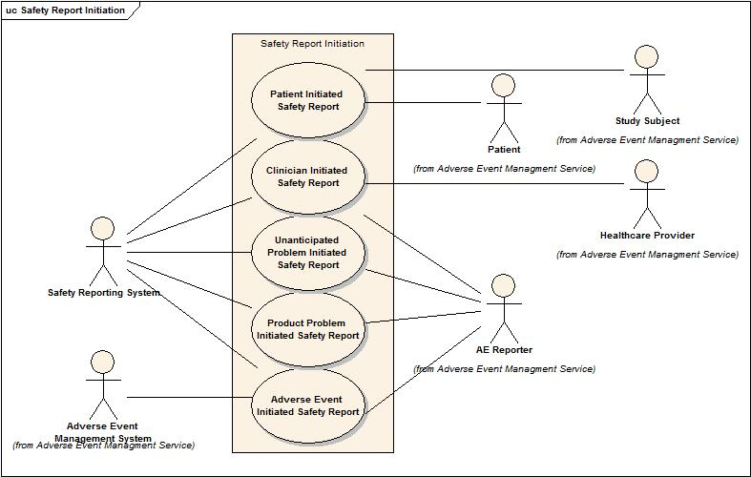

SR-SB1 – Clinician Initiated Safety Report
Outline | An adverse event requiring safety reporting is identified by a Healthcare Provider during the clinical exam of a Patient as part of clinical care.
Detail | During a clinical exam, Dr. Jones (Healthcare Provider) observes that Mike Sweet (Patient) is experiencing severe headache after taking a prescribed medication. Dr. Jones determines this adverse event should be reported in the safety report and initiates a safety report. Lucy Taylor (Safety Reporter) subsequently completes the safety report and submits it to the proper recipient(s).

SR-SB2 – Patient Initiated Safety Report
Outline | A Patient directly reports an adverse symptom and it is initiated as a safety report.
Detail | Mike Sweet (Patient) has recently been treated by Dr. Jones for headaches. Since the treatment for his headache Mike Sweet has experienced severe bouts of dizziness and nausea. Mike Sweet records his dizziness and nausea symptoms onto a safety report and submits it to the appropriate recipient(s).

SR-SB3 –Adverse Event Initiated Safety Report
Outline | An adverse event requiring safety reporting to the Study Sponsor is observed on a Study Subject.
Detail | During a scheduled clinical exam for the clinical trial, Dr. Jones (Healthcare Provider) observes that Jerry Carlos (Study Subject) is experiencing an adverse event that requires safety reporting to PharmaX (Study Sponsor). Dr. Jones describes the adverse event in Jerry Carlos’ chart. Lucy Taylor (Safety Reporter) reviews the chart and enters the adverse event information onto the safety report.

SR-SB4 – Product Problem Initiated Safety Report
Outline | A product problem requiring safety reporting to the Study Sponsor is observed on a Study Subject.
Detail | Prior to implanting an investigational device used to treat Jerry Carlos’ (Study Subject) prostate cancer, Dr. Jones (Healthcare Provider) observes that the device appears to be dirty. He determines that this is a safety issue that should be reported to PharmaX (Study Sponsor). The dirty device product problem is then described on the Safety Report and subsequently submitted to PharmaX.

SR-SB5 – Unanticipated Problem Initiated Safety Report
Outline | An unanticipated problem occurs on a study and requires reporting to the IRB.
Detail | During the conduct of a clinical trial, a laptop is lost which contains protected health information (PHI) including patient diagnoses and social security numbers. Dr. Linda Lu (Principal Investigator) determines that the losing the laptop with PHI was unexpected, was related to the study, and places study subjects at an increased level of risk not previously disclosed in the informed consent. Dr. Lu reports this unanticipated problem to the Institutional Review Board (IRB).

Safety Report Updates
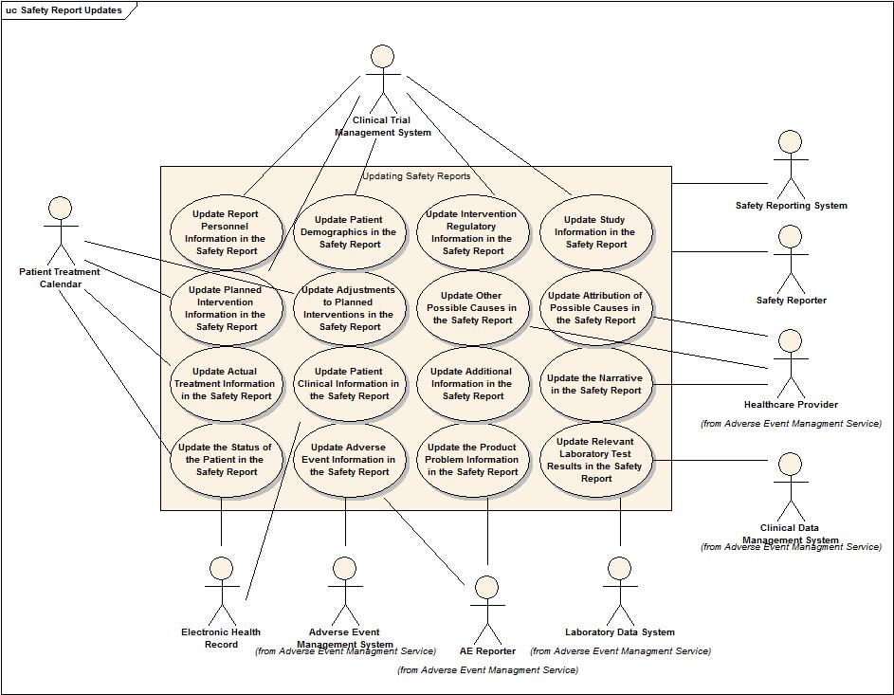

SR-SB6 – Update Report Personnel Information in the Safety Report
Outline | The contact information for the named personnel responsible for completing, approving, and submitting the safety report is updated in the safety report.
Detail | Lucy Taylor (Safety Reporter) enters all required and any optional information in the safety report regarding her contact information as the person completing the safety report. She also enters all required and appropriate optional contact information regarding Dr. David Jones (Healthcare Provider), the responsible physician named on the safety report. During the report submission, Alaska Greer (Safety Report Submitter) enters in the Safety Report all required and appropriate optional information regarding her contact information as the submitter of the safety report.

SR-SB7 – Update Study Information in the Safety Report
Outline | The safety report is updated with the basic information regarding the clinical trial.
Detail | Lucy Taylor (Safety Reporter) updates the safety report with the required information and any other pertinent optional information regarding the study, including but not limited to the Study ID, Study Title, Study Phase, Principal Investigator, and Study Sponsor.

SR-SB8 – Update Adverse Event Information in the Safety Report
Outline | The Safety Report is updated with new adverse event information.
Detail | The adverse event experienced by Jerry Carlos (Study Subject) has been included in the Safety Report. This adverse event eventually resolves and the date of resolution is recorded in Jerry Carlos’ medical chart. Lucy Taylor (Safety Reporter) reviews the patient chart and identifies that the adverse event resolved. Lucy Taylor then searches the Adverse Event Management System for the adverse event record and updates the record with the resolution date. Lucy Taylor (Safety Reporter) is then prompted to update the Safety Report with the resolution date of the adverse event.

SR-SB9 – Update the Product Problem Information in the Safety Report
Outline | A Safety Report is updated with new product problem information.
Detail | The details of the contaminated vaccine are updated onto the Safety Report by Lucy Taylor (Safety Reporter).

SR-SB10 – Update the Narrative in the Safety Report
Outline | The Safety Report is updated to include a clinical narrative describing the entire event.
Detail | Dr. David Jones (Healthcare Provider) describes in-depth all of the relevant information regarding the presentation, progression, treatment, and resolution of the adverse event experienced by Jerry Carlos (Study Subject). He enters this narrative onto the Safety Report.

SR-SB11 – Update the Status of the Patient in the Safety Report
Outline | The Safety Report is updated with the information regarding the status of the Patient or Study Subject at the time of the report, with respect to the adverse event.
Detail | Dr. David Jones (Healthcare Provider) annotates the Safety Report with the information that Jerry Carlos (Study Subject) is still recovering from the adverse event.

SR-SB12 – Update Planned Intervention Information in the Safety Report
Outline | The Safety Report is updated with the information regarding the planned interventions that a Study Subject was supposed to receive.
Detail | Lucy Taylor (Safety Reporter) looks up the Jerry Carlos’ (Study Subject) records in the Clinical Trials Management System (CTMS) to obtain the information regarding the study treatments that Jerry Carlos was supposed to receive.

SR-SB13 – Update Actual Treatment Information in the Safety Report
Outline | The Safety Report is updated with the information regarding the actual interventions that a Study Subject received.
Detail | Lucy Taylor (Safety Reporter) looks up Jerry Carlos’ (Study Subject) records in the Clinical Data Management System (CDMS) to obtain information regarding the study treatments Jerry Carlos actually received.

SR-SB14 – Update Adjustments to Planned Interventions in the Safety Report
Outline | The Safety Report is updated with the information regarding the adjustments to the planned interventions that were made because of the adverse event.
Detail | Lucy Taylor (Safety Reporter) examines the planned interventions for Jerry Carlos (Study Subject) and compares them to the actual treatments he received. She notices a discrepancy between the two and identifies a comment in the CDMS that indicates the intervention was reduced due to the adverse event. She updates the Safety Report with this information.

SR-SB15 – Update Intervention Regulatory Information in the Safety Report
Outline | The Safety Report is updated with the information regarding the regulatory status of the relevant study interventions.
Detail | Lucy Taylor (Safety Reporter) queries the Clinical Trials Management System (CTMS) for regulatory information regarding the study interventions administered to Jerry Carlos (Study Subject). She finds that one of the study drugs is investigational. She obtains the information regarding the holder of the investigational drug application and updates the Safety Report with this information.

SR-SB16 – Update Patient Demographics in the Safety Report
Outline | The Safety Report is updated with information regarding the Patient’s demographics.
Detail | Lucy Taylor (Safety Reporter) queries the Electronic Health Record (EHR) for Michael Sweet (Patient) and obtains basic demographic information including, but not limited to, his age, sex, ethnicity, and race. Lucy Taylor then updates the Safety Report with this information as appropriate.

SR-SB17 – Update Patient Clinical Information in the Safety Report
Outline | The Safety Report is updated with relevant clinical information regarding the Patient.
Detail | Lucy Taylor (Safety Reporter) queries the Electronic Health Record (EHR) for Michael Sweet (Patient) and obtains basic clinical information including, but not limited to, his height, weight, concomitant medications, prior therapies, pre-existing conditions, diseases, and metastatic sites of disease. Lucy Taylor then updates the Safety Report with this information as appropriate.

SR-SB18 – Update Other Possible Causes in the Safety Report
Outline | The Safety Report is updated with information regarding any possible causes of the problem not already identified.
Detail | Dr. Linda Lu (Principal Investigator) is reviewing the Safety Report and notices that the car accident Jerry Carlos (Study Subject) was involved in is not identified as a possible cause of Mr. Carlos’ severe neck pain. Dr. Lu updates the Safety Report with this information.

SR-SB19 – Update Attribution of Possible Causes in the Safety Report
Outline | Likely cause(s) of each adverse event or problem is documented on the Safety Report.
Detail | Dr. Linda Lu (Principal Investigator) is reviewing the Safety Report and assigns the likely cause(s) of each adverse event.

SR-SB20 – Update Relevant Laboratory Test Results in the Safety Report
Outline | Relevant laboratory tests are documented on the Safety Report.
Detail | Lucy Taylor (Safety Reporter) updates the Safety Report with laboratory test results relevant to the presentation, progression, and resolution of the severe fatigue adverse event exhibited by Mike Sweet (Patient).

SR-SB21 – Update Additional Information in the Safety Report
Outline | Relevant supporting documentation is linked to the Safety Report.
Detail | Lucy Taylor (Safety Reporter) updates the Safety Report with links to the CT scan results and radiology consults related to the adverse event experienced by Jerry Carlos (Study Subject).

Safety Report Transactions
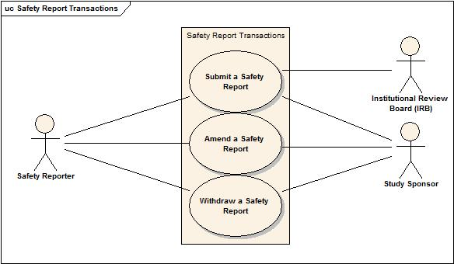

SR-SB22 – Submit a Safety Report
Outline | The Safety Report is submitted to the appropriate recipient(s).
Detail | Lucy Taylor (Safety Reporter) submits the safety report to the PharmaX (Sponsor) and the Institutional Review Board (IRB). The Notification System sends out a notification to Dr. Linda Lu (Principal Investigator) and Dr. Jones (Healthcare Provider) informing them that the Safety Report has been submitted.

SR-SB24 – Withdraw a Safety Report
Outline | A submitted Safety Report is withdrawn.
Detail | Lucy Taylor (Safety Reporter) identifies that the Safety Report recently submitted was submitted in error. She submits a request to the Safety Reporting System to withdraw the Safety Report. The Safety Report is subsequently withdrawn and notifications are sent by the Notification System to inform appropriate personnel of the report withdraw.

SR-SB24 – Amend a Safety Report
Outline | A submitted Safety Report is amended.
Detail | Lucy Taylor (Safety Reporter) identifies an update required to be made to a submitted Safety Report. She amends the submitted Safety Report, updates the appropriate information, and submits the updated Safety Report.

Search and Retrieve Safety Reports
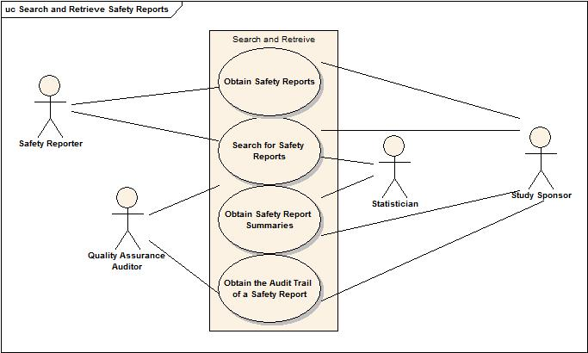

SR-SB25 – Search for Safety Reports
Outline | Search criteria are provided and Safety Report records satisfying the search criteria are identified.
Detail | Lucy Taylor (Safety Reporter) needs to find certain Safety Report records for Jerry Carlos (Study Subject). She enters the search criteria into the Safety Reporting System. The Safety Reporting System identifies the records which satisfy the search criteria.

SR-SB26 – Obtain Safety Reports
Outline | Safety Report records of interest are identified, the information to be returned from those records is specified, and the requested information is provided.
Detail | Peter Porter (Statistician) needs to obtain specific information on certain Safety Report records for Jerry Carlos (Study Subject). He sends a request to the Safety Reporting System that identifies both the Safety Report records he is interested in and the information he would like to obtain from these records. The Safety Reporting System retrieves the specified information on the specified records and returns the requested information to Peter Porter.

SR-SB27 – Obtain Safety Report Summaries
Outline | Safety Report records of interest are identified, the attribute(s) on which to summarize the records are specified, along with method of summarization, and the requested summaries are provided
Detail | Dr. Lu (Principal Investigator) would like to summarize a collection of Safety Report records by the regulatory application number (i.e. IND #) to which they are associated. In the Safety Reporting System she identifies the Safety Report records in her collection of interest, provides the attribute(s) upon which she would like to categorize the collection (in this case, IND #), and provides the method of summary (e.g. frequency count). The Safety Reporting System processes the request and returns the summary information.

SR-SB35 – Obtain the Audit Trail of a Safety Report
Outline | A Quality Assurance Auditor requests to view the audit trail of create, update, and delete operations associated with a specific safety report.
Detail | Joshua Daniels (Quality Assurance Auditor) is performing an audit of the safety data for study NCI00234. He identifies a safety report for which he would like to view the audit trail of all create, update, and delete operations. This information is requested to and returned by the Safety Reporting System.

Safety Reporting Rules
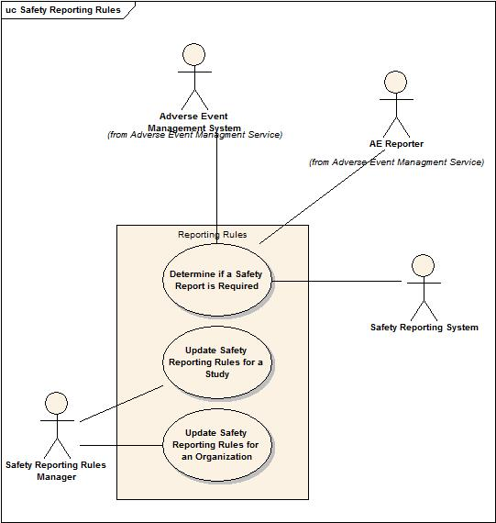

SR-SB28 – Determine if a Safety Report is Required
Outline | An adverse event is assessed to determine if it needs to be reported in the safety report.
Detail | Taylor Smith (AE Reporter) needs to know if Jerry Carlos’ (Study Subject) recent headache needs to be reported to the sponsor in an expedited manner. She finds the adverse event in the Adverse Event Management System and asks the system if further reporting is required. The Adverse Event Management System sends information about the headache adverse event to The Safety Reporting System where it is evaluated against the reporting rules. The results of the evaluation are sent back to the Adverse Event Management System and displayed to Taylor Smith instructing her which reports are needed and when they are due.

SR-SB29 – Update Safety Reporting Rules for a Study
Outline | The criteria for the study are updated against which an adverse event is assessed to determine if it needs to be reported in the safety report.
Detail | Patty Smith (Reporting Rule Manager) reviews the study protocol document and identifies the conditions under which certain safety reports should be completed. She enters these criteria in the Safety Reporting System where they will be available for reference by AE Reporters to evaluate when safety reporting is required.

SR-SB30 – Update Safety Reporting Rules for an Organization
Outline | The criteria for the study organization are updated against which an adverse event is assessed to determine if it needs to be reported in the safety report.
Detail | Patty Smith (Reporting Rule Manager) is provided with the criteria under which the IRB requires a safety report to be submitted to them. She enters these criteria in the Safety Reporting System where they will be available for reference by AE Reporters to evaluate when safety reporting to the IRB is required.

Safety Report Definitions
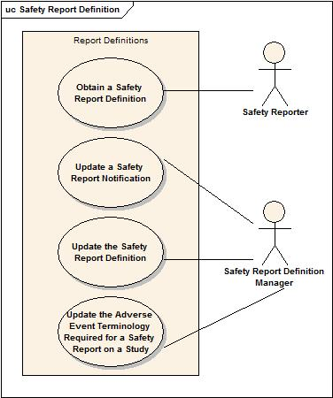

SR-SB31 – Update the Safety Report Definition
Outline | A Report Definition Manager specifies the requirements for a specific safety report.
Detail | Ricky Higgs (Report Definition Manager) identifies the mandatory, optional, and not applicable attributes for a Safety Report. He enters this information into the Safety Reporting System where it will be available for reference by AE Reporters to determine the requirements for completing a given Safety Report.

SR-SB32 – Update a Safety Report Notification
Outline | A Healthcare Provider specifies the conditions under which they will receive a notification regarding a safety report.
Detail | Dr. Linda Lu (Principal Investigator) would like to receive an email notification when a safety report is submitted on study NCI00234. After a safety report is entered into the Safety Reporting System for study NCI00234 an email is subsequently sent to Dr. Lu regarding this report.

SR-SB33 – Obtain a Safety Report Definition
Outline | A Safety Reporter obtains the requirements for completing a safety report.
Detail | Lucy Taylor (Safety Reporter) is preparing to generate a safety report. She reviews the requirements of the safety report and identifies the mandatory, optional, and not applicable attributes for the safety report.

SR-SB34 – Update the Adverse Event Terminology Required for a Safety Report on a Study
Outline | A Report Definition Manager updates the terminology to be used for safety reporting for a specific study.
Detail | Ricky Higgs (Report Definition Manager) is preparing to update the report definitions for use on study NCI00234. He reviews the protocol and identifies the CTCAE v3.0 as the adverse event terminology to use for safety reports on this study and MedDRA v12 as the terminology to use for “Other, specify” terms. He updates the report definitions with the appropriate terminologies for use on this study.

Safety Report Review
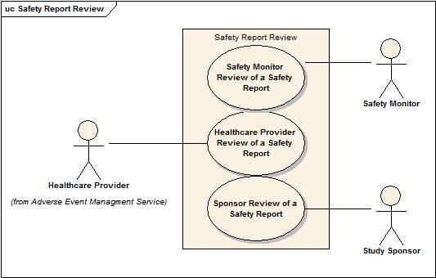

SR-SB36 – Update the Safety Report Review Workflow
Outline | The Study Data Manager for the study specifies the workflow that should be followed for reviewing safety reports for a study site.
Detail | May Cooper (Study Data Manager) defines the mandatory and optional steps that should be followed for reviewing a specific Safety Report. This workflow is provided to Ricky Higgs (Report Definition Manager) who enters this workflow information into the Safety Reporting System and associates the workflow with the appropriate report definition.

SR-SB37 – Healthcare Provider Review of a Safety Report
Outline | A Safety Reporter sends a Safety Report to a Healthcare Provider for review. The Healthcare provider then reviews the safety report.
Detail | Lucy Taylor (Safety Reporter) completes most of a safety report and sends it to Dr. David Jones (Healthcare Provider) for review. Dr. Jones is notified of a pending safety report review. He then reviews the report, provides comments and/or updates the report, and completes his review.

SR-SB38 – Safety Monitor Review of a Safety Report
Outline | A Safety Reporter sends a Safety Report to a Study Safety Monitor for review. The Study Safety Monitor then reviews the report.
Detail | Lucy Taylor (Safety Reporter) completes most of a safety report and sends it to Ray Potter (Study Safety Monitor) at the Coordinating Center for review. Ray is notified of a pending safety report review. He reviews the records, provides comments and/or updates the report, and completes his review.

SR-SB39 – Sponsor Review of a Safety Report
Outline | A Safety Reporter sends a Safety Report to a Sponsor for review. The Sponsor then reviews the report.
Detail | Lucy Taylor (Safety Reporter) completes most of a safety report and sends it to PharmaX (Sponsor) for review. PharmaX is notified of a pending safety report review. PharmaX reviews the records, provides comments, and completes the review.

Safety Reporting Activity Diagrams
The activity diagrams below describe the actions associated with two (2) critical activities that will be supported by this service.

Safety Report Definition and Rules Managment Activities
The below diagram describes the actions involved with managing safety report definitions and safety reporting rules. This activity would be considered required set-up prior to being able to initiate and complete a safety report.
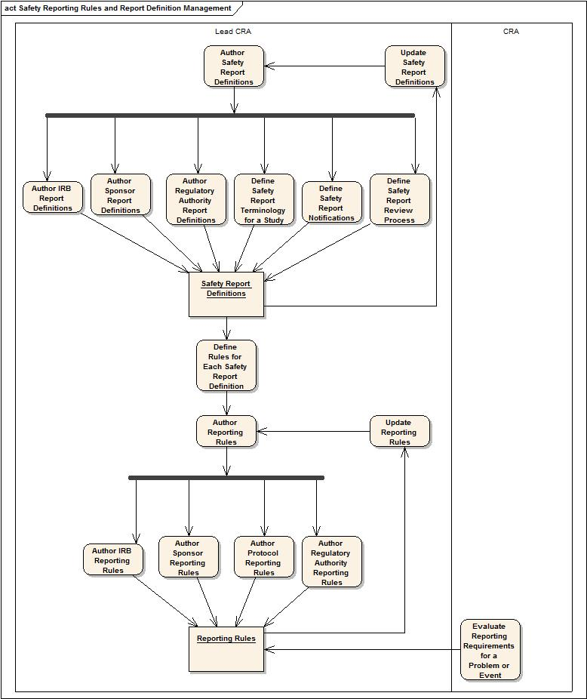

Safety Report Management Activities
The below diagram describes the actions associated with initiating and completing a safety report and sending the safety report through any appropriate transition.
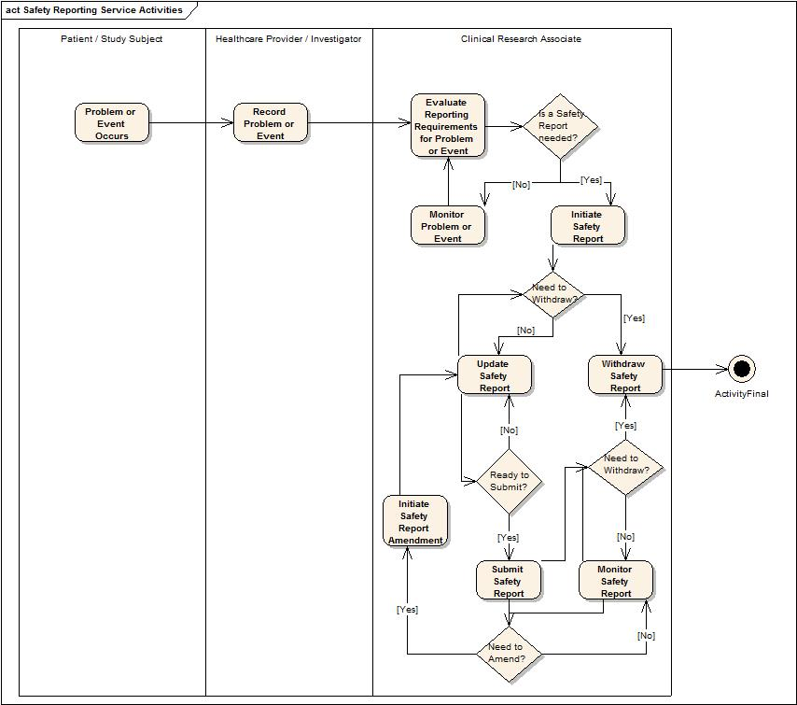

Safety Report State Transitions
The below diagram describes the state transitions that a safety report may undergo.
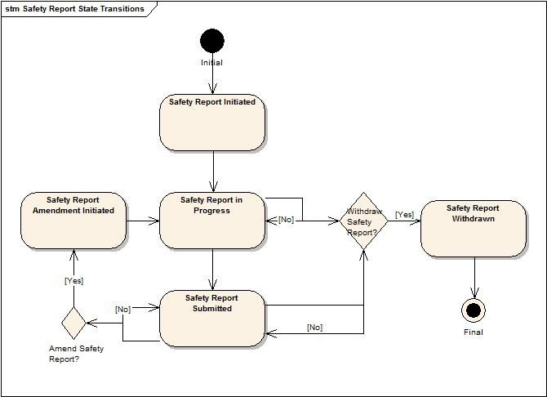

Detailed Functional Model

Structure of the Service
The following list of capabilities was created from an analysis of the storyboards.
Capability | Description
Initiate Safety Report | Provides the capability to initiate safety report.
Associate Adverse Event to a Safety Report | Provides the capability to associate adverse event to a safety report.
Associate Problem to a Safety Report | Provides the capability to associate problem to a safety report.
Dissociate Adverse Event from a Safety Report | Provides the capability to dissociate adverse event from a safety report.
Dissociate Problem from a Safety Report | Provides the capability to dissociate problem from a safety report.
Update Adverse Event Information in the Safety Report | Provides the capability to update adverse event information in the safety report.
Update Problem Information in the Safety Report | Provides the capability to update problem information in the safety report.
Associate a Study to a Safety Report | Provides the capability to associate a study to a safety report.
Associate Additional Information to a Safety Report | Provides the capability to associate additional information to a safety report.
Associate Subject to a Safety Report | Provides the capability to associate a person to a safety report who is the subject of the report.
Dissociate a Study from a Safety Report | Provides the capability to dissociate a study from a safety report.
Dissociate Subject from a Safety Report | Provides the capability to dissociate a Subject from a safety report.
Update Attribution in the Safety Report | Provides the capability to update attribution in the safety report.
Update Intervention Regulatory Information in the Safety Report | Provides the capability to update intervention regulatory information in the safety report.
Update Laboratory Test Results in the Safety Report | Provides the capability to update laboratory test results in the safety report.
Update Other Possible Causes in the Safety Report | Provides the capability to update other possible causes in the safety report.
Update Patient Clinical Measurements in the Safety Report | Provides the capability to update basic patient clinical measurements in the safety report.
Update Patient Disease History in the Safety Report | Provides the capability to update patient disease history in the safety report.
Update Patient Concomitant Medications in the Safety Report | Provides the capability to update patient concomitant medication information in the safety report.
Update Patient Prior Therapies in the Safety Report | Provides the capability to update patient prior therapy information in the safety report.
Update Patient Demographics in the Safety Report | Provides the capability to update patient demographics in the safety report.
Update Reporter in the Safety Report | Provides the capability to update the reporter in the safety report.
Update Healthcare Provider in the Safety Report | Provides the capability to update the healthcare provider in the safety report.
Update Submitter in the Safety Report | Provides the capability to update submitter in the safety report.
Update Product Problem Information in the Safety Report | Provides the capability to update product problem information.
Update the Patient Status in the Safety Report | Provides the capability to update the patient status in the safety report.
Update the Planned Intervention Information in the Safety Report | Provides the capability to update the planned intervention information in the safety report.
Update the Narrative in the Safety Report | Provides the capability to update the safety report narrative
Update Treatment Information in the Safety Report | Provides the capability to update treatment information in the safety report.
Amend a Safety Report | Provides the capability to amend a safety report.
Submit a Safety Report | Provides the capability to submit a safety report.
Withdraw a Safety Report | Provides the capability to withdraw a safety report.
Create Safety Report Definition | Provides the capability to create a safety report definition.
Update Safety Report Definition Details | Provides the capability to update the basic details in a safety report definition.
Update Safety Report Definition Delivery Details | Provides the capability to update the delivery details in the safety report definition.
Update Safety Report Definition Mandatory Fields | Provides the capability to update the mandatory fields in the safety report definition.
Create Safety Report Definition Notification | Provides the capability to create a notification template in the safety report definition.
Update Safety Report Definition Notification | Provides the capability to update a notification template in the safety report definition.
Deactivate Safety Report Definition Notification | Provides the capability to deactivate a notification template in the safety report definition.
Deactivate Safety Report Definition | Provides the capability to deactivate a safety report definition.
Query Safety Report Definition | Provides the capability to find safety report definition.
Get Safety Report Definition | Provides the capability to get a safety report definition.
Update Safety Report Terminology for a Study | Provides the capability to update the safety report terminology to be used for a study.
Create Organization Safety Reporting Rules | Provides the capability to create safety reporting rules for an organization.
Update Organization Safety Reporting Rules | Provides the capability to update safety reporting rules for an organization.
Deactivate Organization Safety Reporting Rules | Provides the capability to deactivate safety reporting rules for an organization.
Create Study Safety Reporting Rules | Provides the capability to create safety reporting rules for a study.
Update Study Safety Reporting Rules | Provides the capability to update safety reporting rules for a study.
Deactivate Study Safety Reporting Rules | Provides the capability to deactivate safety reporting rules for a study.
Query Safety Reporting Rules | Provides the capability to find safety report rules.
Get Safety Reporting Rules | Provides the capability to get a safety reporting rules.
Evaluate Against Safety Reporting Rules | Provides the capability to evaluate an adverse event or problem against safety reporting rules.
Query Safety Reports | Provides the capability to find safety reports.
Get Safety Reports | Provides the capability to get safety reports.
View Safety Report | Provides the capability to view a safety report in a specific report definition template.
Get Audit Trail of a Safety Report | Provides the capability to get audit trail of a safety report.
Get Safety Report Summary Data | Provides the capability to get safety report summary data.
Create Safety Report Review Process | Provides the capability to create a safety report review process.
Update Safety Report Review Process | Provides the capability to update a safety report review process.
Deactivate Safety Report Review Process | Provides the capability to deactivate a safety report review process.
Get Safety Report Review Process | Provides the capability to get safety report review process.
Review Safety Report | Provides the capability to review safety report.

Detail of the Capabilities
Name [M] | Initiate Safety Report
Description [M] | Enables a client system to create a safety report record in the Safety Reporting System with all fields required for safety report creation.  If successful, a properly formed Safety Report object with an identifier is returned as an acknowledgement that the Safety Report is initiated.
Pre-Conditions [M] | The Report Definition Exists
Security Pre-Conditions [M] | Access control mechanisms need to be in place to ensure that the client has valid privileges to exercise this capability.
Inputs [M] | Mandatory:  The Report Definition Identifier  Optional:  Study Identifier  Subject Identifier  Patient Identifier  Adverse Event Identifier  Product Problem Identifier
Outputs [M] | A safety report object with an identifier
Post-Conditions [O] | A safety report is initiated on the system
Exception Conditions [M] | The Report Definition Identifier is invalid.  Any of the optional inputs are invalid.  The Subject Identifier is invalid for the provided Study Identifier.  The Subject Identifier is invalid for the provided Patient Identifier.
Aspects left for Technical Bindings [O]
Notes [O]

Name [M] | Associate Adverse Events to a Safety Report
Description [M] | Provides the capability to associate adverse events to a safety report.
Pre-Conditions [M] | The Safety Report record exists  The Adverse Event record exists
Security Pre-Conditions [M] | Access control mechanisms need to be in place to ensure that the client has valid privileges to exercise this capability.
Inputs [M] | Mandatory:  The Safety Report record identifier.  The Adverse Event record identifiers.
Outputs [M] | Return an instance of the updated Safety Report object.
Post-Conditions [O] | The Safety Report is updated
Exception Conditions [M] | Safety Report Identifier is invalid  Adverse Event Identifier is invalid  The Adverse Event record is invalid for the Subject or Patient on the Safety Report
Aspects left for Technical Bindings [O]
Notes [O] | This operation depends on Safety Report Query Profile to retrieve the Safety Report object in order to allow a service consumer to update it.

Name [M] | Associate Problem to a Safety Report
Description [M] | Provides the capability to associate a problem to a safety report.
Pre-Conditions [M] | The Safety Report record exists  The Problem record exists
Security Pre-Conditions [M] | Access control mechanisms need to be in place to ensure that the client has valid privileges to exercise this capability.
Inputs [M] | Mandatory:  The Safety Report record identifier.  The Problem record identifier.
Outputs [M] | Return an instance of the updated Safety Report object.
Post-Conditions [O] | The Safety Report is updated
Exception Conditions [M] | Safety Report Identifier is invalid  Problem Identifier is invalid
Aspects left for Technical Bindings [O]
Notes [O] | This operation depends on Safety Report Query Profile to retrieve the Safety Report object in order to allow a service consumer to update it.

Name [M] | Dissociate Adverse Event from a Safety Report
Description [M] | Provides the capability to dissociate an adverse event from a safety report.
Pre-Conditions [M] | The Safety Report record exists  The Adverse Event record exists
Security Pre-Conditions [M] | Access control mechanisms need to be in place to ensure that the client has valid privileges to exercise this capability.
Inputs [M] | Mandatory:  The Safety Report record identifier.  The Adverse Event record identifier.
Outputs [M] | Return an instance of the updated Safety Report object.
Post-Conditions [O] | The Safety Report is updated
Exception Conditions [M] | Safety Report Identifier is invalid  Adverse Event Identifier is invalid
Aspects left for Technical Bindings [O]
Notes [O] | This operation depends on Safety Report Query Profile to retrieve the Safety Report object in order to allow a service consumer to update it.

Name [M] | Dissociate Problem from a Safety Report
Description [M] | Provides the capability to dissociate a problem from a safety report.
Pre-Conditions [M] | The Safety Report record exists  The Problem record exists
Security Pre-Conditions [M] | Access control mechanisms need to be in place to ensure that the client has valid privileges to exercise this capability.
Inputs [M] | Mandatory:  The Safety Report record identifier.  The Problem record identifier.
Outputs [M] | Return an instance of the updated Safety Report object.
Post-Conditions [O] | The Safety Report is updated
Exception Conditions [M] | Safety Report Identifier is invalid  Problem Identifier is invalid
Aspects left for Technical Bindings [O]
Notes [O] | This operation depends on Safety Report Query Profile to retrieve the Safety Report object in order to allow a service consumer to update it.

Name [M] | Update Adverse Event Information in the Safety Report
Description [M] | Provides the capability to update the adverse event information in the safety report.
Pre-Conditions [M] | The Safety Report record exists.  The Adverse Event is associated to the Safety Report
Security Pre-Conditions [M] | Access control mechanisms need to be in place to ensure that the client has valid privileges to exercise this capability.
Inputs [M] | Mandatory:  - Safety Report Identifier.  - Adverse Event Identifier.  Optional:  Adverse Event attribute(s) that should be updated on the Safety Report along with the new values to which the attribute(s) will be updated.
Outputs [M] | Return an instance of the updated Safety Report object.
Post-Conditions [O] | The Adverse Event on the Safety Report is updated
Exception Conditions [M] | Safety Report Identifier is invalid  Adverse Event Identifier is invalid  Adverse Event attributes are invalid or improperly formatted
Aspects left for Technical Bindings [O]
Notes [O] | This operation depends on Safety Report Query Profile to retrieve the Safety Report object in order to allow a service consumer to update it.

Name [M] | Update Problem Information in the Safety Report
Description [M] | Provides the capability to update the problem information in the safety report.
Pre-Conditions [M] | The Safety Report record exists.  The Problem is associated to the Safety Report
Security Pre-Conditions [M] | Access control mechanisms need to be in place to ensure that the client has valid privileges to exercise this capability.
Inputs [M] | Mandatory:  The Safety Report record identifier.  The Problem record identifier.  Optional:  Any information related to the problem.
Outputs [M] | Return an instance of the updated Safety Report object.
Post-Conditions [O] | The Problem on the Safety Report is updated
Exception Conditions [M] | Safety Report Identifier is invalid  Problem Identifier is invalid
Aspects left for Technical Bindings [O]
Notes [O] | This operation depends on Safety Report Query Profile to retrieve the Safety Report object in order to allow a service consumer to update it.

Name [M] | Associate a Study to a Safety Report
Description [M] | Provides the capability to associate a study to a safety report.
Pre-Conditions [M] | The Safety Report record exists.  The Study exists
Security Pre-Conditions [M] | Access control mechanisms need to be in place to ensure that the client has valid privileges to exercise this capability.
Inputs [M] | Mandatory:  - Safety Report Identifier  - Study Identifier
Outputs [M] | Return an instance of the updated Safety Report object.
Post-Conditions [O]
Exception Conditions [M] | Safety Report Identifier is invalid.  Study Identifier is invalid.
Aspects left for Technical Bindings [O]
Notes [O] | This operation depends on Safety Report Query Profile to retrieve the Safety Report object in order to allow a service consumer to update it.

Name [M] | Associate Additional Information to a Safety Report
Description [M] | Provides the capability to associate additional information to a safety report.
Pre-Conditions [M] | The Safety Report record exists.
Security Pre-Conditions [M] | Access control mechanisms need to be in place to ensure that the client has valid privileges to exercise this capability.
Inputs [M] | Mandatory:  - Safety Report Identifier  - Additional Information Identifier
Outputs [M] | Return an instance of the updated Safety Report object.
Post-Conditions [O]
Exception Conditions [M] | Safety Report Identifier is invalid  Additional Information Identifier is invalid
Aspects left for Technical Bindings [O]
Notes [O] | This operation depends on Safety Report Query Profile to retrieve the Safety Report object in order to allow a service consumer to update it.

Name [M] | Associate Subject to a Safety Report
Description [M] | Provides the capability to associate a person to a safety report who is the subject of the report.
Pre-Conditions [M] | The Safety Report record exists.
Security Pre-Conditions [M] | Access control mechanisms need to be in place to ensure that the client has valid privileges to exercise this capability.
Inputs [M] | Mandatory:  - Safety Report Identifier  Conditional:  - Study Subject Identifier  - Patient Identifier  - Person Identifier
Outputs [M] | Return an instance of the updated Safety Report object.
Post-Conditions [O]
Exception Conditions [M] | Safety Report Identifier is invalid  Study Subject Identifier is invalid  Study Subject Identifier is not valid for the Study Identifier on the report.  Patient Identifier is invalid  Person Identifier is invalid
Aspects left for Technical Bindings [O]
Notes [O] | This operation depends on Safety Report Query Profile to retrieve the Safety Report object in order to allow a service consumer to update it.

Name [M] | Dissociate a Study from a Safety Report
Description [M] | Provides the capability to dissociate a study from a safety report.
Pre-Conditions [M] | The Safety Report record exists.  The Study is associated to the Safety Report.
Security Pre-Conditions [M] | Access control mechanisms need to be in place to ensure that the client has valid privileges to exercise this capability.
Inputs [M] | Mandatory:  - Safety Report Identifier  - Study Identifier to dissociate  Optional:  - Reason for the dissociation
Outputs [M] | Return an instance of the updated Safety Report object.
Post-Conditions [O]
Exception Conditions [M] | Safety Report Identifier is invalid  Study Identifier is invalid
Aspects left for Technical Bindings [O]
Notes [O] | This operation depends on Safety Report Query Profile to retrieve the Safety Report object in order to allow a service consumer to update it.

Name [M] | Dissociate Person from a Safety Report
Description [M] | Provides the capability to dissociate person from a safety report.
Pre-Conditions [M] | The Safety Report record exists.  The Person is associated to the Safety Report.
Security Pre-Conditions [M] | Access control mechanisms need to be in place to ensure that the client has valid privileges to exercise this capability.
Inputs [M] | Mandatory:  - Safety Report Identifier  - Person Identifier to dissociate  Optional:  - Reason for the dissociation
Outputs [M] | Return an instance of the updated Safety Report object.
Post-Conditions [O]
Exception Conditions [M] | Safety Report Identifier is invalid  Person Identifier is invalid
Aspects left for Technical Bindings [O]
Notes [O] | This operation depends on Safety Report Query Profile to retrieve the Safety Report object in order to allow a service consumer to update it.

Name [M] | Update Attribution in the Safety Report
Description [M] | Provides the capability to update attribution in the safety report.
Pre-Conditions [M] | The Safety Report record exists.
Security Pre-Conditions [M] | Access control mechanisms need to be in place to ensure that the client has valid privileges to exercise this capability.
Inputs [M] | Mandatory:  - Safety Report Identifier  - Adverse Event or Product Problem Identifiers  - The cause of the Adverse Event or Product Problem and the degree of causation.
Outputs [M] | Return an instance of the updated Safety Report object.
Post-Conditions [O]
Exception Conditions [M] | Safety Report Identifier is invalid.  Adverse Event Identifier is invalid.  Production Problem Identifier is invalid.
Aspects left for Technical Bindings [O]
Notes [O] | This operation depends on Safety Report Query Profile to retrieve the Safety Report object in order to allow a service consumer to update it.

Name [M] | Update Intervention Regulatory Information in the Safety Report
Description [M] | Provides the capability to update intervention regulatory information in the safety report.
Pre-Conditions [M] | The Safety Report record exists.
Security Pre-Conditions [M] | Access control mechanisms need to be in place to ensure that the client has valid privileges to exercise this capability.
Inputs [M] | Mandatory:  - Safety Report Identifier  - Intervention Identifier  - Regulatory information for Intervention
Outputs [M] | Return an instance of the updated Safety Report object.
Post-Conditions [O]
Exception Conditions [M] | Safety Report Identifier is invalid  Intervention Identifier is invalid  Regulatory information for Intervention is invalid
Aspects left for Technical Bindings [O]
Notes [O] | This operation depends on Safety Report Query Profile to retrieve the Safety Report object in order to allow a service consumer to update it.

Name [M] | Update Laboratory Test Results in the Safety Report
Description [M] | Provides the capability to update laboratory test results in the safety report.
Pre-Conditions [M] | The Safety Report record exists.  Lab Test for patient/subject exist
Security Pre-Conditions [M] | Access control mechanisms need to be in place to ensure that the client has valid privileges to exercise this capability.
Inputs [M] | Mandatory:  - Safety Report Identifier  - Lab Test Identifier  - Lab Test Attributes  - Lab Test Attribute Values
Outputs [M] | Return an instance of the updated Safety Report object.
Post-Conditions [O]
Exception Conditions [M] | Safety Report Identifier is invalid  Lab Test Identifier is invalid  Lab Test Attributes are invalid  Lab Test Attribute Values are invalid
Aspects left for Technical Bindings [O]
Notes [O] | This operation depends on Safety Report Query Profile to retrieve the Safety Report object in order to allow a service consumer to update it.

Name [M] | Update Other Possible Causes in the Safety Report
Description [M] | Provides the capability to update other possible causes in the safety report.
Pre-Conditions [M] | The Safety Report record exists.
Security Pre-Conditions [M] | Access control mechanisms need to be in place to ensure that the client has valid privileges to exercise this capability.
Inputs [M] | Mandatory:  - Safety Report Identifier  - Other Cause Identifier
Outputs [M] | Return an instance of the updated Safety Report object.
Post-Conditions [O]
Exception Conditions [M] | Safety Report Identifier is invalid  Other Cause Identifier is invalid
Aspects left for Technical Bindings [O]
Notes [O] | This operation depends on Safety Report Query Profile to retrieve the Safety Report object in order to allow a service consumer to update it.  The Other Cause Identifier may be the name of the other cause.

Name [M] | Update Patient Clinical Measurements in the Safety Report
Description [M] | Provides the capability to update basic patient clinical measurements in the safety report.
Pre-Conditions [M] | The Safety Report record exists.  The Patient is associated to the Safety Report.
Security Pre-Conditions [M] | Access control mechanisms need to be in place to ensure that the client has valid privileges to exercise this capability.
Inputs [M] | Mandatory:  - Safety Report Identifier  - Patient Identifier or Study Subject Identifier or Report Person Identifier  Optional:  - Baseline Performance  - Height  - Weight
Outputs [M] | Return an instance of the updated Safety Report object.
Post-Conditions [O]
Exception Conditions [M] | Safety Report Identifier is invalid  Patient Identifier is invalid  Study Subject Identifier is invalid  Report Person Identifier is invalid  Clinical Attributes are invalid  Clinical Attribute Values are invalid
Aspects left for Technical Bindings [O]
Notes [O] | This operation depends on Safety Report Query Profile to retrieve the Safety Report object in order to allow a service consumer to update it.

Name [M] | Update Patient Disease History in the Safety Report
Description [M] | Provides the capability to update patient disease history in the safety report.
Pre-Conditions [M] | The Safety Report record exists.  The Patient is associated to the Safety Report.
Security Pre-Conditions [M] | Access control mechanisms need to be in place to ensure that the client has valid privileges to exercise this capability.
Inputs [M] | Mandatory:  - Safety Report Identifier  - Report Patient Identifier  Optional:  - Disease History Attributes (i.e. primary disease, primary site of disease, initial date of diagnosis, metastatic sites of disease, pre-existing conditions)  - Disease History Attribute Values
Outputs [M] | Return an instance of the updated Safety Report object.
Post-Conditions [O]
Exception Conditions [M] | Safety Report Identifier is invalid  Report Patient Identifier is invalid  Disease History Attributes are invalid  Disease History Attribute Values are invalid
Aspects left for Technical Bindings [O]
Notes [O] | This operation depends on Safety Report Query Profile to retrieve the Safety Report object in order to allow a service consumer to update it.

Name [M] | Update Patient Concomitant Medications in the Safety Report
Description [M] | Provides the capability to update patient concomitant medications in the safety report.
Pre-Conditions [M] | The Safety Report record exists.  The Patient is associated to the Safety Report.
Security Pre-Conditions [M] | Access control mechanisms need to be in place to ensure that the client has valid privileges to exercise this capability.
Inputs [M] | Mandatory:  - Safety Report Identifier  - Report Patient Identifier  Optional:  - Concomitant Medication Attributes (i.e. name, date(s), description)  - Concomitant Medication Attribute Values
Outputs [M] | Return an instance of the updated Safety Report object.
Post-Conditions [O]
Exception Conditions [M] | Safety Report Identifier is invalid  Report Patient Identifier is invalid  Concomitant Medication Attributes are invalid  Concomitant Medication Attribute Values are invalid
Aspects left for Technical Bindings [O]
Notes [O] | This operation depends on Safety Report Query Profile to retrieve the Safety Report object in order to allow a service consumer to update it.

Name [M] | Update Patient Prior Therapies in the Safety Report
Description [M] | Provides the capability to update patient prior therapies in the safety report.
Pre-Conditions [M] | The Safety Report record exists.  The Patient is associated to the Safety Report.
Security Pre-Conditions [M] | Access control mechanisms need to be in place to ensure that the client has valid privileges to exercise this capability.
Inputs [M] | Mandatory:  - Safety Report Identifier  - Report Patient Identifier  Optional:  - Prior Therapy Attributes (i.e. name, date(s), agents)  - Prior Therapy Attributes Values
Outputs [M] | Return an instance of the updated Safety Report object.
Post-Conditions [O]
Exception Conditions [M] | Safety Report Identifier is invalid  Report Patient Identifier is invalid  Prior Therapy Attributes are invalid  Prior Therapy Attribute Values are invalid
Aspects left for Technical Bindings [O]
Notes [O] | This operation depends on Safety Report Query Profile to retrieve the Safety Report object in order to allow a service consumer to update it.

Name [M] | Update Patient Demographics in the Safety Report
Description [M] | Provides the capability to update patient demographics in the safety report.
Pre-Conditions [M] | The Safety Report record exists.  The Patient, Study Subject, or Report Person is associated to the Safety Report.
Security Pre-Conditions [M] | Access control mechanisms need to be in place to ensure that the client has valid privileges to exercise this capability.
Inputs [M] | Mandatory:  - Safety Report Identifier  - Report Patient Identifier  Optional:  - Patient Demographic Attributes (i.e. sex, race, ethnicity, DOB)  - Patient Demographic Attribute Values
Outputs [M] | Return an instance of the updated Safety Report object.
Post-Conditions [O]
Exception Conditions [M] | Safety Report Identifier is invalid  Report Patient Identifier is invalid  Demographic Attributes are invalid  Demographic Attribute Values are invalid
Aspects left for Technical Bindings [O]
Notes [O] | This operation depends on Safety Report Query Profile to retrieve the Safety Report object in order to allow a service consumer to update it.

Name [M] | Update Reporter in the Safety Report
Description [M] | Provides the capability to update the reporter in the safety report.
Pre-Conditions [M] | The Safety Report record exists.
Security Pre-Conditions [M] | Access control mechanisms need to be in place to ensure that the client has valid privileges to exercise this capability.
Inputs [M] | Mandatory:  - Safety Report Identifier  - Reporter Identifier  Optional:  - Reporter Attributes and Attribute Values specific to the Safety Report.
Outputs [M] | Return an instance of the updated Safety Report object.
Post-Conditions [O]
Exception Conditions [M] | Safety Report Identifier is invalid  Reporter Identifier is invalid  Reporter Attributes are invalid  Reporter Attribute Values are invalid
Aspects left for Technical Bindings [O]
Notes [O] | This operation depends on Safety Report Query Profile to retrieve the Safety Report object in order to allow a service consumer to update it.  The safety report may require or provide the option to detail additional information about the reporter that may not be associated directly to the reporter. Examples of such additional information could include a cell phone number to be used as a contact detail for the specific safety report.

Name [M] | Update Healthcare Provider in the Safety Report
Description [M] | Provides the capability to update the healthcare provider in the safety report.
Pre-Conditions [M] | The Safety Report record exists.
Security Pre-Conditions [M] | Access control mechanisms need to be in place to ensure that the client has valid privileges to exercise this capability.
Inputs [M] | Mandatory:  - Safety Report Identifier  - Healthcare Provider Identifier  Optional:  - Healthcare Provider Attributes and Attribute Values specific to the Safety Report.
Outputs [M] | Return an instance of the updated Safety Report object.
Post-Conditions [O]
Exception Conditions [M] | Safety Report Identifier is invalid  Healthcare Provider Identifier is invalid  Healthcare Provider Attributes are invalid  Healthcare Provider Attribute Values are invalid
Aspects left for Technical Bindings [O]
Notes [O] | This operation depends on Safety Report Query Profile to retrieve the Safety Report object in order to allow a service consumer to update it.  The safety report may require or provide the option to detail additional information about the healthcare provider that may not be associated directly to the healthcare provider. Examples of such additional information could include a cell phone number to be used as a contact detail for the specific safety report.

Name [M] | Update Submitter in the Safety Report
Description [M] | Provides the capability to update the submitter in the safety report.
Pre-Conditions [M] | The Safety Report record exists.
Security Pre-Conditions [M] | Access control mechanisms need to be in place to ensure that the client has valid privileges to exercise this capability.
Inputs [M] | Mandatory:  - Safety Report Identifier  - Submitter Identifier  Optional:  - Submitter Attributes and Attribute Values specific to the Safety Report.
Outputs [M] | Return an instance of the updated Safety Report object.
Post-Conditions [O]
Exception Conditions [M] | Safety Report Identifier is invalid  Submitter Identifier is invalid  Submitter Attributes are invalid  Submitter Attribute Values are invalid
Aspects left for Technical Bindings [O]
Notes [O] | This operation depends on Safety Report Query Profile to retrieve the Safety Report object in order to allow a service consumer to update it.  The safety report may require or provide the option to detail additional information about the submitter that may not be associated directly to the submitter. Examples of such additional information could include a cell phone number to be used as a contact detail for the specific safety report.

Name [M] | Update Product Problem Information in the Safety Report
Description [M] | Provides the capability to update product problem information.
Pre-Conditions [M] | The Safety Report record exists.
Security Pre-Conditions [M] | Access control mechanisms need to be in place to ensure that the client has valid privileges to exercise this capability.
Inputs [M] | Mandatory:  - Safety Report Identifier  - Product Problem Identifier  - Product Problem Attributes  - Product Problem Attribute Values
Outputs [M] | Return an instance of the updated Safety Report object.
Post-Conditions [O]
Exception Conditions [M] | Safety Report Identifier is invalid  Product Problem Identifier is invalid  Product Problem Attributes are invalid  Product Problem Attribute Values are invalid
Aspects left for Technical Bindings [O]
Notes [O] | This operation depends on Safety Report Query Profile to retrieve the Safety Report object in order to allow a service consumer to update it.

Name [M] | Update the Patient Status in the Safety Report
Description [M] | Provides the capability to update the patient status in the safety report.
Pre-Conditions [M] | The Safety Report record exists.
Security Pre-Conditions [M] | Access control mechanisms need to be in place to ensure that the client has valid privileges to exercise this capability.
Inputs [M] | Mandatory:  - Safety Report Identifier  - Report Patient Identifier  - Patient Status Attributes  - Patient Status Attribute Values
Outputs [M] | Return an instance of the updated Safety Report object.
Post-Conditions [O]
Exception Conditions [M] | Safety Report Identifier is invalid  Report Patient Identifier is invalid  Patient Status Attributes are invalid  Patient Status Attribute Values are invalid
Aspects left for Technical Bindings [O]
Notes [O] | This operation depends on Safety Report Query Profile to retrieve the Safety Report object in order to allow a service consumer to update it.

Name [M] | Update the Planned Intervention Information in the Safety Report
Description [M] | Provides the capability to update the planned intervention information in the safety report.
Pre-Conditions [M] | The Safety Report record exists.
Security Pre-Conditions [M] | Access control mechanisms need to be in place to ensure that the client has valid privileges to exercise this capability.
Inputs [M] | Mandatory:  - Safety Report Identifier  - Planned Intervention Identifier  - Planned Intervention Attributes  - Planned Intervention Attribute Values
Outputs [M] | Return an instance of the updated Safety Report object.
Post-Conditions [O]
Exception Conditions [M] | Safety Report Identifier is invalid  Planned Intervention Identifier is invalid  Planned Intervention Attributes are invalid  Planned Intervention Attribute Values are invalid
Aspects left for Technical Bindings [O]
Notes [O] | This operation depends on Safety Report Query Profile to retrieve the Safety Report object in order to allow a service consumer to update it.

Name [M] | Update the Narrative in the Safety Report
Description [M] | Provides the capability to update the safety report narrative.
Pre-Conditions [M] | The Safety Report record exists.
Security Pre-Conditions [M] | Access control mechanisms need to be in place to ensure that the client has valid privileges to exercise this capability.
Inputs [M] | Mandatory:  - Safety Report Identifier  - Safety Report Narrative  Optional:  - Safety Report Narrative Author
Outputs [M] | Return an instance of the updated Safety Report object.
Post-Conditions [O]
Exception Conditions [M] | Safety Report Identifier is invalid  Safety Report Narrative is improperly formatted
Aspects left for Technical Bindings [O]
Notes [O] | This operation depends on Safety Report Query Profile to retrieve the Safety Report object in order to allow a service consumer to update it.

Name [M] | Update Treatment Information in the Safety Report
Description [M] | Provides the capability to update treatment information in the safety report.
Pre-Conditions [M] | The Safety Report record exists.
Security Pre-Conditions [M] | Access control mechanisms need to be in place to ensure that the client has valid privileges to exercise this capability.
Inputs [M] | Mandatory:  - Safety Report Identifier  - Treatment Identifier  - Treatment Attributes  - Treatment Attribute Values
Outputs [M] | Return an instance of the updated Safety Report object.
Post-Conditions [O]
Exception Conditions [M] | Safety Report Identifier is invalid  Treatment Identifier is invalid  Treatment Attributes are invalid  Treatment Attribute Values are invalid
Aspects left for Technical Bindings [O]
Notes [O] | This operation depends on Safety Report Query Profile to retrieve the Safety Report object in order to allow a service consumer to update it.

Name [M] | Amend a Safety Report
Description [M] | Provides the capability to amend a safety report.
Pre-Conditions [M] | The Safety Report record exists and is in a submitted state.
Security Pre-Conditions [M] | Access control mechanisms need to be in place to ensure that the client has valid privileges to exercise this capability.
Inputs [M] | Mandatory:  - Safety Report Identifier  - Amendment Identifier  Optional:  - Reason for the amendment
Outputs [M] | Return an instance of the updated Safety Report object.
Post-Conditions [O]
Exception Conditions [M] | Safety Report Identifier is invalid  Amendment Identifier is invalid
Aspects left for Technical Bindings [O]
Notes [O] | This operation depends on Safety Report Query Profile to retrieve the Safety Report object in order to allow a service consumer to update it.

Name [M] | Submit a Safety Report
Description [M] | Provides the capability to submit a safety report
Pre-Conditions [M] | The Safety Report record exists.  The Safety Report is complete and adheres to all business rules required for report submission.
Security Pre-Conditions [M] | Access control mechanisms need to be in place to ensure that the client has valid privileges to exercise this capability.
Inputs [M] | Mandatory:  - Safety Report Identifier  - Submitter Identifier  Optional:  - Additional Recipient Identifiers
Outputs [M] | Return an instance of the updated Safety Report object.
Post-Conditions [O]
Exception Conditions [M] | Safety Report Identifier is invalid  Submitter Identifier is invalid  Additional Recipient Identifiers are invalid  The Safety Report is incomplete or improperly formatted for submission.
Aspects left for Technical Bindings [O]
Notes [O] | This operation depends on Safety Report Query Profile to retrieve the Safety Report object in order to allow a service consumer to update it.

Name [M] | Withdraw a Safety Report
Description [M] | Provides the capability to withdraw a safety report.
Pre-Conditions [M] | The Safety Report record exists.
Security Pre-Conditions [M] | Access control mechanisms need to be in place to ensure that the client has valid privileges to exercise this capability.
Inputs [M] | Mandatory:  - Safety Report Identifier  - Withdrawer Identifier  Optional:  - Reason for the Safety Report Withdraw
Outputs [M] | Return an instance of the updated Safety Report object.
Post-Conditions [O]
Exception Conditions [M] | Safety Report Identifier is invalid  Withdrawer Identifier is invalid
Aspects left for Technical Bindings [O]
Notes [O] | This operation depends on Safety Report Query Profile to retrieve the Safety Report object in order to allow a service consumer to update it.

Name [M] | Create Safety Report Definition
Description [M] | Provides the capability to create a safety report definition.
Pre-Conditions [M]
Security Pre-Conditions [M] | Access control mechanisms need to be in place to ensure that the client has valid privileges to exercise this capability.
Inputs [M] | Mandatory:  - Safety Report Definition Object with all attributes to initiate  - Safety Report Definition Attribute Values
Outputs [M] | Return an instance of the created Safety Report Definition object.
Post-Conditions [O]
Exception Conditions [M] | Safety Report Definition Attributes are invalid  Safety Report Definition Attributes Values are invalid
Aspects left for Technical Bindings [O] | Determination of method for Safety Report Definition identification.
Notes [O] | This operation may depend on the Query Safety Report Definition capability to search for an existing Safety Report Definition.

Name [M] | Update Safety Report Definition Details
Description [M] | Provides the capability to update the basic details a safety report definition.
Pre-Conditions [M] | The Safety Report Definition exists
Security Pre-Conditions [M] | Access control mechanisms need to be in place to ensure that the client has valid privileges to exercise this capability.
Inputs [M] | Mandatory:  - Safety Report Definition Object with all basic detail attributes and values to update
Outputs [M] | Return an instance of the updated Safety Report Definition object.
Post-Conditions [O]
Exception Conditions [M] | Safety Report Definition Identifier is invalid  Safety Report Definition Basic Detail Attributes are invalid  Safety Report Definition Basic Detail Attribute Values are invalid
Aspects left for Technical Bindings [O] | Determination of method for Safety Report Definition identification.
Notes [O] | This operation may depend on the Query Safety Report Definition capability to search for an existing Safety Report Definition.

Name [M] | Update Safety Report Definition Delivery Details
Description [M] | Provides the capability to update the delivery details in the safety report definition.
Pre-Conditions [M] | The Safety Report Definition exists
Security Pre-Conditions [M] | Access control mechanisms need to be in place to ensure that the client has valid privileges to exercise this capability.
Inputs [M] | Mandatory:  - Safety Report Definition Object with all delivery detail attributes and values to update
Outputs [M] | Return an instance of the updated Safety Report Definition object.
Post-Conditions [O]
Exception Conditions [M] | Safety Report Definition Identifier is invalid  Safety Report Definition Delivery Attributes are invalid  Safety Report Definition Delivery Attributes Values are invalid
Aspects left for Technical Bindings [O] | Determination of method for Safety Report Definition identification.
Notes [O] | This operation may depend on the Query Safety Report Definition capability to search for an existing Safety Report Definition.

Name [M] | Update Safety Report Definition Mandatory Fields
Description [M] | Provides the capability to update the mandatory field requirements in the safety report definition.
Pre-Conditions [M] | The Safety Report Definition exists
Security Pre-Conditions [M] | Access control mechanisms need to be in place to ensure that the client has valid privileges to exercise this capability.
Inputs [M] | Mandatory:  - Safety Report Definition Object with all mandatory field attributes and values to update
Outputs [M] | Return an instance of the updated Safety Report Definition object.
Post-Conditions [O]
Exception Conditions [M] | Safety Report Definition Identifier is invalid  Safety Report Definition Mandatory Field Attributes are invalid  Safety Report Definition Mandatory Field Attribute Values are invalid
Aspects left for Technical Bindings [O] | Determination of method for Safety Report Definition identification.
Notes [O] | This operation may depend on the Query Safety Report Definition capability to search for an existing Safety Report Definition.

Name [M] | Deactivate Safety Report Definition
Description [M] | Provides the capability to deactivate a safety report definition.
Pre-Conditions [M] | The Safety Report Definition exists.
Security Pre-Conditions [M] | Access control mechanisms need to be in place to ensure that the client has valid privileges to exercise this capability.
Inputs [M] | Mandatory:  - Safety Report Definition Identifier  Optional:  - Reason for deactivating the Safety Report Definition
Outputs [M] | Return an instance of the deactivated Safety Report Definition object.
Post-Conditions [O]
Exception Conditions [M] | Safety Report Definition Identifier is invalid
Aspects left for Technical Bindings [O]
Notes [O] | This operation depends on Safety Report Query Profile to retrieve the Safety Report object in order to allow a service consumer to update it.

Name [M] | Query Safety Report Definition
Description [M] | Provides the capability to find safety report definition.
Pre-Conditions [M] | The Safety Report Definition exists.
Security Pre-Conditions [M] | Access control mechanisms need to be in place to ensure that the client has valid privileges to exercise this capability.
Inputs [M] | Mandatory:  - Safety Report Definition Object for query by example operation.
Outputs [M] | Returns identification of Safety Report Definition objects satisfying the query by example criteria.
Post-Conditions [O]
Exception Conditions [M] | Improperly formatted Safety Report Definition Object
Aspects left for Technical Bindings [O]
Notes [O]

Name [M] | Get Safety Report Definition
Description [M] | Provides the capability to get a safety report definition.
Pre-Conditions [M] | The Safety Report Definition record exists.
Security Pre-Conditions [M] | Access control mechanisms need to be in place to ensure that the client has valid privileges to exercise this capability.
Inputs [M] | Mandatory:  - Safety Report Definition Identifier
Outputs [M] | Return the entire Safety Report Definition object requested.
Post-Conditions [O]
Exception Conditions [M] | Safety Report Definition Identifier is invalid
Aspects left for Technical Bindings [O]
Notes [O]

Name [M] | Update Safety Report Terminology for a Study
Description [M] | Provides the capability to update the safety report terminology to be used for a study.
Pre-Conditions [M] | The Safety Report Definition record exists.
Security Pre-Conditions [M] | Access control mechanisms need to be in place to ensure that the client has valid privileges to exercise this capability.
Inputs [M] | Mandatory:  - Safety Report Definition Identifier  - Study Identifier  - Safety Report Terminology Identifier
Outputs [M] | Returns a confirmation that the specified terminology will be used when completing the given safety report definition on the given study.
Post-Conditions [O]
Exception Conditions [M] | Safety Report Definition Identifier is invalid  Study Identifier is invalid  Safety Report Terminology Identifier is invalid
Aspects left for Technical Bindings [O]
Notes [O] | In the event that the safety report terminology for a study is updated after a safety report has already been initiated, the elements using the previous terminology will not automatically be re-coded to the new terminology.

Name [M] | Create Organization Safety Reporting Rules
Description [M] | Provides the capability to create safety reporting rules for an organization.
Pre-Conditions [M]
Security Pre-Conditions [M] | Access control mechanisms need to be in place to ensure that the client has valid privileges to exercise this capability.
Inputs [M] | Mandatory:  - Safety Reporting Rules Object including  - Attributes  - Attribute Values  - Organization Identifier
Outputs [M] | Return an instance of the created Safety Reporting Rules object.
Post-Conditions [O]
Exception Conditions [M] | Improperly formatted Safety Reporting Rules Object  Organization Identifier is invalid
Aspects left for Technical Bindings [O]
Notes [O]

Name [M] | Update Organization Safety Reporting Rules
Description [M] | Provides the capability to update safety reporting rules.
Pre-Conditions [M]
Security Pre-Conditions [M] | Access control mechanisms need to be in place to ensure that the client has valid privileges to exercise this capability.
Inputs [M] | Mandatory:  - Safety Reporting Rules Object including  - Attributes to update  - Attribute Values to update  - Organization Identifier
Outputs [M] | Return an instance of the updated Safety Reporting Rules object.
Post-Conditions [O]
Exception Conditions [M] | Improperly formatted Safety Reporting Rules Object  Organization Identifier is invalid
Aspects left for Technical Bindings [O]
Notes [O]

Name [M] | Deactivate Organization Safety Reporting Rules
Description [M] | Provides the capability to deactivate the safety reporting rules for an organization.
Pre-Conditions [M] | The Organization Safety Reporting Rules record exists.
Security Pre-Conditions [M] | Access control mechanisms need to be in place to ensure that the client has valid privileges to exercise this capability.
Inputs [M] | Mandatory:  - Safety Reporting Rules Organization Identifier  Optional:  - Reason for deactivating the Safety Reporting Rules
Outputs [M] | Return an instance of the deactivated Safety Reporting Rules object.
Post-Conditions [O]
Exception Conditions [M] | Safety Reporting Rules Organization Identifier is invalid
Aspects left for Technical Bindings [O]
Notes [O]

Name [M] | Create Study Safety Reporting Rules
Description [M] | Provides the capability to create safety reporting rules for a study.
Pre-Conditions [M]
Security Pre-Conditions [M] | Access control mechanisms need to be in place to ensure that the client has valid privileges to exercise this capability.
Inputs [M] | Mandatory:  - Safety Reporting Rules Object including  - Attributes  - Attribute Values  - Study Identifier  - Organization Identifier
Outputs [M] | Return an instance of the created Safety Reporting Rules object.
Post-Conditions [O]
Exception Conditions [M] | Improperly formatted Safety Reporting Rules Object  Study Identifier is invalid  Organization Identifier is invalid
Aspects left for Technical Bindings [O]
Notes [O]

Name [M] | Update Study Safety Reporting Rules
Description [M] | Provides the capability to update safety reporting rules for a study.
Pre-Conditions [M]
Security Pre-Conditions [M] | Access control mechanisms need to be in place to ensure that the client has valid privileges to exercise this capability.
Inputs [M] | Mandatory:  - Safety Reporting Rules Object including  - Attributes  - Attribute Values  - Study Identifier  - Organization Identifier
Outputs [M] | Return an instance of the updated Safety Reporting Rules object.
Post-Conditions [O]
Exception Conditions [M] | Improperly formatted Safety Reporting Rules Object  Study Identifier is invalid  Organization Identifier is invalid
Aspects left for Technical Bindings [O]
Notes [O]

Name [M] | Deactivate Study Safety Reporting Rules
Description [M] | Provides the capability to deactivate the safety reporting rules for a Study.
Pre-Conditions [M] | The Study Safety Reporting Rules record exists.
Security Pre-Conditions [M] | Access control mechanisms need to be in place to ensure that the client has valid privileges to exercise this capability.
Inputs [M] | Mandatory:  - Safety Reporting Rules Organization Identifier  - Safety Reporting Rules Study Identifier  Optional:  - Reason for deactivating the Safety Reporting Rules
Outputs [M] | Return an instance of the deactivated Safety Reporting Rules object.
Post-Conditions [O]
Exception Conditions [M] | Safety Reporting Rules Organization Identifier is invalid  Safety Reporting Rules Study Identifier is invalid
Aspects left for Technical Bindings [O]
Notes [O]

Name [M] | Query Safety Reporting Rules
Description [M] | Provides the capability to find safety report rules.
Pre-Conditions [M]
Security Pre-Conditions [M] | Access control mechanisms need to be in place to ensure that the client has valid privileges to exercise this capability.
Inputs [M] | Mandatory:  - Safety Reporting Rules object with attributes properly populated to support a query by example operation.
Outputs [M] | Return Identifiers of the Safety Reporting Rules objects satisfying the query by example criteria.
Post-Conditions [O]
Exception Conditions [M] | Safety Reporting Rule Object format is invalid
Aspects left for Technical Bindings [O]
Notes [O]

Name [M] | Get Safety Reporting Rules
Description [M] | Provides the capability to get a safety reporting rules.
Pre-Conditions [M] | The Safety Reporting Rules record exists.
Security Pre-Conditions [M] | Access control mechanisms need to be in place to ensure that the client has valid privileges to exercise this capability.
Inputs [M] | Mandatory:  - Safety Reporting Rules Identifier
Outputs [M] | Return an instance of the requested Safety Reporting Rules object.
Post-Conditions [O]
Exception Conditions [M] | Safety Reporting Rule Identifier is invalid
Aspects left for Technical Bindings [O]
Notes [O]

Name [M] | Evaluate Against Safety Reporting Rules
Description [M] | Provides the capability to evaluate an adverse event or problem against safety reporting rules.
Pre-Conditions [M] | The Safety Reporting Rule record exists.
Security Pre-Conditions [M] | Access control mechanisms need to be in place to ensure that the client has valid privileges to exercise this capability.
Inputs [M] | Mandatory:  - Adverse Event Identifier or  - Product Problem Identifier  Optional:  - Study Identifier  - Organization Identifier
Outputs [M] | Returns the Safety Report Definition(s), if any, that are recommended for completion.
Post-Conditions [O]
Exception Conditions [M] | Adverse Event Identifier is invalid  Product Problem Identifier is invalid  Study Identifier is invalid  Organization Identifier is invalid
Aspects left for Technical Bindings [O]
Notes [O]

Name [M] | Create Safety Report Definition Notification
Description [M] | Provides the capability to create a notification template in the safety report definition.
Pre-Conditions [M] | The Safety Report Definition exists
Security Pre-Conditions [M] | Access control mechanisms need to be in place to ensure that the client has valid privileges to exercise this capability.
Inputs [M] | Mandatory:  - The Safety Report Definition Notification Object populated with attributes requiring initialization  - The Safety Report Definition Identifier.
Outputs [M] | Return an instance of the updated Safety Report Definition Notification object.
Post-Conditions [O]
Exception Conditions [M] | Safety Report Definition Notification Object format is invalid
Aspects left for Technical Bindings [O]
Notes [O]

Name [M] | Update Safety Report Definition Notification
Description [M] | Provides the capability to update a notification template in the safety report definition.
Pre-Conditions [M] | The Safety Report Definition Notification exits
Security Pre-Conditions [M] | Access control mechanisms need to be in place to ensure that the client has valid privileges to exercise this capability.
Inputs [M] | Mandatory:  - The Safety Report Definition Notification Object with populated with attributes requiring update.
Outputs [M] | Return an instance of the updated Safety Report Definition Notification object.
Post-Conditions [O]
Exception Conditions [M] | Safety Report Notification Object format is invalid  Safety Report Notification Identifier is invalid
Aspects left for Technical Bindings [O] | Method of identification of Safety Report Definition Notification.  Method of identification of Safety Report Definition.
Notes [O]

Name [M] | Deactivate Safety Report Definition Notification
Description [M] | Provides the capability to deactivate a notification template in the safety report definition.
Pre-Conditions [M] | The Safety Report Definition Notification record exists.
Security Pre-Conditions [M] | Access control mechanisms need to be in place to ensure that the client has valid privileges to exercise this capability.
Inputs [M] | Mandatory:  - Safety Report Definition Notification Identifier  Optional:  - Reason for deactivation the Safety Report Definition Notification.
Outputs [M] | Return an instance of the deactivated Safety Report Definition Notification object.
Post-Conditions [O]
Exception Conditions [M] | Safety Report Definition Notification Identifier is invalid
Aspects left for Technical Bindings [O]
Notes [O] | This operation depends on Safety Report Definition Query Profile to retrieve the Safety Report Definition object in order to allow a service consumer to deactivate it.

Name [M] | Query Safety Reports
Description [M] | Provides the capability to find safety reports.
Pre-Conditions [M] | The Safety Report record exists.
Security Pre-Conditions [M] | Access control mechanisms need to be in place to ensure that the client has valid privileges to exercise this capability.
Inputs [M] | Mandatory:  - Safety Report Object with attributes populated to support a query by example operation.
Outputs [M] | Returns identifiers instance Safety Report object satisfying the search criteria of the query by example operation.
Post-Conditions [O]
Exception Conditions [M] | Safety Report Identifier is invalid  Safety Report Object is improperly formatted.
Aspects left for Technical Bindings [O]
Notes [O]

Name [M] | Get Safety Reports
Description [M] | Provides the capability to retrieve safety reports.
Pre-Conditions [M] | The Safety Report record exists.
Security Pre-Conditions [M] | Access control mechanisms need to be in place to ensure that the client has valid privileges to exercise this capability.
Inputs [M] | Mandatory:  - Safety Report Identifiers
Outputs [M] | Returns the complete objects of the requested Safety Reports.
Post-Conditions [O]
Exception Conditions [M] | Safety Report Identifier is invalid
Aspects left for Technical Bindings [O]
Notes [O]

Name [M] | View Safety Report
Description [M] | Provides the capability to retrieve safety reports.
Pre-Conditions [M] | The Safety Report record exists.
Security Pre-Conditions [M] | Access control mechanisms need to be in place to ensure that the client has valid privileges to exercise this capability.
Inputs [M] | Mandatory:  - Safety Report Identifier  - View Format (e.g. MedWatch 3500A pdf)
Outputs [M] | Returns the requested Safety Report in the requested viewable format.
Post-Conditions [O]
Exception Conditions [M] | Safety Report Identifier is invalid  View Format is invalid
Aspects left for Technical Bindings [O]
Notes [O]

Name [M] | Get Audit Trail of a Safety Report
Description [M] | Provides the capability to get audit trail of a safety report.
Pre-Conditions [M] | The Safety Report record exists.
Security Pre-Conditions [M] | Access control mechanisms need to be in place to ensure that the client has valid privileges to exercise this capability.
Inputs [M] | Mandatory:  - Safety Report Identifier  Optional:  - Operation type(s)  - Date range  - User ID
Outputs [M] | Returns detailed records of all create, read, update, and delete operations performed on the Safety Report object, or a subset of operations based upon the optional filter criteria.
Post-Conditions [O]
Exception Conditions [M] | Safety Report Identifier is invalid  The Operation type(s) are invalid  The Date range is invalid  The User ID is invalid
Aspects left for Technical Bindings [O]
Notes [O]

Name [M] | Get Safety Report Summary Data
Description [M] | Provides the capability to get safety report summary data.
Pre-Conditions [M] | The Safety Report record exists.
Security Pre-Conditions [M] | Access control mechanisms need to be in place to ensure that the client has valid privileges to exercise this capability.
Inputs [M] | Mandatory:  - Safety Report Identifiers  - Safety Report Attributes to summarize  - The methods of summarization for the Safety Report Attributes
Outputs [M] | Returns the summarized Safety Report objects.
Post-Conditions [O]
Exception Conditions [M] | Safety Report Identifier is invalid  Safety Report Attributes to summarize are invalid  The methods of summarization for the Safety Report Attributes are invalid
Aspects left for Technical Bindings [O]
Notes [O]

Name [M] | Create Safety Report Review Process
Description [M] | Provides the capability to create a safety report review process.
Pre-Conditions [M] | The Safety Report Definition exists.
Security Pre-Conditions [M] | Access control mechanisms need to be in place to ensure that the client has valid privileges to exercise this capability.
Inputs [M] | Mandatory:  - Safety Report Review Object  - Safety Report Definition Identifier  Optional:  - Organization Identifier  - Study Identifier
Outputs [M] | Returns an instance of the created review process for the specified Safety Report Definition with a Safety Report Review Identifier
Post-Conditions [O]
Exception Conditions [M] | Safety Report Review Object is invalid  Safety Report Definition Identifier is invalid  Organization Identifier is invalid  Study Identifier is invalid
Aspects left for Technical Bindings [O] | Method of identification of Safety Report Definition.  Method of identification of Safety Report Review Process.
Notes [O]

Name [M] | Update Safety Report Review Process
Description [M] | Provides the capability to update a safety report review process.
Pre-Conditions [M] | The Safety Report Review Process exists.
Security Pre-Conditions [M] | Access control mechanisms need to be in place to ensure that the client has valid privileges to exercise this capability.
Inputs [M] | Mandatory:  - Safety Report Review Process Identifer  - Safety Report Review Process Object with attributes and values to update.  Optional:  - Study Identifier  - Organization Identifier
Outputs [M] | Returns an instance of the updated review process.
Post-Conditions [O]
Exception Conditions [M] | Safety Report Review Process Identifier is invalid  Safety Report Review Object is invalid  Organization Identifier is invalid  Study Identifier is invalid
Aspects left for Technical Bindings [O] | Method of identification of Safety Report Review Process.
Notes [O]

Name [M] | Deactivate Safety Report Review Process
Description [M] | Provides the capability to deactivate a safety report review process.
Pre-Conditions [M] | The Safety Report Review Process exists.
Security Pre-Conditions [M] | Access control mechanisms need to be in place to ensure that the client has valid privileges to exercise this capability.
Inputs [M] | Mandatory:  - Safety Report Review Process Identifier  Optional:  - Reason for deactivation
Outputs [M] | Returns an instance of the deactivated review process.
Post-Conditions [O]
Exception Conditions [M] | Safety Report Review Process Identifier is invalid
Aspects left for Technical Bindings [O] | Method of identification of Safety Report Review Process.
Notes [O]

Name [M] | Get Safety Report Review Process
Description [M] | Provides the capability to get safety report review process.
Pre-Conditions [M] | The Safety Report record exists.
Security Pre-Conditions [M] | Access control mechanisms need to be in place to ensure that the client has valid privileges to exercise this capability.
Inputs [M] | Mandatory:  - Safety Report Identifier
Outputs [M] | Returns an instance of the review process for the specified Safety Report.
Post-Conditions [O]
Exception Conditions [M] | Safety Report Identifier is invalid  Safety Report Review Process does not exist for this report
Aspects left for Technical Bindings [O]
Notes [O]

Name [M] | Review Safety Report
Description [M] | Provides the capability to review safety report.
Pre-Conditions [M] | The Safety Report record exists.
Security Pre-Conditions [M] | Access control mechanisms need to be in place to ensure that the client has valid privileges to exercise this capability.
Inputs [M] | Mandatory:  - Safety Report Identifier  - Review Disposition  - Reviewer Identifier  - Date / Time of Review  Optional:  - Comments regarding review
Outputs [M] | Returns an instance of the reviewed Safety Report object.
Post-Conditions [O]
Exception Conditions [M] | Safety Report Identifier is invalid  Review Disposition is invalid  Reviewer Identifier is invalid  Date / Time of Review is invalid  Review comments are invalid
Aspects left for Technical Bindings [O]
Notes [O]

Profiles

Functional Profiles
Functional Profiles are intended to be deployed as a collection of operations that have been designed to provide coherent and consistent access to capabilities. The functional profiles allow service provider to gradually implement and comply with this specification.

Service Composite Structure
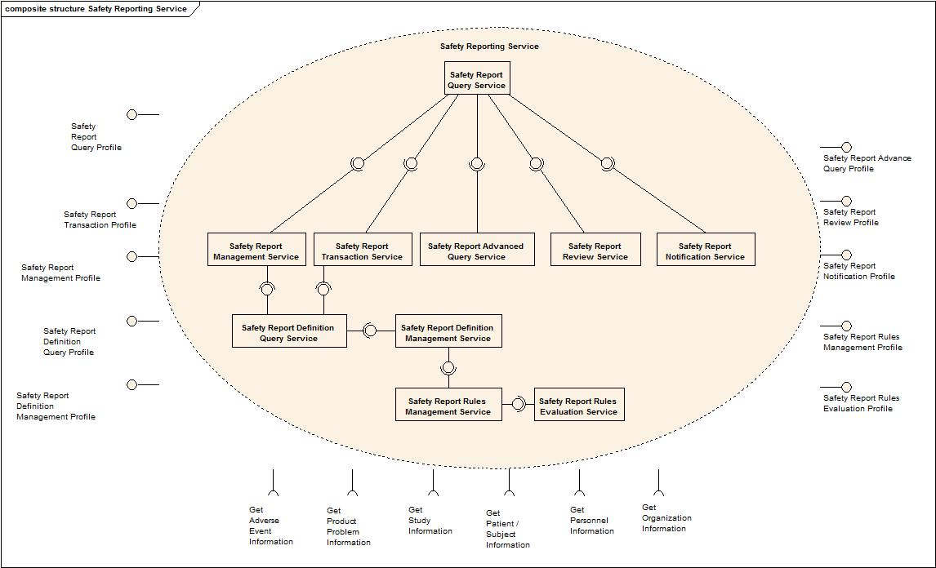

Functional Profile Details
Functional Profile No. | Functional Profile Name | Functional Profile Description | Capability Name
SR-FP1 | Safety Report Query | The Safety Report Query functional profile provides an encapsulation boundary for the commissioner of the query to be guaranteed that the information provided by a given query is correct and complete. | - Query Safety Reports  - Get Safety Reports  - View Safety Report
SR-FP2 | Safety Report Management | The Management series of capabilities details the complete encapsulation boundary behind which the Safety Report object may be managed. | - Initiate Safety Report  - Associate Adverse Event to a Safety Report  - Associate Problem to a Safety Report  - Dissociate Adverse Event from a Safety Report  - Dissociate Problem from a Safety Report  - Update Adverse Event Information in the Safety Report  - Update Problem Information in the Safety Report  - Associate a Study to a Safety Report  - Associate Additional Information to a Safety Report  - Associate Subject to a Safety Report  - Dissociate a Study from a Safety Report  - Dissociate Subject from a Safety Report  - Update Adverse Event Information  - Update Attribution in the Safety Report  - Update Intervention Regulatory Information in the Safety Report  - Update Laboratory Test Results in the Safety Report  - Update Other Possible Causes in the Safety Report  - Update Patient Clinical Measurements in the Safety Report  - Update Patient Disease History in the Safety Report  - Update Patient Concomitant Medications in the Safety Report  - Update Patient Prior Therapies in the Safety Report  - Update Patient Demographics in the Safety Report  - Update Reporter in the Safety Report  - Update Healthcare Provider in the Safety Report  - Update Submitter in the Safety Report  - Update Product Problem Information  - Update the Patient Status in the Safety Report  - Update the Planned Intervention Information in the Safety Report  - Update the Safety Report Narrative  - Update Treatment Information in the Safety Report
SR-FP3 | Safety Report Transaction | The Safety Report Transaction functional profile provides for a series of capabilities to perform the transactions required for safety reporting. | - Submit Safety Report  - Amend Safety Report  - Withdraw Safety Report
SR-FP4 | Safety Report Definition Management | The Safety Report Definition functional profile provides the complete encapsulation boundary behind which the Safety Report Definition may be managed. | - Create Safety Report Definition  - Update Safety Report Definition Details  - Update Safety Report Definition Delivery Details  - Update Safety Report Definition Mandatory Fields  - Deactivate Safety Report Definition  - Update Safety Report Adverse Event Terminology for a Study
SR-FP5 | Safety Report Rules Management | The Safety Report Rules functional profile provides the complete encapsulation boundary behind which the Safety Report Rules may be managed. | - Create Organization Safety Reporting Rules  - Update Organization Safety Reporting Rules  - Deactivate Organization Safety Reporting Rules  - Create Study Safety Reporting Rules  - Update Study Safety Reporting Rules  - Deactivate Study Safety Reporting Rules  - Query Safety Reporting Rules  - Get Safety Reporting Rules
SR-FP6 | Safety Report Notification | The Notification functional profile provides a series of functional capabilities for other systems, services, and users to manage the notifications that shall be triggered based upon updates to adverse event records and the associations to those records. | - Create Safety Report Definition Notification  - Update Safety Report Definition Notification  - Deactivate Safety Report Definition Notification
SR-FP7 | Safety Report Review | The Safety Report Review functional profile provides a series of functional capabilities for other systems, services, and users to manage and execute the safety report review process. | - Create Safety Report Review Process  - Update Safety Report Review Process  - Deactivate Safety Report Review Process  - Get Safety Report Review Process  - Review Safety Report
SR-FP8 | Safety Report Advanced Query | The Advanced Query functional profile provides an encapsulation boundary for the commissioner of the query to be guaranteed that the information provided by a given query is correct and complete. This functional profile provides functionality beyond that provided in the Safety Report Query functional profile. | - Get Audit Trail of Safety Report  - Get Safety Report Summary Data
SR-FP9 | Safety Report Rules Evaluation | The Safety Report Rules Evaluation functional profile provides a series of functional capabilities for other systems, services, and users to evaluate if a safety report is required. | - Evaluate Against Safety Reporting Rules
SR-FP10 | Safety Report Definition Query | The Safety Report Definition functional profile provides a series of functional capabilities for other systems, services, and users to find and obtain a safety report definition. | - Query Safety Report Definition  - Get Safety Report Definition

Semantic Profiles
Semantic Profile No. | Semantic Profile Name | Constrained Information Model | Semantic Profile Description
SR-SP1 | BRIDG V3.0 Safety Report | BRIDG V3.0.2 | - Initiate Safety Report  - Associate Adverse Event to a Safety Report  - Associate Problem to a Safety Report  - Dissociate Adverse Event from a Safety Report  - Dissociate Problem from a Safety Report  - Update Adverse Event Information in the Safety Report  - Update Problem Information in the Safety Report  - Associate a Study to a Safety Report  - Associate Additional Information to a Safety Report  - Associate Subject to a Safety Report  - Dissociate a Study from a Safety Report  - Dissociate Subject from a Safety Report  - Update Adverse Event Information in the Safety Report  - Update Attribution in the Safety Report  - Update Intervention Regulatory Information in the Safety Report  - Update Laboratory Test Results in the Safety Report  - Update Other Possible Causes in the Safety Report  - Update Patient Clinical Measurements in the Safety Report  - Update Patient Disease History in the Safety Report  - Update Patient Concomitant Medications in the Safety Report  - Update Patient Prior Therapies in the Safety Report  - Update Patient Demographics in the Safety Report  - Update Reporter in the Safety Report  - Update Healthcare Provider in the Safety Report  - Update Submitter in the Safety Report  - Update Product Problem Information in the Safety Report  - Update the Patient Status in the Safety Report  - Update the Planned Intervention Information in the Safety Report  - Update the Narrative in the Safety Report  - Update Treatment Information in the Safety Report  - Amend a Safety Report  - Submit a Safety Report  - Withdraw a Safety Report  - Create Safety Report Definition  - Update Safety Report Definition Details  - Update Safety Report Definition Delivery Details  - Update Safety Report Definition Mandatory Fields  - Create Safety Report Definition Notification  - Update Safety Report Definition Notification  - Deactivate Safety Report Definition Notification  - Deactivate Safety Report Definition  - Query Safety Report Definition  - Get Safety Report Definition  - Update Safety Report Terminology for a Study  - Create Organization Safety Reporting Rules  - Update Organization Safety Reporting Rules  - Deactivate Organization Safety Reporting Rules  - Create Study Safety Reporting Rules  - Update Study Safety Reporting Rules  - Deactivate Study Safety Reporting Rules  - Query Safety Reporting Rules  - Get Safety Reporting Rules  - Evaluate Against Safety Reporting Rules  - Query Safety Reports  - Get Safety Reports  - View Safety Report  - Get Audit Trail of a Safety Report  - Get Safety Report Summary Data  - Create Safety Report Review Process  - Update Safety Report Review Process  - Deactivate Safety Report Review Process  - Get Safety Report Review Process  - Review Safety Report

BRIDG Information Model
The Safety Reporting Service binds and complies with semantics of BRIDG V3.0.2 information model. The subset of this model applicable for this service is displayed below.
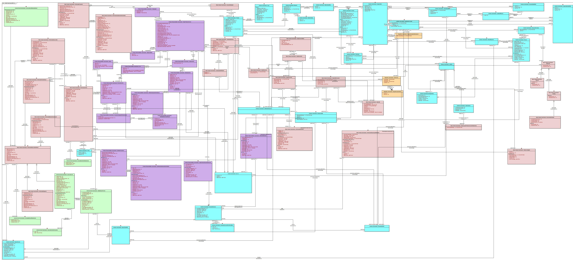

Conformance Profiles
Conformance No | SR-CP1
Conformance Name | BRIDG based Entire Safety Report Conformance Profile
Description | This is the conformance profile defines the entire functionality for the Safety Reporting Service using BRIDG based semantics
Usage Context | This profile would be used by a study administrator or equivalent that has responsibility for all aspects of safety report management.
Mandatory | No
Functional Profile(s) | SR-FP1: Safety Report Query  SR-FP2: Safety Report Management  SR-FP3: Safety Report Transaction  SR-FP4: Safety Report Definition Management  SR-FP5: Safety Report Rules Management  SR-FP6: Safety Report Notification  SR-FP7: Safety Report Review  SR-FP8: Safety Report Advanced Query  SR-FP9: Safety Report Rules Evaluation  SR-FP10: Safety Report Definition Query
Semantic Profile(s) | SR-SP1 : BRIDG V3.0.2 Safety Report

Conformance No | AE-CP2
Conformance Name | BRIDG based Essential Safety Report Conformance Profile
Description | This is the conformance profile defines the essential functionality for initiating, updating, completing, and finding safety reports using BRIDG based semantics
Usage Context | This profile would be used by a user or system that has responsibility for safety report management.
Mandatory | Yes
Functional Profile(s) | SR-FP1: Safety Report Query  SR-FP2: Safety Report Management  SR-FP3: Safety Report Transaction  SR-FP10: Safety Report Definition Query
Semantic Profile(s) | SR-SP1 : BRIDG V3.0.2 Safety Report

System Implementation Details

System Runtime Interactions
The following diagram shows interaction between Safety Reporting Service and other participants.
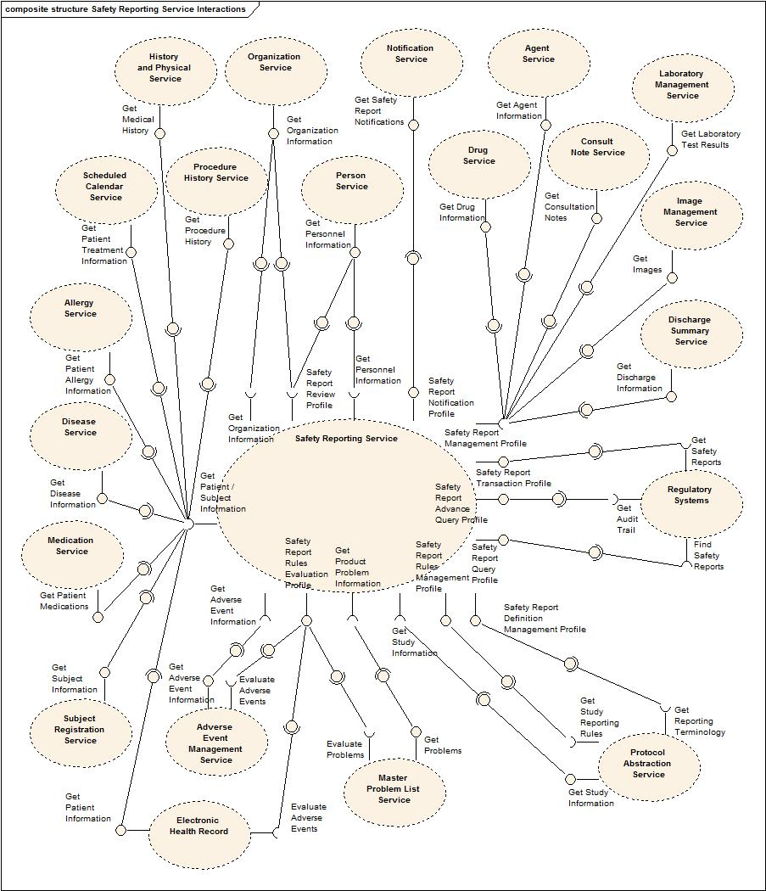

Implementation/Deployment Considerations
Implementation Considerations | Impacts
This specification is intended to support both local and federated adverse event data management where multiple local deployments would interact together to form a larger whole. | The system may have to be configured such that specific profiles are served by different processes.

Conformance and Compliance

Compliance and Conformance Statements
Name | Type | Viewpoint | Description | Test method
Query Performance | Obligation | Engineering | The Safety Reporting Service should provide a response capable of supporting a synchronous UI based client | Test cases to include performance testing.
Multiple Jurisdictions | Obligation | Enterprise | The Safety Reporting Service will span jurisdictional boundaries and will need to support a federated data model. | Test cases include multiple domain scenarios.
Secured Access | Obligation | Engineering | The Safety Reporting Service should have access control mechanism in place to restrict access to the secured data | 1. Design review  2. Test cases to be defined for security
Additional Functionality | Permission | Computational | The Safety Reporting Service can provide additional functionality other than specified in these specifications | Design Review
Semantic Model | Obligation | Informational | The Safety Reporting Service must support NCI’s version of BRIDG 3.0.1 model Adverse Event class. | Design Review
Functional Profiles | Obligation | Computational | Functional Profiles shall be deployed as functional wholes. Ignoring or omitting functional behavior defined within a functional profile is not permitted, nor is diverging from the detailed functional specifications provided in Section 4. | - Design Review  - Test cases
Functional Profiles – Conformant Implementation | Obligation | Computational | A conformant implementation of this specification must deploy at least the BRIDG based Essential Safety Reporting Conformance Profile. | - Design Review  - Test cases

Appendix A – Relevant Standards

Name | Description | Location
BRIDG v3.0.2 | BRIDG model used for modeling the Safety Reporting Service | http://gforge.nci.nih.gov/frs/?group_id=342
HL7v3 | Health Level 7 version 3 | http://www.hl7.org/implement/standards/v3messages.cfm

Appendix B – References
Name | Description | Location
BRIDG v3.0.2 | BRIDG model used for modeling the AE Service | http://gforge.nci.nih.gov/frs/?group_id=342
caAERS Use Case Document | Document containing use cases for the caAERS application | https://wiki.nci.nih.gov/display/caAERS/Use+Cases+-+caAERS
Safety Reporting Domain Model | BRIDG v3.0.x based Safety Reporting Domain Model | https://ncisvn.nci.nih.gov/svn/caaersappdev/docs/models/Services/BRIDGv3.0.1_based_AEServices_analysis.EAP
caAERS Design Model | Design model for caAERS | https://ncisvn.nci.nih.gov/svn/caaersappdev/docs/models/caAERS_model.eap

Appendix C - Glossary
Term | Description
adverse event | An injury related to medical management, in contrast to complications of disease. Medical management includes all aspects of care, including diagnosis and treatment, failure to diagnose or treat, and the systems and equipment used to deliver care.
AdEERS | The Adverse Event Expedited Reporting System used by the NCI Cancer Therapy Evaluation Program (CTEP) for safety reporting.
BRIDG | The Biomedical Research Integrated Domain Group (BRIDG) has developed a comprehensive domain analysis model representing biomedical/clinical research.
caAERS | Cancer Adverse Event Reporting System
clinical trial | A scientific investigation (or study) utilizing human subjects.
CTCAE | Common Terminology Criteria for Adverse Events
MedDRA | Medical Dictionary for Regulatory Activities
expected adverse event | A safety report that has been previously demonstrated to have a probability of occurring as a result of certain medical treatment.
epoch | A characterization of a type of period during a clinical trial.
grade | The degree of severity of the adverse event.
protocol | The written document detailing the materials and methods for a clinical trial.
reporting period | A defined period during a clinical trial.
solicited adverse event | A safety report for which an evaluation is prompted and actively sought.

Appendix D – Cross Reference Tables

List of Storyboards
# | Storyboard | Description | Source
SR-SB1 | Clinician Initiated Safety Report | An adverse event requiring safety reporting is identified by a Healthcare Provider during the clinical exam of a Patient as part of clinical care. | caAERS Use Cases
SR-SB2 | Patient Initiated Safety Report | A Patient directly reports an adverse symptom and it is initiated as a safety report. | caAERS Use Cases
SR-SB3 | Adverse Event Initiated Safety Report | An adverse event requiring safety reporting to the Study Sponsor is observed on a Study Subject. | caAERS Use Cases
SR-SB4 | Product Problem Initiated Safety Report | A product problem requiring safety reporting to the Study Sponsor is observed on a Study Subject. | caAERS Use Cases
SR-SB5 | Unanticipated Problem Initiated Safety Report | An unanticipated problem occurs on a study and requires reporting to the IRB. | caAERS Use Cases
SR-SB6 | Update Report Personnel Information in the Safety Report | The information regarding the clinical personnel and reporting points-of-contact are updated on the safety report. | caAERS Use Cases
SR-SB7 | Update Study Information in the Safety Report | The safety report is updated with the basic information regarding the clinical trial. | caAERS Use Cases
SR-SB8 | Update Adverse Event Information in the Safety Report | The Safety Report is updated with new adverse event information. | caAERS Use Cases
SR-SB9 | Update the Product Problem Information in the Safety Report | A Safety Report is updated with new product problem information. | caAERS Use Cases
SR-SB10 | Update the Narrative in the Safety Report | The Safety Report is updated to include a clinical narrative describing the entire event. | caAERS Use Cases
SR-SB11 | Update the Status of the Patient in the Safety Report | The Safety Report is updated with the information regarding the status of the Patient or Study Subject at the time of the report, with respect to the adverse event. | caAERS Use Cases
SR-SB12 | Update Planned Intervention Information in the Safety Report | The Safety Report is updated with the information regarding the planned interventions that a Study Subject was supposed to receive. | caAERS Use Cases
SR-SB13 | Update Actual Treatment Information in the Safety Report | The Safety Report is updated with the information regarding the actual interventions that a Study Subject received. | caAERS Use Cases
SR-SB14 | Update Adjustments to Planned Interventions in the Safety Report | The Safety Report is updated with the information regarding the adjustments to the planned interventions that were made because of the adverse event. | caAERS Use Cases
SR-SB15 | Update Intervention Regulatory Information in the Safety Report | The Safety Report is updated with the information regarding the regulatory status of the relevant study interventions. | caAERS Use Cases
SR-SB16 | Update Patient Demographics in the Safety Report | The Safety Report is updated with information regarding the Patient’s demographics. | caAERS Use Cases
SR-SB17 | Update Patient Clinical Information in the Safety Report | The Safety Report is updated with relevant clinical information regarding the Patient. | caAERS Use Cases
SR-SB18 | Update Other Possible Causes in the Safety Report | The Safety Report is updated with information regarding any possible causes of the problem not already identified. | caAERS Use Cases
SR-SB19 | Update Attribution of Possible Causes in the Safety Report | Likely cause(s) of each adverse event or problem is documented on the Safety Report. | caAERS Use Cases
SR-SB20 | Update Relevant Laboratory Test Results in the Safety Report | Relevant laboratory tests are documented on the Safety Report. | caAERS Use Cases
SR-SB21 | Update Additional Information in the Safety Report | Relevant supporting documentation is linked to the Safety Report. | caAERS Use Cases
SR-SB22 | Submit a Safety Report | The Safety Report is submitted to the appropriate recipient(s). | caAERS Use Cases
SR-SB24 | Withdraw a Safety Report | A submitted Safety Report is withdrawn. | caAERS Use Cases
SR-SB24 | Amend a Safety Report | A submitted Safety Report is amended. | caAERS Use Cases
SR-SB25 | Search for Safety Reports | Search criteria are provided and Safety Report records satisfying the search criteria are identified. | caAERS Use Cases
SR-SB26 | Obtain Safety Reports | Safety Report records of interest are identified, the information to be returned from those records is specified, and the requested information is provided. | caAERS Use Cases
SR-SB27 | Obtain Safety Report Summaries | Safety Report records of interest are identified, the attribute(s) on which to summarize the records are specified, along with method of summarization, and the requested summaries are provided | caAERS Use Cases
SR-SB28 | Determine if a Safety Report is Required | An adverse event is assessed to determine if it needs to be reported in the safety report. | caAERS Use Cases
SR-SB29 | Update Safety Reporting Rules for a Study | The criteria for the study are updated against which an adverse event is assessed to determine if it needs to be reported in the safety report. | caAERS Use Cases
SR-SB30 | Update Safety Reporting Rules for an Organization | The criteria for the study organization are updated against which an adverse event is assessed to determine if it needs to be reported in the safety report. | caAERS Use Cases
SR-SB31 | Update the Safety Report Definition | A Report Definition Manager specifies the requirements for a specific safety report. | caAERS Use Cases
SR-SB32 | Update a Safety Report Notification | A Healthcare Provider specifies the conditions under which they will receive a notification regarding a safety report. | caAERS Use Cases
SR-SB33 | Obtain a Safety Report Definition | A Safety Reporter obtains the requirements for completing a safety report. | caAERS Use Cases
SR-SB34 | Update the Adverse Event Terminology Required for a Safety Report on a Study | A Report Definition Manager updates the terminology to be used for safety reporting for a specific study. | caAERS Use Cases
SR-SB35 | Obtain the Audit Trail of a Safety Report | A Quality Assurance Auditor requests to view the audit trail of create, update, and delete operations associated with a specific safety report. | caAERS Use Cases
SR-SB36 | Update the Safety Report Review Workflow | The Study Data Manager for the study specifies the workflow that should be followed for reviewing safety reports for a study site. | caAERS Use Cases
SR-SB37 | Healthcare Provider Review of a Safety Report | A Safety Reporter sends a Safety Report to a Healthcare Provider for review. The Healthcare provider then reviews the safety report. | caAERS Use Cases
SR-SB38 | Safety Monitor Review of a Safety Report | A Safety Reporter sends a Safety Report to a Study Safety Monitor for review. The Study Safety Monitor then reviews the report. | caAERS Use Cases
SR-SB39 | Sponsor Review of a Safety Report | A Safety Reporter sends a Safety Report to a Sponsor for review. The Sponsor then reviews the report. | caAERS Use Cases

Storyboards to Capabilities Mapping
# | Storyboard | Capabilities | Functional Profile
SR-SB1 | Clinician Initiated Safety Report | - Initiate Safety Report | Safety Report Management
SR-SB2 | Patient Initiated Safety Report | - Initiate Safety Report | Safety Report Management
SR-SB3 | Adverse Event Initiated Safety Report | - Initiate a Safety Report  - Associate Adverse Event to a Safety Report  - Dissociate Adverse Event from a Safety Report  - Update Adverse Event Information in the Safety Report | Safety Report Management
SR-SB4 | Product Problem Initiated Safety Report | - Initiate a Safety Report  - Associate Problem to a Safety Report  - Dissociate Problem from a Safety Report  - Update Problem Information in the Safety Report | Safety Report Management
SR-SB5 | Unanticipated Problem Initiated Safety Report | - Initiate a Safety Report  - Associate Adverse Event to a Safety Report  - Dissociate Adverse Event from a Safety Report  - Update Adverse Event Information in the Safety Report  - Associate Problem to a Safety Report  - Dissociate Problem from a Safety Report  - Update Problem Information in the Safety Report | Safety Report Management
SR-SB6 | Update Report Personnel Information in the Safety Report | - Initiate a Safety Report  - Update Reporter in the Safety Report  - Update Healthcare Provider in the Safety Report  - Update Submitter in the Safety Report | Safety Report Management
SR-SB7 | Update Study Information in the Safety Report | - Initiate a Safety Report  - Associate a Study to a Safety Report  - Dissociate a Study from a Safety Report | Safety Report Management
SR-SB8 | Update Adverse Event Information in the Safety Report | - Update Adverse Event Information | Safety Report Management
SR-SB9 | Update the Product Problem Information in the Safety Report | - Update Product Problem Information | Safety Report Management
SR-SB10 | Update the Narrative in the Safety Report | - Update the Safety Report Narrative | Safety Report Management
SR-SB11 | Update the Status of the Patient in the Safety Report | - Update the Patient Status in the Safety Report | Safety Report Management
SR-SB12 | Update Planned Intervention Information in the Safety Report | - Update the Planned Intervention Information in the Safety Report | Safety Report Management
SR-SB13 | Update Actual Treatment Information in the Safety Report | - Update Treatment Information in the Safety Report | Safety Report Management
SR-SB14 | Update Adjustments to Planned Interventions in the Safety Report | - Update Treatment Information in the Safety Report | Safety Report Management
SR-SB15 | Update Intervention Regulatory Information in the Safety Report | - Update Intervention Regulatory Information in the Safety Report | Safety Report Management
SR-SB16 | Update Patient Demographics in the Safety Report | - Update Patient Demographics in the Safety Report  - Associate Person to a Safety Report  - Dissociate Person from a Safety Report | Safety Report Management
SR-SB17 | Update Patient Clinical Information in the Safety Report | - Update Patient Clinical Measurements in the Safety Report  - Update Patient Disease History in the Safety Report  - Update Patient Concomitant Medication in the Safety Report  - Update Patient Prior Therapies in the Safety Report | Safety Report Management
SR-SB18 | Update Other Possible Causes in the Safety Report | - Update Other Possible Causes in the Safety Report | Safety Report Management
SR-SB19 | Update Attribution of Possible Causes in the Safety Report | - Update Attribution in the Safety Report | Safety Report Management
SR-SB20 | Update Relevant Laboratory Test Results in the Safety Report | - Update Laboratory Test Results in the Safety Report | Safety Report Management
SR-SB21 | Update Additional Information in the Safety Report | - Update Additional Information in the Safety Report | Safety Report Management
SR-SB22 | Submit a Safety Report | - Submit a Safety Report | Safety Report Transaction
SR-SB24 | Withdraw a Safety Report | - Withdraw a Safety Report | Safety Report Transaction
SR-SB24 | Amend a Safety Report | - Amend a Safety Report | Safety Report Transaction
SR-SB25 | Search for Safety Reports | - Query Safety Reports | Safety Report Query
SR-SB26 | Obtain Safety Reports | - Get Safety Reports  - View Safety Report | Safety Report Query
SR-SB27 | Obtain Safety Report Summaries | - Get Safety Report Summaries | Safety Report Advanced Query
SR-SB28 | Determine if a Safety Report is Required | - Evaluate Safety Reporting Rules | Safety Reporting Rules Evaluation
SR-SB29 | Update Safety Reporting Rules for a Study | - Create Study Safety Reporting Rules  - Update Study Safety Reporting Rules  - Deactivate Study Safety Reporting Rules | Safety Reporting Rules Management
SR-SB30 | Update Safety Reporting Rules for an Organization | - Create Organization Safety Reporting Rules  - Update Organization Safety Reporting Rules  - Deactivate Organization Safety Reporting Rules | Safety Reporting Rules Management
SR-SB31 | Update the Safety Report Definition | - Create Safety Report Definition  - Update Safety Report Definition Details  - Update Safety Report Definition Delivery Details  - Update Safety Report Definition Mandatory Fields  - Deactivate Safety Report Definition | Safety Report Definition Management
SR-SB32 | Update a Safety Report Notification | - Create Safety Report Definition Notification  - Update Safety Report Definition Notification  - Deactivate Safety Report Definition Notification | Safety Report Notification
SR-SB33 | Obtain a Safety Report Definition | - Query Safety Report Definition  - Get Safety Report Definition | Safety Report Definition Query
SR-SB34 | Update the Adverse Event Terminology Required for a Safety Report on a Study | - Update Safety Report Adverse Event Terminology for a Study | Safety Report Definition Management
SR-SB35 | Obtain the Audit Trail of a Safety Report | - Get Audit Trail of a Safety Report | Safety Report Advanced Query
SR-SB36 | Update the Safety Report Review Workflow | - Create Safety Report Review Process  - Query Safety Report Review Process  - Get Safety Report Review Process  - Update Safety Report Review Process  - Deactivate Safety Report Review Process | Safety Report Review
SR-SB37 | Healthcare Provider Review of a Safety Report | - Get Safety Report Review Process  - Review Safety Report | Safety Report Review
SR-SB38 | Safety Monitor Review of a Safety Report | - Get Safety Report Review Process  - Review Safety Report | Safety Report Review
SR-SB39 | Sponsor Review of a Safety Report | - Get Safety Report Review Process  - Review Safety Report | Safety Report Review

Actors
Actor | Type | Description
Healthcare Provider | Person | The treating physician for a study subject or a patient.
Safety Reporter | Person | The person responsible for completing the safety report.
Safety Report Submitter | Person | The person responsible for submitting the safety report.
AE Reporter | Person | The person responsible for recording adverse events.
Patient | Person | Patient undergoing clinical care outside the scope of a clinical trial.
Study Subject | Person | A participant on a clinical trial. Also know as Study Participant.
Principal Investigator | Person | A subscriber to notifications regarding adverse events.
Report Definition Manager | Person | A person responsible for maintaining the definition of safety reports.
Reporting Rule Manager | Person | A person responsible for maintaining safety reporting rules.
Clinical Data Coordinator | Person | A person who participates in adverse event data entry and data management activities.
Study Data Manager | Person | A person responsible for managing the data of the entire study.
Study Safety Monitor | Person | A person responsible for monitoring the safety of the entire study.
Statistician | Person | A person responsible for analyzing the data on a study.
Quality Assurance Auditor | Person | A person responsible for ensuring the adherence to standard operating procedures.
Institutional Review Board | Person | A committee responsible for reviewing, monitoring, and approving all investigations at an organization involving human subjects.
Study Sponsor | Person | An organization sponsoring a clinical study.
Safety Reporting System | System | A system used to manage safety reports.
Adverse Event Management System | System | A system used to manage adverse event records.
Safety Report | System | The form, either paper or electronic, used to record and report the safety issue.
Clinical Trials Management System (CTMS) | System | The system used to store the information regarding protocols, people, organizations, and subjects, and schedules that are needed to conduct a clinical trial.
Notification System | System | Used to provide notifications regarding Safety Reporting activities.
Electronic Health Record (EHR) System | System | The system which houses the clinical data associated with the conduct of routine clinical care.
Clinical Data Management System (CDMS) | System | The system which houses the clinical data associated with the conduct of a clinical trial.

