

Compliance Report for International AE Reporting

The caBIG® Adverse Event Management System
subcontract number: 28xs108
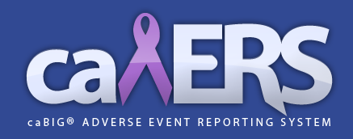

Submitted by Paul Baumgartner
paul.baumgartner@semanticbits.com

Submitted: 03/10/2011

Summary
The purpose of this report is to summarize the compliance of the caBIG® Adverse Event Reporting System (caAERS) with the various requirements for supporting international adverse event reporting.

International Adverse Event Reporting

Supported by caAERS
- caAERS supports generation of the MedWatch 3500A adverse event form.
- caAERS supports generation of the CIOMS international adverse event form.
- caAERS supports the use of “seriousness” as a criteria in safety reporting decision support.
- caAERS has been designed with respect to the BRIDG domain model.
- caAERS supports the use of MedDRA, an internationally recognized medical terminology.
- caAERS supports reporting of adverse events using the verbatim.
- caAERS supports the ability to change the names of field labels within the user interface.

Not supported by caAERS
- caAERS does not yet support languages aside from English.
- caAERS does not yet support international date formats.

