

FDA Regulations Compliance Report

The caBIG® Adverse Event Management System
subcontract number: 28xs108
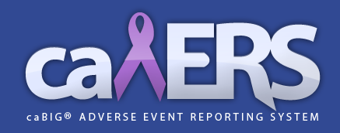

Submitted by Paul Baumgartner
paul.baumgartner@semanticbits.com

Submitted: 03/10/2011

Summary
The purpose of this report is to summarize the compliance of the caBIG® Adverse Event Reporting System (caAERS) with the various regulations applicable to the FDA. Listed below are the areas where caAERS support the US FDA’s requirements and the gaps in this support as grouped by three categories: adverse event reporting, electronic submission and review, and 21 CFR Part 11.

Adverse Event Reporting

Supported by caAERS
- caAERS supports generation of the MedWatch 3500A adverse event form.
- caAERS supports generation of the CIOMS international adverse event form.
- caAERS supports the use of “seriousness” as a criteria in safety reporting decision support.
- caAERS has been designed with respect to the BRIDG domain model.
- caAERS supports labeling agents according to their regulatory status (i.e. IND, commercial, exempt, etc) and allows decision support rules to be authored with respect to this status.
- caAERS supports reporting of adverse events using the verbatim.
- caAERS supports the ability to change the names of field labels within the user interface.

Not supported by caAERS
- caAERS does not yet support the generation of a Form 1571 required in order to submit a safety report against an IND.

Electronic Submission and Review
The following is a reference to the FDA’s requirements for electronic submission and review: http://www.fda.gov/Drugs/DevelopmentApprovalProcess/FormsSubmissionRequirements/ElectronicSubmissions/default.htm

Supported by caAERS
- caAERS supports the generation of XML based outputs which could be converted to eCTD format outside of the caAERS system.

Not supported by caAERS
- caAERS does not yet support direct electronic submission of a safety report to the FDA.
- caAERS does not yet support generating and electronic common technical document (eCTD).

21 CFR Part 11

Supported by caAERS
- caAERS was developed according to good software development lifecycle (SDL) practices including requirements and use case documentation, traceability, oversight, and testing.

Not supported by caAERS
- caAERS does not yet support electronic signatures.
- caAERS had not yet undergone an outside audit to evaluate it’s support of 21 CFR Part 11.

