Create – Import MedDRA Technical Specification

Technical Specification

Version Histroy
Version | Date Modified | Author
 |  | Krikor Krumlian

Contacts and Support
KrikorKrumlian kkrumlian@akazaresearch.com | NA
NA | NA

LISTSERV Facilities Pertinent to software teams
LISTSERV | URL | Name
Caaersappdev-technical | caaersappdev-technical@gforge.nci.nih.gov. | caAERS technical forum
Table of Contents
1 Scope and Purpose 4
2 Overview 4
2.1 Features 4
2.2 Assumptions 4
3 Design Approach 4
3.1 Domain Objects 4
3.2 Persistence Layer 4
3.3 Service Layer 5
3.4 Controller Layer 5
3.5 View Layer 5
4 Implementation 5
4.1 Domain Model 5
4.2 Sequence Diagram 6
4.3 Activity Diagram 6
5 Testing 7
5.1 Domain Layer 7
5.2 Persistence Layer 7
5.3 Service Layer 7
5.4 Web Layer 7

List of Figures
Figure 1 6
Figure 2 7

Scope and Purpose
The scope of this document is to provide technical design / specification, for the Participant module within caAERS. The specification will include the use case realization in each of the iteration, accompanying UML models and documentation wherever appropriate.
The purpose of this document is to facilitate development with an initial phase of analysis and design and support as a documentation of the overall design in the Core project for other developers.

Overview

Features
This feature will allow you to import the medDRA Code into the caAERS web application. http://www.meddramsso.com/MSSOWeb/index.htm
caAERS is equipped with the data structure to store the medDRA hierarchy. MedDRA is a 5 level hierarchy - The MedDRA dictionary is organized by System Organ Class (SOC), divided into High-Level Group Terms (HLGT), High-Level Terms (HLT), Preferred Terms (PT) and finally into Lower-Level Terms (LLT).
As of the time of writing this document caAERS can import medDRA version 9.x.

Assumptions
MedDRA code is not available as an open source product. So parties interested in importing this code into caAERS must have the appropriate license to do so.
Once you obtain the MedDRA package there will be a folder which contains the “.asc” files. caAERS uses those files to import the medDRA code. The following files are required – llt.asc , pt.asc , hlt.asc , hlgt.asc , soc.asc , hlt_pt.asc , hlgt_hlt.asc , soc_hlgt.asc .

Design Approach

Domain Objects
caAERS has a domain driven design with analysis starting from a BRIDG (Biomedical Research Integrated Domain Group) Harmonized model. A set of domain objects will be created in gov.nih.nci.cabig.caaers.domain. Once domain model is finalized, an immediate Implementation Model is based out of the domain model which identifies the Java classes, associations. The domain objects are persisted using Hibernate and Hibernate 3 annotations will be used for mapping to database elements instead of separate hbm files. These annotations can in turn be configured via Spring’s bean configuration files.

Persistence Layer
DAO implementations will be created to facilitate database access. The application will only access the database via a DAO interface object. The MedDRA import does not use hibernate to achieve persistence. It instead relies on Jdbc and specifically JdbcTemplate provided by the Spring framework. The use of Jdbc is to improve performance on high volume inserts doen while import the MedDRA code.

Service Layer
The service layer will expose a set of interfaces for the client to call in (currently the interface decided is a Web Interface). The Controller classes typically delegate the functionality to Service classes. Spring adds the dependency injection for the implemented classes as Controller need not be coupled with the SAM.

Controller Layer
Spring’s MVC is being used as the MVC architecture for caAERS. All the Controller classes for the respective use case will be located in the package gov.nih.nci.cabig.caaers.web

View Layer
The view technology incorporated in caAERS consists of JSP pages, css, AJAX and tag libraries included from Spring.

Implementation

Domain Model
Derived from Domain Analysis model, the implementation model is a model realized for a Java implementation with classes, associations. The MedDRA library is divided into a Five hierarchal structure. The hierarchy start with System Organ Class, High Level Group Terms, High Level Terms, Preferred Terms, Low Level Terms.
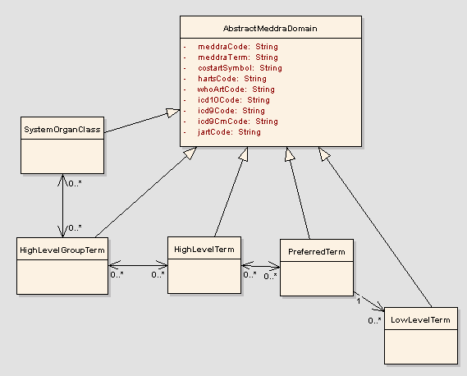
Figure 1

Sequence Diagram
Core controller of Import Meddra is based on Spring’s ParametrizedFormController. This controller will load the initial page where a text box is provided with a place to fill in the folder name(this is the folder containing the MedDRA files). After pressing the Import Meddra Button import starts.

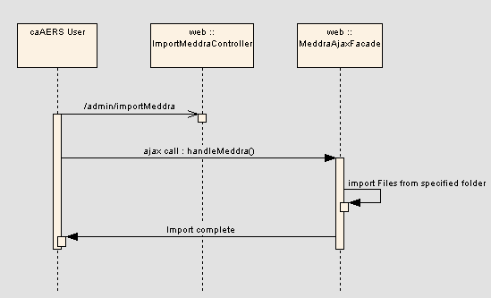

Activity Diagram
The workflow is a two tab workflow.

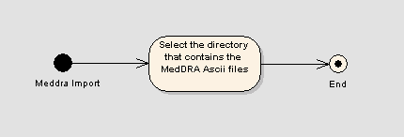
Figure 2

Testing

Domain Layer
No tests available for the domain layer – a straight forward domain.

Persistence Layer

Test Class Name | Target
gov.nih.nci.cabig.caaers.dao.MedDRADaoTest.java | Tests the MedDRADao.java class – this class is responsible in performing jdbc based imports into the database
gov.nih.nci.cabig.caaers.dao.LowLevelTermDaoTest.java | Test the LowLevelTermDao.java class- This class performs querying for by meddra code.

Service Layer

No Service layer code present for this feature

Web Layer

The point of failure in this feature is the Dao layer

