caAERS – Import Study,Participant

Technical Specification

Version Histroy
Version | Date Modified | Author
 |  | Krikor Krumlian

Contacts and Support
KrikorKrumlian kkrumlian@akazaresearch.com | NA
NA | NA

LISTSERV Facilities Pertinent to software teams
LISTSERV | URL | Name
Caaersappdev-technical | caaersappdev-technical@gforge.nci.nih.gov. | caAERS technical forum
Table of Contents
1 Scope and Purpose 4
2 Overview 4
2.1 Features 4
2.2 Assumptions 4
3 Design Approach 4
3.1 Domain Objects 4
3.2 Persistence Layer 4
3.3 Service Layer 5
3.4 Controller Layer 5
3.5 View Layer 5
4 Implementation 5
4.1 Domain Model 5
4.2 Sequence Diagram 5
4.3 Activity Diagram 9
5 Testing 9
5.1 Domain Layer 9
5.2 Persistence Layer 9
5.3 Service Layer 9
5.4 Web Layer 9

List of Figures
Figure 1 9

Scope and Purpose
The scope of this document is to provide technical design / specification, for the Participant module within caAERS. The specification will include the use case realization in each of the iteration, accompanying UML models and documentation wherever appropriate.
The purpose of this document is to facilitate development with an initial phase of analysis and design and support as a documentation of the overall design in the Core project for other developers.

Overview

Features
This feature allows the Import of study/protocol and participant information into caAERS. We provide an xml schema and an example xml document that shows how the import is supposed to be done.

Assumptions
The Study/Protocol information should be imported prior to Participant information. With its current implementation imported studies and participants cannot be updated via another import.

Design Approach

Domain Objects
caAERS has a domain driven design with analysis starting from a BRIDG (Biomedical Research Integrated Domain Group) Harmonized model. A set of domain objects will be created in gov.nih.nci.cabig.caaers.domain. Once domain model is finalized, an immediate Implementation Model is based out of the domain model which identifies the Java classes, associations. The domain objects are persisted using Hibernate and Hibernate 3 annotations will be used for mapping to database elements instead of separate hbm files. These annotations can in turn be configured via Spring’s bean configuration files.

Persistence Layer
DAO implementations will be created to facilitate database access. The application will only access the database via a DAO interface object. Each implementation of the dao interface would a specific implementation (in this case, hibernate) which extend the org.Springframework.orm.hibernate3.support.HibernateDaoSupport class that provides a good template for quickly building data access methods without the risk of database leaks and poor error handling.

Service Layer
The service layer will expose a set of interfaces for the client to call in (currently the interface decided is a Web Interface). The Controller classes typically delegate the functionality to Service classes. Spring adds the dependency injection for the implemented classes as Controller need not be coupled with the SAM.

Controller Layer
Spring’s MVC is being used as the MVC architecture for caAERS. All the Controller classes for the respective use case will be located in the package gov.nih.nci.cabig.caaers.web

View Layer
The view technology incorporated in caAERS consists of JSP pages, css, AJAX and tag libraries included from Spring.

Implementation

Domain Model

No Domian model changes associated with this feature.

Sequence Diagram
Core controller of Import is based on Spring’s AbstractWizardFormController. This eliminates the session/form handling by the developer and provides fine extension points for generating a workflow between a well defined set of pages with the notion of back/next buttons. The validations used on the page are two level – client side javascript and server side Spring Validator.

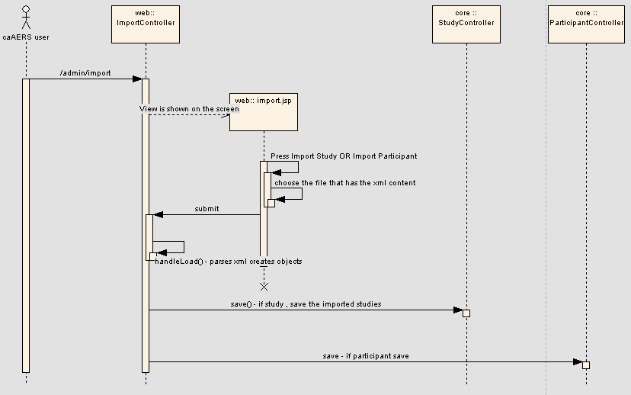

We are providing some rules on how to use import. We have also included those xml schemas and files in the SVN project docs folder.

Rules and features associated with uploading Participants

A Uniqueness check currently configured on firstName and lastName : So if a participant we are trying to import has the same name and last name as another participant currently in caAERS then caAERS will flag this record and not import it
A Participant contains data specifying which study/protocol it should belong to. Studies are pinpointed through a search for its identifiers. If the participant we are trying to import does not belong to any of the studies in the system then this record will be flagged and not imported
We can attach a single participant to multiple Studies / Protocols
Generated xml should validate against the xml schema provided in this email
Import Happens through the UI Administration / Import
User will be able to view the records that have been flagged with an appropriate message

An Example XML

<?xml version="1.0" encoding="UTF-8"?>

<participants>
<participant>
<firstName>Mike</firstName>
<lastName>Jordam</lastName>
<maidenName></maidenName>
<middleName></middleName>
<dateOfBirth>2007-04-15</dateOfBirth>
<gender>Unknown</gender>
<race>Unknown</race>
<ethnicity>Unknown</ethnicity>
<assignments>
<assignment>
<studySite>
<study>
<longTitle>Phase</longTitle>
<identifiers>
<identifier>
<type>Local Identifier</type>
<value>50502</value>
<source>WFU</source>
<primaryIndicator>No</primaryIndicator>
</identifier>
</identifiers>
</study>
</studySite>
</assignment>
<assignment>
<studySite>
<study>
<longTitle>Phase</longTitle>
<identifiers>
<identifier>
<type>Local Identifier</type>
<value>29206</value>
<source>WFU</source>
<primaryIndicator>No</primaryIndicator>
</identifier>
</identifiers>
</study>
</studySite>
</assignment>
</assignments>
</participant>
</participants>

Rules and features associated with uploading Studies
A Uniqueness check currently configured on study identifiers: So if a study we are trying to import has the same identifier as another study currently in caAERS then caAERS will flag this record and not import it.

Generated xml should validate against the xml schema provided in this email.
If the agent and disease information do not exist then the xml would look like this. You are right the complex type will not be there

An Xml Example
<?xml version="1.0" encoding="UTF-8"?>
<studies>
<study>
<shortTitle>theTitle23</shortTitle>
<longTitle>Hello World</longTitle>
<primarySponsorCode>Yes</primarySponsorCode>
<identifiers>
<identifier>
<type>Protocol Authority Identifier</type>
<value>50502</value>
<source>CALGB</source>
<primaryIndicator>Yes</primaryIndicator>
</identifier>
<identifier>
<type>Protocol Authority Identifier</type>
<value>50502</value>
<source>CALGB</source>
<primaryIndicator>Yes</primaryIndicator>
</identifier>
</identifiers>
<studySites>
<studySite>
<site>
<name>default</name>
</site>
</studySite>
</studySites>
</study>
</studies>

Agents can be added by adding the following complex type to the above xml. Add to the end of the xml file
<studyAgents>
<studyAgent>
<agent>
<name>(H115D)VHL35 Peptide</name>
<nscNumber>726584</nscNumber>
</agent>
</studyAgent>
</studyAgents>

Diseases can be added by adding the following complex type to the above xml
<studyDiseases>
<studyDisease>
<diseaseTerm>
<ctepTerm>AIDS-related Non-Hodgkin lymphoma</ctepTerm>
<category>
<name>AIDS-related Lymphoma</name>
</category>
</diseaseTerm>
</studyDisease>
</studyDiseases>

Activity Diagram
The workflow is a two tab workflow.
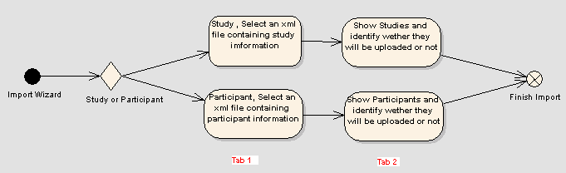
Figure 1

Testing

Domain Layer
No Domain objects added for this feature

Persistence Layer

Test Class Name | Target
gov.nih.nci.cabig.caaers.dao.StudyDao | Test the Save functionality for saving the new objects
gov.nih.nci.cabig.caaers.dao.ParticipantDao | Test the Save functionality for saving the new objects

Service Layer
No Service Layer objects added for this feature

Web Layer

