caBIG® Platform Independent Model and Service Specification

Safety Report Service

0.1.0

December 3rd, 2010

Authors | Srini Akkala
Editor | Srini Akkala
Reviewers | Kalpesh Patel, Harsh Marwaha, Brian McIndoe, Santosh Joshi
Architecture Inception Team | Kalpesh Patel, Christo Andonyadis

Version Number | Date | Contributor | Description
0.0.1 |  | Srini Akkala | Initial Draft

TABLE OF CONTENTS

1 Introduction 5
1.1 Overview 5
1.2 Relationship to Standards 5
1.3 Relation to the Safety Reporting Conceptual Functional Service Specification 5
1.3.1 Conformance and Compliance 6
2 Platform Independent Model and Service Specification 8
2.1 Overview and Architecture 8
2.2 Implementation Considerations 8
2.2.1 Assumptions 9
2.2.2 Deployment Considerations 9
2.2.3 Jurisdictional Domains 9
2.3 Information Model 9
2.3.1 SafetyReportVersion Type 9
2.3.2 SafetyReport Implementation model 11
2.3.3 Error Implementation Model 13
2.4 Control Data Type Definitions 14
2.4.1 Status/Return Values/Exceptions 14
2.4.2 Error Codes 14
3 Interfaces 16
3.1 UML Model of Interfaces 16
3.2 Operations (Enumeration) 18
3.3 Operation Behavior Descriptions 23
3.3.1 SafetyReportQuery Interface 23
3.3.2 SafetyReportManagement Interface 25
3.3.3 SafetyReportTransaction Interface 43
3.3.4 SafetyReportDefinitionManagement Interface 45
3.3.5 SafetyReportRulesManagement Interface 49
3.3.6 SafetyReportNotification Interface 53
3.3.7 SafetyReportReview Interface 54
3.3.8 SafetyReportAdvancedQuery Interface 58
3.3.9 SafetyReportRulesEvaluation Interface 58
3.3.10 SafetyReportDefinitionQuery Interface 59
4 Dynamic Model 60
4.1 Safety Report Management 61
4.2 Safety Report Query 62
4.3 Safety Report Transaction 63
4.4 Safety Report Definition Management 64
4.5 Safety Report Rules Management 65
4.6 Safety Report Notification 65
4.7 Safety Report Review 66
4.8 Safety Report Advanced Query 66
4.9 Safety Report Rules Evaluation 66
4.10 Safety Report Definition Query 67
5 Profiles 68
5.1 Functional Profiles 68
5.1.1 68
5.2 Semantic Profiles 70
6 Relationship with other services 71
7 Conformance Statements 73
8 Appendix A - References 76
9 Appendix B - Glossary 77
10 Appendix C - Cross Reference Tables 78
10.1 Interface to Profile Mapping 78

Adverse Event Service Platform Independent Model and Service Specification

Introduction

Overview
The purpose of the Safety Reporting Service is to provide a standard set of interfaces to create, manage, and submit safety reports. This service will enable the searching, analysis, sharing, and data mining of these reports. Additionally, this service will provide the ability to evaluate harmful or potentially harmful events against criteria to determine appropriate reporting requirements. This service will also facilitate the interaction and interoperability between systems that require and provide safety reports. As a result of this interoperability, this service will potentially improve the quality and availability of safety reports and improve the monitoring of safety on cancer clinical trials and in cancer clinical care.
For its representation, it uses a constrained SafetyReportVersion Class from the NCI version of BRIDG 3.0.2 (https://gforge.nci.nih.gov/plugins/scmsvn/viewcvs.php/BRIDG/?root=ent-resources) and ISO 21090 data types (http://gforge.nci.nih.gov/frs/download.php/3819/ISO_21090_20080317.pdf). Thus, the semantics of the Safety Reporting Services’ Safety Report representation are directly conformant to the BRIDG 3.0.2 and ISO 21090 data types.

The scope of potential usage of this service is unbounded within the health care environment, where safety reporting is needed and the BRIDG forms the basis of the implemented Information Model, and computable semantic interoperability is a goal.

Relationship to Standards

Standards | Description
BRIDG v3.0.2 | Service conforms to NCI’s version of BRIDG v3.0.2
HL7v3 | The service conforms to NCI’s HL7V3 RIM
ISO 21090 | The service conforms to NCI’s version of ISO 21090 data types

Relation to the Safety Reporting Conceptual Functional Service Specification

Conceptual Functional Service Specification Name | Conceptual Functional Service Specification Version | Description & Link to the Conceptual Functional Service Specification
Safety Reporting Conceptual Functional Service Specification | 0.6 | https://ncisvn.nci.nih.gov/svn/caaersappdev/docs/DesignDocs/essn/SafetyReportingService/docs/CIMSS/CIMSS_Safety_Reporting_Service.doc

Deviation from the Conceptual Functional Service Specification | Reason for Deviation
None

Conformance and Compliance

Conformance Profile No. | SR-CP1
Conformance Profile Name | BRIDG based Entire SR Conformance Profile
Functional Profiles
  Functional Profile No. | Functional Profile Name
  SR-FP1 | Safety Report Query
  SR-FP2 | Safety Report Management
  SR-FP3 | Safety Report Transaction
  SR-FP4 | Safety Report Definition Management
  SR-FP5 | Safety Report Rules Management
  SR-FP6 | Safety Report Notification
  SR-FP7 | Safety Report Review
  SR-FP8 | Safety Report Advanced Query
  SR-FP9 | Safety Report Rules Evaluation
  SR-FP10 | Safety Report Definition Query
Semantic Profiles
  Semantic Profile No. | Semantic Profile Name
  SR-SP1 | BRIDG V3.0.2 Adverse Event

Platform Independent Model and Service Specification

Overview and Architecture
The sections below fully describe the operations and behavior of the interfaces provided by the Safety Reporting Service. It is important to note that the structure of interfaces is specifically defined for the Service provider. These are effectively distinct to the groupings of capabilities defined in Functional Profiles that form the basis for conformance and for consumption of the service by Clients. In some cases, the functional profiles may approximate or match the interface structure.

Ten interfaces have been defined:
- SafetyReportQuery: Interface provides capability to perform query operations to retrieve Safety Report data.
- SafetyReportManagement : Interface provides capability to manage Safety Report.
- SafetyReportTransaction : Interface provides capability to perform transactions required for Safety Reporting.
- SafetyReportDefinitionManagement : Interface provides capability to manage Report Definition .
- SafetyReportRulesManagement : Interface provides capability to manage Safety Reporting Rules.
- SafetyReportNotification : Interface provides capability to manage notifications triggered based on updates to adverse event and associations of those records.
- SafetyReportReview : Interface provides capability to manage and execute the safety report review process..
- SafetyReportAdvancedQuery : Interface provides capability to perform query operations to retrieve Safety Report Summary and Audit data..
- SafetyReportRulesEvaluation : Interface provides capability to evaluate if a safety report is required.
- SafetyReportDefinitionQuery : Interface provides capability to find and obtain a safety report definition.

Implementation Considerations

Implementation Consideration | Impact
ISO datatypes may need to be constrained for the implementation | The service developed might not be fully complaint with ISO 21090

Assumptions

Assumptions | Affects
Audit & Logging is assumed to be handled by supporting infrastructure | As a result it is not explicitly referenced in individual operations and assumed to be done automatically
Authorization checks are enforced | Only authorized users will be allowed access

Deployment Considerations

Deployment Consideration | Impact
Local Deployment Mode | Service should be able to run locally in the same container as the client application
Remote Deployment Mode | Service should run remotely and be able to support remote client
Inter domain / Inter Enterprise | The Safety Reporting Service provides inter-domain or inter-enterprise access by multiple applications / services from remote domains and enterprises.

Jurisdictional Domains

Jurisdictional Domains | Boundary
NCI’s OCIO | The service will be deployed within NCI network
Institutional IRB | The service will be deployed at various institutions and will be subject to the management procedures and policies within their jurisdictional boundaries

Information Model

SafetyReportVersion Type

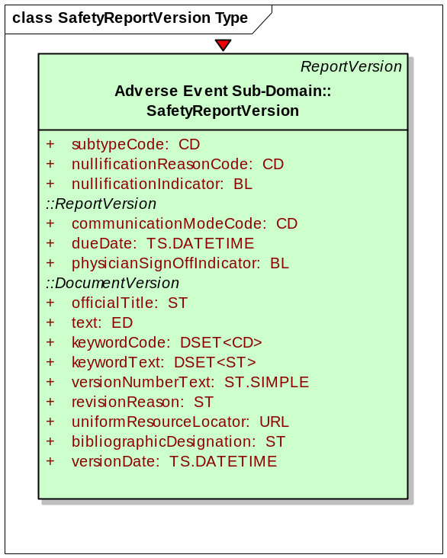
SafetyReportVersion Class used by Safety Report Service

Attribute Name | Type | Type
subTypeCode | CD | A coded value specifying a further classification of type.
nullificationReasonCode | CD | A coded value specifying the reason why the safety report report is nullified.
nullificationIndicator | BL | Specifies whether the report cancels a previously sent adverse event.
communicationModeCode | CD | A coded value specifying the form in which the report is transmitted.
dueDate | TS.DATETIME | The date (and time) on which the report is expected or scheduled to be submitted.
physicianSignOffIndicator | BL | Specifies whether the physician has reviewed and signed off on a version of a report.
officialTitle | ST | The formal title of the document.
versionNumberText | ST.SIMPLE | A character string that identifies a given collection of content of a document at a point in time.
revisionReason | ST | The reason why the document is revised.
uniformResourceLocator | URL | A complete reference to a website (including http://) from which the document contents can be retrieved.
bibliographicDesignation | ST | A text block containing publishing and authoring information that allows receivers of this document version to refer appropriately to this document version.
versionDate | TS.DATETIME | The date (and time) on which the document is versioned.

SafetyReport Implementation model

SafetyReportVersion class and its associations are derived from BRIDG information model. The Enterprise Architect Project for the Safety Report Implementation Model can be found here (https://ncisvn.nci.nih.gov/svn/caaersappdev/docs/models/Services/BRIDGv3.0.2_based_DAM_for_caAERSv2.2.EAP). The class diagram the Safety Report implementation model is shown below:

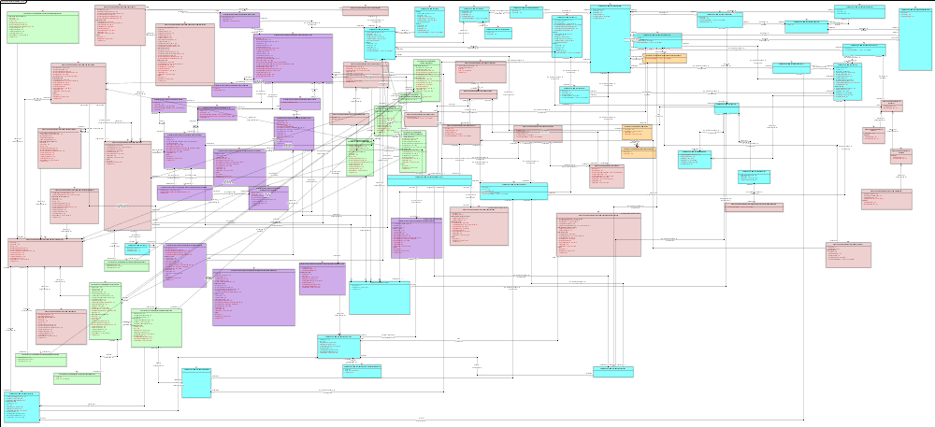
Safety Reporting - Implementation Model derived from BRIDG Information Model
Diagram is BRIDG 3.0.2 compliant.

Additional classes were defined in the Safety Reporting implementation model. These classes are not derived from the BRIDG 3.0.2 model. The class diagram below shows these classes:
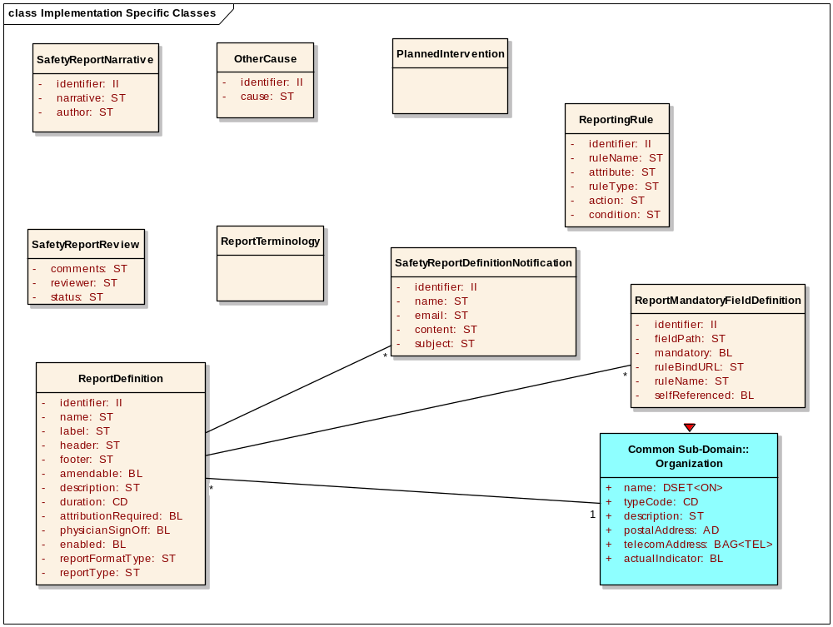
Safety Report implementation classes not derived from BRIDG

Since BRIDG uses ISO 21090 data types, which are HL7 V3 RIM R2 compliant, Adverse Event Service uses the following ISO 21090 Data Types:

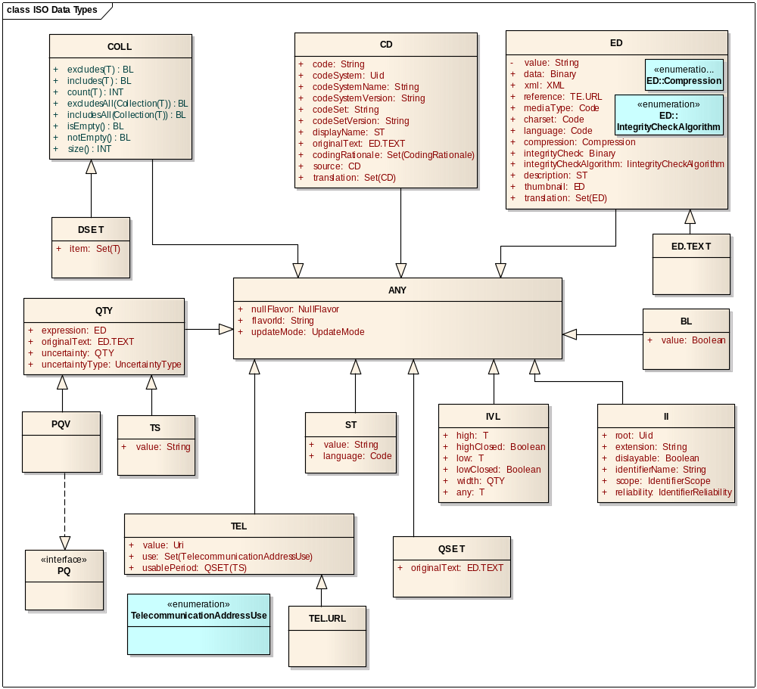
ISO 21090 Data Types used by Safety Reporting Service

Error Implementation Model

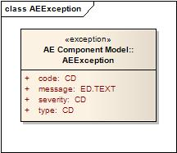

Attribute Name | Type | Attribute Description
code | CD | The actual error code which is Exception class represents
message | CD | The detailed error message
severity | CD | The severity of this error. It can be “FATAL”, “HIGH”, “MEDIUM” or “LOW”
type | CD | Indicates what type of error has occurred. E.g. Business, System etc.

Control Data Type Definitions

Status/Return Values/Exceptions

Data Type | Type (Status / Return Value / Exception) | Data Type Description
SafetyReportException | Exception | Exception thrown when there is an error in the operation of Safety Reporting Service methods

Error Codes
Error Code | Error Condition | Error/Exception Description
SRE10100 | Major | Safety Report Identifier is invalid
SRE10101 | Major | Safety Report Identifier is invalid
SRE10102 | Major | View Format is invalid
SRE10103 | Major | The Report Definition Identifier is invalid
SRE10104 | Major | The Subject Identifier is invalid for the provided Study Identifier
SRE10105 | Major | The Subject Identifier is invalid for the provided Patient Identifier.
SRE10106 | Major | Adverse Event Identifier is invalid
SRE10107 | Major | The Adverse Event record is invalid for the Subject or Patient on the Safety Report
SRE10108 | Major | Problem Identifier is invalid
SRE10109 | Major | Additional Information Identifier is invalid
SRE10110 | Major | Patient Identifier is invalid
SRE10111 | Major | Person Identifier is invalid
SRE10112 | Major | Study Subject Identifier is invalid
SRE10113 | Major | Regulatory information for Intervention is invalid
SRE10114 | Major | Intervention Identifier is invalid
SRE10115 | Major | Lab Test is invalid
SRE10116 | Major | Other Cause Identifier is invalid
SRE10117 | Major | Report Person Identifier is invalid
SRE10118 | Major | PerformanceClinicalResult is invalid
SRE10119 | Major | Disease History is invalid
SRE10120 | Major | Concomitant Medication is invalid
SRE10121 | Major | Prior Therapy is invalid
SRE10122 | Major | Healthcare Provider is invalid
SRE10123 | Major | Submitter is invalid
SRE10124 | Major | Report Patient is invalid
SRE10125 | Major | Safety Report Narrative is improperly formatted
SRE10126 | Major | Safety Report Identifier is invalid
SRE10127 | Major | Treatment is invalid
SRE10128 | Major | Amendment Identifier is invalid
SRE10129 | Major | Withdrawer Identifier is invalid
SRE10130 | Major | Safety Report Definition is invalid

Interfaces

UML Model of Interfaces

Interface No | Interface Name
SR-INF1 | SafetyReportQuery
SR-INF2 | SafetyReportManagement
SR-INF3 | SafetyReportTransaction
SR-INF4 | SafetyReportDefinitionManagement
SR-INF5 | SafetyReportRulesManagement
SR-INF6 | SafetyReportNotification
SR-INF7 | SafetyReportReview
SR-INF8 | SafetyReportAdvancedQuery
SR-INF9 | SafetyReportRulesEvaluation
SR-INF10 | SafetyReportDefinitionQuery

Following is the Interface model for Safety Reporting Service:
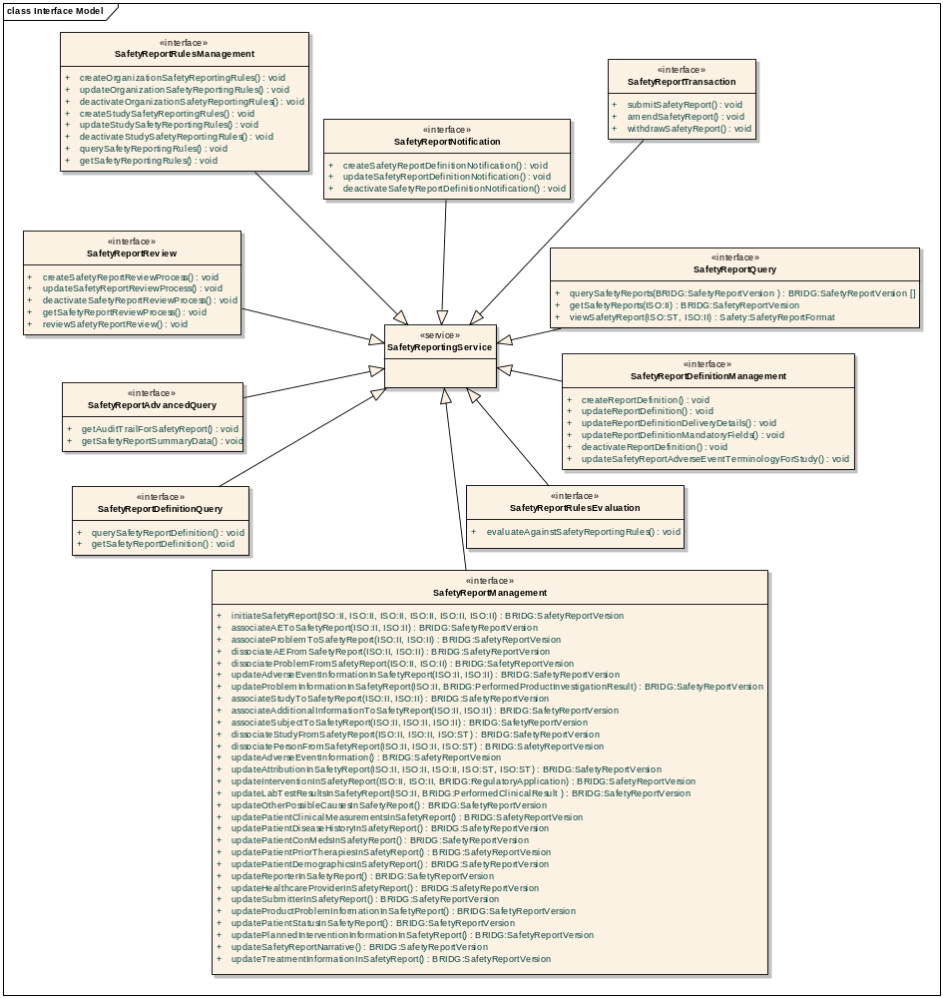
Safety Reporting Services Interface Model

Operations (Enumeration)

Operation No. | Operation Name | Interface Name
SR-INF1-OP1 | querySafetyReports | SafetyReportQuery
SR-INF1-OP2 | getSafetyReports | SafetyReportQuery
SR-INF1-OP3 | viewSafetyReport | SafetyReportQuery
SR-INF2-OP1 | initiateSafetyReport | SafetyReportManagement
SR-INF2-OP2 | associateAEToSafetyReport | SafetyReportManagement
SR-INF2-OP3 | associateProblemToSafetyReport | SafetyReportManagement
SR-INF2-OP4 | dissociateAEFromSafetyReport | SafetyReportManagement
SR-INF2-OP5 | dissociateProblemFromSafetyReport | SafetyReportManagement
SR-INF2-OP6 | updateAdverseEventInformationInSafetyReport | SafetyReportManagement
SR-INF2-OP7 | updateProblemInformationInSafetyReport | SafetyReportManagement
SR-INF2-OP8 | associateStudyToSafetyReport | SafetyReportManagement
SR-INF2-OP9 | associateAdditionalInformationToSafetyReport | SafetyReportManagement
SR-INF2-OP10 | associateSubjectToSafetyReport | SafetyReportManagement
SR-INF2-OP11 | dissociateStudyFromSafetyReport | SafetyReportManagement
SR-INF2-OP12 | dissociateSubjectFromSafetyReport | SafetyReportManagement
SR-INF2-OP13 | updateAdverseEventInformation | SafetyReportManagement
SR-INF2-OP14 | updateAttributionInSafetyReport | SafetyReportManagement
SR-INF2-OP15 | updateInterventionInSafetyReport | SafetyReportManagement
SR-INF2-OP16 | updateLabTestResultsInSafetyReport | SafetyReportManagement
SR-INF2-OP17 | updateOtherPossibleCausesInSafetyReport | SafetyReportManagement
SR-INF2-OP18 | updatePatientClinicalMeasurementsInSafetyReport | SafetyReportManagement
SR-INF2-OP19 | updatePatientDiseaseHistoryInSafetyReport | SafetyReportManagement
SR-INF2-OP20 | updatePatientConMedsInSafetyReport | SafetyReportManagement
SR-INF2-OP21 | updatePatientPriorTherapiesInSafetyReport | SafetyReportManagement
SR-INF2-OP22 | updatePatientDemographicsInSafetyReport | SafetyReportManagement
SR-INF2-OP23 | updateReporterInSafetyReport | SafetyReportManagement
SR-INF2-OP24 | updateHealthcareProviderInSafetyReport | SafetyReportManagement
SR-INF2-OP25 | updateSubmitterInSafetyReport | SafetyReportManagement
SR-INF2-OP26 | updateProductProblemInformationInSafetyReport | SafetyReportManagement
SR-INF2-OP27 | updatePatientStatusInSafetyReport | SafetyReportManagement
SR-INF2-OP28 | updatePlannedInterventionInformationInSafetyReport | SafetyReportManagement
SR-INF2-OP29 | updateSafetyReportNarrative | SafetyReportManagement
SR-INF2-OP30 | updateTreatmentInformationInSafetyReport | SafetyReportManagement
SR-INF3-OP1 | submitSafetyReport | SafetyReportTransaction
SR-INF3-OP2 | amendSafetyReport | SafetyReportTransaction
SR-INF3-OP3 | withdrawSafetyReport | SafetyReportTransaction
SR-INF4-OP1 | createReportDefinition | SafetyReportDefinitionManagement
SR-INF4-OP2 | updateReportDefinition | SafetyReportDefinitionManagement
SR-INF4-OP3 | updateReportDefinitionDeliveryDetails | SafetyReportDefinitionManagement
SR-INF4-OP4 | updateReportDefinitionMandatoryFields | SafetyReportDefinitionManagement
SR-INF4-OP5 | deactivateReportDefinition | SafetyReportDefinitionManagement
SR-INF4-OP6 | updateSafetyReportAdverseEventTerminologyForStudy | SafetyReportDefinitionManagement
SR-INF5-OP1 | createOrganizationSafetyReportingRules | SafetyReportRulesManagement
SR-INF5-OP2 | updateOrganizationSafetyReportingRules | SafetyReportRulesManagement
SR-INF5-OP3 | deactivateOrganizationSafetyReportingRules | SafetyReportRulesManagement
SR-INF5-OP4 | createStudySafetyReportingRules | SafetyReportRulesManagement
SR-INF5-OP5 | updateStudySafetyReportingRules | SafetyReportRulesManagement
SR-INF5-OP6 | deactivateStudySafetyReportingRules | SafetyReportRulesManagement
SR-INF5-OP7 | querySafetyReportingRules | SafetyReportRulesManagement
SR-INF5-OP8 | getSafetyReportingRules | SafetyReportRulesManagement
SR-INF6-OP1 | createSafetyReportDefinitionNotification | SafetyReportNotification
SR-INF6-OP2 | updateSafetyReportDefinitionNotification | SafetyReportNotification
SR-INF6-OP3 | deactivateSafetyReportDefinitionNotification | SafetyReportNotification
SR-INF7-OP1 | createSafetyReportReviewProcess | SafetyReportReview
SR-INF7-OP2 | updateSafetyReportReviewProcess | SafetyReportReview
SR-INF7-OP3 | deactivateSafetyReportReviewProcess | SafetyReportReview
SR-INF7-OP4 | getSafetyReportReviewProcess | SafetyReportReview
SR-INF7-OP5 | reviewSafetyReportReview | SafetyReportReview
SR-INF8-OP1 | getAuditTrailForSafetyReport | SafetyReportAdvancedQuery
SR-INF8-OP2 | getSafetyReportSummaryData | SafetyReportAdvancedQuery
SR-INF9-OP1 | evaluateAgainstSafetyReportingRules | SafetyReportRulesEvaluation
SR-INF10-OP1 | querySafetyReportDefinition | SafetyReportDefinitionQuery
SR-INF10-OP2 | getSafetyReportDefinition | SafetyReportDefinitionQuery

Operation Behavior Descriptions

SafetyReportQuery Interface

Name [M] | querySafetyReports
Description [M] | Provides the capability to find safety reports.
Pre-Conditions [M] | The Safety Report record exists.
Security Pre-Conditions [M] | Access control mechanisms need to be in place to ensure that the client has valid privileges to exercise this capability.
Inputs [M] | Mandatory:  - BRIDG:SafetyReportVersion Object with attributes populated to support a query by example operation.
Outputs [M] | BRIDG:SafetyReportVersion[ ]
Post-Conditions [O]
Exception Conditions [M] | Safety Report Identifier is invalid  Safety Report Object is improperly formatted.
Aspects left for Technical Bindings [O]
Notes [O]

Name [M] | getSafetyReports
Description [M] | Provides the capability to retrieve safety reports.
Pre-Conditions [M] | The Safety Report record exists.
Security Pre-Conditions [M] | Access control mechanisms need to be in place to ensure that the client has valid privileges to exercise this capability.
Inputs [M] | Mandatory:  - ISO:II [ ] (BRIDG:DocumentIdentifier.identifier)
Outputs [M] | BRIDG:SafetyReportVersion[ ]
Post-Conditions [O]
Exception Conditions [M] | Safety Report Identifier is invalid
Aspects left for Technical Bindings [O]
Notes [O]

Name [M] | viewSafetyReport
Description [M] | Provides the capability to retrieve safety reports.
Pre-Conditions [M] | The Safety Report record exists.
Security Pre-Conditions [M] | Access control mechanisms need to be in place to ensure that the client has valid privileges to exercise this capability.
Inputs [M] | Mandatory:  - ISO:II (BRIDG:DocumentIdentifier.identifier)  - ISO:ST (Desired Viewing Format )
Outputs [M] | Safety:SafetyReportFormat
Post-Conditions [O]
Exception Conditions [M] | Safety Report Identifier is invalid  View Format is invalid
Aspects left for Technical Bindings [O]
Notes [O]

SafetyReportManagement Interface

Name [M] | initiateSafetyReport
Description [M] | Enables a client system to create a safety report record in the Safety Reporting System with all fields required for safety report creation.  If successful, a properly formed Safety Report object with an identifier is returned as an acknowledgement that the Safety Report is initiated.
Pre-Conditions [M] | The Report Definition Exists
Security Pre-Conditions [M] | Access control mechanisms need to be in place to ensure that the client has valid privileges to exercise this capability.
Inputs [M] | Mandatory:  ISO:II (BRIDG:DocumentIdentifier.identifier)  Optional:  ISO:II (BRIDG:StudyVersion.identifier)  ISO:II (BRIDG:Subject.identifier)  ISO:II (Patient Identifier)  ISO:II (BRIDG:AdverseEvent.identifier)  ISO:II (BRIDG:PerformedProductInvestigationResult.identifier)
Outputs [M] | BRIDG:SafetyReportVersion
Post-Conditions [O] | A safety report is initiated on the system
Exception Conditions [M] | The Report Definition Identifier is invalid.  Any of the optional inputs are invalid.  The Subject Identifier is invalid for the provided Study Identifier.  The Subject Identifier is invalid for the provided Patient Identifier.
Aspects left for Technical Bindings [O]
Notes [O]

Name [M] | associateAEToSafetyReport
Description [M] | Provides the capability to associate adverse events to a safety report.
Pre-Conditions [M] | The Safety Report record exists  The Adverse Event record exists
Security Pre-Conditions [M] | Access control mechanisms need to be in place to ensure that the client has valid privileges to exercise this capability.
Inputs [M] | Mandatory:  ISO:II (BRIDG:DocumentIdentifier.identifier)  ISO:II [ ] (BRIDG:AdverseEvent Event.identifier]
Outputs [M] | BRIDG:SafetyReportVersion
Post-Conditions [O] | The Safety Report is updated
Exception Conditions [M] | Safety Report Identifier is invalid  Adverse Event Identifier is invalid  The Adverse Event record is invalid for the Subject or Patient on the Safety Report
Aspects left for Technical Bindings [O]
Notes [O] | This operation depends on Safety Report Query Profile to retrieve the Safety Report object in order to allow a service consumer to update it.

Name [M] | associateProblemToSafetyReport
Description [M] | Provides the capability to associate a problem to a safety report.
Pre-Conditions [M] | The Safety Report record exists  The Problem record exists
Security Pre-Conditions [M] | Access control mechanisms need to be in place to ensure that the client has valid privileges to exercise this capability.
Inputs [M] | Mandatory:  ISO:II (BRIDG:DocumentIdentifier.identifier)  ISO:II  (BRIDG: PerformedProductInvestigationResult.identifier)
Outputs [M] | BRIDG:SafetyReportVersion
Post-Conditions [O] | The Safety Report is updated
Exception Conditions [M] | Safety Report Identifier is invalid  Problem Identifier is invalid
Aspects left for Technical Bindings [O]
Notes [O] | This operation depends on Safety Report Query Profile to retrieve the Safety Report object in order to allow a service consumer to update it.

Name [M] | dissociateAEFromSafetyReport
Description [M] | Provides the capability to dissociate an adverse event from a safety report.
Pre-Conditions [M] | The Safety Report record exists  The Adverse Event record exists
Security Pre-Conditions [M] | Access control mechanisms need to be in place to ensure that the client has valid privileges to exercise this capability.
Inputs [M] | Mandatory:  ISO:II (BRIDG:DocumentIdentifier.identifier)  ISO:II (BRIDG:AdverseEvent.identifier.)
Outputs [M] | BRIDG:SafetyReportVersion
Post-Conditions [O] | The Safety Report is updated
Exception Conditions [M] | Safety Report Identifier is invalid  Adverse Event Identifier is invalid
Aspects left for Technical Bindings [O]
Notes [O] | This operation depends on Safety Report Query Profile to retrieve the Safety Report object in order to allow a service consumer to update it.

Name [M] | dissociateProblemFromSafetyReport
Description [M] | Provides the capability to dissociate a problem from a safety report.
Pre-Conditions [M] | The Safety Report record exists  The Problem record exists
Security Pre-Conditions [M] | Access control mechanisms need to be in place to ensure that the client has valid privileges to exercise this capability.
Inputs [M] | Mandatory:  ISO:II (BRIDG:DocumentIdentifier.identifier)  ISO:II  (BRIDG: PerformedProductInvestigationResult.identifier)
Outputs [M] | BRIDG:SafetyReportVersion.
Post-Conditions [O] | The Safety Report is updated
Exception Conditions [M] | Safety Report Identifier is invalid  Problem Identifier is invalid
Aspects left for Technical Bindings [O]
Notes [O] | This operation depends on Safety Report Query Profile to retrieve the Safety Report object in order to allow a service consumer to update it.

Name [M] | Update Adverse Event Information in the Safety Report
Description [M] | Provides the capability to update the adverse event information in the safety report.
Pre-Conditions [M] | The Safety Report record exists.  The Adverse Event is associated to the Safety Report
Security Pre-Conditions [M] | Access control mechanisms need to be in place to ensure that the client has valid privileges to exercise this capability.
Inputs [M] | Mandatory:  - ISO:II (BRIDG:DocumentIdentifier.identifier).  - ISO:II (BRIDG:AdverseEvent.Identifier.  Optional:  Adverse Event attribute(s) that should be updated on the Safety Report along with the new values to which the attribute(s) will be updated.
Outputs [M] | BRIDG:SafetyReportVersion.
Post-Conditions [O] | The Adverse Event on the Safety Report is updated
Exception Conditions [M] | Safety Report Identifier is invalid  Adverse Event Identifier is invalid  Adverse Event attributes are invalid or improperly formatted
Aspects left for Technical Bindings [O]
Notes [O] | This operation depends on Safety Report Query Profile to retrieve the Safety Report object in order to allow a service consumer to update it.

Name [M] | updateProblemInformationInSafetyReport
Description [M] | Provides the capability to update the problem information in the safety report.
Pre-Conditions [M] | The Safety Report record exists.  The Problem is associated to the Safety Report
Security Pre-Conditions [M] | Access control mechanisms need to be in place to ensure that the client has valid privileges to exercise this capability.
Inputs [M] | Mandatory:  ISO:II (BRIDG:DocumentIdentifier.identifier)  BRIDG: PerformedProductInvestigationResult
Outputs [M] | BRIDG:SafetyReportVersion
Post-Conditions [O] | The Problem on the Safety Report is updated
Exception Conditions [M] | Safety Report Identifier is invalid  Problem Identifier is invalid
Aspects left for Technical Bindings [O]
Notes [O] | This operation depends on Safety Report Query Profile to retrieve the Safety Report object in order to allow a service consumer to update it.

Name [M] | associateStudyToSafetyReport
Description [M] | Provides the capability to associate a study to a safety report.
Pre-Conditions [M] | The Safety Report record exists.  The Study exists
Security Pre-Conditions [M] | Access control mechanisms need to be in place to ensure that the client has valid privileges to exercise this capability.
Inputs [M] | Mandatory:  - ISO:II (BRIDG:DocumentIdentifier.identifier)  - ISO:II (BRIDG:StudyVersion.identifier)
Outputs [M] | BRIDG:SafetyReportVersion
Post-Conditions [O]
Exception Conditions [M] | Safety Report Identifier is invalid.  Study Identifier is invalid.
Aspects left for Technical Bindings [O]
Notes [O] | This operation depends on Safety Report Query Profile to retrieve the Safety Report object in order to allow a service consumer to update it.

Name [M] | associateAdditionalInformationToSafetyReport
Description [M] | Provides the capability to associate additional information to a safety report.
Pre-Conditions [M] | The Safety Report record exists.
Security Pre-Conditions [M] | Access control mechanisms need to be in place to ensure that the client has valid privileges to exercise this capability.
Inputs [M] | Mandatory:  - ISO:II (BRIDG:DocumentIdentifier.identifier)  - ISO:II (AE:AdditionalInformation.Identifier)
Outputs [M] | BRIDG:SafetyReportVersion.
Post-Conditions [O]
Exception Conditions [M] | Safety Report Identifier is invalid  Additional Information Identifier is invalid
Aspects left for Technical Bindings [O]
Notes [O] | This operation depends on Safety Report Query Profile to retrieve the Safety Report object in order to allow a service consumer to update it.

Name [M] | associateSubjectToSafetyReport
Description [M] | Provides the capability to associate a person to a safety report who is the subject of the report.
Pre-Conditions [M] | The Safety Report record exists.
Security Pre-Conditions [M] | Access control mechanisms need to be in place to ensure that the client has valid privileges to exercise this capability.
Inputs [M] | Mandatory:  - ISO:II (BRIDG:DocumentIdentifier.identifier)  Conditional:  - ISO:II (BRIDG:StudySubject.Identifier)  - ISO:II (BRIDG:Person.identifier)
Outputs [M] | BRIDG: SafetyReportVersion.
Post-Conditions [O]
Exception Conditions [M] | Safety Report Identifier is invalid  Study Subject Identifier is invalid  Study Subject Identifier is not valid for the Study Identifier on the report.  Patient Identifier is invalid  Person Identifier is invalid
Aspects left for Technical Bindings [O]
Notes [O] | This operation depends on Safety Report Query Profile to retrieve the Safety Report object in order to allow a service consumer to update it.

Name [M] | dissociateStudyFromSafetyReport
Description [M] | Provides the capability to dissociate a study from a safety report.
Pre-Conditions [M] | The Safety Report record exists.  The Study is associated to the Safety Report.
Security Pre-Conditions [M] | Access control mechanisms need to be in place to ensure that the client has valid privileges to exercise this capability.
Inputs [M] | Mandatory:  - ISO:II (BRIDG:DocumentIdentifier.identifier)  - ISO:II (BRIDG:StudyVersion. Identifier)  Optional:  - ISO:ST (Reason for the dissociation)
Outputs [M] | BRIDG:SafetyReportVersion.
Post-Conditions [O]
Exception Conditions [M] | Safety Report Identifier is invalid  Study Identifier is invalid
Aspects left for Technical Bindings [O]
Notes [O] | This operation depends on Safety Report Query Profile to retrieve the Safety Report object in order to allow a service consumer to update it.

Name [M] | dissociatePersonFromSafetyReport
Description [M] | Provides the capability to dissociate person from a safety report.
Pre-Conditions [M] | The Safety Report record exists.  The Person is associated to the Safety Report.
Security Pre-Conditions [M] | Access control mechanisms need to be in place to ensure that the client has valid privileges to exercise this capability.
Inputs [M] | Mandatory:  - ISO:II (BRIDG:DocumentIdentifier.identifier)  - ISO:II (BRIDG:Person.identifier)  Optional:  - ISO:STReason for the dissociation
Outputs [M] | BRIDG:SafetyReportVersion.
Post-Conditions [O]
Exception Conditions [M] | Safety Report Identifier is invalid  Person Identifier is invalid
Aspects left for Technical Bindings [O]
Notes [O] | This operation depends on Safety Report Query Profile to retrieve the Safety Report object in order to allow a service consumer to update it.

Name [M] | updateAttributionInSafetyReport
Description [M] | Provides the capability to update attribution in the safety report.
Pre-Conditions [M] | The Safety Report record exists.
Security Pre-Conditions [M] | Access control mechanisms need to be in place to ensure that the client has valid privileges to exercise this capability.
Inputs [M] | Mandatory:  - ISO:II (BRIDG:DocumentIdentifier.identifier)  - ISO:II (BRIDG:AdverseEvent)  - ISO:II (BRIDG:PerformedProductInvestigationResult Identifiers)  - ISO:ST (The cause of the Adverse Event or Product Problem )  - ISO:ST (and the degree of causation.)
Outputs [M] | BRIDG: SafetyReportVersion.
Post-Conditions [O]
Exception Conditions [M] | Safety Report Identifier is invalid.  Adverse Event Identifier is invalid.  Production Problem Identifier is invalid.
Aspects left for Technical Bindings [O]
Notes [O] | This operation depends on Safety Report Query Profile to retrieve the Safety Report object in order to allow a service consumer to update it.

Name [M] | updateInterventionInSafetyReport
Description [M] | Provides the capability to update intervention regulatory information in the safety report.
Pre-Conditions [M] | The Safety Report record exists.
Security Pre-Conditions [M] | Access control mechanisms need to be in place to ensure that the client has valid privileges to exercise this capability.
Inputs [M] | Mandatory:  - ISO:II (BRIDG:DocumentIdentifier.identifier)  - ISO:II (BRIDG: PerformedSubstanceAdministration.Identifier)  - BRIDG: RegulatoryApplication
Outputs [M] | BRIDG: SafetyReportVersion.
Post-Conditions [O]
Exception Conditions [M] | Safety Report Identifier is invalid  Intervention Identifier is invalid  Regulatory information for Intervention is invalid
Aspects left for Technical Bindings [O]
Notes [O] | This operation depends on Safety Report Query Profile to retrieve the Safety Report object in order to allow a service consumer to update it.

Name [M] | updateLabTestResultsInSafety Report
Description [M] | Provides the capability to update laboratory test results in the safety report.
Pre-Conditions [M] | The Safety Report record exists.  Lab Test for patient/subject exist
Security Pre-Conditions [M] | Access control mechanisms need to be in place to ensure that the client has valid privileges to exercise this capability.
Inputs [M] | Mandatory:  - ISO:II (BRIDG:DocumentIdentifier.identifier)  - BRIDG:PerformedClinicalResult (Lab Test Identifier , Lab Test Attributes ,Lab Test Attribute Values)
Outputs [M] | BRIDG: SafetyReportVersion.
Post-Conditions [O]
Exception Conditions [M] | Safety Report Identifier is invalid  Lab Test Identifier is invalid  Lab Test Attributes are invalid  Lab Test Attribute Values are invalid
Aspects left for Technical Bindings [O]
Notes [O] | This operation depends on Safety Report Query Profile to retrieve the Safety Report object in order to allow a service consumer to update it.

Name [M] | updateOtherPossibleCausesInSafety Report
Description [M] | Provides the capability to update other possible causes in the safety report.
Pre-Conditions [M] | The Safety Report record exists.
Security Pre-Conditions [M] | Access control mechanisms need to be in place to ensure that the client has valid privileges to exercise this capability.
Inputs [M] | Mandatory:  - ISO:II (BRIDG:DocumentIdentifier.identifier)  - Safety:OtherCause.identifier
Outputs [M] | BRIDG: SafetyReportVersion.
Post-Conditions [O]
Exception Conditions [M] | Safety Report Identifier is invalid  Other Cause Identifier is invalid
Aspects left for Technical Bindings [O]
Notes [O] | This operation depends on Safety Report Query Profile to retrieve the Safety Report object in order to allow a service consumer to update it.  The Other Cause Identifier may be the name of the other cause.

Name [M] | updatePatientClinicalMeasurementsInSafety Report
Description [M] | Provides the capability to update basic patient clinical measurements in the safety report.
Pre-Conditions [M] | The Safety Report record exists.  The Patient is associated to the Safety Report.
Security Pre-Conditions [M] | Access control mechanisms need to be in place to ensure that the client has valid privileges to exercise this capability.
Inputs [M] | Mandatory:  - ISO:II (BRIDG:DocumentIdentifier.identifier)  - ISO:II (BRIDG:Person.identifier  or BRIDG:StudySubject Identifier or BRIDG:Person Identifier)  Optional:  - BRIDG:PerformanceClinicalResult.result (Baseline Performance)  - BRIDG:PerformanceCLinicalResult.result (Height)  - BRIDG:PerformanceCLinicalResult.result (Weight)
Outputs [M] | BRIDG: SafetyReportVersion.
Post-Conditions [O]
Exception Conditions [M] | Safety Report Identifier is invalid  Patient Identifier is invalid  Study Subject Identifier is invalid  Report Person Identifier is invalid  Clinical Attributes are invalid  Clinical Attribute Values are invalid
Aspects left for Technical Bindings [O]
Notes [O] | This operation depends on Safety Report Query Profile to retrieve the Safety Report object in order to allow a service consumer to update it.

Name [M] | updatePatientDiseaseHistoryTheSafetyReport
Description [M] | Provides the capability to update patient disease history in the safety report.
Pre-Conditions [M] | The Safety Report record exists.  The Patient is associated to the Safety Report.
Security Pre-Conditions [M] | Access control mechanisms need to be in place to ensure that the client has valid privileges to exercise this capability.
Inputs [M] | Mandatory:  - ISO:II (BRIDG:DocumentIdentifier.identifier)  - ISO:II (BRIDG:Person.identifier)  Optional:  - BRIDG:PerformedDiagnosis  (Disease History Attributes (i.e. primary disease, primary site of disease, initial date of diagnosis, metastatic sites of disease, pre-existing conditions)  Disease History Attribute Values)
Outputs [M] | BRIDG: SafetyReportVersion.
Post-Conditions [O]
Exception Conditions [M] | Safety Report Identifier is invalid  Report Patient Identifier is invalid  Disease History Attributes are invalid  Disease History Attribute Values are invalid
Aspects left for Technical Bindings [O]
Notes [O] | This operation depends on Safety Report Query Profile to retrieve the Safety Report object in order to allow a service consumer to update it.

Name [M] | updatePatientConMedsInSafetyReport
Description [M] | Provides the capability to update patient concomitant medications in the safety report.
Pre-Conditions [M] | The Safety Report record exists.  The Patient is associated to the Safety Report.
Security Pre-Conditions [M] | Access control mechanisms need to be in place to ensure that the client has valid privileges to exercise this capability.
Inputs [M] | Mandatory:  - ISO:II (BRIDG:DocumentIdentifier.identifier)  - ISO:II (BRIDG:Person.identifier (Report Patient Identifier))  Optional:  - BRIDG:PerformedSubstanceAdministration  (Concomitant Medication Attributes (i.e. name, date(s), description)  Concomitant Medication Attribute Values)
Outputs [M] | BRIDG: SafetyReportVersion.
Post-Conditions [O]
Exception Conditions [M] | Safety Report Identifier is invalid  Report Patient Identifier is invalid  Concomitant Medication Attributes are invalid  Concomitant Medication Attribute Values are invalid
Aspects left for Technical Bindings [O]
Notes [O] | This operation depends on Safety Report Query Profile to retrieve the Safety Report object in order to allow a service consumer to update it.

Name [M] | updatePatientPriorTherapiesInSafetyReport
Description [M] | Provides the capability to update patient prior therapies in the safety report.
Pre-Conditions [M] | The Safety Report record exists.  The Patient is associated to the Safety Report.
Security Pre-Conditions [M] | Access control mechanisms need to be in place to ensure that the client has valid privileges to exercise this capability.
Inputs [M] | Mandatory:  - ISO:II (BRIDG:DocumentIdentifier.identifier)  - ISO:II BRIDG:Person.identifier (Report Patient Identifier)  Optional:  - BRIDG : PerformedMedicalHistoryResult  (Prior Therapy Attributes (i.e. name, date(s), agents)  Prior Therapy Attributes Values )
Outputs [M] | BRIDG: SafetyReportVersion.
Post-Conditions [O]
Exception Conditions [M] | Safety Report Identifier is invalid  Report Patient Identifier is invalid  Prior Therapy Attributes are invalid  Prior Therapy Attribute Values are invalid
Aspects left for Technical Bindings [O]
Notes [O] | This operation depends on Safety Report Query Profile to retrieve the Safety Report object in order to allow a service consumer to update it.

Name [M] | updatePatientDemographicsInSafetyReport
Description [M] | Provides the capability to update patient demographics in the safety report.
Pre-Conditions [M] | The Safety Report record exists.  The Patient, Study Subject, or Report Person is associated to the Safety Report.
Security Pre-Conditions [M] | Access control mechanisms need to be in place to ensure that the client has valid privileges to exercise this capability.
Inputs [M] | Mandatory:  - ISO:II (BRIDG:DocumentIdentifier.identifier)  - ISO:II BRIDG:Person.identifier (Report Patient Identifier)  Optional:  - BRIDG:Person  (Patient Demographic Attributes (i.e. sex, race, ethnicity, DOB)  Patient Demographic Attribute Values )
Outputs [M] | BRIDG: SafetyReportVersion.
Post-Conditions [O]
Exception Conditions [M] | Safety Report Identifier is invalid  Report Patient Identifier is invalid  Demographic Attributes are invalid  Demographic Attribute Values are invalid
Aspects left for Technical Bindings [O]
Notes [O] | This operation depends on Safety Report Query Profile to retrieve the Safety Report object in order to allow a service consumer to update it.

Name [M] | updateReporterInSafetyReport
Description [M] | Provides the capability to update the reporter in the safety report.
Pre-Conditions [M] | The Safety Report record exists.
Security Pre-Conditions [M] | Access control mechanisms need to be in place to ensure that the client has valid privileges to exercise this capability.
Inputs [M] | Mandatory:  - ISO:II (BRIDG:DocumentIdentifier.identifier)  - BRIDG:DocumentAuthor
Outputs [M] | BRIDG: SafetyReportVersion.
Post-Conditions [O]
Exception Conditions [M] | Safety Report Identifier is invalid  Reporter Identifier is invalid  Reporter Attributes are invalid  Reporter Attribute Values are invalid
Aspects left for Technical Bindings [O]
Notes [O] | This operation depends on Safety Report Query Profile to retrieve the Safety Report object in order to allow a service consumer to update it.  The safety report may require or provide the option to detail additional information about the reporter that may not be associated directly to the reporter. Examples of such additional information could include a cell phone number to be used as a contact detail for the specific safety report.

Name [M] | updateHealthcareProviderInSafetyReport
Description [M] | Provides the capability to update the healthcare provider in the safety report.
Pre-Conditions [M] | The Safety Report record exists.
Security Pre-Conditions [M] | Access control mechanisms need to be in place to ensure that the client has valid privileges to exercise this capability.
Inputs [M] | Mandatory:  - ISO:II (BRIDG:DocumentIdentifier.identifier)  - BRIDG:HealthcareProvider
Outputs [M] | BRIDG: SafetyReportVersion.
Post-Conditions [O]
Exception Conditions [M] | Safety Report Identifier is invalid  Healthcare Provider Identifier is invalid  Healthcare Provider Attributes are invalid  Healthcare Provider Attribute Values are invalid
Aspects left for Technical Bindings [O]
Notes [O] | This operation depends on Safety Report Query Profile to retrieve the Safety Report object in order to allow a service consumer to update it.  The safety report may require or provide the option to detail additional information about the healthcare provider that may not be associated directly to the healthcare provider. Examples of such additional information could include a cell phone number to be used as a contact detail for the specific safety report.

Name [M] | updateSubmitterInSafety Report
Description [M] | Provides the capability to update the submitter in the safety report.
Pre-Conditions [M] | The Safety Report record exists.
Security Pre-Conditions [M] | Access control mechanisms need to be in place to ensure that the client has valid privileges to exercise this capability.
Inputs [M] | Mandatory:  - ISO:II (BRIDG:DocumentIdentifier.identifier)  - BRIDG:ReportSubmitter
Outputs [M] | BRIDG: SafetyReportVersion.
Post-Conditions [O]
Exception Conditions [M] | Safety Report Identifier is invalid  Submitter Identifier is invalid  Submitter Attributes are invalid  Submitter Attribute Values are invalid
Aspects left for Technical Bindings [O]
Notes [O] | This operation depends on Safety Report Query Profile to retrieve the Safety Report object in order to allow a service consumer to update it.  The safety report may require or provide the option to detail additional information about the submitter that may not be associated directly to the submitter. Examples of such additional information could include a cell phone number to be used as a contact detail for the specific safety report.

Name [M] | updateProductProblemInformationInSafetyReport
Description [M] | Provides the capability to update product problem information.
Pre-Conditions [M] | The Safety Report record exists.
Security Pre-Conditions [M] | Access control mechanisms need to be in place to ensure that the client has valid privileges to exercise this capability.
Inputs [M] | Mandatory:  - ISO:II (BRIDG:DocumentIdentifier.identifier)  - BRIDG:PerformedProductInvestigationResult
Outputs [M] | BRIDG: SafetyReportVersion.
Post-Conditions [O]
Exception Conditions [M] | Safety Report Identifier is invalid  Product Problem Identifier is invalid  Product Problem Attributes are invalid  Product Problem Attribute Values are invalid
Aspects left for Technical Bindings [O]
Notes [O] | This operation depends on Safety Report Query Profile to retrieve the Safety Report object in order to allow a service consumer to update it.

Name [M] | updatePatientStatusInSafetyReport
Description [M] | Provides the capability to update the patient status in the safety report.
Pre-Conditions [M] | The Safety Report record exists.
Security Pre-Conditions [M] | Access control mechanisms need to be in place to ensure that the client has valid privileges to exercise this capability.
Inputs [M] | Mandatory:  - ISO:II (BRIDG:DocumentIdentifier.identifier)  - BRIDG:Person
Outputs [M] | BRIDG: SafetyReportVersion.
Post-Conditions [O]
Exception Conditions [M] | Safety Report Identifier is invalid  Report Patient Identifier is invalid  Patient Status Attributes are invalid  Patient Status Attribute Values are invalid
Aspects left for Technical Bindings [O]
Notes [O] | This operation depends on Safety Report Query Profile to retrieve the Safety Report object in order to allow a service consumer to update it.

Name [M] | updatePlannedInterventionInformationSafetyReport
Description [M] | Provides the capability to update the planned intervention information in the safety report.
Pre-Conditions [M] | The Safety Report record exists.
Security Pre-Conditions [M] | Access control mechanisms need to be in place to ensure that the client has valid privileges to exercise this capability.
Inputs [M] | Mandatory:  - ISO:II (BRIDG:DocumentIdentifier.identifier)  - Safety:PlannedIntervention
Outputs [M] | BRIDG: SafetyReportVersion.
Post-Conditions [O]
Exception Conditions [M] | Safety Report Identifier is invalid  Planned Intervention Identifier is invalid  Planned Intervention Attributes are invalid  Planned Intervention Attribute Values are invalid
Aspects left for Technical Bindings [O]
Notes [O] | This operation depends on Safety Report Query Profile to retrieve the Safety Report object in order to allow a service consumer to update it.

Name [M] | updateNarrativeInSafety Report
Description [M] | Provides the capability to update the safety report narrative.
Pre-Conditions [M] | The Safety Report record exists.
Security Pre-Conditions [M] | Access control mechanisms need to be in place to ensure that the client has valid privileges to exercise this capability.
Inputs [M] | Mandatory:  - ISO:II (BRIDG:DocumentIdentifier.identifier)  - Safety:SafetyReportNarrative
Outputs [M] | BRIDG: SafetyReportVersion.
Post-Conditions [O]
Exception Conditions [M] | Safety Report Identifier is invalid  Safety Report Narrative is improperly formatted
Aspects left for Technical Bindings [O]
Notes [O] | This operation depends on Safety Report Query Profile to retrieve the Safety Report object in order to allow a service consumer to update it.

Name [M] | updateTreatmentInformationInSafetyReport
Description [M] | Provides the capability to update treatment information in the safety report.
Pre-Conditions [M] | The Safety Report record exists.
Security Pre-Conditions [M] | Access control mechanisms need to be in place to ensure that the client has valid privileges to exercise this capability.
Inputs [M] | Mandatory:  - ISO:II (BRIDG:DocumentIdentifier.identifier)  - BRIDG:PerformedActivity
Outputs [M] | BRIDG: SafetyReportVersion.
Post-Conditions [O]
Exception Conditions [M] | Safety Report Identifier is invalid  Treatment Identifier is invalid  Treatment Attributes are invalid  Treatment Attribute Values are invalid
Aspects left for Technical Bindings [O]
Notes [O] | This operation depends on Safety Report Query Profile to retrieve the Safety Report object in order to allow a service consumer to update it.

SafetyReportTransaction Interface

Name [M] | amendSafetyReport
Description [M] | Provides the capability to amend a safety report.
Pre-Conditions [M] | The Safety Report record exists and is in a submitted state.
Security Pre-Conditions [M] | Access control mechanisms need to be in place to ensure that the client has valid privileges to exercise this capability.
Inputs [M] | Mandatory:  - ISO:II (BRIDG:DocumentIdentifier.identifier)  - ISO:II (Amendment Identifier)  Optional:  - ISO:ST (Reason for the amendment)
Outputs [M] | BRIDG:SafetyReportVersion.
Post-Conditions [O]
Exception Conditions [M] | Safety Report Identifier is invalid  Amendment Identifier is invalid
Aspects left for Technical Bindings [O]
Notes [O] | This operation depends on Safety Report Query Profile to retrieve the Safety Report object in order to allow a service consumer to update it.

Name [M] | submitSafetyReport
Description [M] | Provides the capability to submit a safety report
Pre-Conditions [M] | The Safety Report record exists.  The Safety Report is complete and adheres to all business rules required for report submission.
Security Pre-Conditions [M] | Access control mechanisms need to be in place to ensure that the client has valid privileges to exercise this capability.
Inputs [M] | Mandatory:  - ISO:II (BRIDG:DocumentIdentifier.identifier)  - BRIDG:Person.identifier (Submitter Identifier)  Optional:  - BRIDG:Person.identifier[ ] (Additional Recipient Identifiers(
Outputs [M] | BRIDG:SafetyReportVersion.
Post-Conditions [O]
Exception Conditions [M] | Safety Report Identifier is invalid  Submitter Identifier is invalid  Additional Recipient Identifiers are invalid  The Safety Report is incomplete or improperly formatted for submission.
Aspects left for Technical Bindings [O]
Notes [O] | This operation depends on Safety Report Query Profile to retrieve the Safety Report object in order to allow a service consumer to update it.

Name [M] | withdrawSafetyReport
Description [M] | Provides the capability to withdraw a safety report.
Pre-Conditions [M] | The Safety Report record exists.
Security Pre-Conditions [M] | Access control mechanisms need to be in place to ensure that the client has valid privileges to exercise this capability.
Inputs [M] | Mandatory:  - ISO:II (BRIDG:DocumentIdentifier.identifier)  - Withdrawer Identifier  Optional:  - ISO:ST (Reason for the Safety Report Withdraw)
Outputs [M] | Return an instance of the updated Safety Report object.
Post-Conditions [O]
Exception Conditions [M] | Safety Report Identifier is invalid  Withdrawer Identifier is invalid
Aspects left for Technical Bindings [O]
Notes [O] | This operation depends on Safety Report Query Profile to retrieve the Safety Report object in order to allow a service consumer to update it.

SafetyReportDefinitionManagement Interface

Name [M] | createSafetyReportDefinition
Description [M] | Provides the capability to create a safety report definition.
Pre-Conditions [M]
Security Pre-Conditions [M] | Access control mechanisms need to be in place to ensure that the client has valid privileges to exercise this capability.
Inputs [M] | Mandatory:  - Safety:ReportDefinition (Safety Report Definition Object with attributes/values to initiate)
Outputs [M] | Safety:ReportDefinition
Post-Conditions [O]
Exception Conditions [M] | Safety Report Definition Attributes are invalid  Safety Report Definition Attributes Values are invalid
Aspects left for Technical Bindings [O] | Determination of method for Safety Report Definition identification.
Notes [O] | This operation may depend on the Query Safety Report Definition capability to search for an existing Safety Report Definition.

Name [M] | updateSafetyReportDefinitionDetails
Description [M] | Provides the capability to update the basic details a safety report definition.
Pre-Conditions [M] | The Safety Report Definition exists
Security Pre-Conditions [M] | Access control mechanisms need to be in place to ensure that the client has valid privileges to exercise this capability.
Inputs [M] | Mandatory:  - Safety:ReportDefinition (Safety Report Definition Object with all basic detail attributes and values to update)
Outputs [M] | Safety:ReportDefinition
Post-Conditions [O]
Exception Conditions [M] | Safety Report Definition Identifier is invalid  Safety Report Definition Basic Detail Attributes are invalid  Safety Report Definition Basic Detail Attribute Values are invalid
Aspects left for Technical Bindings [O] | Determination of method for Safety Report Definition identification.
Notes [O] | This operation may depend on the Query Safety Report Definition capability to search for an existing Safety Report Definition.

Name [M] | updateSafetyReportDefinitionDeliveryDetails
Description [M] | Provides the capability to update the delivery details in the safety report definition.
Pre-Conditions [M] | The Safety Report Definition exists
Security Pre-Conditions [M] | Access control mechanisms need to be in place to ensure that the client has valid privileges to exercise this capability.
Inputs [M] | Mandatory:  - Safety:ReportDefinition (Safety Report Definition Object with all delivery detail attributes and values to update)
Outputs [M] | Safety:ReportDefinition
Post-Conditions [O]
Exception Conditions [M] | Safety Report Definition Identifier is invalid  Safety Report Definition Delivery Attributes are invalid  Safety Report Definition Delivery Attributes Values are invalid
Aspects left for Technical Bindings [O] | Determination of method for Safety Report Definition identification.
Notes [O] | This operation may depend on the Query Safety Report Definition capability to search for an existing Safety Report Definition.

Name [M] | updateSafetyReportDefinitionMandatoryFields
Description [M] | Provides the capability to update the mandatory field requirements in the safety report definition.
Pre-Conditions [M] | The Safety Report Definition exists
Security Pre-Conditions [M] | Access control mechanisms need to be in place to ensure that the client has valid privileges to exercise this capability.
Inputs [M] | Mandatory:  - Safety:ReportDefinition (Safety Report Definition Object with all mandatory field attributes and values to update)
Outputs [M] | Safety:ReportDefinition
Post-Conditions [O]
Exception Conditions [M] | Safety Report Definition Identifier is invalid  Safety Report Definition Mandatory Field Attributes are invalid  Safety Report Definition Mandatory Field Attribute Values are invalid
Aspects left for Technical Bindings [O] | Determination of method for Safety Report Definition identification.
Notes [O] | This operation may depend on the Query Safety Report Definition capability to search for an existing Safety Report Definition.

Name [M] | deactivateSafetyReportDefinition
Description [M] | Provides the capability to deactivate a safety report definition.
Pre-Conditions [M] | The Safety Report Definition exists.
Security Pre-Conditions [M] | Access control mechanisms need to be in place to ensure that the client has valid privileges to exercise this capability.
Inputs [M] | Mandatory:  - ISO:II (Safety:ReportDefinition.Identifier )  Optional:  - ISO:ST (Reason for deactivating the Safety Report Definition)
Outputs [M] | Safety:ReportDefinition
Post-Conditions [O]
Exception Conditions [M] | Safety Report Definition Identifier is invalid
Aspects left for Technical Bindings [O]
Notes [O] | This operation depends on Safety Report Query Profile to retrieve the Safety Report object in order to allow a service consumer to update it.

Name [M] | updateSafetyReportTerminologyForStudy
Description [M] | Provides the capability to update the safety report terminology to be used for a study.
Pre-Conditions [M] | The Safety Report Definition record exists.
Security Pre-Conditions [M] | Access control mechanisms need to be in place to ensure that the client has valid privileges to exercise this capability.
Inputs [M] | Mandatory:  - ISO:II (Safety:ReportDefinition Identifier)  - ISO:II (BRIDG:StudyVersion.Identifier)  - ISO:II (Safety:ReportTerminology.Identifier)
Outputs [M] | ISO:BL
Post-Conditions [O]
Exception Conditions [M] | Safety Report Definition Identifier is invalid  Study Identifier is invalid  Safety Report Terminology Identifier is invalid
Aspects left for Technical Bindings [O]
Notes [O] | In the event that the safety report terminology for a study is updated after a safety report has already been initiated, the elements using the previous terminology will not automatically be re-coded to the new terminology.

SafetyReportRulesManagement Interface

Name [M] | createOrganizationSafetyReportingRules
Description [M] | Provides the capability to create safety reporting rules for an organization.
Pre-Conditions [M]
Security Pre-Conditions [M] | Access control mechanisms need to be in place to ensure that the client has valid privileges to exercise this capability.
Inputs [M] | Mandatory:  - Safety:ReportingRule (populated Safety Reporting Rules Object)  - ISO:II (BRIDG:Organization.Identifier )
Outputs [M] | Safety:ReportingRule
Post-Conditions [O]
Exception Conditions [M] | Improperly formatted Safety Reporting Rules Object  Organization Identifier is invalid
Aspects left for Technical Bindings [O]
Notes [O]

Name [M] | updateOrganizationSafetyReportingRules
Description [M] | Provides the capability to update safety reporting rules.
Pre-Conditions [M]
Security Pre-Conditions [M] | Access control mechanisms need to be in place to ensure that the client has valid privileges to exercise this capability.
Inputs [M] | Mandatory:  - Safety:ReportingRule (populated Safety Reporting Rules Object)  - ISO:II (BRIDG: Organization Identifier )
Outputs [M] | - Safety:ReportingRule
Post-Conditions [O]
Exception Conditions [M] | Improperly formatted Safety Reporting Rules Object  Organization Identifier is invalid
Aspects left for Technical Bindings [O]
Notes [O]

Name [M] | deactivateOrganizationSafetyReportingRules
Description [M] | Provides the capability to deactivate the safety reporting rules for an organization.
Pre-Conditions [M] | The Organization Safety Reporting Rules record exists.
Security Pre-Conditions [M] | Access control mechanisms need to be in place to ensure that the client has valid privileges to exercise this capability.
Inputs [M] | Mandatory:  - BRIDG:Organization.identifier (Safety Reporting Rules Organization Identifier)  Optional:  - ISO:ST (Reason for deactivating the Safety Reporting Rules)
Outputs [M] | - Safety:ReportingRule
Post-Conditions [O]
Exception Conditions [M] | Safety Reporting Rules Organization Identifier is invalid
Aspects left for Technical Bindings [O]
Notes [O]

Name [M] | createStudySafetyReportingRules
Description [M] | Provides the capability to create safety reporting rules for a study.
Pre-Conditions [M]
Security Pre-Conditions [M] | Access control mechanisms need to be in place to ensure that the client has valid privileges to exercise this capability.
Inputs [M] | Mandatory:  - Safety:ReportingRule (populated Safety Reporting Rules Object)  - ISO:II (BRIDG:StudyVersion Identifier)  - ISO:II (BRIDG:Organization Identifier )
Outputs [M] | - Safety:ReportingRule
Post-Conditions [O]
Exception Conditions [M] | Improperly formatted Safety Reporting Rules Object  Study Identifier is invalid  Organization Identifier is invalid
Aspects left for Technical Bindings [O]
Notes [O]

Name [M] | updateStudySafetyReportingRules
Description [M] | Provides the capability to update safety reporting rules for a study.
Pre-Conditions [M]
Security Pre-Conditions [M] | Access control mechanisms need to be in place to ensure that the client has valid privileges to exercise this capability.
Inputs [M] | Mandatory:  - Safety:ReportingRule (populated Safety Reporting Rules Object)  - ISO:II (BRIDG:StudyVersion Identifier)  - ISO:II (BRIDG:Organization Identifier )
Outputs [M] | Safety:ReportingRule
Post-Conditions [O]
Exception Conditions [M] | Improperly formatted Safety Reporting Rules Object  Study Identifier is invalid  Organization Identifier is invalid
Aspects left for Technical Bindings [O]
Notes [O]

Name [M] | deactivateStudySafetyReportingRules
Description [M] | Provides the capability to deactivate the safety reporting rules for a Study.
Pre-Conditions [M] | The Study Safety Reporting Rules record exists.
Security Pre-Conditions [M] | Access control mechanisms need to be in place to ensure that the client has valid privileges to exercise this capability.
Inputs [M] | Mandatory:  - ISO:II (BRIDG:StudyVersion Identifier)  ISO:II (BRIDG:Organization Identifier )Optional:  - ISO:ST (Reason for deactivating the Safety Reporting Rules)
Outputs [M] | Safety:ReportingRule
Post-Conditions [O]
Exception Conditions [M] | Safety Reporting Rules Organization Identifier is invalid  Safety Reporting Rules Study Identifier is invalid
Aspects left for Technical Bindings [O]
Notes [O]

Name [M] | querySafetyReportingRules
Description [M] | Provides the capability to find safety report rules.
Pre-Conditions [M]
Security Pre-Conditions [M] | Access control mechanisms need to be in place to ensure that the client has valid privileges to exercise this capability.
Inputs [M] | Mandatory:  - Safety:ReportingRule (Safety Reporting Rules object with attributes properly populated to support a query by example operation.)
Outputs [M] | Safety:ReportingRule [ ]
Post-Conditions [O]
Exception Conditions [M] | Safety Reporting Rule Object format is invalid
Aspects left for Technical Bindings [O]
Notes [O]

Name [M] | getSafetyReportingRules
Description [M] | Provides the capability to get a safety reporting rules.
Pre-Conditions [M] | The Safety Reporting Rules record exists.
Security Pre-Conditions [M] | Access control mechanisms need to be in place to ensure that the client has valid privileges to exercise this capability.
Inputs [M] | Mandatory:  - ISO:II (Safety:ReportingRule.Identifier)
Outputs [M] | Safety:ReportingRule.
Post-Conditions [O]
Exception Conditions [M] | Safety Reporting Rule Identifier is invalid
Aspects left for Technical Bindings [O]
Notes [O]

SafetyReportNotification Interface

Name [M] | createSafetyReportDefinitionNotification
Description [M] | Provides the capability to create a notification template in the safety report definition.
Pre-Conditions [M] | The Safety Report Definition exists
Security Pre-Conditions [M] | Access control mechanisms need to be in place to ensure that the client has valid privileges to exercise this capability.
Inputs [M] | Mandatory:  - Safety: SafetyReportDefinitionNotification (The Safety Report Definition Notification Object populated with attributes requiring initialization)  - ISO:II (BRIDG:SafetyReportDefinition Identifier.)
Outputs [M] | Safety: SafetyReportDefinitionNotification
Post-Conditions [O]
Exception Conditions [M] | Safety Report Definition Notification Object format is invalid
Aspects left for Technical Bindings [O]
Notes [O]

Name [M] | updateSafetyReportDefinitionNotification
Description [M] | Provides the capability to update a notification template in the safety report definition.
Pre-Conditions [M] | The Safety Report Definition Notification exits
Security Pre-Conditions [M] | Access control mechanisms need to be in place to ensure that the client has valid privileges to exercise this capability.
Inputs [M] | Mandatory:  - Safety: SafetyReportDefinitionNotification (The Safety Report Definition Notification Object with populated with attributes requiring update.)
Outputs [M] | Safety: SafetyReportDefinitionNotification
Post-Conditions [O]
Exception Conditions [M] | Safety Report Notification Object format is invalid  Safety Report Notification Identifier is invalid
Aspects left for Technical Bindings [O] | Method of identification of Safety Report Definition Notification.  Method of identification of Safety Report Definition.
Notes [O]

Name [M] | deactivateSafetyReportDefinitionNotification
Description [M] | Provides the capability to deactivate a notification template in the safety report definition.
Pre-Conditions [M] | The Safety Report Definition Notification record exists.
Security Pre-Conditions [M] | Access control mechanisms need to be in place to ensure that the client has valid privileges to exercise this capability.
Inputs [M] | Mandatory:  - ISO:II (Safety: SafetyReportDefinitionNotification. Identifier)  Optional:  - ISO:ST (Reason for deactivation the Safety Report Definition Notification.)
Outputs [M] | Safety: SafetyReportDefinitionNotification
Post-Conditions [O]
Exception Conditions [M] | Safety Report Definition Notification Identifier is invalid
Aspects left for Technical Bindings [O]
Notes [O] | This operation depends on Safety Report Definition Query Profile to retrieve the Safety Report Definition object in order to allow a service consumer to deactivate it.

SafetyReportReview Interface

Name [M] | createSafetyReportReviewProcess
Description [M] | Provides the capability to create a safety report review process.
Pre-Conditions [M] | The Safety Report Definition exists.
Security Pre-Conditions [M] | Access control mechanisms need to be in place to ensure that the client has valid privileges to exercise this capability.
Inputs [M] | Mandatory:  - Safety:SafetyReportReview  - ISO:II (Safety:SafetyReportDefinition Identifier)  Optional:  - ISO:II (BRIDG:Organization Identifier)  - ISO:II (BRIDG:StudyVersion Identifier)
Outputs [M] | - Safety:SafetyReportReview
Post-Conditions [O]
Exception Conditions [M] | Safety Report Review Object is invalid  Safety Report Definition Identifier is invalid  Organization Identifier is invalid  Study Identifier is invalid
Aspects left for Technical Bindings [O] | Method of identification of Safety Report Definition.  Method of identification of Safety Report Review Process.
Notes [O]

Name [M] | updateSafetyReportReviewProcess
Description [M] | Provides the capability to update a safety report review process.
Pre-Conditions [M] | The Safety Report Review Process exists.
Security Pre-Conditions [M] | Access control mechanisms need to be in place to ensure that the client has valid privileges to exercise this capability.
Inputs [M] | Mandatory:  - Safety:SafetyReportReview  Optional:  - ISO:II (BRIDG:Organization Identifier)  - ISO:II (BRIDG:StudyVersion Identifier)
Outputs [M] | - Safety:SafetyReportReview
Post-Conditions [O]
Exception Conditions [M] | Safety Report Review Process Identifier is invalid  Safety Report Review Object is invalid  Organization Identifier is invalid  Study Identifier is invalid
Aspects left for Technical Bindings [O] | Method of identification of Safety Report Review Process.
Notes [O]

Name [M] | deactivateSafetyReportReviewProcess
Description [M] | Provides the capability to deactivate a safety report review process.
Pre-Conditions [M] | The Safety Report Review Process exists.
Security Pre-Conditions [M] | Access control mechanisms need to be in place to ensure that the client has valid privileges to exercise this capability.
Inputs [M] | Mandatory:  - ISO:II (Safety:SafetyReportReview.Identifier)  Optional:  - ISO:ST(Reason for deactivation)
Outputs [M] | - Safety:SafetyReportReview
Post-Conditions [O]
Exception Conditions [M] | Safety Report Review Process Identifier is invalid
Aspects left for Technical Bindings [O] | Method of identification of Safety Report Review Process.
Notes [O]

Name [M] | getSafetyReportReviewProcess
Description [M] | Provides the capability to get safety report review process.
Pre-Conditions [M] | The Safety Report record exists.
Security Pre-Conditions [M] | Access control mechanisms need to be in place to ensure that the client has valid privileges to exercise this capability.
Inputs [M] | Mandatory:  - ISO:II (Safety:SafetyReportReview. Identifier)
Outputs [M] | - Safety:SafetyReportReview
Post-Conditions [O]
Exception Conditions [M] | Safety Report Identifier is invalid  Safety Report Review Process does not exist for this report
Aspects left for Technical Bindings [O]
Notes [O]

Name [M] | reviewSafetyReport
Description [M] | Provides the capability to review safety report.
Pre-Conditions [M] | The Safety Report record exists.
Security Pre-Conditions [M] | Access control mechanisms need to be in place to ensure that the client has valid privileges to exercise this capability.
Inputs [M] | Mandatory:  - ISO:II (Safety:SafetyReportReview.Identifier)  - ISO:ST (Review Disposition)  - ISO:II (BRIDG:Person(Reviewer) Identifier)  - ISO:TsDateTime(Date / Time of Review)  Optional:  - ISO:ST (Comments regarding review)
Outputs [M] | - Safety:SafetyReportReview  .
Post-Conditions [O]
Exception Conditions [M] | Safety Report Identifier is invalid  Review Disposition is invalid  Reviewer Identifier is invalid  Date / Time of Review is invalid  Review comments are invalid
Aspects left for Technical Bindings [O]
Notes [O]

SafetyReportAdvancedQuery Interface

Name [M] | getSafetyReportSummaryData
Description [M] | Provides the capability to get safety report summary data.
Pre-Conditions [M] | The Safety Report record exists.
Security Pre-Conditions [M] | Access control mechanisms need to be in place to ensure that the client has valid privileges to exercise this capability.
Inputs [M] | Mandatory:  - Safety Report Identifiers  - Safety Report Attributes to summarize  - The methods of summarization for the Safety Report Attributes
Outputs [M] | Returns the summarized Safety Report objects.
Post-Conditions [O]
Exception Conditions [M] | Safety Report Identifier is invalid  Safety Report Attributes to summarize are invalid  The methods of summarization for the Safety Report Attributes are invalid
Aspects left for Technical Bindings [O]
Notes [O]

SafetyReportRulesEvaluation Interface

Name [M] | evaluateAgainstSafetyReportingRules
Description [M] | Provides the capability to evaluate an adverse event or problem against safety reporting rules.
Pre-Conditions [M] | The Safety Reporting Rule record exists.
Security Pre-Conditions [M] | Access control mechanisms need to be in place to ensure that the client has valid privileges to exercise this capability.
Inputs [M] | Mandatory:  - ISO:II (BRIDG:Adverse Event Identifier or  - Product Problem Identifier)  Optional:  - ISO:II (BRIDG:StudyVersion Identifier)  - ISO:II (BRIDG:Organization Identifier)
Outputs [M] | Safety:ReportDefinition[ ]
Post-Conditions [O]
Exception Conditions [M] | Adverse Event Identifier is invalid  Product Problem Identifier is invalid  Study Identifier is invalid  Organization Identifier is invalid

SafetyReportDefinitionQuery Interface

Name [M] | querySafetyReportDefinition
Description [M] | Provides the capability to find safety report definition.
Pre-Conditions [M] | The Safety Report Definition exists.
Security Pre-Conditions [M] | Access control mechanisms need to be in place to ensure that the client has valid privileges to exercise this capability.
Inputs [M] | Mandatory:  - Safety:ReportDefinition (Safety Report Definition Object for query by example operation.)
Outputs [M] | Safety:ReportDefinition [ ]
Post-Conditions [O]
Exception Conditions [M] | Improperly formatted Safety Report Definition Object
Aspects left for Technical Bindings [O]
Notes [O]

Name [M] | getSafetyReportDefinition
Description [M] | Provides the capability to get a safety report definition.
Pre-Conditions [M] | The Safety Report Definition record exists.
Security Pre-Conditions [M] | Access control mechanisms need to be in place to ensure that the client has valid privileges to exercise this capability.
Inputs [M] | Mandatory:  - ISO:II (Safety:ReportDefinition.Identifier)
Outputs [M] | Safety:ReportDefinition
Post-Conditions [O]
Exception Conditions [M] | Safety Report Definition Identifier is invalid
Aspects left for Technical Bindings [O]
Notes [O]

Dynamic Model

The following architecturally significant sequence diagrams should sufficiently demonstrate the dynamics of the Safety Reporting Service.

Safety Report Management
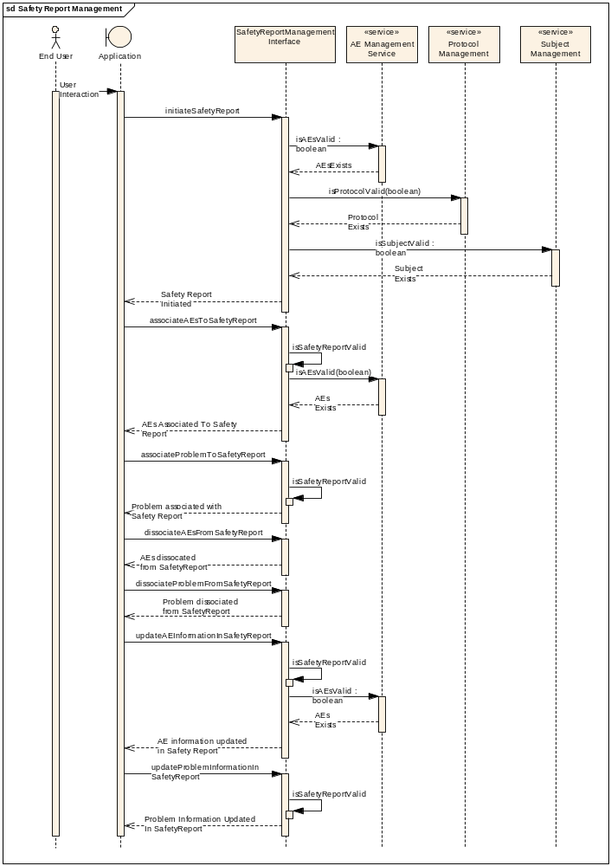

Safety Report Query

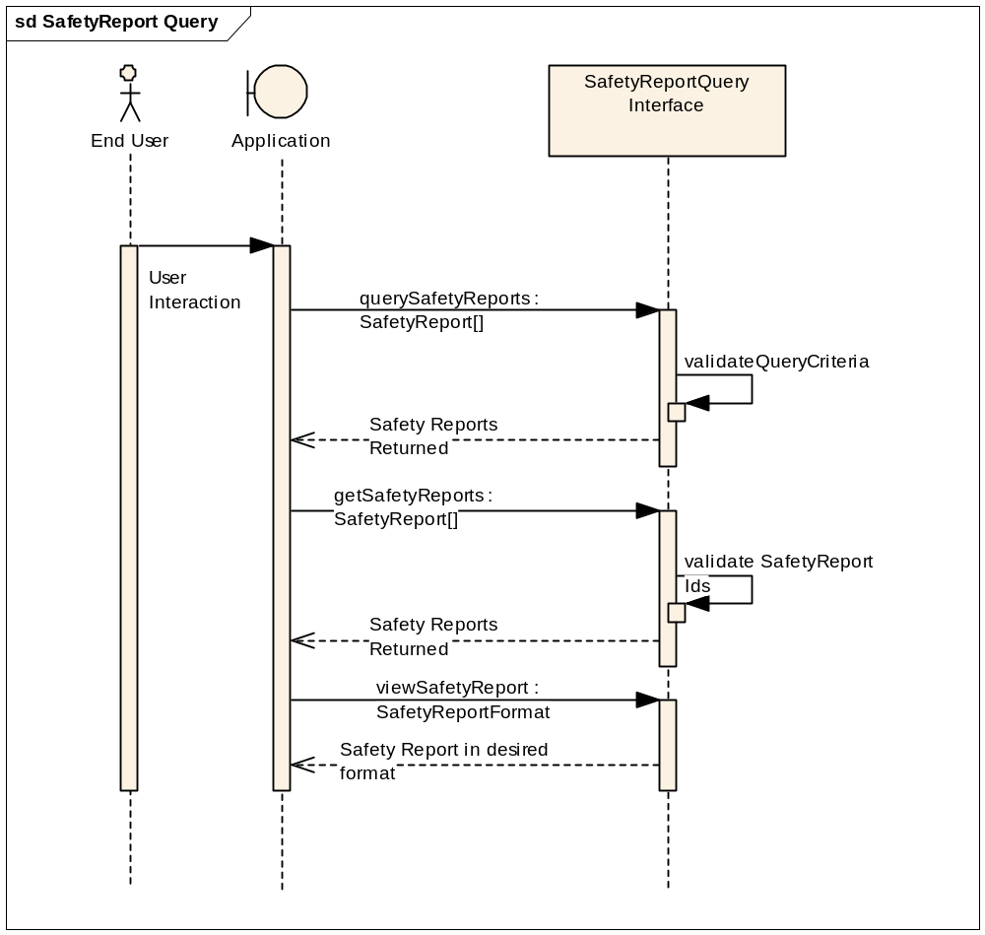

Safety Report Transaction

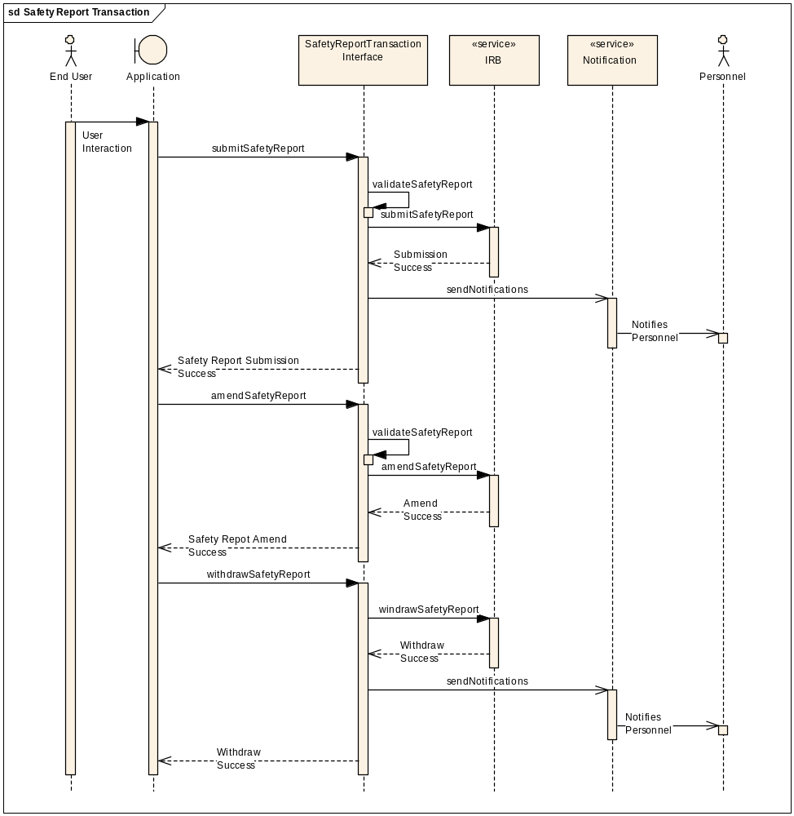

Safety Report Definition Management
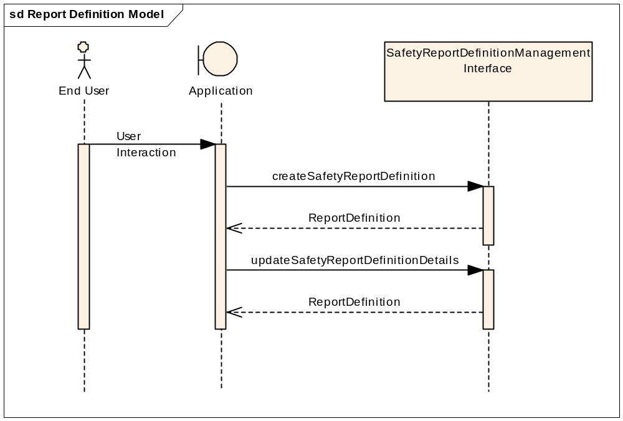

Safety Report Rules Management
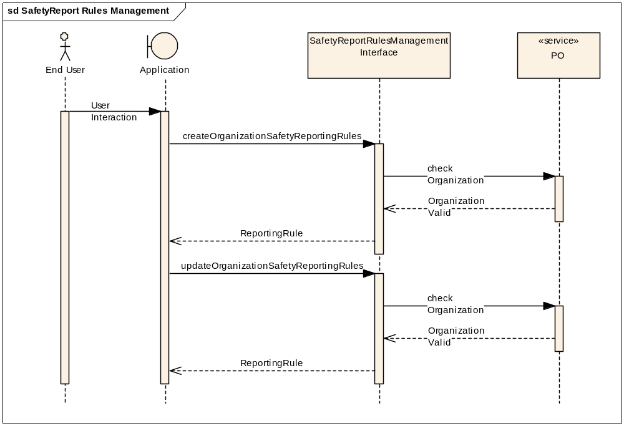

Safety Report Notification
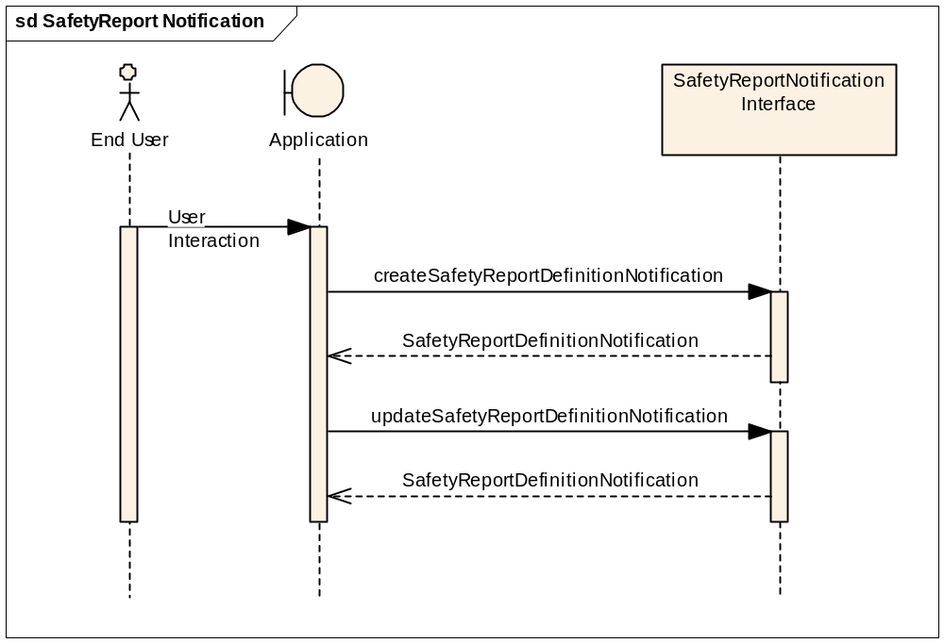

Safety Report Review
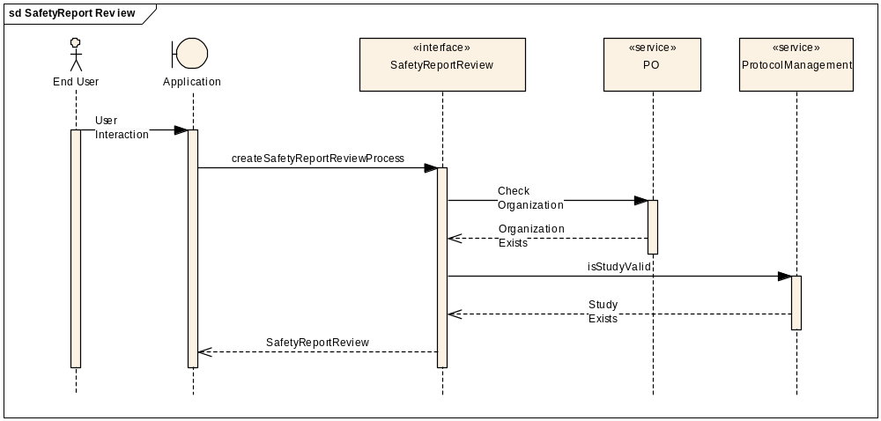

Safety Report Advanced Query

Safety Report Rules Evaluation
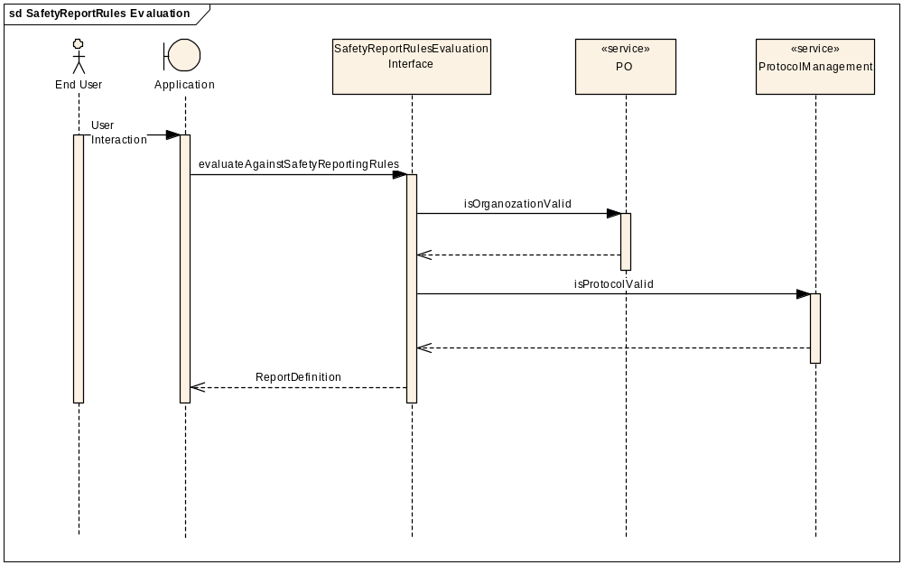

Safety Report Definition Query
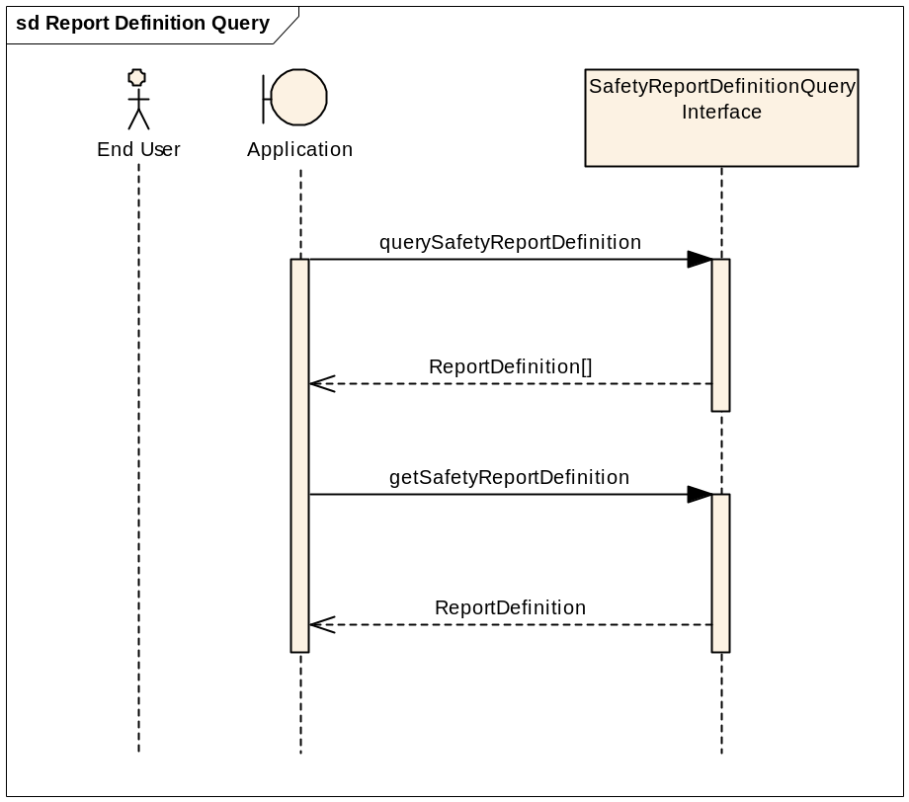

Profiles

Functional Profiles

Functional Profile No. | Functional Profile Name | Functional Profile Description
SR-FP1 | Safety Report Query | The Safety Report Query functional profile provides an encapsulation boundary for the commissioner of the query to be guaranteed that the information provided by a given query is correct and complete.
SR-FP2 | Safety Report Management | The Management series of capabilities details the complete encapsulation boundary behind which the Safety Report object may be managed.
SR-FP3 | Safety Report Transaction | The Safety Report Transaction functional profile provides for a series of capabilities to perform the transactions required for safety reporting.
SR-FP4 | Safety Report Definition Management | The Safety Report Definition functional profile provides the complete encapsulation boundary behind which the Safety Report Definition may be managed.
SR-FP5 | Safety Report Rules Management | The Safety Report Rules functional profile provides the complete encapsulation boundary behind which the Safety Report Rules may be managed.
SR-FP6 | Safety Report Notification | The Notification functional profile provides a series of functional capabilities for other systems, services, and users to manage the notifications that shall be triggered based upon updates to adverse event records and the associations to those records.
SR-FP7 | Safety Report Review | The Safety Report Review functional profile provides a series of functional capabilities for other systems, services, and users to manage and execute the safety report review process.
SR-FP8 | Safety Report Advanced Query | The Advanced Query functional profile provides an encapsulation boundary for the commissioner of the query to be guaranteed that the information provided by a given query is correct and complete. This functional profile provides functionality beyond that provided in the Safety Report Query functional profile.
SR-FP9 | Safety Report Rules Evaluation | The Safety Report Rules Evaluation functional profile provides a series of functional capabilities for other systems, services, and users to evaluate if a safety report is required.
SR-FP10 | Safety Report Definition Query | The Safety Report Definition functional profile provides a series of functional capabilities for other systems, services, and users to find and obtain a safety report definition.

Semantic Profiles

Semantic Profile No. | Semantic Profile Name | Constrained Information Model
SR-SP1 | BRIDG V3.0 Safety Report | BRIDG V3.0.2

Relationship with other services

The following diagram illustrates the positioning of the Safety Report Service within the Clinical Trials business process (at a logical level). The full set of interactions depicted here are beyond the scope of this specification, but the overall intent is to convey the interoperability from safety reporting.

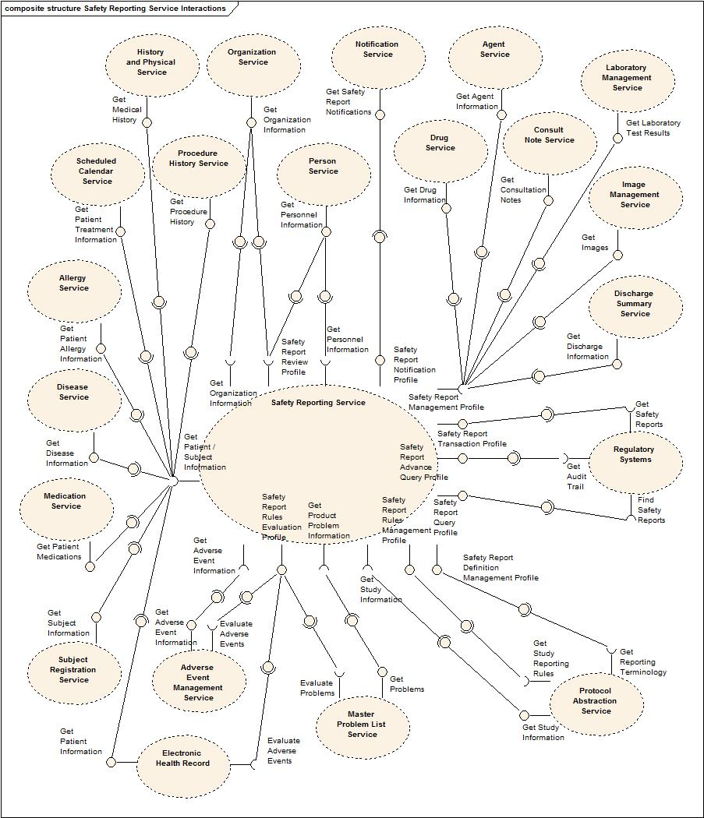
Safety Reporting Component and Dependency Model

Service / System / Actors Name | Dependant / Depends | Data | Description

Conformance Statements

No | Name | Type | Viewpoint | Description | Test method
1 | Query Performance | Obligation | Engineering | The Safety Report Query Profile should provide a response within 0.5 seconds to support a synchronous UI based client | Test cases to include performance testing.
2 | Multiple Jurisdictions | Obligation | Enterprise | The Safety Reporting Service will span jurisdictional boundaries and will need to support a federated data model. | Test cases include multiple domain scenarios.
3 | Secured Access | Obligation | Engineering | The Safety Reporting service should have access control mechanism in place to restrict access to the secured data | Design review  Test cases to be defined for security
4 | Additional Functionality | Permission | Computational | The Safety Reporting service can provide additional functionality other than specified in these specifications | 1. Design Review
5 | Semantic Model | Obligation | Informational | The Safety Reporting service must support NCI’s version of BRIDG 3.0.2 model Adverse Event class. | Design Review
6 | Functional Profiles | Obligation | Computational | Functional Profiles shall be deployed as functional wholes. Ignoring or omitting functional behavior defined within a functional profile is not permitted, nor is diverging from the detailed functional specifications provided in Section 4. | Design Review  Test cases
7 | Functional Profiles | Obligation | Computational | A conformant implementation of this specification must deploy at least one Functional Profile. If that Functional Profile has dependencies on other profiles, then those dependencies must be deployed as well to support the provenance of that service instance. | Design Review  Test cases
8 | Associate Functional Profile | Obligation | Computational | If deployed, the Associate Functional Profile may associate foreign identifiers with local identifiers. Local identifier can be either MRN or any other identifiers which can be used to identify any additional information associated with the Adverse Event such as a specimen, an image or a chart etc. | Test cases
9 | Boundary | Obligation | Computational | Implementations of the Management and Query profiles shall be authoritative within an organization’s boundaries only, and are not intended to provide an encapsulation boundary that supports different rules or policies regarding the management and access to information regarding a given adverse event focal object. | Test cases
10 | Information Authority | Obligation | Computational | Implementations of other profiles may provide access to information external to a given organization’s boundary. This shall not imply authority for that information except transitively, and supporting that authority is expected to be supported directly by conformance statements at the Platform Independent and Platform Specific levels. | Test cases

Appendix A - References

Name | Description | Location
NCI’s BRIDG v3.0 | NCI’s BRIDG model used for modeling the AE Service | https://gforge.nci.nih.gov/frs/download.php/7606/BRIDG_Release_3.0_Package.zip
caAERS Use Case Document | Document containing use cases for the caAERS application | https://wiki.nci.nih.gov/display/CTMS/Use+Cases+-+caAERS

Appendix B - Glossary

Term | Description
BRIDG | The Biomedical Research Integrated Domain Group (BRIDG) has developed a comprehensive domain analysis model representing biomedical/clinical research.

Appendix C - Cross Reference Tables

Interface to Profile Mapping

Interface No. | Interface | Profile No. | Profile
SR-INF1 | SafetyReportQuery | SR-FP1 | Safety Report Query
SR-INF2 | SafetyReportManagement | SR-FP2 | Safety Report Management
SR-INF3 | SafetyReportTransaction | SR-FP3 | Safety Report Transaction
SR-INF4 | SafetyReportDefinitionManagement | SR-FP4 | Safety Report Definition Management
SR-INF5 | SafetyReportRulesManagement | SR-FP5 | Safety Report Rules Management
SR-INF6 | SafetyReportNotification | SR-FP6 | Safety Report Notification
SR-INF7 | SafetyReportReview | SR-FP7 | Safety Report Review
SR-INF8 | SafetyReportAdvancedQuery | SR-FP8 | Safety Report Advanced Query
SR-INF9 | SafetyReportRulesEvaluation | SR-FP9 | Safety Report Rules Evaluation
SR-INF10 | SafetyReportDefinitionQuery | SR-FP10 | Safety Report Definition Query

