Conceptual Functional Service Specification

Adverse Event Management

0.3.0

07/09/2010

Architecture Inception Team | Kalpesh Patel
Editors | Multiple
Authors | Brian McIndoe, Paul Baumgartner

Document Version | Date | Author | Changes
0.1.4 |  | Kunal Modi | Incorporated review comments from caAERS Team
0.1.5 |  | Kunal Modi | Incorporated final review comments and Aligned it with CFSS Template v.0.0.9
0.1.6 |  | Harsh Marwaha | Minor formatting changes, and updated reference to Create operation in diagrams
0.1.7 |  | Kunal Modi | Incorporated Smita’s comments
0.2.0 | 01/11/2010 | Brian McIndoe | Incorporated new CFSS template. Added content required by new template and revised existing content.
0.2.1 | 01/13/2010 | Paul Baumgartner | Incorporated feedback from SemanticBits team.
0.2.2 | 01/21/2010 | Brian McIndoe | Revisions to include CTEP reporting requirements.
0.2.3 | 01/22/2010 | Brian McIndoe | Revisions to include new capability (Update Adverse Event Safety Report) and updated Conformance and Compliance statements
0.2.4 | 01/24/2010 | Brian McIndoe | Minor corrections
0.2.5 | 01/27/2010 | Brian McIndoe | Incorporated review feedback from caAERS team
0.3.0 | 07/09/2010 | Paul Baumgartner | Renamed to “Adverse Event Management” Service; removed safety reporting elements that will be moved into a separate scope document.

Table of Contents
1 Overview and Business Case 6
1.1 Service Description and Purpose 6
1.2 Scope 7
1.3 Assumptions 8
2 Business Storyboards 10
2.1 Primary Actors 10
2.1.1 People Actors 10
2.1.2 System Actors 10
2.2 Story Boards 11
2.2.1 Overview 11
2.2.2 AE-SB1 – Patient Reported Outcomes 11
2.2.3 AE-SB2 – Lab Initiated Adverse Event 12
2.2.4 AE-SB3 – CDMS Initiated Adverse Event 12
2.2.5 AE-SB4 – Processing of Adverse Event 13
2.2.6 AE-SB5 – Evaluation of Reporting Requirements for an Adverse Event 13
3 Detailed Functional Model 14
3.1 Structure of the Service 14
3.2 Detail of the Capabilities 15
4 Profiles 29
4.1 Functional Profiles 29
4.2 Information Profiles 32
4.2.1 BRIDG Information Model 32
4.2.2 Adverse Event State Machine 33
4.2 Semantic Profiles 34
4.3 Conformance Profiles 35
5 System Implementation Details 36
5.1 System Runtime Interaction Details 36
5.2 Implementation/Deployment Considerations 37
6 Conformance and Compliance 38
6.1 Compliance and Conformance Statements 38
7 Appendix A – Relevant Standards 41
8 Appendix B – References 42
9 Appendix C - Glossary 43
10 Appendix D – Cross Reference Tables 44
10.1 List of Storyboards 44
10.2 Storyboards to Capabilities Mapping 45
10.3 Actors 45

Overview and Business Case

Name of Service
The service discussed in this specification will be known as the Adverse Event Management Service, or AEMS for short.

Service Description and Purpose
An adverse event is any undesirable medical experience associated with the use of a product or procedure on a person. Adverse events are identified and recorded during the conduct of clinical trials and as a part of clinical care. Adverse events can be identified through a combination of several mechanisms such as patient self-reporting, clinical observation, or quantitative measurements (i.e. laboratory results). Likewise, adverse events can be recorded by patients or clinical trial subjects, clinical researchers, health care delivery professionals, and the systems that support clinical care (e.g. laboratory systems)
The purpose of the Adverse Event Management Service is to provide a standard set of interfaces to record, manage, query, and obtain adverse event records within the cancer clinical trial space and cancer care delivery space. The common, reusable set of interfaces provided by this service will facilitate the interaction and interoperability between systems that require and provide adverse event data. As a result of this interoperability, this service will likely improve the quality and availability of adverse event information while likely reducing the cost of providing this information. This service is not intended to facilitate to reporting of adverse events to regulatory agencies and oversight committees, such as the Food and Drug Administration (FDA) and Institutional Review Boards (IRBs), respectively. The aforementioned functionality is within the scope of the Safety Reporting Service.

Scope
Items | Scope / Out of Scope | Source
Provide the ability to create, update, and delete/deactivate records of adverse events. | Scope | Adverse Event Management Service Scope Document
Provide the ability to search for and retrieve adverse event records using a variety of search criteria based on study, subject/patient, organization, personnel, and adverse event attributes. | Scope | Adverse Event Management Service Scope Document
Provide support to utilize other systems and services, as authorized. | Scope | Adverse Event Management Service Scope Document
Provide adverse event data to authorized systems and services. | Scope | Adverse Event Management Service Scope Document
Provide support for federated adverse event data management. | Scope | Adverse Event Management Service Scope Document
Provide an audit log of all create, update, and delete activity pertaining to an adverse event record. | Scope | Adverse Event Management Service Scope Document
Provide the ability to associate an adverse event record with a patient and/or a study subject. | Scope | Adverse Event Management Service Scope Document
Provide the ability to define, update, delete and search solicited adverse events for a study | Scope | Adverse Event Management Service Scope Document
Provide the ability to define, update, delete and search for expected adverse events for a study. | Scope | Adverse Event Management Service Scope Document
Provide notification message to user that SAE reporting is required (Note: This will be addressed by the Notification Service) | Out of Scope
Assumption | Affects | Source
It is assumed that this service will be used for adverse events experienced by a person and thus the pre-conditions of an existing valid patient or study participant must be met. | Information about the adverse event must be available at time of entry | Adverse Service Event Scope Document
There will be multiple sources of data for a single adverse event. For example, an adverse event may be initiated via a Lab System, information regarding the treatment of the event may be sent via an electronic health record, and the course on which the event occurred may come from a participant calendar system. | There needs to be many ways to initiate an adverse event. Adverse events will need to be updated from multiple sources. | Adverse Event Management Service Scope Document
Users (human and system) must be authorized to access the study to which they are attempting to perform an action on. | A security mechanism that can limit users by study and action needs to be in place.
The adverse event sent to the AE Management System may be sent using the AE coding terminology specified for the study. | The AE needs to be coded appropriately. A future Coding service could be developed for this.

Business Storyboards

Primary Actors
The following actors are used in the storyboards below.

People Actors
Name | Role | Notes
Dr. David Jones | Healthcare Provider | Usually an investigator on the study
Lucy Taylor | CRA | Clinical Research Associate; common synonyms are Research Nurse, Study Coordinator
Jerry Carlos | Subject/Patient | Also know as Study Participant
Dr. Linda Lu | Principle Investigator | A subscriber to notifications regarding adverse events.
John Miller | Laboratory Technician

System Actors
Name | Notes
Adverse Event Management System | A system used to record adverse events.
Protocol Management Service | Used to perform a lookup to ensure that the protocol (study) is valid and active.
Subject Registration Service | Used to ensure that the subject is enrolled in the study
Scheduled Calendar Service | Used to access Course/Cycle information and provide notifications with respect to adverse events.
Person Service | Used to associate the person(s) involved with recording the adverse event.
Organization Service | Used to associate the organization(s) involved with the adverse event.
Laboratory Data System | Used to store the results of laboratory tests.
Lab Result Grading Service | Used to obtain automated grading of lab based adverse events.
Notification Management Service | Used to provide infrastructure to provide notifications regarding adverse event management activities.
Safety Reporting Service | Used to evaluate adverse events against criteria to determine appropriate reporting requirements.
EHR System | Electronic Health Record System
Patient Reported Outcome System | Used to record adverse symptoms (events) directly from patients without clinician interpretation.
CDMS | Clinical Data Management System

Story Boards

Overview
Jerry Carlos was diagnosed with prostate cancer early this year. Based on his disease characteristics, lab results, etc., Dr. Jones, his health care provider, enrolled him in a prostate cancer study – NCI00234 that is being conducted at Dr. Jones’s hospital. It is a Phase II study that is testing an Investigational New Drug (IND). Based on the Study Schedule Jerry is required to visit Dr. Jones for various activities related to the study as well as for examination. During one of his regular examinations Dr Jones discovers that Jerry has developed a severe rash on his body. Dr. Jones immediately records this as a potential Adverse Event into the EHR System. The EHR System reports this AE to the AE Management System. Lucy Taylor who is the Clinical Research Associate (CRA) for this study obtains and records additional basic data related to the Adverse Event (i.e. AE term, severity, seriousness, potential relatedness to the study). Lucy also analyzes the laboratory results in conjunction with clinical notes from Jerry Carlos’s routine visit. She determines that there is a potential adverse event occurrence. This information is entered in the Adverse Event Management System. Then based on the defined business process for this study, the Adverse Event is sent to the Safety Reporting Service for evaluation of reporting requirements.

AE-SB1 – Patient Reported Outcomes
Outline | Patient reports an adverse symptom directly into the Patient Reported Outcome (PRO) system.
Detail | As part the study he is participating on, Jerry Carlos (the subject) completes a weekly questionnaire regarding symptoms that he is experiencing. Jerry Carlos records these symptoms into the PRO system. The PRO system uses the AEMS to electronically report this to the Adverse Event Management System used for this clinical trial.

AE-SB2 – Lab Initiated Adverse Event
Outline | A Lab Technician reports an out-of-range laboratory result as an adverse event.
Detail | During a routine visit Jerry Carlos has a blood sample drawn as part of the treatment. His sample is analyzed by John Miller, the lab technician at the laboratory and it is found that the potassium level is well beyond normal range. The lab system flags the sample as a potential adverse event and uses the AEMS electronically reports this finding to an Adverse Event Management System for this clinical trial.

AE-SB3 – CDMS Initiated Adverse Event
Outline | A Clinical Research Administrator notices a potential adverse event and enters it into the CDMS system
Detail | Lucy Taylor, the Clinical Research Administrator is analyzing the laboratory results in conjunction with clinical notes from Jerry Carlos’s routine visit. It is determined that there is a potential adverse event occurrence. This information is entered in the CDMS (such as C3D or OpenClinica) that electronically reports this finding to an Adverse Event Management System for this clinical trial.

AE-SB4 – Processing of Adverse Event
Outline | Additional data on the event is collected and a determination made on the causality of the drug on the event.
Detail | Once the Adverse Event has been initiated, Lucy Taylor the CRA obtains and records additional basic data related to the Adverse Event (i.e. AE term, severity, seriousness, concomitant medications). She determines that the event is unexpected and that it is the possible that the treatment caused it. She saves the information which updates the Adverse Event Management System.

AE-SB5 – Evaluation of Reporting Requirements for an Adverse Event
Outline | The adverse event will need to be evaluated according to the protocol guidelines and the requirements of the sponsors and regulatory authorities.
Detail | The adverse event information is sent to the Safety Reporting Service to evaluate the reporting requirements for the adverse event.

AE-SB6 – Clinician Identified Adverse Event
Outline | An adverse event is identified by the physician during a clinical exam.
Detail | During a routine clinical exam, Dr. Jones observes that Jerry Carlos (the study participant) is experiencing an adverse event. Dr. Jones describes the adverse event in Jerry Carlos’ chart. Lucy Taylor (the CRA) later reviews the chart and enters the adverse event information into a web interface which then invokes the Adverse Event Management Service and updates the appropriate records in the Adverse Event Management System.

Detailed Functional Model

Structure of the Service
Name | Description
Initiate Adverse Event | Provides the capability to initiate an AE record from any source.
Update Adverse Event | Provides the capability to update an AE record.
Deactivate an Adverse Event | Provides the capability to request that the state of an Adverse Event be changed. This could be used to perform a logical delete (deactivation) of an Adverse Event entered by mistake.
Associate ID with Existing Adverse Event | Provides the capability to associate additional identifying information with an existing Adverse Event.
Dissociate ID with Existing Adverse Event | Provides the capability to disassociate additional identifying information with an existing Adverse Event.
Associate Adverse Events | Provides the capability to logically group multiple Adverse Events.
Get Associated Adverse Events | Provides the capability to retrieve a collection of Adverse Events that have been logically grouped together.
Disassociate Adverse Events | Provides the capability to removed links between multiple Adverse Events that have previously been logically grouped.
Subscribe to an Adverse Event and Its Updates | Provides the capability to subscribe to an Adverse Event and receive notice of any updates to the event.
Unsubscribe to an Adverse Event and Its Updates | Provides the capability to unsubscribe to a previously subscribed Adverse Event.
Find Adverse Events | Provides the ability to search for Adverse Events matching search criteria.
Retrieve Adverse Event Records | Provides the ability to retrieve Adverse Event records.
Retrieve Audit Trail of an Adverse Event | Provides the ability to retrieve an audit trail of all changes that have been made to an Adverse Event record.
Define Solicited Adverse Event | Provides the capability to initiate a solicited Adverse Event record for a study.
Update Solicited Adverse Event | Provides the capability to update a solicited Adverse Event record.
Gather Analytical Data | Provides the ability to retrieve collections of Adverse Event data for further analysis.

Detail of the Capabilities
Name [M] | Initiate Adverse Event
Description [M] | Enables a client system to initiate an Adverse Event. E.g. when a lab system finds that there is abnormal or out of range lab results on a given patient, it can Initiate an Adverse Event using this capability.  Initiate means create a record in the Adverse Event Management System with all required fields populated.  If successful, an instance of an AdverseEvent is returned with a generated Identifier. A properly formed and returned AdverseEvent object with an identifier is an acknowledgement that the Adverse Event is initiated.
Pre-Conditions [M] | Study exists  Patient exists  Patient is enrolled in the study and has a study subject identifier
Security Pre-Conditions [M] | Access control mechanism needs to be in place to ensure that the user is logged in and has valid privileges to Initiate an Adverse Event
Inputs [M] | Adverse Event coded term or verbatim  Study Identifier  Patient Identifier
Outputs [M] | AdverseEvent Identifier  Adverse Event Object
Post-Conditions [O] | An Adverse Event is initiated on the system
Exception Conditions [M] | Invalid Adverse Event Object representation  Specified Protocol is invalid  Invalid data type or code value for any attribute  Participant is not registered in the specified protocol as a subject
Aspects left for Technical Bindings [O] | Where identifier is not part of the input, some means is necessary to identify potential duplicates. This may necessitate matching on other key attributes
Notes [O]

Name [M] | Update Adverse Event
Description [M] | Enables updating an existing Adverse Event. This service encapsulates all necessary information for an Adverse Event from Clinical Trial stand-point and is compliant to V3.0 BRIDG representation.
Pre-Conditions [M] | Adverse Event exists  Study exists  Patient exists  Patient is enrolled in the study
Security Pre-Conditions [M] | Access control mechanism needs to be in place to ensure that the user is logged in and has valid privileges to Update an Adverse Event.
Inputs [M] | BRIDG AdverseEvent class and its aggregation/composition classes with values filled for both the existing and the changed attributes. Identifier is a required field.  BRIDG->AdverseEvent attributes:  - Adverse Event Identifier  - Grade/Severity Code  - Seriousness code  - Expected Indicator  - Hospitalization Required Indicator  - Onset Date  - Resolution Date
Outputs [M] | Return an instance of the updated AdverseEvent object. A properly formed and returned AdverseEvent object with the updated data is an acknowledgement that the Adverse Event is updated.
Post-Conditions [O] | Adverse Event is updated  Subscribers are notified of this event
Exception Conditions [M] | Adverse Event Identifier is invalid  One or more mandatory attributes required for an update of the Adverse Event object have not been provided  Invalid data type or code value for any attribute  Invalid Adverse Event Object representation
Aspects left for Technical Bindings [O] | The way by which interfaces are realized between Dependent Systems
Notes [O] | This operation depends on AE Query Profile to retrieve the AdverseEvent object in order to allow a service consumer to update it  This operation requires the entire AdverseEvent object consisting of both the existing as well as the changed attributes to be passed. External Systems can use the Query Operation to obtain the latest AdverseEvent object and update it and pass it as parameter to this operation.

Name [M] | Request to Change State of an Adverse Event
Description [M] | Allows changing the state of an Adverse Event. For example this operation can be used for removing/deactivating an Adverse Event to rectify any Adverse Event that was entered by mistake with proper audit trail.
Pre-Conditions [M] | Adverse Event exists
Security Pre-Conditions [M] | Access control mechanism needs to be in place to ensure that the user is logged in and has valid privileges to Request State Change of an Adverse Event.
Inputs [M] | AdverseEvent Identifier  Target state for the Adverse Event
Outputs [M] | Return a request identifier. The service consumer can then use this identifier to get the status of their request
Post-Conditions [O] | Request to update Adverse Event state is initiated  Subscribers are notified of this event
Exception Conditions [M] | Invalid AdverseEvent Identifier  Invalid state request
Aspects left for Technical Bindings [O] | Format or data type for the Request Identifier
Notes [O]

Name [M] | Associate IDs with Existing Adverse Event
Description [M] | Provides ability to associate a local identifier (such as MRN or any other identifier) of the system to the existing Adverse Event. This operation can be used to associate additional related information with the Adverse Event. This could be a specimen, an image or a chart.
Pre-Conditions [M] | Specified Adverse Event exists
Security Pre-Conditions [M] | Access control mechanism needs to be in place to ensure that the user is logged in and has valid privileges to Associate Local ID with an Existing Adverse Event.
Inputs [M] | An instance of the BRIDG AdverseEvent class with the identifier populated.  Local Identifier to be associated.
Outputs [M] | Return an acknowledgement that the association was successfully created
Post-Conditions [O] | Adverse Events are linked/associated with the local identifier  Subscribers to the Adverse Event are notified of this event
Exception Conditions [M] | Adverse Event Identifier is invalid  Adverse Event is not found for the given identifier
Aspects left for Technical Bindings [O] | Format or data type of local identifier  Format or data type of Acknowledgement
Notes [O]

Name [M] | Associate Adverse Events
Description [M] | Enables linking multiple related Adverse Events together for study purposes
Pre-Conditions [M] | All specified Adverse Events exist
Security Pre-Conditions [M] | Access control mechanism needs to be in place to ensure that the user is logged in and has valid privileges to Associate Adverse Events.
Inputs [M] | A list of instances of BRIDG AdverseEvent class (DSET<AdverseEvent>) where each AdverseEvent instance has the identifier attribute populated  Reason for association
Outputs [M] | Return an acknowledgement that the association was successfully created
Post-Conditions [O] | All Adverse Events are linked/associated  Subscribers to any of the Adverse Events are notified
Exception Conditions [M] | One or more of the AdverseEvent Identifiers is invalid  Adverse Event is not found for one of the given identifiers  Only one Adverse Event is passed as input
Aspects left for Technical Bindings [O] | When one or more Adverse Events are linked, we need to have a way to deal with data anomalies. Certain data fields may differ from one Adverse Event to the other  Format or data type of reason for association
Notes [O] | This operation depends on AE Query Profile to retrieve all Adverse Events that are being associated

Name [M] | Get Associated Adverse Events
Description [M] | Enables getting associated Adverse Events for a given Adverse Event.
Pre-Conditions [M] | Adverse Event exists
Security Pre-Conditions [M] | Access control mechanism needs to be in place to ensure that the user is logged in and has valid privileges to Get Associated Adverse Events.
Inputs [M] | An instance of BRIDG AdverseEvent class with the identifier attribute populated  (Optional) Reason for association
Outputs [M] | Return a DSET<<BRIDG Adverse Event class>>. Each element of the DSET is a BRIDG Adverse Event object associated with the input Adverse Event. Each returned Adverse Event has at least the identifier populated.  If the reason for association is provided then only the Adverse Events associated for that reason are returned  An empty DSET if there are no associated Adverse Events
Post-Conditions [O] | All associated Adverse Events are returned to the service consumer
Exception Conditions [M] | Adverse Event is not found for the given identifier  Invalid reason code specified in the input
Aspects left for Technical Bindings [O] | Format or data type for reason of association
Notes [O] | This operation depends on AE Query Profile to retrieve Adverse Events that are being associated

Name [M] | Disassociate Adverse Events
Description [M] | Enables dissociating two Adverse Events that are associated earlier (e.g. using associateAEs operation)
Pre-Conditions [M] | All specified Adverse Events exist and they are associated
Security Pre-Conditions [M] | Access control mechanism needs to be in place to ensure that the user is logged in and has valid privileges to Dissociate Adverse Events.
Inputs [M] | BRIDG Adverse Event class with the identifier populated  Associated BRIDG Adverse Event class with the identifier populated  Reason for association (Optional)
Outputs [M] | Return an acknowledgement that the association was successfully created
Post-Conditions [O] | Input Adverse Events are dissociated  If reason for association is specified then only the association for that reason is broken.  Subscribers of both Adverse Events are notified of this event
Exception Conditions [M] | Adverse Event is not found for the given identifiers  No association can be found for the given identifiers and reason for association  Invalid data type or code value for any attribute
Aspects left for Technical Bindings [O] | When one or more Adverse Events are dissociated, we need to have a way to deal with any data dependency from one adverse event to another. Certain data fields may depend from one Adverse Event to other  Format or data type for reason for association
Notes [O] | This operation depends on AE Query Profile to retrieve both Adverse Events that need to be dissociated

Name [M] | Subscribe to an Adverse Event and Its Updates
Description [M] | Enables subscribing to Adverse Event updates
Pre-Conditions [M] | Adverse Event exists
Security Pre-Conditions [M] | Access control mechanism needs to be in place to ensure that the user is logged in and has valid privileges to Subscribe to an Adverse Event and Its Updates.
Inputs [M] | Criteria in form of DSET<<BRIDG Adverse Event class>>. Each element of the set is a BRIDG Adverse Event object and its aggregation/composition objects with required attributes filled and with desired optional attributes filled. The criteria specified in multiple Adverse Event classes result in an OR logical condition while the criteria specified within a single Adverse Event class result in an AND logical condition. For example a query of Adverse Event with expectedIndicator=1 and hospitalizationRequiredIndicator=”1” or highlightedIndicator=1 would have two elements in this input parameter. The first one with expectedIndicator=1 and hospitalizationRequiredIndicator=”1” and the second one with highlightedIndicator =1  Subscriber class with its Identifier
Outputs [M] | Return Subscription object with its identifier. A properly formed and returned Subscription class with its identifier is an acknowledgement that the subscription is created.
Post-Conditions [O] | Subscription is created
Exception Conditions [M] | Invalid data type or code value for any attribute.  No matching Adverse Events are found for the given criteria
Aspects left for Technical Bindings [O] | Notification to subscriber is automated via email, text or manual is left to implementation  Notification may take the form of a simple identifier / attribute combination, a canned query, a report, or an audit trail  However, subscribers should request notification relevant against both business processes and subject to appropriate local governance  The data type of the Subscription and Subscriber
Notes [O] | This operation depends on AE Query Profile to retrieve AdverseEvent so that a subscription is registered

Name [M] | Unsubscribe to an Adverse Event and Its Updates
Description [M] | Enables a user to unsubscribe for an Adverse Event to which they were previously subscribed.
Pre-Conditions [M] | Subscription exists.
Security Pre-Conditions [M] | Access control mechanism needs to be in place to ensure that the user is logged in and has valid privileges to Unsubscribe to an Adverse Event and Its Updates.
Inputs [M] | Subscription class and its Identifier.
Outputs [M] | Return updated Subscription object with its identifier. A properly formed and returned Subscription object updated to state that the subscription is no longer active is an acknowledgement that the unsubscribe operation succeeded
Post-Conditions [O] | Subscription is cancelled
Exception Conditions [M] | Invalid data type or code value for any attribute.  No matching subscription is found for the given Identifier.
Aspects left for Technical Bindings [O] | Data type for Subscription
Notes [O] | This operation depends on AE Query Profile to retrieve Adverse Event so that a subscription is registered

Name [M] | Find Adverse Event
Description [M] | Facilitates searching for Adverse Events
Pre-Conditions [M] | Search criteria are provided
Security Pre-Conditions [M] | Access control mechanism needs to be in place to ensure that the user is logged in and has valid privileges to Find Adverse Event.
Inputs [M] | Search Criteria in form of DSET<<BRIDG Adverse Event class>>. Each element of the set is a BRIDG Adverse Event object and its aggregation/composition objects with required attributes filled and with desired optional attributes filled. The criteria specified in multiple Adverse Event objects result in an OR logical condition while the criteria specified within a single Adverse Event object results in an AND logical condition. For example a query of Adverse Event with expectedIndicator=1 and hospitalizationRequiredIndicator=”1” or highlightedIndicator=1 would have two elements in this input parameter. The first one with expectedIndicator=1 and hospitalizationRequiredIndicator=”1” and the second one with highlightedIndicator =1
Outputs [M] | Return one or more Adverse Events matching search criteria  Indicates pagination if search found bulky results
Post-Conditions [O] | Returns one or more Adverse Events matching search criteria  Returns no Adverse Event if there is no match
Exception Conditions [M] | Minimum and Mandatory attributes of search criteria have not been provided.  Invalid data type or code value for any attribute
Aspects left for Technical Bindings [O]
Notes [O] | Need to determine what is minimum search criteria that must be provided  Need to define the pagination standard  Default boundary checks are enforced to avoid system/service failures

Name [M] | Retrieve Adverse Event
Description [M] | Retrieves entire Adverse Event record based on the Adverse Event Identifier. Retrieves entire object graph for specified Adverse Event
Pre-Conditions [M] | Adverse Event exists
Security Pre-Conditions [M] | Access control mechanism needs to be in place to ensure that the user is logged in and has valid privileges to Retrieve Adverse Event.
Inputs [M] | BRIDG Adverse Event object with Identifier populated
Outputs [M] | Return entire Adverse Event object
Post-Conditions [O] | Returns an entire Adverse Event  Returns no Adverse Event if there is no match
Exception Conditions [M] | Minimum and Mandatory attributes of search criteria have not been provided, especially identifier or key term  Invalid data type or code value for any attribute
Aspects left for Technical Bindings [O]
Notes [O] | Need to determine what is minimum search criteria that must be provided

Name [M] | Retrieve Audit Trail of an Adverse Event
Description [M] | Retrieves an entire audit trail of all changes to a specified Adverse Event. It retrieves all the audit information pertaining to that AE stored within this service only. This audit information contains a log of all the changes made to the AE through the defined business process. NOTE: This function will return audit trail information for AE stored within that service only. If multisite audit trail is required then the coordinating site can include aggregate audit if available.
Pre-Conditions [M] | Adverse Event exists
Security Pre-Conditions [M] | Access control mechanism needs to be in place to ensure that the user is logged in and has valid privileges to Retrieve Audit Trail of an Adverse Event.
Inputs [M] | Adverse Event class with Adverse Event’s identifier populated  Date range for which audit trail is desired
Outputs [M] | Return audit trail of the Adverse Event within the desired date range
Post-Conditions [O] | Returns audit trail information
Exception Conditions [M] | Invalid data type or code value for any attribute  Adverse Event cannot be found for the given identifier
Aspects left for Technical Bindings [O]
Notes [O]

Name [M] | Gather Analytical Data
Description [M] | Enables querying and retrieving of data based on various adverse event criteria.
Pre-Conditions [M]
Security Pre-Conditions [M] | Access control mechanism needs to be in place to ensure that the user is logged in and has valid privileges to Generate Analytical Report.
Inputs [M] | Any adverse event search criteria in the form of a BRIDG adverse event class  Any study identifier  Any study subject identifier (optional)
Outputs [M] | A collection object containing the results
Post-Conditions [O] | Returns data
Exception Conditions [M] | Invalid Study Identifier  Invalid data type or code value for any attribute  Invalid Study Subject Identifier
Aspects left for Technical Bindings [O] | Format or data type for the report criteria
Notes [O]

Profiles

Functional Profiles
Functional Profiles are intended to be deployed as a collection of operations that have been designed to provide coherent and consistent access to capabilities. The functional profiles allow service provider to gradually implement and comply with this specification. The functional profiles that align with the Collaborations detailed in section 2 (above) are outlined below.
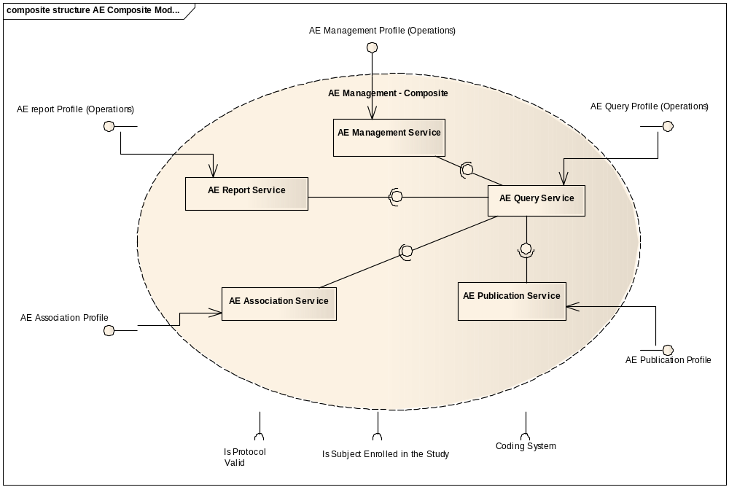

Functional Profile No. | Functional Profile Name | Functional Profile Description | Capability Name
AE-FP1 | AE Query | The Query Functional Profile provides an encapsulation boundary for the commissioner of the query to be guaranteed that information provided by a given query is authoritative and correct. Thus, an implementation of the query profile must be able to manage and be aware of persistence locks, business rules, Adverse Event state, and so on, to provide a data graph that is consistent with the local business rules that apply to Adverse Events in a deployed instance. | - Find Adverse Events  - Retrieve Adverse Events  - Retrieve Audit Trail of Adverse Event  - Gather Analytical Data  - Get Associated Adverse Events
AE-FP2 | AE Management | The Management series of capabilities details the complete encapsulation boundary behind which the Adverse Event focal object may be managed. That is, it provides for a coherent set of functions regarding that focal object expressed in a state machine (see Information Profile) that must be managed together. | - Initiate an Adverse Event record  - Update an Adverse Event record  - Request to change a state of an Adverse Event
AE-FP4 | AE Associate | The Association Functional Profile provides for a series of capabilities to connect an Adverse Event instance with another, whether that association happens across system or organizational boundaries. This association is provided for local use only, though the association may be between a local identifier and a foreign identifier. Foreign identifiers may never be associated with each other except transitively through a local identifier.  Note that “local” is defined for the purposes of this functional profile as the domain of users that are given access to a deployed instance of this functional profile, and does not limit the nature of the identifiers that may be associated. Thus, local may in fact mean trans-organizational when this profile is associated with a regionally-available service.  The Association Profile may have a dependency on the Publication Profile. | - Associate IDs with an existing Adverse Event  - Associate Adverse Events  - Get Associated Adverse Events  - Dissociate an Adverse Event
AE-FP5 | AE Publication | The Publication Functional Profile provides a series of functional capabilities for other systems, services, and users to be notified with state transitions associated in the Management Functional Profile. | - Subscribe to an Adverse Event and its Updates  - Unsubscribe to Adverse Event Updates

Information Profiles

BRIDG Information Model
The Adverse Event Management Service binds and complies with semantics of BRIDG V3.0 information model. The subset of this model applicable for this service is displayed below.

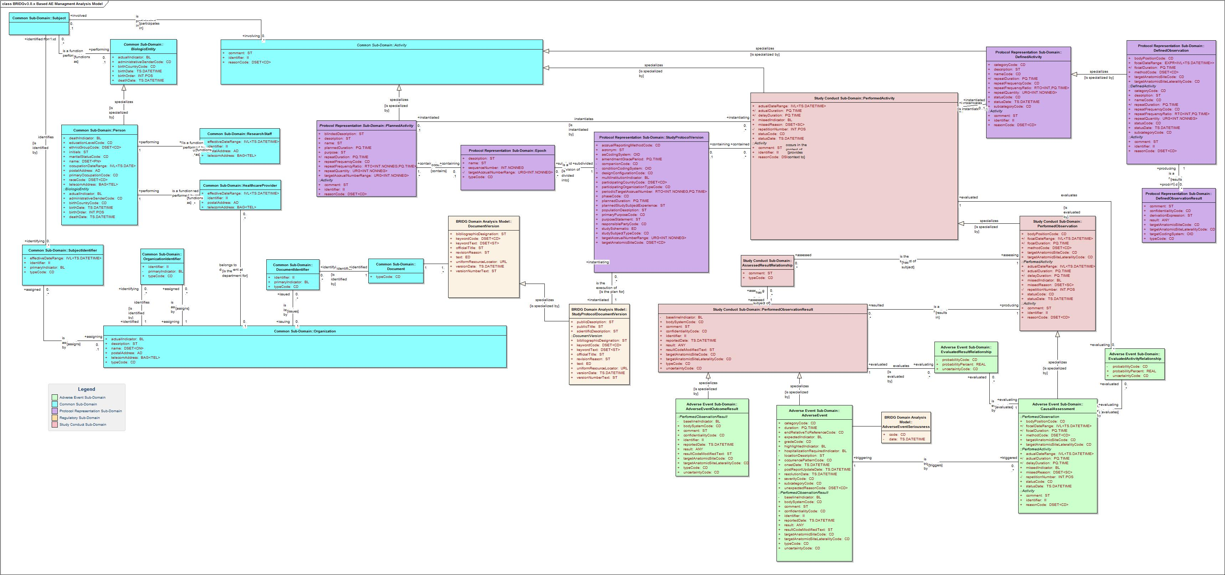

Adverse Event State Machine
An adverse event goes through states described by following state transition diagram.
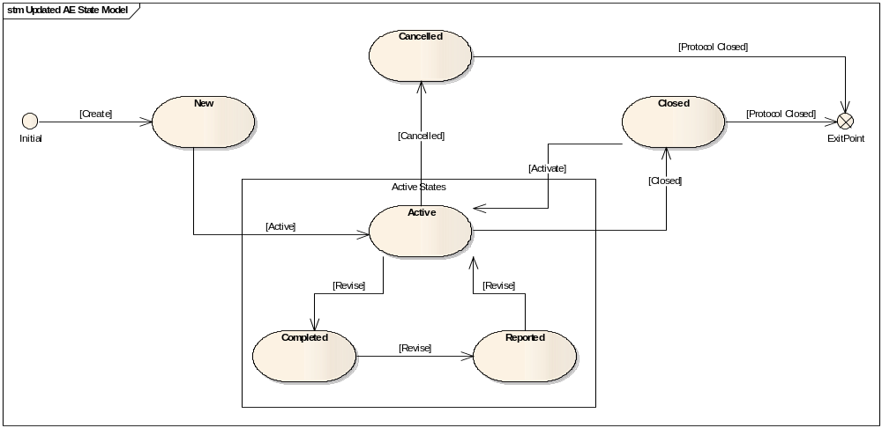

Semantic Profiles
Semantic Profile No. | Semantic Profile Name | Constrained Information Model | Semantic Profile Description
AE-SP1 | BRIDG V3.0 Adverse Event | BRIDG V3.0 Adverse Event Class | - Find Adverse Events  - Retrieve Adverse Events  - Retrieve Audit Trail of Adverse Event  - Initiate an Adverse Event  - Update an Adverse Event  - Request to change a state of an Adverse Event  - Get Status of a State Change Event  - Associate Local ID with an existing Adverse Event  - Associate Adverse Events  - Get Associated Adverse Events  - Dissociate an Adverse Event  - Subscribe to an Adverse Event and its Updates  - Unsubscribe to Adverse Event Updates

Conformance Profiles
Conformance No | AE-CP1
Conformance Name | BRIDG based Entire AE Conformance Profile
Description | This is the conformance profile defines the entire functionality for the Adverse Event Management Service using BRIDG based semantics
Usage Context | This profile would be used by a study administrator or equivalent that has responsibility for all aspects of Adverse Event Reporting.
Mandatory | Yes
Functional Profile(s) | AE-FP1 : AE Query, AE-FP2 :Management, AE-FP4 : AE Associate, AE-FP5 : AE Publication
Semantic Profile(s) | AE-SP1 : BRIDG V3.0 Adverse Event

System Implementation Details

System Runtime Interaction Details
The following communication diagram shows interaction between Adverse Event Management system and other participants. The diagram shows the service functional profiles used by participants for creating, managing, and querying adverse event records.
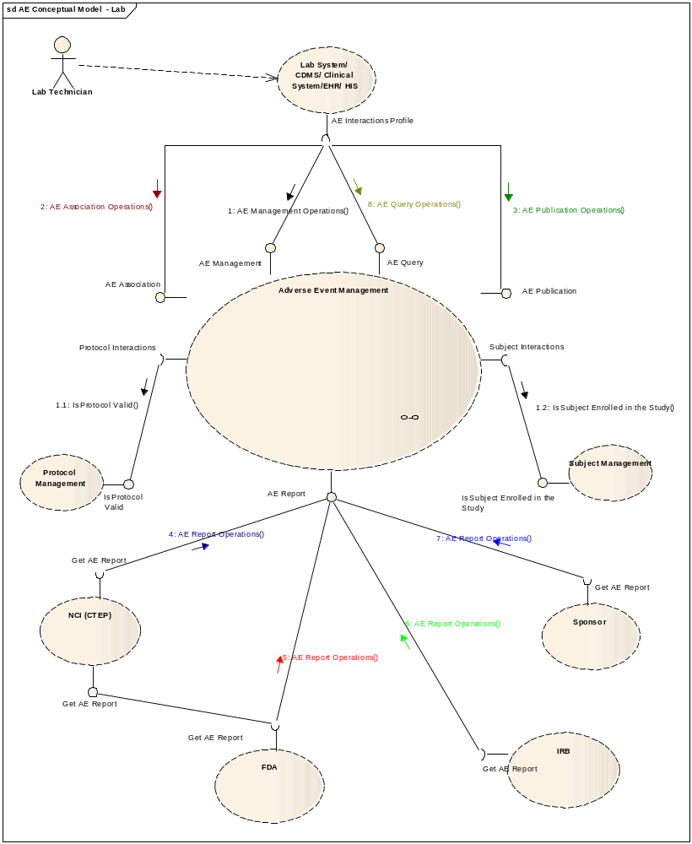

Implementation/Deployment Considerations
Implementation Considerations | Impacts
Several parts of this specification can support different federation models, and also draw distinctions between what can be federated and what cannot.  - Management operations are intended to be deployed locally within a domain that has a consistent set of rules, policies, and human mediation components | The system may have to be configured such that specific profiles are served by different processes.

Conformance and Compliance

Compliance and Conformance Statements
Name | Type | Viewpoint | Description | Test method
Query Performance | Obligation | Engineering | The Adverse Event Management Service Query Profile should provide a response within 0.5 seconds to support a synchronous UI based client | Test cases to include performance testing.
Multiple Jurisdictions | Obligation | Enterprise | The Adverse Event Management Service will span jurisdictional boundaries and will need to support a federated data model. | Test cases include multiple domain scenarios.
Secured Access | Obligation | Engineering | The Adverse Event Management Service service should have access control mechanism in place to restrict access to the secured data | 1. Design review  2. Test cases to be defined for security
Additional Functionality | Permission | Computational | The Adverse Event Management Service can provide additional functionality other than specified in these specifications | Design Review
Semantic Model | Obligation | Informational | The Adverse Event Management Service must support NCI’s version of BRIDG 3.0 model Adverse Event class. | Design Review
Functional Profiles | Obligation | Computational | Functional Profiles shall be deployed as functional wholes. Ignoring or omitting functional behavior defined within a functional profile is not permitted, nor is diverging from the detailed functional specifications provided in Section 4. | - Design Review  - Test cases
Functional Profiles – Conformant Implementation | Obligation | Computational | A conformant implementation of this specification must deploy at least one Functional Profile. If that Functional Profile has dependencies on other profiles, then those dependencies must be deployed as well to support the provenance of that service instance. | - Design Review  - Test cases
Associate Functional Profile | Obligation | Computational | If deployed, the Associate Functional Profile may associate foreign identifiers with local identifiers. Local identifier can be either MRN or any other identifiers which can be used to identify any additional information associated with the Adverse Event such as a specimen, an image or a chart etc. | Test cases
Boundary | Obligation | Computational | Implementations of the Management and Query profiles shall be authoritative within an organization’s boundaries only, and are not intended to provide an encapsulation boundary that supports different rules or policies regarding the management and access to information regarding a given adverse event focal object. | Test cases
Information Authority | Obligation | Computational | Implementations of the Associate, Reporting, and Publication profiles may provide access to information external to a given organization’s boundary. This shall not imply authority for that information except transitively, and supporting that authority is expected to be supported directly by conformance statements at the Platform Independent and Platform Specific levels. | Test cases

Appendix A – Relevant Standards

Name | Description | Location
BRIDG v3.0 | BRIDG model used for modeling the AE Service | http://gforge.nci.nih.gov/frs/?group_id=342
HL7v3 | Health Level 7 version 3 | http://www.hl7.org/implement/standards/v3messages.cfm

Appendix B – References
Name | Description | Location
BRIDG v3.0 | BRIDG model used for modeling the AE Service | http://gforge.nci.nih.gov/frs/?group_id=342
caAERS Use Case Document | Document containing use cases for the caAERS application | https://wiki.nci.nih.gov/display/CTMS/Use+Cases+-+caAERS
Adverse Event Domain Model | Adverse Event Domain Model | https://gforge.nci.nih.gov/plugins/scmsvn/viewcvs.php/trunk/models/AdverseEvent.eap?root=ent-services&view=log

Appendix C - Glossary
Term | Description
BRIDG | The Biomedical Research Integrated Domain Group (BRIDG) has developed a comprehensive domain analysis model representing biomedical/clinical research.
caAERS | Cancer Adverse Event Reporting System

Appendix D – Cross Reference Tables

List of Storyboards
# | Name | Description | Source
AE-SB1 | Patient Reported Outcome | Patient Reports an adverse event during a routine doctor’s visit | CTMS BAM Section 1.4.2
AE-SB2 | Lab initiated Adverse Event | A Lab Technician records an adverse event . | caAERS Use Case Document: Use Case No 4
AE-SB3 | CDMS Initiated Adverse Event | A Clinical Research Administrator notices a potential adverse event and enters it into the CDMS system | CTMS BAM 1.4.6
AE-SB4 | Processing of Adverse Event | A clinical Research Associate obtains the Adverse Event and adds information to it | caAERS Use Case Document: Use Case No 6
AE-SB5 | Evaluation of Adverse Event Reporting Requirements | The Adverse Event is evaluated for reporting by the Safety Reporting Service. | caAERS Use Case Document: Use Case No 2

Storyboards to Capabilities Mapping
# | Storyboard | Capabilities | Functional Profiles
AE-SB1 | Patient Reported Outcome | Initiate AE  Update AE | AE Management
AE-SB1 | Patient Reported Outcome | Query AE | AE Query
AE-SB2 | Lab initiated Adverse Event | Initiate AE  Update AE | AE Management
AE-SB2 | Lab initiated Adverse Event | Query AE | AE Query
AE-SB3 | CDMS Initiated Adverse Event | Initiate AE  Update AE | AE Management
AE-SB3 | CDMS Initiated Adverse Event | Query AE | AE Query
AE-SB4 | Processing of Adverse Event | Update AE | AE Management
AE-SB4 | Processing of Adverse Event | Query AE | AE Query
AE-SB4 | Processing of Adverse Event | Publish AE | AE Publication
AE-SB5 | Evaluation of Adverse Event Reporting Requirements | Query AE | AE Query

Actors
Actors | Functional Profile | Type | Operations used
Electronic Health Record System | AE Management | Client | Stores medical records, client of the AEMS
Health Care Provider | AE Management | Person | Enters the Adverse Event
Adverse Event Management System | AE Management | Service | Supports CRUD API for Adverse Events
Clinical Research Associate | AE Query | Person | Retrieves a specific Adverse Event Record
Electronic Health Record System | AE Query | Client | Client of the Adverse Event Management System
Adverse Event Management System | AE Query | Service | Supports the Query API for Adverse Events

