Conceptual Functional Service Specification

Adverse Event

0.2.5

01/27/2010

Architecture Inception Team | Kalpesh Patel
Editors | Multiple
Authors | Brian McIndoe

Document Version | Date | Author | Changes
0.1.4 |  | Kunal Modi | Incorporated review comments from caAERS Team
0.1.5 |  | Kunal Modi | Incorporated final review comments and Aligned it with CFSS Template v.0.0.9
0.1.6 |  | Harsh Marwaha | Minor formatting changes, and updated reference to Create operation in diagrams
0.1.7 |  | Kunal Modi | Incorporated Smita’s comments
0.2.0 | 01/11/2010 | Brian McIndoe | Incorporated new CFSS template. Added content required by new template and revised existing content.
0.2.1 | 01/13/2010 | Paul Baumgartner | Incorporated feedback from SemanticBits team.
0.2.2 | 01/21/2010 | Brian McIndoe | Revisions to include CTEP reporting requirements.
0.2.3 | 01/22/2010 | Brian McIndoe | Revisions to include new capability (Update Adverse Event Safety Report) and updated Conformance and Compliance statements
0.2.4 | 01/24/2010 | Brian McIndoe | Minor corrections
0.2.5 | 01/27/2010 | Brian McIndoe | Incorporated review feedback from caAERS team

Table of Contents
1 Overview and Business Case 4
1.1 Service Description and Purpose 4
1.2 Scope 4
1.3 Assumptions 5
2 Business Storyboards 7
2.1 Primary Actors 7
2.1.1 People Actors 7
2.1.2 System Actors 7
2.2 Story Boards 7
2.2.1 Overview 7
2.2.2 AE-SB1 – Patient Reported Outcomes 8
2.2.3 AE-SB2 – Lab Initiated Adverse Event 8
2.2.4 AE-SB3 – CDMS Initiated Adverse Event 9
2.2.5 AE-SB4 – Processing of Adverse Event 9
2.2.6 AE-SB5 – Reporting of Adverse Event 9
2.3 Adverse Event Reporting Discussion 10
3 Detailed Functional Model 12
3.1 Structure of the Service 12
3.2 Detail of the Capabilities 14
4 Profiles 33
4.1 Functional Profiles 33
4.2 Information Profiles 36
4.2.1 BRIDG Information Model 36
4.2.2 Adverse Event State Machine 37
4.2 Semantic Profiles 38
4.3 Conformance Profiles 39
5 System Implementation Details 41
5.1 System Runtime Interaction Details 41
5.2 Implementation/Deployment Considerations 42
6 Conformance and Compliance 43
6.1 Compliance and Conformance Statements 43
7 Appendix A – Relevant Standards 46
8 Appendix B – References 47
9 Appendix C - Glossary 48
10 Appendix D – Cross Reference Tables 49
10.1 List of Storyboards 49
10.2 Storyboards to Capabilities Mapping 49
10.3 Actors 50

Overview and Business Case

Service Description and Purpose
The Adverse Event Service provides a set of interfaces for the management and reporting of Adverse Events within the Clinical Trial space. Adverse Events (including potential, non-serious, or serious Adverse Events) are identified at different points in the clinical trial life cycle. They can be identified by the patient, family members, the clinician, the lab (via auto grading), a Clinical Data Management System, an Electronic Health Record, or other input.
The purpose of this service is to provide specifications for a key set of infrastructure components that may be integrated with user-facing applications as well as other infrastructure components to assist Site Coordinators, Clinicians, CRA’s and Data Safety Monitors to manage adverse events, generate safety reports on adverse events while conducting a clinical trial, perform data mining, and so forth. These and other systems that support the broader clinical trials process will interact with Adverse Event Management systems via these services.
Additionally, certain adverse events need to be reported to regulatory bodies (FDA, IRB, etc.) as well as to sponsors (e.g., NCI CTEP, industry, etc.) of clinical trials.
Finally there are ancillary systems that will need information regarding an adverse event, or will need to provide additional information to support an adverse event report, its processing, and/or its status.
The development of a common, reusable set of interfaces provided by this service will facilitate standardization; integration and interoperability between various systems that need Adverse Event functionality, or need access to authoritative Adverse Event information.
This service specification provides a key infrastructure component for NCI to support Adverse Event management and integration with other systems. This service serves as a main platform for integrating Adverse Event management needs among all heterogeneous systems/components independent of platform within the clinical domain.

Scope
Items | Scope / Out of Scope | Source
Provide the ability to initiate, update and manage the state of an Adverse Event. | Scope | Adverse Event Service Scope Document
Provide the ability to associate together related Adverse Events. | Scope | Adverse Event Service Scope Document
Provide Adverse Event data to other systems that are authorized to see it. | Scope | Adverse Event Service Scope Document
Provide Adverse Event Safety Reports to the various stakeholders and consumers of these reports. | Scope | Adverse Event Service Scope Document
Federated Multi Site Adverse Event Reporting | Scope | Adverse Event Service Scope Document
Provide adverse event reporting requirements abstracted from the protocol. | Out of Scope
Provide notification message to user that SAE reporting is required (Note: This will be addressed by the Notification Service) | Out of Scope

Assumptions
Assumption | Affects | Source
It is assumed that this service will be used for adverse events observed during a clinical trial, thus the pre-conditions of an existing valid Study, Participant, and Course/Reporting Period must be met. | Information about the adverse event must be available at time of entry | Adverse Service Event Scope Document
The requirements for adverse event reporting (e.g., reporting time frames vs. grade, expectedness and causality) are dictated by the study protocol document. | The business rules need to be configured accordingly. | caAERS Team
The adverse event sent to the AE Management System may be sent using the AE coding terminology specified for the study. | The AE needs to be coded appropriately. A future Coding service could be developed for this.
There will be multiple sources of data for a single adverse event. For example, an adverse event may be initiated via a Lab System, information regarding the treatment of the event may be sent via an electronic health record, and the course on which the event occurred may come from a participant calendar system. | There needs to be many ways to initiate an adverse event. Adverse events will need to be updated from multiple sources. | Adverse Event Service Scope Document
Users (human and system) must be authorized to access the study to which they are attempting to perform an action on. | A security mechanism that can limit users by study and action needs to be in place.

Business Storyboards

Primary Actors
The following actors are used in the storyboards below.

People Actors
Name | Role | Notes
Dr. David Jones | Healthcare Provider | Usually an investigator on the study
Lucy Taylor | CRA | Clinical Research Associate; common synonyms are Research Nurse, Study Coordinator
Jerry Carlos | Subject/Patient | Also know as Study Participant
John Miller | Laboratory Technician

System Actors
Name | Notes
EHR System | Electronic Health Record System
CDMS | Clinical Data Management System

Story Boards

Overview
Jerry Carlos was diagnosed with Prostate cancer early this year. Based on his disease characteristics, lab results, etc., Dr. Jones, his health care provider, enrolled him in a prostate cancer study – NCI00234 that is being conducted at Dr. Jones’s hospital. It is a Phase II study that is testing an Investigational New Drug (IND). Based on the Study Schedule Jerry is required to visit Dr. Jones for various activities related to the study as well as for examination. During one of his regular examinations Dr Jones discovers that Jerry has developed a severe rash on his body. Dr. Jones immediately records this as a potential Adverse Event into the EHR System. The EHR System reports this AE to the AE Management System. Lucy Taylor who is the Clinical Research Associate (CRA) for this study obtains and records additional basic data related to the Adverse Event (i.e. AE term, severity, seriousness, potential relatedness to the study). Lucy also analyzes the laboratory results in conjunction with clinical notes from Jerry Carlos’s routine visit. She determines that there is a potential adverse event occurrence. This information is entered in the Adverse Event Management System. Then based on the defined business process for this study, the Adverse Event is reported to appropriate stakeholders (such as NCI, FDA, IRB, Sponsor etc.)

AE-SB1 – Patient Reported Outcomes
Outline | Patient Reports an adverse event during a routine doctor’s visit
Detail | Jerry Carlos (the subject) visits his health care provider Dr. David Jones for a routine exam as part of the Study he is participating in. During the exam Dr. Jones discovers that Jerry has developed a headache that coincides with one of his Investigational New Drug (IND) treatments. Dr. Jones records this as a potential adverse event in his EHR system. The EHR system electronically reports this finding to an Adverse Event Management System for this clinical trial. The Adverse Event Management System initiates the Adverse Event reporting process based on the defined business process.  In an alternate flow, the patient Jerry Carlos develops a rash on his arms and back. He calls Dr. Jones and reports this. Dr. Jones records this also as a potential Adverse Event in the EHR system which then reports it to the Adverse Event Management System. Adverse Event Management System consults service of the Protocol System and determines that this is not an expected

AE-SB2 – Lab Initiated Adverse Event
Outline | A Lab Technician reports an adverse event based on the protocol and grading system
Detail | During a routine visit Jerry Carlos has a blood sample drawn as part of the treatment. His sample is analyzed by John Miller, the lab technician at the laboratory and it is found that the potassium level is well beyond normal range. The lab system flags the sample as a potential adverse event and electronically reports this finding to an Adverse Event Management System for this clinical trial. The Adverse Event Management System initiates the Adverse Event reporting process based on the defined business process.

AE-SB3 – CDMS Initiated Adverse Event
Outline | A Clinical Research Administrator notices a potential adverse event and enters it into the CDMS system
Detail | Lucy Taylor, the Clinical Research Administrator is analyzing the laboratory results in conjunction with clinical notes from Jerry Carlos’s routine visit. It is determined that there is a potential adverse event occurrence. This information is entered in the CDMS (such as C3D or OpenClinica) that electronically reports this finding to an Adverse Event Management System for this clinical trial. The Adverse Event Management System initiates the Adverse Event reporting process based on the defined business process.

AE-SB4 – Processing of Adverse Event
Outline | Additional data on the event is collected and a determination made on the causality of the drug on the event.
Detail | Once the Adverse Event has been initiated, Lucy Taylor the CRA obtains and records additional basic data related to the Adverse Event (i.e. AE term, severity, seriousness, concomitant medications). She determines that the event is unexpected and that it is the possible that the treatment caused it. She saves the information which updates the Adverse Event Management System.

AE-SB5 – Reporting of Adverse Event
Outline | A report of the Adverse Event will need to be made according to the protocol guidelines and the requirements of the sponsors and regulatory authorities.
Detail | The event is processed through the business rules for this trial and the Adverse Event Management System determines the reports to provide to the appropriate stakeholders (e.g., NCI, IRB, FDA etc.) Based on the protocol guidelines/specification the Adverse Event is reported to various protocol stakeholders, such as sponsors (NCI, Industry, etc.) and regulatory authorities (FDA, IRB) etc. Each of these stakeholders requires reporting in their proprietary format. Adverse Event reporting is initiated electronically where it is available.

Adverse Event Reporting Discussion
The Principal Investigator for a study has primary responsibility for AE identification, documentation, grading and assignment of causality. The AE reporting requirements for a specific study are formalized and published in the Study Protocol which becomes the overriding source for rules and procedures to be implemented on a study.
Requirements for AE processing and reporting are mandated by regulatory authorities and sponsor organizations such as NCI CTEP. Significant repercussions are possible for failure to report Serious Adverse Events including FDA warning letters and suspension of the study pending implementation of a corrective action plan.
All Adverse Events that occur during a study should be collected and reported. Serious Adverse Events (SAE) are Adverse Events that have expedited reporting requirements. The rules for SAE reporting are mandated by the FDA, however, sponsors such as NCI CTEP can impose additional reporting requirements. An SAE is defined as “any adverse drug experience occurring at any dose that results in any of the following outcomes: death, is life threatening, requires inpatient hospitalization, or causes a significant disability/incapacity”.
In the case of NCI CTEP, the factors that need to be considered when determining whether to treat an AE as an SAE are:
- Grade which in general relates to Severity with a grade of 3 being a severe and undesirable AE, a 4 being life threatening, and 5 being death.
- Expectedness. An AE is expected if it is listed in the Protocol as an expected AE, or if it is on the Agent Specific Adverse Event List (ASAEL) maintained by CTEP. An unexpected SAE usually has a shorter time window for reporting than an expected SAE.
- Attribution, also sometimes referred to as causality. This is a determination of whether the SAE is related to the study treatment. The grades of attribution are: Unrelated, Unlikely, Possible, Probable and Definite.
- The Phase of trial. Different reporting schedules are in effect for Phase 1 trials vs. Phase 2 and 3.
- Prolongation of an event or a new hospitalization related to the event.
CTEP publishes rules that show the reporting deadline for an SAE based on Grade, Expectedness, Attribution and Phase. These rules are entered into an Adverse Event Management System and drive the expedited reporting process. See CTEP NCI Guidelines: Adverse Event Reporting Requirements for more information.
The following diagram shows the typical SAE reporting process from the Healthcare professional to the AE Management System. The purple colored boxes map to the Adverse Event Service capabilities identified in section 3.1 “Structure of the Service”.

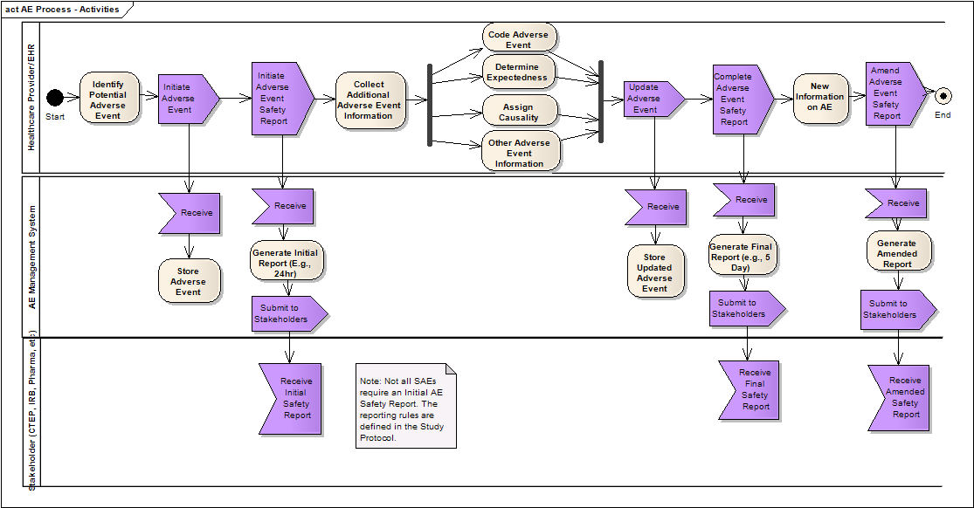

Detailed Functional Model

Structure of the Service
Name | Description
Initiate an Adverse Event | Provides the capability to initiate an AE from any source.
Update an Adverse Event | Provides the capability to update an AE.
Request to Change State of an Adverse Event | Provides the capability to request that the state of an Adverse Event be changed. This could be used to perform a logical delete (deactivation) of an Adverse Event entered by mistake.
Get Status of State Change Request | Provides the capability to get the status of a previously issued change state request.
Associate Local ID with Existing Adverse Event | Provides the capability to associate additional information with an existing Adverse Event.
Associate Adverse Events | Provides the capability to associate together multiple Adverse Events.
Get Associated Adverse Events | Provides the capability to retrieve a collection of Adverse Events that have been associated together.
Disassociate Adverse Events | Provides the capability to disassociate multiple Adverse Events that have previously been associated together.
Subscribe to an Adverse Event and Its Updates | Provides the capability to subscribe to an Adverse Event and receive notice of any updates to the event.
Unsubscribe to an Adverse Event and Its Updates | Provides the capability to unsubscribe to a previously subscribed Adverse Event.
Find Adverse Event | Provides the ability to search for Adverse Events matching search criteria.
Retrieve Adverse Event | Provides the ability to retrieve an entire Adverse Event.
Retrieve Audit Trail of an Adverse Event | Provides the ability to retrieve an audit trail of all changes that have been made to an Adverse Event.
Gather Analytical Data | Provides the ability to retrieve collections of Adverse Event data for further analysis. .
Initiate Adverse Event Safety Report | Provides the ability to start an adverse event safety report (Submit the initial report).
Complete Adverse Event Safety Report | Provides the ability to complete an adverse event safety report (Submit the final report).
Amend Adverse Event Safety Report | Provides the ability to amend a completed adverse event safety report.
Retrieve Adverse Event Safety Report | Provides the ability to retrieve a previously created adverse event safety report.
Update Adverse Event Safety Report | Provides the ability to update an un-submitted adverse event safety report
Withdraw Adverse Event Safety Report | Provides the ability to withdraw an Adverse Event Safety Report.
Retrieve Audit Trail of an Adverse Event Safety Report | Provides the ability to retrieve an audit trail of all changes that have been made to an Adverse Event Safety Report.

Detail of the Capabilities
Name [M] | Initiate Adverse Event
Description [M] | Enables a client system to initiate an Adverse Event. E.g. when a lab system finds that there is abnormal or out of range lab results on a given patient, it can Initiate an Adverse Event using this capability.  Initiate means create a record in the Adverse Event Management System with all required fields populated.  If successful, an instance of an AdverseEvent is returned with a generated Identifier. A properly formed and returned AdverseEvent object with an identifier is an acknowledgement that the Adverse Event is initiated and reporting business process has started
Pre-Conditions [M] | Study exists  Patient exists  Patient is enrolled in the study and has a study subject identifier
Security Pre-Conditions [M] | Access control mechanism needs to be in place to ensure that the user is logged in and has valid privileges to Initiate an Adverse Event
Inputs [M] | Adverse Event (M: term/text, date)  Study Identifier  Patient Identifier
Outputs [M] | AdverseEvent Identifier  Adverse Event Object
Post-Conditions [O] | An Adverse Event is initiated on the system
Exception Conditions [M] | Invalid Adverse Event Object representation  Specified Protocol is invalid  Invalid data type or code value for any attribute  Participant is not registered in the specified protocol as a subject
Aspects left for Technical Bindings [O] | Where identifier is not part of the input, some means is necessary to identify potential duplicates. This may necessitate matching on other key attributes
Notes [O]

Name [M] | Update Adverse Event
Description [M] | Enables updating an existing Adverse Event. This service encapsulates all necessary information for an Adverse Event from Clinical Trial stand-point and is compliant to V3.0 BRIDG representation.
Pre-Conditions [M] | Adverse Event exists  Study exists  Patient exists  Patient is enrolled in the study
Security Pre-Conditions [M] | Access control mechanism needs to be in place to ensure that the user is logged in and has valid privileges to Update an Adverse Event.
Inputs [M] | BRIDG AdverseEvent class and its aggregation/composition classes with values filled for both the existing and the changed attributes. Identifier is a required field.  BRIDG->AdverseEvent attributes:  - Adverse Event Identifier  - Grade Code  - Severity Code  - Seriousness code  - Occurrence Pattern Code  - Expected Indicator  - Unexpected Reason Code  - Highlighted Indicator  - Hospitalization Required Indicator  - Onset Date  - Resolution Date
Outputs [M] | Return an instance of the updated AdverseEvent object. A properly formed and returned AdverseEvent object with the updated data is an acknowledgement that the Adverse Event is updated.
Post-Conditions [O] | Adverse Event is updated  Subscribers are notified of this event
Exception Conditions [M] | Adverse Event Identifier is invalid  One or more mandatory attributes required for an update of the Adverse Event object have not been provided  Invalid data type or code value for any attribute  Invalid Adverse Event Object representation
Aspects left for Technical Bindings [O] | The way by which interfaces are realized between Dependent Systems
Notes [O] | This operation depends on AE Query Profile to retrieve the AdverseEvent object in order to allow a service consumer to update it  This operation requires the entire AdverseEvent object consisting of both the existing as well as the changed attributes to be passed. External Systems can use the Query Operation to obtain the latest AdverseEvent object and update it and pass it as parameter to this operation.

Name [M] | Request to Change State of an Adverse Event
Description [M] | Allows changing the state of an Adverse Event. For example this operation can be used for removing/deactivating an Adverse Event to rectify any Adverse Event that was entered by mistake with proper audit trail.
Pre-Conditions [M] | Adverse Event exists
Security Pre-Conditions [M] | Access control mechanism needs to be in place to ensure that the user is logged in and has valid privileges to Request State Change of an Adverse Event.
Inputs [M] | AdverseEvent Identifier  Target state for the Adverse Event
Outputs [M] | Return a request identifier. The service consumer can then use this identifier to get the status of their request
Post-Conditions [O] | Request to update Adverse Event state is initiated  Subscribers are notified of this event
Exception Conditions [M] | Invalid AdverseEvent Identifier  Invalid state request
Aspects left for Technical Bindings [O] | Format or data type for the Request Identifier
Notes [O]

Name [M] | Get Status of State Change Request
Description [M] | Enables service consumer to get the status of a previously submitted request to change the state of an Adverse Event
Pre-Conditions [M] | Adverse Event exists  Request Identifier exists
Security Pre-Conditions [M] | Access control mechanism needs to be in place to ensure that the user is logged in and has valid privileges to Get Status of State Change Request for an Adverse Event.
Inputs [M] | Request Identifier
Outputs [M] | Status of the request
Post-Conditions [O] | Service consumer is notified of the status of their request
Exception Conditions [M] | Request Identifier is invalid  No request found for the given identifier
Aspects left for Technical Bindings [O] | Format or data type for the request identifier and its status
Notes [O]

Name [M] | Associate Local ID with Existing Adverse Event
Description [M] | Provides ability to associate a local identifier (such as MRN or any other identifier) of the system to the existing Adverse Event. This operation can be used to associate additional related information with the Adverse Event. This could be a specimen, an image or a chart.
Pre-Conditions [M] | Specified Adverse Event exists
Security Pre-Conditions [M] | Access control mechanism needs to be in place to ensure that the user is logged in and has valid privileges to Associate Local ID with an Existing Adverse Event.
Inputs [M] | An instance of the BRIDG AdverseEvent class with the identifier populated.  Local Identifier to be associated.
Outputs [M] | Return an acknowledgement that the association was successfully created
Post-Conditions [O] | Adverse Events are linked/associated with the local identifier  Subscribers to the Adverse Event are notified of this event
Exception Conditions [M] | Adverse Event Identifier is invalid  Adverse Event is not found for the given identifier
Aspects left for Technical Bindings [O] | Format or data type of local identifier  Format or data type of Acknowledgement
Notes [O]

Name [M] | Associate Adverse Events
Description [M] | Enables linking multiple related Adverse Events together for study purposes
Pre-Conditions [M] | All specified Adverse Events exist
Security Pre-Conditions [M] | Access control mechanism needs to be in place to ensure that the user is logged in and has valid privileges to Associate Adverse Events.
Inputs [M] | A list of instances of BRIDG AdverseEvent class (DSET<AdverseEvent>) where each AdverseEvent instance has the identifier attribute populated  Reason for association
Outputs [M] | Return an acknowledgement that the association was successfully created
Post-Conditions [O] | All Adverse Events are linked/associated  Subscribers to any of the Adverse Events are notified
Exception Conditions [M] | One or more of the AdverseEvent Identifiers is invalid  Adverse Event is not found for one of the given identifiers  Only one Adverse Event is passed as input
Aspects left for Technical Bindings [O] | When one or more Adverse Events are linked, we need to have a way to deal with data anomalies. Certain data fields may differ from one Adverse Event to the other  Format or data type of reason for association
Notes [O] | This operation depends on AE Query Profile to retrieve all Adverse Events that are being associated

Name [M] | Get Associated Adverse Events
Description [M] | Enables getting associated Adverse Events for a given Adverse Event.
Pre-Conditions [M] | Adverse Event exists
Security Pre-Conditions [M] | Access control mechanism needs to be in place to ensure that the user is logged in and has valid privileges to Get Associated Adverse Events.
Inputs [M] | An instance of BRIDG AdverseEvent class with the identifier attribute populated  (Optional) Reason for association
Outputs [M] | Return a DSET<<BRIDG Adverse Event class>>. Each element of the DSET is a BRIDG Adverse Event object associated with the input Adverse Event. Each returned Adverse Event has at least the identifier populated.  If the reason for association is provided then only the Adverse Events associated for that reason are returned  An empty DSET if there are no associated Adverse Events
Post-Conditions [O] | All associated Adverse Events are returned to the service consumer
Exception Conditions [M] | Adverse Event is not found for the given identifier  Invalid reason code specified in the input
Aspects left for Technical Bindings [O] | Format or data type for reason of association
Notes [O] | This operation depends on AE Query Profile to retrieve Adverse Events that are being associated

Name [M] | Disassociate Adverse Events
Description [M] | Enables dissociating two Adverse Events that are associated earlier (e.g. using associateAEs operation)
Pre-Conditions [M] | All specified Adverse Events exist and they are associated
Security Pre-Conditions [M] | Access control mechanism needs to be in place to ensure that the user is logged in and has valid privileges to Dissociate Adverse Events.
Inputs [M] | BRIDG Adverse Event class with the identifier populated  Associated BRIDG Adverse Event class with the identifier populated  Reason for association (Optional)
Outputs [M] | Return an acknowledgement that the association was successfully created
Post-Conditions [O] | Input Adverse Events are dissociated  If reason for association is specified then only the association for that reason is broken.  Subscribers of both Adverse Events are notified of this event
Exception Conditions [M] | Adverse Event is not found for the given identifiers  No association can be found for the given identifiers and reason for association  Invalid data type or code value for any attribute
Aspects left for Technical Bindings [O] | When one or more Adverse Events are dissociated, we need to have a way to deal with any data dependency from one adverse event to another. Certain data fields may depend from one Adverse Event to other  Format or data type for reason for association
Notes [O] | This operation depends on AE Query Profile to retrieve both Adverse Events that need to be dissociated

Name [M] | Subscribe to an Adverse Event and Its Updates
Description [M] | Enables subscribing to Adverse Event updates
Pre-Conditions [M] | Adverse Event exists
Security Pre-Conditions [M] | Access control mechanism needs to be in place to ensure that the user is logged in and has valid privileges to Subscribe to an Adverse Event and Its Updates.
Inputs [M] | Criteria in form of DSET<<BRIDG Adverse Event class>>. Each element of the set is a BRIDG Adverse Event object and its aggregation/composition objects with required attributes filled and with desired optional attributes filled. The criteria specified in multiple Adverse Event classes result in an OR logical condition while the criteria specified within a single Adverse Event class result in an AND logical condition. For example a query of Adverse Event with expectedIndicator=1 and hospitalizationRequiredIndicator=”1” or highlightedIndicator=1 would have two elements in this input parameter. The first one with expectedIndicator=1 and hospitalizationRequiredIndicator=”1” and the second one with highlightedIndicator =1  Subscriber class with its Identifier
Outputs [M] | Return Subscription object with its identifier. A properly formed and returned Subscription class with its identifier is an acknowledgement that the subscription is created.
Post-Conditions [O] | Subscription is created
Exception Conditions [M] | Invalid data type or code value for any attribute.  No matching Adverse Events are found for the given criteria
Aspects left for Technical Bindings [O] | Notification to subscriber is automated via email, text or manual is left to implementation  Notification may take the form of a simple identifier / attribute combination, a canned query, a report, or an audit trail  However, subscribers should request notification relevant against both business processes and subject to appropriate local governance  The data type of the Subscription and Subscriber
Notes [O] | This operation depends on AE Query Profile to retrieve AdverseEvent so that a subscription is registered

Name [M] | Unsubscribe to an Adverse Event and Its Updates
Description [M] | Enables a user to unsubscribe for an Adverse Event to which they were previously subscribed.
Pre-Conditions [M] | Subscription exists.
Security Pre-Conditions [M] | Access control mechanism needs to be in place to ensure that the user is logged in and has valid privileges to Unsubscribe to an Adverse Event and Its Updates.
Inputs [M] | Subscription class and its Identifier.
Outputs [M] | Return updated Subscription object with its identifier. A properly formed and returned Subscription object updated to state that the subscription is no longer active is an acknowledgement that the unsubscribe operation succeeded
Post-Conditions [O] | Subscription is cancelled
Exception Conditions [M] | Invalid data type or code value for any attribute.  No matching subscription is found for the given Identifier.
Aspects left for Technical Bindings [O] | Data type for Subscription
Notes [O] | This operation depends on AE Query Profile to retrieve Adverse Event so that a subscription is registered

Name [M] | Find Adverse Event
Description [M] | Facilitates searching for Adverse Events
Pre-Conditions [M] | Search criteria are provided
Security Pre-Conditions [M] | Access control mechanism needs to be in place to ensure that the user is logged in and has valid privileges to Find Adverse Event.
Inputs [M] | Search Criteria in form of DSET<<BRIDG Adverse Event class>>. Each element of the set is a BRIDG Adverse Event object and its aggregation/composition objects with required attributes filled and with desired optional attributes filled. The criteria specified in multiple Adverse Event objects result in an OR logical condition while the criteria specified within a single Adverse Event object results in an AND logical condition. For example a query of Adverse Event with expectedIndicator=1 and hospitalizationRequiredIndicator=”1” or highlightedIndicator=1 would have two elements in this input parameter. The first one with expectedIndicator=1 and hospitalizationRequiredIndicator=”1” and the second one with highlightedIndicator =1
Outputs [M] | Return one or more Adverse Events matching search criteria  Indicates pagination if search found bulky results
Post-Conditions [O] | Returns one or more Adverse Events matching search criteria  Returns no Adverse Event if there is no match
Exception Conditions [M] | Minimum and Mandatory attributes of search criteria have not been provided.  Invalid data type or code value for any attribute
Aspects left for Technical Bindings [O]
Notes [O] | Need to determine what is minimum search criteria that must be provided  Need to define the pagination standard  Default boundary checks are enforced to avoid system/service failures

Name [M] | Retrieve Adverse Event
Description [M] | Retrieves entire Adverse Event based on the Adverse Event Identifier. Retrieves entire object graph for specified Adverse Event
Pre-Conditions [M] | Adverse Event exists
Security Pre-Conditions [M] | Access control mechanism needs to be in place to ensure that the user is logged in and has valid privileges to Retrieve Adverse Event.
Inputs [M] | BRIDG Adverse Event object with Identifier populated
Outputs [M] | Return entire Adverse Event
Post-Conditions [O] | Returns an entire Adverse Event  Returns no Adverse Event if there is no match
Exception Conditions [M] | Minimum and Mandatory attributes of search criteria have not been provided, especially identifier or key term  Invalid data type or code value for any attribute
Aspects left for Technical Bindings [O]
Notes [O] | Need to determine what is minimum search criteria that must be provided

Name [M] | Retrieve Audit Trail of an Adverse Event
Description [M] | Retrieves an entire audit trail of all changes to a specified Adverse Event. It retrieves all the audit information pertaining to that AE stored within this service only. This audit information contains a log of all the changes made to the AE through the defined business process. NOTE: This function will return audit trail information for AE stored within that service only. If multisite audit trail is required then the coordinating site can include aggregate audit if available.
Pre-Conditions [M] | Adverse Event exists
Security Pre-Conditions [M] | Access control mechanism needs to be in place to ensure that the user is logged in and has valid privileges to Retrieve Audit Trail of an Adverse Event.
Inputs [M] | Adverse Event class with Adverse Event’s identifier populated  Date range for which audit trail is desired
Outputs [M] | Return audit trail of the Adverse Event within the desired date range
Post-Conditions [O] | Returns audit trail information
Exception Conditions [M] | Invalid data type or code value for any attribute  Adverse Event cannot be found for the given identifier
Aspects left for Technical Bindings [O]
Notes [O]

Name [M] | Gather Analytical Data
Description [M] | Enables querying and retrieving of data based on various adverse event criteria. This will be a Query By Example function that will return a collection of matching Adverse Event information.
Pre-Conditions [M]
Security Pre-Conditions [M] | Access control mechanism needs to be in place to ensure that the user is logged in and has valid privileges to Generate Analytical Report.
Inputs [M] | Any adverse event search criteria in the form of a BRIDG adverse event class  Any study identifier  Any study subject identifier (optional)
Outputs [M] | A collection object containing the results
Post-Conditions [O] | Returns data
Exception Conditions [M] | Invalid Study Identifier  Invalid data type or code value for any attribute  Invalid Study Subject Identifier
Aspects left for Technical Bindings [O] | Format or data type for the report criteria
Notes [O] | The format and content of the Event Trend report need to be defined by the caAERS team.

Name [M] | Initiate Adverse Event Safety Report
Description [M] | Enables generation of the Initial Adverse Event Safety Report. Note that for NCI CTEP this would be the Initial (24 hour) report.
Pre-Conditions [M] | Adverse Event or Adverse Event association exists
Security Pre-Conditions [M] | Access control mechanism needs to be in place to ensure that the user is logged in and has valid privileges to Initiate Adverse Event Safety Report.
Inputs [M] | A BRIDG adverse event class with identifier populated or a DSET of associated adverse events.  Any mandatory or optional adverse event report elements.
Outputs [M] | Return Safety Report ID  Return entire Safety Report object
Post-Conditions [O] | Report is generated
Exception Conditions [M] | Invalid data type or code value for any attribute
Aspects left for Technical Bindings [O] | Format or data type for the report criteria
Notes [O] | The Adverse Event Management System submits the Initial Safety Report to the configured stakeholders (NCI CTEP, FDA, IRB, etc).

Name [M] | Complete Adverse Event Safety Report
Description [M] | Allows the generation of an updated adverse event safety report (the Complete report, e.g., the 5 day CTEP report) and the status assigned to the report.
Pre-Conditions [M] | Safety Report already exists and the initial report has been submitted.
Security Pre-Conditions [M] | Access control mechanism needs to be in place to ensure that the user is logged in and has valid privileges to Complete Adverse Event Safety Report.
Inputs [M] | Safety Report ID  Any mandatory or optional adverse event report elements.
Outputs [M] | Return Safety Report ID  Return entire Safety Report object
Post-Conditions [O] | Report is generated
Exception Conditions [M] | Invalid data type or code value for any attribute
Aspects left for Technical Bindings [O] | Format or data type for the report
Notes [O] | The Adverse Event Management System submits the Complete Safety Report to the configured stakeholders (NCI CTEP, FDA, IRB, etc).

Name [M] | Amend Adverse Event Safety Report
Description [M] | Allows amending a previously submitted adverse event safety report.
Pre-Conditions [M] | Safety Report already exists and has been submitted.
Security Pre-Conditions [M] | Access control mechanism needs to be in place to ensure that the user is logged in and has valid privileges to Amend Adverse Event Safety Report.
Inputs [M] | Safety Report ID  Any mandatory or optional adverse event report elements.
Outputs [M] | Return Safety Report ID  Return entire Safety Report object
Post-Conditions [O] | Report is generated
Exception Conditions [M] | Invalid data type or code value for any attribute
Aspects left for Technical Bindings [O] | Format or data type for the report
Notes [O]

Name [M] | Retrieve Adverse Event Safety Report
Description [M] | Allows retrieving a Safety Report and the status assigned to the report (i.e. Pending, Complete, Withdrawn).
Pre-Conditions [M] | Safety Report already exists
Security Pre-Conditions [M] | Access control mechanism needs to be in place to ensure that the user is logged in and has valid privileges to Retrieve Adverse Event Safety Report.
Inputs [M] | Safety Report ID
Outputs [M] | Return entire Safety Report object
Post-Conditions [O] | Report is retrieved
Exception Conditions [M] | Invalid report ID.
Aspects left for Technical Bindings [O] | Format or data type for the report
Notes [O]

Name [M] | Update Adverse Event Safety Report
Description [M] | Enables updating of an existing Safety Report that has not yet been submitted. The Report to be updated will first need to be retrieved using the Retrieve Adverse Event Safety Report capability.
Pre-Conditions [M] | Safety Report already exists  The Safety Report has not yet been submitted
Security Pre-Conditions [M] | Access control mechanism needs to be in place to ensure that the user is logged in and has valid privileges to Update Adverse Event Safety Report.
Inputs [M] | Entire Safety Report object including the original Safety Report Identifier
Outputs [M] | Return an acknowledgement that the update was successful
Post-Conditions [O] | Report is updated
Exception Conditions [M] | Invalid report ID.  Malformed Safety Report object
Aspects left for Technical Bindings [O]
Notes [O]

Name [M] | Withdraw Adverse Event Safety Report
Description [M] | Provides the ability to withdraw an Adverse Event Safety Report. This function will send a notification to the stakeholder that the Safety Report is being withdrawn and will set the status of the report accordingly. Only initial reports can be withdrawn.
Pre-Conditions [M] | Safety Report exists  The Safety Report has a status of Initial or In-Progress
Security Pre-Conditions [M] | Access control mechanism needs to be in place to ensure that the user is logged in and has valid privileges to Update Adverse Event Safety Report.
Inputs [M] | Entire Safety Report object including the original Safety Report Identifier
Outputs [M] | Return the Safety Report object with the status updated to Withdrawn. Send a notification to Stakeholder(s) that the Safety Report has been withdrawn.
Post-Conditions [O] | Report is withdrawn
Exception Conditions [M] | Invalid report ID.  Malformed Safety Report object
Aspects left for Technical Bindings [O]
Notes [O]

Name [M] | Retrieve Audit Trail of an Adverse Event Safety Report
Description [M] | Retrieves an entire audit trail of all changes to a specified Adverse Event Safety Report. It retrieves all the audit information pertaining to that Safety Report. This audit information contains a log of all the changes made to the Safety Report through the defined business process. NOTE: This function will return audit trail information for Safety Report stored within that service only. If multisite audit trail is required then the coordinating site can include aggregate audit if available.
Pre-Conditions [M] | Adverse Event exists
Security Pre-Conditions [M] | Access control mechanism needs to be in place to ensure that the user is logged in and has valid privileges to Retrieve Audit Trail of an Adverse Event Safety Report.
Inputs [M] | Safety Report class with Safety Report’s identifier populated  Date range for which audit trail is desired
Outputs [M] | Return audit trail of the Safety Report within the desired date range
Post-Conditions [O] | Returns audit trail information
Exception Conditions [M] | Invalid data type or code value for any attribute  Safety Report cannot be found for the given identifier
Aspects left for Technical Bindings [O]
Notes [O]

Profiles

Functional Profiles
Functional Profiles are intended to be deployed as a collection of operations that have been designed to provide coherent and consistent access to capabilities. The functional profiles allow service provider to gradually implement and comply with this specification. The functional profiles that align with the Collaborations detailed in section 2 (above) are outlined below.
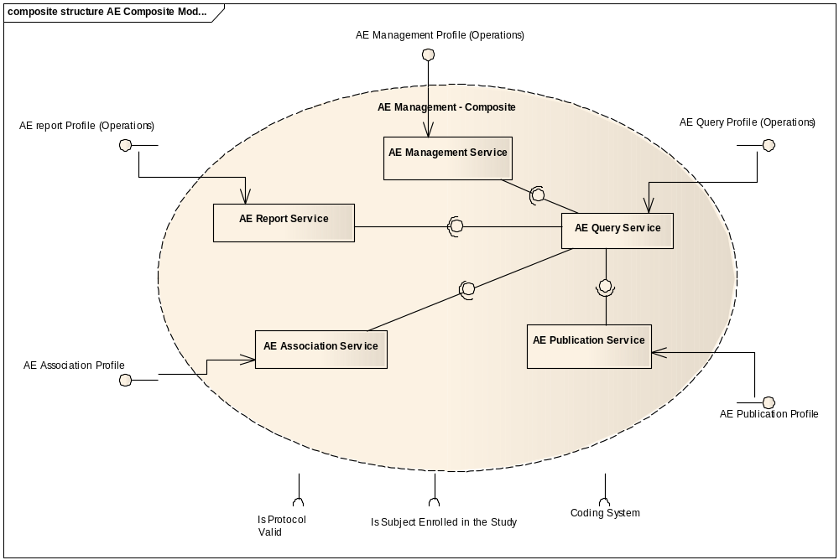

Functional Profile No. | Functional Profile Name | Functional Profile Description | Capability Name
AE-FP1 | AE Query | The Query Functional Profile provides an encapsulation boundary for the commissioner of the query to be guaranteed that information provided by a given query is authoritative and correct. Thus, an implementation of the query profile must be able to manage and be aware of persistence locks, business rules, Adverse Event state, and so on, to provide a data graph that is consistent with the local business rules that apply to Adverse Events in a deployed instance. | - Find Adverse Events  - Retrieve Adverse Events  - Retrieve Audit Trail of Adverse Event  - Retrieve Adverse Event Report  - Retreive Adverse Event Safety Report  - Gather Analytical Data
AE-FP2 | AE Management | The Management series of capabilities details the complete encapsulation boundary behind which the Adverse Event focal object may be managed. That is, it provides for a coherent set of functions regarding that focal object expressed in a state machine (see Information Profile) that must be managed together. | - Initiate an Adverse Event  - Update an Adverse Event  - Request to change a state of an Adverse Event  - Get Status of a State Change Event
AE-FP3 | AE Report | The Reporting series of capabilities is intended to support local and regulatory reporting requirements. This Functional Profile is dependent on the Query Profile, and may have a further dependency on the Association Profile. | - Initiate Adverse Event Safety Report  - Complete Adverse Event Safety Report  - Update Adverse Event Safety Report  - Amend Adverse Event Safety Report  - Withdraw Adverse Event Safety Report
AE-FP4 | AE Associate | The Association Functional Profile provides for a series of capabilities to connect an Adverse Event instance with another, whether that association happens across system or organizational boundaries. This association is provided for local use only, though the association may be between a local identifier and a foreign identifier. Foreign identifiers may never be associated with each other except transitively through a local identifier.  Note that “local” is defined for the purposes of this functional profile as the domain of users that are given access to a deployed instance of this functional profile, and does not limit the nature of the identifiers that may be associated. Thus, local may in fact mean trans-organizational when this profile is associated with a regionally-available service.  The Association Profile may have a dependency on the Publication Profile. | - Associate Local ID with an existing Adverse Event  - Associate Adverse Events  - Get Associated Adverse Events  - Dissociate an Adverse Event
AE-FP5 | AE Publication | The Publication Functional Profile provides a series of functional capabilities for other systems, services, and users to be notified with state transitions associated in the Management Functional Profile. | - Subscribe to an Adverse Event and its Updates  - Unsubscribe to Adverse Event Updates

Information Profiles

BRIDG Information Model
The Adverse Event service binds and complies with semantics of BRIDG V3.0 information model. This model can be found at (http://gforge.nci.nih.gov/frs/?group_id=342).
Note that the following diagram identifies classes’ specific to Adverse Events with the color Green.
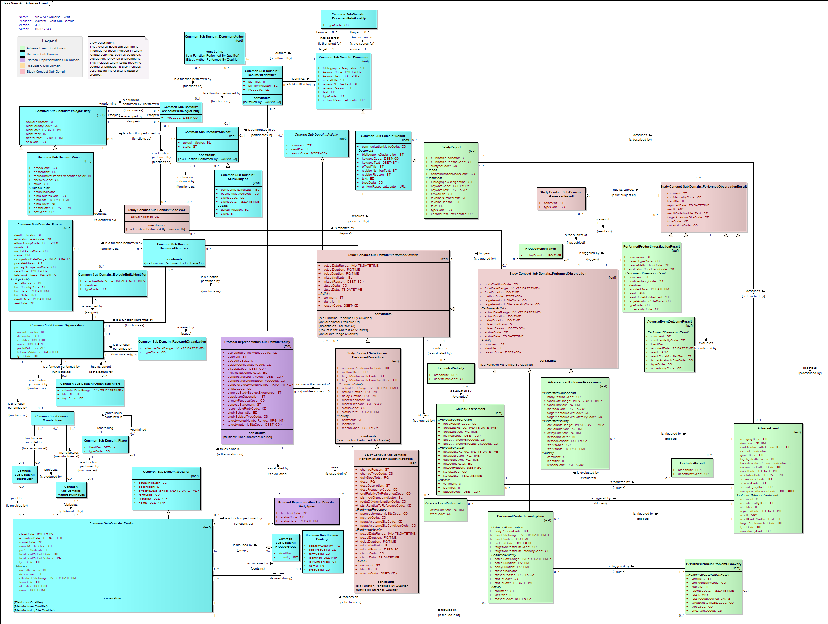

Adverse Event State Machine
An adverse event goes through states described by following state transition diagram.
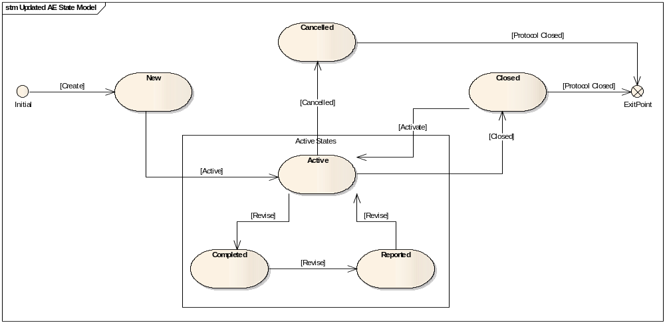

Semantic Profiles
Semantic Profile No. | Semantic Profile Name | Constrained Information Model | Semantic Profile Description
AE-SP1 | BRIDG V3.0 Adverse Event | BRIDG V3.0 Adverse Event Class | - Find Adverse Events  - Retrieve Adverse Events  - Retrieve Audit Trail of Adverse Event  - Retrieve Audit Trail of Adverse Event Safety Report  - Retrieve Adverse Event Safety Report  - Initiate an Adverse Event  - Update an Adverse Event  - Request to change a state of an Adverse Event  - Get Status of a State Change Event  - Report Adverse Event  - Associate Local ID with an existing Adverse Event  - Associate Adverse Events  - Get Associated Adverse Events  - Dissociate an Adverse Event  - Subscribe to an Adverse Event and its Updates  - Unsubscribe to Adverse Event Updates  - Initiate Adverse Event Safety Report  - Update Adverse Event Safety Report  - Complete Adverse Event Safety Report  - Amend Adverse Event Safety Report  - Withdraw Adverse Event Safety Report

Conformance Profiles
Conformance No | AE-CP1
Conformance Name | BRIDG based Entire AE Conformance Profile
Description | This is the conformance profile defines the entire functionality for the Adverse Event Service using BRIDG based semantics
Usage Context | This profile would be used by a study administrator or equivalent who has responsibility for all aspects of Adverse Event Reporting.
Mandatory | Yes
Functional Profile(s) | AE-FP1 : AE Query, AE-FP2 :Management, AE-FP3 : Report, AE-FP4 : AE Associate, AE-FP5 : AE Publication
Semantic Profile(s) | AE-SP1 : BRIDG V3.0 Adverse Event

System Implementation Details

System Runtime Interaction Details
The following communication diagram shows interaction between Adverse Event Management system and other participants. The diagram shows the service functional profiles used by participants for creating, processing and reporting of Adverse Events.
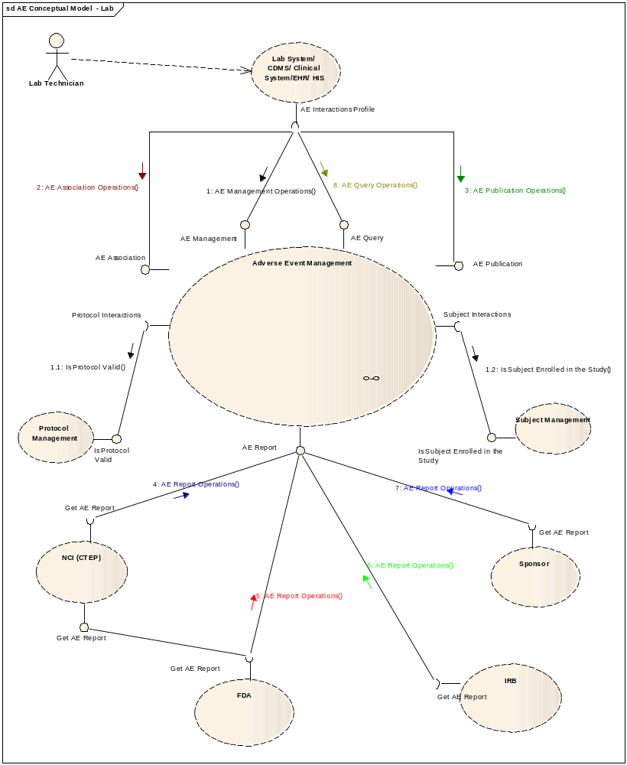

Implementation/Deployment Considerations
Implementation Considerations | Impacts
Several parts of this specification can support different federation models, and also draw distinctions between what can be federated and what cannot.  - Management operations are intended to be deployed locally within a domain that has a consistent set of rules, policies, and human mediation components  - Reporting operations may be deployed to take into account super-organizational, regional, or even national information. | The system may have to be configured such that specific profiles are served by different processes.

Conformance and Compliance

Compliance and Conformance Statements
Name | Type | Viewpoint | Description | Test method
Query Performance | Obligation | Engineering | The AE Query Profile should provide a response within 0.5 seconds to support a synchronous UI based client | Test cases to include performance testing.
Multiple Jurisdictions | Obligation | Enterprise | The AE Service will span jurisdictional boundaries and will need to support a federated data model. | Test cases include multiple domain scenarios.
Secured Access | Obligation | Engineering | The AE service should have access control mechanism in place to restrict access to the secured data | 1. Design review  2. Test cases to be defined for security
Additional Functionality | Permission | Computational | The AE service can provide additional functionality other than specified in these specifications | Design Review
Semantic Model | Obligation | Informational | The AE service must support NCI’s version of BRIDG 3.0 model Adverse Event class. | Design Review
Functional Profiles | Obligation | Computational | Functional Profiles shall be deployed as functional wholes. Ignoring or omitting functional behavior defined within a functional profile is not permitted, nor is diverging from the detailed functional specifications provided in Section 4. | - Design Review  - Test cases
Functional Profiles – Conformant Implementation | Obligation | Computational | A conformant implementation of this specification must deploy at least one Functional Profile. If that Functional Profile has dependencies on other profiles, then those dependencies must be deployed as well to support the provenance of that service instance. | - Design Review  - Test cases
Associate Functional Profile | Obligation | Computational | If deployed, the Associate Functional Profile may associate foreign identifiers with local identifiers. Local identifier can be either MRN or any other identifiers which can be used to identify any additional information associated with the Adverse Event such as a specimen, an image or a chart etc. | Test cases
Boundary | Obligation | Computational | Implementations of the Management and Query profiles shall be authoritative within an organization’s boundaries only, and are not intended to provide an encapsulation boundary that supports different rules or policies regarding the management and access to information regarding a given adverse event focal object. | Test cases
Information Authority | Obligation | Computational | Implementations of the Associate, Reporting, and Publication profiles may provide access to information external to a given organization’s boundary. This shall not imply authority for that information except transitively, and supporting that authority is expected to be supported directly by conformance statements at the Platform Independent and Platform Specific levels. | Test cases

Appendix A – Relevant Standards

Name | Description | Location
BRIDG v3.0 | BRIDG model used for modeling the AE Service | http://gforge.nci.nih.gov/frs/?group_id=342
HL7v3 | Health Level 7 version 3 | http://www.hl7.org/implement/standards/v3messages.cfm

Appendix B – References
Name | Description | Location
BRIDG v3.0 | BRIDG model used for modeling the AE Service | http://gforge.nci.nih.gov/frs/?group_id=342
caAERS Use Case Document | Document containing use cases for the caAERS application | https://wiki.nci.nih.gov/display/CTMS/Use+Cases+-+caAERS
Adverse Event Domain Model | Adverse Event Domain Model | https://gforge.nci.nih.gov/plugins/scmsvn/viewcvs.php/trunk/models/AdverseEvent.eap?root=ent-services&view=log
CTEP NCI Guidelines: Adverse Event Reporting Requirements | CTEP’s guidelines for investigators regarding Adverse Event Reporting for situations where CTEP holds the IND | http://ctep.cancer.gov/protocolDevelopment/electronic_applications/docs/newadverse_2006.pdf

Appendix C - Glossary
Term | Description
BRIDG | The Biomedical Research Integrated Domain Group (BRIDG) has developed a comprehensive domain analysis model representing biomedical/clinical research.
caAERS | Cancer Adverse Event Reporting System
CTEP | Cancer Therapy Evaluation Program
Serious Adverse Event | An SAE is defined as “any adverse drug experience occurring at any dose that results in any of the following outcomes: death, is life threatening, requires inpatient hospitalization, or causes a significant disability/incapacity”

Appendix D – Cross Reference Tables

List of Storyboards
# | Name | Description | Source
AE-SB1 | Patient Reported Outcome | Patient Reports an adverse event during a routine doctor’s visit | CTMS BAM Section 1.4.2
AE-SB2 | Lab initiated Adverse Event | A Lab Technician reports an adverse event based on their protocol and grading system | caAERS Use Case Document: Use Case No 4
AE-SB3 | CDMS Initiated Adverse Event | A Clinical Research Administrator notices a potential adverse event and enters it into the CDMS system | CTMS BAM 1.4.6
AE-SB4 | Processing of Adverse Event | A clinical Research Associate obtains the Adverse Event and adds information to it | caAERS Use Case Document: Use Case No 6
AE-SB5 | Reporting of Adverse Event | The Adverse Event is reported to the various protocol stakeholders | caAERS Use Case Document: Use Case No 2

Storyboards to Capabilities Mapping
# | Storyboard | Capabilities | Functional Profiles
AE-SB1 | Patient Reported Outcome | Initiate AE  Update AE | AE Management
AE-SB1 | Patient Reported Outcome | Query AE | AE Query
AE-SB2 | Lab initiated Adverse Event | Initiate AE  Update AE | AE Management
AE-SB2 | Lab initiated Adverse Event | Query AE | AE Query
AE-SB3 | CDMS Initiated Adverse Event | Initiate AE  Update AE | AE Management
AE-SB3 | CDMS Initiated Adverse Event | Query AE | AE Query
AE-SB4 | Processing of Adverse Event | Update AE | AE Management
AE-SB4 | Processing of Adverse Event | Query AE | AE Query
AE-SB4 | Processing of Adverse Event | Publish AE | AE Publication
AE-SB5 | Reporting of Adverse Event | Generate Report | AE Report

Actors
Actors | Functional Profile | Type | Operations used
Electronic Health Record System | AE Management | Client | Stores medical records, client of the AEMS
Health Care Provider | AE Management | Person | Enters the Adverse Event
Adverse Event Management System | AE Management | Service | Supports CRUD API for Adverse Events
Clinical Research Associate | AE Query | Person | Retrieves a specific Adverse Event Record
Electronic Health Record System | AE Query | Client | Client of the Adverse Event Management System
Adverse Event Management System | AE Query | Service | Supports the Query API for Adverse Events

