Conceptual Functional
Service Specification
for
Clinical Trials Adverse Event Management

Version 0.1.3

Authors | Kalpesh Patel  Hari Damera
Editors | Kalpesh Patel
Reviewers | Kalpesh Patel – Ekagra Software Technologies  Paul Boyes – Guidewire Architecture  John Koisch – Guidewire Architecture
Architecture Inception Team | Kalpesh Patel – Ekagra Software Technologies  Paul Boyes – Guidewire Architecture  John Koisch – Guidewire Architecture  Hari Damera – Ekagra Software Technologies

Document Version | Author |  | Changes
0.0.6 | Kalpesh S. Patel | Incorporated changes from Todd Parnell’s comments
0.0.7 | John J. Koisch |  | Updated based on Adverse Events and Adverse Events differential, adjusted for federation
0.0.8 | Kalpesh S. Patel |  | Modified based on review and with comments
0.0.9 | Hari Damera |  | Addressed Kalpesh’s comments and updated with ‘justify’ align paragraph for all sections, etc.
0.1.0 | Kalpesh S. Patel |  | Modified some content and added state diagram.
0.1.1 | Hari Damera |  | Categorized functional use cases vs. profiles, updated all diagrams to reflect the profile changes.
0.1.2 | Kalpesh S. Patel |  | Modified based on comments from Alan Honey and further review
0.1.3 | Harsh Marwaha  Kalpesh S. Patel |  | Modifications
Table of Contents
1 Executive Summary: 6
1.1 Service Description and Purpose 6
1.2 Scope 6
1.3 Out of Scope 6
1.4 The reason why the service is necessary 7
2 Business Story Boards 7
2.1 Primary Actors 7
2.2 General Collaborative Example 8
2.3 Story board 1 – Patient Reported Outcome 9
2.4 Story board 2 – Lab initiated Adverse Event 11
2.5 Story board 3 – CDMS initiated Adverse Event 11
2.6 Story board 4 – Processing of Adverse Event 12
2.7 Story board 5 – Reporting of Adverse Event 13
3 Service Use Cases and Profiles Derived from Story boards 14
3.1 Functional Use Cases 14
3.2 AE Management Profile 15
3.2.1 Initiate an Adverse Event 15
3.2.2 Create an Adverse Event 15
3.2.3 Update an Adverse Event 15
3.2.4 Update Seriousness of Adverse Event 16
3.2.5 Request to Change State of an Adverse Event 16
3.2.6 Associate local ID with Existing Adverse Events 16
3.2.7 Get Status of State Change Request 16
3.3 AE Association Profile 16
3.3.1 Associate Adverse Events 16
3.3.2 Get Associated Adverse Events 16
3.3.3 Dissociate Adverse Events 16
3.4 AE Publication Profile 16
3.4.1 Subscribe to Adverse Event Updates 16
3.4.2 Unsubscribe to Adverse Event Updates 16
3.5 AE Report Profile 17
3.5.1 Generate Report 17
3.5.2 Retrieve Audit Trail of an Adverse Events 17
3.5.3 Perform Analysis 17
3.6 AE Query Profile 17
3.6.1 Find Adverse Events 17
3.6.2 Retrieve an Adverse Event 17
4 Detailed Functional Model for each Operation 18
4.1 Initiate an Adverse Event 18
4.2 Create an Adverse Event 19
4.3 Update an Adverse Event 21
4.4 Update Seriousness of Adverse Event 22
4.5 Request to Change State of an Adverse Event 23
4.6 Get Status of State Change Request 24
4.7 Associate local ID with Existing Adverse Event 25
4.8 Associate Adverse Events 25
4.9 Get Associated Adverse Events 26
4.10 Dissociate Adverse Events 27
4.11 Subscribe to Adverse Events and its Updates 28
4.12 Unsubscribe to Adverse Event Update 29
4.13 Find Adverse Events 30
4.14 Retrieve Adverse Event 31
4.15 Retrieve Expected Adverse Events for the study 32
4.16 Retrieve Audit Trail of an Adverse Event 32
4.17 Generate Report 33
4.18 Perform Analysis 34
5 System Interaction Details 35
6 Profiles 37
6.1 Information Profiles 37
6.1.1 BRIDG Information Model 37
6.1.2 Adverse Event State Machine 37
6.2 Functional Profiles 38
6.2.1 AE Management Profile 38
6.2.2 AE Association Profile 38
6.2.3 AE Publication Profile 39
6.2.4 AE Reporting Profile 39
6.2.5 AE Query Profile 39
7 Structure of the Service 39
7.1 Adverse Events 39
7.2 Assumptions and Dependencies 39
7.2.1 Security 39
7.3 Implementation Considerations 39
7.3.1 Deployment Scenarios 39
7.3.2 Information Bindings 40
8 Recommendations for Conformance and Compliance 41
8.1 Conformance Assertions 41
8.2 Recommendations for NCI Core Specification 41
9 Appendix A - Relevant Standards 42
10 Appendix B - Glossary 42

Executive Summary:

Service Description and Purpose
The Adverse Event Service provides a set of interfaces for the management and reporting of Adverse Events within the Clinical Trial space. Adverse Events (to include potential, normal, or serious Adverse Events) are identified at different points in the clinical trial life cycle. They can be identified by the patient, the clinician, the lab (via auto grading), a Clinical Trial Management System, an Electronic Health Record, or other input. The purpose of this service is to provide specifications for a key set of infrastructure components that may be integrated with user-facing applications as well as other infrastructure components to assist Site Coordinator, CRO and Data Safety Monitor Board to manage adverse events, get reports on adverse events while conducting a clinical trial study, to perform data mining, and so forth. These and other systems that support the broader clinical trials process will interact with Adverse Event Management systems via these services.
Additionally, certain adverse events need to be reported to regulatory bodies (FDA, NCI, IRB, etc.) as well as to sponsors of clinical trials. There are times when the reporting bodies will want to interact directly with the adverse event in question to request a report directly from the system.
Finally there are ancillary systems that will need information regarding an adverse event, or will need to provide additional information to support an adverse event report, its processing, and/or its status.

Scope
The Adverse Event Service provides the ability to manage, report, and query Adverse Events. The Adverse Event Service directly implements the semantics of the classes related to Adverse Event in the V2.1 of BRIDG model.
The Adverse Event Service provides a single service specification that defines the semantics, dependencies and functionality required for accessing, managing, querying/reporting, and validating Adverse Event Report, allowing CRO to make informed decisions.
This Service Specification provides a key infrastructure component for the NCI to support Adverse Event management, reporting, and integration with other systems. It provides a durable software architecture framework that anticipates new or future usage of Adverse Events and their various representations. This service serves as a main platform for integrating any Adverse Event Management needs among all heterogeneous systems/components independent of platform and other choices within the clinical domain.

Out of Scope
Explicit support for federated Adverse Events management is out of scope in this interface specification and should be dealt with separately by the NCI. However, where an aspect of this specification touches on federation, it will be noted if it is not justified otherwise.

The reason why the service is necessary
The Adverse Event Service offers a single coherent architectural component that provides the integration semantics around the management and reporting needs associated with Adverse Events. These integration semantics provide the foundation for both simple and complex compositions with other software components, whether provided by the NCI or by other vendors, without explicit regard for how the service may ultimately be implemented or deployed. These integration semantics are developed using the principles of Service Oriented Architecture as adopted by the NCI (https://wiki.nci.nih.gov/display/EAWiki/Enterprise+Architecture+Wiki). As specified in the NCI Enterprise Conformance and Compliance Framework, these semantics may be realized in a number of implementations that should conform to the conformance statements in this and related specifications.
This Service Specification provides the NCI with the architectural and technological underpinnings for providing interested parties with a single authoritative means by which other systems may share information regarding Adverse Events. As the management and reporting of Adverse Events is ubiquitous across the clinical trials space, this specification provides a key foundational piece for integrating clinical trials systems. Finally, it assures common coverage of these essential pieces of information as they relate to Clinical Trials.
As an example, Adverse Events in a clinical trial are initiated by one or more of the events that occur in the life cycle of the clinical trial. Some of the examples are provided below.
- Patient reported outcome during normal visit or a call with a complaint
- An out of range Lab result is automatically graded to be an adverse event
- Analysis in CDMS indicates a potential Adverse Event
As these events occur, they need to be recorded, analyzed, graded, and then reported to sponsors, regulatory authorities, or other concerned parties. If necessary, a patient’s treatment schedule needs to change as well. These events are recorded by different people in different organizations and potentially using systems that are not integrated. A system (such as Cancer Adverse Events Reporting System - caAERS) that provides the ability to record, manage, and report on Adverse Events shall also provide services to coherently initiate, update, and track Adverse Events and insure expedited and accurate reporting of the Adverse Events while increasing overall efficiency of the clinical trial process and may also have positive impact on patient’s treatment.

Business Story Boards

Primary Actors
The following actors are used in the storyboards below.
Name | Role | Notes
Dr. David Jones | Healthcare Provider
Sally Smith | Site/Trail Coordinator
Lucy Taylor | CRO
Carol Brooke | Data Safety Monitor Board
Mark McNeil | Regulatory Authority
Jerry Carlos | Subject/Patient
John Miller | Laboratory
Warren Cooper | Radiology

General Collaborative Example
The following activity diagram is taken from the i-SPY 2 project (TODO link) and demonstrates an instance of potential collaboration between parties in the management of Adverse Events. The storyboards below represent a granular view of the business functionality that is contextualized in any deployed instance by a prescribed set of business activities such as those displayed in this diagram, and similar analysis and a resulting Collaborative Model would be associated with any given instance of deployed systems supporting Adverse Events. Thus, this diagram is included here to show an example of the larger framework in which the following storyboards would be valid. There is no explicit relationship made between this diagram and the storyboards as both an authoritative Collaborative Specification and specific implementations are beyond the scope of this Service Specification.
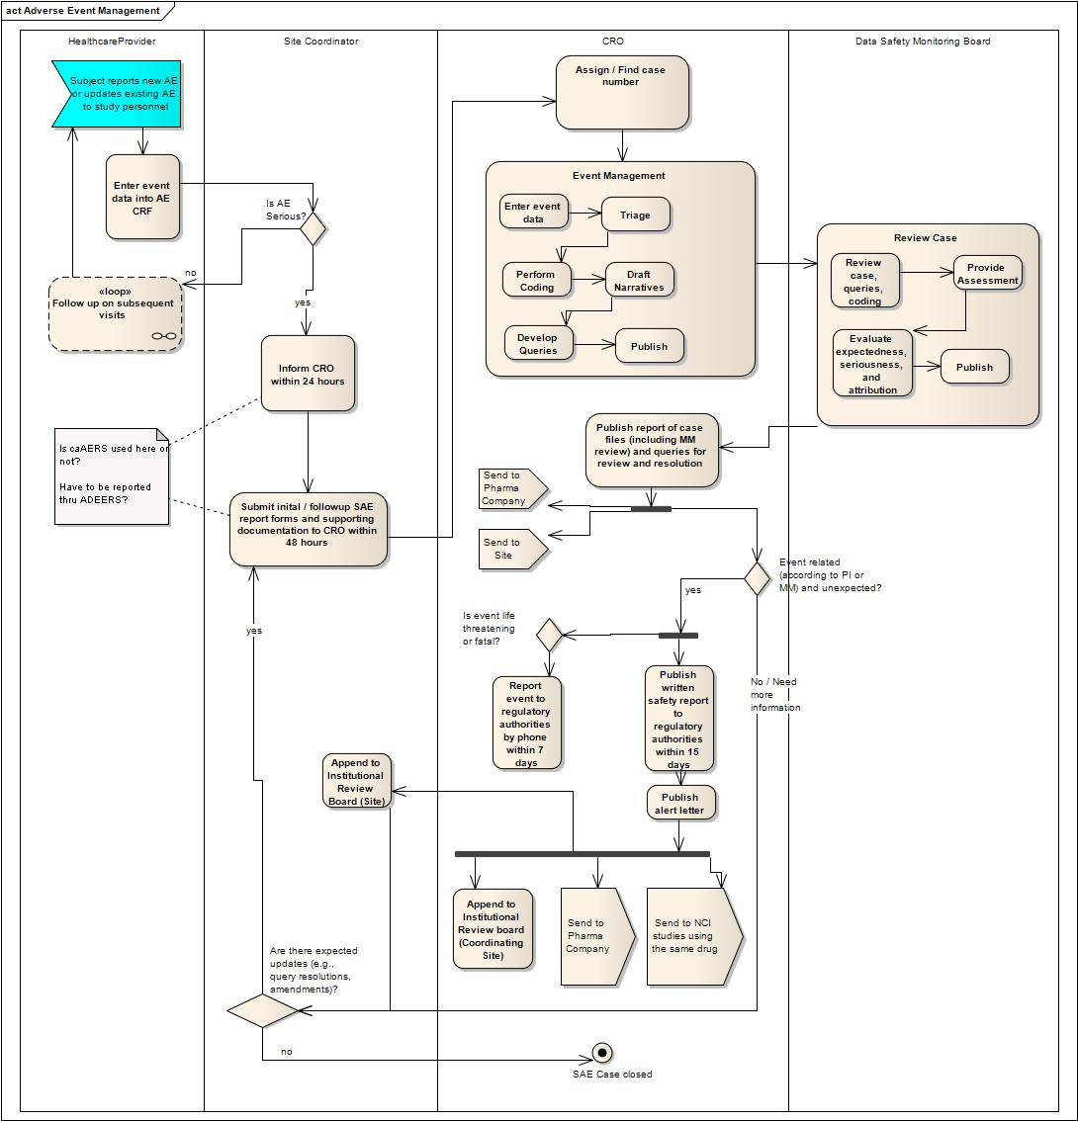
Figure 1: An instance of collaboration between parties involved in the management of Adverse Events. This particular model comes from the i-SPY 2 project which uses the TRANSCEND Infrastructure.

Story board 1 – Patient Reported Outcome
Jerry Carlos (the patient) visits health care provider Dr. David Jones. During the routine exam Dr. Jones discovers that Jerry has developed a headache that coincides with one of his IND treatments. Dr. Jones records this as a potential adverse event in his EHR system. EHR system electronically reports this finding to an Adverse Event Management System for this clinical trial. Adverse Event Management System determines if this is one of the expected outcomes of the specific IND in question. Adverse Event Management System initiates the Adverse Event reporting process.
In an alternate flow, the patient Jerry Carlos develops rash on his arms and back. He calls Dr. Jones and reports this. Dr. Jones records this also as a potential Adverse Event in the EHR system which then reports it to the Adverse Event Management System. Adverse Event Management System consults service of the Protocol System and determines that this is not an expected adverse event and initiates expedited reporting of the Adverse Event.
Following diagram provides interactions with Adverse Event management system for patient reported outcome.
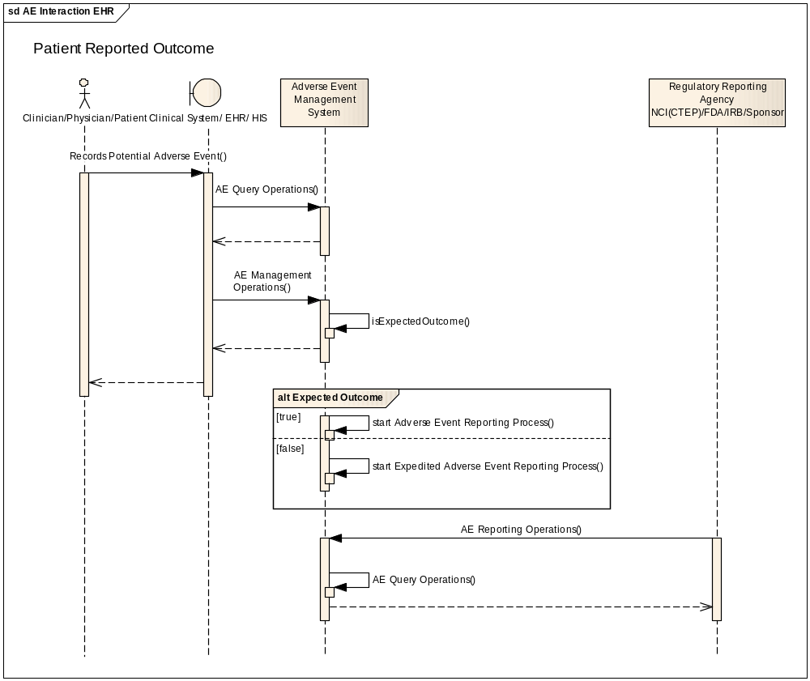

Story board 2 – Lab initiated Adverse Event
During the routine visit Jerry Carlos gets his blood chemistry as part of the treatment. His blood sample is analyzed by John Miller at the laboratory and it is found that potassium level is well beyond normal range. The lab system uses a grading system (or performs Naranjo analysis to get safety score) that flags this as a potential Adverse Event and initiates an Adverse Event in the central Adverse Event Management System.
Following diagram provides interactions with Adverse Event management system for lab initiated Adverse Event.
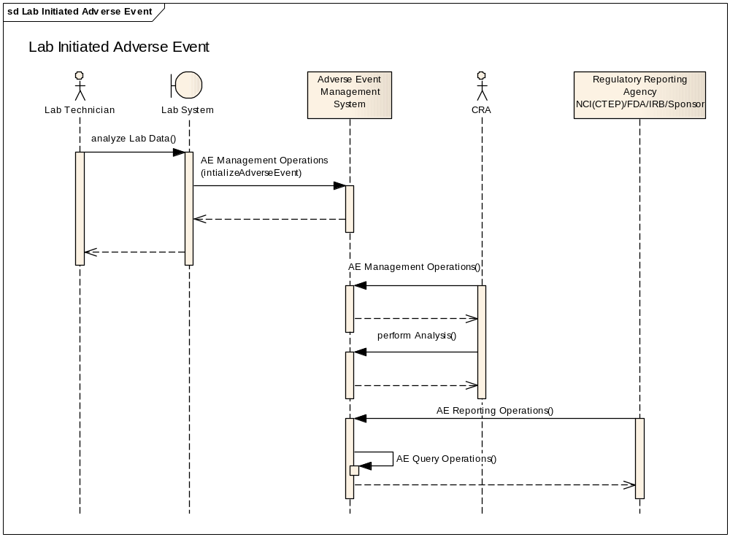

Story board 3 – CDMS initiated Adverse Event
Clinical Research Administrator is analyzing the laboratory results in conjunction with clinical notes from Jerry Carlos’s routine visit. It is determined that there is a potential adverse event occurrence. This information is entered in the CDMS (such as C3D or OpenClinica) that initiates Adverse Event in the central Adverse Event Management System.
Following diagram provides interactions with an Adverse Event management system for CDMS initiated Adverse Event.
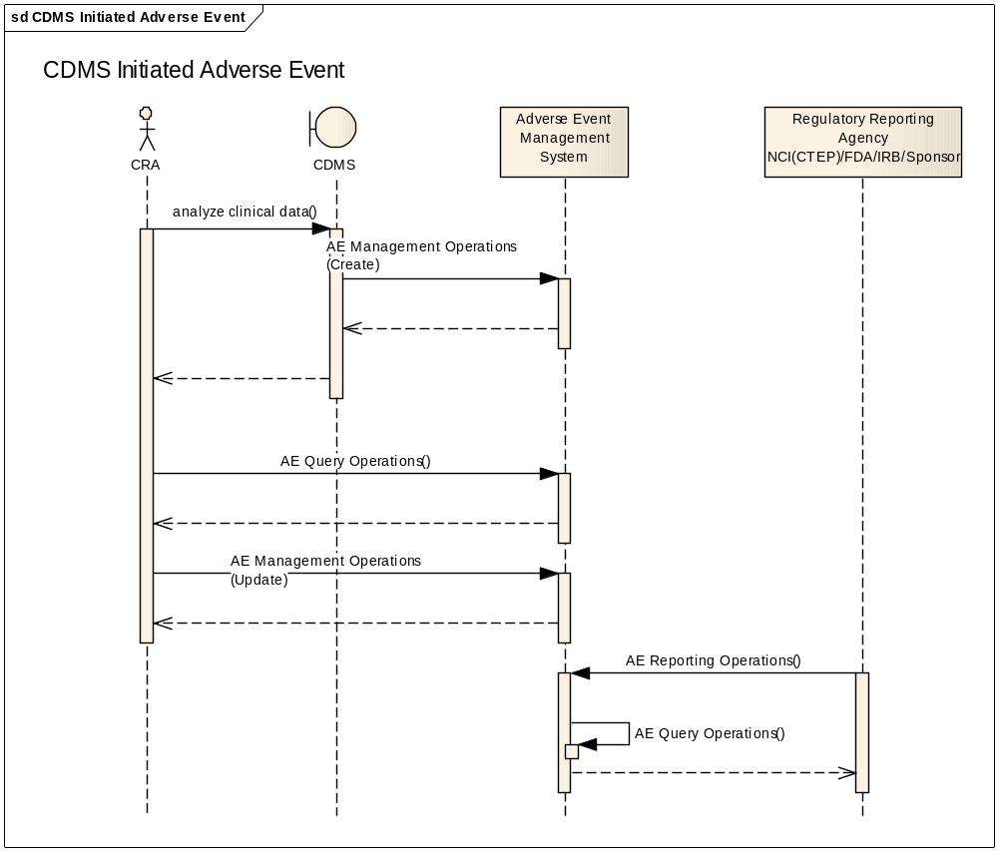

Story board 4 – Processing of Adverse Event
Once Adverse Event is initiated or created, it goes through the manual process to record Adverse Event related data based on appropriate coding system (LOINC, CTCAdverse Events, MedDRA, etc,). The Clinical Research Administrator analyzes the laboratory results in conjunction with clinical notes from Jerry Carlos’s routine visit. It is determined that there is a potential adverse event occurrence. This information is entered in Adverse Event Management System. Then based on the defined business process this Adverse Event is reported to appropriate stakeholders (such as NCI, FDA, IRB, Sponsor etc.)
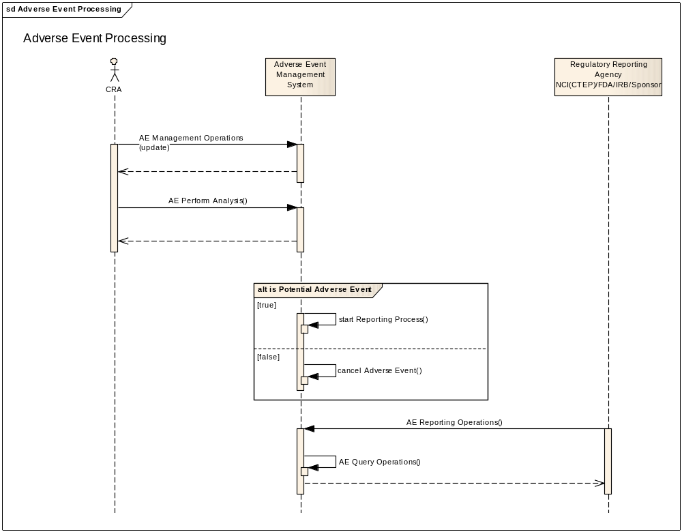

Story board 5 – Reporting of Adverse Event
Based on the protocol definition the Adverse Event is reported to regulatory bodies such as NCI (CTEP), FDA, IRB and sponsor. Each these bodies require reporting in their own format. Adverse Event reporting is initiated electronically where it is available. The regulatory body can electronically request the Adverse Event report as well.
Above diagram provides interactions among regulatory and sponsor systems and Adverse Event Management System for exchanging Adverse Event Report.

Service Use Cases and Profiles Derived from Story boards

Functional Use Cases
Services derived from the story boards are categorized into three functional areas.
- Adverse Event Management: Operations in this service interface allow external service consumer to initiate, create and update Adverse Event and its seriousness. This service interface also provides operations to associate and dissociate multiple adverse events, and to remove any given adverse event to allow end user to manage with events that are entered by mistake with proper audit trail.
- Adverse Event Report (regulatory reporting): Operations in this service interface allow the regulatory body or a sponsor’s system to request and obtain Adverse Event Report.
- Adverse Event Query and search: The operations in this profile allow external service consumer to search and find an Adverse Event and obtain fully structured Adverse Event.
These use cases are organized in following five functional profiles:
- AE Management Profile
- AE Association Profile
- AE Publication Profile
- AE Report Profile
- AE Query Profile
Each of these profiles is discussed in detail below.

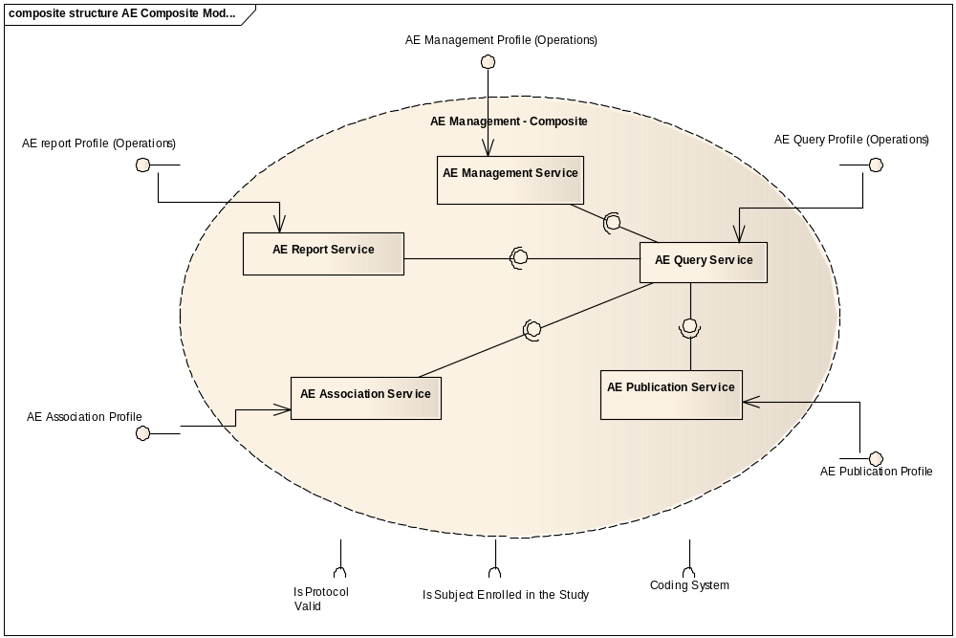

AE Management Profile
The Management Profile is concerned with the management of instances of Adverse Events. It should include the following operations:

Initiate an Adverse Event
This operation allows an external system to initiate processing of a potential adverse event in the Adverse Event Management System. Once the Adverse Event process is initiated a manual process is kicked off in the Adverse Event Management System to capture remaining information related to the initiated adverse event and complete processing of the initiated Adverse Event through its regulatory reporting.

Create an Adverse Event
This operation of an Adverse Event service allows external system to create an entire Adverse Event. Adverse Event is created and saved into Adverse Event Management System. This includes all adverse event related information and based on some determination expedited or regular business process is triggered.

Update an Adverse Event
This operation allows update or modification of an existing Adverse Event.

Update Seriousness of Adverse Event
This operation is used to update an existing Adverse Event with seriousness information. The change in seriousness may trigger a different business process.
Comment: This may be same as Update Adverse Event with certain attributes filled.

Request to Change State of an Adverse Event
This operation requests to change state of the existing Adverse Events. This operation is generic pattern to request change in Adverse Event state (please refer to state diagram for all available states). An invalid state transition request will generate an error. E.g. A request can be made to change the state to Deactivate Adverse Event when any mistakes in Adverse Event initiation process needs to be rectified. This operation returns an identifier of the request that the consumer can use later to inquire status of the request. Audit trail is available on this operation.

Associate local ID with Existing Adverse Events
This operation provides ability to associate local identifier (such as MRN or any other identifier) of the system to the existing Adverse Event. The local identifier can identify additional information associated with the Adverse Event such as a specimen, an image or a chart.

Get Status of State Change Request
This operation provides status of the prior request for change in state of an existing Adverse Event.

AE Association Profile

Associate Adverse Events
Associate multiple Adverse Events by their IDs.

Get Associated Adverse Events
This operation returns a list of associated Adverse Event with the given Adverse Event.

Dissociate Adverse Events
Dissociate prior associated Adverse Events by their IDs.

AE Publication Profile

Subscribe to Adverse Event Updates
This operation provides an ability to register for updates to Adverse Events. Subscription can be requested based on specific criteria. For example consumers of the service can subscribe to Adverse Events related to a particular Study or a particular Patient. This is not necessarily system-to-system notification. But it can be an email to end user or even a personal call to the subscriber.

Unsubscribe to Adverse Event Updates
This operation is used to unsubscribe to prior subscription of Adverse Event Updates.

AE Report Profile
The Report Profile is concerned with the regulatory and other policy related reporting of Adverse Events. It should include the following operations:

Generate Report
This service operation allows several inputs to facilitate different kinds of regulatory reports.

Retrieve Audit Trail of an Adverse Events
Retrieve entire audit trail of changes occurring to a specified Adverse Event.

Perform Analysis
Provide service operation to perform Adverse Event analysis. For example this operation can use the Naranjo algorithm on an Adverse Event to determine the safety score.

AE Query Profile
The Query Profile is concerned with the finding and retrieving Adverse Events. It should include the following operations:

Find Adverse Events
This operation of Adverse Event service allows service consumer to find Adverse Events based on specified criteria. The operation will return all the Adverse Events matching the specified search criteria.

Retrieve an Adverse Event
Retrieve an Adverse Event for the given Adverse Event Identifier. It retrieves the entire object graph for the Adverse Event.

Detailed Functional Model for each Operation
This section gives the functional description of each of the interfaces within the adverse event management system from Clinical Trials stand-point. The following separate interfaces have been defined:
- AE Management: provides operations for managing adverse events to site coordinator and CRO.
- AE Association: provides operations for managing associating and dissociating multiple related adverse events
- AE Publication: provides operation to be able to register for any update to adverse event
- AE Report: provides operations for generating reports for analyzing trends, adverse event’s outcome, seriousness, Naranjo Analysis, etc.
- AE Query: provides query operations for discovering and retrieving adverse events.

Initiate an Adverse Event
Description [M] | - Allows a client system to initiate an Adverse Event. E.g. when lab system finds that there is abnormal or out of range lab results on a given patient it can initiate Adverse Event using this operation.
Pre-Conditions [M] | - Study exists  - Patient exists  - Patient is enrolled in the study and has a study subject identifier
Inputs [M] | - BRIDG AdverseEvent class and identifiers for the Study and Patient – not all attributes of this class are required for initiating an Adverse Event
Outputs [M] | - Return an instance of AdverseEvent with an Identifier associated with the initiated Adverse Event. A properly formed and returned AdverseEvent class with identifier is an acknowledgement that the Adverse Event is initiated and reporting business process has started  - No other information of AdverseEvent class is returned
Post-Conditions [O] | - An Adverse Event is initiated and business process is started to report Adverse Event
Exception Conditions [M] | - Invalid Adverse Event Class representation  - Specified Protocol is invalid  - Participant is not registered in the specified protocol as a subject
Aspects left for Technical Bindings [O] | - This operation may or may not be integrated into the Create function below
Reference to Functional Profiles [O] | - AE Management Profile
Notes [O]

Create an Adverse Event
Description [M] | - Allows creating an Adverse Event. This service encapsulates all necessary information for an Adverse Event from Clinical Trial stand-point and is compliant to V2.1 BRIDG representation
Pre-Conditions [M] | - Study exists  - Patient exists  - Patient is enrolled in the study
Inputs [M] | - BRIDG AdverseEvent class and it’s aggregation/composition classes with required attributes filled and with desired optional attributes filled  - BRIDG->AdverseEvent attributes:  - Grade Code  - Severity Code  - Seriousness code  - Occurrence Pattern Code  - Expected Indicator  - Unexpected Reason Code  - Highlighted Indicator  - Hospitalization Required Indicator  - Onset Date  - Resolution Date  - Optional: AE Identifier for Initiated AE
Outputs [M] | - Return an instance of AdverseEvent with an Identifier associated with the initiated Adverse Event. A properly formed and returned AdverseEvent class with identifier is an acknowledgement that the Adverse Event is created  - No other information of AdverseEvent class is returned
Post-Conditions [O] | - An Adverse Event is created  - Adverse Event Identifier is generated
Exception Conditions [M] | - Values of all mandatory attributes for the Adverse Event Class have not been provided  - Invalid data type or code value for any attribute  - Invalid Adverse Event Class representation  - Specified Protocol is invalid  - Participant is not registered in the specified protocol as a subject  - Submitted AE is a potential duplicate of another existing AE
Aspects left for Technical Bindings [O] | - Where identifier is not part of the input, some means is necessary to identify potential duplicates. This may necessitate matching on other key mandatory attributes.
Reference to Functional Profiles [O] | - AE Management Profile
Notes [O]

Update an Adverse Event
Description [M] | - Allows updating an existing Adverse Event. This service encapsulates all necessary information for an Adverse Event from Clinical Trial stand-point and is compliant to V2.1 BRIDG representation.
Pre-Conditions [M] | - Adverse Event exists  - Study exists  - Patient exists  - Patient is enrolled in the study
Inputs [M] | - BRIDG AdverseEvent class and its aggregation/composition classes with required attributes filled and with desired optional attributes filled. Identifier is required field.  - BRIDG->AdverseEvent attributes:  - Grade Code  - Severity Code  - Seriousness code  - Occurrence Pattern Code  - Expected Indicator  - Unexpected Reason Code  - Highlighted Indicator  - Hospitalization Required Indicator  - Onset Date  - Resolution Date  - Adverse Event Identifier
Outputs [M] | - Return an instance of the updated AdverseEvent class. A properly formed and returned AdverseEvent class with the updated data is an acknowledgement that the Adverse Event is updated.
Post-Conditions [O] | - An Adverse Event is updated  - Subscribers are notified of this event
Exception Conditions [M] | - Values of all mandatory attributes required for update for the Adverse Event Class have not been provided, especially AE Identifier  - Invalid data type or code value for any attribute  - Invalid Adverse Event Class representation  - Adverse Event
Aspects left for Technical Bindings [O] | - The way by which interfaces are realized between Dependent Systems
Reference to Functional Profiles [O] | - AE Management Profile  - AE Query Profile
Notes [O] | - This operation depends on AE Query Profile to retrieve AdverseEvent in order to allow service consumer to update it

Update Seriousness of Adverse Event
Description [M] | - Allows updating an existing Adverse Event with seriousness information and saving Adverse Event. This service encapsulates all necessary information for an Adverse Event from Clinical Trial stand-point and is compliant to V2.1 BRIDG representation.
Pre-Conditions [M] | - Adverse Event exists  - Study exists  - Patient exists  - Patient is enrolled in the study
Inputs [M] | - BRIDG AdverseEvent class  - BRIDG->AdverseEvent attributes:  - Seriousness code  - Adverse Event Identifier
Outputs [M] | - Return an instance of the updated AdverseEvent class. A properly formed and returned AdverseEvent class with the updated data is an acknowledgement that the Adverse Event is updated.
Post-Conditions [O] | - An Adverse Event’s seriousness is updated  - Subscribers are notified of this event
Exception Conditions [M] | - Adverse Event is not found for the given identifier  - Values of all mandatory attributes for the Adverse Event Class have not been provided  - Invalid data type or code value for any attribute  - Invalid Adverse Event Class representation  - Specified Protocol is invalid  - Participant is not registered in the specified protocol as a subject
Aspects left for Technical Bindings [O]
Reference to Functional Profiles [O] | - AE Management Profile  - AE Query Profile
Notes [O] | - This operation depends on AE Query Profile to retrieve AdverseEvent in order to allow service consumer to update it

Request to Change State of an Adverse Event
Description [M] | - Allows changing the state of an Adverse Event. For example this operation can be used for removing/deactivating an Adverse Event to rectify any Adverse Event that was entered by mistake with proper audit trail
Pre-Conditions [M] | - Adverse Event exists
Inputs [M] | - BRIDG AdverseEvent class with Identifier populated  - Target state for the Adverse Event
Outputs [M] | - Return an identifier for the request. The service consumer can then use this identifier to get the status of their request
Post-Conditions [O] | - Request to update Adverse Event state is initiated  - Subscribers are notified of this event
Exception Conditions [M] | - Found more than one Adverse Events  - Invalid data type or code value for any attribute
Aspects left for Technical Bindings [O] | - Format or data type for the request identifier
Reference to Functional Profiles [O] | - AE Management Profile
Notes [O]

Get Status of State Change Request
Description [M] | - Allows service consumer to get the status of a previously submitted request to change the state of an Adverse Event
Pre-Conditions [M] | - Adverse Event exists
Inputs [M] | - An identifier for the Adverse Event state change request
Outputs [M] | - Status of the request
Post-Conditions [O] | - Service consumer is notified the status of their request
Exception Conditions [M] | - No request if found for the given identifier
Aspects left for Technical Bindings [O] | - Format or data type for the request identifier and its status
Reference to Functional Profiles [O] | - AE Management Profile
Notes [O]

Associate local ID with Existing Adverse Event
Description [M] | - Provides ability to associate a local identifier (such as MRN or any other identifier) of the system to the existing Adverse Event. This operation can be used to associate additional related information with the Adverse Event. This could be a specimen, an image or a chart.
Pre-Conditions [M] | - Specified Adverse Event exist
Inputs [M] | - An instance of BRIDG AdverseEvent class with the identifier populated.  - Local Identifier to be associated.
Outputs [M] | - Return an acknowledgement that the association was successfully created
Post-Conditions [O] | - Adverse Events are linked/associated with the local identifier  - Subscribers are notified of this event
Exception Conditions [M] | - Adverse Event is not found for the given identifier  - No Adverse Event Identifier is passed as input
Aspects left for Technical Bindings [O] | - Format or data type of local identifier  - Format or data type of Acknowledgement
Reference to Functional Profiles [O] | - AE Association Profile  - AE Query Profile
Notes [O]

Associate Adverse Events
Description [M] | - Allows linking multiple related Adverse Events together for study purpose
Pre-Conditions [M] | - All specified Adverse Events exist
Inputs [M] | - A list of instances of BRIDG AdverseEvent class (DSET<AdverseEvent>) where each AdverseEvent instance has the identifier attribute populated  - Reason for association
Outputs [M] | - Return an acknowledgement that the association was successfully created
Post-Conditions [O] | - All Adverse Events are linked/associated  - Subscribers are notified of this event
Exception Conditions [M] | - Adverse Event is not found for one of the given identifier  - Only one Adverse Event is passed as input
Aspects left for Technical Bindings [O] | - When one or more Adverse Events are linked, we need to have a way to deal with data anomalies. Certain data fields may differ from one Adverse Event to the other  - Format or data type of reason for association
Reference to Functional Profiles [O] | - AE Association Profile  - AE Query Profile
Notes [O] | - This operation depends on AE Query Profile to retrieve all Adverse Events that are being associated

Get Associated Adverse Events
Description [M] | - Allows getting associated Adverse Events for a given Adverse Event.
Pre-Conditions [M] | - Adverse Event exists
Inputs [M] | - An instance of BRIDG AdverseEvent class with the identifier attribute populated  - (Optional) Reason for association
Outputs [M] | - Return a DSET<<BRIDG Adverse Event class>>. Each element of the DSET is a BRIDG Adverse Event class associated with the input Adverse Event. Each returned Adverse Event has at least the identifier populated.  - If the reason for association is provided then only the Adverse Events associated for that reason are returned  - An empty DSET if there are no associated Adverse Events
Post-Conditions [O] | - All associated Adverse Events are returned to the service consumer
Exception Conditions [M] | - Adverse Event is not found for the given identifier  - Invalid reason code specified in the input
Aspects left for Technical Bindings [O] | - Format or data type for reason of association
Reference to Functional Profiles [O] | - AE Association Profile  - AE Query Profile
Notes [O] | - This operation depends on AE Query Profile to retrieve Adverse Events that are being associated

Dissociate Adverse Events
Description [M] | - Allows dissociating two Adverse Events that are associated earlier (e.g. using associateAEs operation)
Pre-Conditions [M] | - All specified Adverse Events exist and they are associated
Inputs [M] | - BRIDG Adverse Event class with the identifier populated  - Associated BRIDG Adverse Event class with the identifier populated  - Reason for association (Optional)
Outputs [M] | - Return an acknowledgement that the association was successfully created
Post-Conditions [O] | - Input Adverse Events are dissociated  - If reason for association is specified then only the association for that reason is broken.  - Subscribers of both Adverse Events are notified of this event
Exception Conditions [M] | - Adverse Event is not found for the given identifiers  - No association can be found for the given identifiers and reason for association  - Invalid data type or code value for any attribute
Aspects left for Technical Bindings [O] | - When one or more Adverse Events are dissociated, we need to have a way to deal with any data dependency from one adverse event to another. Certain data fields may depend from one Adverse Event to other.  - Format or data type for reason for association
Reference to Functional Profiles [O] | - AE Association Profile
Notes [O] | - This operation depends on AE Query Profile to retrieve both Adverse Events that need to be dissociated

Subscribe to Adverse Events and its Updates
Description [M] | - Allows subscribing to an Adverse Event updates
Pre-Conditions [M] | - Adverse Event exists
Inputs [M] | - Criteria in form of DSET<<BRIDG Adverse Event class>>. Each element of the set is a BRIDG Adverse Event class and its aggregation/composition classes with required attributes filled and with desired optional attributes filled. The criteria specified in multiple Adverse Event classes result in an OR logical condition while the criteria specified within a single Adverse Event class result in an AND logical condition. For example a query of Adverse Event with expectedIndicator=1 and hospitalizationRequiredIndicator=”1” or highlightedIndicator=1 would have two elements in this input parameter. The first one with expectedIndicator=1 and hospitalizationRequiredIndicator=”1” and the second one with highlightedIndicator =1  - Subscriber class with its Identifier
Outputs [M] | - Return Subscription object with its identifier. A properly formed and returned Subscription class with its identifier is an acknowledgement that the subscription is created
Post-Conditions [O] | - Subscription is created
Exception Conditions [M] | - Invalid data type or code value for any attribute.  - No matching Adverse Events are found for the given criteria
Aspects left for Technical Bindings [O] | - Notification to subscriber is automated via email, text or manual is left to implementation  - Notification may take the form of a simple identifier / attribute combination, a canned query, a report, or an audit trail  - However, subscribers should request notification relevant against both business processes and subject to appropriate local governance  - The data type of the Subscription and Subscriber
Reference to Functional Profiles [O] | - AE Publication Profile  - AE Query Profile
Notes [O] | - This operation depends on AE Query Profile to retrieve AdverseEvent so that a subscription is registered

Unsubscribe to Adverse Event Update
Description [M] | - Allows unsubscribing to an Adverse Event update.
Pre-Conditions [M] | - Subscription exists.
Inputs [M] | - Subscription class and its Identifier.
Outputs [M] | - Return updated Subscription object with its identifier. A properly formed and returned Subscription class with is updated to state that the subscription is no longer active is an acknowledgement that the unsubscribe operation succeeded
Post-Conditions [O] | - Subscription is cancelled
Exception Conditions [M] | - Invalid data type or code value for any attribute.  - No matching subscription is found for the given Identifier.
Aspects left for Technical Bindings [O] | - Data type for Subscription
Reference to Functional Profiles [O] | - AE Publication Profile  - AE Query Profile
Notes [O] | - This operation depends on AE Query Profile to retrieve Adverse Event so that a subscription is registered

Find Adverse Events
Description [M] | - Facilitates searching for Adverse Events
Pre-Conditions [M] | - Search criteria are provided
Inputs [M] | - Search Criteria in form of DSET<<BRIDG Adverse Event class>>. Each element of the set is a BRIDG Adverse Event class and its aggregation/composition classes with required attributes filled and with desired optional attributes filled. The criteria specified in multiple Adverse Event classes result in an OR logical condition while the criteria specified within a single Adverse Event class result in an AND logical condition. For example a query of Adverse Event with expectedIndicator=1 and hospitalizationRequiredIndicator=”1” or highlightedIndicator=1 would have two elements in this input parameter. The first one with expectedIndicator=1 and hospitalizationRequiredIndicator=”1” and the second one with highlightedIndicator =1
Outputs [M] | - Return one or more Adverse Events matching search criteria  - Indicates pagination if search found bulky results
Post-Conditions [O] | - Returns one or more Adverse Events matching search criteria  - Returns no Adverse Event if there is no match
Exception Conditions [M] | - Minimum and Mandatory attributes of search criteria have not been provided.  - Invalid data type or code value for any attribute
Aspects left for Technical Bindings [O]
Reference to Functional Profiles [O] | - AE Query Profile
Notes [O] | - Need to determine what is minimum search criteria that must be provided  - Need to define the pagination standard  - Default boundary checks are enforced to avoid system/service failures

Retrieve Adverse Event
Description [M] | - Retrieves entire Adverse Event based on the Adverse Event Identifier. Retrieves entire object graph for specified Adverse Event
Pre-Conditions [M] | - Adverse Event exists
Inputs [M] | - BRIDG Adverse Event class with Identifier populated
Outputs [M] | - Return entire Adverse Event
Post-Conditions [O] | - Returns an entire Adverse Event  - Returns no Adverse Event if there is no match
Exception Conditions [M] | - Minimum and Mandatory attributes of search criteria have not been provided, especially identifier or key term  - Invalid data type or code value for any attribute
Aspects left for Technical Bindings [O]
Reference to Functional Profiles [O] | - AE Query Profile
Notes [O] | - Need to determine what is minimum search criteria that must be provided

Retrieve Expected Adverse Events for the study
Description [M] | - Retrieves expected Adverse Events for a given study
Pre-Conditions [M] | - Study exists
Inputs [M] | - BRIDG StudyProtocol class with the identifier populated
Outputs [M] | - Return one or more pre defined Adverse Events  - Indicates pagination if search found bulky results
Post-Conditions [O] | - Returns one or more pre defined Adverse Events for the study  - Returns no Adverse Event if there is no match
Exception Conditions [M] | - No study found for the given identifier  - Invalid data type or code value for any attribute
Aspects left for Technical Bindings [O]
Reference to Functional Profiles [O] | - AE Management Profile (? This may be part of the Protocol Management Service)
Notes [O]

Retrieve Audit Trail of an Adverse Event
Description [M] | - Retrieves an entire audit trail of all changes to specified an Adverse Event
Pre-Conditions [M] | - Adverse Event exists
Inputs [M] | - Adverse Event class with Adverse Event’s identifier populated  - Date range for which audit trail is desired
Outputs [M] | - Return audit trail of the Adverse Event within the desired date range
Post-Conditions [O] | - Returns audit trail information
Exception Conditions [M] | - Invalid data type or code value for any attribute  - Adverse Event cannot be found for the given identifier
Aspects left for Technical Bindings [O]
Reference to Functional Profiles [O] | - AE Management Profile
Notes [O]

Generate Report
Description [M] | - Allows querying and generating the report on seriousness of the event, event trends, etc. This service allows several inputs to facilitate different kinds of reports including regulatory reports in predefined formats.
Pre-Conditions [M] | - Adverse Event exists
Inputs [M] | - Mandatory attributes of report criteria are filled and optional attributes are filled optionally
Outputs [M] | - Return the report
Post-Conditions [O] | - Returns report
Exception Conditions [M] | - Mandatory attributes of report criteria have not been provided, especially identifier or key term  - Invalid data type or code value for any attribute
Aspects left for Technical Bindings [O] | - Format or data type for the report criteria
Reference to Functional Profiles [O] | - AE Reporting Profile
Notes [O]

Perform Analysis
Description [M] | - Perform Adverse Event analysis. For example retrieve a safety score of an Adverse Event based on the Naranjo algorithm
Pre-Conditions [M] | - Analysis is supported  - Adverse Event exists
Inputs [M] | - BRIDG Adverse Event class with the identifier populated
Outputs [M] | - Return analysis result
Post-Conditions [O] | - Returns analysis result
Exception Conditions [M] | - No Adverse Event can be found for the given identifier  - Invalid data type or code value for any attribute
Aspects left for Technical Bindings [O]
Reference to Functional Profiles [O] | - AE Reporting Profile
Notes [O]

System Interaction Details
The following communication diagram shows interaction between Adverse Event Management system and other participants. The diagram shows the service functional profiles used by participants for creating, processing and reporting of Adverse Events.
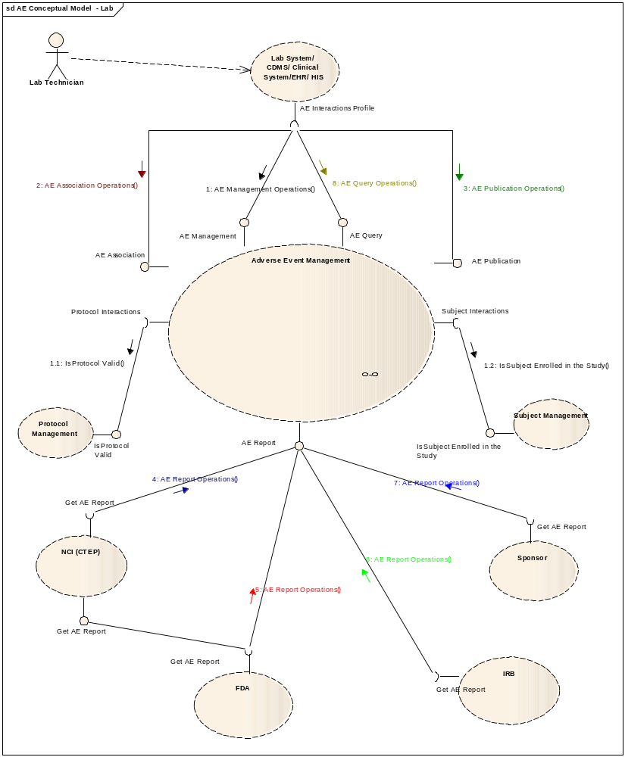

Profiles

Information Profiles

BRIDG Information Model
The Adverse Event service binds and complies with semantics of BRIDG 2.1 information model. This model can be found at (http://gforge.nci.nih.gov/frs/?group_id=342). The model’s diagram is represented below.
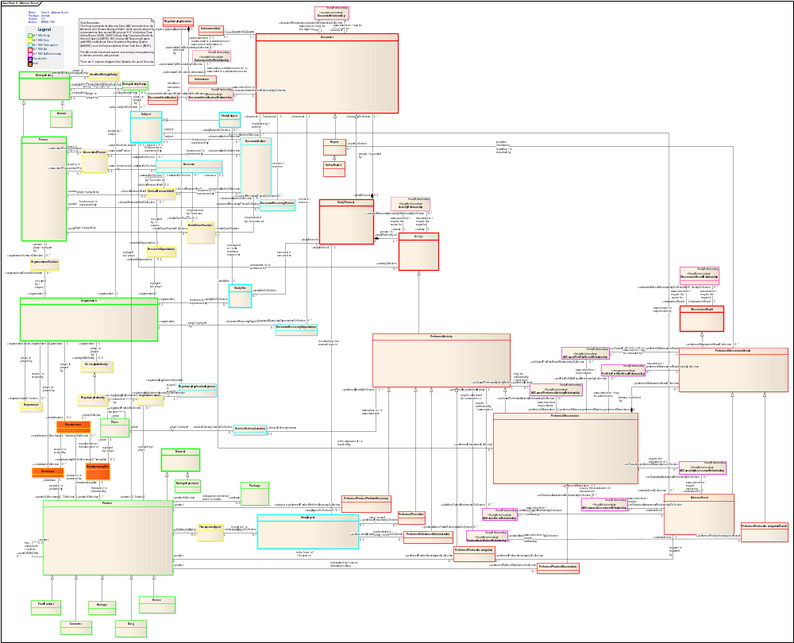

Adverse Event State Machine
An adverse event goes through states described by following state transition diagram.
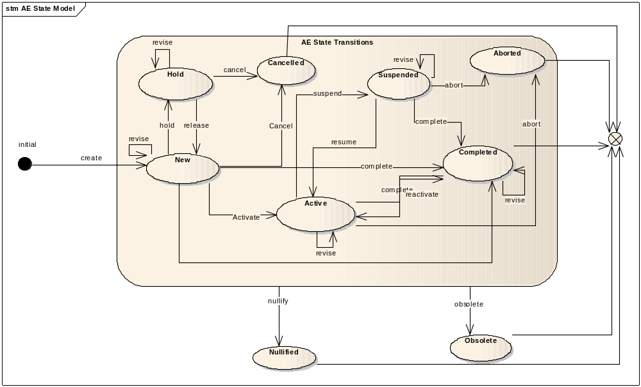

Functional Profiles
Functional Profiles are intended to be deployed as a collection of operations that have been designed to provide coherent and consistent access to capabilities. The functional profiles allow service provider to gradually implement and comply with this specification. The functional profiles that align with the Collaborations detailed in section 2 (above) are outlined below.

AE Management Profile
The Management series of capabilities details the complete encapsulation boundary behind which the Adverse Event focal object may be managed. That is, it provides for a coherent set of functions regarding that focal object expressed in a state machine (see Information Profile) that must be managed together.

AE Association Profile
The Association Functional Profile provides for a series of capabilities to connect an Adverse Event instance with another, whether that association happens across system or organizational boundaries. This association is provided for local use only, though the association may be between a local identifier and a foreign identifier. Foreign identifiers may never be associated with each other except transitively through a local identifier.
Note that “local” is defined for the purposes of this functional profile as the domain of users that are given access to a deployed instance of this functional profile, and does not limit the nature of the identifiers that may be associated. Thus, local may in fact mean trans-organizational when this profile is associated with a regionally-available service.
The Association Profile may have a dependency on the Publication Profile.

AE Publication Profile
The Publication Functional Profile provides a series of functional capabilities for other systems, services, and users to be notified with state transitions associated in the Management Functional Profile.

AE Reporting Profile
The Reporting series of capabilities is intended to support local and regulatory reporting requirements. This Functional Profile is dependent on the Query Profile, and may have a further dependency on the Association Profile.

AE Query Profile
The Query Functional Profile provides an encapsulation boundary for the commissioner of the query to be guaranteed that information provided by a given query is authoritative and correct. Thus, an implementation of the query profile must be able to manage and be aware of persistence locks, business rules, Adverse Event state, and so on, to provide a data graph that is consistent with the local business rules that apply to Adverse Events in a deployed instance.

Structure of the Service
TODO

Adverse Events

Assumptions and Dependencies

Security

Implementation Considerations

Deployment Scenarios

A Note on Federation
Federation in the Clinical Trial Adverse Event could be problematic given the highly localized nature of adverse event management mechanisms. These tend to reflect local legal, technical, and human factors that represent key points of differentiation. This specification views this differential as insurmountable and provides certain mechanisms for federation without either mandating them or fixing the nature of the federation itself. This latter issue should be dealt with on a solution by solution basis using the NCI’s Behavioral Framework and the functional profiles provided herein.
That said, there are several parts of this specification that can support different federation models, and also draw distinctions between what can be federated and what cannot. The Management and Query profiles are intended to be deployed locally within a domain that has a consistent set of rules, policies, and human mediation components. In practice, this means within the scope of a single application.
The Reporting Profile may in fact be deployed to take into account super-organizational, regional, or even national information. However, it is expected to have strict dependencies on other constrained deployed instances of the Reporting Profile (that is, information flows one way with respect to the organizational hierarchy), as well as on the deployed instances of the Query Profile (constrained to local implementations as above).
The Publication profile is intended to provide a one way mechanism for publishing information about a given instance of an adverse event. The consumer of this information may or may not be local to the jurisdiction provided by the deployed instance of the Publication Profile. The consumer of this information is responsible for this published information, but is not expected to make it available through its own locally deployed Query Profiles.
Finally, the Associative Profile is intended to provide an agnostic representation of related Adverse Event identifiers, at least one of which must be a local identifier. This provides for avenues of human mediated integration to support reporting or adverse event management in cases that cross the encapsulation boundaries supported by these functional profiles. However, this human mediation cannot break the NCI policy that the deployed instance of an Adverse Event functional Profile is authoritative for its named jurisdiction. For example, a query by example operation of a non-local identifier called locally cannot return information for that non-local adverse event because the local Query Profile is authoritative locally only. The user would be required to access the non-local Adverse Event Query Service to gain information, and then could not claim authority for that information.

Information Bindings
In all cases, the functional semantics of the Adverse Event Service will be bound by AdverseEvent class in BRIDG and its associated classes like AdverseEventsActionTakenRelationship, AdverseEventsCausalityAssessmentRelationship, AdverseEventsCausalPerfObsResultRelationship, etc. Adverse Event Service adheres to V2.1 of BRIDG model and thus the structure is at the interface definition level and semantically neutral.

Recommendations for Conformance and Compliance

Conformance Assertions
- The Adverse Event Service will use the representation and semantics of the AdverseEvent class of V2.1 of BRIDG model.
- Functional Profiles shall be deployed as functional wholes. Ignoring or omitting functional behavior defined within a functional profile is not permitted, nor is diverging from the detailed functional specifications provided in Section 4.
- A conformant implementation of this specification must deploy at least one Functional Profile. If that Functional Profile has dependencies on other profiles, then those dependencies must be deployed as well to support the provenance of that service instance.
- A conformant implementation shall make available the information components available to commissioning agents of Adverse Event Service capabilities. Information components shall include but not necessarily be limited to class models, vocabulary bindings, and state machines associated with Clinical Trial Adverse Events.
- All management and query functional profiles will be deployed within an organizational jurisdiction only. This implies that all identifiers for the adverse event focal objects shall retain authority locally.
- If deployed, the Associative Functional Profile may associate foreign identifiers with local identifiers.
- Implementations of the Management and Query profiles shall be authoritative within an organization’s boundaries only, and are not intended to provide an encapsulation boundary that supports different rules or policies regarding the management and access to information regarding a given adverse event focal object.
- Implementations of the Association, Reporting, and Publication profiles may provide access to information external to a given organization’s boundary. This shall not imply authority for that information except transitively, and supporting that authority is expected to be supported directly by conformance statements at the Platform Independent and Platform Specific levels.
- Implementations of the Publication profile should only provide information relevant to the subscription, and the subscription should be governed by local practices against appropriate business processes and security concerns. For this reason, it is likely that several subscription profiles may be relevant – for example, one to notify that an adverse event has been upgraded to severe and another that more information has been provided to a given adverse event report. Conformance to this profile shall be evaluated solely on the basis of the information bindings and computational components reflected within this specification, but it should be noted that conformance to this profile needs to be localized within the confines of an agreement between information sharing partners.

Recommendations for NCI Core Specification

Appendix A - Relevant Standards
- Cancer Adverse Event Reporting System (https://cabig.nci.nih.gov/tools/caAERS )
- ICSR ( http://www.fda.gov/cdrh/emdr/healthlvl7files.html )
- BRIDG Model (http://www.bridgmodel.org)
- CDISC/SDTM (http://www.cdisc.org/models/sds/v3.1/index.html)
- HL7 RIM –(http://www.hl7.org)

Appendix B - Glossary
E2B - http://www.fda.gov/CbER/gdlns/iche2bmqa.htm
M2

