Installation Guide
V 0.9

Cancer Adverse Event Reporting System (caAERS)
SemanticBits, LLC

Document Change History
Version Number | Date | Contributor | Description
Prior Drafts |  |  | Prior drafts
V. 0.2 | April 2007 |  | Draft for installing Iteration 2 (March 07). In the previous iteration, the data source configuration was included in the war file, which required adopters to build caAERS locally. In this iteration, we have moved the data source configuration out of the war file so that you will no longer need to build caAERS, going forward.
V. 0.5 | February 2007 | Krikor Krumlian | Initial Draft
V.0.6 | May 2007 | Biju Joseph | Second Draft , maven related changes, some manual steps introduced
V. 0.6.1 | May 2007 | Biju Joseph | Incorporated the changes based on Srinivasa Akkal.
V. 0.7 | July 2007 |  | Updated content, including software version. Removed build software installation (Maven, Eclipse, ANT).
V.0.8 | August 2007 | Paul Galvin | Updated material based on comments and suggestions
V.0.9 | October 2007 | Paul Galvin | Combined installer instructions with the full instructions
V.1.0 | November 2007 | Vinay Kumar and Karthik Iyer | Added caAERS secure data grid service configuration instructions.

caBIG™ is an initiative of the National Cancer Institute, NIH, DHHS

Table of Contents

Introduction 4
Minimal System Requirements 4
Server Software and Technology Requirements 5
Software Requirements 5
Database Requirements 6
Quick Installation 6
Preliminary Considerations 6
1.0 Preliminaries 7
1.1 Installing JDK 7
1.2 Installing Tomcat 7
1.3 Installing the Database 7
2.0 Installing caAERS 7
2.1 Extracting caAERS Installer 8
2.2 Accepting the License Agreement 9
2.3 Choosing a Database 9
2.4 Providing Database Parameters 10
2.5 Directory for Rules Repository 11
2.6 Components to Install 11
2.7 Installation Progress 12
3.0 Configuring caAERS 13
Long Installation 13
1.0 Preliminaries 13
1.1 Installing JDK 13
1.2 Installing Tomcat 14
1.3 Installing an SVN Client 14
1.4 Downloading the Latest Source Code 14
1.5 Download the Latest Compiled .war file 14
2.0 Installing and Configuring the Database 14
2.1 Installing the Database 15
2.2 Configuring the Database for Use with caAERS 15
3.0 Configuring Tomcat 15
4.0 Enabling SSL 17
4.1 Generate a Certificate 17
4.2 Updating the server.xml 17
5.0 Loading the Database with the Schema/Deploying the caAERS.war 17
6.0 Setting up The Secure Data Grid Service 18
6.1 Installation 18
6.2 Preparation for using grid client 18
7.0 Installing ESB for caAERS-AdEERS Integration 20
Contacting Technical Support 20

Introduction
This installation guide outlines the supported configurations and instructions for installing, setting up, and configuring the Cancer Adverse Event Reporting System (caAERS) application.

Overview of caAERS | The caAERS application is an open source, standards-compliant software application that can be used by organizations that manage patients on cancer clinical trials. caAERS is a standalone, web-based application that allows users to enter SAE and AE reports.

caAERS Deployment:

Client
PostgreSQL/
Oracle

caaers.war

Tomcat

Diagram 1 caAERS Deployment

Client | Web browser, preferably Internet Explorer 6 or Firefox 1.5
Tomcat | Web server and servlet container, Apache Tomcat 5.5.23
caaers.war | Contains the files of the caAERS application
PostgreSQL/Oracle | Database to support caAERS, PostgreSQL 8.x or Oracle 10g

Minimal System Requirements

Minimal Client System Requirements | - Internet connection  - Firefox 1.5 or higher or Internet Explorer 6

The caAERS server has been tested on the platforms shown in Table 1.
 | Macintosh | Windows
Model | Xserve G4 | Dell Dimension 8200
CPU | 2 x 1 GHz PowerPC G4 | 1 x Intel® Pentium™ Processor 1.80GHz
Memory | 2 GB | 1 GB
Local Disk | System 2 x 180 GB | System 1 x 36GB
OS | OSX 10.4 | Windows XP
Table 1 Platform Testing Environment

Server Software and Technology Requirements

Software Requirements
Required Software | You must download and install a set of required software that is not included with the caAERS application software bundle. The software name, version, description, and URL hyperlinks (for download) are listed below in Table 2.

Required Software:
Software Name | Version | Description | URL
Java SE Development Kit | JDK 5.0 or higher | The Java SE development kit with JRE, compilers and debuggers | http://java.sun.com/javase/downloads/index.jsp
Apache Tomcat | 5.5.23 or higher | Servlet container for JSP | http://tomcat.apache.org/download-55.cgi
Table 2 Required software and technology

Database Requirements

Database Software | The caAERS application requires access to a properly-configured database. JDBC drivers for HSQLDB and PostgreSQL have been included. If your site is using an Oracle database, you will need to obtain the necessary Oracle drivers and place them in the db/lib directory. caAERS is built with database-independence in mind and has been tested on the following:

Database Name | Version | Description | URL
PostgreSQL | 8.1.9 or higher | PostgreSQL is a powerful, open source relational database system. | http://www.postgresql.org/download/
Oracle | 10g Release 2 or higher | Industry-leading, commercial database product. | http://www.oracle.com/technology/software/products/database/oracle10g
Table 3 Database software

Quick Installation

Preliminary Considerations
BEFORE YOU BEGIN | caAERS has been tested with the operating systems and hardware specified on page 1 of this guide. Although we have made an effort to develop caAERS as a platform-independent application, we cannot guarantee that it will work if you are using variations of these operating systems and/or hardware. Although installing caAERS on a system already setup with the proper versions of the JDK, database, and Tomcat should require only about 30 minutes, installation from scratch could take several hours.  For installation on Windows, an account with administrator privileges must be used.

If you are comfortable with setting up and deploying Java applications on Tomcat, please follow the brief instructions below. It does not contain all the details necessary for installing and configuring caAERS. If you’ve never set up caAERS before, we recommend using the detailed instructions.
  - Check you meet minimum system requirements
  - Install JDK, Tomcat, and Database
  - Go to http://sbdev1000.semanticbits.com:8030/installer/. Select the Installer Webstart link to automatically save caAERSInstaller.jar to your machine and open up the installer wizard.
  - Follow the installer instructions
  - When the installer is complete, open the datasource.properties file in ${tomcat.dir}/conf/caaers to be check it was configured correctly. The rules.repository= property must include 2 backslashes (/) instead of forward slashes (\) if it is a Windows operating system. Once the information has been updated, restart Tomcat and go to https://localhost:8443/caaers/. Login with the following information
Username = SYSTEM_ADMIN
Password = system_admin

1.0 Preliminaries
This section describes the preliminary steps required to establish an environment required to successfully run the caAERS application.

1.1 Installing JDK
Download and install Java Standard Edition 5.0 or higher from (http://java.sun.com/javase/downloads/index.jsp). Make sure the directory name where you install java or the parent directories do not contain a white space in between any characters in the name of the directory. Throughout this guide the java installation directory will be referred as ${java.dir}.

Add the ${java.dir}\bin to your system PATH. Also set a new environment variable named JAVA_HOME, whose value must = ${java.dir}

1.2 Installing Tomcat
Download Apache Tomcat version 5.5.23 or higher from http://tomcat.apache.org/download-55.cgi. Install the Tomcat application in a convenient location. Throughout this guide the Tomcat installation directory will be referred as ${tomcat.dir}. Add a new environment variable CATALINA_HOME, whose value must be set to ${tomcat.dir}

Configure server.xml in the ${tomcat.dir}/conf to enable https connections on port 8443 or 443. Also, generate an SSL certificate using the instructions at http://tomcat.apache.org/tomcat-5.5-doc/ssl-howto.html. Save the generated certificate in your c:\ directory.

1.3 Installing the Database
In your database management system, create a new database named caaers.

2.0 Installing caAERS
For this section of the guide, please go to http://sbdev1000.semanticbits.com:8030/installer/. There will be a link called Installer Webstart and another link called caAERSInstaller.jar. Selecting the Installer Webstart link should automatically save caAERSInstaller.jar to your machine and open up the installer wizard. If it does not, you can click on caAERSInstaller.jar to save the jar file to your machine manually. Once it has been saved, you can double-click the jar file to begin the installation process.

Please make sure the server.xml in the ${tomcat.dir}/conf is enabled for https connections on either port 8443 or 443.

Also, please make sure there is a database called caaers created in Postgres and the owner is set to postgres.

The following steps will begin when either the Installer Webstart link has been selected, or the jar file has been opened.

2.1 Extracting caAERS Installer
The caAERS Installer will begin extracting files need to complete the process. The following screen will be displayed as it is extracting.

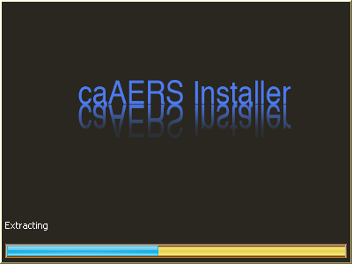

Once the installer has finished extracting, this page will be displayed:

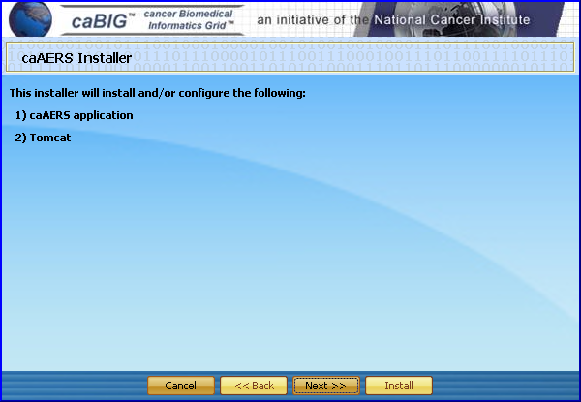

Click the “Next >>” button to move forward in the process. The “<< Back” and “Install” buttons will be grayed out.

2.2 Accepting the License Agreement
Click the radio button next to the text that says “I Accept.” After selecting the radio button, please select “Next >>.”

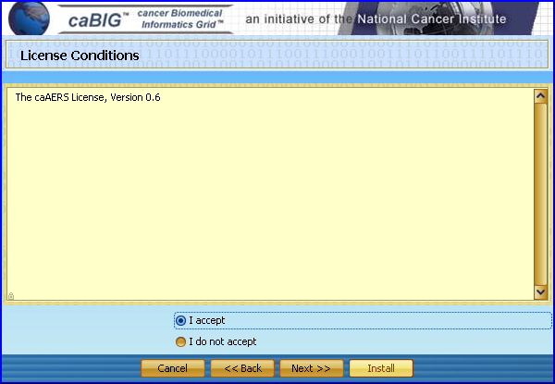

2.3 Choosing a Database
Please choose the database to be used with caAERS. For this process, we will be selecting the Postgres database. Once the database has been chosen, please select “Next >>.”

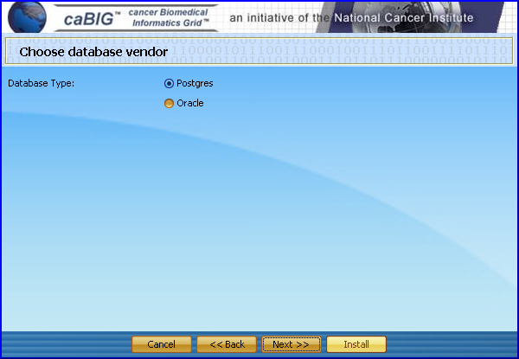

2.4 Providing Database Parameters
To install caAERS successfully, the installer needs to know certain parameters of your database. Please enter the appropriate information in all of the fields. Once the information is valid, select “Next >>.”

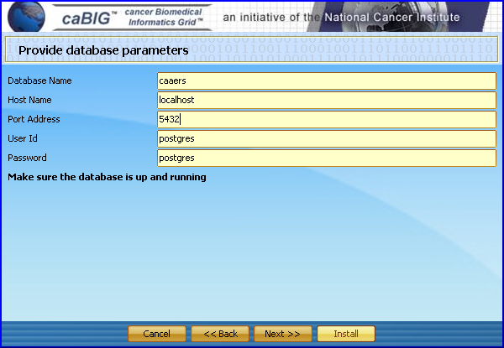

2.5 Directory for Rules Repository
Provide a valid folder location for the Rules Repository for caAERS to use. If the directory is invalid, the installer will not move on to the next step. You can browse to the correct directory by selecting the “Select Folder” button. After selecting the folder, click “Next >>.”

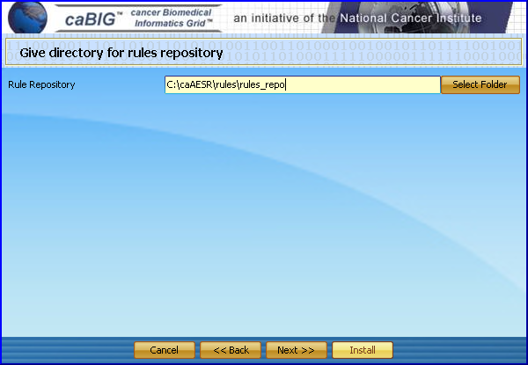

2.6 Components to Install
The next step in the installation process will confirm with you what will be installed. Please select “Next >>.”

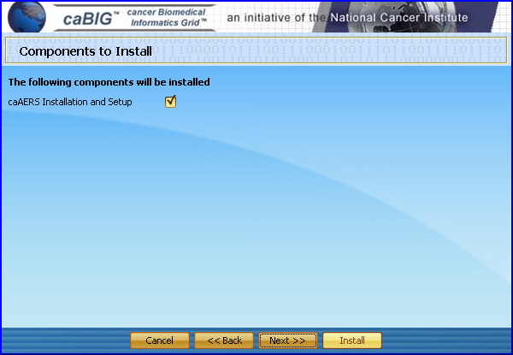

2.7 Installation Progress
In order to start the installation process, click the “Install” button. Once the button has been selected, the process will be initiated and you will be shown a status screen. This process will take a few minutes to run.

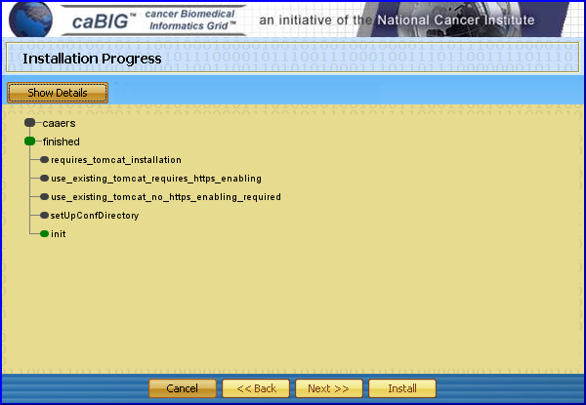

When the process has completed after a few minutes, the following screen will appear. Click “OK” and then click “Exit.”

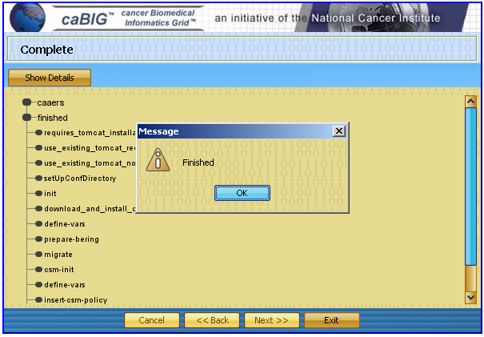

3.0 Configuring caAERS
The installation process has completed, but before any users can access the home page, the datasource.properties file in ${tomcat.dir}/conf/caaers must be checked to make sure it was configured correctly. The rules.repository= property must include 2 backslashes (/) instead of forward slashes (\) if it is a Windows operating system.

Once the information has been updated, restart Tomcat and go to https://localhost:8443/caaers/. Login with the following information
Username = SYSTEM_ADMIN
Password = system_admin

Please refer to the caAERS QuickStart Guide to set up the required information to use the application.

Long Installation

1.0 Preliminaries
This section describes the preliminary steps required to establish an environment required to successfully run the caAERS application.
1.1 Installing JDK
Download and install Java Standard Edition 5.0 or higher from (http://java.sun.com/javase/downloads/index.jsp). Make sure the directory name where you install java or the parent directories do not contain a white space in between any characters. Throughout this guide the java installation directory will be referred as ${java.dir}.

Add the ${java.dir}\bin to your system PATH. Also set a new environment variable named JAVA_HOME, whose value must = ${java.dir}
1.2 Installing Tomcat
Download the Apache Tomcat version 5.5.23 or higher from http://tomcat.apache.org/download-55.cgi. Install the Tomcat application in a convenient location. Throughout this guide the Tomcat installation directory will be referred as ${tomcat.dir}. Add a new environment variable CATALINA_HOME, whose value must = ${tomcat.dir}
1.3 Installing an SVN Client
To checkout the latest code, you need to have a Subversion (SVN) client installed on your system. Install the Subversion client provided below.

Windows
- Standalone:
http://tortoisesvn.tigris.org/

Mac
- Standalone:
http://www.apple.com/downloads/macosx/development_tools/svnx.html

1.4 Downloading the Latest Source Code
Once the SVN client is installed create a directory in a convenient location to checkout the caAERS source code. Throughout this guide the source code directory will be referred as ${workspace}.

Right click ${workspace}, select SVN Checkout and enter the following repository URL:
https://gforge.nci.nih.gov/svnroot/caaersappdev/trunk/

1.5 Download the Latest Compiled .war file
Proceed to the caAERS Subversion repository at http://gforge.nci.nih.gov/frs/?group_id=249. Use this URL to download the latest compiled .war file caaers-20070412.zip from the caAERS project site. Unzip the file contents into a convenient location, this directory will be referred as ${caAERS}.

2.0 Installing and Configuring the Database
caAERS supports two databases, Oracle and PostgreSQL. To successfully deploy caAERS you need to have one of these databases installed on your system.

Note: The instructions for installing an Oracle or Postgres database are beyond the scope of this document. Refer to the installation documents that accompany these databases for step-by-step instructions.

2.1 Installing the Database
Complete the following steps to prepare the database for caAERS:

- Install the preferred database product (PostgreSQL 8.1.9 or Oracle 10g)
- Create an empty database for caAERS to use. You may give your database any valid name, but this guide will use “caaers” as the name in each example.
- Create a schema named “caaers” in the database.
- Create a superuser with privileges to access the database created above.

Note: There is a readme.database in \caaers\projects\core that provides more details on how to do the configuration with Postgres and Oracle databases.

2.2 Configuring the Database for Use with caAERS
The following directions will explain how to set this up in etc/caaers directory, for the Postgres database.

- Create the directory: c:\etc and a subfolder\caaers
- Go to ${workspace}\caaers\projects\rules\db
  - To configure the database, copy the file "caaers.properties.sample", into c:\etc\caaers\ and rename the file "datasource.properties". Then, edit datasource.properties attributes to match the “caaers” database.
    - Set `datasource.url` to the JDBC URL for your database
    - Set the username and password to use to access this URL
    - Uncomment the database configuration block that corresponds to your database type

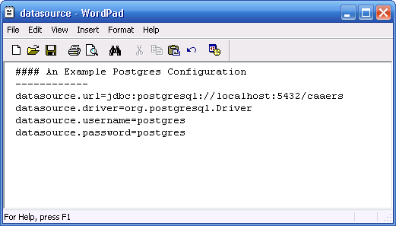

3.0 Configuring Tomcat
- Add the following lines in ${tomcat.dir}/conf/catalina.properties (Every file referenced below will be contained in the ${tomcat.dir}/conf/cabig/ folder)

gov.nih.nci.security.configFile= ${tomcat.dir}/conf/cabig/ApplicationSecurityConfig.xml
java.security.auth.login.config= ${tomcat.dir}/conf/cabig/csm_jaas.config

- To manually install these configuration files:
  - Create a new folder: ${tomcat.dir}/conf/cabig
  - Copy all the files in ${workspace}/projects/core/tools/csm/conf/cabig to ${tomcat.dir}/conf/cabig

    - Open ApplicationSecurityConfig.xml and caaers.hibernate.cfg.xml in a text editor and replace the following:
    - @csm.context.name@ to caaers
    - @tomcat.security.dir@ to ${tomcat.dir}/conf/cabig

- Open the csm_jaas.config and change the following fields:
  - Driver
  - url
  - user
  - psswd

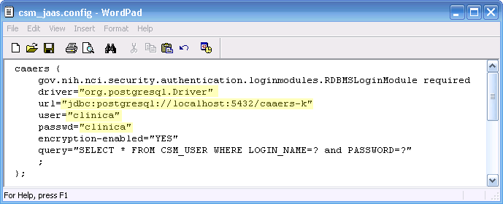

(The above screenshot is an example for Postgres. If you are using Oracle please make the appropriate changes.)

- Open caaers.hibernate.cfg.xml and change the following datasource related properties
  - Username
  - Password
  - URL
  - Driver Class
  - Dialect

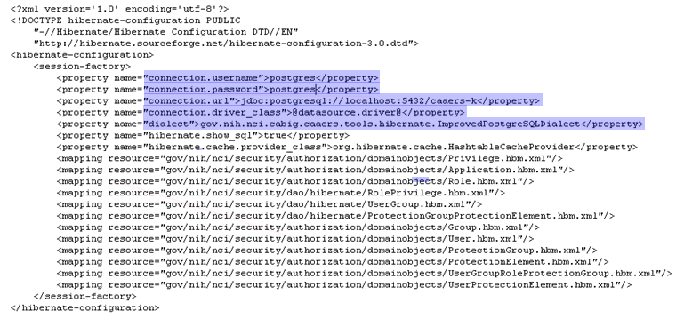
(The above screenshot is an example for Postgres. If you are using Oracle please make the appropriate changes.)

4.0 Enabling SSL
Please refer to the detailed instructions available in http://tomcat.apache.org/tomcat-5.0-doc/ssl-howto.html, to enable SSL.
4.1 Generate a Certificate
- From the command prompt switch to ${tomcat.dir}/conf/cabig, then run the following command
keytool -genkey -alias tomcat -keyalg RSA -keystore caaers_keystore. This will generate a file, “caaers_keystore” in the active directory.

- The keytool command will request the following information, please complete each field
  - Store password
  - Firstname
  - Last name
  - Dns
  - Key password
4.2 Updating the server.xml
- Switch to ${tomcat.dir}/conf, open the server.xml in a text editor
- Search for the lines “<!-- Define a SSL Coyote HTTP/1.1 Connector on port 8443 -->”
- Update the <Connector> element, by un commenting it and specifying the relative directory of the keystore.

<!-- Define a SSL Coyote HTTP/1.1 Connector on port 8443 -->
<Connector className="org.apache.coyote.tomcat5.CoyoteConnector"
port="8443" minProcessors="5" maxProcessors="75"
enableLookups="true" disableUploadTimeout="true"
acceptCount="100" debug="0" scheme="https" secure="true";
clientAuth="false" sslProtocol="TLS"
keystoreFile="conf/cabig/caaers_keystore"/>

5.0 Loading the Database with the Schema/Deploying the caAERS.war
- Copy the caaers.war file from the directory ${caAEERS}
- Start Tomcat, by executing the startup.bat or startup.sh file located in ${tomcat.dir}/bin
- Starting Tomcat will automatically deploy the caaers.war file, this will create a /caeers directory within ${tomcat.dir}/webapps and load the schema into the caaers database
- Open a Browser and navigate to http://localhost:8080/caaers/
- The test login name is “SYSTEM_ADMIN” and password is “system_admin”.

Please refer to the caAERS QuickStart Guide to set up the required information to use the application.

6.0 Setting up The Secure Data Grid Service
6.1 Installation
In order to install the caAERS grid service it is required that the globus toolkit be available on tomcat. The following instructions pertain to installation of globus on tomcat.

- Download the following toolkit: http://www-unix.globus.org/toolkit/survey/index.php?download=ws-core-4.0.3-bin.zip
- Unzip the compressed folder in an appropriate directory.
- Open the command prompt and navigate to the unzipped directory which should be named: ws-core-4.0.3.
- On the command line type: “ant -f share\globus_wsrf_common\tomcat\tomcat.xml deployTomcat -Dtomcat.dir = tomcat_home,” where tomcat home would be the directory where tomcat is installed.
- If the build is successful, then navigate to the webapps folder of tomcat and make sure the “wsrf” folder has been created.

Now we can continue with the installation of the caAERS Grid Service on globus on tomcat.

- Download the zip file ( caAERSDataService.zip ) from <URL>
- Unzip it to an appropriate folder.
- Open the command prompt and navigate to that folder.
- Type: “ant deployTomcat” ( Make sure CATALINA_HOME is pointing to the appropriate tomcat )
- If deployment was successful, start tomcat
- To check if the caAERS data service is up and running type the following URL in the browser
https://<host name>:8443/wsrf-ds/services/cagrid/caaers?wsdl
This should show the wsdl ( it is just an xml ) in the browser.
6.2 Preparation for using grid client

The grid client is used to access the caAERS Data Service. This requires that the grid service is correctly configured.

6.2.1 Configuration

The following requirements are assumed to be true in order for configuration to be performed:

- It is assumed that grid security infrastructure is in place [Dorian, syncGTS, IDP].
- Given an existing infrastructure the following information needs to be extracted:
  - The URL for Dorian.
  - The root certificate [CA] of Dorian.
Copy the root certificate of Dorian on the client machine under the following directory: $user_home/.globus/certificates. Make sure the extension of the certificate is “.0” [“dot zero”]. Also copy this certificate into the userhome where the caaers data grid service is running. It is important that the certificate should be applied in the userhome of the user account under which tomcat is running. Finally change run-tools.xml. A sample of run-tools.xml is shown below.

<project name="run-tools file" basedir="." default="runClient">
<target name="runClient" depends="checkGlobus, defineClasspaths" description="Run the sample Client">
<property name="service.url" value="data service url " />
<property name="dorian.url" value="dorian url" />
<property name="uid" value="userid" />
<property name="pwd" value="password" />

<echo message="Connecting to service: ${service.url}" />
<java classname="gov.nih.nci.cagrid.caaers.client.ClientTest" classpathref="run.classpath" fork="no">
<jvmarg value="-DGLOBUS_LOCATION=${ext.globus.dir}" />
<arg value="${service.url}" />
<arg value="${dorian.url}" />
<arg value="${uid}" />
<arg value="${pwd}" />
</java>
</target>
</project>

The user needs to specify the following properties in run-tools.xml:
- service.url: This is the URL of where the service is located. Typically the value for the service URL will look like: https://localhost:8443/wsrf-ds/services/cagrid/Caaers
- dorian.url: Specify the URL of where Dorian is located. Typically the value for the Dorian URL will look like: https://localhost:8443/wsrf-ds/services/cagrid/Caaers
- uid and pwd: This should be the user id and password for an existing user account in Dorian IDP.

6.2.1 Running the grid client

After suitable setup of the run-tools.xml, the caAERS data service can be accessed as follows:

- Go to the command prompt
- Navigate to the folder where caAERSDataService.zip was unzipped
- Type: “ant runClient”
- The client should run and be able to successfully connect to the caAERS data service.

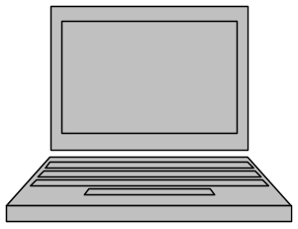
DorianSecure Data Grid Service
IDP
CA
Client
caAERS
[Secure Data Grid Service]
run-tools.xml

7.0 Installing ESB for caAERS-AdEERS Integration

Contacting Technical Support
Application Support | Please direct any concerns to the Project Manager of the caAERS Development team, Edmond Mulaire.

