Compatibility Submission Package

A number of artifacts will be required for the V/CDE and Architecture WS Mentors to adequately review an application for silver level compatibility. Many of these artifacts are unique to the V/CDE or Architecture WS, however a few will need to be reviewed by both the V/CDE and Architecture mentors. All artifacts required in the Compatibility Submission Package are listed below.

The compatibility submission package will comprise the following artifacts:
- Brief Description of the data system and its design (a power point presentation to the VCDE and Arch WS.)
- Requirements/Specification Document (required to provide context)
- Implementation/Design Document (optional: recommended to provide context)
- UML Model (including Diagram) for the data system in Enterprise Architect Format (EA format preferred but not required)
- Semantically annotated XMI file describing the data system. This file must be in XMI 1.1 format with the Rose/Unisys extensions
- Completed Semantic Integration Workbench (SIW) report (see appendix 1) and clean error log from SIW.
- UML Loader checklist (see appendix 2)
- Value Domain Report (see appendix 3)
- Vocabulary Report (see appendix 4)
- Standards Report (see appendix 5)
- Full CDE Use Report (export from CDE Browser)
- An API description document (e.g., JavaDocs, PerlDocs, or word document)
- Adopter Test Log (for API)
- Pointers to CVS or other repository for software code that shows objects input and output from system.
- Test Approach document (optional: recommended to provide context)
- Use Case Documentation (optional: recommended to provide context)

Artifacts will be used by the V/CDE mentors to determine if the application satisfies silver level compatibility for CDEs, vocabularies and models. Artifacts will be used by the Architecture mentors to determine if the application is using an open access messaging interface that will be able to be grid enabled at a future point. Note, grid enablement is not a criterium for silver level compatibility. A more detailed checklist and review process will be established for a gold level compatibility review. Both the V/CDE and Architecture WS mentors will need to review the UML model in detail as the model also contains important information about the API.

This package is designed to provide sufficient information to the V/CDE and Architecture mentors to determine if the system meets the appropriate compatibility guidelines. Examples of many of the artifacts are included as appendices. The CDE use report is obtained from the caDSR by selecting ‘Download to Excel’.

V/CDE and Architecture Mentor Report:
The V/CDE and Architecture mentor report should contain the following elements:

- Exec. Summary/recommendation
- Compatibility Checklist
  - Information Models
    - Model Conforms to UML best practices
  - Vocabularies
    - Controlled Terminology used where appropriate
    - Standard Vocabularies used where appropriate
    - Vocabulary best practices followed
  - Data Elements
    - All attributes correctly annotated
    - All data elements loaded into the caDSR
    - Appropriate value domains curated
    - Standard Data Elements used where appropriate
    - ISO11179 best practices followed
  - Messaging Interfaces/APIs
    - API is Open access
    - Well-described
    - Can be exposed as a grid node
  - Model suitability
    - Classes sufficiently distinct for appropriate semantic integration
    - Semantic annotation conforms to described data.
- Known Deficiencies and Recommended Corrections
- These should be assembled as a powerpoint presentation to the VCDE and Arch WS’s and as an excel spreadsheet and Word document which documents and explicitly makes suggested and required changes.

Appendix 1: Sample Semantic Connector Report

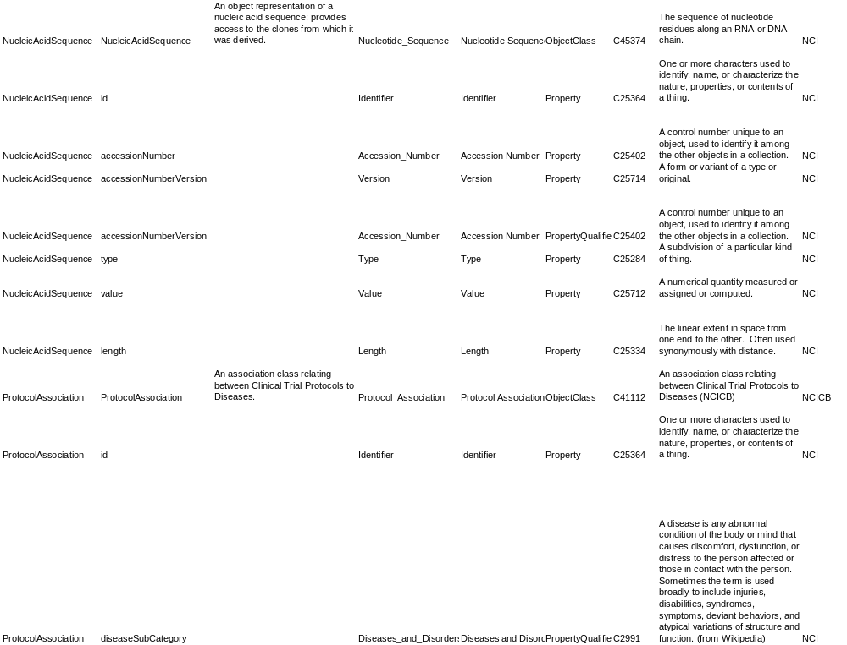

Appendix 2: UML Loader Checklist

To submit a UML model for registration in the caDSR, please complete the following.

Step 1: Complete the following information

- Contacts:

MODEL OWNER Submitting Organization Name: __________________________________________________________________________________
Model Owner name: ____________________________________________________________________
Model Owner email: ____________________________________________________________________
Model Owner Phone: ___________________________________________________________________
Point of Contact (POC) Name if different than Model Owner: name: _________________________________________________________________________________
POC email: ___________________________________________________________________________
POC Phone: __________________________________________________________________________
POST LOAD CONTACT (PLC): Who to notify when load is complete if different than POC:
PLC email: ____________________________________________________________________________
PLC Phone: ___________________________________________________________________________

- Run Time Parameters:

    - Information to identify the project in caDSR:

DESCRIPTION: Brief description of the model and intended usages: e.g. Application xyz is based on this model…to be used in the Classification Scheme definiton

_________________________________________________________________________________

_________________________________________________________________________________

Classification Scheme: Name (Project name)

________________________________________________________________________________
Classification Scheme Item: UML Package(s) Alias

_______________________________________________________________________________

_______________________________________________________________________________

_________________________________________________________________________________

Version being loaded: _____________ (e. g 1.0)
If previously loaded, what was the version number? _____________
    - WORKFLOW STATUS: Default workflow status for administered items:

_X_ Draft New (default unless otherwise specified) __ Draft Mod __ Released
    - CONTEXT: caDSR Context into which administered item are to be loaded:

____________ (e. g. caBIG, CTEP, CIP, NHLBI, etc)

- DATA TYPES: List attribute data types used in object model:
__________________________________________________________________

Step 2: Include the following in a zipped file

UML Model with diagrams
XMI file without diagrams (SDK Manual describes how to export the file.)
Semantic Connector report, if available
Value Domains with Permissible Value and Value Meanings for curation
Other metadata documentation such as Users Guides or Instructions

Step 3: Send the model to NCICB Applications Support

If sending via email –

Send the information to NCIBC@pop.nci.nih.gov
Include “For Semantic Connection” in the subject line
Attach the completed Submission Template
Attach the model and related documentation as a zipped file (change the extension .zip to .z before sending)

If sending the Submission Package on a disk or CD by mail or delivery service, enclose a printed copy of the completed Submission Template, include the zip file of documentation, and send to:

NCICB Application Support
Model For Semantic Connector
Suite 403
6116 Executive Blvd.
Rockville, MD 20852
Appendix 3: Sample Value Domain Report

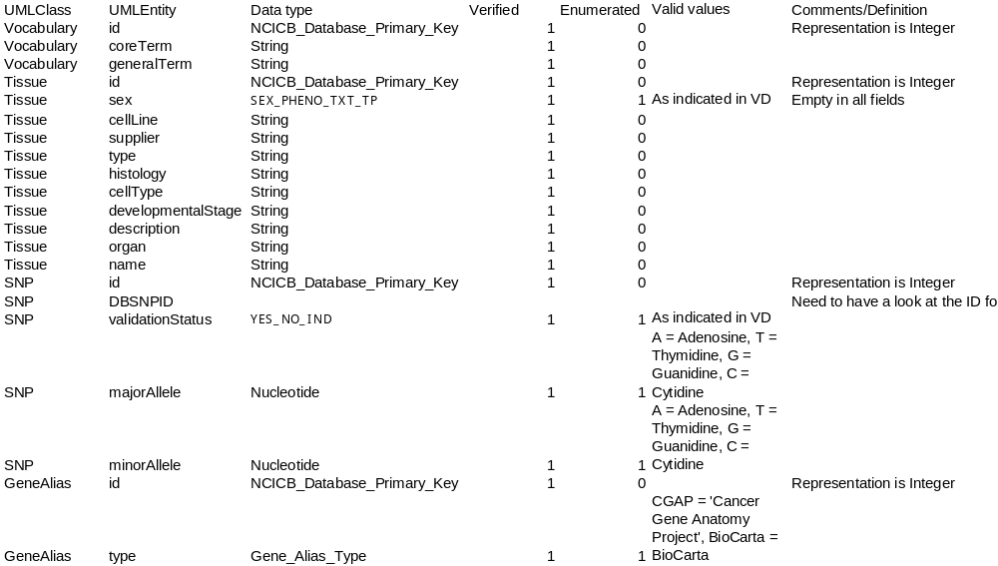
Appendix 4: Vocabulary Report
Instructions: Please list all controlled terminologies used in this project. For vocabularies that are not caBIG standards, please list the source of the vocabulary and a URL/URI where they can be obtained.

Name | Source | URL/URI | UML Class:Attributes that utilize this vocabulary
Appendix 5: Standards Report

Instructions: Please list all relevant CDE and vocabulary standards used in this project. In addition, please list any standards relevant to your subject area that were not used, along with an explanation for bypassing these standards in the section marked ‘Deviation Report’. In the deviation report please assign ‘Type’ using ‘V’ for vocabularies and ‘CDE’ for Common Data Elements. Under ‘Identifier’ please list CDEs by public ID and version; for vocabularies, please give the vocabulary name.

CDE Standards Used:
Public ID | Version | Long Name

Vocabulary Standards Used:
Vocabulary Name | UML Class:Attributes that utilize this vocabulary

Deviation Report:
Type | Identifier | Explanation

