
National Cancer Institute
Center for Bioinformatics
(NCICB)

caArray
Use Case Summary

Last Revised: | 6.13.2007
Produced By: | NCICB Development Team
Version: | 0.3

Document Approvals
The list contains the name for the core project team and any key stakeholders who have an interest in the success of the project. An “S” identifies persons responsible for approval from the Business and Development. Sign off of the document would be required when a decision is made not to take action for defined gaps.
S | Name | Role | S | Name | Role
S | Anand Basu | NCICB Engineering Manager | S | Juli Klemm, Ph.D. | Product Manager
 | Brent Gendleman | Development Project Manager |  | Jerry Eads | NCICB Project Manager
 | Eric Tavela | Development Architect |  | Ron Keene | NCICB Independent QA
 | Don Swan | NCICB Application Support
Revision History
When you make a change to a document, you must add an entry to this Revision History table and you must manually type the Last Revised Date on the front cover.
Date | Version | Description | Revised by
4/6/2007 | 0.1 | Initial Draft | Rob Daly
5/14/2007 | 0.2 | Detailed for Review | Brent Gendleman
6/12/2007 | 0.3 | Incorporated Product Manager’s scoping of the Use Cases for the 2.0 Release | Brent Gendleman

Table of Contents
1. Introduction 5
2. Use Case Model 5
2.1. Use Case Model 5
2.2. Actors 6
2.2.1. Anonymous User 6
2.2.2. Biostatistician 6
2.2.3. caArray User 7
2.2.4. Collaborator 7
2.2.5. Curator 7
2.2.6. Data Owner 7
2.2.7. External System 7
2.2.8. Lab Administrator 7
2.2.9. Lab Scientist 7
2.2.10. LDAP 8
2.2.11. Patient 8
2.2.12. Principal Investigator 8
2.2.13. Project Executor 8
2.2.14. Project Submitter 8
2.2.15. Registered User 8
2.2.16. Research Scientist 9
2.2.17. System Administrator 9
2.3. Annotation and Array Management 9
2.3.1. Data Extraction 10
2.3.2. Project Management 11
2.3.3. Data Submission 12
2.3.4. Validation 14
2.3.5. Navigation 15
2.3.6. Manage Queries 15
2.3.7. Manage Virtual Project 15
2.3.8. Navigate Repository 15
2.3.9. Organize Workspace 16
2.3.10. Search for Arrays Using Natural Text 16
2.3.11. Search Repository 16
2.3.12. Search Using Filters 16
2.4. System Administration and Reporting 16
2.4.1. Administration 17
2.4.2. Curation 17
2.4.3. Reporting 19
2.4.4. User Management 19

Introduction
The Purpose of this Document is to define the Use Case for caArray. It is an auto-generated document from Enterprise Architect via the RTF Document Generator using the caArray Use Summary template. The primary goal of caArray is to further translational cancer research through acquisition, dissemination and aggregation of high quality array data to support subsequent analysis. Further, the opportunity for caArray to evolve to handle other types of array data will provide greater impetus for use among the Cancer Centers and their collaborators which will ultimately benefit the cancer community. Data from expression, SNP, methylation, and protein arrays are anticipated for inclusion in caArray. Also under consideration are the burgeoning platforms of RNAi and CHip-chip data. Tissue microarrays represent another array-based technique that require a significantly different business process in their creation but are being considered for inclusion in the repository.

Use Case Model

Use Case Model
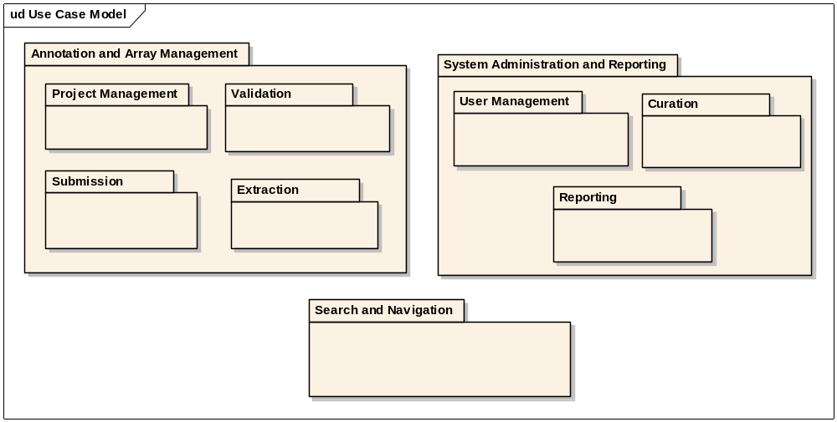
Figure:: Use Case Model
This is the overall package structure of the use case model.

Actors
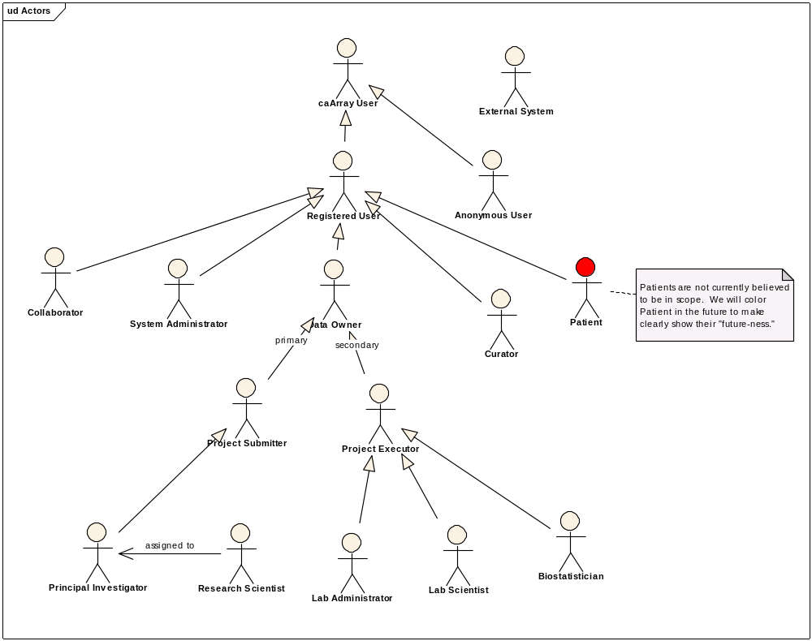
Figure:: Actors

Anonymous User
This is any user who visits caArray but does not get identified through a log in or other form of authentication/authorization. Another name for this actor might be "public user."

Biostatistician
A biostatistician is a special form of submitter who is responsible for statistical analysis of project data. The key actions to be performed are review of experiment designs, submission of quality control metadata, and uploading of normalized data and the annotation of the parameters used.

caArray User
caArray User is anyone who directly accesses caArray, via the interactive or programmatic interfaces. Immediate descendents include Registered User and Anonymous User. In the case of extraction, a caArray User has a need to extract arrays (including array data and annotations) for "downstream" use, such as analysis via analytic tools or importing into additional repositories.

Collaborator
A collaborator is assigned by a Principal Investigator to receive a "preview" of a project and possibly even work on a subset of the project. A preview represents access to a project prior to its being made public by the Principal Investigator. The collaborator(s) is expected to actively contribute to the project's execution by providing samples and/or analysis.

Curator
A curator is a caArray user responsible for curating the data present in caArray. Curators have special privileges to ensure the quality (through editing, demoting, and promoting) the content of caArray.

Data Owner
A data owner represents the primary users of the application from the research lab and the core facility.

External System
A generalized Actor intended to represent those applications/systems that programmatically communicate with caArray. Examples of external sstems we know want to interact with caArray include WebGenome, geWorkBench, and caIntegrator.Examples of programmatic access might include an API, web service, or grid -- specific mechanisms that will be supported have not been solidified.

Lab Administrator
A lab administrator is responsible for managing lab operations. They will typically interact with submitting investigators, assign work, and run reports on the operations of the lab.

Lab Scientist
A lab scientist is the primary handler of samples in the lab. They run the experiments, collaborate with the statisticians and document their activities step by step.

LDAP
LDAP (Lightweight Directory Access Protocol) is a software protocol for enabling anyone to locate organizations, individuals, and other resources such as files and devices in a network, whether on the public Internet or on a corporate intranet. LDAP is a "lightweight" (smaller amount of code) version of Directory Access Protocol (DAP), which is part of X.500, a standard for directory services in a network. LDAP is lighter because in its initial version it did not include security features. LDAP originated at the University of Michigan and has been endorsed by at least 40 companies.

Patient
NOTE: We do not believe Patient will be in scope for 2.0, but we felt we should capture it for now.

Principal Investigator
A specific form of Submitter, a Principal Investigator (PI) typically owns experiments and studies/projects.

Project Executor
A generalization of the core facility roles, this actor is used to simplify use case writing.

Project Submitter
A project submitter is a specific form of Registered User who will be most likely to make submissions of projects, including the experimental design, the desired samples and the quality control governing the samples. They will belong to an institution, most likely through an association with a particular research lab.

Registered User
A registered user is a specific form of caArray User who is known to caArray (done so throuhg the act of registering).One must be a Registered User before one can submit to caArray.In terms of submission, a registered user can actively contrbute and maintain arrays (including array annotations and array data) to caArray. Registered users who perform submissions are typically researchers with something valuable to offer caArray, such as a Lab Scientist or Prinicpal Investigator.

Research Scientist
This actor supports the principal investigator in performing data entry tasks such as submitting a project's experimental design, sample annotation and quality control metrics used in the collection and treatment of the samples. While the project's "owner" is the Principal Investigator, we anticipate that the data entry activities will be performed by individuals with this role assigned

System Administrator
A system administrator is responsible for ensuring caArray operates effectively. They are repsonsible for managing users and groups, providing status of the quality of operation of the caArray application, and ensuring the system is backed up and recoverable, among other things.

Annotation and Array Management
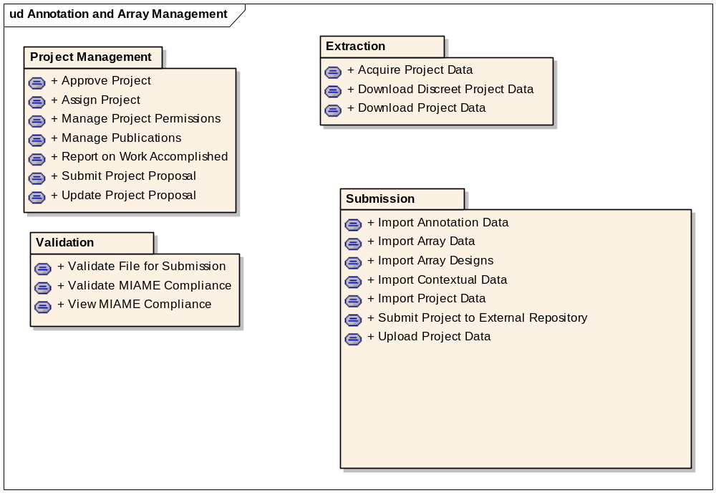
Figure:: Annotation and Array Management

Data Extraction
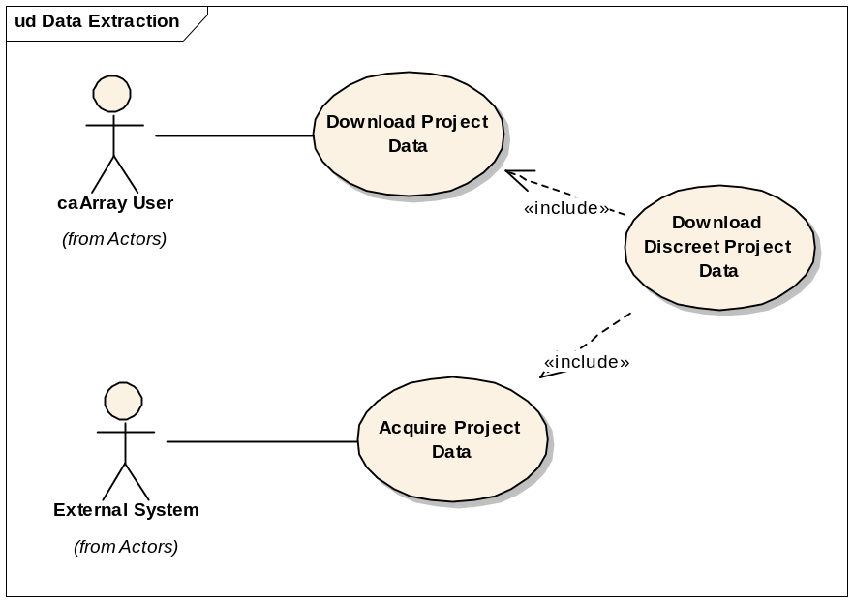
Figure:: Data Extraction

Acquire Project Data-- High
Initiated by an External System - though primarily by caBIG Analysis Services - this use case allows for the extraction of project data that is public and protected data is the appropriate authorization is used. This is not intended to be executed through a user interface, rather this will be accomplished through an API and will likely invoke other use cases (particularly search) to find and then acquire the data desired to be pulled into the other application. The use case may expand to include external systems such as GEO or Array Express or other systems that are local to the installer that may have an interest in the data contained in caArray.

Download Discreet Project Data - Low
Initiated by any user, this use case allows for a subset of array data and its associated annotation to be extracted from caArray. Rather than pulling the entire .cel file for example, a much smaller subset of the data contained within the .cel file would be available - such as five of the thousands of rows for a given set of gene names.

Download Project Data - High
Initiated by any caArray User, this use case allows for the extraction of data from any publicly available instance of caArray. No permission restrictions are required to acquire the data, either at a project level or inidvidual samples within or across projects. For data that is permission protected, the same mechanism will apply but only users associated with the project will be able to perform this action. Once the data of interest is found, the user should be informed of expected download time.

Project Management
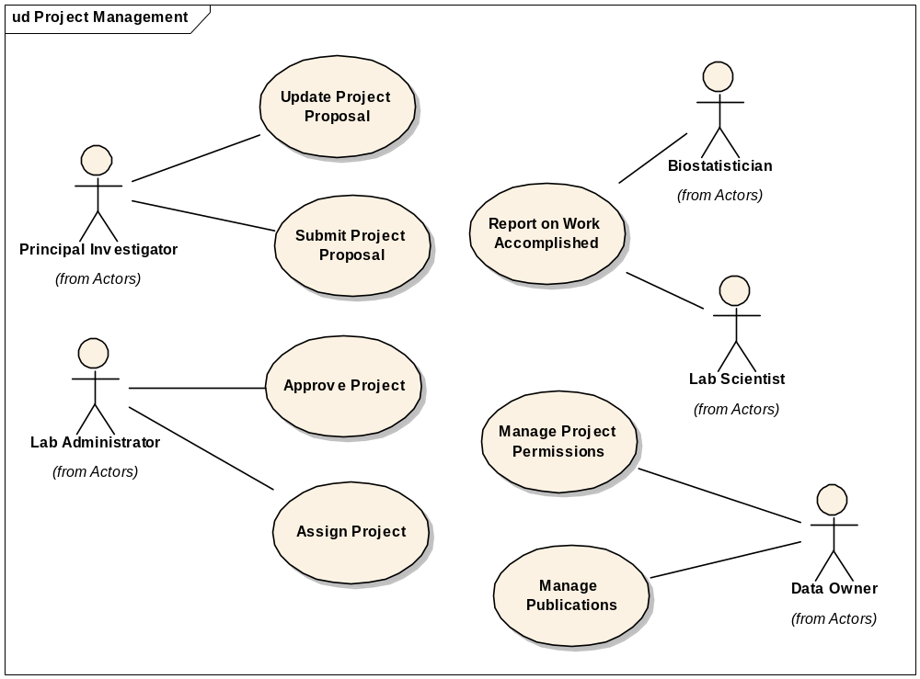
Figure:: Project Management

Approve Project - Medium
Initiated by a Lab Administrator, this use case provides the ability to review a project submitted to the administrator’s core, edit it if necessary, write comments and make a decision to return it for revision, reject it or approve the project.

Assign Project - Medium
Initiated by a Lab Administrator, this use case supports the assignment of a lab scientist and a biostatistician for a particular project or reassigns the project as needed.

Manage Project Permissions - High
Initiated by a Data Owner, this use case allows for the promotion of a project's visibility. This action can apply to an entire project or to specific samples within the project. The basic visibility states of the project are: restricted, institution, group, public and collaborator. There is no restriction on changing a project's visibility, though it is not advisable once a publication has been published against the project.

Manage Publications- High
Initiated by a Data Owner, this use case allows for the creation, editing and deletion of publication associations to a project. Common formats for publications will be presented in addition to the ability to auto-populate the fields based on pubmed id. Several types of publications are available: manuscripts, abstracts and posters. More than one association can be made.

Report on Work Accomplished – Med
Initiated by the Lab Scientist and at key analytical and quality control points, the Biostatistician, this use case allows them to detail what work they are doing step by step. The data entry performed will also be used by the system to inform the Principal Investigator and others interested, to see the status of work and kick-off timers for additional use cases.

Submit Project Proposal - Medium
Initiated by a Principal Investigator, this use case allows for the creation, editing and submission of annotation supports array projects. Several high level items will be covered including the platform of choice, funding mechanism, and sample annotation. A minimum set of information must be collected prior to being allowed to submit but almost as soon as a project is begun it can be saved as draft to be retrieved by the Principal Investigator when desired. In addition, the PI may choose to have a research scientist complete the submission on their behalf.

Update Project Proposal - Medium
Initiated by the Principal Investigator, this use case allows for editing a proposed project to reflect changes requested by the lab administrator or to simply update a proposal that is in draft status.

Data Submission
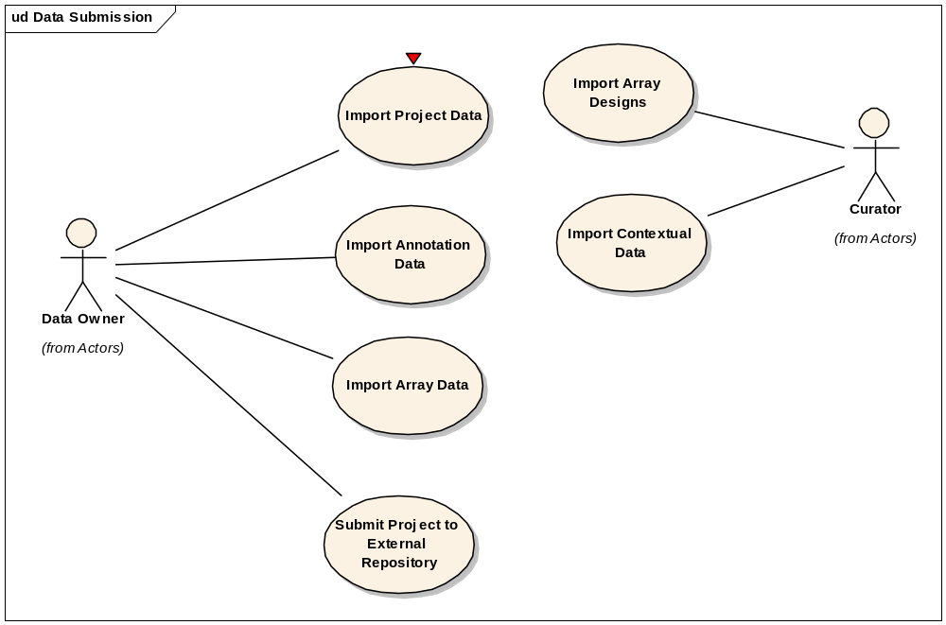
Figure:: Data Submission

Import Annotation Data - High
Initiated by a Data Owner, this use case permits the uploading of pre-formatted annotations into caArray from files on their local file system. MAGE-TAB is one format known to need support. MAGE-ML is a consideration that is currently supported in 1.5 but may be discontinued. Other formats are not identified.

Import Array Data - High
Initiated by a Data Owner, this use case represents the uploading of just arrays targeted to a particular sample or set of samples inside of a project. Typically, this use case will be initiated by a Lab Scientist, but we have made allowances for raw data to be uploaded by a PI's research lab.

Import Array Designs - High
Initiated by a Curator, this use case allows for the uploading of array designs on an as needed basis. A significant number of array designs will come pre-loaded from the NCICB but when necessary, a particular institution may need to upload array designs that are dated (when pushing in legacy data) or be in front of the curve (prior to official support).

Import Contextual Data - Medium
Initiated by a Curator, this use case allows for the import of non-project specific entries into caArray. Specifically, the entries include: contacts and organizations, protocols, hardware and software. For people, this use case does not create accounts - it just lessons the effort required to do so. The format for the import is to be determined but MAGE-TAB is an expected candidate.

Import Project Data - High
Initiated by a Data Owner, this use case enables the uploading of annotation and array content collectively into caArray. An essential flow of events will look something like:+ Data Owner navigates to target location of interest (a particular project, sample, set of samples, or a default uploading location sans project) that permits import.+ Data Owner chooses type of import from available actions.+ System shows what is available for import given the context.+ Data Owner chooses from possible choices..+ System responds with a file chooser dialog to locate file(s) to import.+ Data Owner uses file chooser dialog to locate file(s).+ If possible, Data Owner can select a "run in foreground" or run in background" option for impending import.+ Data Owner submits.+ System performs import. **(need to determine whether parsing should kick off "completion" or simply that the data made it and is available for parsing)+ System notifies user of completion.Due to the large file size of arrays, this may take minutes or even hours to complete (thus the "run in background".

Submit Project to External Repository –Low
Initiated by any Data Owner for a particular Institute, this use case enables the project annotation and array data to be deposited in web-based microarray repositories. Two repositories have been identified, the Gene Expression Omnibus and Array Express. The desire is to enable the system to automate this process fully, but a manual process will be required until those two systems allow for other techniques to be employed. Once a project has been submitted, the status will be indicated to all. Special Requirements, such as acquiring and inputting the Accession Number from GEO on a per sample basis will become available.

Validation
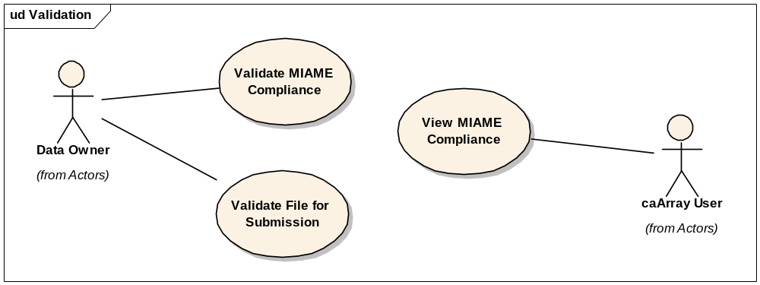
Figure:: Validation

Validate File for Submission - High
Initiated by a Data Owner, this use case enables the verification of annotation or array data or both to be validatated prior to submission. This use case is primarily an extension point to the Upload Data use case, but in case a user only wants to validate as a guide for additional work to be performed, it is available external of the Upload Data actions.

Validate MIAME Compliance –Low
Initiated by a Data Owner, this use case allows for a per project or per form validation to be run and to return positive or negative reports to the user. In the case of a negative report, the area of MIAME affected and the causal elements (or lack thereof) will be presented. The report status does not affect whether the project can continue or even to be made public. However, indicators will be present in a summary view of the project and it can be used as a search criteria.

View MIAME Compliance –Low
Initiated by a caArray user, this use case allows for anyone to view whether a project in MIAME compliance or not and to investigate why it isn’t.

Navigation
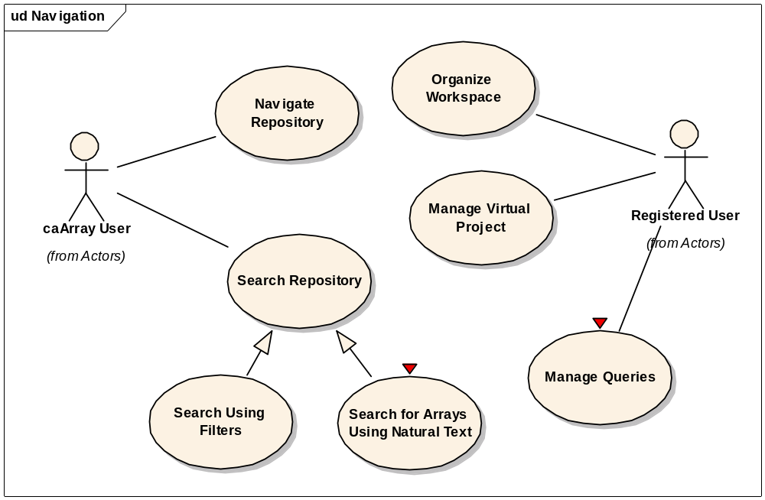
Figure:: Navigation

Manage Queries - Low
Initiated by any Registered User, this use case allows for the saving of criteria used in searches that the user found valuable. They will be able to name the search, re-run it when they like, and change paramters. While no version control is expected (or implied) the abilty to copy a search and modiy the copy is available to the user. In addition, the ability to share a "query definition"(the name plus the parameters) with another user is envisioned though defered past 2.0

Manage Virtual Project - Medium
Initiated by any Registered User, this use case enables the creation, editing, and deletion of virtual projects within one's workspace. A virtual project contains references to other project information, most commonly sample annotation and arrays, and supports features common to "real" projects, such as downloading data. The names must be unique per user and will be made available when reviewing other projects for taking additive actions (e.g., "send to virtual project").

Navigate Repository - High
Initiated by a caArray User, this use case presents a tabular, and perhaps graphical, representation of high level meta data about the contents of the repository. The number of projects available by state, species, platform and disease type will be displayed with the ability to switch from a local instance to those available across the caGRID.

Organize Workspace - High
This use case permits Registered Users to preserve references to arrays for ease of access and navigation in future sessions. the concepts of folders and subfolders will likely be very familiar to users and we intend to put as few limitations/structure as possible. A default structure of projects and samples will be made available. This is distinct from virtual projects which collects references within one project.

Search for Arrays Using Natural Text - Medium
A.K.A. "Spotlight" Search or "Horizontal" Search - caBIO TeamThis is a free text, single edit field search that quickly finds results (<10 seconds typically) though the results will be governed (e..g, never more than 150 arrays returned). It is assumed a handful of important (and indexed) fields are considered. Consider the Spotlight search Apple employes, particulalry the text search of the Apple iTunes Store.... millions of items to be searched, extremely fast and governeed results.

Search Repository - High
This is a generlized use case that describes how users will be able to locate content of caArray based on user-specified criteria. We will likely offer several forms, including friendly "iTunes-like" natural text searches that search a limited set of often-referenced values, filter-based searches on high level entities (protocols, investigator, etc.), and potentially more discrete/field-specific searches based on specific values and ranges of values (such as certain genes with a minimal intensity value, or specific probe sets, etc.). The most significant value will be not just the ability to find information but to do something with the result - download the data, directly hyperlink to additional data, easily refine the query parameters.

Search Using Filters - High
This is a conventional field-based search. The filters for each entity that can be searched are driven by those entities. For example, Name or Applicable Platform might be filters for a search of and for Array Designs.

System Administration and Reporting

Administration
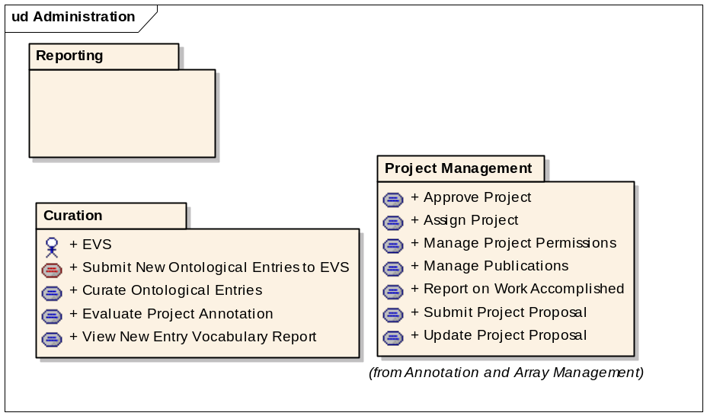
Figure:: Administration

Curation
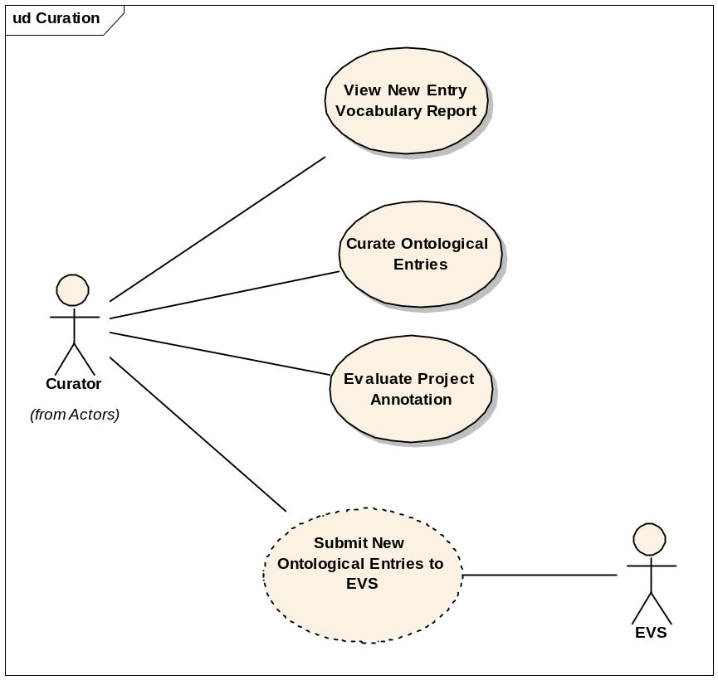
Figure:: Curation

Curate Ontological Entries - Low
Initiated by the Curator, Curate is a generalized use case to describe the act of curating caArray's submitted content.The sorts of things we anticipate requiring curation include:1) Shareable resources such as protocols and array designs and their names.2) Projects, to ensure that their annotaitons are meaningful and consistent.3) Proposal and promotion of ontology entries, even those that are merely referenced by caArray but are maintained by external organizations.

Evaluate Project Annotation - Low
Initiated by a Curator, this use case allows for the review of entries made by Data Owners in the execution of a project. Similar to the spirit of copy editing a paper, the meaning can't be changed, only clarified or made consistent, in support of quality project annotation.

Submit New Ontological Entries to EVS - Low
Initiated by a Curator, this use case allows for the compilation of entries that have resulted from project activity or which are invented by the Curator and submit them to EVS. caMOD has implemented a process to support this.

View New Entry Vocabulary Report - Low
Initiated by a Curator, this use case reports on new terms that have been submitted by Data Owners during the course of a project's execution. The data is made available as soon as a project has moved into the "complete' state. The report allows a curator to review any new items and to take the appropriate action (accept or edit).

Reporting
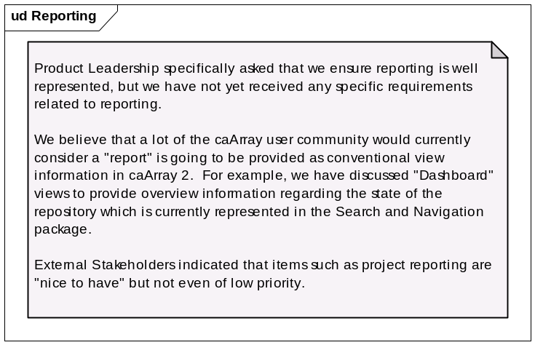
Figure:: Reporting

User Management
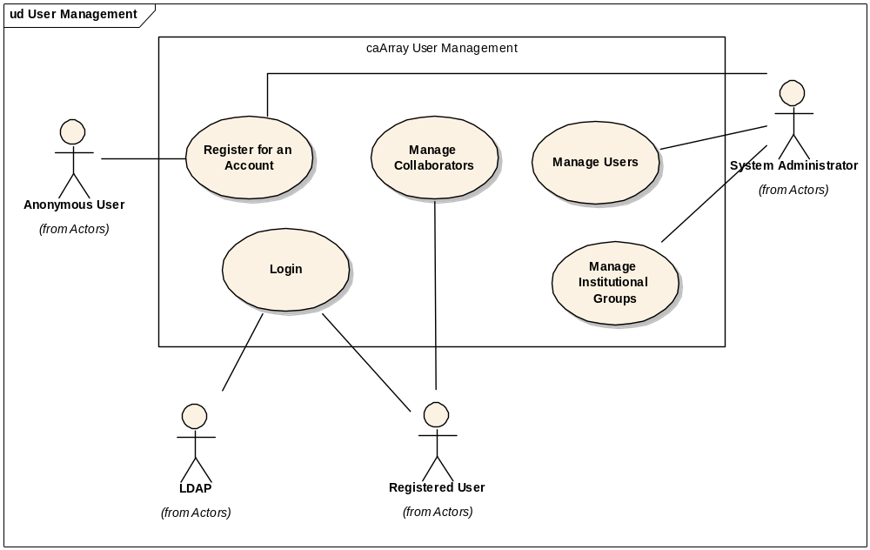
Figure:: User Management

Login - High
Initiated by any Registered User, this use case allows for the validation of the authenticity and authority of the given user either against a networked (LDAP) set of users or a local set (database).

Manage Collaborators - High
Initiated by a registered user, this use case allows for the creation, editing and deletion of collaboration groups and the users within them. This set of users can then be given access by a Data Owner to a project, set of projects or particular samples and their underlying array data. In order to add a collaborator, they must also be registered in the system.

Manage Institutional Groups - High
Initiated by a System Administrator, this use case allows for the creation, editing and deletion of an Institution's groups. This typically will help organize an institution's research labs and core facilities, which will allows for organizing users among them. However, the ability to create supersets of institutions will also be available to the System Administrator.

Manage Users- High
Activate a User: An Admin user can disable an "Inactive" caArray user from the Modify User Details screen. On this screen, there will be a button Activate User next to the user status. Clicking on this button will attempt to set the End Date value a blank string (null value). On successful save of the user information, the user account will be seen as active since there is no end date specified.Search: An admin user can search for groups existing in the system. The "Group Name" can be used as criteria to narrow down the groups list.An Admin user can disable an "Active" caArray user from the Modify User Details screen. On this screen, there will be a button Disable User next to the user status. Clicking on this button will attempt to set the End Date value to the previous day’s date. On successful save of the user information, the user account will be deemed to be inactive as the end date is set to the previous day. Once the Admin User accesses the User Management Area of the application, they can search for other caArray users. The following fields have been identified (initially) that can be used as criteria to narrow down the user list: + Login Name + First Name + Last Name + Institution + E-Mail AddressOnce a user has been found, the logged-in Admin user can view the user details by clicking on the hyperlinked User Name or Login Name fields.

Register for an Account - High
Initiated by an Anonymous User, this use case allows the user to gain access to restricted features. This may occassionally be performed on behalf of an anonymous user by the System Administrator. This functionality will allow the Admin user(s) to create new users for the caArray application. Note that the Password and Confirm Password fields are displayed only when the database is being used for authentication. If LDAP authentication is in use, these fields are not displayed and are, hence, not required.

