Iteration Plan
caArray 2.0 - Elaboration 2

Last Revised: | August 6, 2007
Produced By: | caArray Development Team
Version: | 0.3

Document Approvals
The list contains the name and contact information for the core project team and any key stakeholders who have an interest in the success of the project. An “S” identifies persons responsible for approval from the Business and Development. Sign off of the document would be required when a decision is made not to take action for defined gaps.

S | Name | Role | S | Name | Role
S | Anand Basu | NCICB Engineering Manager | S | Juli Klemm, Ph.D. | Product Manager
 | Brent Gendleman | Development Project Manager |  | Jerry Eads | NCICB Project Manager
 | Eric Tavela | Development Architect |  | Ron Keene | NCICB Independent QA
 | Don Swan | NCICB Application Support
Revision History
When you make a change to a document, you must add an entry to this Revision History table and you must manually type the Last Revised Date on the front cover.

Date | Version | Description | Revised by
7/28/07 | 0.1 | Initial Draft | Brent Gendleman
8/3/07 | 0.2 | Revised per team discussion | Brent Gendleman
8/6/07 | 0.3 | Revised per dev team review and compiling other considerations | Brent Gendleman
Copyrights and Trademarks
© Copyright 2007 by NCICB, caBIGTM. All rights reserved.

Table of Contents
1. Introduction 4
1.1. References 4
2. Plan 4
2.1. Iteration Activities 4
2.2. Iteration Schedule 5
3. Resources 7
4. Use Cases 7
4.1. Specifications to be detailed 7
4.2. Analysis to be performed 9
4.3. Architectural Prototype to be delivered 10
5. Evaluation Criteria 10
5.1. Project Management 11
5.2. Requirements 11
5.3. Analysis and Design 11
5.4. Implementation 11
5.5. Test 12
5.6. Deployment 12
5.7. Environment 12
5.8. Configuration and Change Management 12

Introduction
This Iteration Plan describes the detailed plans for the E2 Iteration of caArray 2.0. The Iteration duration has shifted a week from the estimate in E1 from August 30th to September 6. In addition, while E1 can claim many successes, there was unfinished business that is to be delivered in the first two weeks of this iteration.
During the E2 Iteration the requirements will be further analyzed and use case specifications will be detailed for an additional number of the use cases that must be analyzed for Elaboration to be a success. In addition, the User Interface has taken on a higher priority based on several factors – the most vital one being a switch from a functionality driven schedule to a time driven schedule where the product release must be available by the middle of December to be included in a bundle and the next being a desire to deliver an alpha release in October. The analysis and design for a discreet set of the architectural significant use cases selected for Release 2.0 will be completed. The architectural prototype will be developed to test the feasibility and performance of the architecture that is required for Release 2.0. Test data will be collected and used to demonstrate functionality with an initial release to Quality Assurance expected mid-way through the iteration (August 17th). By that time, the environment for automating the deployment of builds between Development and QA must be available, though the mechanism may change.

References
- project_management/caarray_schedule.mpp
- requirements/caarray_vision.doc
- requirements/caarray_use_case _summary.doc
- analysis_and_design/caarray_software_architecture_document.doc

Plan

Iteration Activities
The following activities, according to discipline, are planned for this iteration. The requirements and the analysis and design activities remain the focus; a significant portion of the effort will be establishing the physical architecture and proving several threads through it.
Activities | Start | End
Project Management | Fri 7/27/07 | Thu 9/06/07
Requirements | Fri 7/27/07 | Mon 8/31/07
Analysis and Design | Mon 8/6/07 | Fri 8/17/07
Implementation | Wed 8/1/07 | Thu 9/6/07
Test | Mon 8/13/07 | Thu 9/6/07
Environment | Wed 8/1/07 | Thu 8/16/07
Configuration and Change Management | Fri 7/27/07 | Fri 8/31/07

Iteration Schedule
As the iteration evolves over time, updates will be made to the Microsoft Project schedule on at least a weekly basis with 1 hour reviews scheduled each Wednesday. However, in order to support evaluating how we execute against the plan, the schedule is produced below.
Elaboration - Iteration 2 | 29.7d | Fri 7/27/07 | Thu 9/6/07
Project Management | 28.7d | Fri 7/27/07 | Wed 9/5/07
Dev Team Iteration Plan | 1d | Tue 7/31/07 | Tue 7/31/07
E1 Assessment | 0.5d | Mon 7/30/07 | Mon 7/30/07
E2 Review | 1d | Mon 8/13/07 | Mon 8/13/07
Weekly Status Meetings | 3d | Wed 8/1/07 | Wed 9/5/07
Hold Dev to QA Handoff | 2d | Thu 8/16/07 | Fri 8/17/07
Plan for Next Iteration | 2d | Fri 8/24/07 | Mon 8/27/07
Requirements | 25.7d | Fri 7/27/07 | Fri 8/31/07
Incorporate Stakeholder Feedback on Vision and Supp Spec | 16d | Wed 8/1/07 | Wed 8/22/07
Incorporate Stakeholder Feedback on E1 Use Cases | 3d | Fri 7/27/07 | Wed 8/1/07
UX Modeling/Wireframes (from E1 deferred) | 5d | Thu 8/9/07 | Wed 8/15/07
UI Mockups for Prioritized Use Cases | 7d | Thu 8/16/07 | Fri 8/24/07
Stylesheet Framework (from E1 deferred) | 5d | Mon 8/27/07 | Fri 8/31/07
Detail E2 Use Cases | 5d | Thu 8/2/07 | Wed 8/8/07
UC Download Project Data (from E1 deferred) | 0.5d | Fri 8/3/07 | Fri 8/3/07
UC Manage Users | 0.5d | Fri 8/3/07 | Fri 8/3/07
UC Manage Project Permissions | 1d | Mon 8/6/07 | Mon 8/6/07
Detail C1 Use Cases | 3d | Fri 8/10/07 | Tue 8/14/07
UC Navigate Repository | 1d | Fri 8/10/07 | Fri 8/10/07
UC Search Repository | 1d | Mon 8/13/07 | Wed 8/13/07
UC Search Using Filters | 1d | Tue 8/14/07 | Wed 8/14/07
Capture Special Requirements for SNPs | 5d | Thu 8/2/07 | Wed 8/8/07
Validate Project Data Files: Define Validation Rules | 1d | Fri 8/3/07 | Fri 8/3/07
Analysis and Design | 10d | Mon 8/6/07 | Fri 8/17/07
Use-Case Design | 5d | Mon 8/6/07 | Fri 8/10/07
Manage Project Permissions | 3d | Tue 8/7/07 | Thu 8/9/07
Validate Project Data Files | 1d | Fri 8/10/07 | Fri 8/10/07
Login | 1d | Mon 8/6/07 | Mon 8/6/07
Logical Model Final Draft | 2d | Mon 8/6/07 | Tue 8/7/07
Subsystem Design | 8d | Mon 8/6/07 | Wed 8/15/07
FileAccessService | 4d | Tue 8/7/07 | Fri 8/10/07
MageTabParser: Validation | 4d | Mon 8/6/07 | Thu 8/9/07
ArrayDataService: Validation | 2d | Fri 8/10/07 | Mon 8/13/07
ArrayDesignService: Validation | 2d | Tue 8/14/07 | Wed 8/15/07
Remote API Grid Implementation | 2.5d | Wed 8/8/07 | Fri 8/10/07
PermissionsManagementService | 3d | Mon 8/6/07 | Wed 8/8/07
Authorization Mechanism | 4d | Thu 8/9/07 | Tue 8/14/07
External Review: Grid API | 1d | Fri 8/10/07 | Mon 8/13/07
Finalize Deliverables | 2d | Thu 8/16/07 | Fri 8/17/07
Implementation | 27d | Wed 8/1/07 | Thu 9/6/07
E1 Completion | 3d | Wed 8/1/07 | Fri 8/3/07
Complete Hibernate Mappings | 10d | Wed 8/1/07 | Fri 8/3/07
Remote Java API | 3d | Wed 8/1/07 | Fri 8/3/07
Complete MAGE-TAB parsing | 3d | Wed 8/1/07 | Fri 8/3/07
Complete MAGE-TAB translation | 3d | Wed 8/1/07 | Fri 8/3/07
Subsystem Implementation | 17d | Mon 8/13/07 | Tue 9/4/07
FileAccessService | 5d | Mon 8/13/07 | Fri 8/17/07
MageTabParser: Validation | 5d | Thu 8/16/07 | Wed 8/22/07
ArrayDataService: Validation | 3d | Thu 8/23/07 | Mon 8/27/07
ArrayDesignService: Validation | 2d | Tue 8/28/07 | Wed 8/29/07
PermissionsManagement | 5d | Wed 8/15/07 | Tue 8/21/07
Object Access Authorization Mechanism | 2d | Wed 8/22/07 | Thu 8/23/07
Remote API Grid Implementation | 5d | Wed 8/29/07 | Tue 9/4/07
Implement Use Cases | 5d | Wed 8/22/07 | Tue 8/28/07
Manage Project Permissions | 3d | Wed 8/22/07 | Fri 8/24/07
Validate Project Data Files | 1d | Mon 8/27/07 | Mon 8/27/07
Login | 1d | Tue 8/28/07 | Tue 8/28/07
Implement Additional Array Design Parsers | 10d | Mon 8/20/07 | Fri 8/31/07
Illumina | 3d | Mon 8/20/07 | Wed 8/22/07
Affymetrix SNP | 2d | Thu 8/30/07 | Fri 8/31/07
Implement Additional Array Data Parsers | 11d | Thu 8/23/07 | Thu 9/6/07
Illumina | 4d | Mon 9/3/07 | Thu 9/6/07
Affymetrix SNP | 2d | Thu 8/23/07 | Fri 8/24/07
Affymetrix CHP | 2d | Mon 8/27/07 | Tue 8/28/07
Test | 19d | Mon 8/13/07 | Thu 9/6/07
Validate Project Data Files Test Cases | 1d | Wed 8/29/07 | Wed 8/29/07
Manage Permission Test Cases | 1d | Thu 8/30/07 | Thu 8/30/07
Import Data Files Test Suite | 1d | Fri 8/31/07 | Fri 8/31/07
Remote Java API Test Suite | 4d | Mon 9/3/07 | Thu 9/6/07
Finalize Deliverables | 2d | Mon 8/13/07 | Tue 8/14/07
Release Test Plan | 2d | Mon 8/13/07 | Tue 8/14/07
Environment | 12d | Wed 8/1/07 | Thu 8/16/07
Review Build and Deploy Plan with SCM Initiative | 0.4d | Wed 8/1/07 | Wed 8/1/07
Review and Demonstration Meetings (Eng + Prod | QA | Systems | 3d | Wed 8/1/07 | Mon 8/6/07
Complete Acquisition of DEV and QA Environment | 2d | Thu 8/2/07 | Fri 8/3/07
"Development Process ""Quick Start""" | 1d | Mon 8/6/07 | Mon 8/6/07
Complete DEV to QA Integration | 3d | Mon 8/6/07 | Wed 8/8/07
Incorporate Automated Deployment Process | 2d | Wed 8/15/07 | Thu 8/16/07
Configuration and Change Management | 25d | Fri 7/27/07 | Fri 8/31/07
Manage Gforge Content | 25d | Fri 7/27/07 | Fri 8/31/07

Resources
The development team will be at partial strength with 7 individuals. They are:
Team Member | Role | Percentage on Project
Brent Gendleman | Project Manager/Requirements Specifier | 50%
Eric Tavela | Architect | 80%
John Pike | Developer/PM Support | 80%
Rashmi Srinivasa | Developer/Requirement Specifier | 20%
Bill Mason | Developer | 100%
Todd Parnell | Developer | 80%
Matt Rehfuss | UI Designer | 80%

There are several vacations and other absences described below:
John Pike – out from July 30 – August 6
Eric Tavela – out from September 1 – September 17 (MGED Conference + Vacation)
Rashmi Srinivasa – on maternity leave from August 13- October 13
Todd Parnell – out from August 27 – Sept 4
In addition, Brent Gendleman will be onsite at the NCICB through August 1, and then from August 13 – August 23 and again between September 5 – 17.
We are considering options to fill potential gaps to ensure proper delivery by November – including moving or adding personnel.

Use Cases

Specifications to be detailed
Figure 1 represents all the use cases to be detailed by the close of Elaboration as defined in E1. However, recent changes have forced us to reconsider. Figure 2 demonstrates a slightly revised scale down of scope.
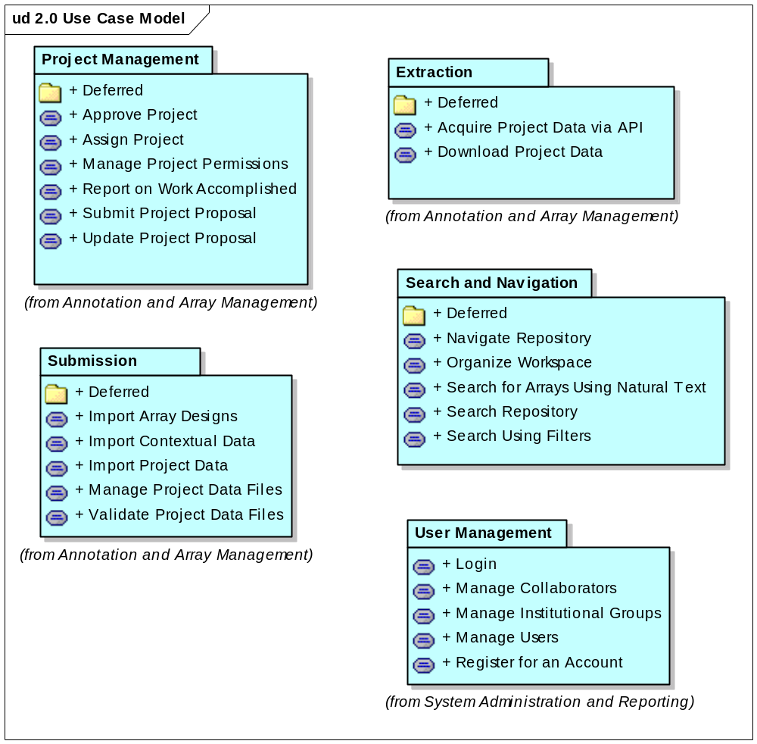
Figure 1. 2.0 Use Case Model from E1

For this iteration, we will prioritize the detailing of the following use cases:
  - UC Manage Project Permissions
  - UC Download Project Data
  - UC Manage Users
These should be done first to support analysis and design activities occurring during E2. The remainder will be tackled later in the iteration.
  - UC Navigate Repository
  - UC Search Repository
  - UC Search Using Filters
The entirety will be visualized through wireframes and html mockups culminating in a style sheet to be incorporated in C1 – with expected modifications from all stakeholders.

Analysis to be performed
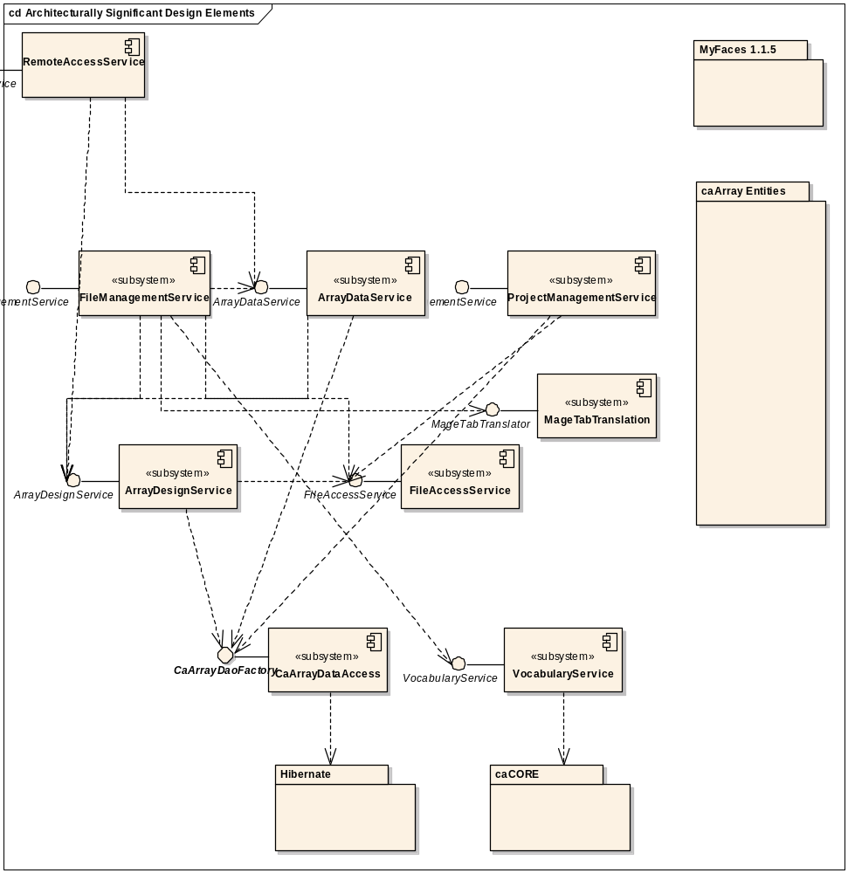
Figure 2. Architecturally Significant Design Elements

Architectural Prototype to be delivered
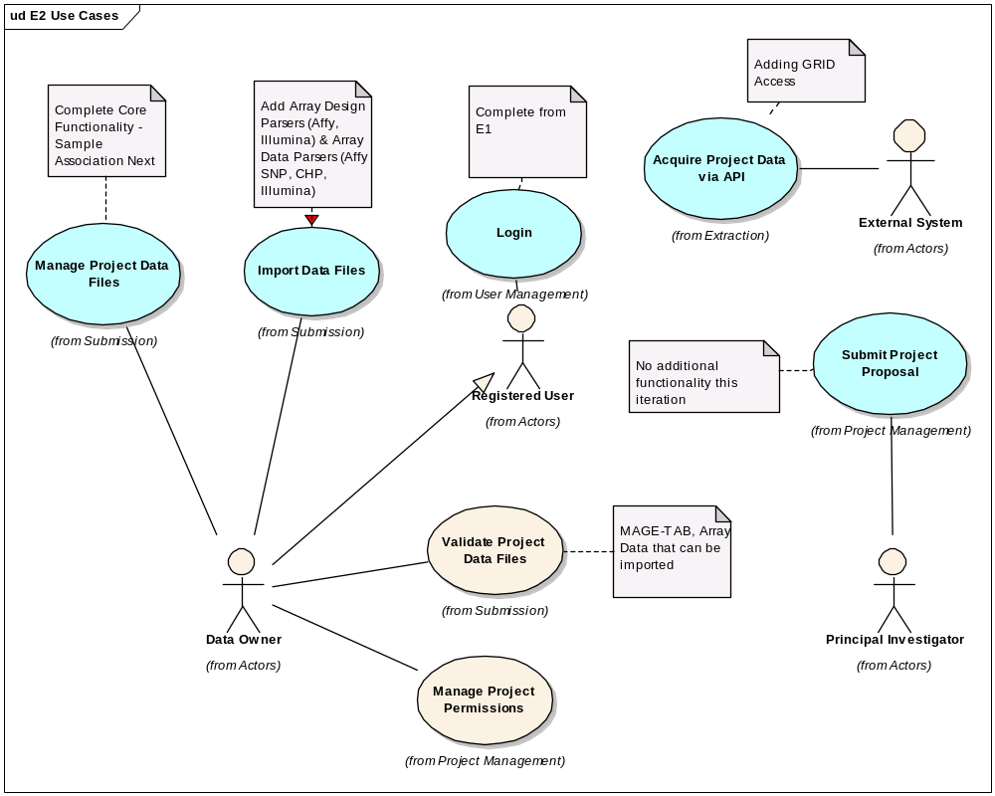
Figure 3 Use Cases for E2 Prototype
The use cases in Blue are ones initiated in E1 and the ones in white are being introduced in E2.

Evaluation Criteria
The primary goal of the E2 Iteration is to complete the analysis and design of selected use cases and to develop a working architectural prototype that eliminates significant risk. The risks to mitigated are:
- Finalizing the scope for the 2.0 release
- Upload, validation, parsing and storage of Affymetrix and Illumina data
- Grid accessibility to data
- Domain Object Model for caArray
- User Interface Design for significant use cases and supplementary requirements
- Ability to automate the deployment from DEV to QA
- Tech Stack Compatibility with Bundled Tools for the December Release
The more granular goals will be highlighted per discipline.

Project Management
The project schedule is updated in concert with the development team and reported to the external teams on a weekly basis.
The remainder of the E2 iteration is tightly planned and reported on, the C1 iteration is planned and available for the iteration review meeting, and the 2.0 Generation Plan is reviewed by all relevant teams and their input validated with the Product, Quality Assurance, Systems and Engineering Manager.
Each deliverable developed during the E2 Iteration will be peer reviewed and subject to approval from the team.
We complete the activities on time. We will end the iteration regardless based on the calendar but if we do not achieve all the tasks, it will be duly noted in the iteration review.

Requirements
All the targeted use cases for E2 plus all additional use cases that impact the architecture and/or user interface are written to ensure that the team has the appropriate time for additional analysis and design activities and the full set of use cases are available for C1 and all 2.0 use cases are available early in C1.
UC based wire frames, mockups and a representative style sheet for the use cases to be completed in C1 are available.
Begin interaction with User Documentation Team.

Analysis and Design
All targeted use cases modeled as use-case realizations in the caArray UML model.
Domain Object/Logical Model is peer-reviewed and updated to support caDSR submission and Silver Compliance at a minimum.

Implementation
Implement all identified Subsystems
Implemental use cases Login, Manage Project Permissions,
Establish GRID access through the API
Implement hybridization data file parsing and storage for Affymetrix and Illumina files (both SNP and gene expression).
Implement array design storage sufficiently to support import of Affymetrix hybridization data (SNP and gene expression).
Implement Validation for targeted formats (MAGE-TAB, Affy, Illumina)
Implement remote API for retrieval of hybridization data.

Test
Continue dialogue with Independent Quality Assurance (IQA) to establish policy and procedures for delivering tags and what they will contain depending on the iteration cycle.
Craft a test plan to incorporate all of our deliverables in concordant fashion with QA and external teams
Deploy two tags to QA – an initial handoff and an end of milestone release
Write automated tests for all implemented use case threads.

Deployment
Present a pilot for the automation of builds from DEV to QA and a plan to move forward and accommodate adjustments from respective teams

Environment
Work to establish DEV and QA Environments with Systems and QA
Manage and integrate all code and tests through Cruise Control.

Configuration and Change Management
Evaluate Requirement Priorities and manage GForge, models and documents to reflect decisions.

