Iteration Plan
caArray 2.0 - Construction 2

Last Revised: | October 3, 2007
Produced By: | caArray Development Team
Version: | 0.2

Document Approvals
The list contains the name and contact information for the core project team and any key stakeholders who have an interest in the success of the project. An “S” identifies persons responsible for approval from the Business and Development. Sign off of the document would be required when a decision is made not to take action for defined gaps.

S | Name | Role | S | Name | Role
S | Anand Basu | NCICB Engineering Manager | S | Juli Klemm, Ph.D. | Product Manager
 | Brent Gendleman | Development Project Manager |  | Jerry Eads | NCICB Project Manager
 | Eric Tavela | Development Architect |  | Ron Keene | NCICB Independent QA
 | Don Swan | NCICB Application Support
Revision History
When you make a change to a document, you must add an entry to this Revision History table and you must manually type the Last Revised Date on the front cover.

Date | Version | Description | Revised by
9/30/07 | 0.1 | Initial Draft | Brent Gendleman
10/03/07 | 0.2 | Revised to reflect C1 Status, Reorganized to support assigned responsibilities, relationship to upcoming deadlines in C2, C3, T1 | Brent Gendleman
Copyrights and Trademarks
© Copyright 2007 by CBIIT, caBIGTM. All rights reserved.

Table of Contents
1. Introduction 4
1.1. References 4
2. Plan 4
2.1. Iteration Schedule 4
3. Resources 7
4. Use Cases Error! Bookmark not defined.
4.1. Specifications to be detailed 8
4.2. Analysis to be performed 8
4.3. Software to be delivered 8
5. Evaluation Criteria 9

Introduction
This Iteration Plan describes the detailed plans for the C2 Iteration of caArray 2.0. The Iteration duration will be from October 9 to November 2. In addition, we have been unable to make up the ground from previous iterations E2 and C1 and need to address key functional areas and have a scope discussion for the 2.0 release. Many architectural issues – including but not limited to our use of CSM 4.0, caGRID 1.1., switch from JSF to Struts2, Domain Model Changes and associated impact, build and deployment automation across tiers have been overcome. However, we are roughly a full team month behind schedule which has a cascading affect on the other teams we depend on for the software to be successful (IQA, App Support, Documentation, Senior Management, caBIG clients and mentors). Other Architectural Issues remain that will be dealt with during the first week of the iteration – primarily a thorough understanding of the architectural framework, the ability to set and reach performance metrics, and the building out of the application’s features on top of the significant plumbing established. This is our plan to come out of the hole we dug ourselves and position the project with the opportunity for momentum and confidence to be rebuilt.

References
- project_management/caarray_schedule.mpp
- requirements/caarray_vision.doc
- requirements/caarray_use_case _summary.doc
- requirements/user_interface/wireframes/
- analysis_and_design/caarray_software_architecture_document.doc
- caarray gforge: https://gforge.nci.nih.gov/projects/caarray2/ (specifically the trackers for features, use cases, supplemental, test cases and defects)

Plan

Fundamental Tasks for Alpha
There is a significant milestone on October 19 – the desired release date of the Alpha Build. The entire focus of the team will be to support getting the software into a state where the entire team feels comfortable that the release is stable and worthwhile. While covered in a bit more detail in the remainder of this document, we are highlighting it here. The following key components must be available and validated:
Use Case/Component | State | Assigned Team Member
Domain Model | Approved | Eric Tavela
Performance Benchmarks | Set and Met by Dev, Validated by IQA | Bill Mason
Acquire Experiment Data Via API | Java and Grid Validated by IQA | Todd Parnell
Login | Ability to login and logout with different roles (PI default) | John Hedden
Register | Create an account (DB or LDAP) | John Hedden with support from Scott Miller
Upload Experiment Data Files | MAGE-TAB, Gene Expression, SNP for Affy and Illumina  Multiple files (.zip file representation to come next) | John Hedden with Eric Tavela for data support
Validate Experiment Data Files | MAGE-TAB, Gene Expression, SNP for Affy and Illumina | Bill Mason with Eric Tavela for data support
Import Experiment Data Files | MAGE-TAB, Gene Expression, SNP for Affy and Illumina | Eric Tavela
Manage Experiment Data File | Change Type and Delete | Bill Mason
Submit Experiment Proposal | Minimum Annotation to support experiment identity (summary data), save as draft, submit | Dan Kokotov
Update Experiment Proposal | Edit and Submit a draft experiment | Dan Kokotov
Manage Permissions | Set public/private flag on experiment | Todd Parnell
Download Data | Retrieve data through the UI (not full UI implementation) | Eric Tavela

Iteration Schedule
As the iteration evolves over time, updates will be made to the Microsoft Project schedule twice a week (Monday and Thursday) and the notes of the meeting will be distributed to the Product and Engineering Manager. We will also have 1 hour reviews scheduled each Wednesday with the Product and Engineering Manager and weekly Status Meetings across the entire team. While the schedule will be updated, it’s represented here at the start of C2 to support evaluating how we execute against the plan.
Discipline/Task | Duration | Start | Finish
Project Management | 21 d | 9/7/2007 | 10/5/2007
Weekly Status Meetings | 21 d | 9/7/2007 | 10/5/2007
Dev Team Iteration Plan | 1 d | 9/14/2007 | 9/14/2007
Meet with Documentation to support UC Transition | 1 d | 9/19/2007 | 9/19/2007
Meet with App Support to Validate UC's and Overall Product Releases | 1 d | 9/20/2007 | 9/20/2007
E2 Assessment/C1 Review | 0.5 d | 9/21/2007 | 9/21/2007
Plan for Next Iteration | 2 d | 10/1/2007 | 10/2/2007
Finalize Deliverables | 17 d | 9/7/2007 | 10/1/2007
Deliver C1 Plan | 4 d | 9/7/2007 | 9/12/2007
Update Risk List | 1 d | 9/20/2007 | 9/20/2007
Update Alpha and Beta Release Plan | 17 d | 9/7/2007 | 10/1/2007
August Status Report | 0.5 d | 9/17/2007 | 9/17/2007
Finalize C2 Iteration Plans | 8.5 d | 9/7/2007 | 9/19/2007
Requirements | 20 d | 9/7/2007 | 10/4/2007
Incorporate Stakeholder Feedback on Vision and Supp Spec | 16 d | 9/7/2007 | 9/28/2007
Incorporate Stakeholder Feedback on E2 Use Cases | 16 d | 9/7/2007 | 9/28/2007
Incorporate Stakeholder Feedback on UI Mockups | 10 d | 9/21/2007 | 10/4/2007
Update and Create C1 + C2 Wireframes and Mockups | 15 d | 9/7/2007 | 9/27/2007
Capture Special Requirements for SNPs | 4.17 d | 9/7/2007 | 9/13/2007
2.0 Scope Document | 1 d | 9/21/2007 | 9/21/2007
Detail C1 Use Cases | 2.5 d | 9/10/2007 | 9/12/2007
UC Update Experiment Proposal | 0.5 d | 9/10/2007 | 9/10/2007
UC Register For An Account | 1 d | 9/10/2007 | 9/11/2007
UC Manage Collaborators | 1 d | 9/11/2007 | 9/12/2007
Detail 2.x Use Cases | 9 d | 9/12/2007 | 9/25/2007
UC Manage Institutions | 1 d | 9/12/2007 | 9/13/2007
UC Organize Workspace | 5 d | 9/12/2007 | 9/19/2007
UC Approve Project | 0.5 d | 9/19/2007 | 9/19/2007
UC Assign Project | 0.5 d | 9/20/2007 | 9/20/2007
UC Search for Arrays Using Natural Text | 2 d | 9/20/2007 | 9/24/2007
UC Import Contextual Data | 1 d | 9/24/2007 | 9/25/2007
Analysis and Design | 17 d | 9/7/2007 | 10/1/2007
Use Case Design | 7 d | 9/10/2007 | 9/18/2007
Manage Experiment Permissions | 2.14 d | 9/10/2007 | 9/12/2007
Register for an Account | 1 d | 9/13/2007 | 9/13/2007
Navigate Repository | 1 d | 9/14/2007 | 9/14/2007
Search | 1 d | 9/17/2007 | 9/17/2007
Manage Collaborators | 1 d | 9/18/2007 | 9/18/2007
Manage Users | 2 d | 9/17/2007 | 9/18/2007
Finalize SubSystem Design | 4 d | 9/7/2007 | 9/12/2007
PermissionsManagementService | 3 d | 9/7/2007 | 9/11/2007
Authorization Mechanism | 1 d | 9/12/2007 | 9/12/2007
Revise and Document Grid API | 3 d | 9/7/2007 | 9/11/2007
External Review: Revised Grid API | 0.5 d | 9/24/2007 | 9/24/2007
Revise Domain Object Model w/Mentor | 3 d | 9/24/2007 | 9/27/2007
Update Software Architecture Document | 1 d | 10/1/2007 | 10/1/2007
Implementation | 15 d | 9/7/2007 | 9/27/2007
Complete Transition from JSF to Struts 2 | 5 d | 9/7/2007 | 9/13/2007
Complete Elaboration Use Cases | 15 d | 9/7/2007 | 9/27/2007
Implement UC Login | 1 d | 9/7/2007 | 9/7/2007
Implement UC Acquire Experiment Data via API | 2 d | 9/7/2007 | 9/10/2007
Implement UC Import Experiment Data | 3 d | 9/13/2007 | 9/17/2007
Implement UC Manage Project Permissions | 3 d | 9/11/2007 | 9/13/2007
Implement Validate Experiment Data | 2 d | 9/24/2007 | 9/25/2007
Integrate Stylesheet Throughout | 5 d | 9/18/2007 | 9/24/2007
Implement UC Manage Project Data Files (to support sample to file allocation) | 3 d | 9/25/2007 | 9/27/2007
Implement UC Submit Project Proposal | 3 d | 9/24/2007 | 9/26/2007
Begin C1 Use Cases | 9 d | 9/10/2007 | 9/20/2007
Manage Experiment Permissions | 5 d | 9/10/2007 | 9/14/2007
Manage Users | 2 d | 9/14/2007 | 9/17/2007
Manage Collaborators | 2 d | 9/19/2007 | 9/20/2007
Register for an Account | 2 d | 9/17/2007 | 9/18/2007
Complete Subsystem Implementation | 5 d | 9/7/2007 | 9/13/2007
PermissionsManagement | 2 d | 9/10/2007 | 9/11/2007
Object Access Authorization Mechanism | 2 d | 9/7/2007 | 9/10/2007
Remote API Grid Implementation | 5 d | 9/7/2007 | 9/13/2007
Test | 19 d | 9/10/2007 | 10/5/2007
Project Data Files Test Suite | 1 d | 9/21/2007 | 9/21/2007
Validation Test Suite | 15 d | 9/10/2007 | 9/28/2007
Update Elaboration Test Suite | 3 d | 9/28/2007 | 10/2/2007
Release QA Build C1A | 0 d | 9/21/2007 | 9/21/2007
Release QA Build C1B | 0 d | 10/5/2007 | 10/5/2007
Environment | 16.5 d | 9/10/2007 | 10/2/2007
Acquire STAGE Environment | 5 d | 9/10/2007 | 9/14/2007
Update ARC Document | 0.5 d | 9/17/2007 | 9/17/2007
Initiate DEV to QA to STAGE Deployment | 10 d | 9/17/2007 | 10/1/2007
Update Build and Deploy Plan with SCM Initiative | 1 d | 10/1/2007 | 10/2/2007
Configuration and Change Management | 20 d | 9/7/2007 | 10/4/2007
Incorporate Defect Tracking Specifics | 5 d | 9/7/2007 | 9/13/2007
Manage G-Forge Content | 20 d | 9/7/2007 | 10/4/2007
C1 Complete | 0 d | 10/5/2007 | 10/5/2007

Resources
The development team will be at full strength with 7 FTEs. The team is expected to remain at this level through They are:
Team Member | Role | Percentage on Project
Brent Gendleman | Project Manager/Requirements Analyst | 80%
Bill Mason | Developer/QA Liaison | 100%
Todd Parnell | Developer/Tech Lead | 100%
Eric Tavela | Developer/Design Lead | 100%
Dan Kokotov | Developer | 100%
Scott Miller | Developer | 75%
John Hedden | Developer | 100%
Matt Rehfuss | UI Designer | 50%
Rashmi Srinivasa | Developer/Performance Tester | 30%

There are several vacations and other absences described below:
Rashmi Srinivasa – on maternity leave from August 13- October 22 – will work remotely for the remainder of the release life cycle
In addition, Brent Gendleman will be onsite at the NCICB from between October 10 – 19

Use Cases
This section will describe at a high level what requirements, analysis and implementation will occur for C2 to be considered a success.

Specifications to be detailed
For this iteration, all the use cases to be implemented (at least partial flows) have been written. It is expected that minor alterations, particularly based on feedback from the Wireframe Reviews, Internal Team Reviews (IQA, App Support, Documentation), and the application itself are received.

Analysis to be performed
Finalize Data Storage and Retrieval Design
Come up with a strategy to synchronize the EA domain (e.g., logical) model, the java classes and the grid service
Document Strategy for Performance Testing
Determine CSM 3.2 or 4.0 and document use case designs accordingly

Software to be delivered
The use cases in Blue are ones initiated in E1 or E2 and the ones in white are being introduced in C1.
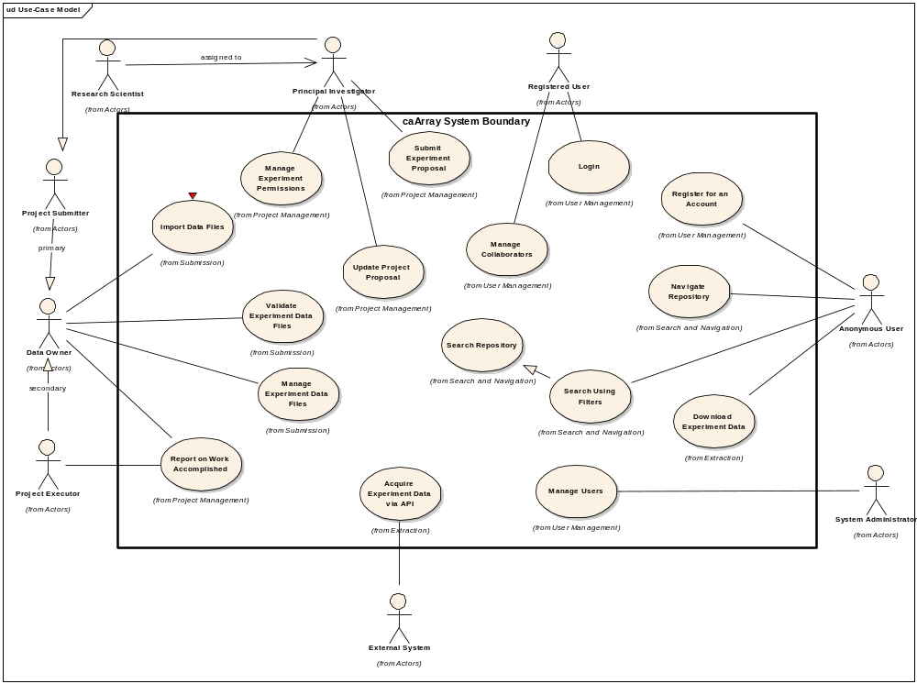
Figure 1 Use Cases for 2.0 Delivery

Evaluation Criteria
The primary goal of the C1 Iteration is to complete the analysis and design of selected use cases, document the Software Architecture in detail to allow us to move forward toward production, prepare for the alpha to be released in C2 and support the efficiency of the full development team that will be available in C2. The major results we need to achieve by the end of the iteration are:
- Detail the Schedule for the remainder of the release
- Complete the High Level Requirements Documentation (Vision, Use Case Summary, Supplemental Specs)
- Begin coordinating with the Documentation Team to support end user documentation and help
- Complete the Wireframes for all 2.0 UI
- Document process for Defect Tracking
- Collaborate with QA, Systems and Documentation to allow them to ramp up into the full delivery of 2.0
- Provide the ability to upload, validation, parsing and storage of SNP (Illumina and Affy) and Gene Expression (Illumina and Agilent)
- Ensure the Grid Service is available to be built along with the software
- Complete the switch from JSF to Struts 2 for the UI
- Have the Software Architecture reviewed by internal and external stakeholders with the 2.0 direction approved.
- Enable Grid accessibility to data
- Finalize the Domain Object Model for caArray to support one last revision to the API prior to Alpha Release Oct. 19
- Automate the deployment from DEV to QA to STAGE (for User Acceptance Testing)
- Tech Stack Compatibility with Bundled Tools for the December Release
- Modify the integration build will check whether the grid service and java object are synch

