Build Architecture and Usage Document
caArray

Last Revised: | 11.12.2007
Produced By: | NCICB Development Team
Version: | 0.4

Document Approvals
The list contains the name for the core project team and any key stakeholders who have an interest in the success of the project. An “S” identifies persons responsible for approval from the Business and Development. Sign off of the document would be required when a decision is made not to take action for defined gaps.

S | Name | Role | S | Name | Role
S | Anand Basu | NCICB Engineering Manager | S | Juli Klemm, Ph.D. | Product Manager
 | Brent Gendleman | Development Project Manager |  | Jerry Eads | NCICB Project Manager
 | Eric Tavela | Development Architect |  | Ron Keene | NCICB Independent QA
 | Don Swan | NCICB Application Support
Revision History
When you make a change to a document, you must add an entry to this Revision History table and you must manually type the Last Revised Date on the front cover.

Date | Version | Description | Revised by
11/08/2007 | 0.1 | Initial draft | Paul Duvall
Copyrights and Trademarks
© Copyright 2007 by NCICB, caBIGTM. All rights reserved.

Table of Contents
1. Introduction 4
1.1. Purpose 4
1.2. Scope 4
1.3. Definitions, Acronyms, and Abbreviations 4
1.4. Notes 4
1.5. References 4
2. Architectural Representation 4
2.1. Automated Build 5
2.1.1. Components 5
2.1.2. Continuous Integration 5
2.1.3. Database Integration 6
2.1.4. Testing 6
2.1.5. Inspections 6
2.1.6. Remote Deployment 7
2.2. Build Promotion 8
2.3. Project Dependencies 8
2.4. Build Dependencies 8
3. Architectural Goals and Constraints 8
3.1. Support for command-line remote deployment 8
3.2. Same build run in any environment 8
4. Derived Requirements 8
5. Target Environments 9
5.1. Overview 9
5.2. Developer Workstation 9
5.2.1. TBD 9
5.2.2. TBD 9
5.3. Integration 9
5.3.1. CruiseControl 9
5.4. DEV 9
5.5. Renaming Subversion tag 13
5.6. QA 15
5.6.1. TBD 15
5.7. STAGE 15
5.7.1. TBD 15
5.8. PROD 15
5.8.1. TBD 15
6. Promoting a Build through Target Environments 15
7. Troubleshooting 17
7.1. What if my command line fails? 18
7.2. How do I check the dependencies on the local build machine? 18
7.3. What if the AntHill Pro build fails? 18
7.4. Database Errors 18
7.5. How do I build a tag from an SVN revision? 18
8. Maintaining the Build 20
9. Appendix A – Build Targets 21

Introduction

Purpose
This document provides a comprehensive architectural overview of the caArray build system, using a number of different architectural views to depict different aspects of this build system. It is intended to capture and convey the significant architectural decisions which have been made on the system.

Scope
This document describes the aspects of caArray’s build architecture. Stakeholders who require a technical understanding of caArray are encouraged to start by reading this document, then reviewing the caArray UML model [CAARRAY_UML], and then by reviewing the source code.

Definitions, Acronyms, and Abbreviations
- Ant – XML-based build scripting tool capable of building software in a platform-independent manner.
- Automated Build – a scripted build capable of running from the command line using a build tool and connection to a version control repository. For caArray, this is implemented using Ant and Subversion.
- CI – Continuous Integration – running an automated build with every change applied to Subversion project
- Installation Environment – NEED INFO.
- Properties File -
- SVN – Subversion – version control system used by caArray project.
- Target Environment – An environment in which the build will deploy to. This includes the developer workstation, integration, Dev, QA, Stage and Production.

Notes
Show test-build.xml, macrodefs.xml in architecture

References
[CAARRAY _UML] caArray UML Models
//cm/caarray2/docs/analysis_and_design/models/caaray.eap

Architectural Representation
The caArray build architecture is represented in this document and using various tools as a set of views of the system from different but complementary perspectives. These views are:
- The Automated Build View – Illustrates and describes the targets as implemented in the Ant build scripts.
- The Build Promotion View – Illustrates how distribution binaries get built and promoted between the DEV, QA, STAGE and PROD environments.
- The Project Dependencies View - Illustrates the internal dependencies within the build that are required in order to build caArray.
- The Build Dependencies View – Describes the external dependencies required in order to build caArray. These dependencies require that certain artifacts must be built prior to a successful build.
TBD.

Automated Build

Components
Show properties, test-build, macrodefs.xml, cruisecontrol config (delegating, etc.)

Continuous Integration
TBD
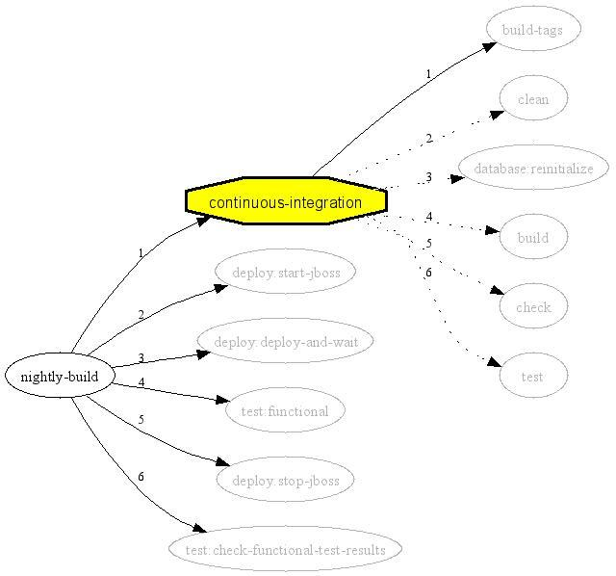

Database Integration
TBD
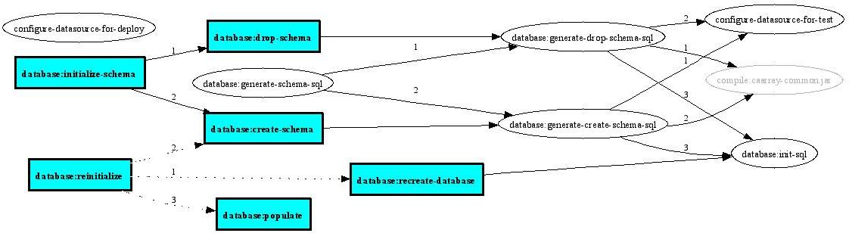

Testing
TBD
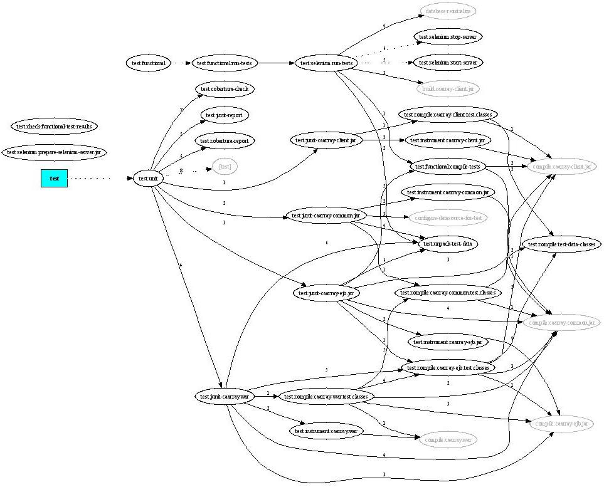

Inspections
TBD
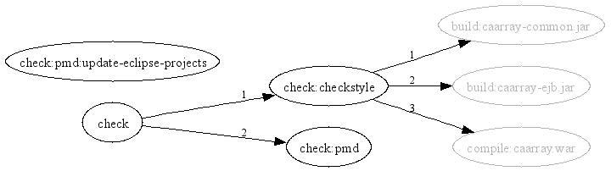

Remote Deployment
TBD

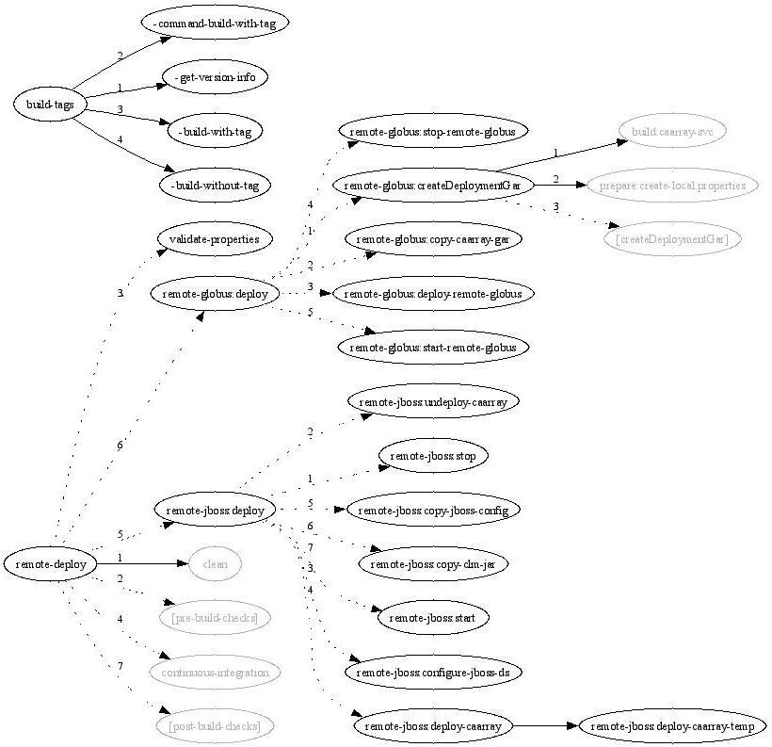

Build Promotion

Project Dependencies

Build Dependencies

Architectural Goals and Constraints
The following factors are key considerations beyond that are guiding the design of build for caArray 2.0.

Support for command-line remote deployment
caArray must be implemented in such a way that it may be certified caBIG Silver compliant. TBD.

Same build run in any environment
TBD.

Derived Requirements
As the Automated Build and Deployment team was initiated, there was a single, general goal: accelerate the delivery of application software. This was communicated as “create a one-click process for moving application software artifacts between target environments”. The table below describes more specific requirements that were derived as part of the discovery process during the implementation of the caArray 2 automated build and deployment pilot project.

Derived Requirement | Description
Single command execution of build
Run a build from an SCM label
Remotely configure a deployment binary
Same build should run in any target environment
All variable information between target environments is externalized into .properties files
Same build should be capable of running from command line and centralized build server (e.g. AntHill Pro)
Application software shall be capable of installing/building for six different installation platforms
Build shall avoid the use of environment variables | Environment variables limit portability
Build shall be capable of rebuilding a database remotely
Build shall be capable of inserting test data remotely
Build shall be capable of enabling non-technical staff to run a build in target environments

Target Environments

Overview

Figure 22 below illustrates the major physical artifacts that comprise the caArray software deployment units. The major artifacts and their relationships to the subsystems they realize are described in Section 6.2.

Properties files
DEV and QA property files are stored into a private SVN repository at https://gforge.nci.nih.gov/svnroot/scm-private/trunk . When building from the command prompt, developers with the proper access authorization should update their local environment property files from this repository. When building from AnthillPro, there is no special step needed. In fact, there is a separate AnthillPro project, caarray-properties, defined as a dependent project to autodeploy-dev, autodeploy-qa and build-deploy-dev-nightly, which automatically updates the environment property files for DEV and QA in AnthillPro. Refer to the following project tree for more information about the AnthillPro propejects.

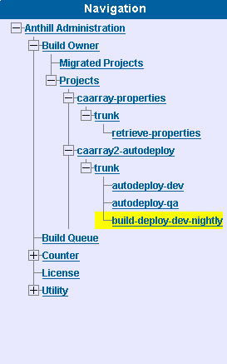

Developer Workstation

TBD
TBD.

TBD
TBD.

Integration

CruiseControl
TODO: Diagram of Six Target Environments (functional differences between environments).

DEV
The following steps describe how to run a caArray 2 build remotely from a centralized build management server (AntHill Pro).

- Go to http://cbiocvs2.nci.nih.gov:8080/AnthillPro/admin/
- Login with the caarray2 user. Password is caarray2
- To build the DEV environment without a tag, select caarray2-autodeploy.trunk.autodeploy-dev. Then, select the Build tab. Once on the Build tab, select the Force Build checkbox and click the Build button. See the figures below for additional information.

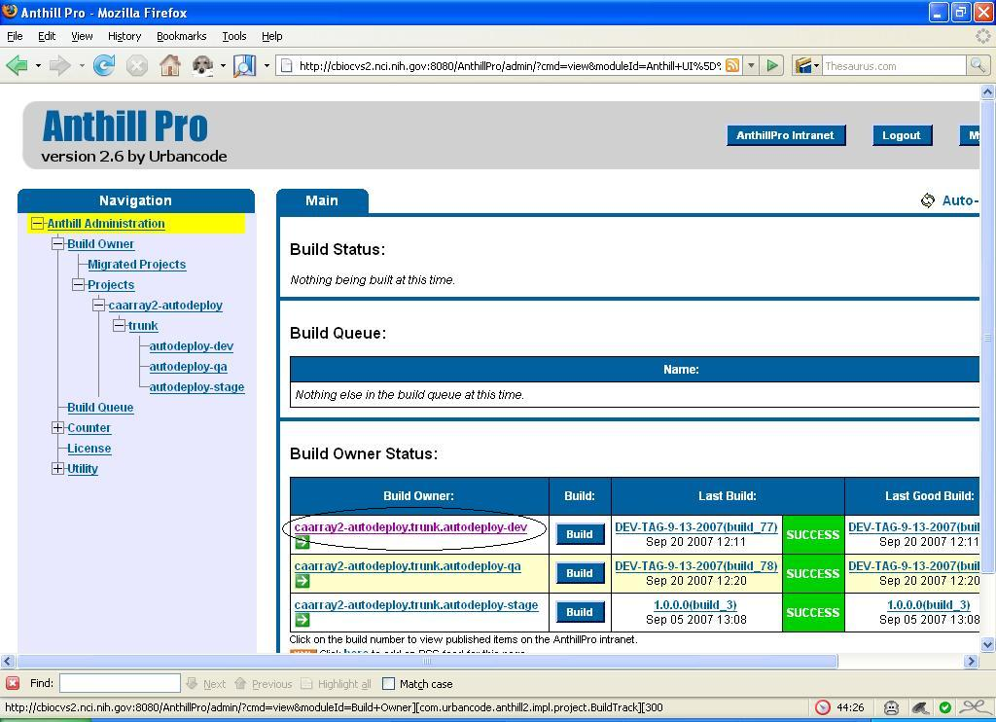
Select Target Environment
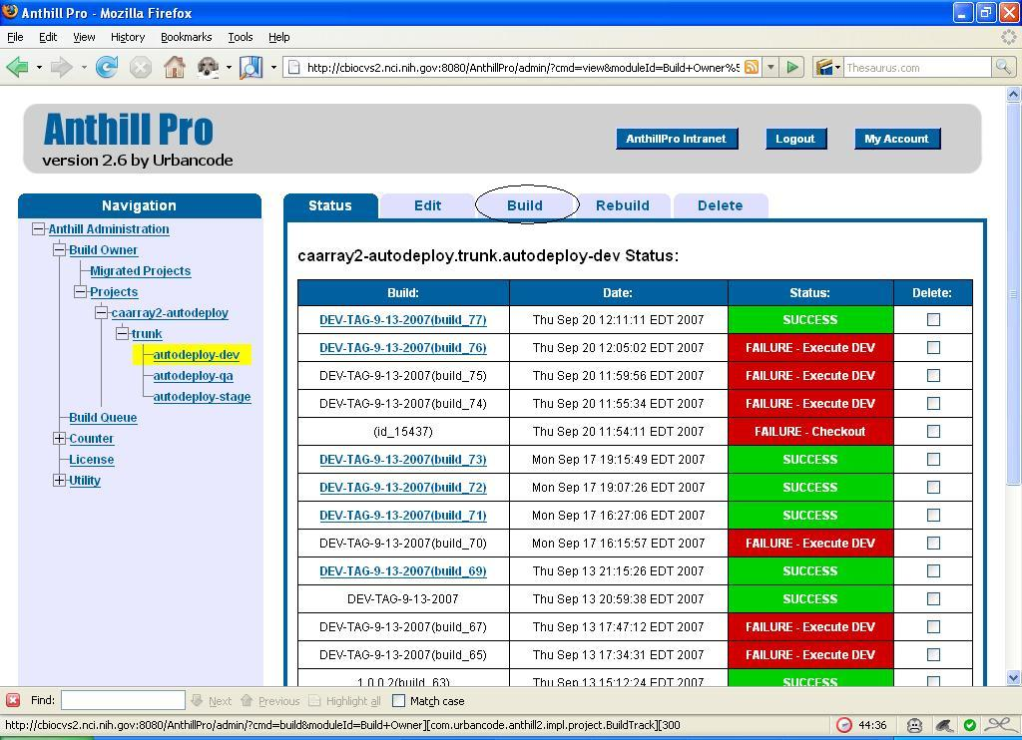
Select the Build Tab
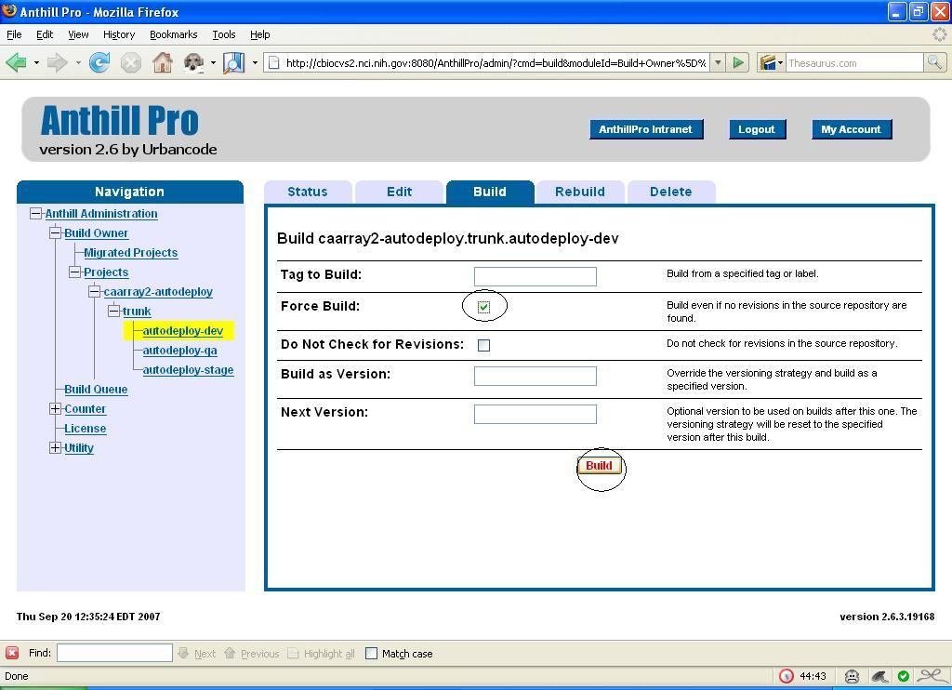
Force The Build

- To build the DEV environment with a tag, select caarray2-autodeploy.trunk.autodeploy-dev. Then, select the Edit tab. Once on the Build tab, enter the tag in the Build as Version text box. Select the Force Build checkbox and click the Build button. See the figure below.

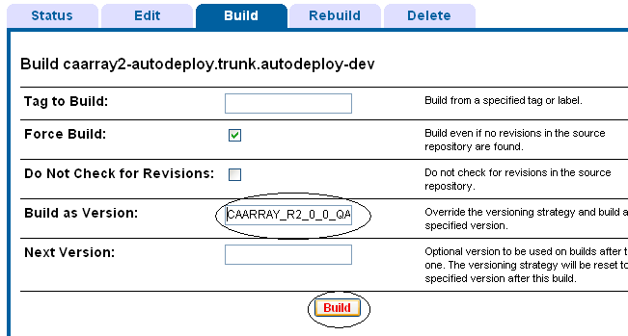
Adding tags in a DEV build

Renaming Subversion tag
Because the default functionality in AntHill Pro is to append a unique build tag to the name of the tag, you must rename it to make it available for QA. This section covers the steps on how to do this.
- Open your Subversion Repo-browser using TortoiseSVN
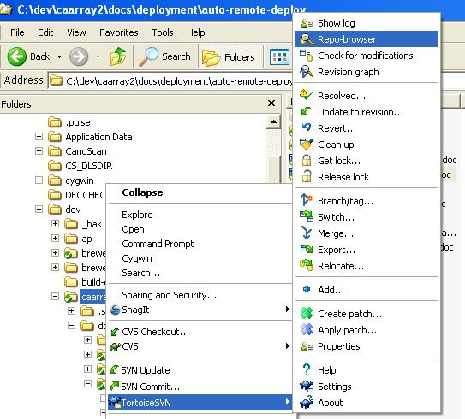

- Go to http://gforge.nci.nih.gov/svnroot/caarray2/tags and search for the most recent QA tag (e.g. it will be named something like CAARRAY_R2_0_0_QA7_build_5355_)
- In TortoiseSVN, right-click on the tag name and select Rename

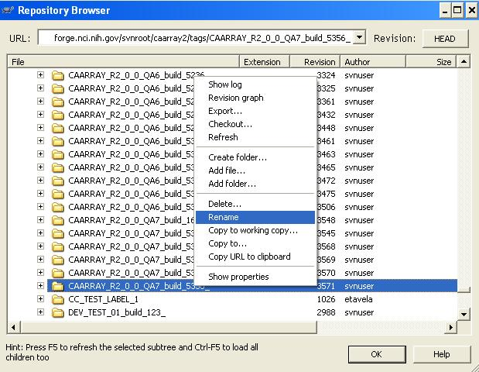

QA

Add something about the location of the QA.properties file

TBD
TBD.

STAGE

TBD
TBD.

PROD

TBD
TBD.

Promoting a Build through Target Environments
To make software available to production, it must go through six environments: developer workstation, integration build, Development, QA, Staging and finally into production. The build architecture supports a model that ensures that the same build can be run in each of these environments. This approach minimizes errors. The architecture is implemented through:
- Same build script is run in each tier with no environments-specific targets
- Builds are executed remotely to minimize build-specific dependencies in target environments
- The only difference between build environment execution is the environment-specific .properties file used (e.g. dev.properties, qa.properties, etc.)
- So-called “heavy-weight dependencies” (e.g. MySQL, JBoss, etc.) must be installed in each environment, with minor configuration changes (This is a risk). However, much of the configuration is automated and run remotely and, therefore, many of these risks have been minimized.

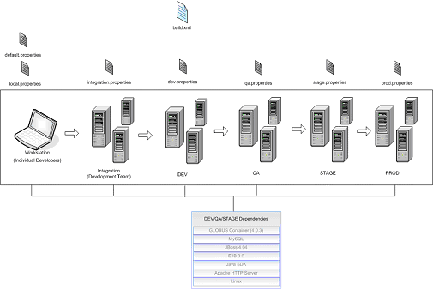

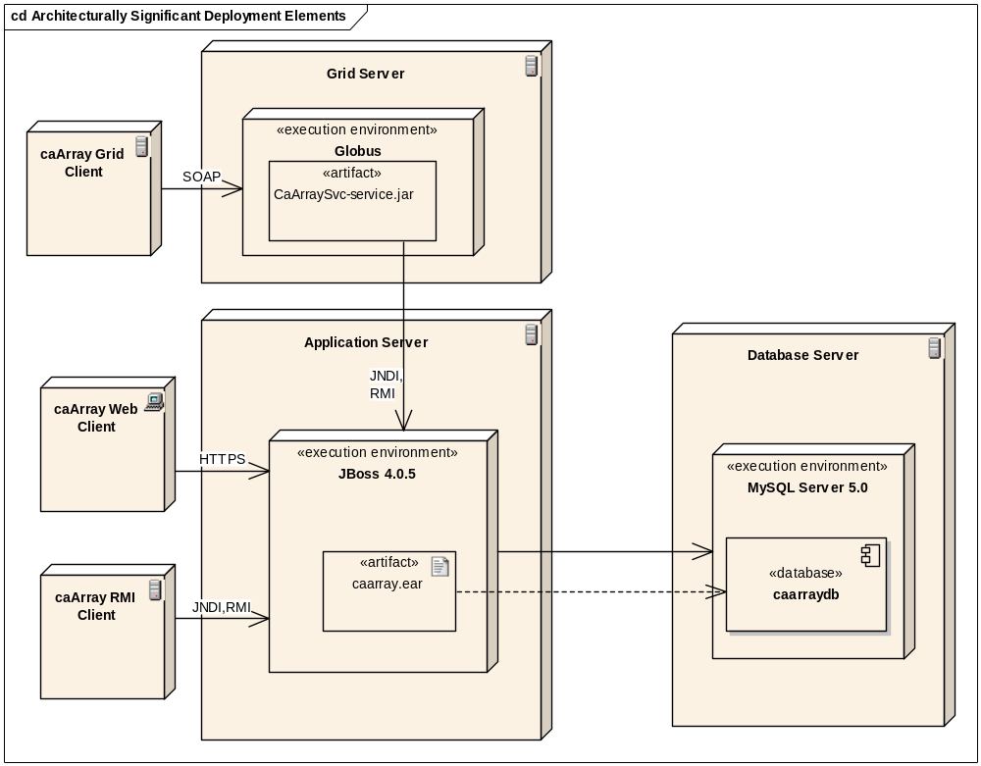
Figure 1 – Architecturally Significant Deployment Elements

Troubleshooting
TBD.
A build architecture diagram with all the possible interface point failures
- Directory or file permission problem
- OS-specific error (Window or Linux)
- Authentication error
- SSH/SCP connection error
- Environment variables not established
- Server is not installed or configured correctly
- Database permissions
- Incorrect server location or port – wrong values passed to script
- Database is down
- Web server is down
- Unable to insert data correctly

What if my command line fails?
- Ensure the following is installed on the machine from which you are executing the script
  - SVN Client
  - Correct version of Ant has been installed. See Running a Local Build
  - Correct version of Java SDK has been installed. See Running a Local Build
  - ANT_HOME environment variable has been added
  - JAVA_HOME environment variable has been added
  - %JAVA_HOME%/bin; has been added to the System PATH environment variable
  - %ANT_HOME%/bin; has been added to the System PATH environment variable

How do I check the dependencies on the local build machine?
- TBD

What if the AntHill Pro build fails?
- Check the heavyweight dependencies are installed and operating correctly (NEED MORE DETAIL)

Database Errors
- TBD

How do I build a tag from an SVN revision?
- TBD

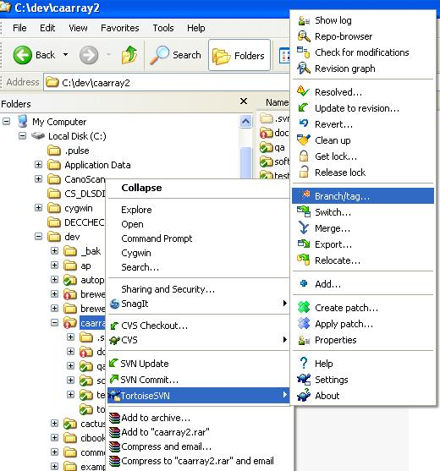

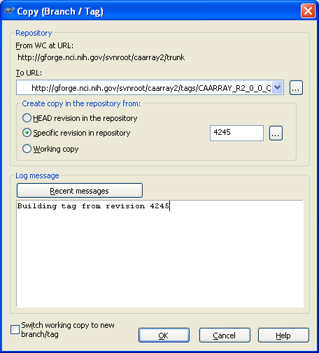

Maintaining the Build
TBD.
- Updating [environment].properties file attributes and values. See https://gforge.nci.nih.gov/svnroot/scm-private/trunk
- Modifying system property flags in AntHill Pro or command line
- Adding new JAR dependencies
- Renaming Subversion tag
- Prior to a QA/Stage build, ensure AntHill configuration in QA is same as DEV

Appendix A – Build Targets
TBD.

Target Name | Description
build
clean
database:create-schema
database:drop-schema
database:initialize-schema
database:populate
database:recreate-database
database:reinitialize
deploy
deploy:copy-jsp
redeploy
svn:getinfo
test
undeploy
-build-with-tag
-build-without-tag
-command-build-with-tag
-get-version-info
build-tags
build:caarray-client.jar
build:caarray-common.jar
build:caarray-ejb.jar
build:caarray-svc
build:caarray.ear
build:caarray.war
check
check:checkstyle
check:pmd
check:pmd:update-eclipse-projects
clean:caarray-client.jar
clean:caarray-common.jar
clean:caarray-ejb.jar
clean:caarray.ear
clean:caarray.war
clean:caarraydb
clean:gridsvc
clean:site.dir
clean:target.dir
clean:test.classes.dir
compile
compile:caarray-client.jar
compile:caarray-common.jar
compile:caarray-ejb.jar
compile:caarray-svc
compile:caarray.war
configure-datasource-for-deploy
configure-datasource-for-test
continuous-integration
database:generate-create-schema-sql
database:generate-drop-schema-sql
database:generate-schema-sql
database:init-sql
deploy:caarray-svc
deploy:caarray.ear
deploy:check-if-jboss-is-running
deploy:deploy-and-wait
deploy:start-jboss
deploy:stop-jboss
nightly-build
prepare:check-for-local.properties
prepare:create-local.properties
remote-deploy
remote-globus:copy-caarray-gar
remote-globus:createDeploymentGar
remote-globus:deploy
remote-globus:deploy-remote-globus
remote-globus:start-remote-globus
remote-globus:stop-remote-globus
remote-jboss:configure-jboss-ds
remote-jboss:copy-clm-jar
remote-jboss:copy-jboss-config
remote-jboss:deploy
remote-jboss:deploy-caarray
remote-jboss:deploy-caarray-temp
remote-jboss:start
remote-jboss:stop
remote-jboss:undeploy-caarray
test:check-functional-test-results
test:cobertura-check
test:cobertura-report
test:compile:caarray-client.test.classes
test:compile:caarray-common.test.classes
test:compile:caarray-ejb.test.classes
test:compile:caarray-war.test.classes
test:compile:test-data-classes
test:functional
test:functional:compile-tests
test:functional:run-tests
test:instrument:caarray-client.jar
test:instrument:caarray-common.jar
test:instrument:caarray-ejb.jar
test:instrument:caarray.war
test:junit-caarray-client.jar
test:junit-caarray-common.jar
test:junit-caarray-ejb.jar
test:junit-caarray.war
test:junit-report
test:selenium:prepare-selenium-server.jar
test:selenium:run-tests
test:selenium:start-server
test:selenium:stop-server
test:unit
test:unpack-test-data
validate-properties
default target: continuous-integration

