Architectural Review Checklist
caArray
Version 0.1

Revision Document History
Date | Version | Description | Author
07/10/2007 | 0.1 | First draft | Brent Gendleman/Eric Tavela NCICB Development Team

Table of Contents
1. Introduction 6
1.1 Purpose 6
1.2 Guidelines for Completing the ARC 6
2. Project Details (To be answered by development team) 6
2.1 General Information 6
2.1.1 Project Description 6
2.1.2 Contact Information 8
2.1.3 Major Deployment Milestones 8
2.2 Architectural Details 8
2.2.1 High level architectural description: 8
2.2.2 High Level Design Diagram (If available): 9
2.2.3 Implementation language(s) used? 10
2.2.4 Will connections/requests to the application be session based (i.e. statefull versus stateless)? If so, is there any reason why application would not support “sticky session” load balancing? 10
2.2.5 Will the application be caching data? If so, what is being cached and how much data will be cached? 11
2.2.6 What data files will be created (if any)? How much data will be saved on an on going basis? 11
2.2.7 Will this application need a database schema(s) created on the NCICB infrastructure? If so, what is the maximum number of objects to be stored? 11
2.2.8 Are there any external/non-NCICB data sources that will be accessed by the application? 11
2.2.9 If this is a web-based application, what are the preferred virtual hosts names to be registered? 11
2.2.10 Any additional architectural details that may be of significance to the needed deployment environment. 11
2.3 Performance Requirements 11
2.3.1 Total number of users for this application? 11
2.3.2 Peak number of concurrent users? 11
2.3.3 Peak number of requests/minute? 11
2.3.4 Up time requirements? 11
2.3.5 Acceptable down time when recovering from major systems disaster? 12
2.4 NCICB Project Dependencies 12
2.4.1 caArray Depends on 12
2.4.2 Projects that depend on caArray 12
2.5 Configuration Management Details 12
2.5.1 Version Control 12
2.5.2 Change Control 12
2.5.3 Migration to SVN 13
2.5.4 Users 13
2.5.5 Build Process 13
2.5.6 Other CM Needs 13
2.6 Additional Notes 14
3. System Requirements (To be answered by both development & systems team) 14
3.1 Operating System 14
Linux 14
3.2 Software (Technology Stack) 14
3.2.1 Web Server: JBoss 4.0.5 14
3.2.2 App Server: JBoss 4.0.5 14
3.2.3 Database Server: MySQL 5.0.27 14
3.2.4 Other software components: J2EE 1.4, J2SDK 1.5.x 14
3.3 Server Hardware 14
3.3.1 Server: Best available 14
3.3.2 Minimum processor speed: Best available 14
3.3.3 Minimum memory: 4 GB 14
3.3.4 Minimum local drive space: 40 GB 14
3.4 Storage 14
3.4.1 Expected file server disk storage (in MB): 100,000 + 14
3.4.2 Expected database storage (in MB): 1000 MB + (expandable) 14
3.4.3 Expected ftp storage (in MB): 100,000+ 14
3.4.4 Expected media/image storage (in MB): none 14
3.5 Load Balancing/Fault Tolerance 14
3.5.1 Does the application support load balancing? At the webserver level, it can support it. 14
3.5.2 Implement load balancing – YES/NO - Yes, but needs to be thoroughly tested on all environments. 14
3.6 Networking 15
3.6.1 Any application specific port assignments? 15
3.6.2 Any additional configuration? 15
3.6.3 Additional Notes 15
4. Proposed NCICB Deployment Environment (To be answered by systems team) 15
4.1 Hardware 15
4.2 Technology Stack 15
4.3 File Server 15
4.4 Database 15
4.5 Networking 15
4.6 Other Resources 15
5. Impact Assessment (To be answered by systems team) 15
5.1 Overview 15
5.2 Cost 15
5.3 Timeline to implement 16
5.4 Additional Notes 16
6. Acceptance 16
7. Appendix 1 - Future Systems Requirements 17
7.1 New Architecture Diagram 17
7.2 Notes on the design change 17
7.3 Hardware 17
7.3.1 Servers 17
7.3.2 Processor speed 17
7.3.3 Memory 17
7.3.4 Drive Space 17
7.4 Software (Technology Stack) 17
7.4.1 Web Server 17
7.4.2 App Server 17
7.4.3 Other components 17
7.5 Fault Tolerance (Redundancy) 17
7.5.1 Does the application support load balancing? 17
7.5.2 Implement load balancing – YES/NO 17
7.5.3 Load balancing requirements 17
7.5.4 Fault tolerance solution suggested 17
7.5.5 Additional requirements (if any) 17
7.6 Performance Enhancements 17
7.6.1 Processing Power 17
7.6.2 Memory 17
7.6.3 I/O 17
7.6.4 Other needs 17

Introduction

Purpose
The purpose of the Architectural Review Checklist (ARC) is to help identify the deployment environment (both hardware and software components) necessary for an application to execute optimally within the NCICB IT infrastructure. The ARC is considered to be a dynamic artifact for any NCICB project and should be maintained in the configuration library (i.e. SVN) for each project. For new projects, this document template will be automatically checked into the projects repository by the SCM team upon project initiation. The ARC should be reviewed on at least a quarterly basis to capture any application design changes that may effect the deployment environment necessary for optimal performance.

Guidelines for Completing the ARC
The ARC is divided into 4 main sections. The first section (Project Details) is meant to capture general information about the project. The project development team should fill out the Project Details section and return it to the systems team. The second section (Systems Requirements) is meant to capture details of specific system requirements for the project. Both the development and system teams will preferably answer the Systems Requirement section jointly. However, depending on the development teams familiarity with the NCICB infrastructure, they may choose to answer either all or parts of this section on their own. The third section (Planned Deployment Environment) specifies the proposed deployment environment for the application and is to be answered by the systems team based on the response to section 1 & 2. Finally, the last section (Impact Assessment) describes the impact (additional hardware/software costs, staffing resources…) to the existing NCICB IT infrastructure in order to support this application. Upon completion of the Deployment Environment and Impact Assessment sections, the systems team will return the ARC to the development team for final review and comments.

Project Details (To be answered by development team)

General Information

Project Description
caArray has a committed following, years of user feedback and contribution on which to build from, sufficient resources, and an expansive vision to support integrative cancer research. Expression profiling is now a standard tool set with which to interrogate biological systems. Parallel advances in computing and new array technology provide an opportunity for collaboration and discovery within the scientific community and across traditional boundaries to reach clinicians and ultimately patients. The insistence on open source development provides the community with the greatest opportunity to gain access to the tools they desperately need to execute their respective mission.

caArray was initially developed with expression profiling in mind, using the caBIG Compatibility Guidelines, as well as the Microarray Gene Expression Data (MGED) society standards for microarray data. Compatibility with these standards and guidelines was and remains required. However, the ability to add new standards that are developing is also necessary to facilitate data exchange and analysis across domains. A number of analytical tools and services that connect to caArray are already available - including geWorkbench and GenePattern - that provide a variety of analysis, visualization and annotation functions for microarray data.

The primary goal of caArray is to further translational cancer research through acquisition, dissemination and aggregation of high quality array data to support subsequent analysis. Initially envisioned to be the de facto repository for cancer related expression data, other applications – primarily the Gene Expression Omnibus (GEO) – has assumed the role. However, the quality of the expression data and the ability to integrate the use of array technology into clinical research remains at issue. Further, the opportunity for caArray to evolve to handle other types of array data will provide greater impetus for use among the Cancer Centers and their collaborators which will ultimately benefit the cancer community. Data from expression and SNP are anticipated for inclusion in caArray 2.0. Also under consideration are the burgeoning platforms of methylation, and protein arrays, RNAi and CHip-chip data. Tissue microarrays represent another array-based technique that require a significantly different business process in their creation but are being considered for inclusion in the repository.

A significant challenge is to find common ground for the annotation, upload and extraction of these array data platforms to support meaningful analysis for cancer research. The need for logical and expedient approaches to storing, querying, retrieving and reporting on array–based data has increased over the last several years due to the contribution of several factors:
- a significant increase in array information (expression and others) available due to:
      - decreases in the cost to generate this data
      - improvements in the technology to generate this data
      - advances in the approaches to analyze this data
- the need to increase the numbers of samples to enhance discovery and ensure validity of results once found;
- and the need to ease the administration of the data and results by giving the community a single point of reference to perform the most essential tasks of array-based research.

The initial generation of caArray (1.0) and subsequent point releases (currently 1.5.0.1 and soon to be 1.6) have provided the interface for annotating scientifically significant meta-data along with the independent ability to upload and download data through an applet or accessing the MAGE-OM API over the grid service provided by caBIG. caArray will improve upon this starting point by organizing the application around the natural workflow between investigators and the array labs that serve them, improve the user experience for storing and retrieving the data produced, query the data through an easier to comprehend API, and bridge the gap between the analysis tools in heavy use in the community today and the data they need to consume. caArray will look to perform intra-platform, intra-experiment queries for local adopters, via the NCICB instance and potentially across the grid collectively to increase the availability of quality data.

caArray will be built to scale with an open architecture and supportive documentation to allow for future enhancements, particularly with regard to interfacing with additional analysis tools, the ability to query across platforms, and poised to exploit web services and/or databases from other components of caBIG when available and prudent. The desire to create an extensible array system that is non-platform-specific and potentially customizable is a theme that should influence the building of caArray.
For complete definition of the requirements, which will be evolving, please see the GForge Project: https://gforge.nci.nih.gov/projects/caarray2/ and in particular, the tracker for requirements and the following documents:
- caarray_vision.doc
- caarray_use_case_summary.doc
- carray_supplementary_specifications.doc

Contact Information
Title | Name | Phone | Email
Engineering Manager | Anand Basu | 301-496-3459 | basuan@mail.nih.gov
Product Manager | Juli Klemm | 978-443-2431 | klemmj@mail.nih.gov
IQA Manager | George Komatsoulis | 301.451.2881 | komatsog@mail.nih.gov
Development Project Manager | Brent Gendleman | 301.435.3870 | gendlemb@mail.nih.gov
Software Architect | Eric Tavela | 301.451.6357 | tavelae@maill.nih.gov
Software Developer | John Pike, Rashmi Srinivasa, Steve Matyas, Bill Mason, Leslie Power, Todd Parnell | See developer table | See developer table
IQA Team | Jenny Glenn, Ron Keene, Tom Boal | 301.451.2220, 301.594.6858, 301.594.6858 | glennje@mail.nih.gov, keeneron@mail.nih.gov, boalt@mail.nih.gov

Major Deployment Milestones
Milestone | Date
Planned Release to QA | Every 2 weeks beginning 8/31/2007*
Planned Release to Staging | Every 2 weeks beginning 9/28/2007*
Planned Release to Production | Every 2 weeks beginning 10/26/2007*
*These dates are based on the current schedule which may need to change based on availability of the environments. We also understand that the 2 week cycle of deployments is different than currently executed.
What we’d really like is to determine by July 31, 2007 if we can move what we have to QA and work on the refinement in time for August 31, 2007.

Architectural Details

High level architectural description:
The Architecture will be evolving over time but the best set of artifacts for full depictions are available in the:
Software Architecture Document
caarray.eap
caArray_cacore_model.eap

The caArray architecture is represented in this document and in the UML design models as a set of views of the system from different but complementary perspectives. These views are:
- The Use-Case View – Describes the functional requirements of the system.
- The Logical View – Describes the organization of the system design into subsystems, interfaces, and classes and how these elements collaborate to provide the functionality described in the use-case view.
- The Process View - Illustrates the process decomposition of the system, including the mapping of classes and subsystems on to processes and threads.
- The Deployment View – Describes how the processes are allocated to hardware and execution environments and the communication paths between hardware nodes.
- The Implementation View – Describes the software components that realize the elements from the logical view and the dependencies between these components.
This style of describing software architecture is the approach recommended by the Rational Unified Process and is based on Philippe Kruchten’s work, “The 4+1 view model of architecture” [KRUCHTEN] and is refined in the Rational Unified Process [RUP].

The design model (from which the logical view is taken) is the most significant model, requiring the most effort and containing the majority of the content. Accordingly, the description of the logical view of caArray’s architecture will receive the most attention here. This section of the document first describes the structural hierarchy of the system in layers, packages, and subsystems and then goes on to describe how these elements collaborate to provide the most architecturally significant functionality. Figure 1 below shows the top-level structural organization of caArray.

caArray is implemented as a J2EE 1.4 application built on top of Java SE 5 (JDK version 1.5.0_10) employing the following core J2EE technologies:
- JSP 2.0
- Servlet 2.4
- JMS 1.1
- EJB 3.0.
Only EJB session and message-driven beans are being used; persistence is being managed directly with Hibernate 3.2 rather than EJB’s persistence API (JPA). JPA provides no significant advantages over Hibernate at this point and Hibernate provides additional extended functionality not included in JPA.

High Level Design Diagram (If available):

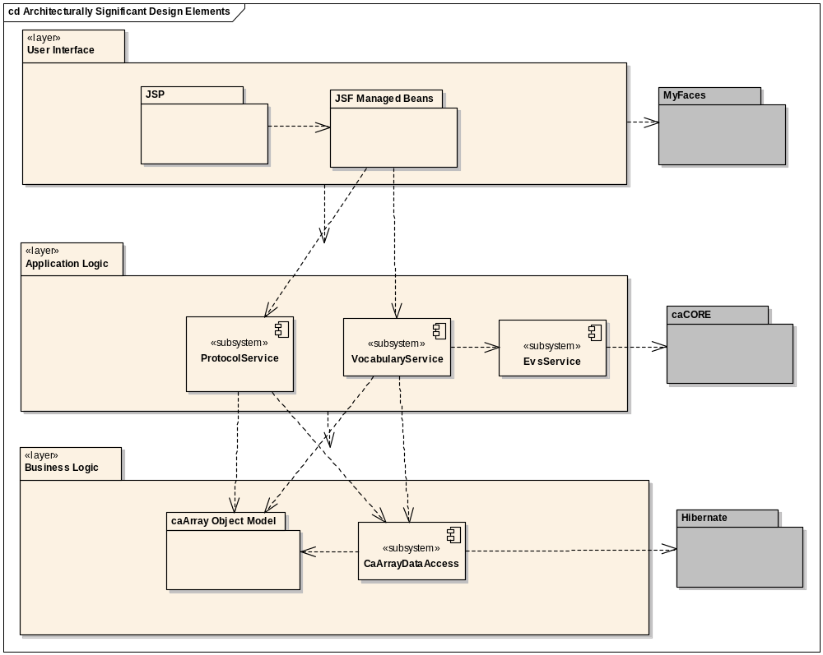
Figure 1. Architecturally Significant Design Elements

Implementation language(s) used?
caArray is implemented as a J2EE 1.4 application built on top of Java SE 5 (JDK version 1.5.0_10) employing the following core J2EE technologies:
JSP 2.0
Servlet 2.4
JMS 1.1
EJB 3.0.
Only EJB session and message-driven beans are being used; persistence is being managed directly with Hibernate 3.2 rather than EJB’s persistence API (JPA). JPA provides no significant advantages over Hibernate at this point and Hibernate provides additional extended functionality not included in JPA.

Will connections/requests to the application be session based (i.e. statefull versus stateless)? If so, is there any reason why application would not support “sticky session” load balancing?
Yes, and there should be no reason why the application would not support “sticky session” load balancing.

Will the application be caching data? If so, what is being cached and how much data will be cached?
Yes, using Hibernate 3.2 and we don’t know how much data (but not a lot).

What data files will be created (if any)? How much data will be saved on an on going basis?
We don’t know. Users will be uploading hybridization data files – which are quite large.

Will this application need a database schema(s) created on the NCICB infrastructure? If so, what is the maximum number of objects to be stored?
Yes, and we expect that the number of objects will be in the ten’s of thousands to hundred’s of thousands of rows.

Are there any external/non-NCICB data sources that will be accessed by the application?
None planned.

If this is a web-based application, what are the preferred virtual hosts names to be registered?
Currently, caarraydb.nci.nih.gov is the host name registered for caArray. However, we potentially need to have 2 production versions of caArray at the same time (1.6 and 2.0). One possibility is caarray.nci.nih.gov which is currently used for information about carray.

Any additional architectural details that may be of significance to the needed deployment environment.
4.0 Tech Stack
Expect to be using JMS internal to the application

Performance Requirements

Total number of users for this application?
Current count from Systems Registration is 857 but we should anticipate – if all goes well – numbers in the thousands

Peak number of concurrent users?
10 – we should reevaluate this as time goes by

Peak number of requests/minute?
50 – we should reevaluate this as time goes by

Up time requirements?
In an ideal scenario, it should be up 24/7. However, practical considerations dictate that the application should be up and running during the normal business hours (8:00 AM to 8:00 PM EST, taking care of Pacific Time).
Weekend Maintenance will be preferable. Additionally, maintenance tasks after 6:00 PM EST will be acceptable.

Acceptable down time when recovering from major systems disaster?
24 hours.

NCICB Project Dependencies

caArray Depends on
caCORE, caBIO, others TBD

Projects that depend on caArray
geWorkbench - http://wiki.c2b2.columbia.edu/workbench/index.php/Home
Developed at the Columbia University, NY is an extendible and flexible desktop tool for microarray data analysis and visualization. The release 1.0 includes several data analysis and visualization functions, including hierarchical clustering, self organizing maps, color mosaic images and biological pathways.

Gene Pattern – http://www.broad.mit.edu/cancer/software/genepattern/
GenePattern puts sophisticated computational methods into the hands of the biomedical research community. A simple application interface gives a broad audience access to a growing repository of analytic tools for genomic data, while an API supports computational biologists. GenePattern is a powerful analysis workflow tool developed to support multidisciplinary genomic research programs and designed to encourage rapid integration of new techniques. It is developed by the Broad Institute.

Bioconductor – http://www.bioconductor.org/
Bioconductor is an open source and open development software project for the analysis and comprehension of genomic data. The project was started in the Fall of 2001. The Bioconductor core team is based primarily at the Fred Hutchinson Cancer Research Center. Other members come from various US and international institutions. Bioconductor is primarily based on the R programming language but we do accept contributions in any programming language.

webGenome – http://webgenome.nci.nih.gov/webGenome/home.do
webGenome is an application for creating genomics plots. This version of the system is designed to operate as a plotting client for other applications. To create plots, you must first select a data set in another affiliated application, such as Rembrandt.

VISDA - https://cabig.nci.nih.gov/tools/VISDA
VISDA (VIsual Statistical Data Analyzer) is an analytical tool for cluster modeling, visualization, and discovery.

Configuration Management Details
Briefly describe your current configuration management practices here.

Version Control
What version control software are you currently using, if any?
SVN

Change Control
What are your current change control practices? What procedures are in place to determine whether to implement a change request?
See caarray_configuration_management_plan.doc

Migration to SVN
Indicate whether you will require SCM support migrating your source code to the NCICB SVN repository.
No – began with SVN

Users
Provide a list of all developers who require access to your repository modules.

Brent Gendleman – gendlemb@mail.nih.gov
Eric Tavela – tavelae@mail.nih.gov
Rashmi Srinivasa – srinivra@mail.nih.gov
Steve Matyas – matyass@mail.nih.gov
John Pike – pikej@mail.nih.gov
Leslie Power – powerless@mail.nih.gov
Todd Parnell – parnellt@mail.nih.gov
Bill Mason – masonwi@mail.nih.gov
Paul Duvall – duvallp@mail.nih.gov
Andy Glover – glovera@mail.nih.gov

Build Process
Describe your build process here. For example, are you using Ant, Make, or something else?
We’re using Ant, look at \software\build\build.xml

Other CM Needs
Describe any other CM needs?
This is a big topic. We would like to have automated deployment by the release of 2.0 – as much as possible - from Dev to QA to Stage and potentially even Production and will work with the teams to support that effort. We are starting now by focusing on Dev to QA. We do have an integration box which could automate that deployment but expect this to be a collaborative effort and supportive of the SCM initiative.

Additional Notes
None right now.

System Requirements (To be answered by both development & systems team)

Operating System

Linux

Software (Technology Stack)

Web Server: JBoss 4.0.5

App Server: JBoss 4.0.5

Database Server: MySQL 5.0.27

Other software components: J2EE 1.4, J2SDK 1.5.x
Others may be necessary as we move through Elaboration. The goal is to have this locked down by the end of Elaboration.

Server Hardware

Server: Best available

Minimum processor speed: Best available

Minimum memory: 4 GB

Minimum local drive space: 40 GB

Storage

Expected file server disk storage (in MB): 100,000 +

Expected database storage (in MB): 1000 MB + (expandable)

Expected ftp storage (in MB): 100,000+

Expected media/image storage (in MB): none

Load Balancing/Fault Tolerance

Does the application support load balancing? At the webserver level, it can support it.

Implement load balancing – YES/NO - Yes, but needs to be thoroughly tested on all environments.

Networking

Any application specific port assignments?
Standard HTTP and HTTPS

Any additional configuration?
FTP Area MAY be necessary

Additional Notes

Proposed NCICB Deployment Environment (To be answered by systems team)

Hardware
<<dev, qa, staging, production servers to be used>>

Technology Stack
<<specific technology stack to be used>>

File Server
<<space allocation on big IP, NFS mount points, initial size allocation…>>

Database
<<database server to used, schema names to be created, initial size, maximum size…>>

Networking
<<e.g. any BigIP configuration necessary, …>>

Other Resources
<<e.g. ftp server access, media server access, …>>

Impact Assessment (To be answered by systems team)

Overview

Cost

Timeline to implement

Additional Notes

Acceptance
Project Lead ( ) | Project Coordinator – NCICB ( )
Systems Team | SCM Administrator

Appendix 1 - Future Systems Requirements
In this section, describe any projected future anticipated requirements for your system.

New Architecture Diagram

Notes on the design change

Hardware

Servers

Processor speed

Memory

Drive Space
Probably the biggest area of future growth, as caArray hopefully increases use and new platforms are introduced into the caArray line (methylation, protein arrays, ChiP-ChiP, tissue microarrays).

Software (Technology Stack)

Web Server

App Server

Other components

Fault Tolerance (Redundancy)

Does the application support load balancing?

Implement load balancing – YES/NO

Load balancing requirements

Fault tolerance solution suggested

Additional requirements (if any)

Performance Enhancements

Processing Power

Memory

I/O

Other needs

