Iteration Plan
caArray 2.0 - Elaboration 1

Last Revised: | June 18, 2007
Produced By: | caArray Development Team
Version: | 0.2

Document Approvals
The list contains the name and contact information for the core project team and any key stakeholders who have an interest in the success of the project. An “S” identifies persons responsible for approval from the Business and Development. Sign off of the document would be required when a decision is made not to take action for defined gaps.

S | Name | Role | S | Name | Role
S | Anand Basu | NCICB Engineering Manager | S | Juli Klemm, Ph.D. | Product Manager
 | Brent Gendleman | Development Project Manager |  | Jerry Eads | NCICB Project Manager
 | Eric Tavela | Development Architect |  | Ron Keene | NCICB Independent QA
 | Don Swan | NCICB Application Support
Revision History
When you make a change to a document, you must add an entry to this Revision History table and you must manually type the Last Revised Date on the front cover.

Date | Version | Description | Revised by
May 24, 2007 | 0.1 | Initial Draft | Brent Gendleman
June 18, 2007 | 0.2 | Revised post 1.x focus | Brent Gendleman
Copyrights and Trademarks
© Copyright 2007 by NCICB, caBIGTM. All rights reserved.

Table of Contents
1. Introduction 4
1.1. References 4
2. Plan 4
2.1. Iteration Activities 4
2.2. Iteration Schedule 5
3. Resources 5
4. Use Cases 6
4.1. Specifications to be detailed 6
4.2. Analysis to be performed 7
4.3. Architectural Prototype to be delivered 7
5. Evaluation Criteria 8
5.1. Project Management 8
5.2. Requirements 8
5.3. Analysis and Design 8
5.4. Implementation 8
5.5. Test 9
5.6. Environment 9
5.7. Configuration and Change Management 9

Introduction
This Iteration Plan describes the detailed plans for the E1 Iteration of caArray 2.0. The Iteration was delayed due to the appropriate team focus on the 1.5, 1.5.0.1 and 1.6 releases. The duration hasn’t shifted but the timeline for completion is roughly 5 weeks later than initially shown.
During the E1 Iteration the requirements will be further analyzed and use case specifications will be detailed for a large number of the use cases that must be analyzed for Elaboration to be a success. The analysis and design for a discreet set of the architectural significant use cases selected for Release 2.0 will be completed. The architectural prototype will be developed to test the feasibility and performance of the architecture that is required for Release 2.0.

References
- project_management/caarray_schedule.mpp
- requirements/caarray_vision.doc
- requirements/caarray_use_case _summary.doc
- analysis_and_design/caarray_software_architecture_document.doc

Plan

Iteration Activities
The following activities, according to discipline, are planned for this iteration. The requirements and the analysis and design activities remain the focus; a significant portion of the effort will be establishing the physical architecture and proving several threads through it.
Activities | Start | End
Project Management | Mon 6/18/07 | Fri 7/27/07
Requirements | Mon 6/18/07 | Fri 7/17/07
Analysis and Design | Mon 6/18/07 | Mon 7/19/07
Implementation | Mon 6/18/07 | Fri 7/26/07
Test | Mon 6/18/07 | Mon 7/27/07
Environment | Mon 7/25/07 | Fri 7/27/07
Configuration and Change Management | Mon 6/18/07 | Mon 7/27/07
Elaboration 1 Complete | Mon 6/18/07 | Wed 7/27/07

Iteration Schedule
As the iteration evolves over time, updates will be made to the Microsoft Project schedule on a weekly basis. However, in order to support evaluating how we execute against the plan, the schedule is produced below.
Discipline/Task | Duration | Start | End
Project Management | 25.7 days | 6/18/2007 | 7/23/2007
Inception Post Mortem | 5 hrs | 6/22/2007 | 6/22/2007
Plan Remainder of Initial Iteration | 1 day | 6/27/2007 | 6/27/2007
Weekly Status Meetings | 1.5 days | 6/18/2007 | 6/19/2007
Plan for Next Iteration | 1 day | 7/23/2007 | 7/23/2007
Requirements | 21 days | 6/18/2007 | 7/17/2007
Update Draft Documents | 3 days | 6/18/2007 | 6/21/2007
Write Prioritized Use Cases | 10 days | 6/18/2007 | 7/2/2007
Create Wireframes for targeted Ucs | 3 days | 7/2/2007 | 7/5/2007
Harmonize Models | 1 day | 6/18/2007 | 6/19/2007
Analysis and Design | 23 days | 6/18/2007 | 7/19/2007
Targeted Use Case Analysis and Design | 10 days | 7/2/2007 | 7/16/2007
Grid Strategy | 8.53 days | 6/18/2007 | 6/28/2007
Parsing Strategy | 3 days | 7/16/2007 | 7/19/2007
Binary Storage | 3 days | 7/16/2007 | 7/19/2007
Represent SNP Data | 3 days | 6/18/2007 | 6/21/2007
Security | 3 days | 7/16/2007 | 7/19/2007
1.6 Data Migration Strategy | 2 days | 7/16/2007 | 7/18/2007
Implementation | 28 days | 6/18/2007 | 7/26/2007
Implement UC Import Project Data | 5 days | 7/19/2007 | 7/26/2007
Implement UC Download Project Data | 5 days | 7/19/2007 | 7/26/2007
Implement UC Login | 2 days | 6/18/2007 | 6/20/2007
Implement UC Report on Work Accomplished | 5 days | 6/20/2007 | 6/27/2007
Test | 29 days | 6/18/2007 | 7/27/2007
Create Functional Test for targeted UC's | 5 days | 7/16/2007 | 7/23/2007
Incorporate Test Cases into Gforge | 1 day | 6/18/2007 | 6/19/2007
Manage Test Assets | 2 days | 7/23/2007 | 7/25/2007
Release Test Plan | 2 days | 7/25/2007 | 7/27/2007
Environment | 2 day | 7/25/2007 | 7/27/2007
Integrate Test Suite into Gforge | 2 day | 7/25/2007 | 7/27/2007
Configuration and Change Management | 25 days | 6/18/2007 | 7/23/2007
Manage Gforge Content | 25 days | 6/18/2007 | 7/23/2007

Resources
The development team will be at full strength with 5 individuals. They are:
Team Member | Role | Percentage on Project
Brent Gendleman | Project Manager/Requirements Specifier | 80%
Eric Tavela | Architect | 100%
John Pike | Developer/PM Support | 100%
Rashmi Srinivasa | Developer/Requirement Specifier | 100%
Steve Matyas | Developer/Environment | 20%

Use Cases

Specifications to be detailed
Figure 1 represents all the use cases to be detailed by the close of Elaboration.
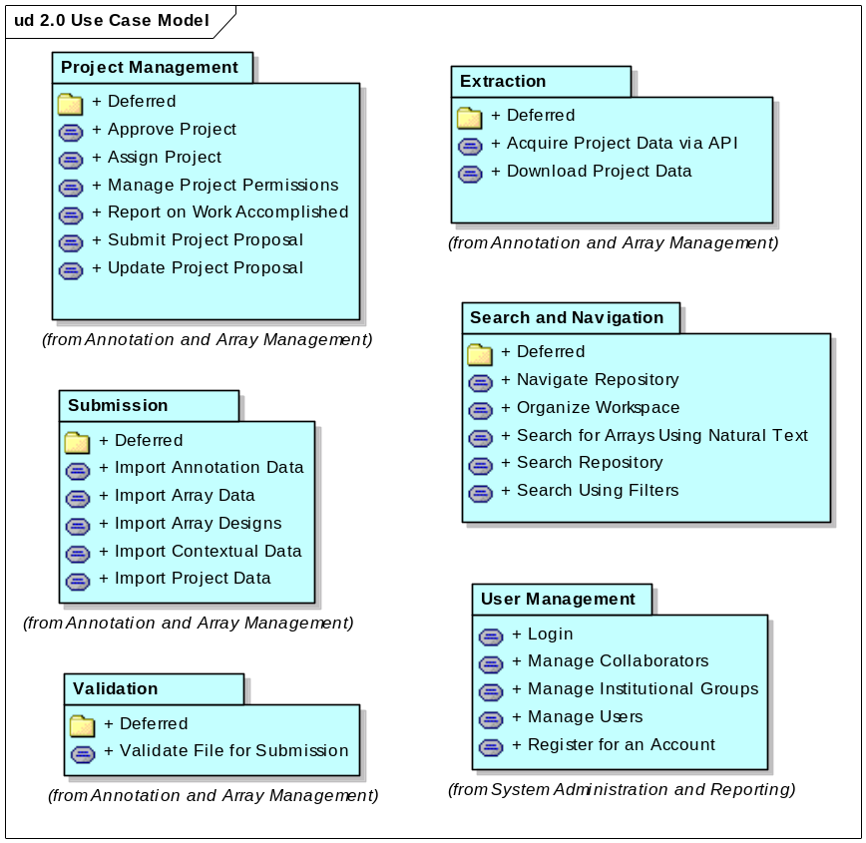
Figure 1. 2.0 Use Case Model
For this iteration, we will prioritize the detailing of the following use cases:
  - UC Login
  - UC Import Project Data
  - UC Submit Project Proposal
  - UC Report on Work Accomplished
  - UC Validate File for Submission
  - UC Download Project Data
  - UC Manage Users
  - UC Manage Institutional Groups
These should be done first to support analysis and design activities occurring during E1. The remainder should be tackled later in the iteration.

Analysis to be performed

Architectural Prototype to be delivered
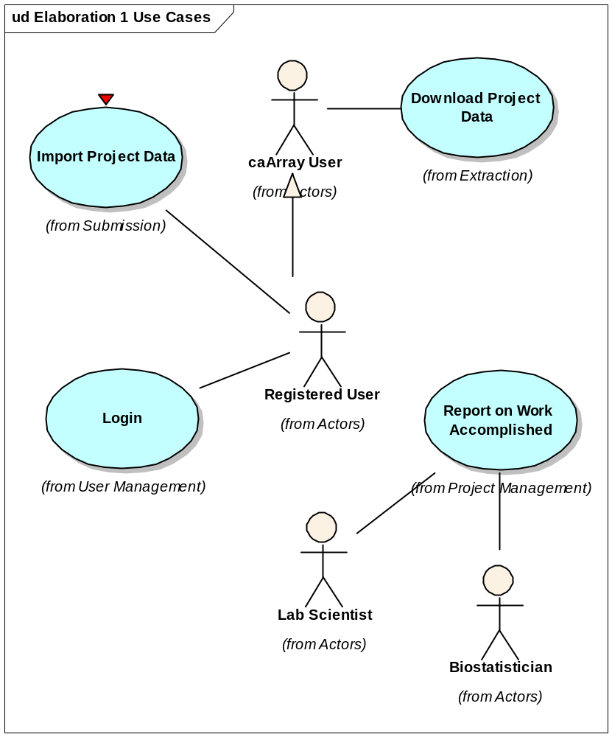
Figure 2 Use Cases for E1 Prototype

Evaluation Criteria
The primary goal of the E1 Iteration is to complete the analysis and design of selected use cases and to develop a working architectural prototype. The more granular goals will be highlighted per discipline.

Project Management
The project schedule is updated in concert with the development team and reported to the external teams on a weekly basis.
The remainder of the E1 iteration is tightly planned and reported on, the E2 iteration is planned and available for the iteration review meeting, and the 2.0 Generation Plan is reviewed by all relevant teams and their input validated with the Product and Engineering Manager.
Each deliverable developed during the E1 Iteration will be peer reviewed and subject to approval from the team.
We complete the activities on time. We will end the iteration regardless based on the calendar but if we do not achieve all the tasks, it will be duly noted in the iteration review.

Requirements
All the targeted use cases for E1 plus all additional use cases that impact the architecture are written to ensure that the team has the appropriate time for analysis and design activities and a full set of use cases are available for Elaboration 2.
In addition, identifying external stakeholders to serve as use case reviewers for the functional areas of:
  - Upload
  - Download
  - Search
  - Extraction
  - Workflow
And establish the process for incorporating their review is an additional goal.

Analysis and Design
Risk associated with the architectural design or system performance against the targeted use cases will be complete by the end of the iteration.

Implementation
Goals here

Test
Continue dialogue with Independent Quality Assurance (IQA) to establish policy and procedures for delivering tags and what they will contain depending on the iteration cycle.
Write Unit Tests for all implemented use case threads.

Environment
Manage and integrate all code and tests through Cruise Control.

Configuration and Change Management
Evaluate Requirement Priorities and manage GForge, models and documents to reflect decisions.

