Use-Case-Model Summary for NP2

Version 1.0
June 30, 2003
Revision History
Date | Version | Description | Author
June 27, 2003 | 0.1 | Initial. Rebuilt from stock with adoption of existing NINDS/NIMH stuff as well as NP2 Rose model. | Rob Daly
June 30, 2003 | 1.0 | First draft, along with generation 2 package of use case model, ready for inception delivery. | Rob Daly

Table of Contents
1. Introduction 4
2. Actors 4
2.1 Consortium Administrator 4
2.2 Consortium Scientist 4
2.3 CRISP 4
2.4 Grantee 4
2.5 Portal Administrator 4
2.6 Registered User 5
2.7 System Administrator 5
2.8 Time 5
3. Use Cases 5
3.1 Assign Proposal 5
3.2 Download My Data 5
3.3 Download Proposal 6
3.4 Download Public Data 7
3.5 Flush Transient Data 7
3.6 Login 7
3.7 Maintain CRISP Data 8
3.8 Make Data Public/Private 8
3.9 Manage Consortium Member Accounts 9
3.10 Manipulate Data 9
3.11 Navigate Repository 9
3.12 Perform Analysis 9
3.13 Report on Work Accomplished 10
3.14 Request Analysis 10
3.15 Review Quality 11
3.16 Search Repository by Advanced Criteria 11
3.17 Search Repository with Known Criteria 11
3.18 Upload Consortium Generated Data 11
3.19 Upload Data 12
3.20 Upload Legacy Data 12
3.21 Upload Transient Data 13
3.22 Validate Data 13
3.23 View Audit Logs 13
3.24 View Consortium Status 13
3.25 View Proposal 14
4. Views 14

Introduction
This use-case model contains the use-cases and actors defined specifically for the NINDS/NIMH Portal Generation 2 (NP2). To streamline the review process, we have included only those elements that are directly affected by the new requirements for generation 2. For example, there are several new use cases, and a few modified use cases. Along with them come some new actors as well as some actors that carry over from generation 1.

Actors

Consortium Administrator
Documentation: A Consortium Administrator is a special registered user whose primary function is to give a quick review of each proposal that is submitted and assign it to one of the Consortium Scientists. In the event of illness or long vacation, they can assign their role to another Consortium Scientist to ensure the process continues to function.

Consortium Scientist
Documentation: A Consortium Scientist is a registered user who works within the Microarray Consortium at one of the three Institutions. These individuals perform the work assigned to them by the Consortium Administrator and detailed in an Extramural Investigator's proposal. They may communicate with the Extramural Investigator outside of the system but will update their progress on each proposal assigned to them via the system, allowing the Extramural Investigator to see progress.

Consortium Scientist accounts and profiles will be self-managed.

CRISP
Documentation: CRISP (Computer Retrieval of Information on Scientific Projects), contains an online accessible database containing information on research projects and programs supported by the Department of Health and Human Services. Most of the research falls within the broad category of extramural projects, grants, contracts, and cooperative agreements conducted primarily by universities, hospitals, and other research institutions; and funded by the National Institutes of Health (NIH) and other government agencies. A relatively small number of research grants are funded by the Centers for Disease Control and Prevention (CDC), the Food and Drug Administration (FDA), the Health Resources and Services Administration (HRSA), and the Agency for Health Care Research and Quality (AHRQ). CRISP also contains information on the intramural programs of the NIH and the FDA.

The system will utilize the CRISP database to help validate that Extramural Investigators who wish to submit a proposal have confirmed grants. It is updated weekly.

Grantee
Documentation: This actor would hold or want to hold an NINDS/NIMH Grant which would allow for the removal of the grant restriction from the current EI, thus enlarging the population served. Pertinent grant information could still be obtained.

This actor is not participating in any use cases in generation 1 nor generation 2. Suggest permanent deletion from the model.

Portal Administrator
Documentation: A Portal Administrator is a registered user who effectively is the super user of the NINDS Portal. They are responsible for keeping the system up and in action. Responsibilities include maintaining the validity of NIMH and NINDS grants stored in the system (via CRISP search results), managing the Consortium Member accounts and profiles, and performing the initial assignment of proposals. There are two flavors to this role - a business orientation and a technical orientation. To satisfy a variety of constraints, those flavors are being rolled up into this actor.

Registered User
Documentation: A Registered User is any user known to the NINDS Portal. Specifically, we expect five roles that are variations on Registered User:

1 - Extramural Investigator;
2 - Consortium Scientist;
3 - Consortium Administrator
4 - Consortium Advisor; and
5 - Portal Administrator.

Extramural Investigators will self-register. Consortium members will be registered by Portal Administrators and then self-manage their details. The development team and or other portal administrators will create consortium and Portal Administrators. A registered user will be able to manage their personal profile (e.g., change their password, update address), but not their role.

System Administrator
Documentation: this actor is not participating in any use cases in generation 1 or generation 2. Suggest permanent deletion from the model.

Time
Documentation: This actor represents scheduled events that can be triggered by the software to do things like send emails, flag proposals for display, and flush data.

Use Cases

Assign Proposal
Business Priority: Medium

Scheduled Iteration: C1

Completion Status: To Be Modified In Generation 2

Documentation: Initiated by the Consortium Administrator, this use case enables the assignment or rejection of submitted proposals. Certain characteristics of the proposal, such as scientific merit or the level/type of service requested will drive this initial process. Notification of the Extramural Investigator will occur when a rejection action is taken and the Consortium Administrator must give a reason.

Download My Data
Business Priority: High

Scheduled Iteration: E1

Completion Status: Outlined

Documentation: Initiated by any registered user, this use case enables the downloading of one's own data (including raw data files and derived data).

Basic Flow:
1. Registered User navigates to home
2. System displays current registered user's home environment
3. Registered User selects items for export (SR1)
4. System displays selected items (perhaps size as well)
5. Registered User chooses export
6. System prompts for destination location (SR2)
7. Registered User specifies location
8. System proceeds to download selected items and displays progress of downloading item (SR3, Alt 1) and continues until complete, at which time S displays completion message (SR4) (do selected items remain selected?)

Alternate Flows

Cancel

Connection fails

Special Requirements

SR 1: Items: folder structure by project, sample, etc.

SR 2: Destination location: folder? Replicates composite structure? Or Zip location

SR 3: Progress of downloading items (time based on access (cable modem, t1, t3), MB count, # of items

SR 4: Completion Message

Download Proposal
Business Priority: Medium

Scheduled Iteration: E2

Completion Status: Defined

Documentation: Initiated by a registered user, it provides a means to download to one's local machine, a file representing the proposal of a project (see View Proposal). Formats anticipated include tab-delimited text as well as XML (MAGE-ML?).

Note that with Generation 1, we have seen three uses for this capability, and to-date, it has been supported through manual intervention or scripts. The three uses are:

1) When returning microarray data to PIs, the export of proposal data is included in the CD (the export is done manually).

2) When using Affymetrix to execute array scans, the folks at TGen (previously CNMC) export the data and then re-key it into Affy. There is an even larger opportunity here, BTW.

3) When publishing data at the CNMC PGA website, the portal administrator has had to manually epxort the data from NINDS/NIMH Portal in order to load it into the PGA site. See http://microarray.cnmcresearch.org/pgagoals.asp for more.

NOTE: We will investigate the claim of "manual" to see exactly what the process is.

Download Public Data
Business Priority: High

Scheduled Iteration: E2

Completion Status: Proposed

Documentation: Initiated by a registered user, this use case allows for the downloading of any publicly available data, including of the registered user's own. It appears to be very much like the "Download My Data" use case with the exception of the data not necessarily being one's own.

NOTE: More than likely, the two use cases "Download My Data" and "Download Public Data" will be merged into one use case.

Flush Transient Data
Business Priority: Low

Scheduled Iteration: C2

Completion Status: Defined

Documentation: Initiated by time (e.g., a CRON job), the system will cleanse itself of data that has been stored temporarily by registered users according to a configuration schedule.

The following will likely be specified in special requirements for this use case:

1) Flush Transient Data will be executed daily at a configurable time (default: midnight).

2) Flush Transient Data will permanently remove any transient data that is considered stale (default: 7 days).

Login
Business Priority: Medium

Scheduled Iteration: E1

Completion Status: To Be Modified In Generation 2

Documentation: Initiated by any registered user, this use case describes the actions that the user performs to gain access to restricted portions of the Web site. The Login use case validates user names and passwords and determines what privileges are available to the user by applying business logic to their role.

As a result of a successful login, the registered user is presented with their home space and the set of operations they have been granted privileges to perform.

Note: The Portal Administrator determines access privileges to specific areas of the Web site.

Maintain CRISP Data
Business Priority: Low

Scheduled Iteration: N/A

Completion Status: N/A

Documentation: THIS IS NOT a software use case, though it is a candidate.

Manually managed by the Portal Administrator, this use case enables the acquisition of grant numbers from the CRISP database and inserts into the NINDS portal. This is done by performing a full search via the CRISP website and capturing the resulting web page. The resulting web page is then parsed and imported using a script. It is under consideration to completely automate this process to simplify the Portal Administrator's job, but since it is a task only performed once every month or so, it remains a low priority.

Make Data Public/Private
Business Priority: Medium

Scheduled Iteration: C1

Completion Status: Defined

Documentation: Initiated by a registered user, this use case permits the owner of project data to make the data either public or private. When first uploaded, data is considered private by default, so it is anticipated that registered users who are owners of their data will ultimately voluntarily make their data public.

While all consortium generated raw data becomes public 6 months after high quality data is extracted, this use case allows the user to determine whether the data uploaded will be immediately available (after it's 'scrubbed'), kept private or perhaps, available by a certain date. By making data public, it allows for others to search against the project's properties and potentially download/export it as well.

Note: There is currently consideration for group rights, so the concept of private should also include a concept of data being private-to-group.

Manage Consortium Member Accounts
Business Priority: Medium

Scheduled Iteration: E1

Completion Status: To Be Modified In Generation 2

Documentation: Initiated by the Portal Administrator, this use case allows them to create, update, unlock and delete accounts.

Manipulate Data
Business Priority: Medium

Scheduled Iteration: E2

Completion Status: Defined

Documentation: Initiated by a registered user, this use case provides for the temporarily persistent manipulation of sample data, including merging, cropping and normalization (limited to a intra-platform normalization).

It is understood that data is manipulated to either be downloaded, analyzed, or both and it is further understood that the resulting data sets will be susceptible to flushing within the prescribed time to flush stale data (default currently established as 7 days).

Navigate Repository
Business Priority: Medium

Scheduled Iteration: E1

Completion Status: Defined

Documentation: Initiated by a registered use, this use case permits navigation throughout the system's repository through basic hierarchical means. For example, when a user logs in, they are placed at their home, from which they can navigate into any projects they have defined for themselves, etc.

NOTE: If navigating outside one's home, we do not have a meaningful hierarchy defined. As a result, there is some doubt regarding the ability of this use case to support hierarchical navigation above/outside one's home space.

Perform Analysis
Business Priority: Medium

Scheduled Iteration: E2

Completion Status: Defined

Documentation: Initiated by a registered user, this use case allows for specific tool analysis to be performed on array data by one or more of a set of tools provided by the system.

NOTE: Need to investigate the potential need for an asynchronous submission of analysis requests. It could include things like reporting on when it was finished and automate informing the investigator and the scientist who performed it, could potentially email the image of the result or a URL that will keep/display the result, or an interface to enter and receive the message. At the same time, none of this might be necessary if we determine that interactive performance is acceptable.

Report on Work Accomplished
Business Priority: Medium

Scheduled Iteration: C2

Completion Status: To Be Modified In Generation 2

Documentation: Initiated by the Consortium Scientist, this allows them to detail what work they are doing step by step. This will also be used to inform Consortium Administrators and Extramural Investigator on the status of work and kick-off timers for additional use cases.

This may include the ability to enter in MIAME compliant data as a part of the business process but it's not required until the end.

Request Analysis
Business Priority: Not Yet Prioritized

Scheduled Iteration: TBD

Completion Status: Proposed

Documentation: Initiated by a registered user (Note: perhaps it should be limited to Extramural Investigators), this use case allows the user to select the sample data set to be analyzed, the method of analysis desired, and forward that information as a request to the consortium for them to execute the analysis.

Potential methods can be broken down into gene lists, visualizations, clustering. Gene lists will have specific filters for normalization, expression or statistical restrictions, fold-changes, or flags. Potentially there could be other attributes which could be requested for filtering.

NOTE: Need to understand what "inspect experiment" means.

Review Quality
Business Priority: Deferred

Scheduled Iteration: TBD

Completion Status: N/A

Documentation: Note sure how this differs form Validate Data, but this use case, initiated by a registered user, provides the ability to test the quality of one or many array data sets against a standard data set for MIAME compliance, Data Variances Thresholds, and other quality characteristics TBD, same gene, etc.)

Search Repository by Advanced Criteria
Business Priority: Deferred

Scheduled Iteration: TBD

Completion Status: N/A

Documentation: Initiated by a registered user, this provides a more sophisticated level of querying that enables a visualization of the schema for user-driven SQL statements to be crafted

Search Repository with Known Criteria
Business Priority: High

Scheduled Iteration: E1

Completion Status: Defined

Documentation: Initiated by a registered user, this use case provides a means to locate and query data sets against prescribed parameters (for example, a combination of organism, tissue type, author/source, platform type).

If results cross projects, it is expected that the result set will appear as an ordered set of projects that contain data that meets the search criteria. The use should be able to navigate into (drill down) the results to examine what was found.

Note that this use case will likely precede analysis and download activity.

Upload Consortium Generated Data
Business Priority: High

Scheduled Iteration: E2

Completion Status: Defined

Documentation: Initiated by a Consortium Scientist, this use case allows for the uploading of specific data that result from microarray analysis performed by one of the Consortium centers (Duke, TGen, and UCLA). It is intended to complement the physical return of data and samples back to Extramural Investigators who have paid their bill. Once uploaded, the Consortium Scientist and Extramural Investigators will be informed of its completeness and location.

Note that unlike Upload Data, this use case may trigger other workflow items within the NINDS/NIMH Portal.

Upload Data
Business Priority: High

Scheduled Iteration: E1

Completion Status: Defined

Documentation: Initiated by a Registered User, this use case allows for the submission of approved array platform data that exist outside the consortium's array centers. The submission process will monitor quality controls governing MIAME compliance to ensure completeness and required process information that may not be captured as a result of it coming from outside the Consortium.

In general, for submission to be accepted, it must contain the address of each feature on the array, feature size, probe set definitions, NCBI accessions, number of color channels and technology description (this must be better defined).

Several flows are possible and could include scenarios where the upload is automated (from db to db) or portioned uploads.

If the data was generated 2+ (?) years ago, the investigator would need to contact a Consortium Administrator to get approval for the upload.

Upload Legacy Data
Business Priority: Deferred

Scheduled Iteration: TBD

Completion Status: N/A

Documentation: Initiated by a Consortium Scientist, this use case enables the uploading of unique data sets that will never reach the level of MIAME compliance and is performed rarely. Generally, specific permission outside the system is granted to individuals, groups or institutions to upload this particular kind of data.

Upload Transient Data
Business Priority: Deferred

Scheduled Iteration: TBD

Completion Status: N/A

Documentation: Initiated by any registered user, this use case allows for temporary storage of data so that analysis can be performed. The quality is not held to the same standard, but may be encouraged for better results. Items like species, format/platform, and other details are required.

Validate Data
Business Priority: Low

Scheduled Iteration: C2

Completion Status: Defined

Documentation: Initiated by a registered user, this provides a convenience mechanism to check data against quality and validation rules (e.g., the MIAME standard) and is intended to stimulate the user's proactive correction of any validation errors.

View Audit Logs
Business Priority: Low

Scheduled Iteration: C2

Completion Status: Defined

Documentation: Initiated by a Consortium Administrator, this use case allows for viewing the log file of user access, which typically contains information like the username, time/date stamp, and activity. If necessary, particularly if HIPAA plays a part, reasons for doing particular activities may also need to be recorded.

View Consortium Status
Business Priority: Medium

Scheduled Iteration: C2

Completion Status: To Be Modified In Generation 2

Documentation: Initiated by the Consortium Advisor, Portal Administrator, or Consortium Administrator, this use case allows for viewing the overall status of the Consortium, with details of the number and pace of work being accomplished, with the ability to view the different Institutions individually or together and be able to see any particular proposal submitted.

View Proposal
Business Priority: Medium

Scheduled Iteration: C2

Completion Status: Defined

Documentation: Initiated by a registered user, this provides a means to examine the proposal used to define a project. Note that there is a complimentary Download Proposal that permits downloading the same information for use on one's local machine.

Views
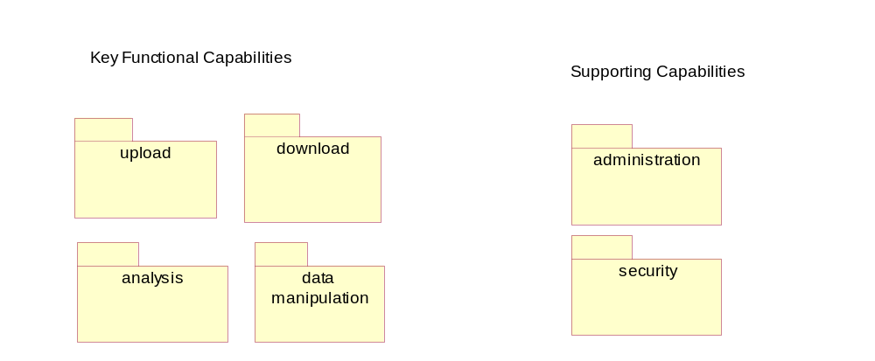
Use-Case Diagram: Use Case View::Generation 2 Use-Case Model::Main Package View
This diagram provides a functional grouping of use cases contained within the packages. For example, use cases related to upload can be found in the upload package, while use cases having to deal with fundamental system administration (like Flush Transient Data) can be found in the administration package.

The groupings are logical only, and do not imply any ordering or semantic dependence among the use cases they contain.

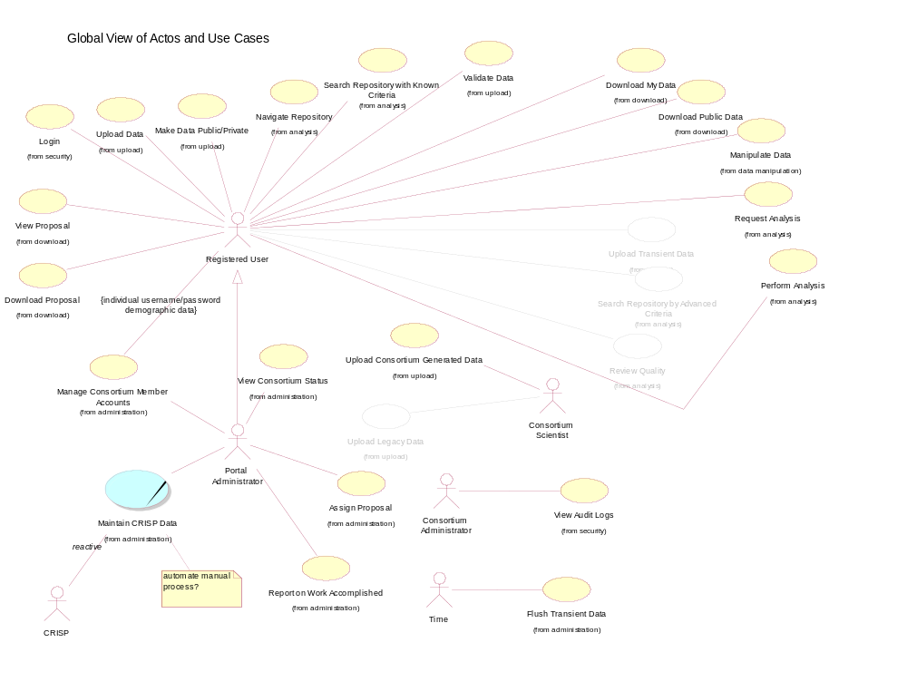
Use-Case Diagram: Use Case View::Generation 2 Use-Case Model::Global View of Actors and Use Cases

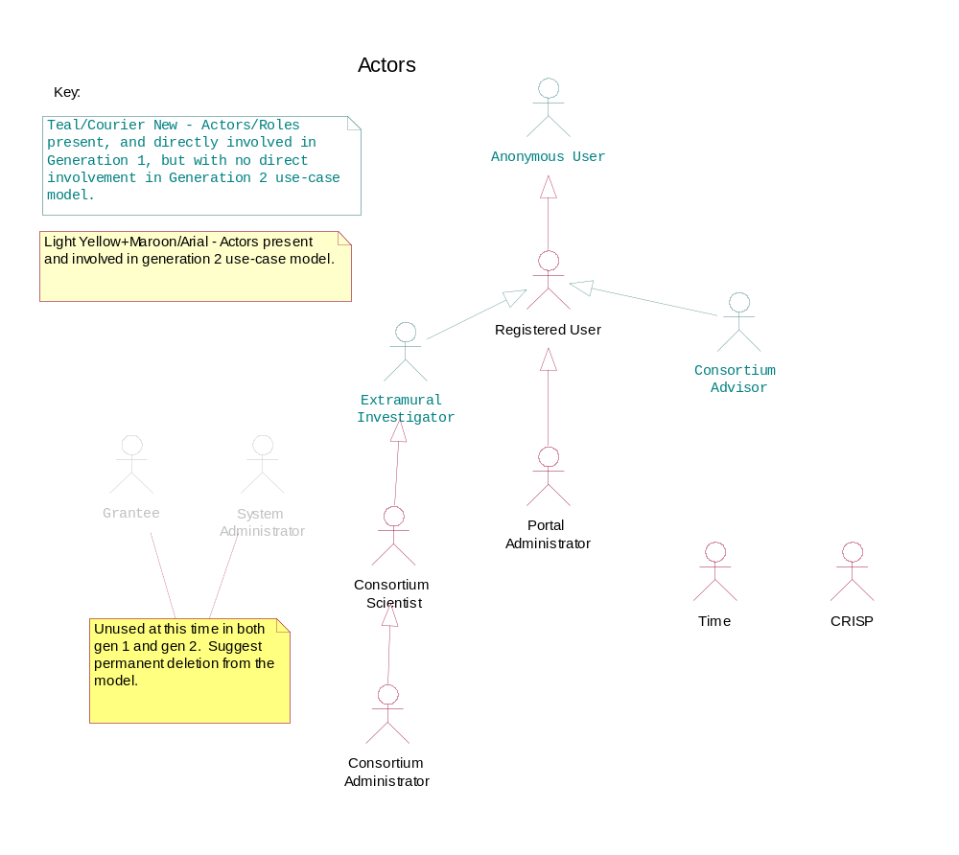
Use-Case Diagram: Use Case View::Generation 2 Use-Case Model::Actors::Main
This diagram illustrates all the actors who have specific use cases provided in generation 2, with the exception of those noted in teal/courier new font; they were included to help tie together related actors and demonstrate the generalization relationships.

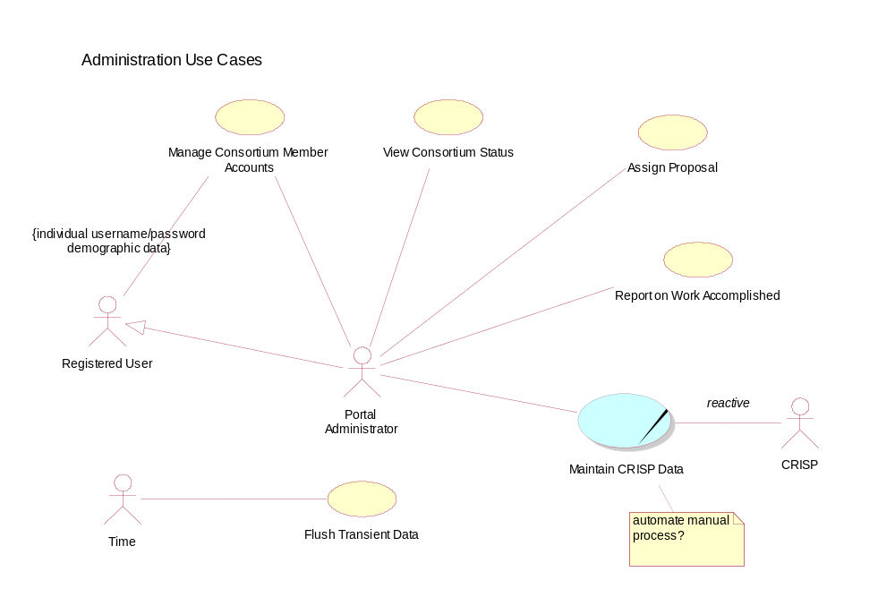
Use-Case Diagram: Use Case View::Generation 2 Use-Case Model::administration::Main

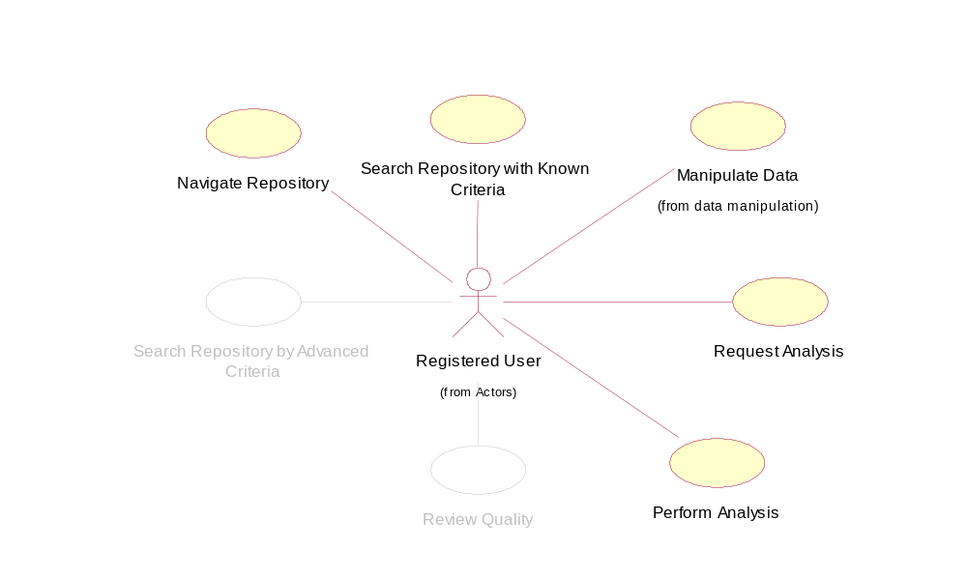
Use-Case Diagram: Use Case View::Generation 2 Use-Case Model::analysis::Main

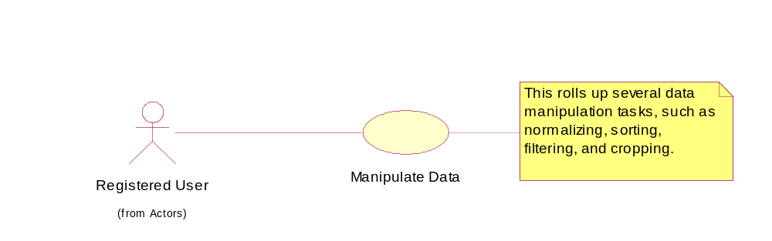
Use-Case Diagram: Use Case View::Generation 2 Use-Case Model::data manipulation::Main

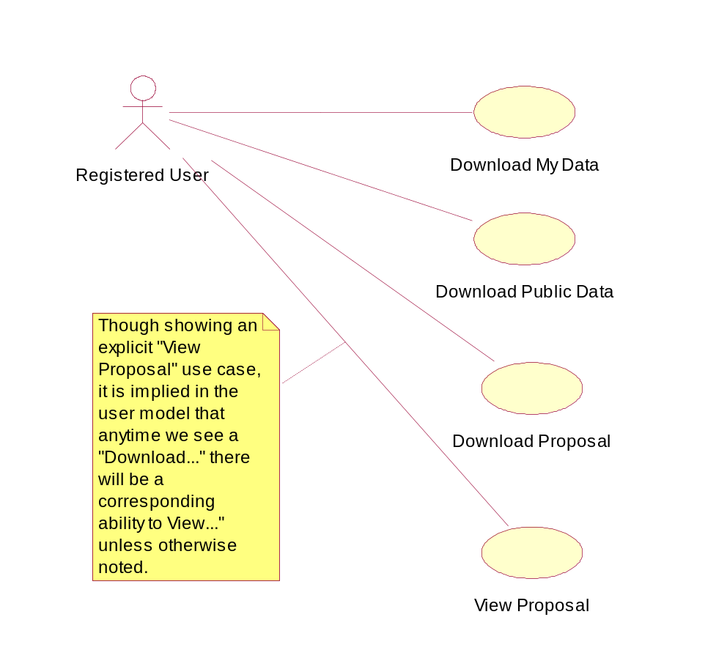
Use-Case Diagram: Use Case View::Generation 2 Use-Case Model::download::Main

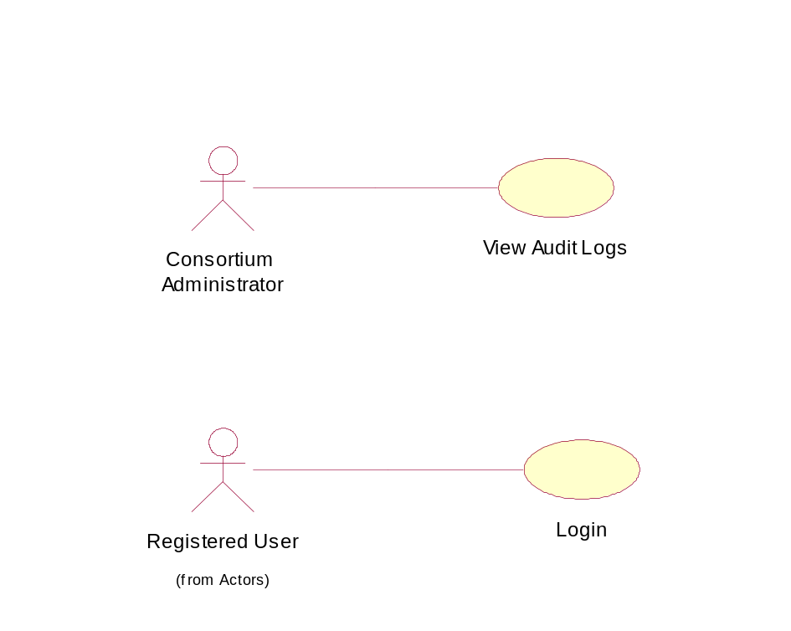
Use-Case Diagram: Use Case View::Generation 2 Use-Case Model::security::Main

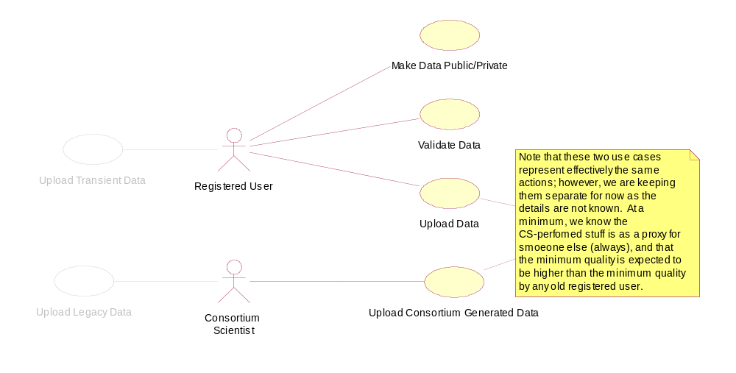
Use-Case Diagram: Use Case View::Generation 2 Use-Case Model::upload::Main

