Use Case Summary
Factory Data Portal

Last Revised: | November 7, 2006
Produced By: | Acxiom Corporation

Document Approvals
The list contains the name and contact information for the core project team and any key stakeholders who have an interest in the success of the project. An “S” identifies persons responsible for approval from the Business and Development. Sign off of the document would be required when a decision is made not to take action for defined gaps.
S | Name | Role | S | Name | Role
S | Todd Barron | Architecture DM (UL) |  | Paul Dyksterhouse | Reqts & Testing (UL)
 | Dan Kwit | Architecture (PM) |  | Peter Defalco | ETL Data (TL)
 | David Harlan | SWAT (TL) | S | Prathima Donapudi | DPI (TL)
 | Dwight Davis | SDM (TL) | S | Melanie Pai | UI TA (TL)
 | Ed Savage | Data Delivery (TL) |  | Tony McHatton | Technical Writer (TL)
 | George Allton | Technical Advisor |  | TA Team | Technical Analysts
 | Kathy Horowitz | ETL Data (TL)
 | Marvin Hamiter | Data Services (TL)

Revision History
When you make a change to a document, you must add an entry to this Revision History table and you must manually type the Last Revised Date on the front cover.
Revision Date | Revised By | Revision Description
03/28/2006 | Brent Gendleman | Initial Draft with initial set of actors and use cases
04/07/2006 | Brent Gendleman | Incorporated notes from meetings with Bas, Joe Thompson and Pamela Hulse
04/11/2006 | Brent Gendleman | Filled in definitions for actors and re-organized the use case context diagram
04/18/2006 | Brent Gendleman | Revamped Actors and Use Case Context diagrams, indicated what use cases would be a part of the scope for Release 1
5/18/06 | Brent Gendleman | Added Use Cases for Common Component: Messaging
8/29/06 | Brent Gendleman | Began Re-organization of the document
9/6/06 | Brent Gendleman | Updated to reflect all identified use cases
10/17/06 | Brent Gendleman | added Business Actors, mapping to System Actors, updates to Security and Data Sensitivity Model, Use Case Models, use case descriptions and Views by Actors (data analyst and delivery analyst). Views still need to be created for each actor (2 of 8 done).
10/18/06 | Brent Gendleman | Included Data Access Security definitions and depictions under each Business Actor, updated Business and System Actor definitions, use cases and added the views. Also added a diagram, table and examples explaining the relationships between roles, work streams and data access
10/19/06 | Brent Gendleman | Mapped Level 0, 1 and 2 with Ellen Adam’s definitions
11/7/06 | Brent Gendleman | Reviewed current repository for updates to Vision and Scope and Use Case Documents, added links to customer Source Forge Versions of each doc, moved State License from Drug to Practitioner
11/9 | Brent Gendleman | Updated File Promotion Use Case Descriptions
Copyrights and Trademarks
© Copyright 2006 by Acxiom Corporation. All rights reserved.
Reproduction of all or any portion of this text, software, or exhibits without written consent is expressly prohibited.
Acxiom is a registered trademark of Acxiom Corporation. All other trademarks and registered trademarks are the property of their respective owners.
Table of Contents
1. Introduction 6
1.1. Objective and Scope 6
1.2. Reference Documents 6
1.3. Unaddressed Issues 7
1.3.1. Validate Work Stream Designations 7
1.3.2. Correlation between Data and File Sets and Sub-Sets Designations, User Capabilities, and Data Access 7
1.3.3. Should work stream permissions apply to the availability of messages and reports? 8
1.3.4. Validate Correlation, Description and between Business Actors and System Actors 8
2. Business Actors 9
2.1. Executive Operations 9
2.2. Administration 10
2.3. Operations Support 10
2.4. Data Asset Management 11
2.5. Client Delivery Management 12
2.6. Analytics 12
3. System Actors 13
3.1. View of System Actors 14
3.2. External System Actor Descriptions 14
3.2.1. Time 14
3.2.2. Customer External Actors 14
3.2.2.1 Contracts System 15
3.2.2.2 Financial System 15
3.2.2.3 Sales System 15
3.2.3. Acxiom External Systems 15
3.2.3.1 Apiary 15
3.2.3.2 LDAP 15
3.2.3.3 Orbiter 15
3.2.3.4 Remedy 16
3.2.4. Customer Actors 16
3.2.4.1 Client 16
3.2.4.2 Data Analyst 16
3.2.4.3 Data Lead 16
3.2.4.4 Data Owner 16
3.2.4.5 Data Governess 16
3.2.4.6 Client Services Analyst 17
3.2.4.7 Client Services Manager 17
3.2.4.8 Delivery Analyst 17
3.2.4.9 Delivery Manager 17
3.2.4.10 Statistician 17
3.2.4.11 Statistician Manager 18
3.2.4.12 Supplier 18
3.2.5. Acxiom Actors 18
3.2.5.1 Acxiom Security Administrator 18
3.2.5.2 Developer 18
3.2.5.3 Operation Support 18
3.2.5.4 Portal Administrator 18
4. Security and Data Restrictions 18
4.1. Role-Based User Access 18
5. Use Case Views by UI Component 20
5.1. Context 20
5.2. Common Packages 20
5.2.1. Security and Administration 20
5.2.1.1 Initiate Change Request 21
5.2.1.2 Manage Users 21
5.2.1.3 Request Access for Users 21
5.2.1.4 Maintain User Work Stream Associations 22
5.2.1.5 Manage Role Capabilities 22
5.2.1.6 Login 22
5.2.1.7 Access Portal Elements 22
5.2.1.8 Update Password 22
5.2.2. Messaging 22
5.2.2.1 View Message Log 23
5.2.2.2 Manage Message Catalog 23
5.2.2.3 Map Event to Response 23
5.2.2.4 Manage Notification Template 24
5.2.2.5 Search Notification Template 24
5.2.2.6 Manage Contacts 24
5.2.2.7 Manage Distribution List 24
5.2.2.8 Search Distribution List 24
5.2.3. Preferences 24
5.2.3.1 Set Preferences 25
5.2.4. Reporting 25
5.2.4.1 Generate Report 26
5.2.4.2 Customize Standard Report 26
5.3. Data Supplier Management 26
5.3.1. Data Supplier 26
5.3.1.1 Load Data Supplier Data 27
5.3.1.2 View Data Supplier Profile 27
5.3.1.3 Set Data Supplier Thresholds 27
5.3.2. File Definition System 28
5.3.2.1 Manage File Definition 28
5.3.2.2 View File Definition History 29
5.3.3. Mapper 29
5.3.3.1 Manage Associations 29
5.3.3.2 Manage Layouts 30
5.3.3.3 Manage Mappings 30
5.3.4. File Tracker 30
5.3.4.1 Search File Arrival 30
5.3.4.2 Track Inbound Files 31
5.3.5. File and Record Management 31
5.3.5.1 File Management 31
5.3.5.2 Manage Files 31
5.3.5.3 View Activity Log 32
5.3.6. Reconciliation 32
5.3.6.1 View Records 33
5.3.6.2 Reject records 33
5.3.6.3 Hold records 33
5.3.6.4 Reconcile record 34
5.3.6.5 View change log history 34
5.3.7. Maintenance 34
5.3.7.1 Manage Factory Data 35
5.3.7.2 Maintain Rule Thresholds 35
5.3.8. Promotion 35
5.3.8.1 Promote File 36
5.3.8.2 Reject File 36
5.3.8.3 Hold File 37
5.3.8.4 Release Deliverable 37
5.3.8.5 Hold Deliverable 37
5.3.8.6 Reject Deliverable 37
5.3.8.7 View File Contents 37
5.4. Client Management 38
5.4.1. Client 38
5.4.1.1 View Client Profile 38
5.4.1.2 Run Client Reports 39
5.4.2. Client Universe 39
5.4.2.1 Create Market 39
5.4.2.2 Copy Market 40
5.4.2.3 Maintain Market 40
5.4.2.4 Evaluate Client Market 40
5.4.2.5 Associate Factor to Market 40
5.4.2.6 Manage Client Factors 41
5.4.2.7 View Client Input Files 41
5.4.2.8 View Reports 41
5.4.3. Deliverable Specification 41
5.4.3.1 Manage Deliverable Specification 42
5.4.3.2 Schedule Deliverable 43
5.4.3.3 Copy Specification 43
5.4.3.4 View Specification Summary 43
5.4.3.5 Filter Display of Specification 43
5.4.3.6 Set Preferences 43
5.4.4. Order Tracker 44
5.4.4.1 Search Orders 44
5.4.4.2 Track Orders 44
5.4.4.3 Manage Orders 45
5.4.4.4 Track Jobs 45
5.4.4.5 Manage Jobs 45
6. Use Case Views Per Actor 46
6.1. Data Asset Management 46
6.1.1. Data Analyst 46
6.1.2. Data Lead 47
6.1.3. Data Owner 47
6.2. Client Delivery Management 47
6.2.1. Client Services Analyst 48
6.2.2. Client Services Manager 48
6.2.3. Delivery Analyst 48
6.2.4. Delivery Manager 49
6.3. Analytics 49
6.3.1. Statistician 49
6.3.2. Statistician Manager 49

Table of Figures
Figure 1 Executive Level Business Actors 9
Figure 2. Administrator Business Actors 10
Figure 3. Operations Support Business Actors 10
Figure 4. Data Asset Management Business Actors mapped to System Actors 11
Figure 5. Client Delivery Management Business Actors mapped to System Actors 12
Figure 6. Analytics Business Actors mapped to System Actors 13
Figure 7. System Actor Overview 14
Figure 8. User Relationship to Roles and Work Streams 19
Figure 9. Use Case Context Diagram 20
Figure 10. Security Use Case View 21
Figure 11. Use Cases for Event Handler GUI 23
Figure 12. Preference Use Case Diagram 25
Figure 13. Report Use Case Diagram 25
Figure 14. Data Supplier Use Case Diagram 27
Figure 15. File Definition Use Case Diagram 28
Figure 16. Mapping Use Case Diagram 29
Figure 17. File Tracker Use Case Diagram 30
Figure 18. File Management Facility Use Case Diagram 31
Figure 19. Reconciliation GUI Use Case Diagram 33
Figure 20. Maintenance GUI Use Case Diagram 35
Figure 21. Promotion GUI Use Case Diagram 36
Figure 22. Client Universe Use Case Diagram 38
Figure 23. Client Universe Use Case Diagram 39
Figure 24. Order Tracker GUI Use Case Diagram 44
Figure 25 View of all Data Analyst, Data Lead and Data Owner Use Cases 47
Figure 26. Client Services Analyst and Manager Composite View 48
Figure 27. Delivery Analyst and Manager Composite View 49
Figure 28. Statistician and Manager Composite View 50

Introduction

Objective and Scope
This document focuses on the User Interface requirements necessary for the development of the Factory Data Portal as identified in the High Level Transformation Processing Business Requirements documents. This document will inform the development of the User Interface to the Data Portal Factory and influence the architecture by representing all the Actors and Use Cases that make up the User Interface portion of the System. Much of the document represents an extract from StarUML models in addition to the Vision and Scope documents written for each identified User Interface. This is a living document that will be released by the end of each iteration over the entire lifecycle of the project.

Reference Documents
- Meetings with Joe Thompson (4/5/06) for initial depiction of System Actorsm, Business Analysts (4/7/06) – describing process and worksheet for eliciting actors, Pamela Hulse (4/6/06) concerning Security and Data Governance.
- L1 and L2 Process Overviews
- Wolters Kluwer Organization Charts for Customer Operations and Product Marketing and Management (hard copy from Pamela Hulse)
- Wolters Kluwer Spreadsheet of all current employees and contractors, their respective departments and titles (from Zoe as of October 12, 2006)
- IRise Simulations for Institution (doc4912 in WKHAT), Client (doc3825 in WKHAT), Transformation Home Page (doc3833 in WKHAT)
- DPI Vision and Scope – high level description of the fundamental functions the portal must support such as single sign-on
- Security Management System GUI Vision and Scope (doc5713 in WKHAT) – details the features allowing for roles, capabilities and work streams to be associated with users.
- Actors_Roles_and_Capabilities_Data_Governance.xls (doc549 in WKHAT)- a matrix of all identified roles against all identified discreet features in the system with an indication of whether work stream and/or data group permissions will affect them.
- All UI Vision and Scope and Use Case Specifications (in WKHAT/Transformation/Requirements/Common for VS’s and Use Cases in a sub-folder broken out by Common, Client Management, Supplier Management and File and Record Management folders) which correspond to the organization of this document and StarUML models.
- Logical Data Model describing Data Access Roles (Ellen Adams hard copy, October 14, 2006)
- StarUML Model: http://tranacx2.corp.acxiom.net/svn/repos/dpi/dpiModels (Subversion and StarUML required, along with your corp logon credentials. See User Guide (doc5160 in TransArch) for set up instructions.
- Product Definition Matrix (doc5188 in WKHAT)

Business Actors
Based on a survey of all current employees and contractors, their departments and job titles, the following sets of Business Actors have been identified. These are mapped to System Actors and the System Actors are identified as a composite and briefly described in the System Actor descriptions section. In addition, each Business Actor is given a data access restriction level of 0, 1, or 2. These restriction levels are defined in the table below which is referenced multiple times in this document.
Data Access Restriction Level | Name | Description
0 | Factory Support Data Access Role | A role assigned to personnel that are supporting the factory but not directly participating in the production of data or deliverables.
1 | Operational Data Access Role | A role assigned to personnel that perform operational functions on data and processes that are used to produce products and services This personnel must have access to operational data in order to perform their job duties. However, they do not have to have direct contact with clients in order to perform their job duties.
2 | Client Interfacing Data Access Role | A role assigned to personnel that interact directly with external clients. This personnel must have direct contact with clients in order to perform their job duties. The intent of the role is to prevent inappropriate exposure of restricted data to a client.
Table 1. Data Access Level Restrictions

Executive Operations
Access Restriction: Factory Support Data Access Role
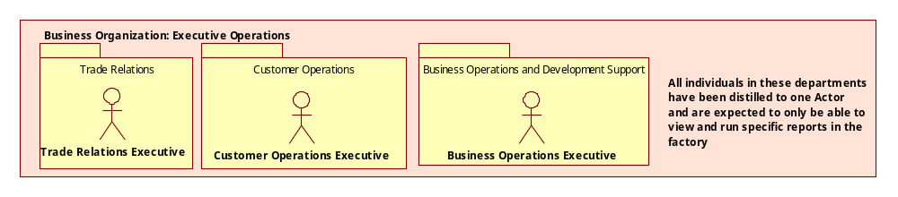
Figure 1 Executive Level Business Actors
These actors will be mapped to System Actors of the same name. Their access to the Data Portal Factory is restricted to reports that are relevant to their particular business unit. For example, the Trade Relations Executive will be able to view any reports that relate to royalties. Customer Operations Executive will have access to reports about the delivery of products, and the Business Operations Executive will have access to a wide spectrum of reports about data processing, schedules and the amount of maintenance being performed across respective fact and dimensions repositories.

Administration
Access Restriction: Factory Support Data Access Role
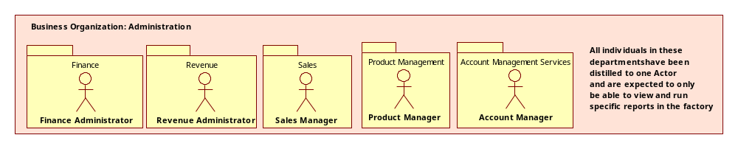
Figure 2. Administrator Business Actors
These actors will be mapped to System Actors of the same name. Their access to the Data Portal Factory is restricted to reports that are relevant to their particular business unit. Most often, these actors will want to validate that the data imported from corporate systems is available and accurate within the Data Portal Factory.

Operations Support
Access Restriction: Factory Support Data Access Role
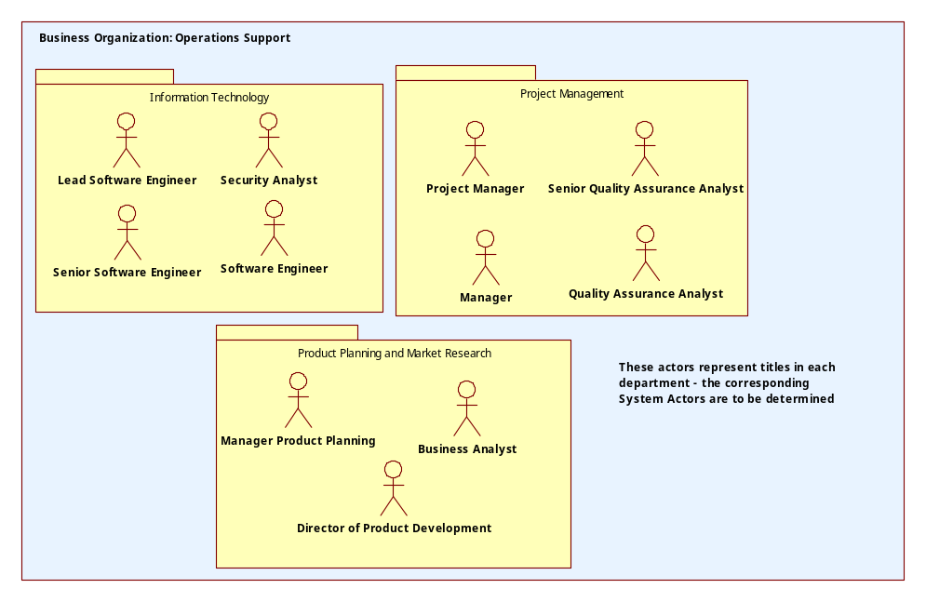
Figure 3. Operations Support Business Actors
It is not clear that these business actors will find a role in the Data Portal Factory, though the may be recipients of data from the factory.

Data Asset Management
Access Restriction: Operational Data Access Role
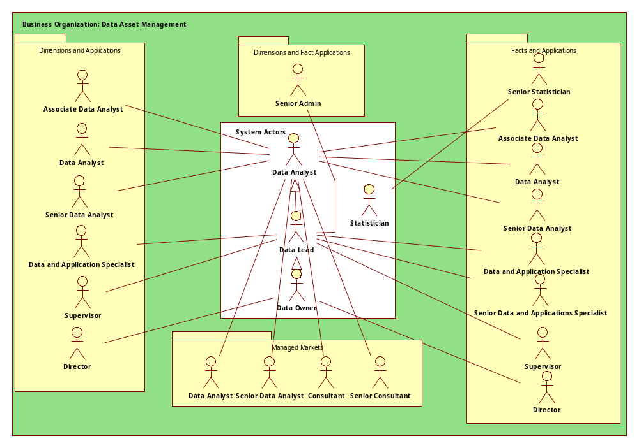
Figure 4. Data Asset Management Business Actors mapped to System Actors
In addition to the Departmental Organization displayed in the above figure, the Data Asset Management group is further organized into the following work streams:
Dimensions
- Drug
- Payer
- Institution
- Practitioner (and State License)
- Geography
Facts
- Invoice
- Claims
- Purchase Sample
These streams are related to the data each team receives and processes through the Factory. These streams are translated into attributes for a given user so that the capabilities defined in the roles they are assigned are restricted to the data of the same type. While not a security restriction, the restriction does support the quality of data by removing the possibility of unintentional errors produced when giving create, update and/or deletion rights to those unfamiliar with the data. It is further anticipated that these teams will need to read or view access to the other streams data. Which streams must be able to see which data still needs to be determined.

Client Delivery Management
Access Restriction: Client Interfacing Data Access Role
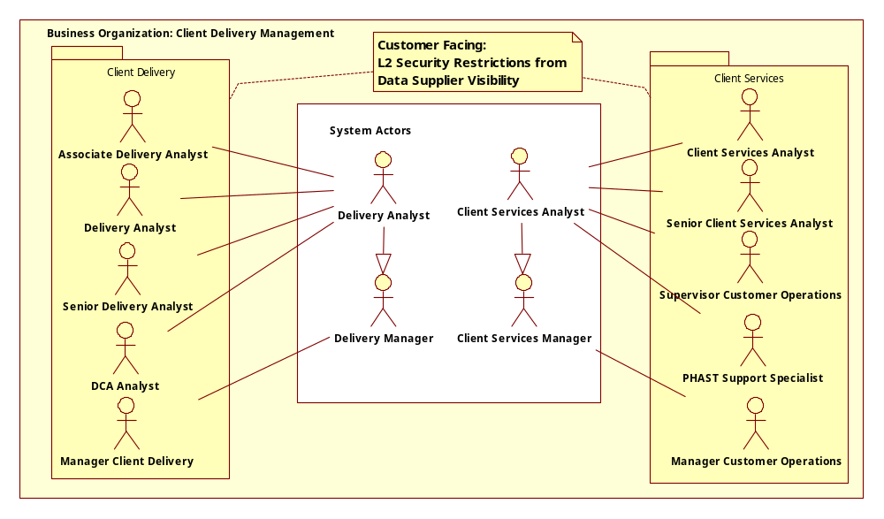
Figure 5. Client Delivery Management Business Actors mapped to System Actors
All of the actors in Client Delivery or Services carry the Client Interfacing Data Access Role restriction. They interact directly with clients and/or their data on a consistent basis. They are responsible for gauging the clients needs, managing the client data supplied, creating the universe of data and defining, approving and releasing the deliverables.

Analytics
Access Role – Dependent on whether they are working for a client’s projection or corporate projections. Corporate projections will have operational data restrictions, Client Projections will have Client Interfacing Data Access Role.
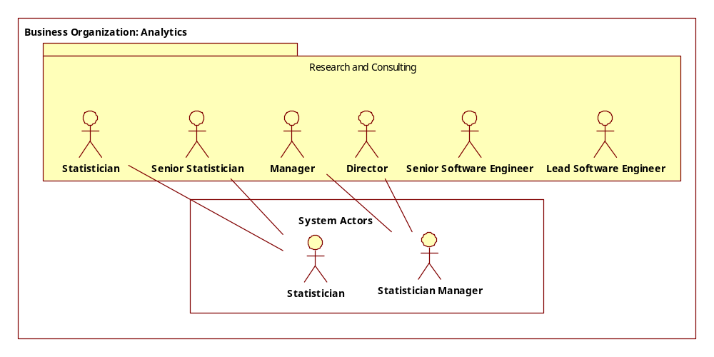
Figure 6. Analytics Business Actors mapped to System Actors

System Actors
The System Actors have been derived from the Business Actors identified in Section 2: Business Actors in addition to non-user actors such as external systems that the portal must interact with and time, as schedules are a key initiator of activity. Each Business Actor who has a need to access the Data Factory Portal in some way, maps to a System Actor, though not necessarily in a 1 to 1 fashion. Quite often, a set of employees of a given title may map to one or many system actor(s) and their mapped role(s) in the system. In addition, not all employees require access to the Data Factory Portal. More importantly, an employee’s title is distinct from the functions they perform – and functionality is how the System Actors are organized and named.

View of System Actors
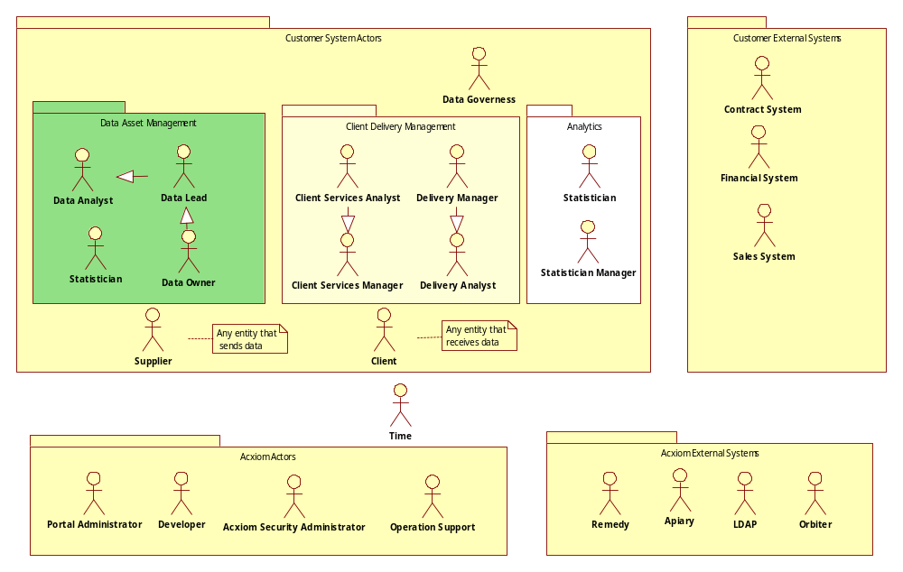
Figure 7. System Actor Overview

External System Actor Descriptions
External actors represent any entities that will act outside of the DPI system but interact with the system in some manner. All actors that have been identified are included.
The only actor that impacts all other actors and is independent of classification as customer or Acxiom is time.

Time
This actor represents the ability for functionality to be initiated based on a schedule that may include annual, quarterly, monthly, weekly, daily or hourly time periods. Schedule plays a large role in the system and will often be the initiator of many use cases or activities within a use case.

Customer External Actors
These external actors are the providers of corporate data covering data suppliers and their hierarchies, clients and their hierarchies, the contracts data suppliers and clients have with the customer and each other and their duration, corresponding contacts, and in the case of clients, the products they have purchased. The overall data model and frequency of the updates is still to be determined.

Contracts System
This actor will supply contractual data on each client to the system. Currently, the contracts system is anticipated to be DiCarta. The data DiCarta will supply is still to be determined but it will be the source of this information and the DPI will not be sending information to update it – though it will display information which may lead to action to be taken in DiCarta.

Financial System
This actor will supply a limited amount of financial data to the Factory. Currently, the system is Oracle Financial but it will eventually migrate to Microsoft’s Great Plains. The details of what kind of data it will be supply (again, uni-directional) is to be determined but a major data element will be the definition of a project number. For every project, there can be any number of products related to it from which the factory will produce any number of deliverables.

Sales System
The actor will supply client specific contact data for each client. The current system is Sales Logic. The exact data it will supply is to be determined.

Acxiom External Systems

Apiary
The Apiary is the Acxiom standard system for the maintenance of passwords. It follows the Acxiom Security Guidelines that regulate the form, quality and schedule of password updates. In order to maintain access to the Data Portal Factory, all users must use this system.

LDAP
This is a network protocol (Light-weight Directory Access Protocol) that will be responsible for maintaining the association of individual users to groups. There will be an LDAP dedicated for the WK/Acxiom Portal, that will contain usernames, passwords and at least one role per user for granting access to the portal. It will also contain authentication/authorization information on other components that the portal integrates with (such as ILog and GIS/Edge).

Orbiter
The user interface for batch processing in the Acxiom Technology Framework. This software runs all the jobs that produce deliverables out of the factory. The information Orbiter contains will be integrated into the Data Portal Factory and Acxiom Developers will be able to access it directly.

Remedy
Remedy is a Commercial Off The Shelf (COTS) trouble ticket support system that will be used as the primary electronic method for making requests of the Acxiom Administrators. Adding users, requesting changes to portal users, indicating issues with the portal are available to customers, while the Acxiom Operations team will be able to use it to track response times and how issues were resolved.

Customer Actors

Client
Access Restriction: Not anticipated to be an active user yet
An entity that has contracted with Wolters Kluwer to receive data deliverables. A Potential Client may also act as a client to allow WK to demonstrate the value of a particular product and supply data necessary (if any) to allow for the creation of that product. It is to be determined whether a WK Client will have any direct access to the Data Portal but identified possibilities include ftp’ing files and the receipt of data products.

Data Analyst
Access Restriction: Operational Data Access Role
This actor focuses on all aspects of pre-factory data from a specific or set of data suppliers that corresponds The activity ranges from the management of data acquisition and upload, validation, and promotion along with getting appropriate notifications, report creation specific to traditional inbound tasks and the maintenance of data suppliers.

Data Lead
Access Restriction: Operational Data Access Role
The lead analyst for a given data work stream (e.g., dimension or fact). They will need to be aware of data progress through the traditional “inbound” process and will be able to perform the same functions as the data analyst but will have additional capabilities to make requests to Remedy to add or remove users and manage the assignment or removal of users from their work stream.

Data Owner
Access Restriction: Operational Data Access Role
The overall manager of a data stream, their primary interaction with the system will be to have visibility into the progress of data related to their stream and quality control reporting. Change requests on data issues relating to their work stream are their unique capability.

Data Governess
Access Restriction: Factory Support Data Access Role
The primary concern of this actor is security of the system and access control – based on contractual or regulatory requirements. The major requests of the system will be for auditing of user activity and access to ensure compliance with access control requirements and sensitivity.

Client Services Analyst
Access Restriction: Client Interfacing Data Access Role
Tied to a specific client (a client specific analyst such as a member of the Pfizer team) or set of clients (organized by WK work streams), this actor is responsible for defining the data a client will submit (acting as a Data Analyst but with the Client Interfacing Data Access Role restriction), organizing the client’s global preferences, and ensuring the quality of data to be used for the generation of their client's deliverables (set up by Delivery Analysts).

Client Services Manager
Access Restriction: Client Interfacing Data Access Role
This actor has the same capabilities as the Client Services Analyst, but will have additional capabilities to make requests to Remedy to add or remove users and manage the assignment or removal of users from their client(s) work stream. Change requests on data issues relating to their work stream are another unique capability.

Delivery Analyst
Access Restriction: Client Interfacing Data Access Role
This actor’s focus is on the production of deliverables for client. Understanding the client’s needs, setting up the specification for each deliverable and any files that the client is sending to supplement their deliverables, receiving updates on the progress of deliverables and the ability to evaluate the quality of the delivery are this actor’s main activities.

Delivery Manager
Access Restriction: Client Interfacing Data Access Role
An actor who can create deliverable specifications that are defined outside of the contracted options, either because the client or the client’s deliverable is prospective or because the options inside a contracted deliverable allow for exceptions but only for the users with this role. Change requests on data issues relating to their work stream and the ability to add or remove users and manage the assignment or removal of users from their work stream are additional capabilities.

Statistician
Access Restriction: Operational Data Access Role
This actor’s focus is to establish and maintain projection factors. The ability to extract representational data, understand what amount of data has moved into the factory and what’s remaining is required to support maintaining accurate factors.

Statistician Manager
Access Restriction: Operational Data Access Role
This actor’s focus is to approve projection factors created or updated by the Statistician.

Supplier
This actor represents any entity that supplies data to the factory. Most commonly this actor is intended to mean Data Agents (a.k.a. “Vendors”), it is not intended to be a restricted role. Clients and even Corporate, often act as Suppliers when they are submitters of data files to be applied or incorporated into the deliverables produced for them.

Acxiom Actors

Acxiom Security Administrator
This actor handles all requests to add, edit or remove users from having access to the portal. They will receives those requests from Remedy.

Developer
A developer will use the portal to access major third-party and Acxiom custom built components that have significant functionality such as ILog’s thick client – which is used for creating business rules that other actors implement or modify parameters of – or Data Stage, Orbiter and other tools.

Operation Support
This actor’s major concern is the overall health of the system with the ability to be altered to how key functions and systems are performing.

Portal Administrator
Manages the portal’s users by assigning permissions to capabilities within each portlet that is available to a given user.

Security and Data Restrictions

Role-Based User Access
OpenLDAP will control authentication of users to the portal and 3rd party components. There will be a direct mapping of each appropriate LDAP Group to a friendly display name referred to as a “Role” which will be used to grant capabilities and control authorization to the functions provided by the Portal – which are described as use cases in the sections below.
The Security Management System User Interface (SMS UI) will control the assignment of capabilities to roles and will also associate users to work streams. Depending on which work stream a user is associated with (such as Drug, Practitioner, Claims, Clients) will determine what underlying data and its availability for visibility and action will be for the user. Each work stream will need to be aligned to data groups at the supplier and file level and data access roles (see Table 1 for the data access definitions). The diagram below summarizes the model for controlling capabilities while also restricting data access.
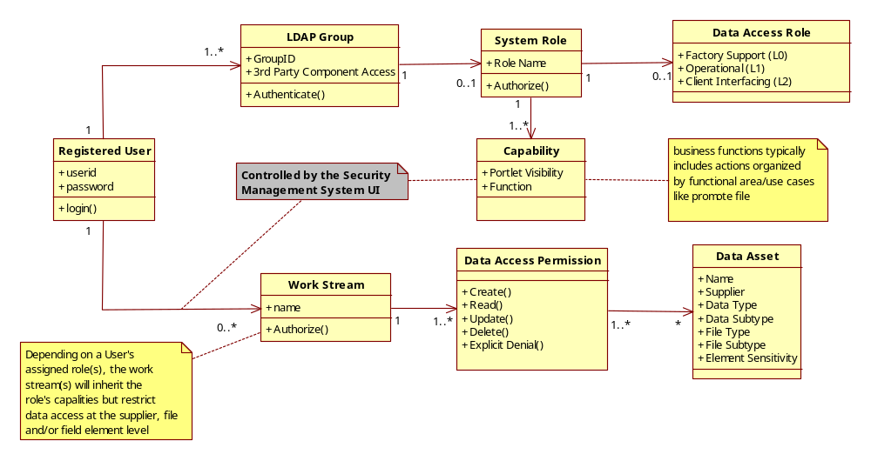
Figure 8. User Relationship to Roles and Work Streams

Use Case Views by UI Component
The use cases listed and described below are all the use cases identified – either because they have come direct from the Business Analysts and apply to DPI or that have been identified through analysis of the DPI component and all of the related GUI’s that the DPI umbrella covers. The use cases are broken out by component and will include a view that shows the relationships between the actors and the functionality they expect to be able to execute and a brief description of each use case. Use Case Specifications which detail the pre-conditions, basic flow, alternate flows, exception flows and post-conditions are written separately and located in the appropriate

Context
The diagram below represents a high level packaging of UI requirements into distinct functional areas: Client Management, Data Supplier Management, File and Record Management, and Common (functionality that crosses more than one package of functionality).
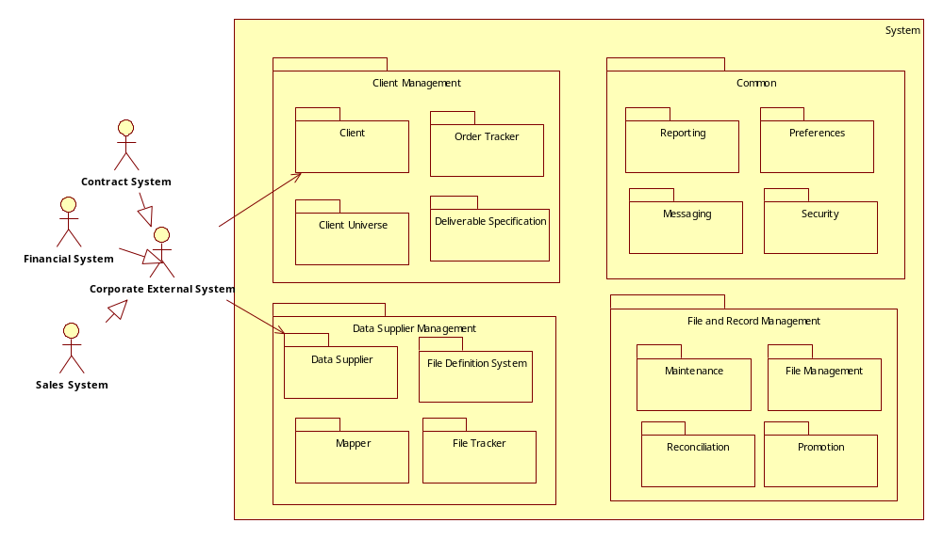
Figure 9. Use Case Context Diagram

Common Packages

Security and Administration
User Interface Vision and Scope Documents:
Data Portal: doc 3924 in TransArch
Security Management System: doc571 in WKHAT
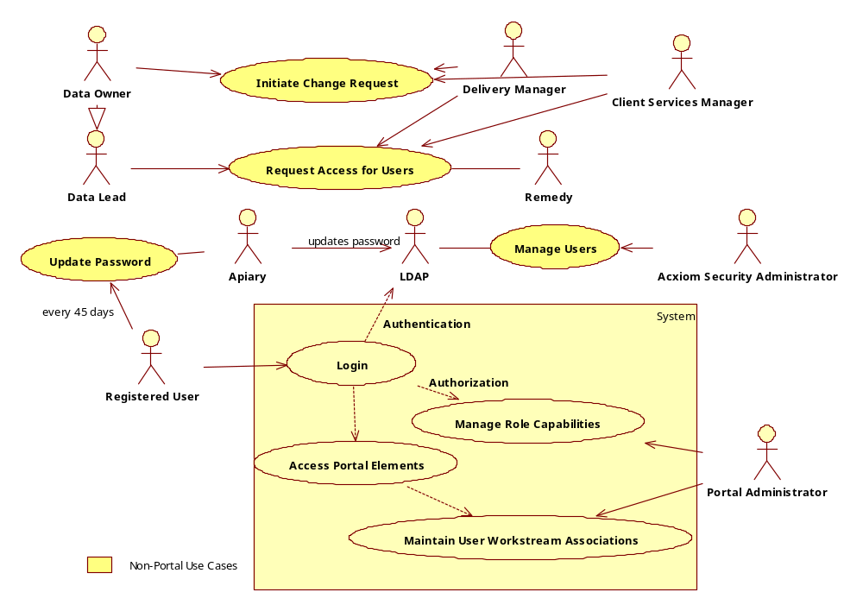
Figure 10. Security Use Case View

Initiate Change Request
For actions that can not be taken through any of the User Interfaces provided by the Portal (such as a fundamental change to a Business Rule versus a threshold), the ability to interact with Remedy to initiate the change request process is available exclusively to managerial roles.

Manage Users
Performed by the Acxiom Security Administrator, this use case enables users to be managed (added, edited or removed) in addition to the role or roles they have. This will be done outside of the portal via LDAP, which the portal will read from to allow users to gain access to the various functional elements the portal contains.

Request Access for Users
In order to add, edit, or remove access for a given user to the portal, a user with Managerial authority must request the change using Acxiom’s Remedy system. The Acxiom Security Administrator will receive the request and make the necessary change(s) requested in the LDAP.

Maintain User Work Stream Associations
Initiated by a Portal Administrator, this use case supports the addition and subtraction of business work streams to individual users. More than one work stream can be assigned (or removed) and the impact will be that whatever role(s) the user belongs to, those capabilities will be restricted by the work stream associated through this use case.
Use Case Document: doc5607 in WKHAT

Manage Role Capabilities
This use case allows the Portal Administrator to maintain roles by associating capabilities underneath each role. All capabilities across the portal will be displayed for each role, and whether it is available or not will be determined by the Portal Administrator. The administrator will also be able to change the defined access for roles and have the changes globally affect those users with those roles upon their next login.
Use Case Document: doc5607 in WKHAT

Login
Provides role-based access to the Web Portal and its capabilities and components via a single sign-on procedure. Each user will be authenticated and authorized to perform actions and gain access to components, pages and other functionality determined by the role they have, the work stream they are associated with (if any) and the underlying data they have rights to see, create, update or delete. A maximum of 5 login attempts will be made available before a user is locked out of the system.
Use Case Document: doc5607 in WKHAT

Access Portal Elements
Initiated by any registered user, this use case allows for the display of the appropriate menus, sub-menus and components that a given user has access to. The mode of display will be to show a user only what they can do, not what they can’t do.

Update Password
Initiated by any registered user, this use case allows for the user to update their password in accordance with the Acxiom Security Policy. This must be done within a 45 day time period since the last password update occurred or the user must call the Acxiom Help Desk to get their password reset.

Messaging
For the Event Handler Graphical User Interface (EVHGUI), an “event” is equivalent to any message produced by a component of the system. The events must be explicitly identified as information that requires visibility (at a minimum) and action (at the maximum). The most common type of action will be “notifications” but not all events will have notifications tied to them – some may just need to be seen. Originally thought to be two GUI components, the EVH GUI for simplicity has taken over the functionality of the Notifier GUI as well. This could also be called the “Message GUI” as it is the interface for viewing all messages.
See Unaddressed Issues concerning whether anyone can read anyone’s messages or if it needs to be restricted.
Vision and Scope Document: doc6035 in WKHAT
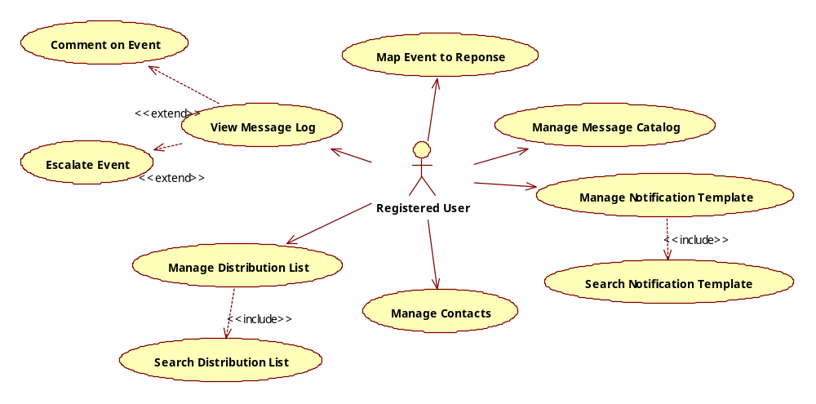
Figure 11. Use Cases for Event Handler GUI

View Message Log
Initiated by any registered user, this use case allows for viewing all messages produced by the system and its’ components and the detail for any given message selected. To enhance usability the filtering down via a search mechanism will be made available.
Use Case Document: needs to be added to WKHAT

Manage Message Catalog
Initiated by any registered user, this use case enables the adding, modifying, searching and deletion of messages that will form a catalog to choose from when executing the mapping of these messages which are designated as events to a catalog of responses.
Use Case Document: needs to be added to WKHAT

Map Event to Response
Brief description needs updating.
Use Case Document: needs to be added to WKHAT

Manage Notification Template
Brief description needs updating.
Use Case Document: needs to be added to WKHAT

Search Notification Template
Brief description needs updating.
Use Case Document: needs to be added to WKHAT

Manage Contacts
Initiated by any Registered User, this use case allows for managing contacts in the contact list. This will allow adding a new contact, viewing, modifying and disable a contact. The creator of the contact will be identified and the information they provide will include organization, address, phone numbers and email addresses. Any contact present in this list can be included as a member in any Distribution List.
Use Case Document: needs to be added to WKHAT

Manage Distribution List
Initiated by any registered user, this use case allows for managing distribution lists for notifications. This use case allows for creating, editing and deleting distribution lists by pulling from the available contacts in order to add them as members. Any singular distribution list can be used for more than one response type and can exist independent of a relationship to a response. The indication of which response type(s) a distribution list is connected to will be made available to the user.
Use Case Document: needs to be added to WKHAT

Search Distribution List
Initiated by any registered user, this use case allows for searching Distribution list based on multiple parameters: List’s title, a member’s name or email address and status. In addition to searching Distribution List, this Use Case also allows selecting and viewing individual list in the result set and will call the Manage Distribution List where appropriate. The results will be displayed alphabetically by the first character of the distribution list.
Use Case Document: needs to be added to WKHAT

Preferences
The requirements for preferences are still be defined. It is assumed that preferences will be available across the UI’s and while the parameters supplied for preferences will be different depending on the UI invoked, the actions of setting and editing them will be the same.
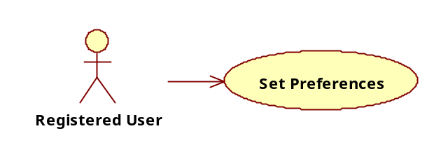
Figure 12. Preference Use Case Diagram

Set Preferences
Initiated by any registered user, this use case allows for the definition and editing of display options governing a specific user interface component. For example, if a user is in the Order Tracker UI, they would be able to set a preference for the date range they want as a default and/or the clients they wish to have populated in the tracker from the ones they are able to view.
Use Case Document: needs to be written

Reporting
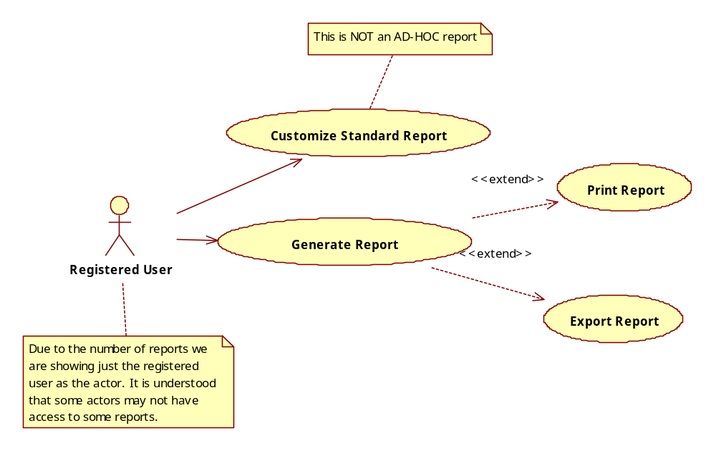
Figure 13. Report Use Case Diagram

Generate Report
Initiated by an authorized user, this use case enables to generate a report from a standard report template by specifying lists of report columns, inclusion/exclusion criteria and sort order. Optionally, the use case enables to save or print the displayed report and/or export report data.
Use Case Document: needs to be added to WKHAT

Customize Standard Report
Initiated by an authorized user, this use case enables to customize a standard report template by adding a new attribute to the template, deleting existing attributes on the template or changing and editing attributes. The use case also enables saving of such custom template for future use.
Use Case Document: needs to be added to WKHAT

Data Supplier Management

Data Supplier
The Data Supplier Graphical User Interface (DSGUI) will provide a centralized location for viewing data supplier profiles to ensure that the data loaded into the Factory is accurate. The ability to change the information presented is not available in this GUI; however it is a source of information for making decisions about whether change is required and does impact the creation of downstream deliverables . Data suppliers are the organizations that provide data which must run through sets of inbound processes prior to being loaded into the Data Factory. The primary objective of the interface will be the viewing of an organizational profile that contains the name and type of data supplier, contact information, contract information, and the relationships between a supplier and as many subsidiaries as needed. The associations of data supplier to the definition of different kinds of file it delivers will be navigable from this GUI but the definition of files are created and managed through the File Definition System GUI.
Vision and Scope Document: doc4968 in WKHAT
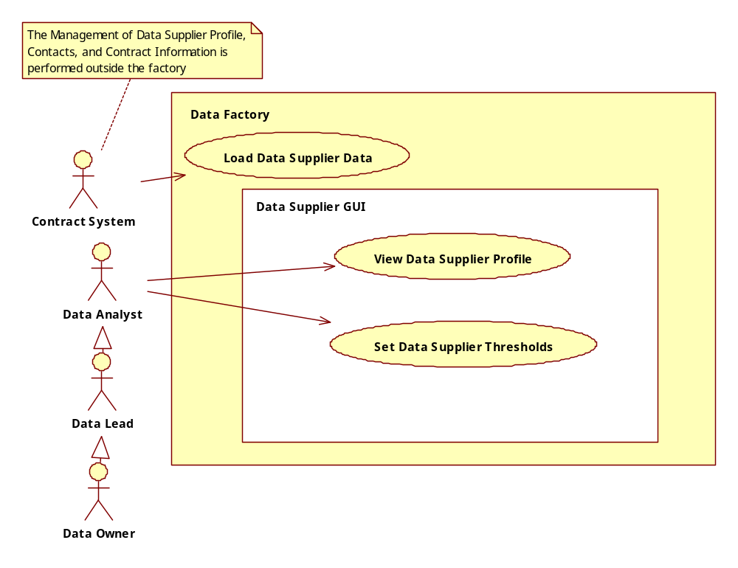
Figure 14. Data Supplier Use Case Diagram

Load Data Supplier Data
Initiated by the Contracts System, this use case enables all the profile, contractual and intra-relationship information between data suppliers to be loaded on a routine basis.

View Data Supplier Profile
Initiated by a Data Analyst (or a Data Lead or Data Owner acting as a Data Analyst), this use case enables the viewing of data supplier profiles, the contractual relationships they have with corporate and other suppliers, subsidiaries and the variety of contact types. This view can be filtered by supplier, with a visual indicator of parent companies versus subsidiaries.
Use Case Document: needs to be written

Set Data Supplier Thresholds
Initiated by a Data Analyst, this use case supports the ability to manage specific thresholds at a data supplier level that will support governing the quality of data that each supplier sends (such as the percentage of record errors allowable). The available fields would be pre-configured with default values and would apply recursively for each file that was defined for the specific supplier and if the parent company, each subsidiary, unless modified at the subsidiary or even file level.
Use Case Document: needs to be written

File Definition System
The File Definition System Graphical User Interface (FDS GUI) provides a web interface for a Data Analyst to define and update the characteristics of each file (File Set, Single File) submitted by data suppliers. It is intended to be used for initial set ups and maintenance of file specifications. Each file/file set is characterized by a set of pre-defined attributes. The user interface enables the user to set the values of these attributes that would allow the file to move to the data factory for downstream processing such as map, convert and cleanse. One of these attributes is an indicator of whether the file will be automatically promoted to the staging area or manual intervention is required. Additionally, the display of the associated layouts and mappings for each file and the ability to navigate to the Mapper GUI to view, create, or modify layouts and mappings will be available through the GUI.
Vision and Scope Document: doc4969 in WKHAT
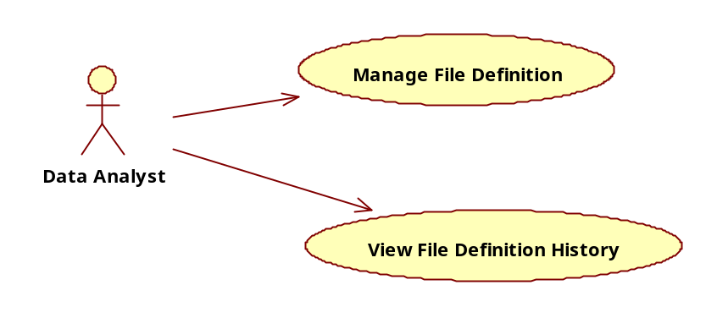
Figure 15. File Definition Use Case Diagram

Manage File Definition
Initiated by a Data Analyst, this use case enables for the creation, editing and deleting of file definitions. All the attributes required to complete the definition will be available and the dependencies between attributes will be enforced. The use case also enables the Data Analyst to associate pre-defined layouts and mappings with the file for which the definition is being created. The author, date of creation, and version number of the file definition will be automatically populated.
This use case also allows for the definition of set of files that are expected, including the scenario where one file has a delimiter that separates files that are contained therein. In addition to the file set being defined, each expected file that the initial file contains must also be defined. Once the definition has been established, the ability to edit or delete the file set and individual files within the set can be accomplished.
Use Case Document: doc5669 in WKHAT

View File Definition History
Initiated by the Data Analyst, this use case allows for the viewing of all versions of a specific file definition. Any version can be selected and the details, including the associated layouts and mappings will be navigable from the result. However, only the current version of the file definition can be edited. The use case also enables the Data Analyst to view the number of files received against a specific version of file definition.
Use Case Document: doc5670 in WKHAT

Mapper
The Mapper GUI provides an interface for the user to view available raw target (also referred to as raw source) and standard target layouts and source to raw target to standard target layout-level and field-level mappings. The interface provides the functionality for the user to create new layouts and define new layout-level and field-level mappings. While defining new mappings the interface provides the user with the option to select from a set of predefined business rules that apply on those mappings. The user will be able to export layout structures, mappings, and rules from the GUI.
The GUI provides the option to send a request to add new field(s) and add new rules. The user can select a target field and be able to view the field definition. The user can select a business rule and be able to view any reference table(s) associated with the rule.
Vision and Scope Document: doc4970 in WKHAT
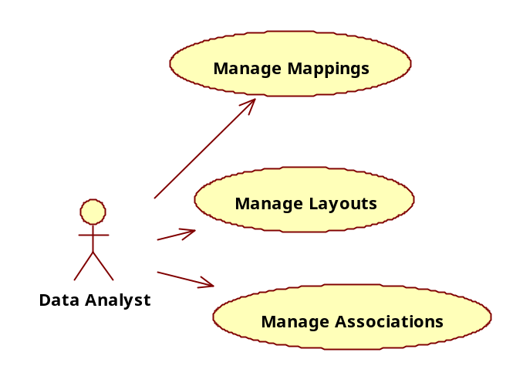
Figure 16. Mapping Use Case Diagram

Manage Associations
The "Manage Associations" use case details the steps involved in associating the existing predefined raw target and standard target layouts to new record types of a file type. The use case also involves steps that explain the search process for filtering predefined standard layouts to best suit the need.
Use Case Document: needs to be written

Manage Layouts
The "Manage Layouts" use case details all the basic and alternative steps involved in viewing, creating, editing, and deleting raw target and standard target layouts and the layout fields.
Use Case Document: needs to be written

Manage Mappings
The "Manage Mappings" use case builds the basic and alternative scenarios involved in viewing, creating, editing, and deleting source to raw target mapping, raw target to standard target mapping, and filed to field mappings between the layouts. This use case also includes the steps involved in assigning/associating rules to the mappings.
Use Case Document: doc6028 in WKHAT

File Tracker
The File Tracker GUI enables a user to track the status of a file from the moment it is scheduled to when it is finally promoted to the Grid. The tracking of a file via this GUI begins with the File Receipt process where a user is presented with basic file arrival information. For the files that have been received the GUI displays some basic information about the file such as its delivery cycle, data supplier, date and time received, actual record length, its validation status, and arrival status, whether it was on-time or delayed. The ability to track files that were expected but did not arrive is also supported by the GUI.
Vision and Scope Document: Doc5131 in WKHAT
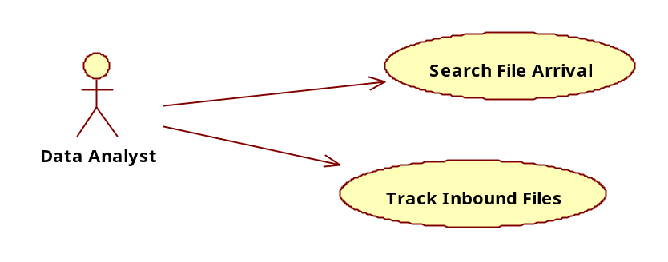
Figure 17. File Tracker Use Case Diagram

Search File Arrival
Initiated by a Data Analyst, the Search File Arrival use case enables the user to view arrival information on specific files by filtering on the attributes of interest to the user. The most common attributes a user is likely to filter on include the Data Supplier Name, File Receipt Date, File Late Indicator, and File Error Indicator. In functionality this use case will perform the same functions as the Search Distribution List use case with the only difference being the attributes that will be displayed to the user.
Use Case Document: doc5671 in WKHAT

Track Inbound Files
Initiated by an Operations Analyst or a Data Analyst (hereafter referred to as “user”) this use case enables a user to track the progress of an inbound file as it passes through the various inbound processing steps until it is promoted to the data factory. This use case enables a user to view arrival information for a file, track the file’s status, interrupt the processing of a file, view job-level details regarding each file, and further drill down to the process-level to view metrics on all the processes that were executed or are currently in progress to process a file. Each level of data is presented to the user with the use of multiple screens, and the user is presented with links on each screen to be able to navigate between them.
Use Case Document: doc5668 in WKHAT

File and Record Management

File Management
The File Management Facility Graphical User Interface (FMFGUI) enables the management of files that are routed and/or rejected from various processes such as File Receipt, Map & Convert, Cleanse & Match, and Promotion. The FMFGUI allows an authorized user to view and manage such files. The managing of files includes manipulating, copying, pasting, moving, renaming, and deleting files. The interface also logs any of the activities performed on files by users.
Vision and Scope Document: doc5186 in WKHAT
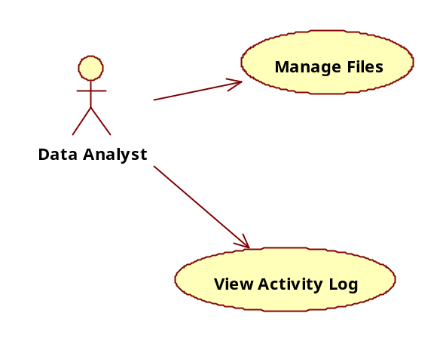
Figure 18. File Management Facility Use Case Diagram

Manage Files
Initiated by a Data Analyst, this use case enables to view, search, rename, move, copy and paste, and delete files. THIS NEEDS CONFIRMATION
Use Case Document: doc5656 in WKHAT

View Activity Log
Initiated by the Data Analyst, this use case allows the user to view the activity log of any user actions on files. All activities performed by the user will be logged by the system, and this information can be viewed via this interface. The use case also enables a user to filter/search to view the log based upon desired parameters.
Use Case Document: doc5657 in WKHAT

Reconciliation
The Reconciliation Graphical User Interface (RECONGUI) enables Data Analysts to reconcile records that were rejected by inbound processing ETL jobs because of the errors/issues encountered during the cleansing, standardization, and matching processes. The RECONGUI displays each record(s) requiring user intervention as determined by the application of business rules and provides the facility to act by editing record level data or exposing the user to alternate approaches to solve the problem. The more common alternative approaches include: modifying an existing layout or map or creating a new one; adjusting the parameters of an existing cleansing or matching rule; identifying the need for a new rule to be created; or by modifying existing data in the factory by adding rows to tables or by completing information in a dimension. Once the correction of the record(s), the mapping modification, or the factory data modification has been saved, the corrected or affected records will be routed back to the start of the process. This action supports quality by ensuring that records are not loaded into the factory with inconsistent or undesirable edits applied through the user interface and that the mechanisms that caught the records initially will perform those same checks.
Vision and Scope Document: doc4926 in WKHAT
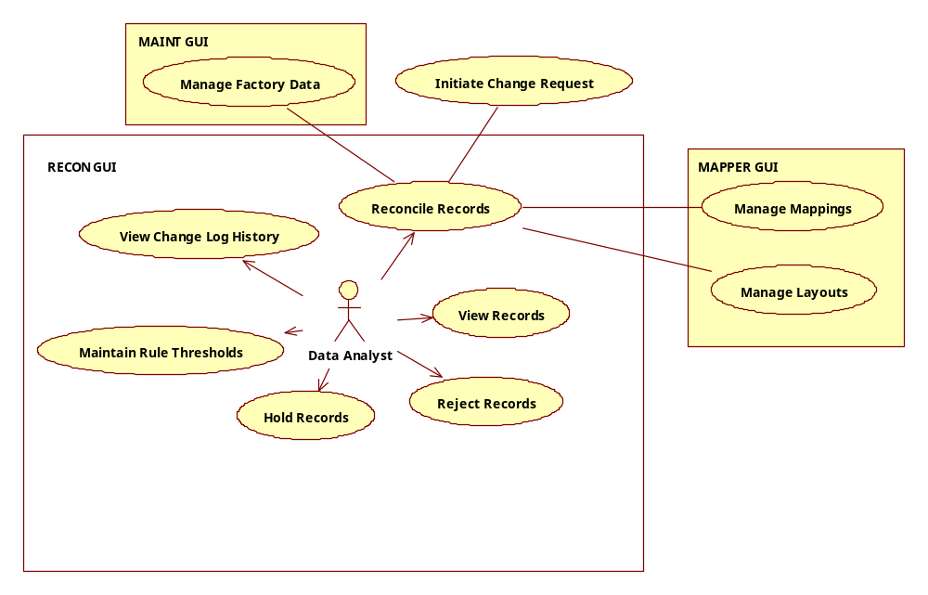
Figure 19. Reconciliation GUI Use Case Diagram

View Records
Initiated by a data analyst (user), this use case enables the viewing of records that need to be reconciled. The use case also enables the viewing of records based upon the filtering criteria that the user has provided and applying rules to control presentation/selection of records in need of reconciliation.
Use Case Document: doc6031 in WKHAT

Reject records
Initiated by a data analyst (user), this use case enables rejecting a record or set of records present in the reconciliation queue. Rejected is a final state of the record and while it should be stored, the record(s) can not be “unrejected” and put back into the processing queue.
Use Case Document: doc5653 in WKHAT

Hold records
Initiated by a data analyst (user), this use case enables putting a record or set of records (awaiting reconciliation) on hold. The held status of a record indicates that a user has initiated some work towards reconciliation of the record but the record has not been reconciled yet.
Use Case Document: doc5660 in WKHAT

Reconcile record
Initiated by a data analyst (user), this use case enables re-processing of a record or set of records present in reconciliation queue with or without editing the fields within the record. The use case includes the reconciliation of any types of errors such as mapping, standardization, basic edits, and matching. The use case also enables the reconciliation of records that were put on hold. Because actual editing of the record’s fields is rare, this use case will most often lead the analyst to other solutions. The use case is extended by the "Maintain Factory Data" use case if reference tables or factory data need to be updated for the purpose of reconciliation. The use case is extended by the "Initiate Change Request" use case for the Ticketing System if rules for processing the record need to be modified or created. The use case is extended by "Maintain Rules" use case for Rules Engine GUI if values for parameters of an existing rule need to be manipulated. The use case is also extended by the "Manage Mapping" and "Manage Layouts" use cases if a layout or mapping needs to be modified or created to address the reconciliation issue.
Use Case Document: doc5539 in WKHAT

View change log history
Initiated by a data analyst (user), this use case enables viewing of a log of change history that was maintained during reconciliation process. The viewing of change history can be filtered by file name, date range, name of the analyst, and reconciliation comments.
Use Case Document: doc5654 in WKHAT

Maintenance
Maintenance Graphical User Interface (MAINTGUI) enables editing an existing data factory record and adding a new record to the factory. Some of the maintenance tasks may include maintaining a reference table; modifying existing data in the factory; and adding rows to tables or completing information in a dimension. In most cases maintenance is a routine task performed by an analyst and is done to make sure that factory data is up to date. In some cases the need for a user to work on Maintenance GUI is driven by the need for reconciling a record/set of records that require updates/changes on the existing warehouse data.
Further, Maintenance GUI enables a user to interface with Rules Engine GUI that provides capability to directly manipulate the parameters of the existing rule. It also enables a user to interface with change management system to initiate the change request to maintain a large volume of data, add a new data processing rule, make a significant change on the existing rule, or to make structural changes to the tables in the warehouse.
Vision and Scope Document: doc5109 in WKHAT
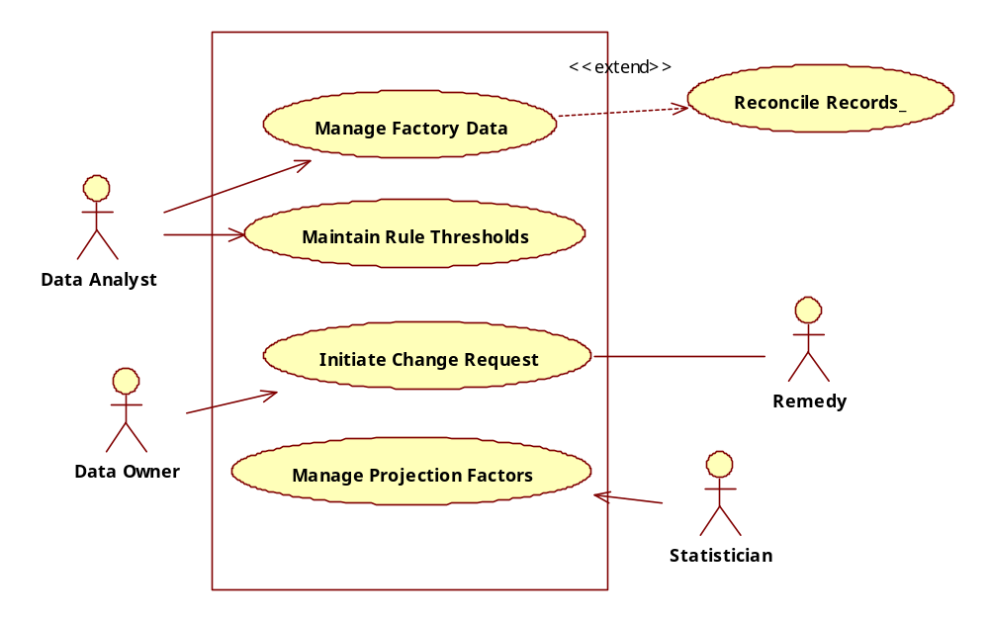
Figure 20. Maintenance GUI Use Case Diagram

Manage Factory Data
Initiated by a Data analyst, this use case enables adding new records and editing and end dating of existing warehouse records including the records for reference tables. The editing can only be performed against the derived or enhanced data for both fact and dimension. New records can only be added to dimensions and reference tables. The use case also enables managing association between entities.
Use Case Document: doc5658 in WKHAT

Maintain Rule Thresholds
Initiated by a Data Analyst, this use case allows for pre-established, editable threshold settings to be modified through the UI for the purpose of altering the course of the file processing that the rule is applied to.
Use Case Document: needs to be written

Promotion
The Promote Graphical User Interface (PromoteGUI) serves two primary purposes: trigger the loading of files into the data factory warehouse and release deliverables created from the factory to their associated location for retrieval. The activities that serve each purpose are common enough that they have been consolidated into this one vision. For the set of users that are primarily concerned with the loading of data – Data Analyst, Data Lead, Data Owner – their use of this GUI will be driven by the desire to view what files have been promoted and review and approve files awaiting promotion. For the set of users primarily interested in approving deliverables for release to their respective client(s) – the Delivery Analyst and Client Manager – their focus is on inspecting the deliverable produced based on an order, ensuring that the data produced meets the specifications, determine whether the deliverable should be released, held or rejected, and be informed of the progress on a deliverable by deliverable basis.
Vision and Scope Document: doc5226 in WKHAT
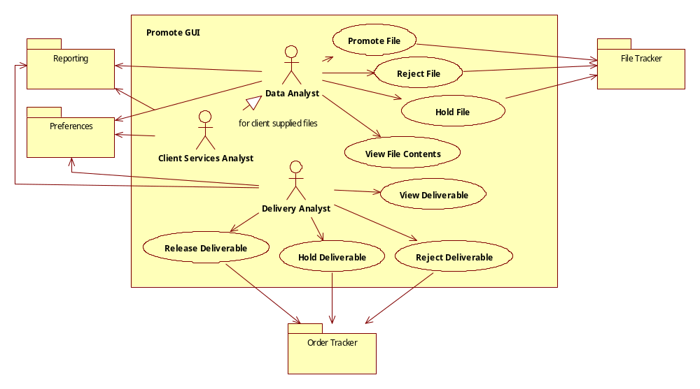
Figure 21. Promotion GUI Use Case Diagram

Promote File
Initiated by a Data Analyst, this use case allows for the promotion of an entire file into the factory. This action can’t be revoked and completes the “inbound” process that begins as soon as a file definition is scheduled and ends at this promotion point. The ability to trace the file’s path through the inbound process is required to assist in the evaluation of whether the file is worthy of promotion. This includes first run files along with those that have been delivered to the promotion queue from the reconciliation queue. A Client Services Analyst, acting as a Data Analyst, will be able to perform this function for all client specific input files.
Use Case Document: doc5659 in WKHAT

Reject File
Initiated by a Data Analyst, this use case supports the rejection of an entire file from entering the factory, the permanent removal of the file or sending the file to reconciliation. Sending a file to reconciliation from promotion means that the file will go through the entire process post receipt – not directly back to the reconciliation queue. These actions can’t be revoked and places the file into a state where it can be retrieved for viewing but can’t be resubmitted for processing (rejection), deleted (removed) or sent through the process (send to reconciliation).
Use Case Document: doc6070 in WKHAT

Hold File
Initiated by a Data Analyst, this use case allows for holding a file from being promoted or rejected. This should inform those interested in the file that the action has been taken (displayed in the file tracker or reportable in the report GUI). The ability to see how many files are in the hold status should be made readily available to the user who made the “hold” determination.
Use Case Document: doc6071 in WKHAT

Release Deliverable
Initiated by a Delivery Analyst, this use case allows for the indicating the release of a single or multiple deliverable(s) for pickup by the client delivery team. Once the deliverable has been released, the order will be viewed as complete. The system should move the file into the appropriate client queue for pickup, update the order tracker and audit which user performed the action at what time.
Use Case Document: needs to be written

Hold Deliverable
Initiated by a Delivery Analyst, this use case allows for the holding of a single or set of deliverables. This action indicates that the inspection of the deliverable is not complete but has been acted upon and additional actions (reject or hold) are still available to be performed.
Use Case Document: needs to be written

Reject Deliverable
Initiated by a Delivery Analyst, this use case allows for rejecting the deliverable produced for a given order. The deliverable can no longer be released (or held) and the order is unfulfilled – meaning a new deliverable must be created either with modifications to the Deliverable Specification or without change (perhaps due to timing of the deliverable’s creation and the data supplier updates required).
Use Case Document: needs to be written

View File Contents
Initiated by either a Data Analyst or Delivery Analyst, this use case allows for opening a file or a deliverable and seeing the contents. This is distinct from the Search criteria as it is understood that a deliverable will take the form of a file (and thus open under the user’s default application for viewing .csv files) but a file awaiting promotion has already been broken down into actual records and while a logical file, is no longer a physical file.
Use Case Document: needs to be written

Client Management

Client
The Client Graphical User Interface (ClientGUI), as a complement to the Client Universe GUI data-centric capabilities, will present an overall view of who a client is in relationship to the deliverables the factory will produce. This “client profile” includes what a client’s interests are, points of contact, what contracts they’ve established and what industry roles they play. These roles (or types) – including “client” which is the focus of this GUI – are derived from what are being called Health Care Entities. In addition, the ability to see the relationships they have with other clients and data suppliers will be provided. The source and maintenance of all the client profile data and their inter-relationships lies outside the factory but will be viewable within it.
Vision and Scope Document: doc5171 in WKHAT
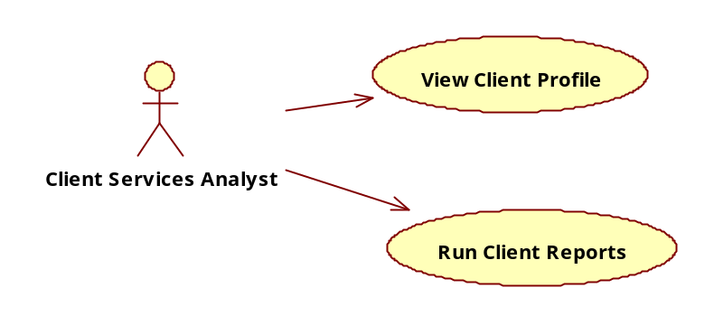
Figure 22. Client Universe Use Case Diagram

View Client Profile
Initiated by Client Services Analyst, this use case allows for viewing a client profile, associated contract information and Data Agents they’ve contracted with. The clients the CSA has access to will be at a minimum, filterable and set using preferences and at a maximum, controlled by the role they have. The ability to view the context of a client (if it is a parent, indicate how many children they have, if it is a subsidiary, be able to show it’s a child and navigate to the parent) is also required.
NOTE: Rather than writing distinct use cases for all the relationships a client could have, they have been subsumed with this one use case. The details a profile will contain and be viewable are:
- Client State: Active vs. Prospective
- Relationships to other Health Care Entities (parent/child relationships)
- Contracted Products and Contract Dates
- Contracted Data Agents
- Excluded Data Agents
- Direct Sales Participation
- Client-specific Contacts (both the client’s contacts and the supporting team)
Use Case Document: needs to be written

Run Client Reports
Initiated by a Client Services Analyst (or Delivery Analyst or any user who has access to client reporting), this use case enables the execution of canned reports that apply regardless of the specific client chosen. The details of what these reports contain, the dynamic parameters required to run them (such as client name and date range) and the ability to print and export are contained in the Business Requirements and supported by the Report GUI.
Use Case Document: needs to be written (likely in conjunction with overall report use cases)

Client Universe
The Client Universe GUI singular purpose is to organize a single view of all client specific data (versus profile information or all factory data) for a Client Services Analyst (CSA) that impacts the production of deliverables. At a logical level, this GUI will support organizing a subset of all the generic factory data (the Data Universe) and granting a view to the data specifically supplied by the client. Together, this represents the client’s universe of data.
Vision and Scope Document: doc5011 in WKHAT
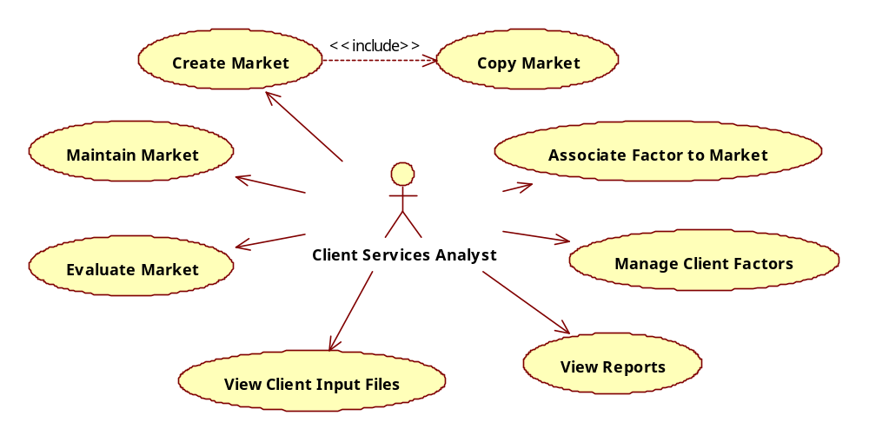
Figure 23. Client Universe Use Case Diagram

Create Market
Initiated by a Client Services Analyst, this use case allows for the creation of a new market for a specific, pre-existing client. Currently, the market is the definition of the set of drugs that are explicitly included, excluded or cited as of interest to the client with varying degrees of detail to be determined by the user on an individual market basis. A market can be created from scratch or copied from a market that has already been defined for the current or a different client.
Use Case Document: doc5367 in WKHAT

Copy Market
Initiated by a CSA, this use case enables the copying of one client's market to another client or within the same client. This is to promote ease of use by allowing for any market or submarket to serve as a template.
Use Case Document: needs to be written

Maintain Market
Initiated by a Client Services Analyst, this use case will allow for the maintenance of a pre-existing client market. Being able to specifically include data elements such as drugs (for example) is the key purpose. The ability to view the market boundary, add or remove a data element that is prescribed by the existing product and client universe, or being able to disable the market (remove from active use) are the key functions the use case provides. A client market must already exist in the system in order for maintenance to occur. Several triggers exist for the maintenance of markets: a pre-defined schedule, a client requested change, new data entering the market. The schedule can be managed through the system and notifications based on new data entering the factory will be automatically available.
Use Case Document: doc5467 in WKHAT

Evaluate Client Market
Initiated by a Client Services Analyst, this use case enables the ability to use a client’s existing market definitions to search the Data Universe for new or dropped values. This can happen on a regularly scheduled basis or upon request. Essentially, this use case allows for gap analysis to be performed – principally to show items not included in a market of sub-market definition or look for drugs or therapeutic areas that meet a client’s identified needs but that their current definitions don’t include. While it is anticipated this use case will support research endeavors, the ability to act on the results found is also important. This will require the ability to include or exclude the new values found.
Use Case Document: doc5462 in WKHAT

Associate Factor to Market
Initiated by a Client Services Analyst, this use case enables the ability to associate factor attributes to a particular client market. The use case supports the functionality of a system displaying all the Markets that have the NDC numbers present in the factor file and allowing a user to associate factors to one or more of the displayed markets. The factors’ attributes are supplied by the clients and are applied towards the four factors: quantity, price, dollar amount, and volume of the drug in a particular client market.
Use Case Document: doc5608 in WKHAT

Manage Client Factors
Initiated by a Client Services Analyst, this use case enables the ability to create a new client factor definition as well as edit the existing one through GUI. When creating a new client factor, the GUI enables a user to define the required attributes for factoring such as which NDCs factoring needs to be applied to, what field the factoring needs to be applied to and the factor value. Once client factor is defined then it can be associated to a particular client market by invoking the use case “Associate Factor to Client Market”. In the case of editing an existing factor definition, the association established previously to client market (if any) is preserved.
Use Case Document: doc5609 in WKHAT

View Client Input Files
Initiated by a Client Services Analyst, this use case enables the ability to view the list of available client input files related to a particular client. The ability to pick one from the displayed list and view the details of the file is also supported. The use case can optionally call the “Maintain Factory Data” use case of Maintenance GUI to perform any edits/maintenance on a selected Input file.
Use Case Document: doc5502 in WKHAT

View Reports
Initiated by a Client Services Analyst, this use enables the ability to view reports on metrics related to Client Universe. One of the identified reports is one that shows all the clients participating in Direct Sales program for a particular drug(s). Such clients can have the ability to see each other’s direct sales data.
Use Case Document: needs to be written/aligned with Reports UI and Client Universe and Reporting Requirements/GAP

Deliverable Specification
The Deliverable Specification GUI’s purpose is to enable the complete management of these client specific deliverables. The specification will be constrained by the products available to be chosen on a client by client basis; the contractual and regulatory requirements between and about the client, company, data suppliers and data sensitivity; and the universe of available client supplied data and their requests for how portions of the warehouse data is organized. All of these relationships will drive the options presented in the GUI and represent preconditions for supporting a Delivery Analyst (DA) creating, editing or deleting a given specification. To support a DA in creating a Deliverable Specification this GUI walks the DA through a logical sequence of steps beginning with the selection of a client, Core Data Process, and Product, and ending with the selection of the presentation format for the data. Some of important functions a DA is able to perform in this GUI are to define the Healthcare Provider Dimension, select options for applying projection factors to the base data, define the aggregation and sorting rules, and define the metrics that need to be derived before and after the data is aggregated.
An important functionality supported by this GUI is that of verifying the contract terms for a given project for a client. In all cases a client enters into a contract to purchase data, and the contract terms dictate the list of options available to configure the data output for the client. It is critical that these contract terms be verified at different points in the deliverable creation process as the DA configures a product for the client.
Vision and Scope Document: doc4957 in WKHAT
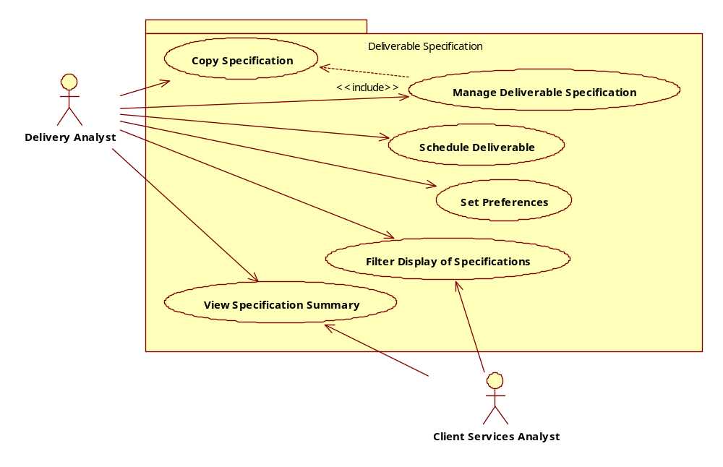
Deliverable Specification Use Case Diagram

Manage Deliverable Specification
Initiated by a Client Service Analyst, this use case enables the creation, editing and deleting of specifications. Options to save once a portion of the specification is defined will be available and will place the deliverable specification into an “incomplete” state. This use case is highly dependent on several other data sources to feed client and contract parameters and governing rules.
Use Case Document:
TM: doc5650 in WKHAT
Payer/Org: doc5866 in WKHAT
Payer/GEO: doc5874 in WKHAT
Launchtrac: doc5761 in WKHAT
Prescriber-Payer: doc5734 in WKHAT

Schedule Deliverable
Initiated by a Client Service Analyst, this use case allows for scheduling the frequency of a deliverable in three flavors: a Standing Order, a One Time Use or as an On-Demand deliverable. The Standing Order means that the deliverable will run recursively based on the time parameter(s) available such as weekly or monthly. A One-Time Use will allow for the production of the deliverable once but it will not be run again without the CSA This may be particularly valuable when trying to validate or test deliverables well in advance of actual contractual delivery time requirements. These attributes can be modified from one to another except in the case of a Standing Order to a One Time Use.
Use Case Document: needs to be written

Copy Specification
Initiated by a Client Service Analyst, this use case allows the CSA to select from complete specifications for a given client (regardless of the scheduled attribute) to create a new specification for that same client. The specification, in it’s entirety will be copied (including the client file selection) but it must be saved with a new name and it will be rendered invalid if the CSA attempts to change the client or the product definition. In addition, there is no expectation of referential integrity between the two specifications meaning that a change in one will not produce a cascading change in the other. The main value to the CSA is to save time and support quality when limited changes are needed from one deliverable specification to the next.
Use Case Document: needs to be written

View Specification Summary
Initiated by a Client Service Analyst, this use case supports a composite view of the specification. Analogous to a purchase order or reservation, the CSA will be able to view and print the details of any deliverable specification they chose.
Use Case Document: needs to be written

Filter Display of Specification
Initiated by a Client Service Analyst, this use case allows the CSA to alter the list of deliverable specifications displayed by Client and or Product. The initial view will be determined by the Preferences set (see Set Preferences Use Case). The ability to sort the result set once the filter has been applied will also be available, as it is a common feature throughout the portal system.
Use Case Document: needs to be written

Set Preferences
Initiated by a Client Service Analyst, this use case allows for setting all preferences related to the Deliverable Specifications GUI. The most common preferences would be what clients and products they want to be displayed when they navigate to the “home page” of the deliverable specification GUI.
Use Case Document: needs to be written.

Order Tracker
The Order Tracker GUI serves both Delivery Analysts and Operations Support analysts by allowing them to track and manage orders created for each client over a specified time period. Orders represent each instance of a deliverable specification based on the schedule dictated in the specification (recurring, one-time, on-demand). For example, a deliverable specification may indicate a recurring schedule on a monthly basis beginning the 15th of each month for a year. Twelve orders will be created.
The status of each order will be tracked through this GUI from the point of scheduling through the release of the order for delivery to the client. Order summaries will be displayed which will indicate a dynamic status of the order, allowing for particular actions to be taken depending on the order’s state independent of one’s role. These include holding, cancelling or re-running an order.
Vision and Scope Document: doc5237 in WKHAT
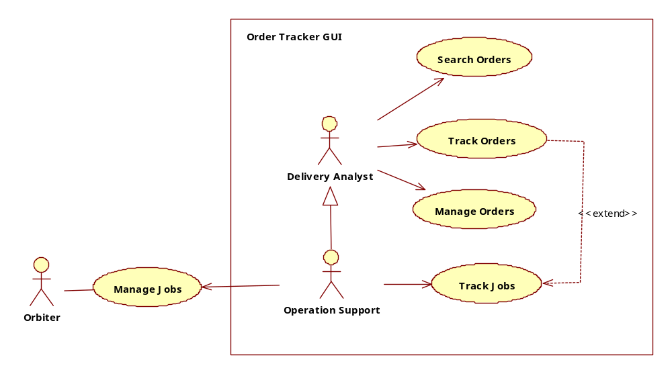
Figure 24. Order Tracker GUI Use Case Diagram

Search Orders
Initiated by either role, this use case allows for a set of attributes to be used to find specific orders of interest. The primary inquires would be based against a given client or set of clients and date or time ranges.
Use Case Document: doc5652 in WKHAT

Track Orders
Initiated by either role, this use case enables the end to end tracking of each order that’s been scheduled, in progress, completed and delivered. As each order changes state over time, this use case will allow the user to see updates and the history of each order that will include comments and actions.
Use Case Document: doc5651 in WKHAT

Manage Orders
Initiated by either role, this use case allows actions to be taken on a specific order that impact the production of the order. Orders can be held, cancelled, changed date, released or re-run depending on the state the order is in and each action taken by a user needs to be recorded. In the case of cancelling an order, a reason must also be given. A comment can be entered independent of any of the previously mentioned actions or in concert with them.
Use Case Document: needs to be written

Track Jobs
An extension of the Track Orders Use Case, this use case enables the Operations Analyst to view the job level details under a specific order to make a decision about whether to act on a given job or to simply gauge progress.
Use Case Document: needs to be written

Manage Jobs
Initiated by an Operations Analyst, this use case allows for jobs to be stopped and started. The functionality lies outside of this GUI and system but the ability to launch the appropriate tool (currently Orbiter) to do this activity will be made available to the Operations Analyst.
Use Case Document: needs to be written

Use Case Views Per Actor
These views of the use cases are organized by each System Actor to give the reader context for what they can do within the boundaries of the specific role. This will also influence the construction of the Dashboard for the role – which can be further modified based on an individual’s user preferences. These diagrams will also show attributes and operations for every role which are broken out in the following table. Work streams, again, refer to dimensional or fact dimensions, while definitions relate to objects such as file definitions, layouts, maps, and market definitions. Messages and Reports may also be organized and distributed by work stream (see Unaddressed Issues)with the same receipt and visibility restrictions. Table 2. Attributes and Operations for Data Groups defines what the Data Group attributes and operations mean.
Attribute
Name | Description
Data Asset Ownership | The data assets and definitions associated with a work stream that allow the user to perform all activities (create, read, update, delete, approve) described in the use cases
Data Asset Visibility | The data assets and definitions associated with a work stream that only allow visibility to users who are not owners.
Operations
View Visible Data | For data and definitions that are not owned by a particular work stream but is permissible to view
Create Owned Data | For data and definitions owned by work stream, allow for creation of data
Read Owned Data | The ability to view owned data and definitions
Update Owned Data | The ability to change owned data and definitions
Delete Owned Data | The ability to delete data (rarely available)
Table 2. Attributes and Operations for Data Groups

Data Asset Management
The following system actors represent what roles are required to support Data Asset Management and the diagrams show what use cases are available.

Data Analyst
As described above, the Data Analyst is primarily interested in the definition, receipt, quality and loading of data into the Factory and once the data is loaded, maintaining the quality of that data. They are restricted by the work stream they are assigned to, which governs the data suppliers, files and data they can view, create and modify prior to data promotion and post promotion.

Data Lead
The Data Lead can do all the activities a Data Analyst can do and has the extra capability of making user modification requests.

Data Owner
The Data Owner also has all the capabilities of the Data Analyst and Data Lead, but has the exclusive right to make change requests – typically concerning rules or data structures – through the Remedy System.
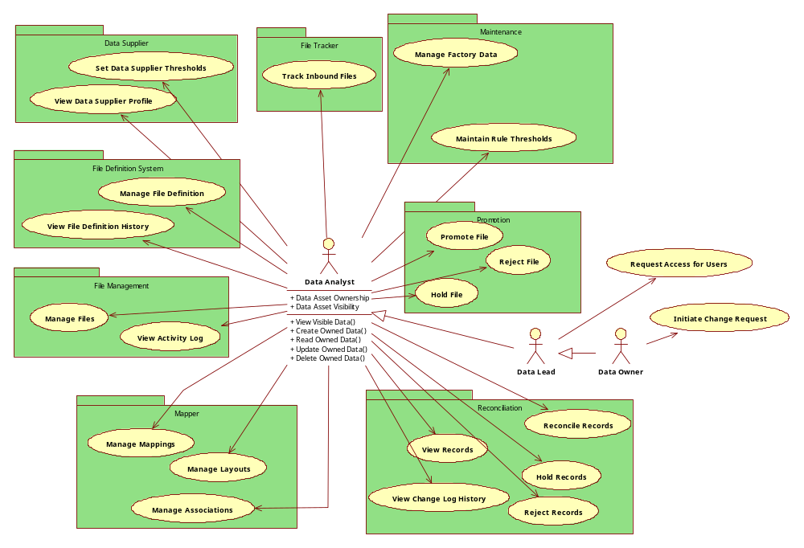
Figure 25 View of all Data Analyst, Data Lead and Data Owner Use Cases

Client Delivery Management
Client Delivery is broken out into 2 parts: Client Services and Client Delivery. Brief descriptions of each role are repeated here along with a graphical depiction of all the use cases each role is able to perform.

Client Services Analyst
The Client Services Analyst is focused on the data required to serve the client(s) they are associated with. When handling client input files, they act as a Data Analyst and perform most of the capabilities that the Data Analyst performs. They handle the definition of client input files and ensure that the data required for deliverable production is available and of high quality.

Client Services Manager
The Client Services Manager can do everything a Client Services Analyst can do with the additional capabilities of making requests for user changes or change requests that primarily relate to data structure or rule changes required to meet client needs.
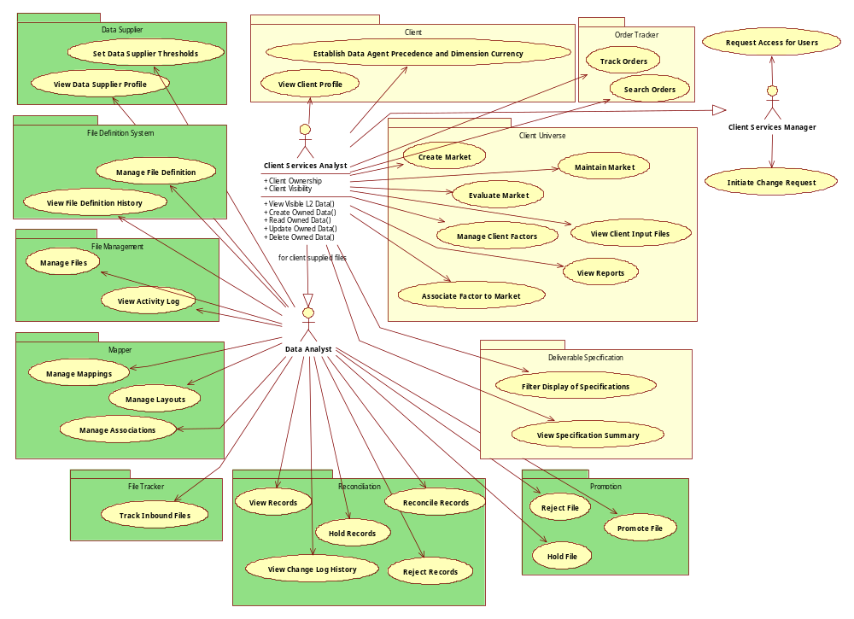
Figure 26. Client Services Analyst and Manager Composite View

Delivery Analyst
The Delivery Analyst is focused on understanding the client’s needs and managing their deliverables. They need to be aware of how the factory is performing in terms of updates to client input files and client specific definitions.

Delivery Manager
The Delivery Manager has the same capabilities as the Delivery Analyst with the added capabilities of having a managerial role with respect to users and change requests. However, they have the added capability and authority to create deliverables that fall outside the bounds of contractual restrictions.
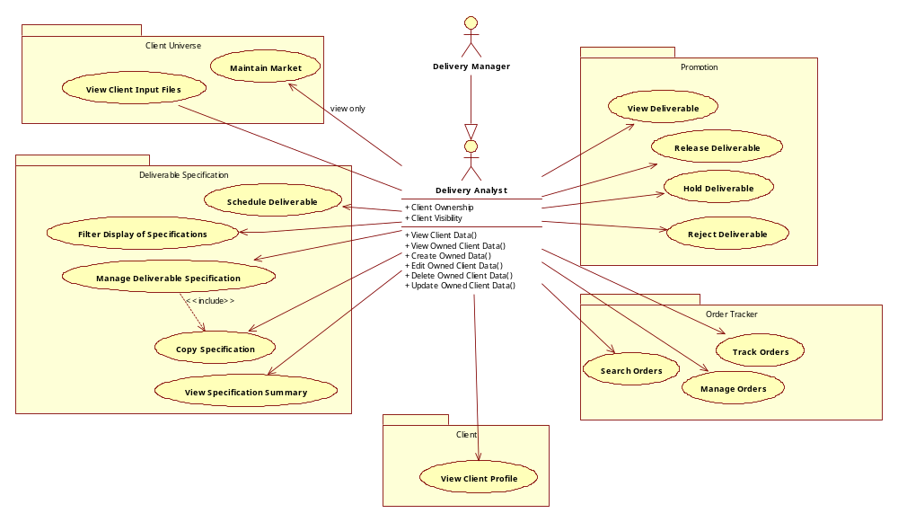
Figure 27. Delivery Analyst and Manager Composite View

Analytics

Statistician
The Statistician is primarily interested in understanding the current state of data to support the creation and maintenance of projection factors that can be applied to represent and create the corporate universe.

Statistician Manager
It is expected that the Manager can do all the actions that the Statistician can do with the additional managerial capabilities shown below.

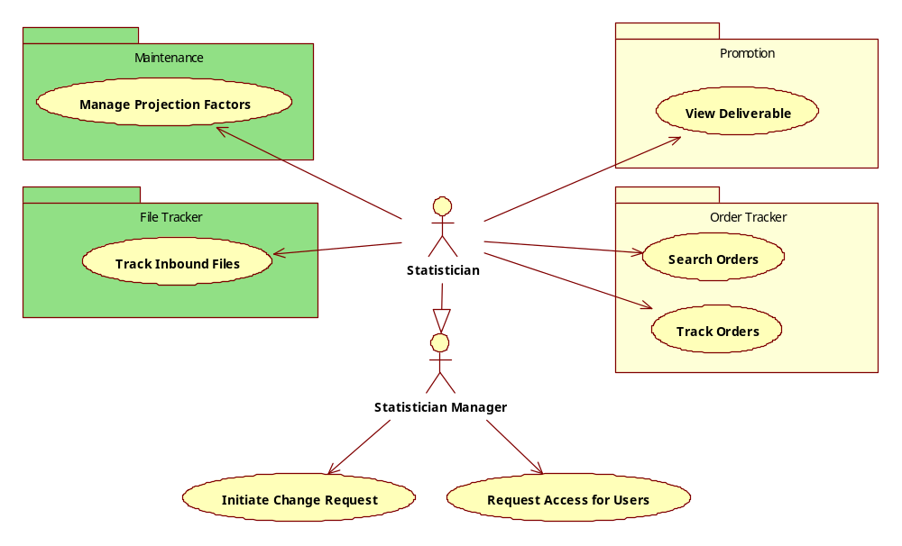
Figure 28. Statistician and Manager Composite View

