Automated Build and Deployment - Developer
NCICB Build and Deployment
Last Revised: | 11/6/07
Produced By: | Levent Gurses  Paul Duvall
Version: | 0.3

Document Approvals
The list contains the name and contact information for the core project team and any key stakeholders who have an interest in the success of the project. An “S” identifies persons responsible for approval from the stakeholder groups. Sign off of the document would be required when a decision is made not to take action for defined gaps.

S | Name | Role | S | Name | Role
S | Anand Basu | CBIIT Engineering Manager |  | Doug Kanoza | SCM Initiative Leader
 | Juli Klemm, Ph.D. | caArray Product Manager |  | George Komatsoulis | CBIIT Director of QA
 | Eric Tavela | Development Architect |  | Brent Gendleman | Development Project Manager
 | Vanessa Caldwell | Database Manager |  | Sriram Kalyanasundaram | Application Manager
 | Don Swan | NCICB Application Support
Revision History
When you make a change to a document, you must add an entry to this Revision History table and you must manually type the Last Revised Date on the front cover.

Date | Version | Description | Revised by
8/24/2007 | 0.1 | Initial draft | Levent Gurses
9/20 | 0.2 | AntHillPro info | Paul Duvall
11/6 | 0.3 | GLOBUS Info | Levent Gurses
Copyrights and Trademarks
© Copyright 2007 by NCICB, caBIGTM. All rights reserved.

Table of Contents
1. Introduction 1
2. Goal 1
3. Running a Local Build 1
4. Running a Remote Build: Command Line 3
4.1. Dynamic build properties 4
4.2. Property Validation 4
5. Running a Remote Build: Build Server 5
5.1. Renaming Subversion tag 8
6. Tier-Specific Dependencies 10
7. Properties Files 10
8. Build Maintenance 11
9. Troubleshooting FAQ 11
9.1. What if my command line fails? 12
9.2. How do I check the dependencies on the local build machine? 12
9.3. What if the AntHill Pro build fails? 12
9.4. Database Errors 12
9.5. What if QA tells me that the tag name is not showing up? 12
9.6. How do I build a tag from an SVN revision? 12
10. Set Up a New Project: Step by Step 12

Introduction
This guide is designed to help teams automate manual builds, configuration and deployment. The guide derives from lessons learned from the successful parallel efforts of the CaArray2 and SCM initiative multi-environment automated build and deployment pilot project and industry best practices and it aims to help simplify the creation of a new automated build project.

Goal
The goal of this guide is to provide a quick start-up reference for setting up a new project for an automated multi-environment build and deploy process.

Running a Local Build
The following steps describe how to run a caArray 2 build on your local workstation.

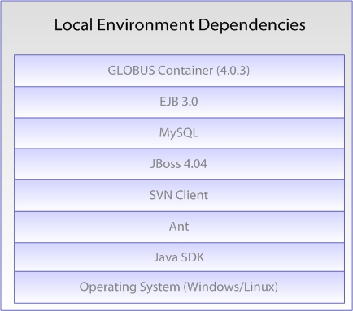

- Install JDK 1.5.0_10
  - Download from http://java.sun.com/javase/downloads/index_jdk5.jsp
  - After installing the JDK, create a JAVA_HOME environment variable (which points to the location of your JDK installation) and add %JAVA_HOME/bin% to the front of the System PATH environment variable.
  - To test proper installation, open a new command prompt and type java –version.
- Install Apache Ant 1.7.0
  - Download from http://ant.apache.org/
  - After installing Ant, create an ANT_HOME environment variable (which points to the location of your Ant installation) and add %ANT_HOME/bin% to the front of the System PATH environment variable.
  - To test proper installation, open a new command prompt and type ant –version. Apache Ant version 1.7.0 compiled on December 13 2006 should be displayed.
- Install the Subversion command line client
  - Download from http://subversion.tigris.org/project_packages.html
  - After installing Subversion, create an SVN_HOME environment variable (which points to location of your Subversion installation) and add %SVN_HOME% to the front of the System PATH environment variable.
  - To test Subversion, open a command prompt and type svn help. A list of SVN commands should be displayed.
- Perform a check-out the project from the NCI GForge repository, e.g. from https://gforge.nci.nih.gov/svnroot/caarray2/trunk to a local working directory
- Download JBoss 4.0.5GA from http://labs.jboss.com/jemsinstaller/downloads/ (version 1.2.0.GA)
  - Click on the “Run Installer” link and follow the instructions. When prompted for the type of install, select “ejb3”. Accept the defaults for the rest of the install.
Note: If you are unable to run the installer download the jar file and from the directory where jems-installer-1.2.0.GA.jar has been downloaded; open a command prompt and type java -jar jems-installer-1.2.0.GA.jar
  - Start the JBoss server by opening a command prompt at the location of the JBoss installation. Go the bin directory and type run (.bat or .sh)
  - Open http://localhost:8080/ and verify JBoss is running properly
- Download MySQL from http://dev.mysql.com/get/Downloads/MySQL-5.0/mysql-5.0.45-win32.zip/from/pick#mirrors
  - Step through the installation process.
  - From Windows, start the MySQL server, by going to the MySQL installation location, then the bin directory. Open a command prompt and type mysqld-nt.exe
- Download Globus from http://www.globus.org/toolkit/downloads/4.0.3/. Create environment variable GLOBUS_LOCATION pointing to the GLOBUS installation directory
- Open the command prompt and type ant deploy.

Running a Remote Build: Command Line
The following steps describe how to run a caArray 2 build remotely from another machine.

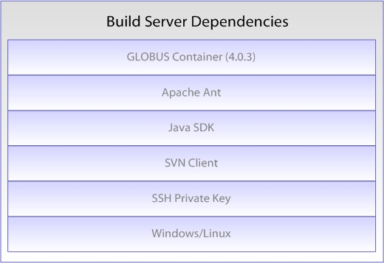

- Run steps 1-4 and then step 9 of Running a Local Build section from above.
- Obtain the environment properties files (from a private Subversion repository at NCICB) and the SSH key files (id_dsa, id_dsa_qa, etc.) and modify each environment property file to point to the right key locations. For example, modify DEV.properties file to point to the location of the SSA private key, id_dsa.
- Run the build
  - Build from tag:
ant -f remote-build.xml -Denvpropertyfile=C:\tools\eclipse\workspace\caarray2-trunk\software\build\DEV.properties -Dnotest=true -Duse.tag=true -Dsvn.tag=DEV-TEST-LBL-9-19-2007

  - Build and create a new tag:
ant -f remote-build.xml -Denvpropertyfile=C:\tools\eclipse\workspace\caarray2-trunk\software\build\DEV.properties -Dnotest=true -Dcreate.tag=true -Dsvn.tag=NEW-DEV-TEST-LBL-9-19-2007

To run in different environments (such as QA), just obtain the .properties file from the private SVN repository.

Dynamic build properties
The standard way to pass properties to an Ant script is through a property file. You can also pass runtime properties on the command prompt using the –D option. The following are the –D properties one can pass to the automated build and deployment script:
- envpropertyfile (required) – sets the environment property file. Has to be a fully qualified file name, e.g. c:\temp\nci\DEV.properties
- notest – when present, all tests will be skipped (required, temporary)
- nodbintegration – when present, skips database integration
- nodeploy – when present, skips JBoss deployment
- noglobus – when present, skips Globus deployment and tests (temporary)
- nocheck – Turn off static analysis source code checks
- use.tag – use the provided tag to build. Mostly needed by QA to deploy a specific tag. Needs svn.tag to work properly.
- create.tag – tells the script that a new SVN tag will be created. Needs svn.tag to work properly.
- svn.tag – specifies the tag to be used or created

Property Validation
Before each build the automated Ant script validates that the key property file stored in the public GForge repository matches the individual environment property file. The task is performed by a custom Ant task which checks two property files and looks for an exact key match. The task does not look into the values of each property. It only validates that the set of properties used by the team matches the template set supplied by the Systems team. In addition, the build master can execute the following command to validate the properties: ant -Denvpropertyfile=[Fully qualified path to environment property file, e.g. c:\temp\nci\DEV.properties] validate-properties. This command will validate the DEV environment properties against the key properties file and will fail the build if there are any discrepancies.

Running a Remote Build: Build Server
The following steps describe how to run a caArray 2 build remotely from a centralized build management server (AntHill Pro).

- Go to http://cbiocvs2.nci.nih.gov:8080/AnthillPro/admin/
- Login with the caarray2 user. Password is caarray2
- To build the DEV environment without a tag, select caarray2-autodeploy.trunk.autodeploy-dev. Then, select the Build tab. Once on the Build tab, select the Force Build checkbox and click the Build button. See the figures below for additional information.

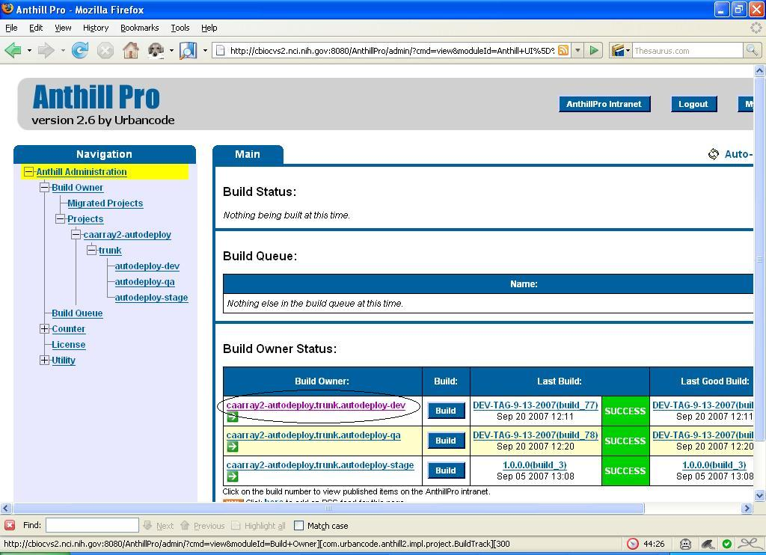
Select Target Environment
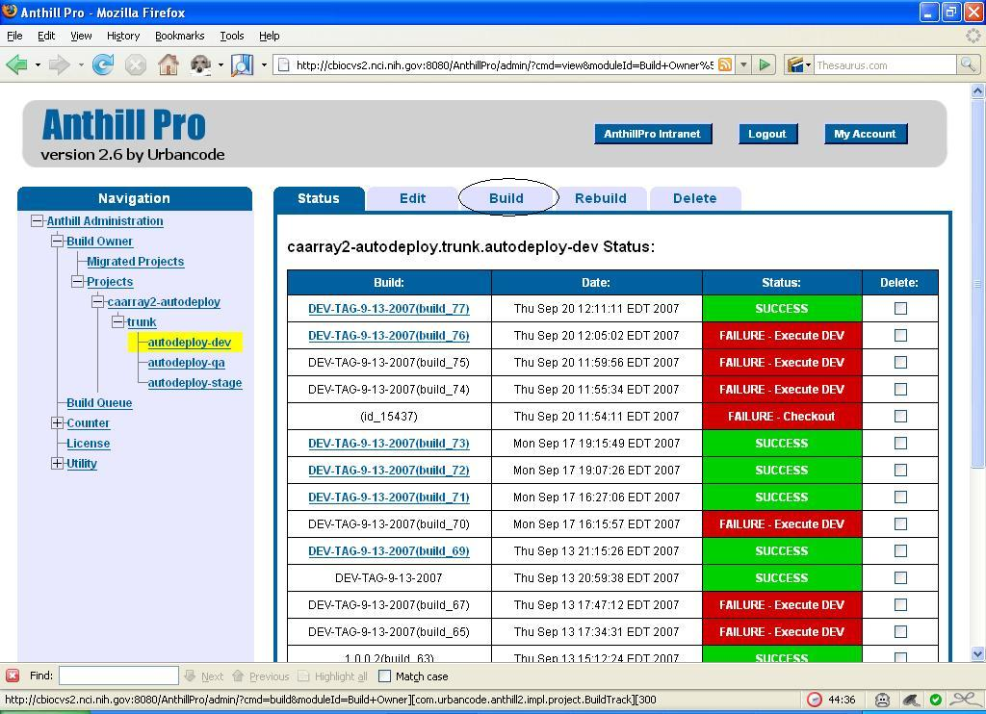
Select the Build Tab
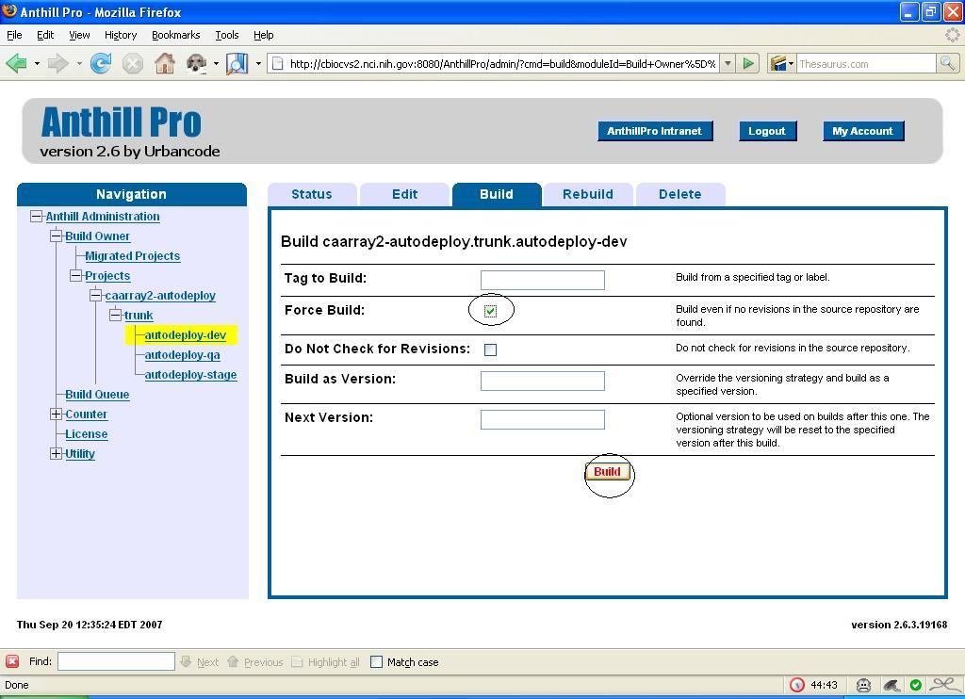
Force The Build

- To build the DEV environment with a tag, select caarray2-autodeploy.trunk.autodeploy-dev. Then, select the Edit tab. Once on the Build tab, enter the tag in the Build as Version text box. Select the Force Build checkbox and click the Build button. See the figure below.

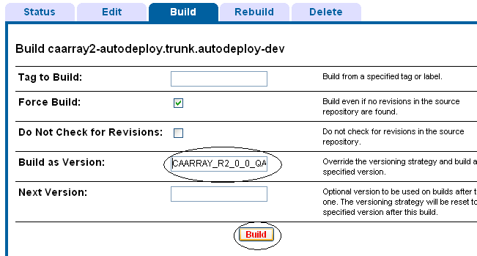
Adding tags in a DEV build

Renaming Subversion tag
Because the default functionality in AntHill Pro is to append a unique build tag to the name of the tag, you must rename it to make it available for QA. This section covers the steps on how to do this.
- Open your Subversion Repo-browser using TortoiseSVN
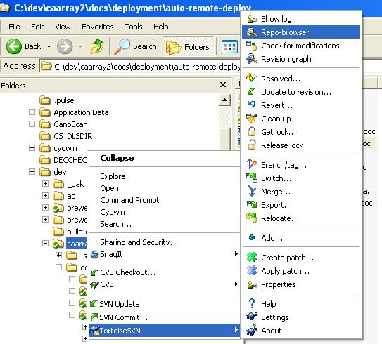

- Go to http://gforge.nci.nih.gov/svnroot/caarray2/tags and search for the most recent QA tag (e.g. it will be named something like CAARRAY_R2_0_0_QA7_build_5355_)
- In TortoiseSVN, right-click on the tag name and select Rename

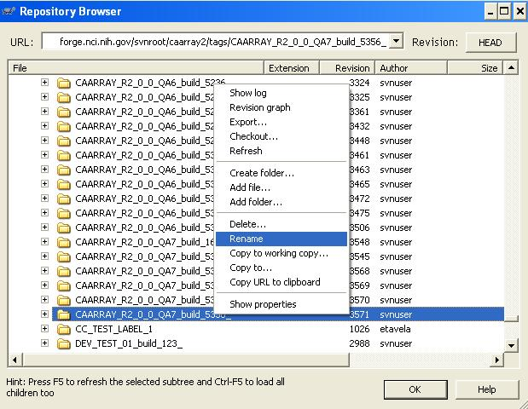

Tier-Specific Dependencies
The diagram below illustrates the dependencies within each environment tier (DEV, QA, STAGE and PROD)
- MySQL 5.0.45 must be installed
  - MySQL system user must be present
- JBoss 4.0.5 GA must be installed
  - EJB 3.0 must be installed
  - server/bin/ncicb_caarray
- Java SDK
- Globus-specific configuration – NEED MORE INFO
- Apache HTTP Server (SSL) – NEED MORE INFO
- Works on Linux and Windows

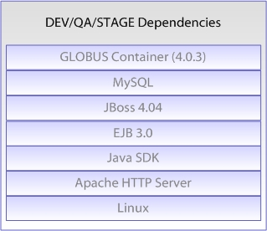

Properties Files
DEV and QA property files are stored into a private SVN repository at https://gforge.nci.nih.gov/svnroot/scm-private/trunk . When building from the command prompt, developers with the proper access authorization should update their local environment property files from this repository. When building from AnthillPro, there is no special step needed. In fact, there is a separate AnthillPro project, caarray-properties, defined as a dependent project to autodeploy-dev, autodeploy-qa and build-deploy-dev-nightly, which automatically updates the environment property files for DEV and QA in AnthillPro. Refer to the following project tree for more information about the AnthillPro propejects.

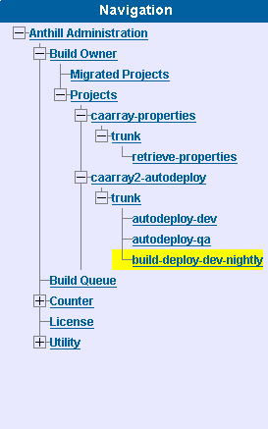

Build Promotion Model
TBD
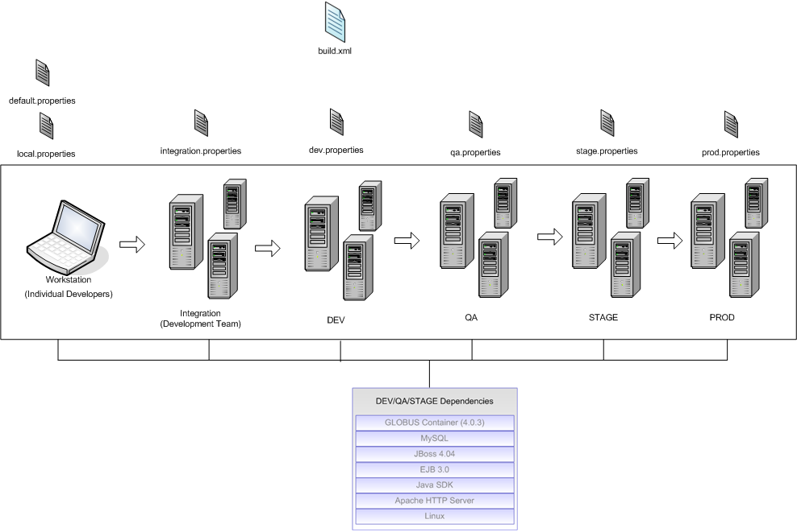

Build Maintenance
- Updating [environment].properties file attributes and values
- Modifying system property flags in AntHill Pro or command line
- Adding new JAR dependencies
- Renaming Subversion tag

Troubleshooting FAQ
A build architecture diagram with all the possible interface point failures
- Directory or file permission problem
- OS-specific error (Window or Linux)
- Authentication error
- SSH/SCP connection error
- Environment variables not established
- Server is not installed or configured correctly
- Database permissions
- Incorrect server location or port – wrong values passed to script
- Database is down
- Web server is down
- Unable to insert data correctly

What if my command line fails?
- Ensure the following is installed on the machine from which you are executing the script
  - SVN Client
  - Ant has been installed (LIST THE VERSION)
  - JDK has been installed (LIST THE VERSION)
  - ANT_HOME environment variable has been added
  - JAVA_HOME environment variable has been added
  - %JAVA_HOME%/bin; has been added to the System PATH environment variable
  - %ANT_HOME%/bin; has been added to the System PATH environment variable

How do I check the dependencies on the local build machine?
- TBD

What if the AntHill Pro build fails?
- Check the heavyweight dependencies are installed and operating correctly (NEED MORE DETAIL)

Database Errors
- TBD

What if QA tells me that the tag name is not showing up?
- TBD

How do I build a tag from an SVN revision?
- TBD

Set Up a New Project: Step by Step
This section outlines how to setup a new project for automated build and remote deployment. However, in practice, in cases of an existing project, an analysis must be performed to properly assess what needs to change on an existing project. These high-level analysis steps (automated static analysis, interviews and human manual analysis) are described in the Roadmap document. For a working implementation of build scripts that adhere to these steps, see https://gforge.nci.nih.gov/svnroot/caarray2/trunk/software/build/.
- Create a local build file build.xml. Add local build targets such as compilation and packaging into this file. When a developer runs a local build using their private local workspace this is the file they’ll use. In contrast to the remote build script this script will not scorch developer’s private workspace – it will build off of that.
Some of the local build targets may include:
  - Clean-up old binaries
  - Compile all Java source code into clean output folders
  - Package binary artifacts
    - Create appropriate JAR files
    - Bundle JAR files into WAR files
    - Bundle JAR and WAR files into EAR files
  - Validate properties
    - Determine the target environment
    - Compare the target environment properties with template properties file
  - Run database integration
    - Run data definition scripts (DDL)
    - Run data manipulation scripts (DML)
  - Deploy
    - Deploy web or enterprise application
    - Deploy application configurations
    - Reset the web or enterprise container (start/stop)
  - Run tests
    - Run unit tests (such as JUnit)
    - Run functional tests (such as Selenium)
    - Run database unit tests (component tests such as with JUnit and DbUnit)
  - Run static analysis
    - Run style checkers such as PMD, Checkstyle or FindBugs
    - Run test coverage tools such as Cobertura
    - Run code complexity tools such as JavaNCSS
    - Run code duplication detectors such as Simian
  - Other optional tasks may include build status notifications and tagging the repository after a successful build
- Create a remote configuration and deployment file remote-build.xml. Add remote config and deployment targets in this file. The remote build file will first scorch the temporary workspace to eliminate the possibility of stale data. It will then perform a clean checkout from SVN and run the sequence of local and remote tasks off of the newly checked out temporary workspace. This will guarantee that the build will be based on the latest from the repository.
In addition to calling local build targets the remote build script may have the following remote targets included:
  - Setup a clean local working area
  - Checkout the latest version of the source code
  - Run remote web or enterprise container configuration
  - Run remote database integration
  - Deploy and verify web or enterprise archive into a remote server
  - Other optional tasks may include setting up remote temp folders and invoking remote SSH and SCP operations
- Call build.xml targets from remote-build.xml.
- Refer to the below diagram as an example of the operations that one can perform in each build file. The underlying principle is reuse of existing build logic and elimination of duplication. Tasks that developers perform to build local environments are kept separate in the local build.xml while remote tasks are bundled in the remote-build.xml file. From a developer’s perspective there is no change required to run a local build – everything in the remote build file is additive.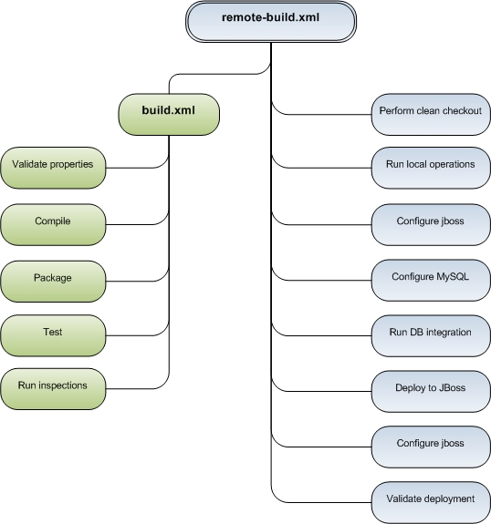
Figure 1 - Logical organization of the Ant targets in the local and remote build files

