Acquire Project Data via API Use Case Specification
caArray
Last Revised: | November 06, 2007
Produced By: | NCICB Development
Version: | 0.5

Document Approvals
The list contains the name and contact information for the core project team and any key stakeholders who have an interest in the success of the project. An “S” identifies persons responsible for approval from the stakeholder groups. Sign off of the document would be required when a decision is made not to take action for defined gaps.

S | Name | Role | S | Name | Role
S | Anand Basu | NCICB Engineering Manager | S | Juli Klemm, Ph.D. | Product Manager
 | Brent Gendleman | Development Project Manager |  | Jerry Eads | NCICB Project Manager
 | Eric Tavela | Development Architect |  | Ron Keene | NCICB Independent QA
 | Don Swan | NCICB Application Support
Revision History
When you make a change to a document, you must add an entry to this Revision History table and you must manually type the Last Revised Date on the front cover.

Date | Version | Description | Revised by
6/25/07 | 0.1 | Initial Draft | Rashmi Srinivasa
7/5/07 | 0.2 | Implementation Questions added/plus some document clean up | Brent Gendleman
10/31/07 | 0.3 | Revised services available through the remote API (section 7). | Rashmi Srinivasa
11/01/07 | 0.4 | Revised Flows (sections 3-5). | Rashmi Srinivasa
11/06/07 | 0.5 | Added details of Convenience Search, post-conditions and maximum Data Set size. | Rashmi Srinivasa
Copyrights and Trademarks
© Copyright 2007 by NCICB, caBIGTM. All rights reserved.

Table of Contents
1. Brief Description 1
1.1. References 1
2. Preconditions 1
2.1. API Service Must Be Available 1
2.2. External System Must Be Able to Access CaArray 1
2.3. External System Must Log-in to Access Protected Data – Java API Only 1
2.4. Knowledge of URL Location of the API Service 1
2.5. No User Interface 2
2.6. Array Data Size Limitation 2
3. Basic Flow of Events 3
4. Alternative Flows 3
4.1. Retrieve Array Data 3
4.2. Retrieve Array Design Details 3
4.3. Download Data File 3
5. Exception Flows 4
5.1. Array Data Size Requested Exceeds Maximum 4
6. Post-conditions 4
7. Special Requirements 4
7.1. Remote APIs Provided 4
7.2. Services Provided Through the Remote APIs 5
7.2.1. The CaArray Search Service 5
7.2.2. The Data Retrieval Service 6
7.2.3. The Array Design Details Service 6
7.2.4. The File Retrieval Service 6

Brief Description
Initiated by an External System, this use case enables programmatic extraction of annotation and array content from caArray using an API. The use case also includes extraction of data from caArray by a grid client through a caGRID service. caBIG Analysis Services is the primary External System targeted and public and protected data should be available provided appropriate authorization is used. The use case may expand to include external systems such as GEO or Array Express or other systems that are local to the installer or NCICB that may have an interest in the data contained in caArray.

References
caArray Vision – functional requirements
caArray Supplementary Specifications – non-functional requirements
caArray Use Case Summary – actor definitions and context

Preconditions

API Service Must Be Available
The deployment of caArray alone will allow the Java API to be available; the Grid API requires a distinct deployment process in order to become available. See Installation Guide: Deploy the caArray Grid Service.

External System Must Be Able to Access CaArray
Any and all firewall(s) between the External System and the caArray Service must be configured to allow the required traffic across appropriate ports.

External System Must Log-in to Access Protected Data – Java API Only
If the External System wants to acquire protected (not public) data, it must execute the login API to log in as the appropriate user who has access to the protected data.

Knowledge of URL Location of the API Service
The service must be available and its location is known.

No User Interface
This use case provides programmatic access and requires knowledge of Web Services, caBIG Query Language (CQL), the caArray Domain Model and programmatic languages.

Array Data Size Limitation
The maximum amount of data that can be returned in a single data retrieval response is (500MB – TBD).

Basic Flow of Events

The External System connects to the remote API, providing the user credentials for anonymous access and acquires the CaArray Search Service.

The External System uses the CaArray Search Service to find one or more Experiments of interest.

The System authenticates the provided credentials and returns the list of experiments.

The External System navigates the object graph (as defined in the domain model), starting with one or more of the Experiments returned in the search, until the Hybridization(s) or ArrayDesign(s) or data files of interest are found.

If array data is of interest, the External System obtains the Data Retrieval Service and executes the “Retrieve Array Data” Alternative Flow.

If array design details are of interest, the External System obtains the Array Design Details Service and executes the “Retrieve Array Design Details” Alternative Flow.

If array data files are of interest, the External System obtains the File Service and executes the “Download Data File” Alternative Flow.

Alternative Flows

Retrieve Array Data

The External System constructs a request with one or more Hybridizations from one or more Experiments, specifying the Quantitation Types of interest.

The External System uses the Data Retrieval Service to obtain the Data Set containing the requested data.

The System returns a data set containing the data for the set of hybridizations and quantitation types requested.

Retrieve Array Design Details

The External System requests the details of the design elements for the array design of interest.

The System returns the feature and probe details of the array design requested.

Download Data File

The External System requests the contents of a data file of interest.

The System returns the contents of the data file requested.

Exception Flows

Array Data Size Requested Exceeds Maximum

At Step 3 in the “Retrieve Array Data” Alternative Flow, the System messages the requestor that the data set size exceeded the threshold, and indicates the data set size for each requested Hybridization.

The data retrieval request in Step 1 (“Retrieve Array Data” Alternative Flow) must be modified into several smaller requests and re-executed.

Post-conditions
The External System has the requested array data, array design details or data files, or an error message if the request was unable to be fulfilled.

Special Requirements

Remote APIs Provided

caArray Remote Java API: Java client applications use this interface to communicate with a running instance of caArray. The interface provides access to the following services: the caArray Search Service, the Data Retrieval Service and the Array Design Details Service. In addition, client applications can access backend objects via domain objects packaged in the client.jar. Section 7.2 describes the proposed services. 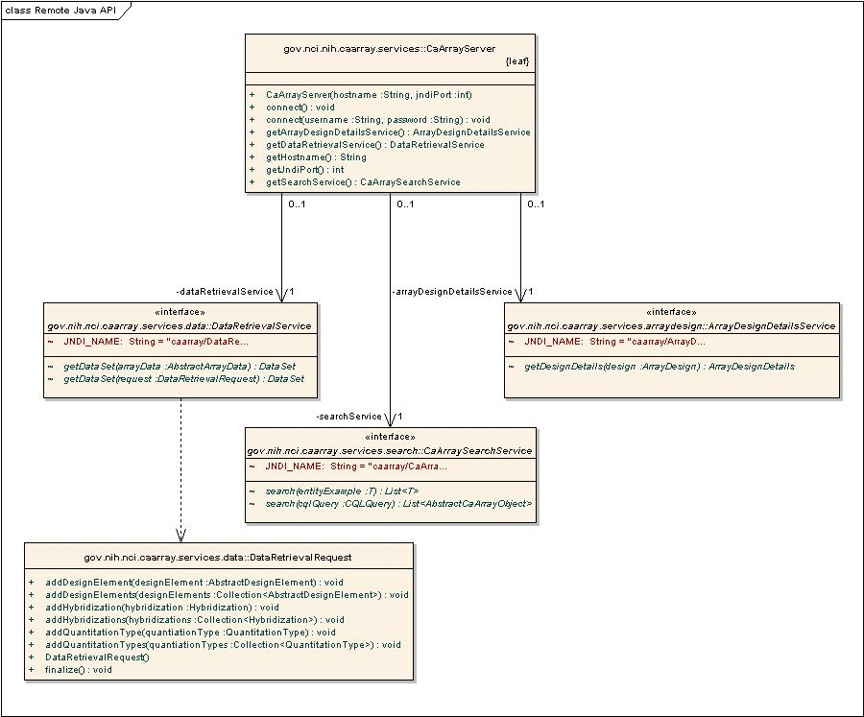

caArray Grid Service API: Non-Java or Java client applications use this interface to communicate with the caArray Grid Service which in turn communicates with a running instance of caArray. The same services described in section 7.2 are accessible through this interface as well.

Services Provided Through the Remote APIs

The CaArray Search Service
The External System uses this service to perform the following types of searches:

Search-by-example using domain objects as the criteria.

CQL (caBIG Query Language) search.

Convenience search methods for commonly executed searches. Convenience search methods can be used to query for all experiments that have a given keyword in one or all of the following attributes:

Experiment ID

Experiment Title

Assay Provider

Array Design

Organism

Sample

Sample ID

Disease State

The Data Retrieval Service
The External System uses this service to retrieve array data for a desired set of hybridizations, filtered by a desired set of quantitation types.

The Array Design Details Service
The External System uses this service to obtains details of an array design including probes and features.
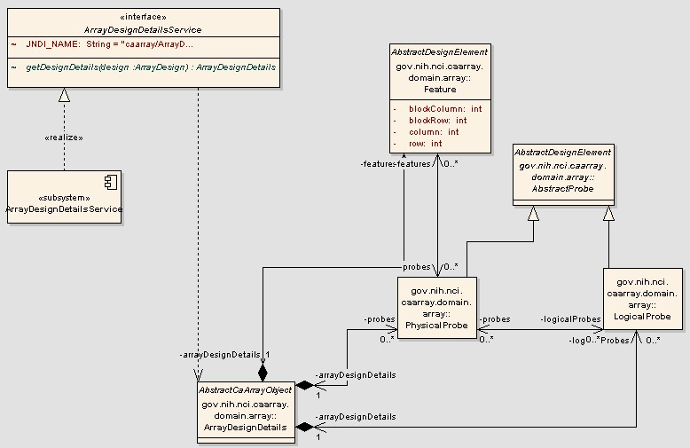

The File Retrieval Service
The External System uses this service to retrieve the contents of an array data file for a Hybridization of interest.

