Automated Build and Deployment Roadmap
NCICB Build and Deployment
Last Revised: | 8/24/07
Produced By: | Paul Duvall
Version: | 0.4

Document Approvals
The list contains the name for the core project team and any key stakeholders who have an interest in the success of the project. An “S” identifies persons responsible for approval from the stakeholder groups. Sign off of the document would be required when a decision is made not to take action for defined gaps.

S | Name | Role | S | Name | Role
S | Anand Basu | CBIIT Engineering Manager |  | Doug Kanoza | SCM Initiative Leader
 | Juli Klemm, Ph.D. | caArray Product Manager | S | George Komatsoulis | CBIIT Director of QA
 | Eric Tavela | Development Architect |  | Brent Gendleman | Development Project Manager
 | Vanessa Caldwell | Database Manager |  | Sriram Kalyanasundaram | Application Manager
 | Don Swan | NCICB Application Support

Revision History
When you make a change to a document, you must add an entry to this Revision History table and you must manually type the Last Revised Date on the front cover.

Date | Version | Description | Revised by
7/15/2007 | 0.1 | Initial draft | Paul Duvall
7/31/2007 | 0.2 | Modifications based on interviews of System Teams (SCM, Applications, Database), caArray Development Team, caArray Engineering Manager and Product Manager, caArray ARC document, and initial implementation for caArray DEV | Paul Duvall
8/16/2007 | 0.3 | Updated for DEV to QA Handoff Meeting and initial roll out | Paul Duvall
8/24/07 | 0.4 | Final Draft prepared for next steps | Paul Duvall
Copyrights and Trademarks
© Copyright 2007 by NCICB, caBIGTM. All rights reserved.

Table of Contents
1. Introduction 3
2. Goal 3
3. Steps to Remote Deployment 3
4. High-Level Implementation Steps 3
4.1. What will development teams need to implement? 3
5. What can be improved? 3
6. What are the guiding principles? 3
6.1. “Build System is KING” 3
6.2. Deployment will use machine-readable files to read configurable data 3
6.3. Works on ANY machine 3
7. How will project analysis occur? 3
8. What constitutes an “Automated Deployment”? 3
9. What Needs to Happen and When? 3
10. Resources 3
11. The Future 3

Introduction
Remote deployment simplifies an otherwise complex configuration and deployment task to a single command. Building off the successful implementation of this approach for the caArray 2 application and the SCM Initiative, this document presents a roadmap for rolling out this approach in an iterative and incremental manner to additional NCICB projects. The main benefits of this approach are:
- Significant reduction in deployment time across tiers
- Reduction of deployment errors due to environment configuration
- Reduction of required overhead
- Dramatic reduction of deployment as a factor in release schedules
Figure 1 illustrates the time and efficiency gains between development and production.

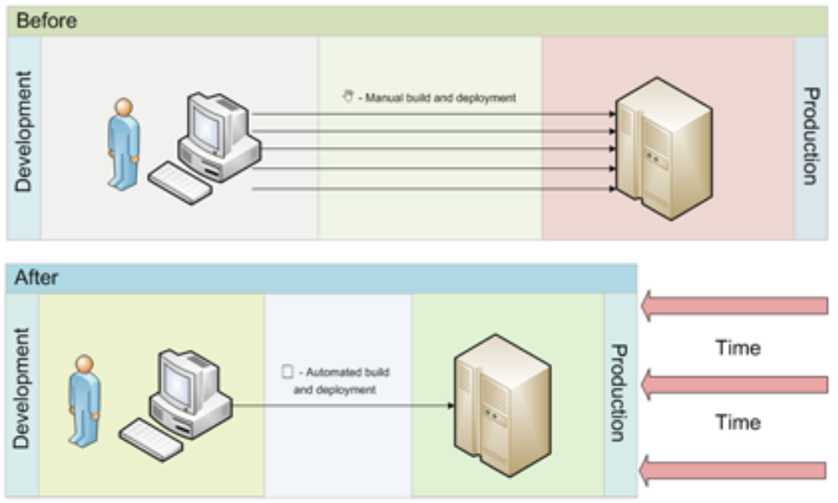
Figure 1 - An automated configuration and deployment shortens the development-production cycle and reduces the number of communication channels required

Goal
The goal of this roadmap is to give decision makers resources to make effective decisions in order to expedite an automated multi-environment build and deployment model. The overarching goal is to make remote deployment the “click of a button”. As implemented, this means that a user will either click a button or provide simple configuration information (such a version control repository label) to build and deploy software.

- What - Speed up delivery time by decreasing manual processes
  - Integrate configuration into the build process rather than requiring manual intervention
- How - Convert attributes (currently maintained in Word documents) into files that are machine-readable (an automated system)
- Why - Enable projects to adapt to changes and deliver software faster with fewer deployment errors and uncertainty of environment contribution to feature failure or defect validation

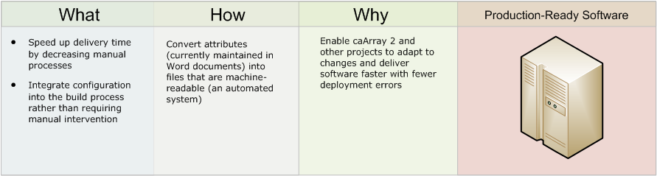
Figure 2 – Goals of Automated Build and Deployment
Once the deployment of software becomes a “nonevent” at NCICB through automation, the program can move toward the capability of providing production-ready software on a weekly or even a daily basis.

Steps to Remote Deployment
The centralized build server will remotely deploy to the DEV, QA, STAGE and PROD environments through an on-demand mechanism provided through AntHill Pro – which will allow for centralized management, metric capture and reporting. However, since caArray 2 (and many other caBIG™ projects) is an open source project, it must be able to be built and deployed outside of the controlled environment of NCICB without license restrictions required by AntHill Pro. Therefore, we’ve provided scripts that perform some of the simpler features provided by AntHill Pro that allows for both environment requirements (internal and external) to be supported. The figure below demonstrates the simple process a user (developer, PM, etc.) must perform prior to deployment of the software to a target environment.
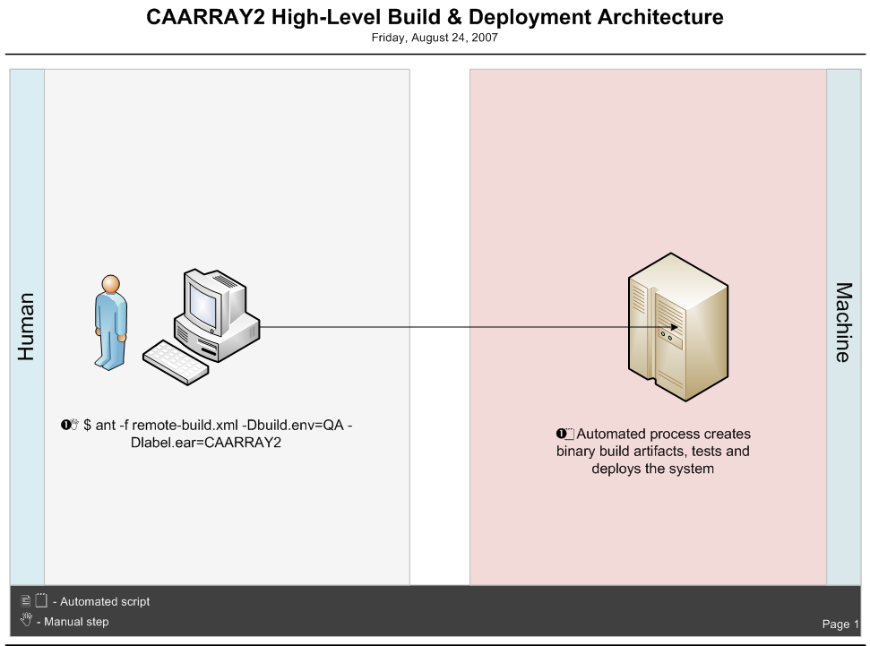
Figure 3 – Example of Single-Step Remote Deployment

High-Level Implementation Steps
Projects that begin following the automated remote build and deployment process will no longer need to manage Word documents that currently are crafted between Development, Quality Assurance and Systems. Instead, Developers and Quality Assurance will manage .properties files. There will be two key types of .properties files:

environment.properties (typical names will be DEV.properties, STAGE.properties). This file contains all of the values for a particular environment and a particular project. This is a private file (ideally maintained in an authenticated version control system) that only the application development team, QA team and Systems teams will have access to.

application-key.properties - This file is a public file that contains attributes only (augmented with descriptions or default values). It will be used to validate a particular environment.properties file to ensure the proper attributes have been defined. This ensures that correct attributes have been defined without the build system needing to have knowledge of the actual values. The benefit is that development can code to the same properties that Systems will use in the STAGE environment without knowledge of the STAGE property values. The Systems team will be defining a single file that will emulate this feature instead of a project-specific file.

What will development teams need to implement?
Development teams will need to extract any configurable values that are currently maintained in the source code, move them to .properties files, modify the source to refer to the property file attributes and retest the software
.properties files will need to be managed in a centralized SCM repository that requires authentication and authorization

Development teams must be capable of running the same build in any environment (i.e. workstation, DEV environment, QA environment, STAGE, etc.). The build system (e.g. Ant build scripts, etc.) will be the single point of application configuration. A symptom this is not occurring for a project is when teams start saying things like “Did you configure the environment variable for the QA machine?”
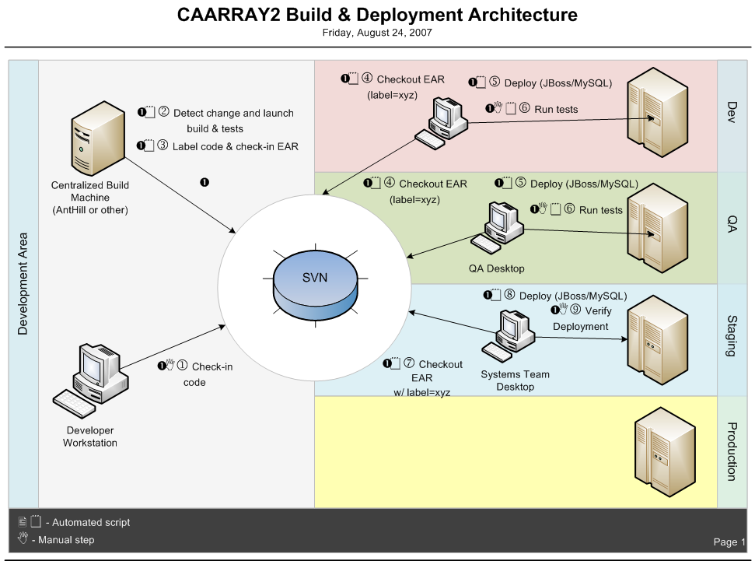
Figure 4 – High-Level Build and Deployment Architecture

What can be improved?
Under the current approach, once development is complete, it takes too long to get changes into production. Because it can be an arduous process to deploy software, either it’s performed less frequently or the release schedule is overly generous as a result. Therefore, new features and changes are delivered all at once toward the “end” of the delivery cycle with high risks to quality and impacting the entire “family” of teams ability to plan. This prevents expeditious feedback and makes change more complex and significantly more costly.

What are the guiding principles?
There are a few key guiding principles that will drive the success of this effort – making build and deployment a “nonevent”. The first is that the build system is “king”. On most projects, this refers to the set of Ant scripts that are responsible for building and deploying the software. This leads us to the second guiding principle. Build scripts should contain behavior only and leave the data to .properties files. This principle eliminates the need for copying/pasting values from Word templates and requires all data to be put in files that can be read by build scripts. Finally, the last guiding principle is that the core behavior in the build scripts should not change based on the environment (workstations, DEV, QA, STAGE and PROD). Only the data in the .properties file will change. These principles are described in detail below.

“Build System is KING”
The build system alone should be able to completely build and remotely deploy the software into ANY environment (DEV, QA, STAGE) solely using files obtained from the project’s version control repository (e.g. Subversion) and any heavy-weight dependencies (i.e. database server, web server, etc.). These heavyweight dependencies should assume a clean environment and not require any application-specific setup and configuration. This configuration should be updated through the build system (e.g. database attributes, stopping/starting web container, database creation/test data, etc.).

Deployment will use machine-readable files to read configurable data
There will be no copying and pasting values from one environment to the next. Therefore, Word documents will no longer be used as a basis to configure an environment. The build system will manage all build and deployment activities.

Works on ANY machine
Ensuring the build process works on any NCICB machine is the most important success criteria. Any developer should be able to produce the same working software artifact on any provisioned machine (NCICB) or machines provisioned by external audiences according to specific, documented, and minimal heavyweight dependencies. The same build process should be able to build on a developer’s workstation, DEV environment, QA environment, STAGE environment without needing to make modifications to these machines (other than the previously identified heavyweight dependencies). From an implementation perspective, this means the build scripts will contain conditional code to work in different target environments.

How will project analysis occur?
To implement these improvements on a project-by-project basis, there will be three primary tools for determining what needs to change within the source code to enable automated build and deployment. They are static analysis, interviews and manual analysis

- Static Analysis – Leverage static analysis tools such as PMD and/or CheckStyle to search code for hard-coded attributes. These attributes can then be extracted to .properties files
- Interviews – Interview technical leads to learn the architecture of the system to assist in any manual analysis. Questions will center on areas that a build system can help automate (such as web server deployments, database integration, and so on).
- Manual Analysis – Experts will analyze the source code and build scripts looking for opportunities to extract values and repetitive, error-prone processes so that they can be run as part of the build system

What constitutes an “Automated Deployment”?
It’s important to define what constitutes an automated (remote) deployment moving forward as the subtleties in language can be the difference between short and long release cycles. The responsibilities outlined below indicate those related to the automated deployment.

Among other responsibilities, the Systems team is responsible for:
- Defining the processes that development teams must adhere to get software into production
- Maintaining the DEV, QA, STAGE and PROD machines
- Installing and maintaining heavy dependencies such as web servers (e.g. Apache and JBoss) and Database server (e.g. MySQL and Oracle)
Among other responsibilities, the Development teams are responsible for:

- Creating build scripts that compile, rebuild database and test data, run automated tests, inspections and package and deploy the software to a web server (e.g. JBoss) in each environment
- Build scripts should work in ANY environment (DEV, QA, STAGE, PROD) with no changes (only the environment.properties file will change)
- All assets to successfully build and deploy the software should exist in the version control repository for the project (other than heavy dependencies such as database and web containers). The configuration behavior for the database and web containers should reside in the build scripts.
- For remote deployment, development teams should organize their build scripts such that there is an extension of the build that is performed on the local developer workstation rather than duplication of these scripts

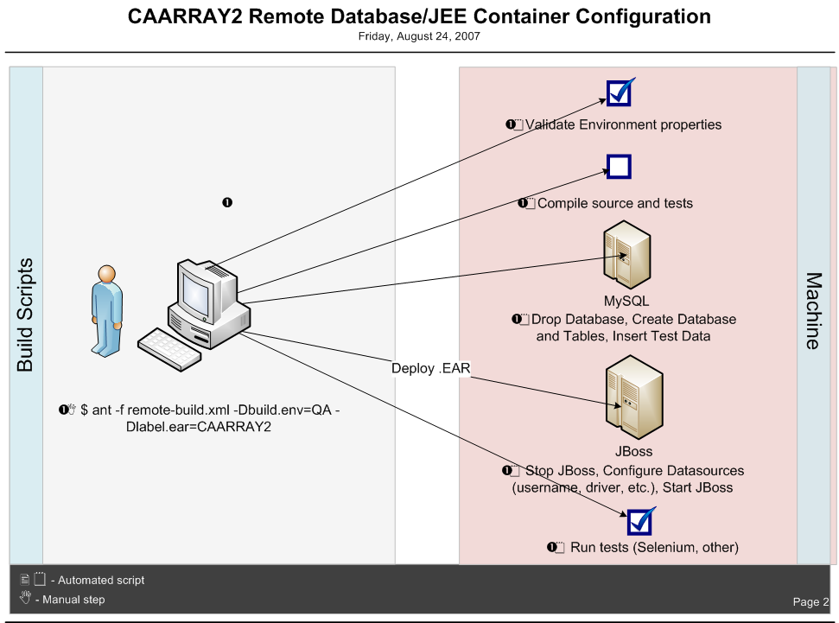
Figure 5 – Database and Web Container Configuration

Compilation
- Compile the source code and the tests

Database Integration/Migration
- Rebuild the database using Data Definition Language (DDL) SQL scripts
- Insert test data using Data Manipulation Language (DML) SQL scripts
- As necessary
  - Data migration for production data schema and data changes (typically, ALTER and INSERT statements)

Testing
- Run automated unit, component, system and functional tests
- As necessary, run automated performance, load and security tests per requirements

Inspection
- In DEV/QA? environment run static and dynamic analysis tools that help target code quality errors such as:
  - Coding Standards and Coding errors
  - Code Coverage
  - Dependency Analysis
  - Code Duplication
  - Cyclomatic Complexity

Deployment
- Remotely deploy software to web server (JBoss)
- Typically, this includes the starting and stopping of the JBoss server and configuring values such as the database username and password to JBoss’s configuration files

Feedback
- Notify teams on the remote build and deployment status after completion via email or other notification mechanism

What Needs to Happen and When?
Requiring every project to immediately adhere to this new process is a sure way to make the initiative fail

Much of the timeline will depend upon the analysis of existing projects, but we’ve listed an estimate based on our experience with other teams. Usually, the most challenging aspect is working with meeting the needs and concerns of the different teams. We recommend using an iterative and incremental approach for implementing these changes for all of NCICB’s development teams. We recommend the following:

- Use the lessons from one project that delivers to Staging regularly (e.g. caArray 2) and identify best practices (one+ month)
- Implement on a handful (three or so) of other projects that use a different technology stack (about three months)
- Begin requiring new projects to adhere to new process (about six months)
- Begin requiring existing projects to retrofit to new process (about nine+ months)
- Incrementally add new features to the build system so that more processes are automated (such as testing) so that there are less manual steps to getting to production
- Development teams must clearly indicate the heavy-weight dependencies and any environment configuration that must be made in target environments (e.g. JBoss w/EJB 3)

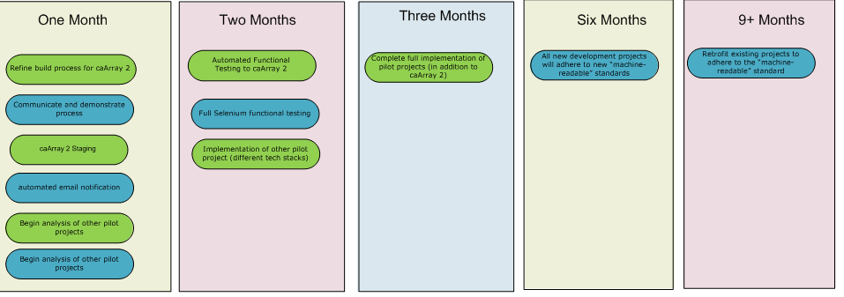
Figure 6 – Project Rollout

One Month
- Refine build process for caArray 2 (continue to reduce any manual steps)
- Communicate and demonstrate process to other development teams
- Extend process to Staging environments for caArray 2
- Add additional quality checks to the build process such as FindBugs, FuseBox, refining CheckStyle checks as necessary
- Add automated email notification to automated Build and Deploy
  - Email notification is already bundled with the AntHill build management server
  - Added to the on-demand deploy
- Begin analysis of other pilot projects (that use different development environments)
  - Projects should be representative of different technology stacks
Two Months
- Integrate automated testing into build process for caArray 2
- Full Selenium functional testing
- Implementing other pilot projects

Three Months
- Complete full implementation of pilot projects (in addition to caArray 2)

6 Months
- All new development projects will adhere to new “machine-readable” standards

9+ Months
- Retrofit existing projects to adhere to the “machine-readable” standard

Resources
- Centralized build machine responsible for remote build and deployment of different software applications
- Build Automation Mentor to work with different development teams
- Working with development team(s) resources with respect to their release schedules
- Systems team resources

The Future
Continuous Production - Set a goal to get all projects to the point where they can produce production-ready software on a daily basis. This will reduce the amount of repetitive and error-prone processes and enable better decision making and increase quality

Extend automated test execution for all projects. This includes unit, component, system, functional, security, load and performance testing. This must occur in be capable of producing production-ready software on a daily basis.

