Application Title
Requirements Management Plan

Version 0.1

Document Approvals
The list contains the name for the core project team and any key stakeholders who have an interest in the success of the project. An “S” identifies persons responsible for approval from the Business and Development. Sign off of the document would be required when a decision is made not to take action for defined gaps.

S | Name | Role | S | Name | Role
S | Anand Basu | NCICB Engineering Manager | S | Juli Klemm, Ph.D. | Product Manager
 | Brent Gendleman | Development Project Manager |  | Jerry Eads | NCICB Project Manager
 | Eric Tavela | Development Architect |  | Ron Keene | NCICB Independent QA
 | Don Swan | NCICB Application Support
Revision History
When you make a change to a document, you must add an entry to this Revision History table and you must manually type the Last Revised Date on the front cover.
Date | Version | Description | Revised by
Table of Contents
1. Introduction 4
1.1 Purpose 4
1.2 Scope 4
1.3 Definitions, Acronyms, and Abbreviations 4
1.4 References 4
1.5 Overview 4
2. Requirements Management 4
2.1 Organization, Responsibilities, and Interfaces 4
2.2 Tools, Environment, and Infrastructure 5
3. The Requirements Management Program 5
3.1 Requirements Identification 5
3.2 Traceability 5
3.2.1 Criteria for Stakeholder Needs (NEED) 6
3.2.2 Criteria for Features (FEAT) 6
3.2.3 Criteria for Use-Case Requirements (UC) 6
3.2.4 Criteria for Supplementary Requirements (SUPP) 6
3.2.5 Criteria for Test Cases (TC) 7
3.3 Attributes 7
3.3.1 Attributes for Need (NEED) 7
3.3.2 Attributes for Feature (FEAT) 7
3.3.3 Attributes for Supplementary Requirement (SUPL) 8
3.3.4 Attributes for Use Case (UC) 10
3.3.5 Requirement Attributes for Test Case (TC) 11
3.4 Reports and Measures 12
3.5 Requirements Change Management 12
3.5.1 Change Request Processing and Approval 12
3.5.2 Change Control Board (CCB) 12
3.5.3 Project Baselines 13
3.6 Workflows and Activities 13
4. Milestones 13
5. Training and Resources 13

Introduction

Purpose
The Requirements Management Plan (RMP) provides a systematic approach to eliciting, organizing, and documenting the requirements of a system. The RMP supports maintenance of a common understanding of requirements between customers and the software development team. The RMP also assists in effectively controlling changes to requirements that can affect the scope of a project. In addition, the RMP prescribes traceability tags, which will be used throughout the software system lifecycle. The tags are used to track how design, development, testing, and user documentation artifacts satisfy documented requirements.

Scope
This Requirements Management Plan defines all aspects of requirements management as it applies to the Application Title project.

Definitions, Acronyms, and Abbreviations
None

References
Development Case
Configuration Management Plan
Software Development Plan
[RUP] Rational Unified Process, version 2003.06.15

Overview
The Requirements Management Plan is divided into sections. Section 2 documents requirements artifacts and requirements types for the Application Title project. Section 3 documents the requirement type attributes that will be tracked in the project’s requirements database and, thus, provide for traceability through the requirements lifecycle. Section 4 establishes traceability criteria for the various requirement types for the project.

Requirements Management

Organization, Responsibilities, and Interfaces
This will be covered in the Project Management Plan [PMP] for the specific project being developed.

Tools, Environment, and Infrastructure
Rational Requisite Pro, version 2003.06.13 is the tool used to record and manage requirements. The RequisitePro project, document files, and requirements database are all stored on the server 5am-corp1.5amsolutions.com. See http://intranet.5amsolutions.com/rup/toolment/reqpro/tm_setup.htm in [RUP] for details on how to configure a new project or client access. Note that it is generally preferable to use the web front-end to RequisitePro than to use the desktop client.
At the completion of each iteration and as necessary, all requirements documents and reports should be exported from RequisitePro and baselined along with the general project artifact base in CM.

The Requirements Management Program

Requirements Identification
Artifact | Traceability Item | Description
ClearQuest Change Request Database | Enhancement Request | Requests for additional or augmented functionality, recorded in the project’s ClearQuest database.
Vision (VIS) | Stakeholder Need (NEED) | Key stakeholder or user need. The business or operational problem (opportunity) that must be fulfilled in order to justify purchase or use. Also known as Goal or  Objective.
Vision (VIS) | Feature (FEAT) | Conditions or capabilities of this release of the system
Use-Case Specification (UCS) | Use-Case Requirement (UC) | Individual detailed requirements as specified in the use-case specification organized in a hierarchy. At the top level of the hierarchy, refers to the use case as a whole.
Supplementary Specification (SS) | Supplementary Requirement (SUPP) | Requirements (often non-functional) that transcend or do not apply to a single use-case.
RequisitePro Requirements Database | Test Case (TC) | The specification (usually formal) of a set of test inputs, execution conditions, and expected results, identified for the purpose of making an evaluation of some particular aspect of a Target Test Item.

Traceability
The following traceability diagram is taken from [5AM_REQ_MDL] and demonstrates the traceability that must be recorded between requirement types.
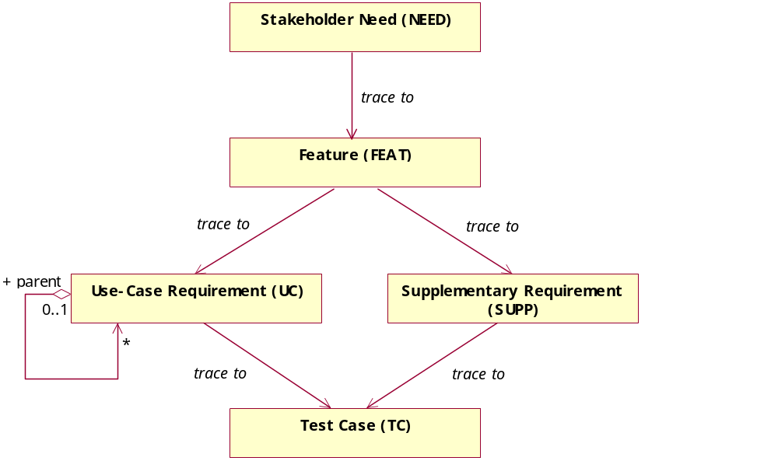
Figure 1 - Requirement Type Traceabilities

Criteria for Stakeholder Needs (NEED)
Stakeholder Needs (NEED) will be traced to Features (FEAT). Any NEED not traced to a FEAT will not be implemented.

Criteria for Features (FEAT)
Features (FEAT) will trace to Supplementary Requirements (SUPP) and/or Use-Case Requirements (UC).
A FEAT may trace directly to a UC. This allows the FEAT to be assigned to a UC before the use case sections have been written and enables impact analysis on the Use-Case Model at the Feature level and vice versa. The Features also trace to the Supplementary Requirements in the Requirements Specification [REQ_SPEC]. All Features that do not trace into the use case model must trace to at least one of the software requirements in the Supplementary Specification.

Criteria for Use-Case Requirements (UC)
The top level Use-Case Requirement (UC) represents the use case in its entirety, whereas any child UC requirements represent requirements within the enclosing use case.
UCs will trace to the Test Cases (TC). This relationship allows us to see which requirements are to be tested and ensure coverage or to assess the impact of a failed test.

Criteria for Supplementary Requirements (SUPP)
Supplementary Requirements (SUPP) will trace to Test Cases (TC).
This relationship allows us to see which requirements are to be tested and ensure coverage or to assess the impact of a failed test.

Criteria for Test Cases (TC)
All Test Cases (TC) must trace from either a UC or a SUPP or a combination of the two, potentially tracing to multiple UCs or SUPPs when appropriate.

Attributes

Attributes for Need (NEED)
Requirement Text is the business Need description.

Business Priority
Used in managing scope and determining development priority.
Critical | Essential business needs that must be met by features of the system.
Required | Important business needs that should be met by features of the system.
Optional | Additional business needs that would be advantages to have incorporated into the system’s features, but are not crucial to a successful system.
TBD | Default To be determined. Represents a decision at a milestone. Business priority has not been set by the stakeholders.

Rationale
This text field is used to track the source of the Need and denotes why it is important to the stakeholders.

Source
This text field describes how the need was first identified, which could be from a document or a stakeholder.

Attributes for Feature (FEAT)
Requirement Text is the feature description.

Business Priority
All requirements are not created equal. Ranking requirements by their relative benefit to the stakeholders opens a dialogue with customers, analysts, and members of the development team. Used in managing scope and determining development priority.

Critical | Essential features. Failure to implement means the system will not meet customer needs. All critical features must be implemented in the release or the schedule will slip.
Required | Features important to the effectiveness and efficiency of the system for most applications. The functionality cannot be easily provided in some other way. Lack of inclusion of a required feature may affect customer or user satisfaction, or even revenue, but release will not be delayed due to lack of any required feature.
Optional | Features that are useful in less typical applications will be used less frequently, or for which reasonably efficient workarounds can be achieved. No significant revenue or customer satisfaction impact can be expected if such an item is not included in a release.
Future Generation | Future and nice to have features.
TBD | Default To be determined. Represents a decision at a milestone. Business priority has not been set by the stakeholders.

Architectural Priority
Architectural priorities are set by the development team. Architectural priority can be assessed indirectly by measuring the uncertainty (range) of the projects’ complexity.

High | Essential features. Failure to implement means the system will not
Medium | Features important to the effectiveness and efficiency of the system
Low | Features that are useful in less typical applications will be used less

Acceptance/Promotion
The acceptance or promotion of an attribute is determined by the completeness and relevance of the attribute at the end of each phase of the life cycle or development.

Proposed | Used to describe features that are under discussion but have not yet been reviewed and accepted by the "official channel," such as a working group consisting of representatives from the project team, product management and user or customer community.
Approved | Capabilities that are deemed useful and feasible and have been approved for implementation by the official channel.
Incorporated | Features incorporated into the product baseline at a specific point in time.
Deferred | Features deferred to be promoted to the next phase of the life cycle or development.
Rejected | Features rejected to be promoted to the next phase of the life cycle or development.

Rationale
This text field is used to track the source of the requested feature. Requirements exist for specific reasons. This field records an explanation or a reference to an explanation. For example, the reference might be to a page and line number of a product requirement specification, or to a minute marker on a video of an important customer interview.

Target Release
Records the intended product version in which the feature will first appear. This field can be used to allocate features from a Vision document into a particular baseline release. When scope management occurs, the Target Release Version Number can be increased so the item will remain in the Vision document but will be scheduled for a later release. Values: enumerates of pre-determined release names.

Source
This text field describes how the need was first identified, which could be from a document or a stakeholder.

Attributes for Software Requirement (REQ)
Requirement text describes what the system should do.

Affects Architecture
Set by the Software Architect, this indicates the requirement has an influence on the software architecture. Values: True or False.

Priority
All requirements are not created equal. Ranking requirements by their relative Priority to the stakeholder opens a dialogue with customers, analysts and members of the development team. Used in managing scope and determining development priority.

Critical | Essential features. Failure to implement means the system will not meet customer needs. All critical features must be implemented in the release or the schedule will slip.
Required | Features important to the effectiveness and efficiency of the system for most applications. The functionality cannot be easily provided in some other way. Lack of inclusion of a required feature may affect customer or user satisfaction, or even revenue, but release will not be delayed due to lack of any required feature.
Optional | Features that are useful in less typical applications will be used less frequently, or for which reasonably efficient workarounds can be achieved. No significant revenue or customer satisfaction impact can be expected if such an item is not included in a release.
Future discussion | Future and nice to have features.

Acceptance/Promotion
Set after negotiation and review by the project management team. Tracks progress during definition of the project baseline.
Proposed | Used to describe features that are under discussion but have not yet been reviewed and accepted by the "official channel," such as a working group consisting of representatives from the project team, product management and user or customer community.
Approved | Capabilities that are deemed useful and feasible and have been approved for implementation by the official channel.
Incorporated | Features incorporated into the product baseline at a specific point in time.
Deferred | Features deferred to be promoted to the next phase of the life cycle or development.
Rejected | Features rejected to be promoted to the next phase of the life cycle or development.

Effort
Effort is assigned values that determine the level of effort required to implement the requirement. The values for effort are:
High | Unknown complexities or haven’t done it before. Estimated to be greater than 2 man-weeks.
Medium | Average complexity. Have done it before or know how to approach it. Estimated to be around 1 to 2 man-weeks.
Low | A few hours to a few man-days. Solution is well known. Confidence is high in the estimates. No expected complexities.

Attributes for Use Case (UC)
Requirement text is the name of the use case.

Brief Description
A few sentences that describe what an actor would use the Use-Case for. It should reflect the role and purpose of the Use-Case.

Affects Architecture
Set by the Software Architect, this indicates that the Use-Case flow of events touches a delicate point in the architecture or exercises a significant portion of the architecture. Values: True or False.

Planned Iteration
The iteration when this Use-Case is expected to be implemented. E.g. Release1 Iter2
Records the intended product version and iteration in which the feature will first appear. When combined with the status field, your team can propose, record and discuss various features of the release without committing them to development. Only features whose Status is set to Incorporated and whose Planned Iteration is defined will be implemented. When scope management occurs, the Planned Iteration Version Number can be increased so the item will remain but will be scheduled for a later release.

Actual Iteration
This indicates the actual iteration in which the use case was built.

Priority
All requirements are not created equal. Ranking requirements by their relative Priority to the stakeholder opens a dialogue with customers, analysts and members of the development team. Used in managing scope and determining development priority.

Critical | Essential features. Failure to implement means the system will not meet customer needs. All critical features must be implemented in the release or the schedule will slip.
Required | Features important to the effectiveness and efficiency of the system for most applications. The functionality cannot be easily provided in some other way. Lack of inclusion of a required feature may affect customer or user satisfaction, or even revenue, but release will not be delayed due to lack of any required feature.
Optional | Features that are useful in less typical applications will be used less frequently, or for which reasonably efficient workarounds can be achieved. No significant revenue or customer satisfaction impact can be expected if such an item is not included in a release.
Future discussion | Future and nice to have features.

Acceptance/Promotion
Set after negotiation and review by the project management team. Tracks progress during definition of the project baseline.
Proposed | Used to describe features that are under discussion but have not yet been reviewed and accepted by the "official channel," such as a working group consisting of representatives from the project team, product management and user or customer community.
Approved | Capabilities that are deemed useful and feasible and have been approved for implementation by the official channel.
Incorporated | Features incorporated into the product baseline at a specific point in time.
Rejected | Features rejected to be promoted to the next phase of the life cycle or development.

Effort
Effort is assigned values that determine the level of effort required to implement the requirement. The values for effort are:

High | Unknown complexities or haven’t done it before. Estimated to be greater than 2 man-weeks.
Medium | Average complexity. Have done it before or know how to approach it. Estimated to be around 1 to 2 man-weeks.
Low | A few hours to a few man-days. Solution is well known. Confidence is high in the estimates. No expected complexities.

Requirement Attributes for Test Case (TC)
Requirement text is a list of steps to execute the Test Case. The steps must be unambiguous such that performance of a test case is repeatable and so that automated test scripts can be written reliably from the description.

Type
The type attribute indicates how the Test Case will be implemented as a Test Script.

Parent | This Test Case requirement is used to organized related, enclosed test cases
Automated – HttpUnit | This Test Case has an associated automated test script implemented in HttpUnit.
Automated – Selenium | This Test Case has an associated automated test script implemented using Selenium.
Manual | This Test Case is performed manually according to the steps given in the requirement Text.

Assigned To
This is the test engineer responsible to write the Test Case. Ideally, this comes from an enumerated list of test engineers.

Planned Iteration
The iteration when the requirement will be implemented and tested. The test case must be written before or during this iteration.

Status
Set by the test assigned test engineer. Tracks progress during test development.
No Activity | No work has been accomplished in implementation of the requirement.
In Progress | Test Case script, either manual or automated, that verifies the requirement is being written.
Written | Test Case has been written but has not passed inspection.
Inspected | Test Case has been written and has been inspected and accepted as valid. Ready to execute.

Test Status
Set by the test assigned test engineer. Tracks progress during test development.
No Activity | No work has been accomplished in implementation of the requirement.
Passed | Test case has completed successfully and the requirement(s) are verified.
Failed | Requirement has failed the test case. Tester reports the defect and needs to retest later.

Test Script Name
This is the name of the test script, if automated. For HttpUnit tests, this will be the fully-qualified class name of the test class.

Reports and Measures
TBD

Requirements Change Management

Change Request Processing and Approval
5AM will work with the project stakeholders to define the requirements during the Inception Phase. At the close of the Inception Phase the requirements set will be submitted to the project authority for approval. After approval sign-off by Booz-Allen and NCICB, changes to the requirements set must be approved by the CCB.

Change Control Board (CCB)
The purpose of having standard, documented change control processes is to ensure that changes are made within a project in a consistent manner and the appropriate stakeholders are informed of the state of the product, changes to it and the cost and schedule impact of these changes.
Due to the short period of performance, the geographically distributed nature of the CCB members, and the schedules of those members, formal CCB meetings will not be convened. Instead, when CCB feedback is required for a change request, 5AM will notify all CCB members by email of the issue and subsequent discussion and approval will be handled by email.
The CCB will be constituted of the following members
- Eric Tavela, Chief Architect, 5AM Solutions
- Mervi Heiskanen, caArray Product Manager, NCICB
- Xiaopeng Bian, NCICB
- Peter Jons, Program Manager, Booz-Allen Hamilton

Project Baselines
Baselines of the project’s requirements set must be created at the end of each iteration and as necessary to publish requirement for stakeholders. Baselines are created by exporting the complete set of requirements documents and reports from RequisitePro to the project CM repository and labeling the artifacts as specified in the Configuration Management Plan [CM_PLAN].

Workflows and Activities
5AM employs the standard RUP workflows and activities for requirements management with any exceptions noted in the [DEV_CASE].

Milestones
The sole notable milestones in the requirements process for caAMEL are the delivery of the requirements set to the program authority and the subsequent approval of the requirements set.

Training and Resources
No special formal training is required for internal or external users to use RequisitePro. 5AM will educate users in using RequisitePro as necessary.

